Research, Build, and Deploy, a Virtualised network
Network Operating Systems and Services | ACCA5023
jonathan wilcox - 2206641
2025
Abstract – This report explores the research and implementation of a small network for NOSS2025, a multinational organization with UK offices in Cardiff and Swansea. The report covers important networking concepts, including hypervisor technologies, IP addressing, routing, and essential network services. The report evaluates each of these topics, outlining the advantages and disadvantages of these technologies. Following the research, a network is designed and deployed using a Type 2 hypervisor. The report documents the setup, testing, troubleshooting, and reflections on challenges encountered.

Table of Contents
Introduction 4
1. Task 1 – Research 5
1.1. Hypervisors 5
1.2. IP Addressing 7
1.3. Routing: 9
1.4. Network Services: 11
2. Task 2 – Technical Documentation 12
2.1. Choosing Hypervisor 12
2.2. Download and Setup 12
2.3. Configure IP Addressing 16
2.4. Test and Troubleshoot 20
3. Reflection 24
Conclusion 25
Abbreviations 26
References 27

Table of Figures

Figure 1. Architecture of type 1 and 2 hypervisors 3
Figure 2. IP communications across networks 5
Figure 3. IPv4 address split into network and host 5
Figure 4. Dynamic routing example 7
Figure 5. Microsoft Windows Server 2022 download centre 11
Figure 6. Debian download centre 12
Figure 7. Sever install from hypervisor software 12
Figure 8. Selecting memory and processors speeds required 13
Figure 9. Windows server installation screen 13
Figure 10. Debian server (command line) installation screen 15
Figure 11. Debian client (GUI) installation screen 15
Figure 12. Windows Server (right) and client (right) IP configuration 16
Figure 13. Windows Server External IP configuration 16
Figure 14. Debian server configuration access denied 17
Figure 15. Debian server configuration access denied 17
Figure 16. Debian issue failing to setup super user 18
Figure 17. Linux Server IP configuration 18
Figure 18. Linux Client IP configuration 19
Figure 19. Unsuccessful Ping to from Windows client to server 20
Figure 20. Troubleshooting – Turning firewall off on Windows client and server 20
Figure 21. Successful Ping from windows server (left) and windows client (right) 21
Figure 22. Successful Ping to Windows Server from Linux server 21
Figure 23. Successful Ping to from windows server to Linux Server 22
Figure 24. unsuccessful Ping to from Linux client to Linux Server 22
Figure 25. Successful Pings between Linux client (right) and Linux Server (left) 23
Figure 26. unsuccessful Pings between Linux client and windows client 23

Introduction

NOSS2025 is a multinational organisation with UK offices based in two locations, Cardiff and Swansea. This report focuses on the research and implementation of a small network for the business. The research covers hypervisor types 1 and 2, IP addressing, routing, and key network services such as virtual private networks (VPNs). This research aims to highlight the fundamental concepts of these technologies, including their advantages and disadvantages, with critical evaluations based on research papers.

Following the research, a network will be designed and deployed. The report will document all processes, including testing. The report will conclude with a reflection on the research and implementation process, highlighting any issues faced and potential areas for improvement.

1. Task 1 – Research

1.1. Hypervisors
IBM describes a hypervisor as a software layer that allows multiple operating systems (OS) to run on a device by using virtual machines (VMs) [1]. Hypervisors manage and allocates resources for each VM, including memory, CPU, and disk space. There are two types of hypervisors:
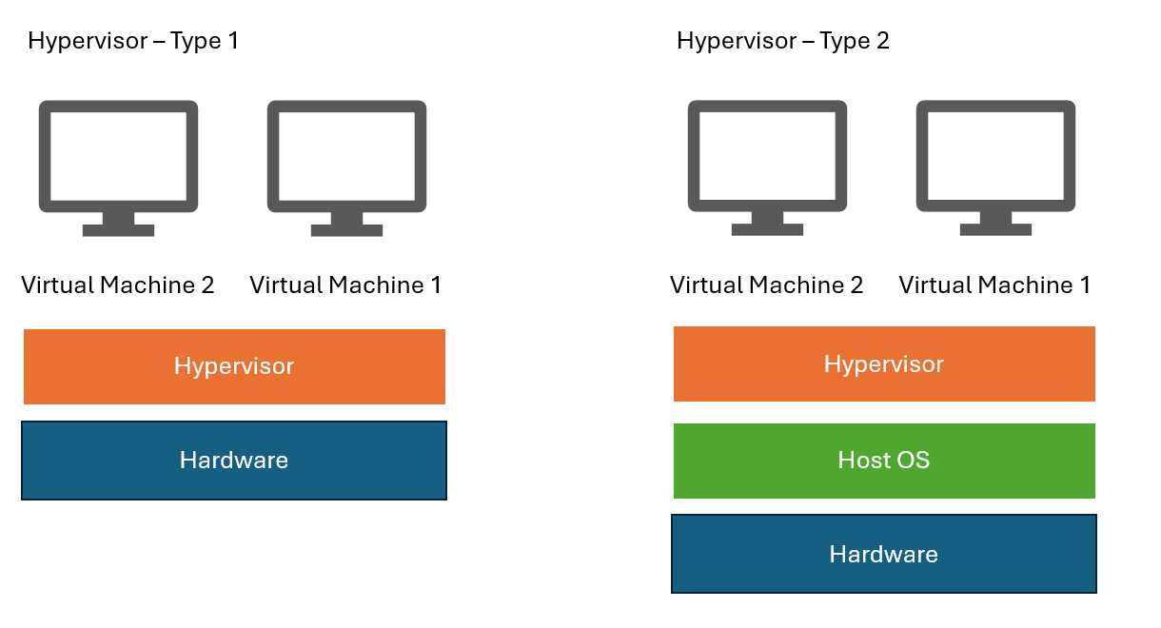
Figure 1. Architecture of type 1 and 2 hypervisors

Type 1 Hypervisors (Bare-Metal): Type 1 hypervisors run directly on physical hardware without requiring a host operating system. This design allows them to interact directly with the CPU, memory, and RAM, resulting in greater efficiency and lower latency compared to Type 2 hypervisors. As they do not need an operating system layer between the hardware and the hypervisor, Type 1 hypervisors are also considered more secure.
VMware is the leading Type 1 hypervisor, holding 44% of the market share. Other solutions include Microsoft Hyper-V and KVM [2]. Type 1 hypervisors do not rely on a host operating system allowing for better scalability, enabling users to upgrade the hardware to run multiple virtual machines while the hypervisor manages resources based on available computing power.
The minimum hardware requirements typically include a CPU, RAM, hard drive, NIC, and a power/cooling system. Most modern hardware/software are compatible with this type of hypervisor, with Windows and Linux being popular operating systems for virtual machines.
Type 2 Hypervisor: Operate on an existing OS rather than directly on hardware. This allows users to use their OS to create and manage virtual machines (VMs). Type 2 hypervisors are usually more suited for smaller-scale solutions [3].
As the host OS runs the hypervisor, this can slightly impact performance; unlike type 1, there is no direct access to hardware, which can increase latency. Type 2 solutions are quick and easier to deploy with a cheaper barrier to entry.
Scalability is more limited due to host OS resources; only a small number of VMs can be deployed at the same time, depending on the host's hardware. Another disadvantage is security, as the host OS is more vulnerable and open to an attack, potentially impacted by viruses and malware; however, firewalls can help mitigate this risk. Type 2 solutions include Parallels and Oracle virtual box [4]. Each solution has minimum hardware and OS requirements for the host device, but most modern-day systems can operate a type 2 solution.
To conclude, when choosing between hypervisors, the user must consider the required solution size. Where hundreds of VM’s are to be deployed, a type 1 solution will be best suited, but this will come with an increased cost. Type 2 solutions are better suited for small and less complicated solutions, which can be implemented quickly and cheaply.

1.2. IP Addressing
IP (Internet Protocol) works with packets to ensure data is transmitted efficiently across a network. Each packet contains destination and source IP data, allowing routers and switches to direct data efficiently.
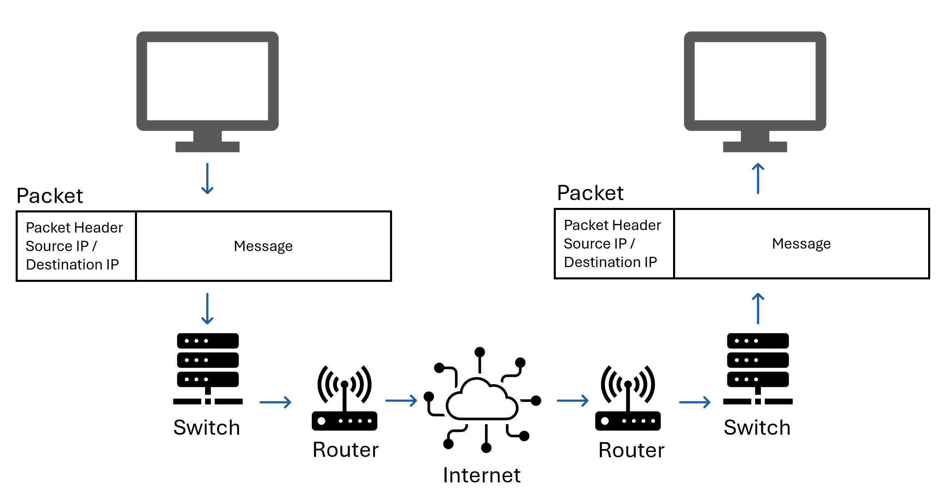
Figure 2. IP communications across networks [5]
IP addresses are crucial for networks and the internet to operate. They comprise a unique string of numbers assigned to a device, allowing networks to identify and communicate with each other [5]. There are two versions of IP:
IP Version 4 (IPv4): uses a 32-bit address structured into four sets of numbers ranging between 0 and 255, for example, 192.168.1.1 [6]. Due to the limitation of approximately 4.3 billion unique addresses, a technology called Network Address Translation (NAT) was introduced, allowing multiple devices on a single network to share one public IP address [7]. To enable NAT, a router is required to modify the IP address in each packet; this can increase network latency.
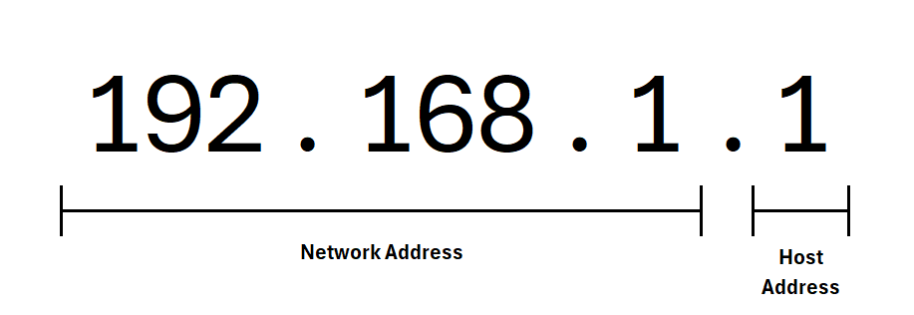
Figure 3. IPv4 address example
IP Version 6 (IPv6): was created to deal with the shortage of IPv4 addresses. IPv6 uses a 128-bit address structured in eight groups of four hexadecimal digits, for example, 2001:0dd8:0012:0001:3c5e:7334:0000:5db1; this large combination allows for 340 undecillion addresses. With so many addresses available, a NAT is not required. However, this is supported to enable communication with version 4 addresses.
IP addresses using casting to send data across a network.
Unicast: to send data to a specific source
Multicast: to send to many sources
Broadcast: data is sent to all devices in the network (not supported in IPv6)
Anycast: Supported on IPv6, allows for communication between the nearest device.
Subnetting is the process of splitting a network into smaller sub-networks. This is achieved by using the host section of an IP address to create subnets. This allows for efficient IP address allocation by assigning only the required addresses to each subnet, enhancing network performance by limiting the number of devices within each subnet.
Subnetting improves security by separating subnets from one another, allowing restricted access between them. Subnets enable network administrators to manage traffic more effectively. IPv6 has a larger address, allowing for larger subnets.
IP addresses are also essential for controlling network security, allowing network administrators to control access to specific addresses and monitor and track traffic. Policies can be set up on particular IPs to permit traffic based on specific rules; for example, an organisation may not be allowed to access certain websites. IPv6 provides enhanced security over v4 because it includes built-in encryption, reducing the risk of an attack.

1.3. Routing:
Routers are part of the distribution layer and connect multiple networks, directing packets to their destination. Routing is the method of selecting a path within a network, resulting in network efficiency that minimises network issues by directing traffic to maximise network capacity [8]
Routing protocols are rules a router uses to determine the path using the most efficient route. To achieve this, routers hold routing tables containing information about the networks and paths for packets to travel. Routers observe the header of each packet and use the routing table to direct to the destination IP address using the appropriate interface [9].
There are two methods of protocols, static and dynamic. Static routing uses routing tables to determine an exact path between devices; the paths are configured manually and remain static unless a network administrator changes the route. The advantages are that routes are not changed, unexpected network behaviour is reduced, and there is no requirement for complex algorithms. There is an added layer of security, as only network admins can configure paths across a network. However, due to administrative burdens, static configurations are only suitable for smaller networks and are not scalable. An example where a static protocol is often used is a dedicated VPN link to a remote office.
Dynamic routing automatically changes the routing table depending on the network. This is achieved using algorithms to determine the quickest path from source to destination, updating the routing table dynamically [10]. Figure 5 below shows how dynamic routing can dynamically change paths based on network conditions where a static connection would fail.
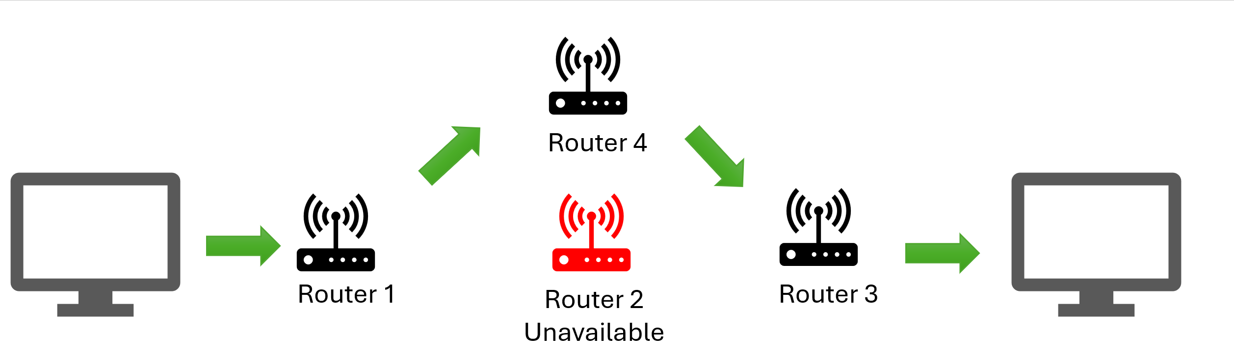
Figure 4. Dynamic routing example
The advantage of this method is the ability to adapt to network conditions, such as changing paths based on network traffic and bandwidth. Dynamic routing is scalable and operates efficiently on extensive networks with automatic configuration. Dynamic routing introduces a greater security risk than static setups; for example, man-in-the-middle attacks can modify routing information to manipulate data flow. Dynamic routing is used by internet service providers (ISPs), where protocols connect global network traffic.
Cisco describes key dynamic routing protocols [11]. Routing information protocol (RIP) updates neighbouring routers regularly, helping them update the shortest path with the fewest hops. Open short path first (OSPF) is a more advanced protocol that uses link state advertisements (LSAs) to learn all connected devices on the network dynamically; this enables a fast recalculation of routes if a network topology changes.
Many of today's networks use a hybrid approach to combine the advantages of both static and hybrid protocols, allowing for balanced security and performance with scalability when needed.

1.4. Network Services:
Virtual private networks (VPNs) direct all internet traffic through a separate encrypted server, protecting incoming/outgoing data from unauthorised access and enabling user privacy [12]. Hosts transmit unencrypted traffic through a VPN tunnel to a VPN gateway, where the data is encrypted between gateways. Security Planet [13] outlines common internet protocols; DMVPN and IPSec technologies are widely adopted due to their strong security, performance and simplified connection process. Best practices include IP encryption to ensure privacy and two-factor authentication to restrict unauthorised access.

Dynamic Host Configuration Protocol (DHCP) is used to automatically assign IP addresses and other network configurations e.g. subnet masks [14]. The protocol temporarily leases IP addresses from a list of addresses (Scope) for a defined period or until they are no longer required. A dedicated DHCP server may be utilised, but smaller networks can use a router for DHCP services. DHCP can reduce network administration and configuration errors. Servers should be regularly monitored to ensure the best performance and identify any errors.

Active Directory Domain Services (AD DS) is a Microsoft-developed service that manages network resources, including user profiles, devices, groups and resources [15]. This is achieved using a hierarchical structure (domain) that organises network objects into containers for more straightforward management. Domains can be structured into trees and forests to mirror a company structure. AD DS is responsible for authenticating devices and users to ensure authorised access. To enhance security, AD should use least private access, only giving the permission necessary.

Certificate Authority is a trusted organisation that issues and manages digital certificates for secure network communication and authentication [16]. Websites use SSL certificates to ensure trust and security for web browsers and authenticate data sent from a web server. Certificates validate the website's identity and encrypt communication; the certificate contains the issuer's name and contact details, including the public key and domain name. A certificate authority should use strict cryptography standards to protect data.

2. Task 2 – Technical Documentation

2.1. Choosing Hypervisor
The network will be set up using Hypervisor 2 technology. The research in Task 1 identified that Type 1 hypervisor is more suited for larger scale networks and comes at a more significant cost. Type 1 also comes with a higher complexity for setup; the upskilling would be difficult with the project's small-time scale.
As a student, a type 2 hypervisor will allow for greater ease of use, with the ability to install and manage on top of an existing operating system without the need for costly equipment. Oracle VirtualBox offers a free, open-source hypervisor that can use multiple operating systems, which will suit the deployment needed for this network.

Download and Setup
Microsoft Windows server and client were downloaded from the official Microsoft Website [17].
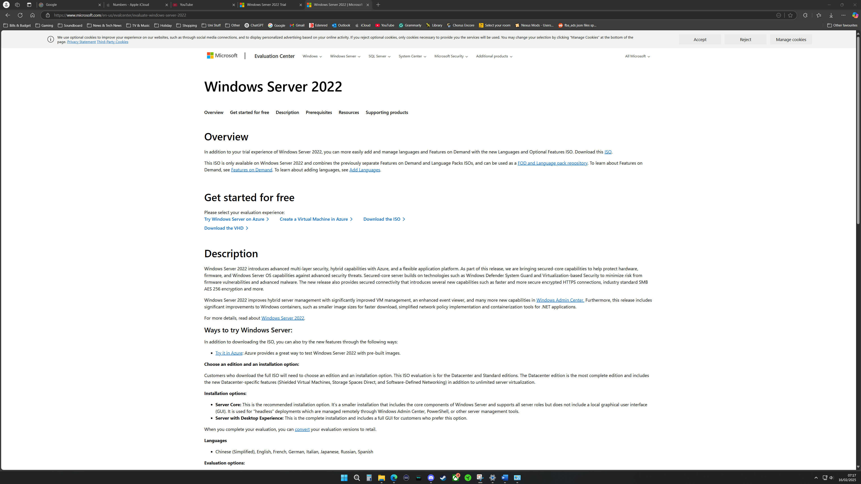
Figure 5. Microsoft Windows Server 2022 download centre
The Linux server/client was downloaded from the official Debian Website [18] as shown in the figure below.

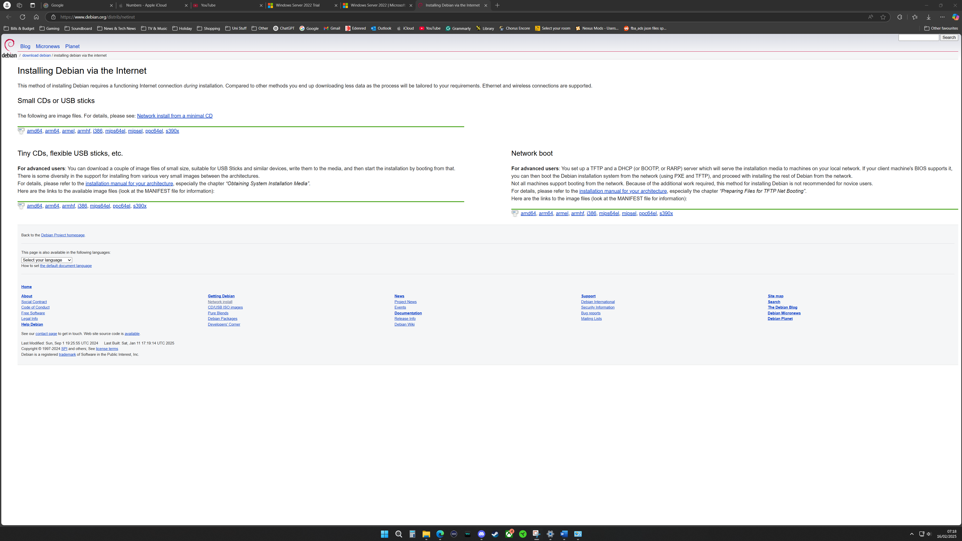
Figure 6. Debian download centre
Virtual box was used as a hypervisor and to install the required servers and clients. The example below the initial windows server setup.
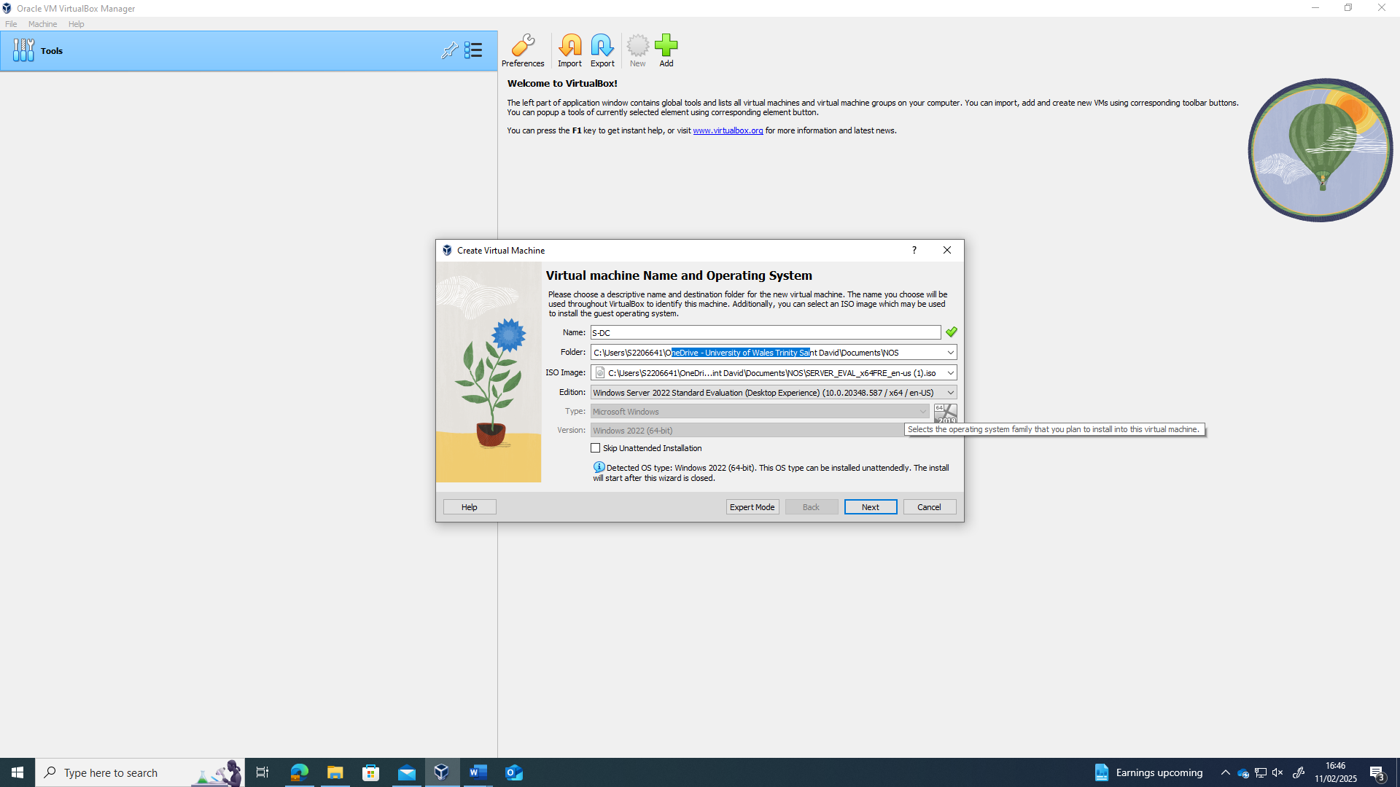
Figure 7. Sever install from hypervisor software
During installation, the storage, memory and processors are allocated to each client as server, as shown in the example below.

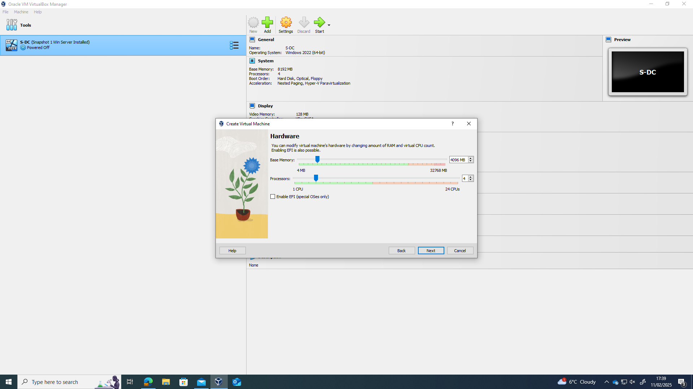
Figure 8. Selecting memory and processors speeds required

The example below shows the windows server operating system installation in progress.
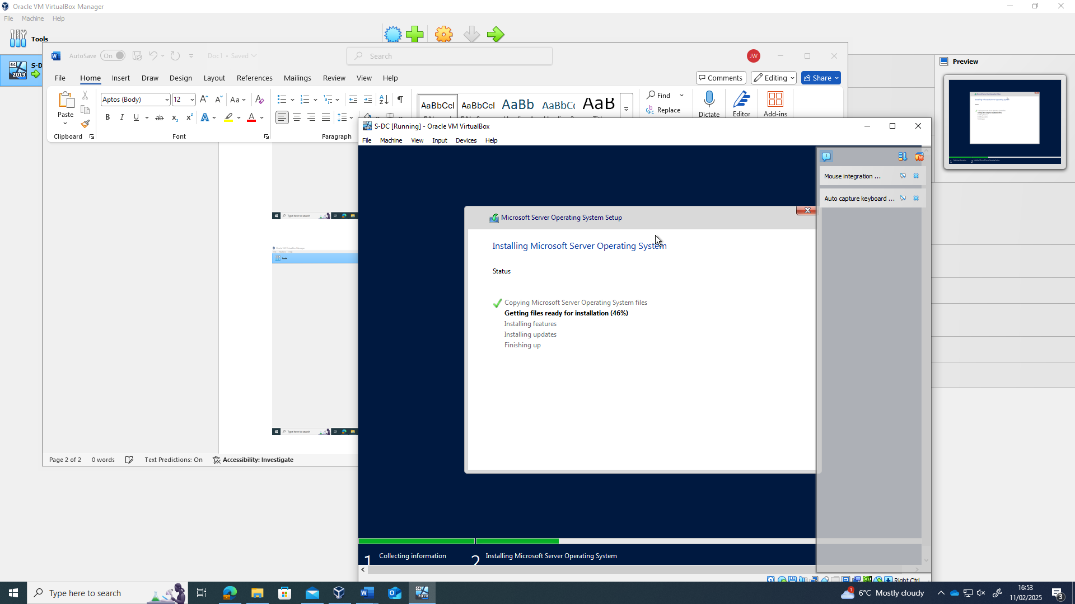
Figure 9. Windows server installation screen

The example below shows the Debian server operating system installation in progress.
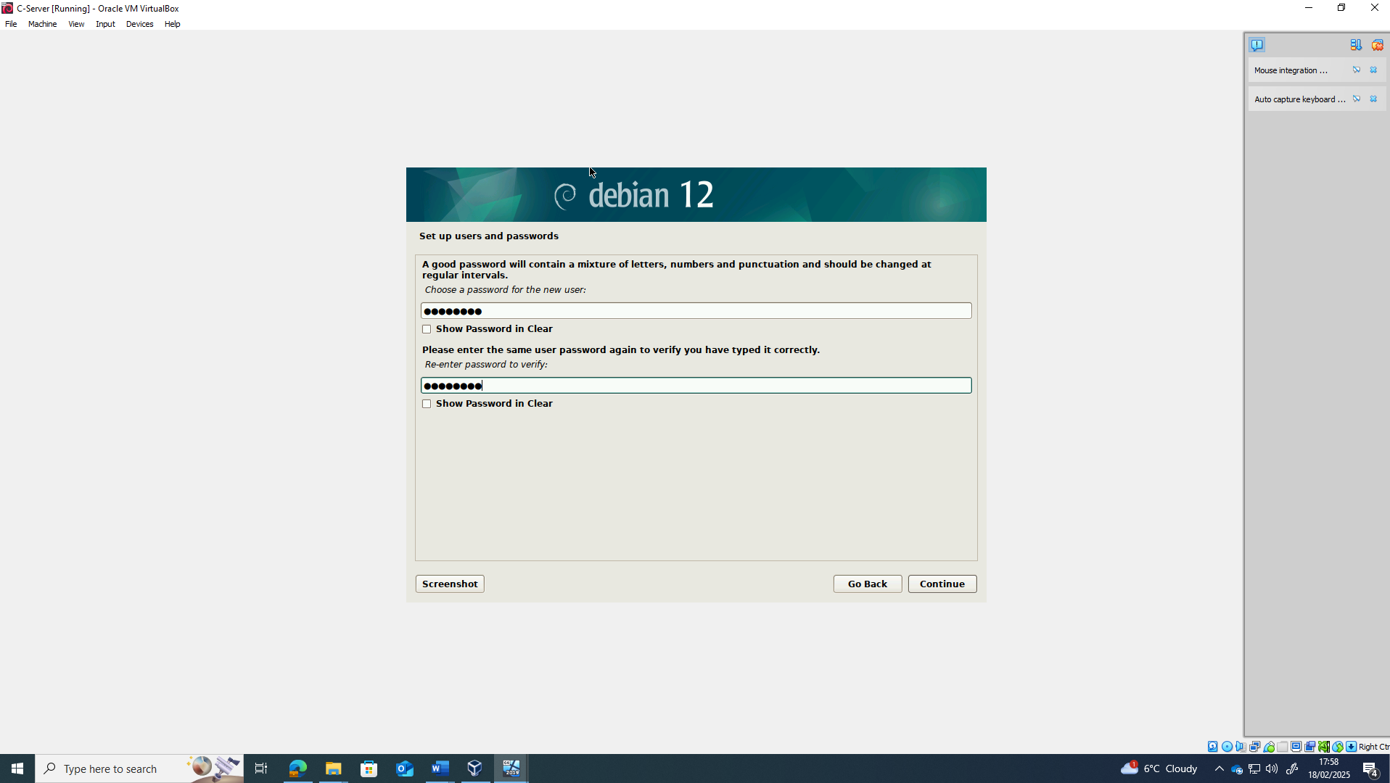
Figure 10. Debian server (command line) installation screen

The example below shows the Debian client operating system installation in progress.
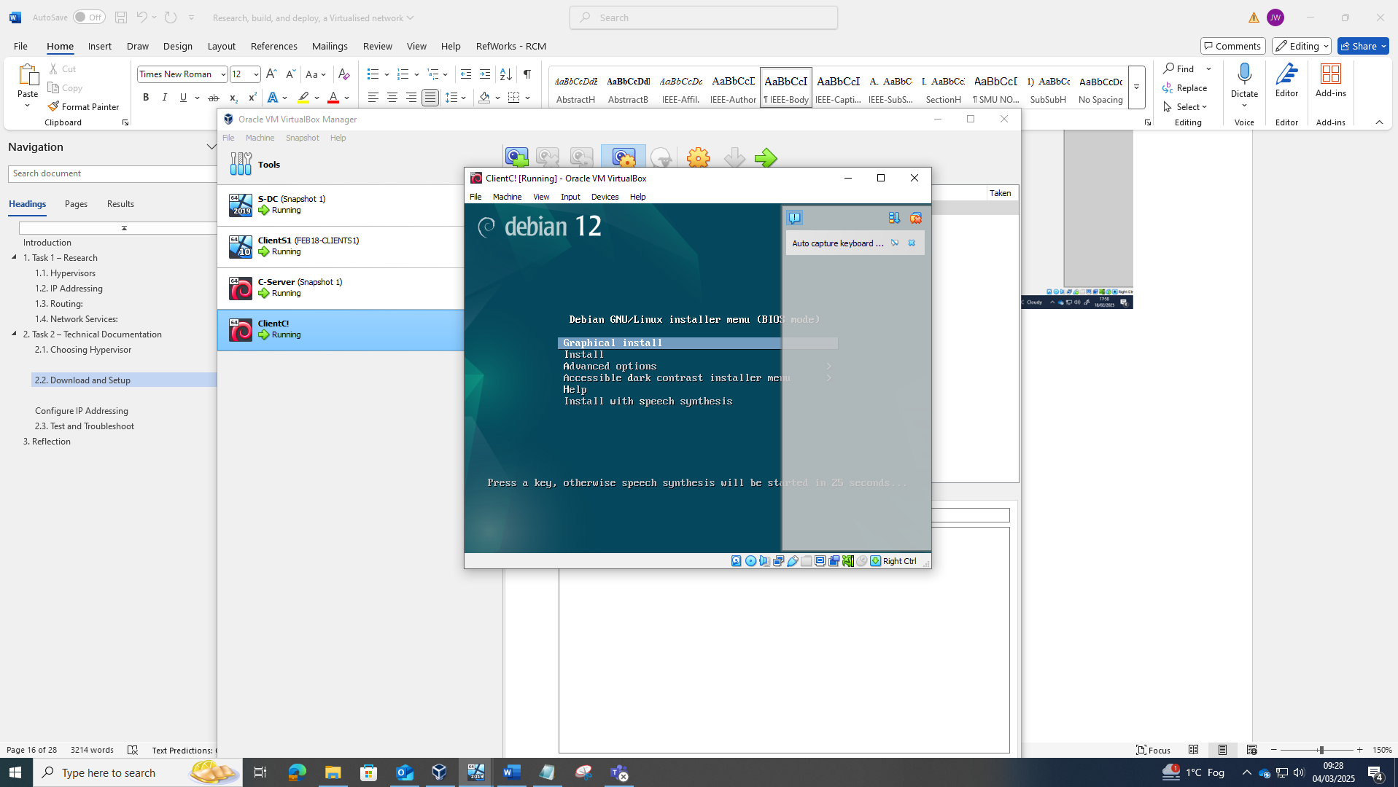
Figure 11. Debian client (GUI) installation screen

Configure IP Addressing
Below shows the IP address configurations for Windows client and Windows server (internal):
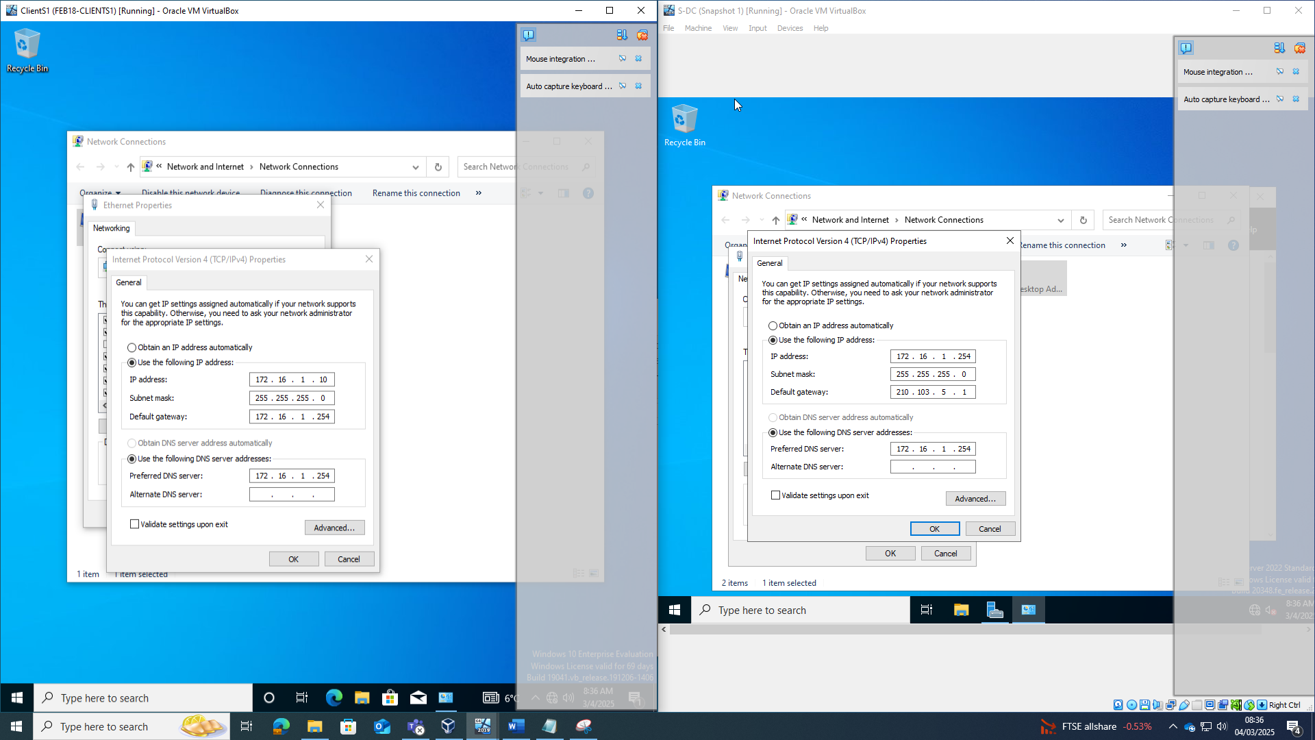
Figure 12. Windows Server (right) and client (right) IP configuration
Below is a screenshot of the windows server (external) IP configuration.

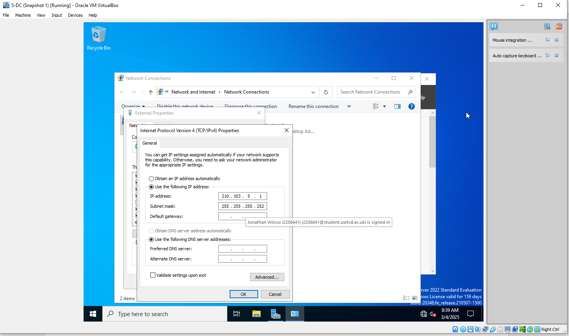
Figure 13. Windows Server External IP configuration

Whilst configuring the Linux server access was denied because the user was not set up as a Sudo user, this was overcome by logging into the root and updating user to a super user to give privileges required.
Whilst setting up super users another issue occurred was package not having utility, this was overcome by entering “sudo nano /etc/apt/sources.list” and pointing the repo to online with the following commands:

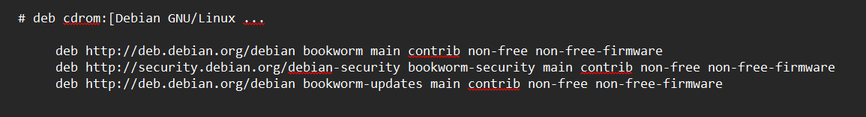
Figure 14. Debian server configuration access denied

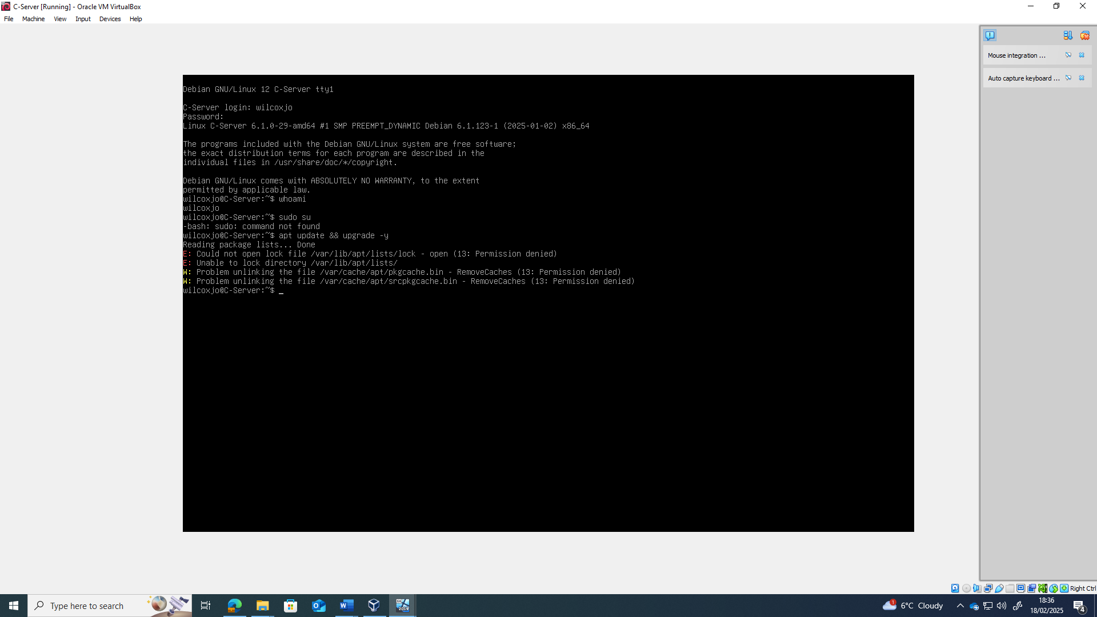
Figure 15. Debian server configuration access denied
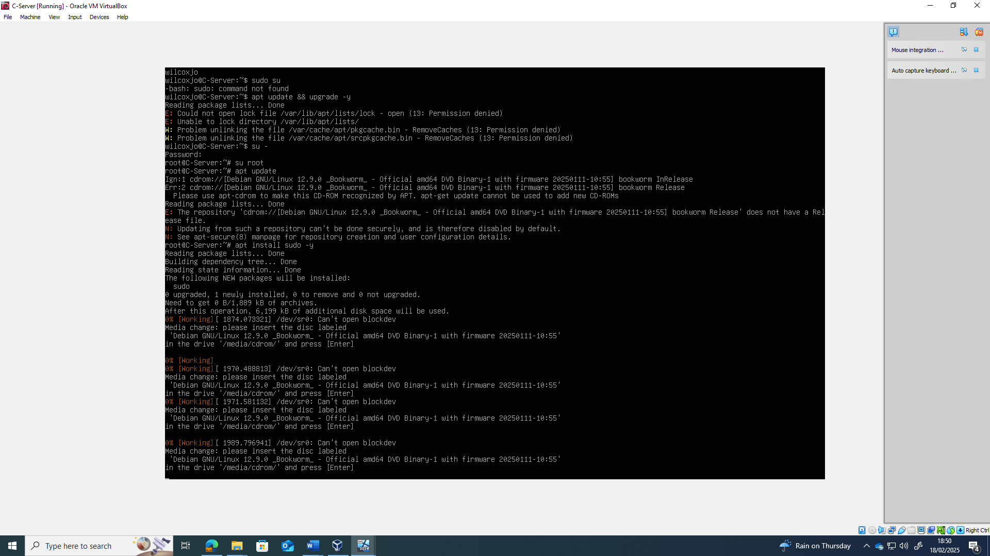
Figure 16. Debian issue failing to setup super user

Once sudo user was set up the IP address for the Linux server were successfully configured as shown below:

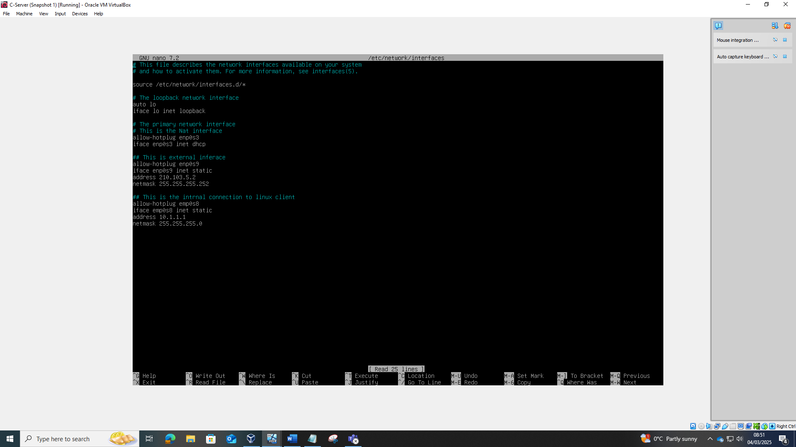
Figure 17. Linux Server IP configuration

Below shows a screenshot of the Linux IP address configuration.
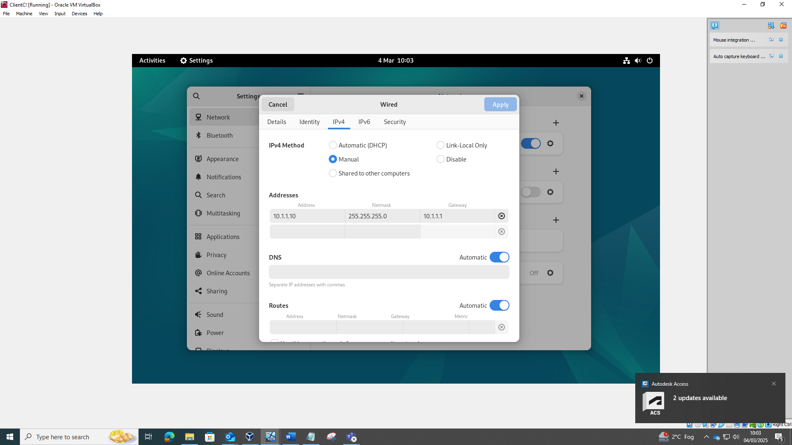
Figure 18. Linux Client IP configuration

Test and Troubleshoot
The initial ping test from Windows client to windows sever and vice versa were unsuccessful. After some troubleshooting it was identified to be a firewall issue. After disabling the firewalls from both Windows client and server the pings were successful.

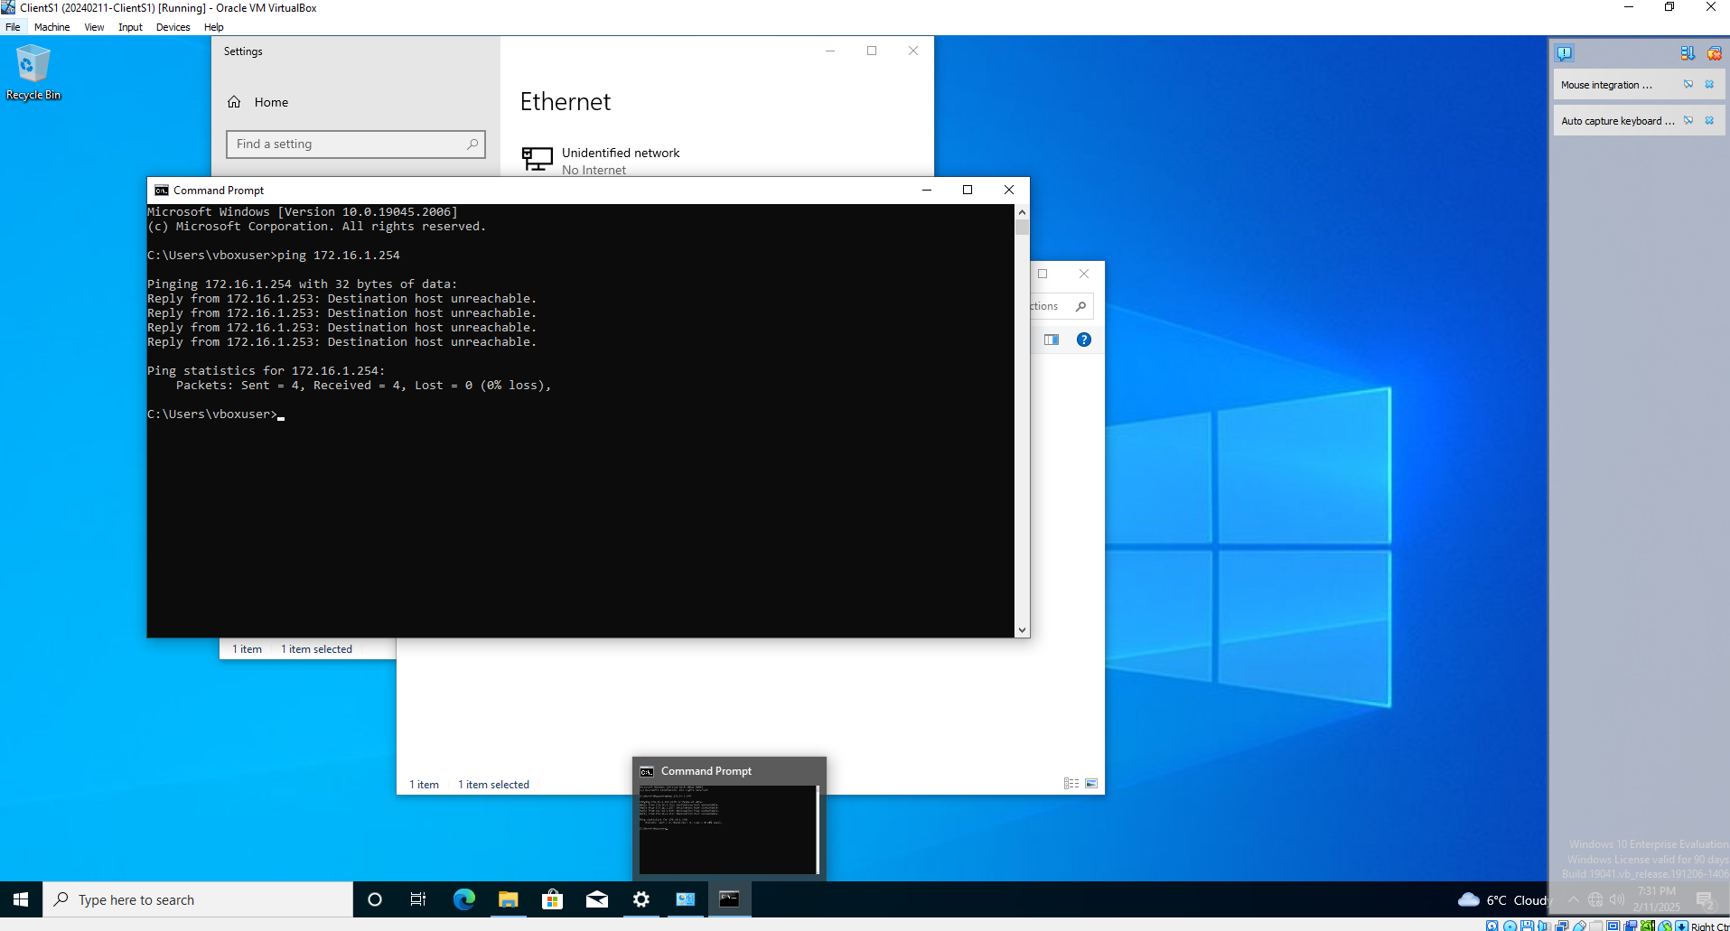
Figure 19. Unsuccessful Ping to from Windows client to server

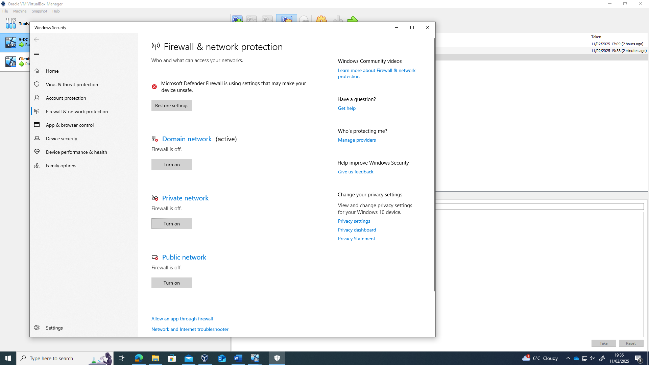
Figure 20. Troubleshooting – Turning firewall off on Windows client and server

The screenshot below shows successful ping from Windows client to server and vice versa:
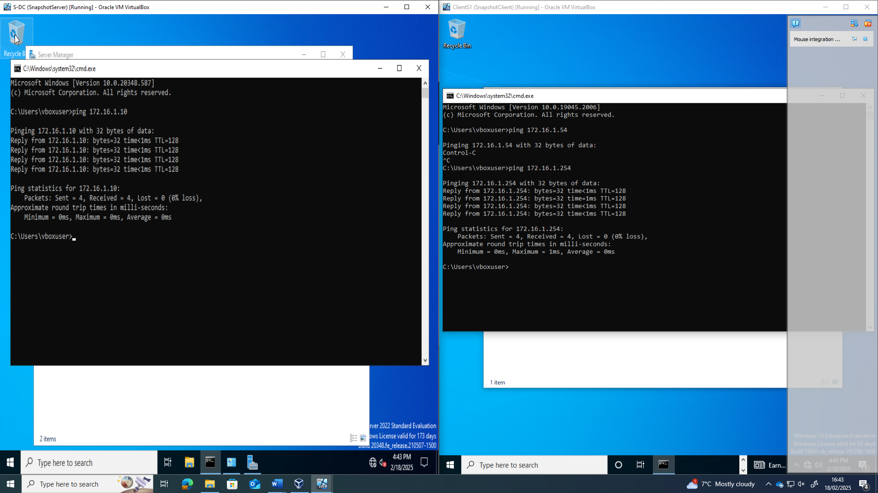

Figure 21. Successful Ping from windows server (left) and windows client (right)

Below shows a successful ping from Linux server to the Windows server:
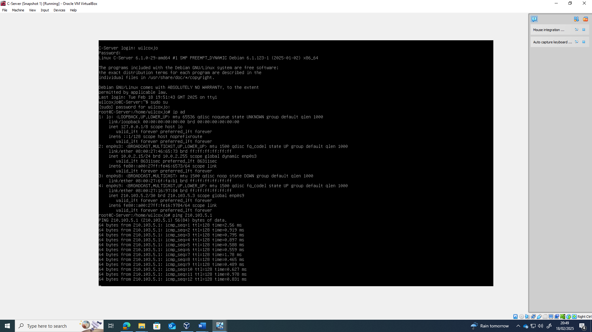
Figure 22. Successful Ping to Windows Server from Linux server

The screenshot below shows successful ping from windows server to Linux server:
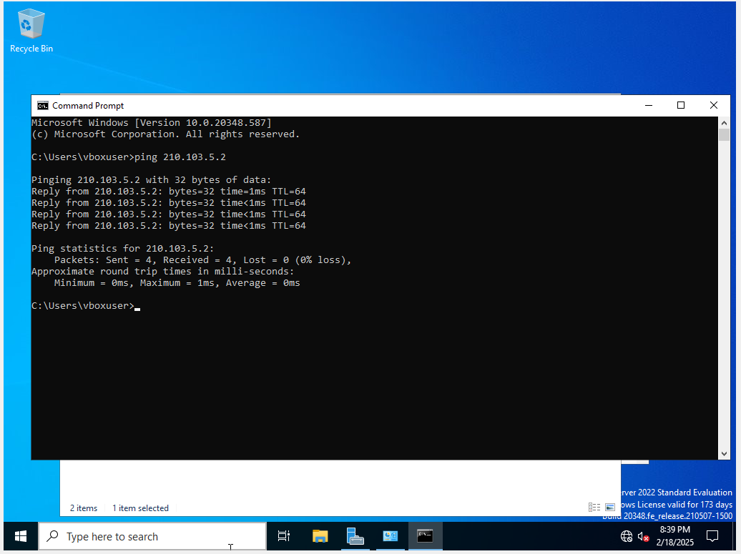

Figure 23. Successful Ping to from windows server to Linux Server
Initially there was an issue pinging the Linux client to the Linux server, this was overcome by inputting the correct gateway address
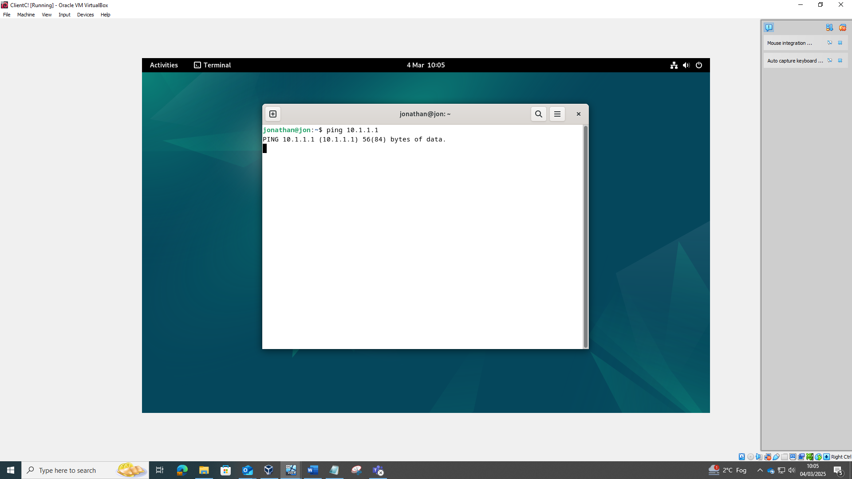

Figure 24. unsuccessful Ping to from Linux client to Linux Server
Below shows the successful ping test between Linux client and Linux server
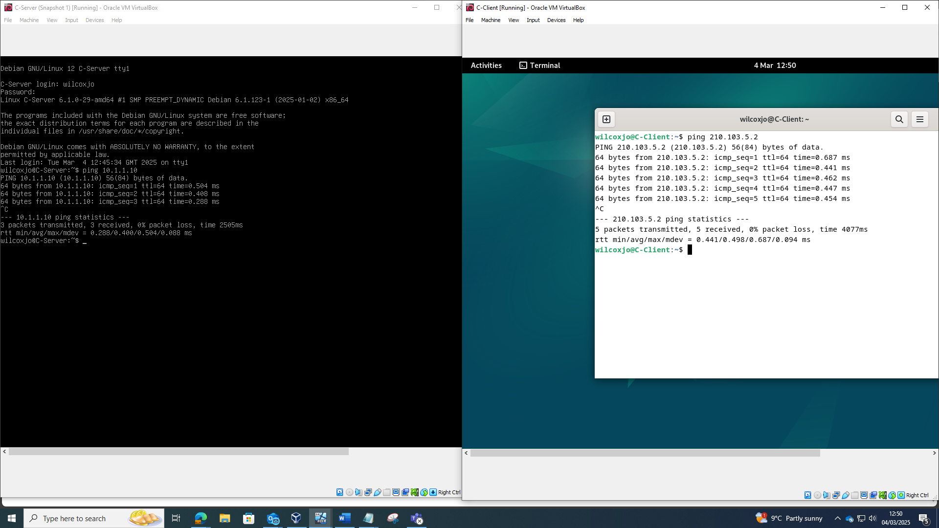
Figure 25. Successful Pings between Linux client (right) and Linux Server (left)

Finally, I attempted to ping Linux client to windows client and this was unsuccessful which was expected.
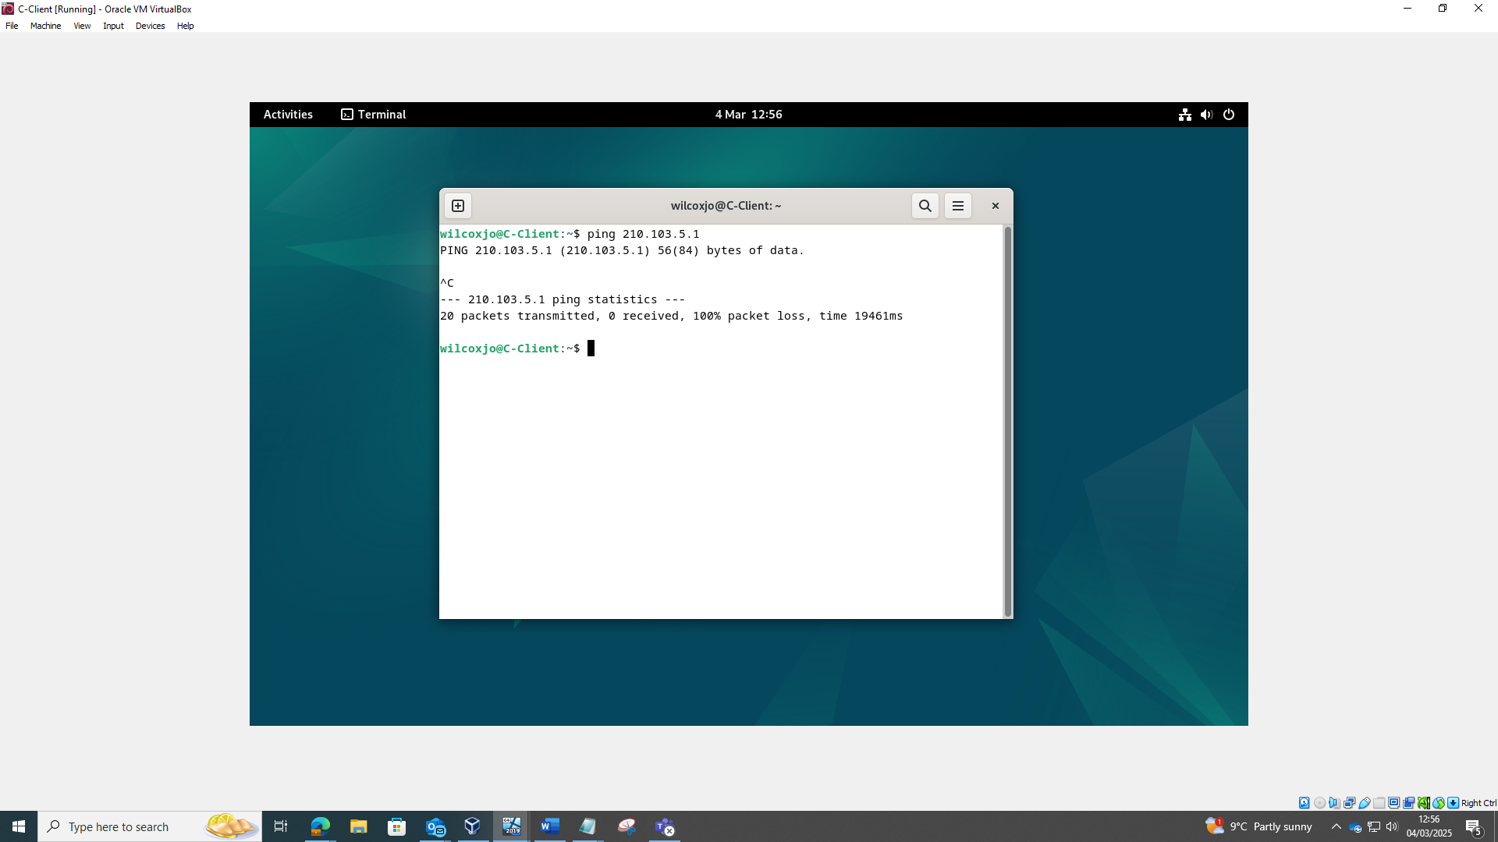
Figure 26. unsuccessful Pings between Linux client and windows client

Reflection

Deploying the topology came with many challenges, including IP conflicts and firewall restrictions. IP address conflicts were resolved through trial and error with the aid of research to understand better how to configure correctly. Firewalls caused issues blocking traffic and preventing a ping test, resulting in the need to disable them to complete the task. Based on years of Microsoft Windows experience, working in these software packages was much easier than working with Linux. To overcome the lack of Linux experience, I completed some basic tutorials to understand the environment better. The VirtualBox hypervisor was easy to set up for each client and server, allowing many customisation options.

Conclusion
The initial research provided the necessary information to complete the organization's network topology. In conclusion, Hypervisor Type 2 was chosen, as it better meets the business's needs regarding smaller scale, cost and time to implement. Additionally, research on IP addressing and routing offered a deeper understanding of the protocols and their functions. Finally, investigating the types of network services helped identify how to manage and secure networks efficiently.
Building the final topology was not straightforward, with many issues requiring troubleshooting. Overcoming these issues helped give a better understanding of network setups and how to troubleshoot effectively, expanding on my initial research with real world examples.
Next steps for this project will be to secure the network, set up and maintain network services and resources.

Abbreviations

Abbreviation | Definition
CPU | Central processing unit
OS | Operating System
RAM | Random Access Memory
VM | Virtual Machine
NIC | Network Interface card
TTL | Time To Live
TCP | Transmission Control Protocol
IP | Internet Protocol
LAN | Local Area Network
ISP | Internet Service Providers
RIP | Routing Information Protocol (RIP)
OSPF | Open Short Path First
LSA | Link State Advertisements
VPN | Virtual Private Network
DHCP | The Dynamic Host Configuration Protocol
AD DS | Active Directory Domain Services
CA | Certificate Authorities

References
[1] S.Stephanie, I.Smalley, "What are hypervisors?”. IBM [Online], Available: https://www.ibm.com/think/topics/hypervisors [Accessed 28/01/2025].
[2] L,S, Vailshery, "Leading 5 virtualization platform technologies worldwide 2024”, statista [Online], Available: https://www.statista.com/statistics/1252355/top-virtualization-technologies-by-domain/ [Accessed 28/01/2025].
[3] Z. Aalam, V. Kumar, and S. Gour, “A review paper on hypervisor and virtual machine security,” Journal of physics. Conference series, vol. 1950, no. 1, pp. 12027-, 2021, doi: 10.1088/1742-6596/1950/1/012027.
[4] C,Hayburst, "Type 1 vs. Type 2 Hypervisors: What’s the Difference?”, biztechmagazine [Online], Available: https://biztechmagazine.com/article/2024/08/type-1-vs-type-2-hypervisors-whats-difference-perfcon [Accessed 01/02/2025].
[5] M. E. Dooley and T. Rooney, IP address management, Second edition. Hoboken, New Jersey: Wiley, 2021. doi: 10.1002/9781119692263.
[6] "IP Address Definition And Explanation”, Fortinet [Online], Available: https://www.fortinet.com/resources/cyberglossary/what-is-ip-address [Accessed 01/02/2025].
[7] E.Al, "Network Address Translation(NAT)”, Medium [Online], Available: https://medium.com/rahasak/network-address-translation-nat-df84dc1cb06c [Accessed 01/02/2025].
[8] R. Graziani and A. Johnson, Routing protocols and concepts : CCNA exploration companion guide. Indianapolis, Ind: Cisco Press, 2008.
[9] Y.Yazar, "What is a routing table”, Tech Target [Online], Available: https://www.techtarget.com/searchnetworking/definition/routing-table [Accessed 3/02/2025].
[10] "Dynamic Routing and Routing Protocols”, Cisco [Online], Available: https://www.learncisco.net/courses/icnd-1/ip-routing-technologies/dynamic-routing.html [Accessed 03/02/2025].
[11] "Routing protocols”, Cisco [Online], Available: https://www.cisco.com/c/en/us/td/docs/net_mgmt/prime/network/3-8/reference/guide/routpro.html [Accessed 03/02/2025].
[12] J. M. Stewart and D. Kinsey, Network security, firewalls, and VPNs., Third edition. Burlington, Massachusetts: Jones & Bartlett Learning, 2021.
[13] c.Luna, " How Does a VPN Work? A Comprehensive Beginner’s Overview”, Security Panet [Online], Available: https://www.esecurityplanet.com/networks/how-does-a-vpn-work/ [Accessed 03/02/2025].
[14] N. Hubballi and N. Tripathi, “A closer look into DHCP starvation attack in wireless networks,” Computers & security, vol. 65, pp. 387–404, 2017, doi: 10.1016/j.cose.2016.10.002.
[15] G. McDonald, P. Papadopoulos, N. Pitropakis, J. Ahmad, and W. J. Buchanan, “Ransomware: Analysing the Impact on Windows Active Directory Domain Services,” Sensors (Basel, Switzerland), vol. 22, no. 3, pp. 953-, 2022, doi: 10.3390/s22030953.
[16] R. B. Lee, Security basics for computer architects. San Rafael, California (1537 Fourth Street, San Rafael, CA 94901 USA): Morgan & Claypool, 2013. doi: 10.2200/S00512ED1V01Y201305CAC025.
[17] “Windows evaluation center”, Microsoft [Online], Available: https://www.microsoft.com/en-us/evalcenter/download-windows-server-2022?msockid=2698d181c86c6ec5083ec41ac94b6fe1 [Accessed 11/02/2025].
[18] “Debian – The universal operating system”, Debian [Online], Available: https://www.debian.org/ [Accessed 11/02/2025].

