

LOCATION: Swansea | LLEOLIAD: abertawe
LEVEL 7 | LEFEL 7
EXAMINATION PERIOD | CYFNOD ARHOLIADAU
January 2018 | IONAWR 2018

MODULE CODE: M7X01691
Emerging Network Technologies
TIME: 2 HOURS (Use 1 ½ NOt 1.5 for time)

answer THREE quESTION out of FOUR

Equipment or materials required – Basic Calculator
Adnoddau neu ddefnyddiau sydd eu hangen – Cyfrifiannell Sylfaenol

ANSWER THREE QUESTIONS

Q1.

You have been commissioned to design a “Smart Garden” using a Wireless Network (WN) technology of your choice for monitoring the Trinity Garden at the new UWTSD SA1 Waterfront campus.

- Design a blueprint network architecture model(s) to conceptualise your design and implementation to address the following:
- Staff and visitors to the garden should be able to tell what areas are available for use such as seating, grass areas and meeting places.
- The WN of choice should be linked to the main campus network so that the usability of the garden can be monitored and managed by estates and display screens across the campus.
- Considerations should be made for monitoring of the air quality, weather conditions and temperature with the use of suitable sensor.
- The design of the blueprint is up to you, but you must state all assumptions made and justify your design decisions.
(20 marks)
Solutions:
Blue print may vary among student, however should be labelled and explained. Diagram should highlight seating areas, sensors (type of sensors such co2, temperature, humidity, occupancy, etc.), grass areas, meeting places. How it’s connected to the main university backbone. More marks will be given if a server room for monitoring the space is been considered. A sample examples:

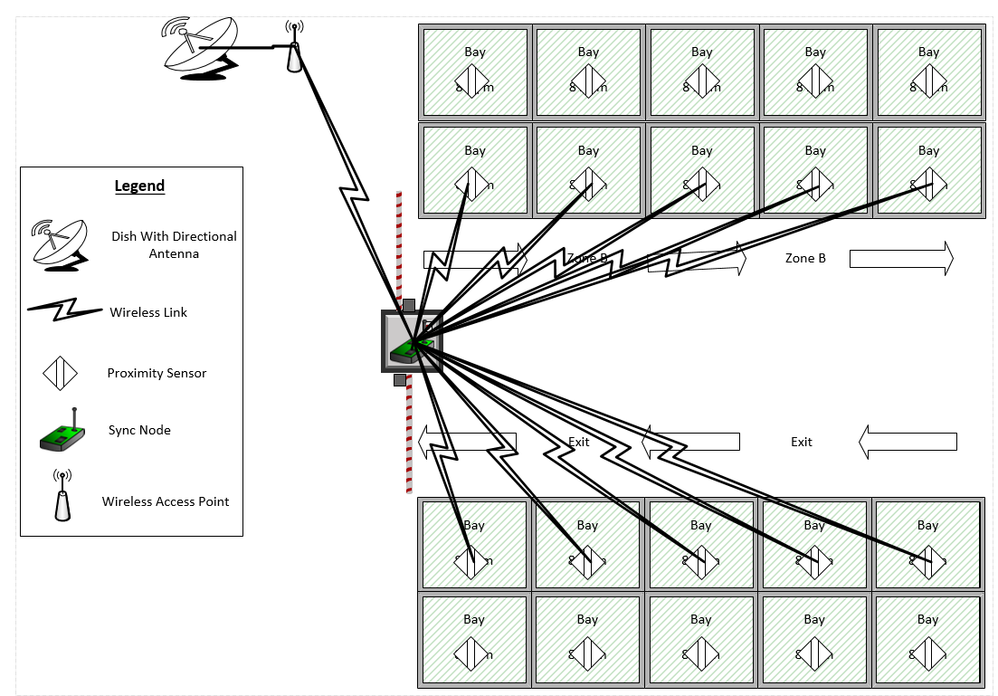

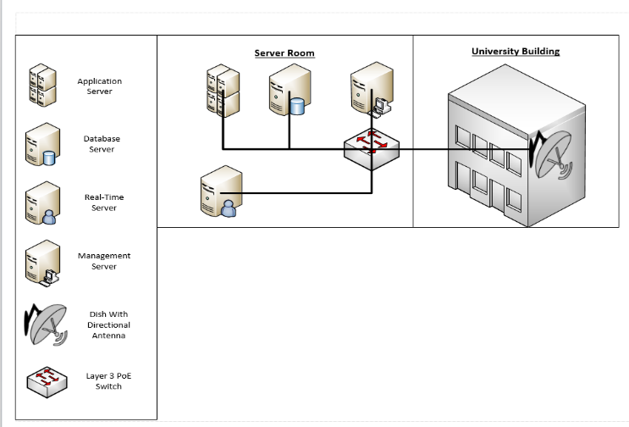

- Explain how the concepts and principles of computer networks relates to communication systems in terms of the following modulation techniques:
  - Amplitude Shift Keying (ASK)
  - Quadrature Phase Shift Keying (QPSK)
  - Quadrature Amplitude Modulation (QAM)
(5 marks)
Solutions:
Definition for each with reasonable explanation is accepted

ASK is a form of amplitude modulation that displays digital data as variations within the amplitude of a carrier wave. This form of modulation typically uses binary functions to determine what information is sent, each sending a unique fixed-amplitude signal across the carrier signal. Due to this, ASK modulation can also be known as On Off Keying (OOK). Examples of ASK implementation are through RFID readers and badges. ASK has a number of advantages such as:
- Very easy to use ASK modulation
- Cost effective
- Transmitters are simple
- Requires little bandwidth

QPSK, which is the most common modulation method used in communication. One advantage QPSK has over BPSK is that it has double the information capacity, possessing four message points making this modulation technique highly bandwidth efficient. Key advantages of this modulation method are:
- High bandwidth efficiency [9].
- High information capacity [9].
- Is a widely used modulation technique [10].
There are also certain disadvantages when using QPSK, such as:
- Increased receiver design complexities [9].
- More sensitive to phase variations compared with BPSK [9].
QAM – This modulation technique is different from BPSK and QPSK, symbols created in QAM incorporate both amplitude and phase, and the main reason is to allow bits of data to transmit further. There are a number of variants of QAM for example 8QAM 16QAM, 64QAM and 256QAM again these techniques will allow for more bits to be transmitted increasing accordingly from 4 to 8 bits per symbol.
QAM modulation makes use of the spectrum, however demodulation is proven to be difficult when noise is introduced, and mainly affecting the amplitude signal randomly, QAM also requires power amplification which must be linear. QAM modulation is more commonly applied within the Cable TV industry, Wireless Local Area Networks, Wi-Fi™, Satellites and Mobile telecommunication systems. As all of these applications need to make use of large data being transmitted across limited bandwidths.

Q2.

The Internet of Things (IoT) is a system of interrelated computing devices, mechanical and digital machines, objects, animals or people with unique identifiers and the ability to transfer data over a network without requiring human interaction.

- Discuss the IoT vision and Future Communication Challenges
(10 Marks)
Solutions:
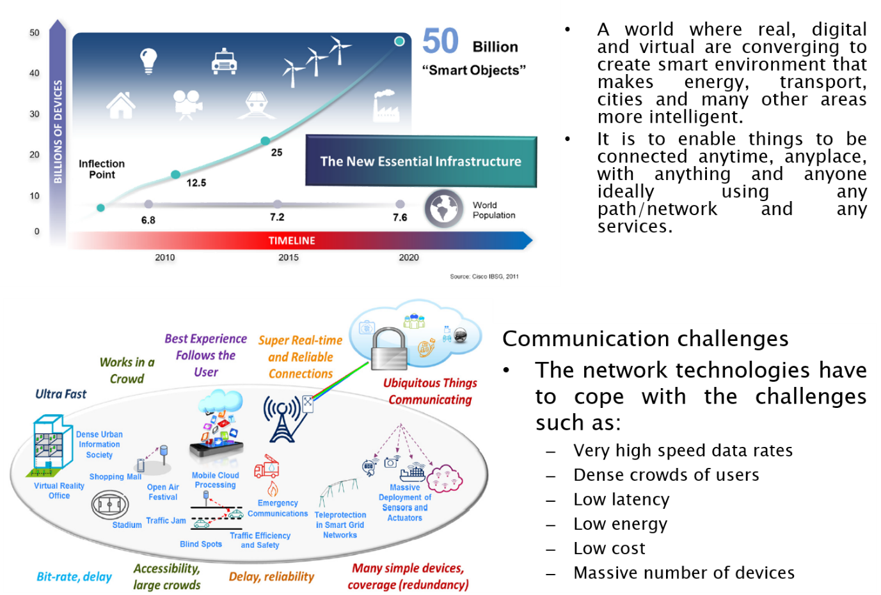

- Identify and explain some security challenges associated with IoT
(15 marks)
Solutions:
- Trust for IoT
  - Lightweight Public Key Infrastructure (PKI) as a basis for trust management.
  - Lightweight Key management systems to enable trust relationships to be established.
  - Quality of Information
  - Decentralised and self-configuring systems as alternatives to PKI for establishing trust e.g. identity federation, peer to peer.
  - Novel methods for assessing trust in people, devices and data, beyond reputation systems.
  - Assurance methods
  - Access Control to prevent data breaches.
- Security for IoT
  - DoS/DDOS
  - General attack detection and recovery/resilience to cope with IoT-specific threats e.g. compromised nodes, malicious code hacking attacks
  - Cyber situation awareness tools/techniques
- Privacy for IoT
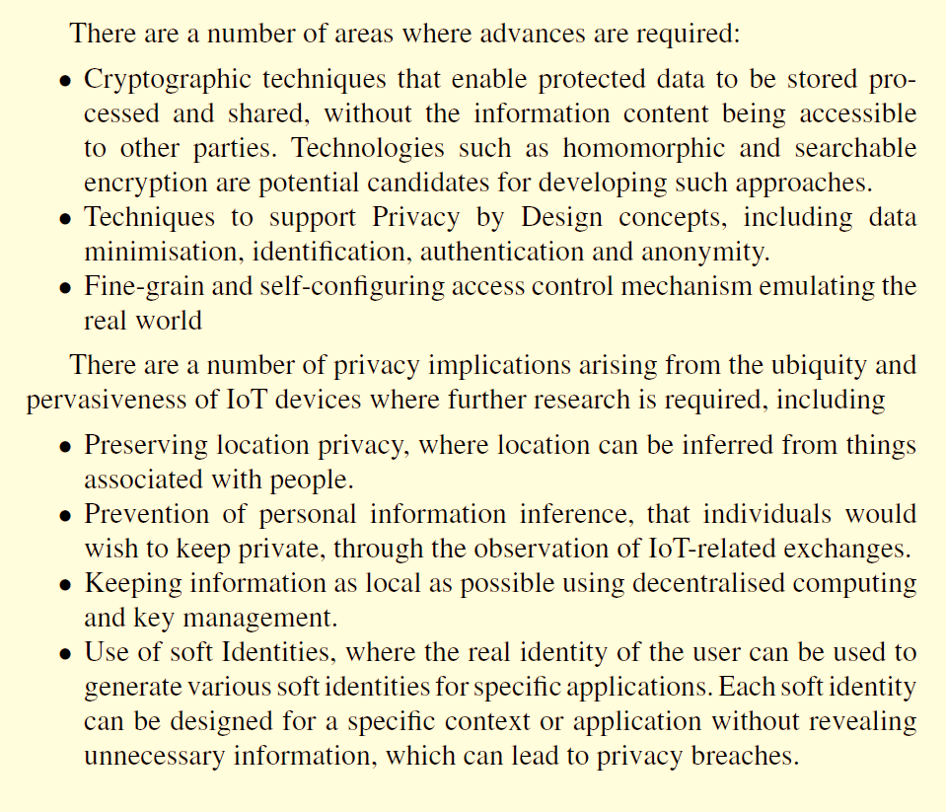

Q3.

- Describe three types of multiplexing; you should include their advantages and disadvantages.

Solutions:
3 marks for describing each type
Frequency:
- Separation of the whole spectrum into smaller frequency bands
- A channel gets a certain band of the spectrum for the whole time
- Advantages:
  - no dynamic coordination necessary
  - works also for analog signals
- Disadvantages:
  - waste of bandwidth
if the traffic is
distributed unevenly
  - inflexible
  - guard spaces
Time:
- A channel gets the whole spectrum for a certain amount of time
- Advantages:
  - only one carrier in the medium at any time
  - throughput high even for many users
- Disadvantages:
  - Precise synchronization necessary

Code:
- Each channel has a unique code
- All channels use the same spectrum
at the same time
- Advantages:
  - bandwidth efficient
  - no coordination and synchronization necessary
  - good protection against interference and tapping
- Disadvantages:
  - lower user data rates
  - more complex signal regeneration
- Implemented using spread spectrum technology

- What is cognitive radio? Describe its architecture and state some of its challenges and issues.
(10 marks)
Solutions:
Any 2 of these points [2 marks]
- Cognitive radios are software defined radios that are perform according to algorithms are the basic building blocks.
- It takes advantage of waveform programmable hardware platform that is so called software-defined radio. Signal processing and machine learning is the core of the whole learning.
- It also autonomously exploit locally vacant or unused spectrum in order to achieve new options of spectrum access.

CR Architecture, the diagram or any 4 of these points [4 marks]

- The SDR including the hardware and the software-defined at the physical layer.
- The cognition layer is directly above the physical layer.
  - the CR engine gets inputs from, and controls, the SDR.
- The logical position on the MAC layer level points out the basic potential function of the cognitive engine
- The cognitive layer knows the available hardware resources, e.g., the capabilities and characteristics of the available modulations.
- The Policy engine would watch and control the decisions of radio in order to prevent the violation of any restrictions defined by the operator or regulation bodies.
- A waveform library provides all transmission modes that adhere to the local regulations. Thus, a minimal user interaction would be necessary to control the physical layer.
- Build upon Software Define Radios (SDRs)
- Has the ability to operate on several bands simultaneously which increases the utility for a dynamic resource allocation over different transmission standards.
- The CRA is made up of two subsystem:
  - Cognitive unit which makes decisions based on various output.
  - A flexible SDR whose operating software provides a range of possible operating modes.

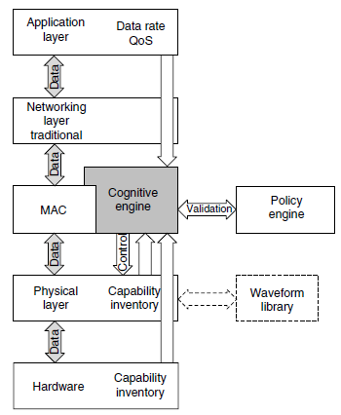

Challenges and issues, any 4 of these points [4marks]
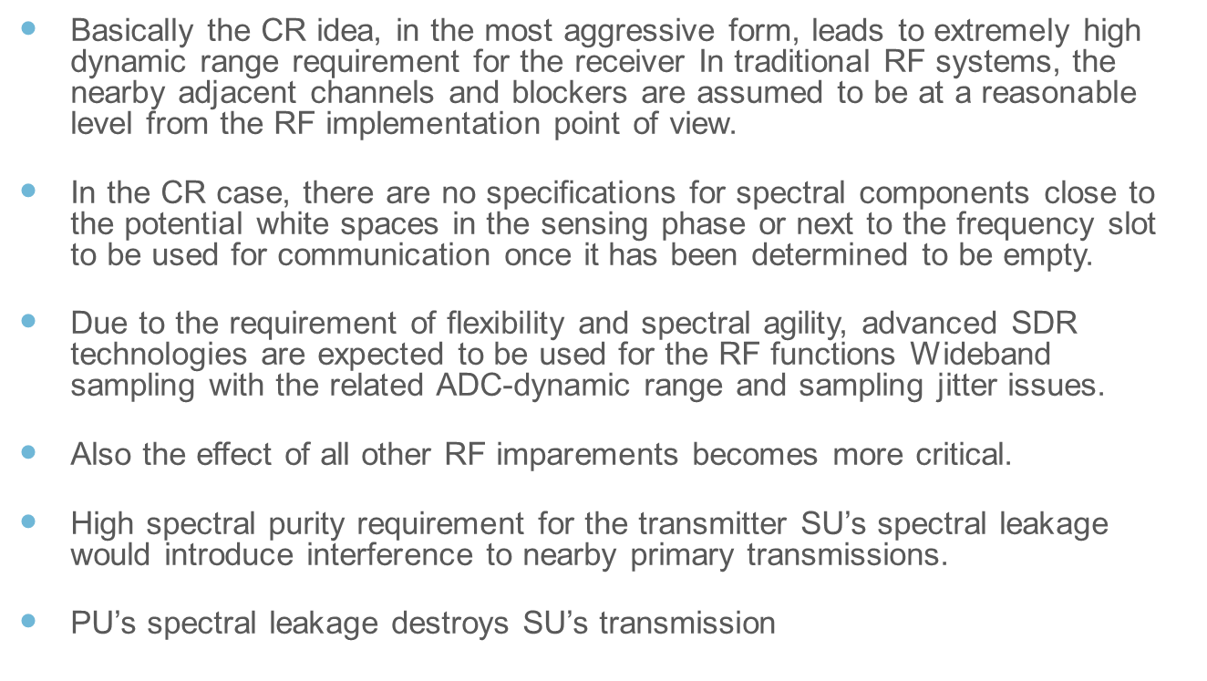

- Explain the difference between contention-based and contention-free protocols.
(6 marks)

Solutions:
3 marks each

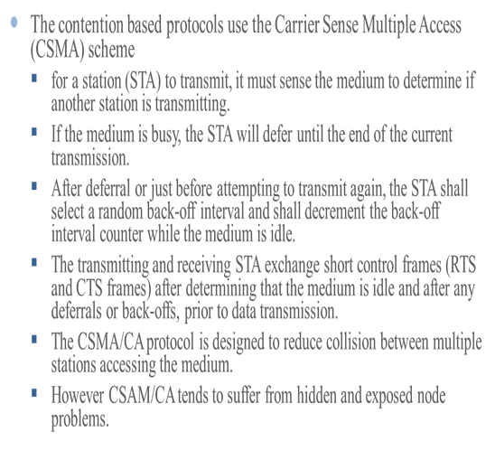
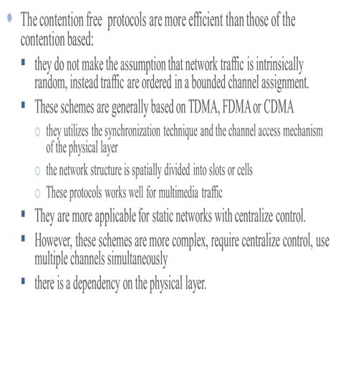
Q4.

Referring to Long Term Evolution (LTE) and LTE Advanced,
  - Do a comparative analysis of both. Diagrams may be used.
(10 marks)
Solutions:
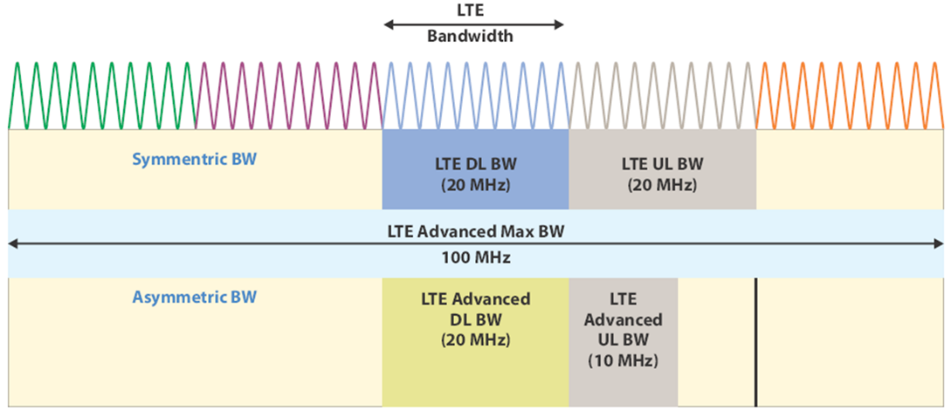

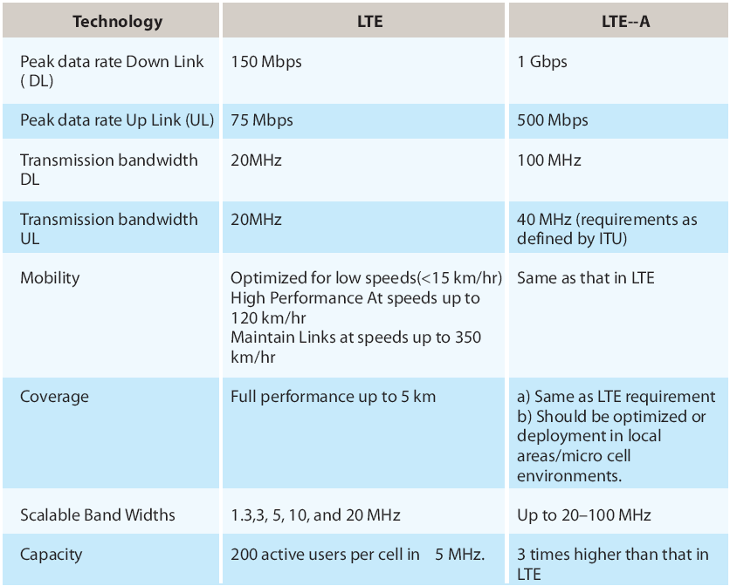

- What are some security concerns
(3 marks)
Solutions:
Any three or more concerns mention give full marks
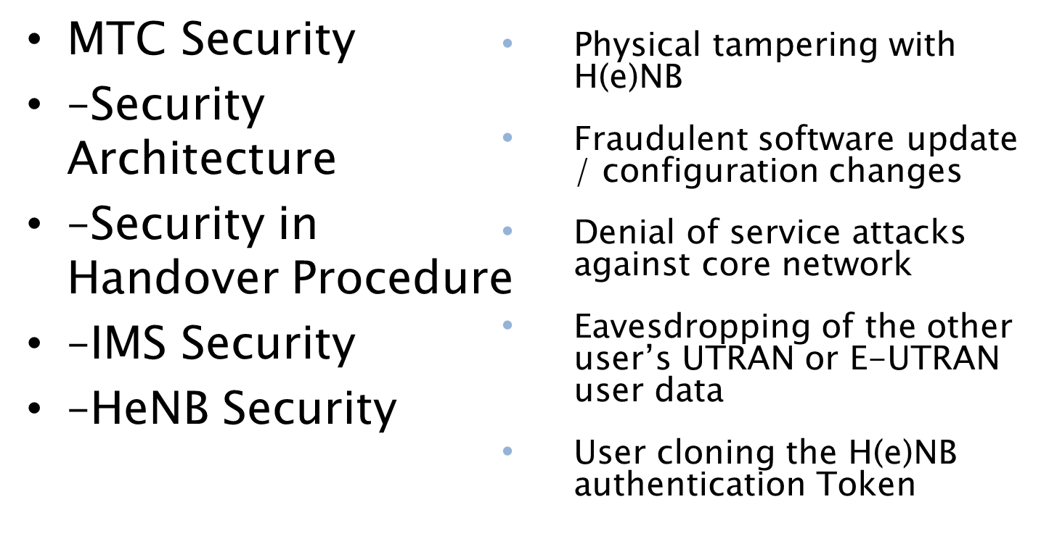

- Consider figure 2 below with a single high-power transmitter which provides a radio communication service to a city with total bandwidth available is 25MHz and each user requires 40 KHz of bandwidth for voice communication.
Figure 2

    - If one antenna is use to cover the entire town,
        - How many users can be supported simultaneously?

Solutions:
Show all necessary work outs.
- If one antenna is use to cover the entire city,
        - How many users can be supported simultaneously?
Solution:
The city can support 25,000KHz/30KHz = 833 users simultaneously. [3 marks]

- If the city is split into hexagonal cells with seven cells per cluster
      - How much allocated spectrum each cell has?
Solution:
Each cell has 1/7 of the spectrum available in any cell. [1 mark]

      - Hence, how many users can each cell supported?
Solution:
Each cell can support 1/7 x 833 = 119 users. [3 marks]

- If a cellular topology was employed where 20 lower power antennas are opportunistically located to minimize both kinds of interference:
      - Now, what is the total number of simultaneous users?
Solution:
The total number of simultaneous user is 119 x 20 = 2,380. [5 marks]

Diwedd/End

