DECATHLON
BLOG

‘’SATISFIED OR SATISFIED, IT IS OUR PRIORITY
BECAUSE WE LOVE SPORT USERS!’’

NAME: GRIGORAS ANDREEA EMILIA
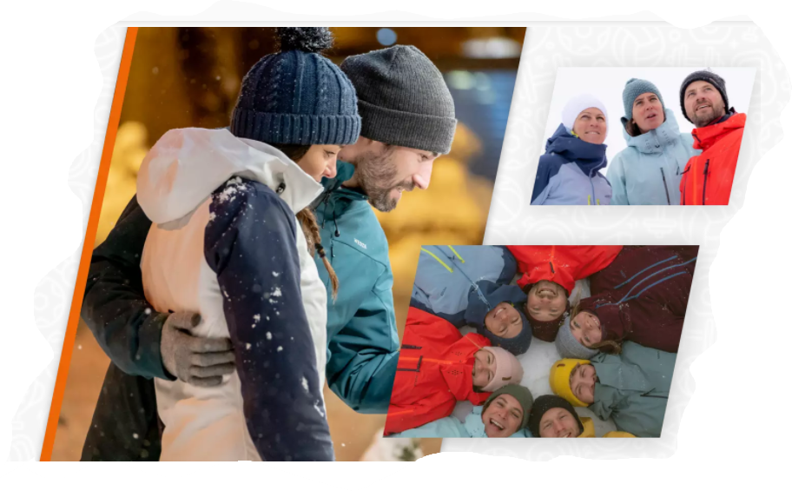
STUDENT NUMBER: 1921553
MODULE TITLE: MARKETING FUNDAMENTALS LCBB4004
ASSIGNMENT TITLE: BLOGGING TO COMMUNICATE - ASSESSMENT 1
LECTURER’S NAME: TUSHARA BALENDRAN

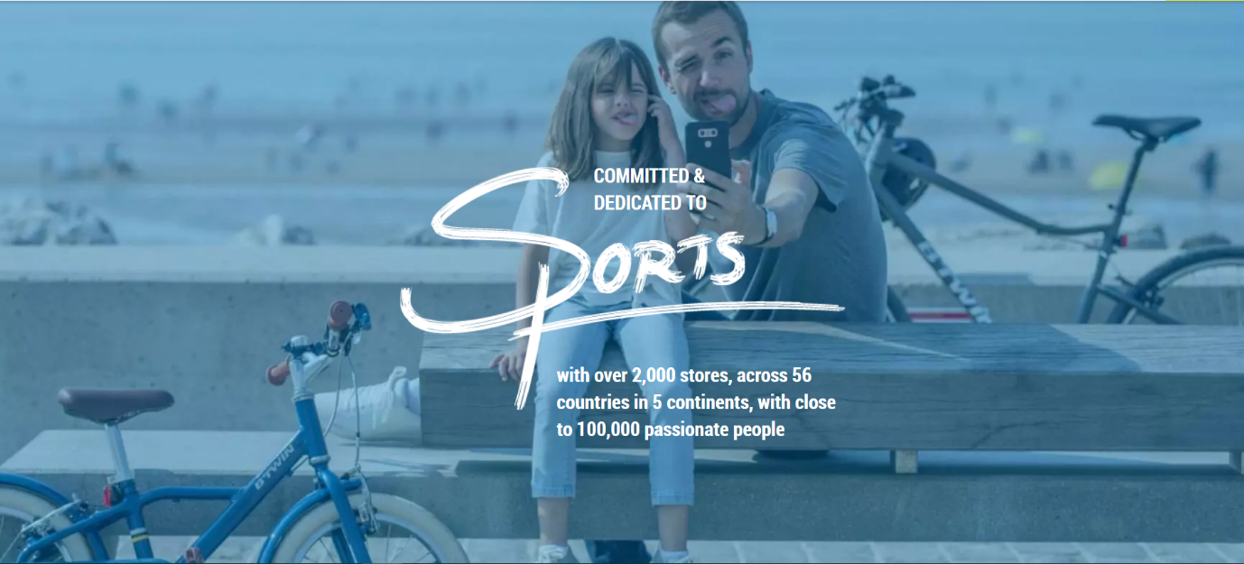

Decathlon is a family-owned company, founded by Michel Leclercq in 1976, who was driven by his passion for sport and opened the first store in Lille, France.
Decathlon is headquartered in Villeneuve d'Ascq, France.
At Decathlon we believe that sports products should be affordable to everyone. Customers of all ages, backgrounds and skill levels are offered the best quality products and design at the lowest possible price.
Our products are available in-store and online and do not forget that you can benefit from our expert advice at any time in order to find your desired item.

Sport for the many!
And yes, we are unique!

We are an international sports retailer with 2080 stores across 56 countries in 5 continents. We want to inspire you and guide you through your sports experiences. We know how important is to have an active life that is why we have the best products for you, developed and innovated by our experts.
We own more than 20 Decathlon brands, each dedicated to a particular sport or practice. Being active is an important part of life for everyone and having our studios and labs it is a great opportunity to reinvest our profit into research and development. The core of our business consists of positivity and the power of people. Our team are sports individuals who are brimming with energy and eagerness for what we do; we're urged to advance and improve, and in particular, to make improves. (About Us - This is Who We Are | Decathlon, 2020)

Decathlon is not just offering a way to practice sport or connect individuals, is more than this, Decathlon connects people’s dreams, hopes and aspirations.
WE ARE A COMPANY WITH A COMMITMENT

We respond to the climate change – we are aware that the production, transport, use and distribution of our products have an impact on our planet.
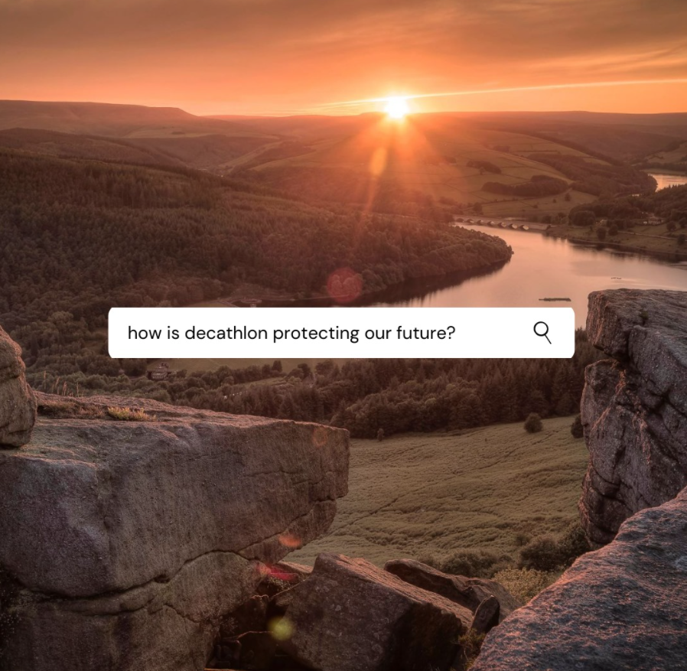

Our environmentally friendly packaging
OUR ECO-FRIENDLY PACKAGING
All orders on Decathlon’s official website will be packaged in simple packaging, for example, without cardboard box for shoes. We pack our clothes, shoes and accessories in a simple way to better protect the environment. At the same time, we make sure that our packaging will protect the products from damage (Decathlon, 2020).

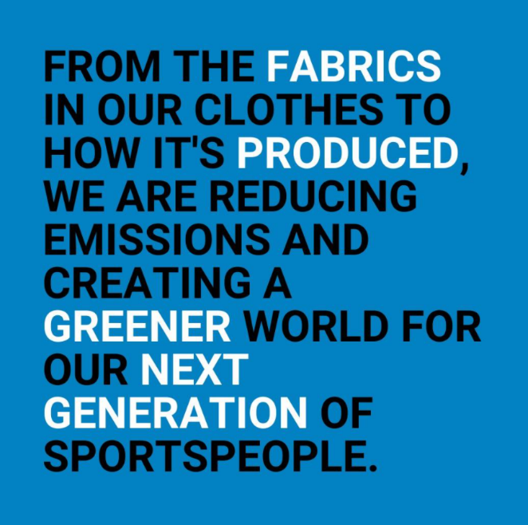
Want to know more?
You can also discover our other commitments and what we do to protect our playgrounds

https://engagements.decathlon.fr/notre-engagement-pour-repondre-a-lenjeu-climatique

OUR PRODUCTS

Decathlon is one of the biggest sporting goods retail companies in the world. We offer a wide collection of products which include sports equipment, clothing, accessories, footwear and much more. Decathlon products are very original and unique therefore the company believes in direct and offline selling as well.
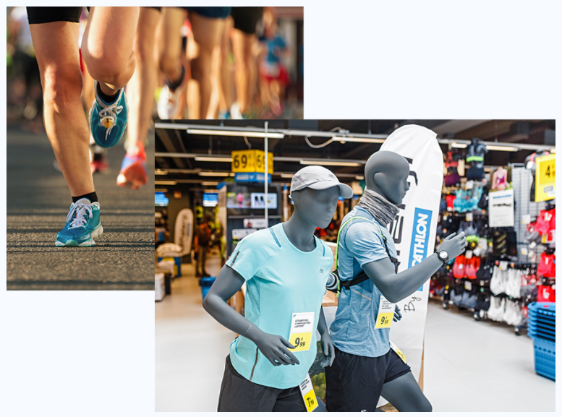
Since its establishment in 1976, Decathlon has continuously embraced and worked for the same objective: make sport more pleasant for everybody. In each corner of the globe, this aim is communicated through two integrated specialised topics:
- The design and production of in-house brand sporting goods covering about 65 sports
- Retailing sporting goods
Decathlon's in-house design group is comprised of 90 multi-disciplinary designers having the equivalent values: trustworthiness, fraternity, and responsibility, all utilised toward making the delight of game available to all. (Publications: JN “Design Management Review”: EBSCOhost, 2015)
We are very proud of our products and you can see below which products received the International Forum Design Awards.
One of these was the Quechua Two-Seconds Tent, which can literally be thrown into the air and will open all alone before it touches the ground. If you have never put up a tent before, you don't have to worry about that anymore! That’s the perfect product for you or for those who want to save time. Once the tent is up, all you have to do is to secure it to the ground. Treat yourself with spacious rooms, comfort and good height.

Can’t believe how easy it is?
Just watch the video https://www.youtube.com/watch?v=PzAvdkFj40o

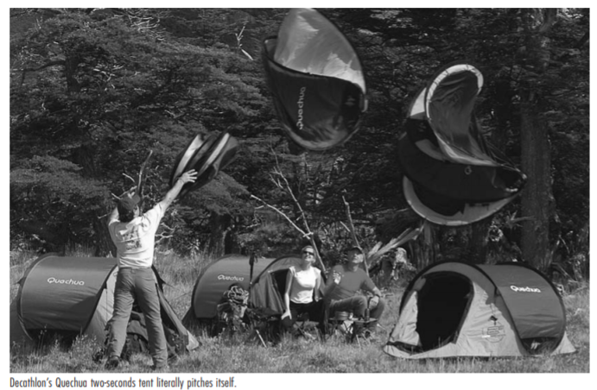

See our latest awards below

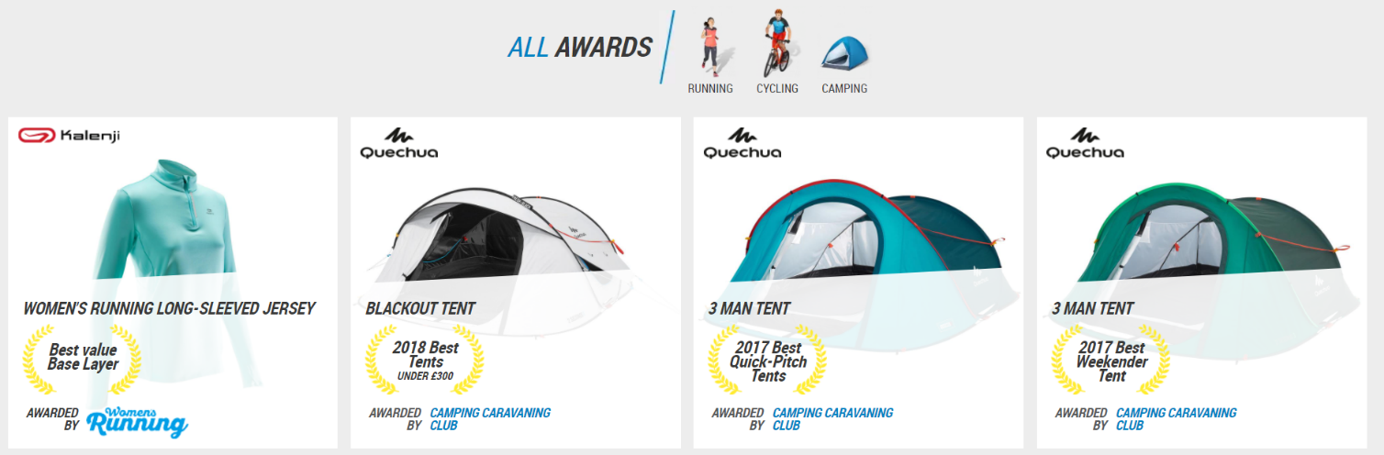
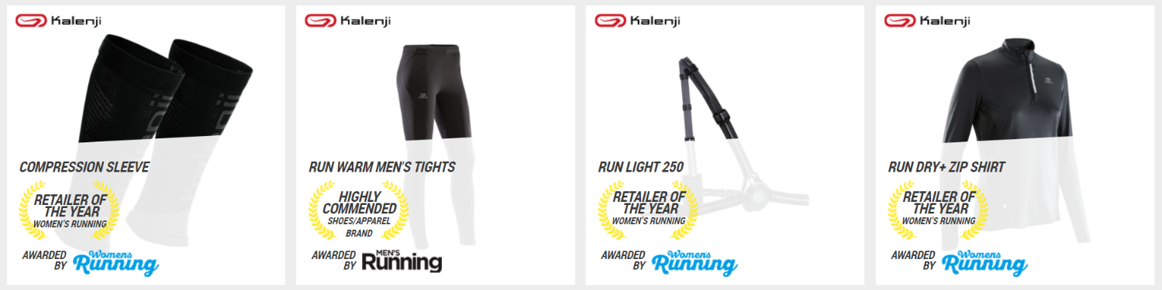
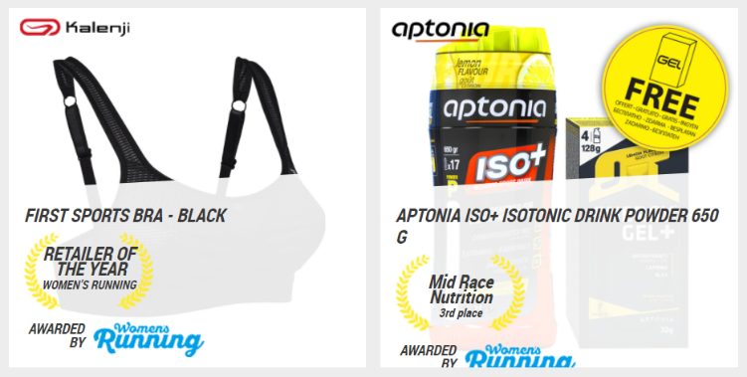

WHAT DO YOU KNOW ABOUT OUR WARRANTY SCHEME?
‘’SATISFIED OR SATISFIED’’

Here at Decathlon, we don't feel it's sufficient for only us to be pleased with our items', we need you to share this pride. That is the reason with our 2-year guarantee (beginning from the date of sale) we will replace any inadequate thing that doesn't satisfy our guidelines of value and magnificent worth.

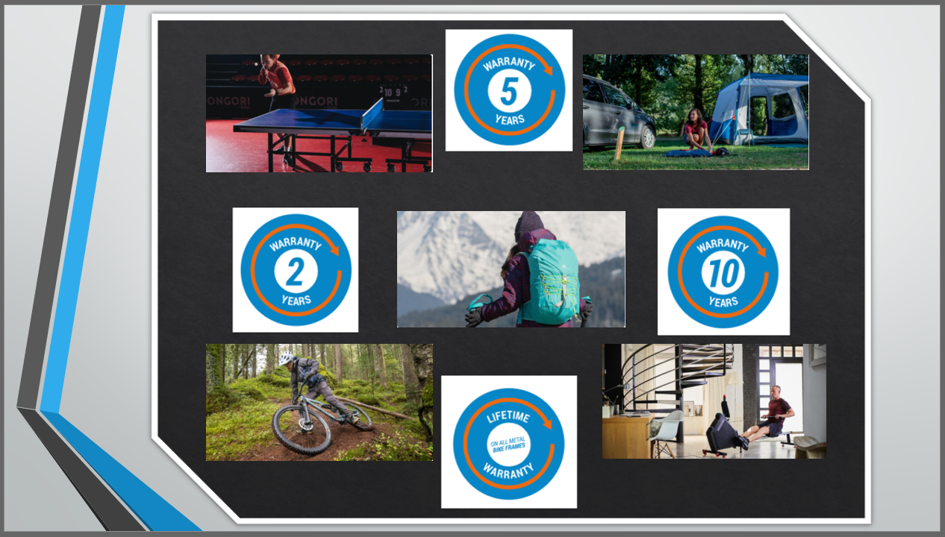

Warranty is our promise for the quality we offer. That’s why we have developed schemes that fit appropriately. We offer lifetime guarantee on equipment build to last such as metal bike frames, the 10-year guarantee on table tennis tables and climbing backpacks, and a 5-year guarantee on carbon bicycle frames, wellness machines, and inflatable tents. (Warranty Information - Our Product Guarantees, 2020)



CUSTOMER VALUE AND SATISFACTION

‘’We are stronger together.’’

Customers are at the core of our business and we are a marketing orientated company providing goods which meet your needs. We know that our long-term success depends on our ability to listen to you as you are the most important factor to us. Our aim is to provide solutions that match identified customer needs or problems. (Fifield, 2012, p.18)
We value your opinion and we constantly work to identify customer needs and ways to put them in practice through the products and experiences we provide.

Did you know?

Your opinion matters to us! If any of our products have a rating lower than 3/5, the item is withdrawn from sale to be improved.

We all know that these days the experience factor assumes a progressively significant part in deciding the accomplishment of an organisation's offering. (Gentile, Spiller and Noci, 2007)
We know how important is to test and try a product before you buy it, that’s why, in store, we make sure our products are available to test, so you can figure out prior choosing to get it.
Our experts are always there to help you, so don’t hesitate to talk to one of them.
Decathlon offers its customers experiences. On our website you can find all the events that take place in your city. We know how much you want to experiment new sports. Whether you are a beginner or have experience in the field, come and join us, our free events are waiting for you. All you have to do is enter the Decathlon website and register for the desired event, depending on the city you live in.
You can find all the information you need on our website. And do not forget to subscribe to out newsletter to find the latest news!!



That is why customer value is so important to us. We understand your needs and wants in order to keep you satisfied (Kotler and Armstrong, 2017, pp.32-50).
Decathlon provides multiple services to its customers such as click and collect, membership cards for individuals, schools and business organisations, B2B gift and e-cards, rental and insurance services. In addition, based on its users preferences and styles, Decathlon offers several workshops in order to customise and modify different items (MarketLine Company Profile: Decathlon S.A: EBSCOhost, 2015).

PRICE

Price is only one factor of the organisation’s marketing strategy. To achieve the company’s objectives at many levels pricing plays a tremendous aspect (Kotler et al. 2019, p.312).

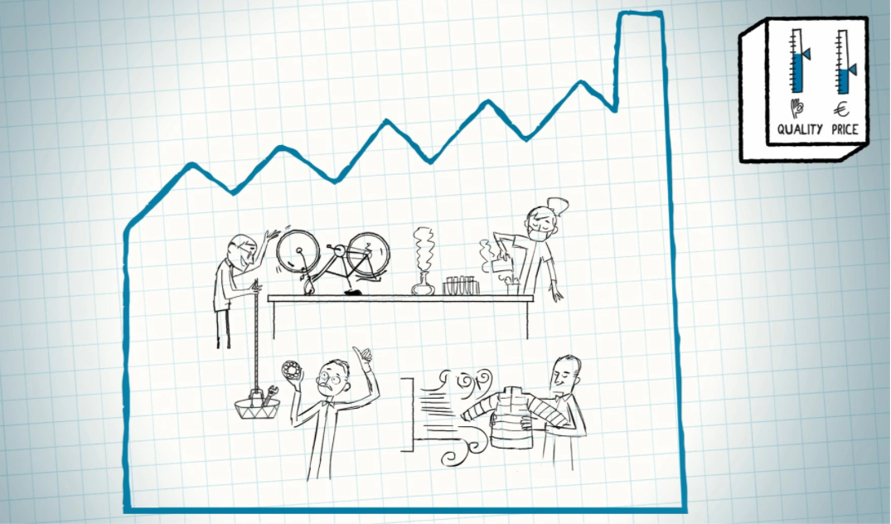

Decathlon wants to be the place where you can get the best-valued products and unbeatable standard. Our aim is to offer superior value for the price we charge.
That is why we are continuously working to maintain low prices and not compromising with quality.
At Decathlon, we keep our prices reasonable through:
- research and development
- integrated design manufacturing
- logistics
- integrated retailing
- business model – low margins, we count on exclusive partners (How Do We Make Our Prices so Affordable?, 2021)
Here is how we do it:
https://www.decathlon.com/blogs/inside-decathlon/how-do-we-make-our-prices-so-affordable

PLACE

The company has over 1647 stores all over the world and around 100 stores in Spain only. Thus, it has worldwide existence in terms of place. Decathlon can be found across 56 countries in 5 continents. The stores in Spain are the delivery centres for all online purchase (Decathlon, 2020).
Decathlon stores around the world, present a solid and exceptional culture, reinforced by two principles: vitality and responsibility.
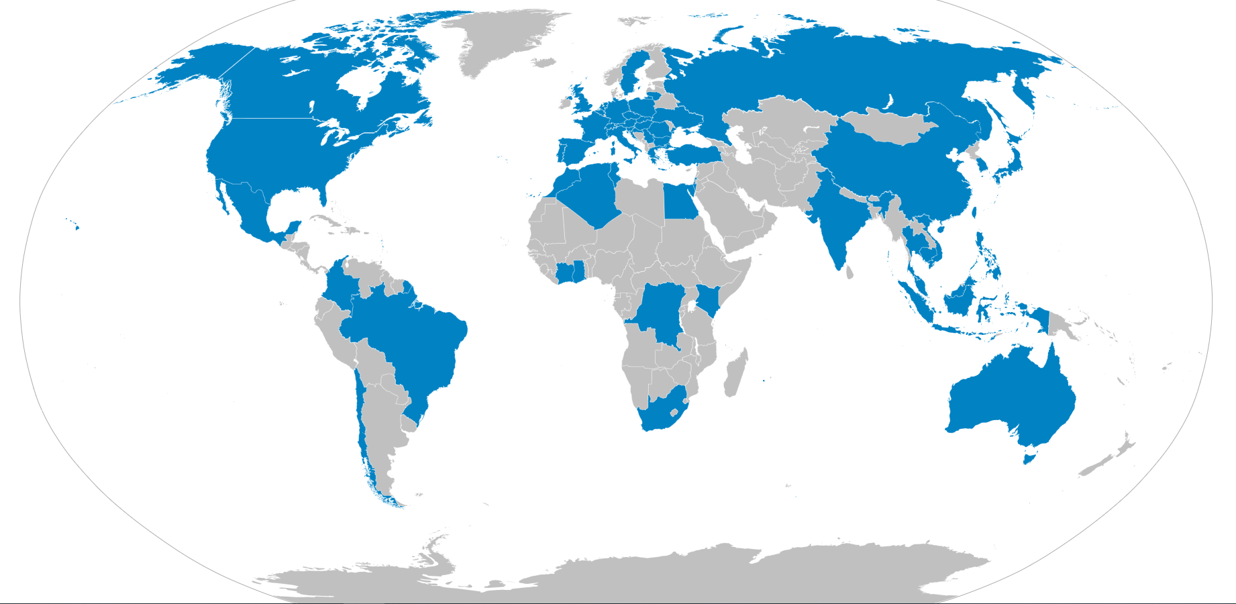
(Decathlon stores worldwide)
Due to efficient logistics and distribution, we are able to maintain a 72-hour delivery time target. In the UK our delivery options are: Click & Collect – free for members, collect at ASDA – delivery cost will be £3.99, Standard delivery - the delivery price will be indicated on your basket page. Standard home delivery starts from £5.99.
Our delivery partners in the UK:
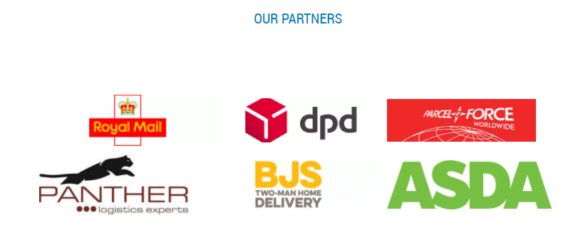

PROMOTION

Decathlon is a very innovative brand which provides high-quality clothes within an affordable price range. We promote our products through word of mouth, various social media platforms and other advertising processes (Decathlon, 2020).
Video campaigns stimulate individuals to shop online and visit stores, and brands that go above and beyond by making customized ads see considerably more achievement. “With online video, we’re able to reach new audiences and encourage them to take action — all while engaging them with customized experiences.” – Laurent Petit, Head of Communications and Marketing, Decathlon (ThinkwithGoogle, 2019)
In addition, the customer in-store experience is a key differentiator. Come and meet our friendly employees. We always expect our customers with a smile, ready to help.
Where is the nearest Decathlon store for you?
Visit: https://www.decathlon.co.uk/store-locator

References:
About Us - This is Who We Are | Decathlon (2020) Decathlon.co.uk. Available at: https://www.decathlon.co.uk/landing/about-decathlon/_/R-a-decathlon (Accessed: November 17, 2020).
Decathlon. (2020). About us.(online) available at: https://www.decathlon.co.uk/. Last accessed on: 5 December 2020.
‌Fifield, P. (2012) Marketing strategy. 2nd Ed. Butterworth-Heinemann.
Gentile, C., Spiller, N. and Noci, G. (2007) “How to Sustain the Customer Experience:,” European Management Journal, 25(5), pp. 395–410. doi: 10.1016/j.emj.2007.08.005.
How Do We Make Our Prices so Affordable? (2021) Decathlon. Decathlon. Available at: https://www.decathlon.com/blogs/inside-decathlon/how-do-we-make-our-prices-so-affordable (Accessed: January 2, 2021).
Kotler, P.T. and Armstrong, G. (2017) Principles of Marketing. 17th Ed. Harlow: Pearson Education Limited.
Kotler, P.T. et al. (2019) Principles of Marketing, Harlow: Pearson Education Limited.
‌MarketLine Company Profile: Decathlon S.A (2018) Decathlon S.A. MarketLine Company Profile, pp. 1–19. Available at: https://search-ebscohost-com.ezproxy.uwtsd.ac.uk/login.aspx?direct=true&db=bth&AN=132624040&site=ehost-live (Accessed: 3 January 2021).
‌Publications: JN “Design Management Review”: EBSCOhost (2015) Ebscohost.com. Available at: https://web.b.ebscohost.com/ehost/command/detail?vid=6&sid=7528ea5e-d01c-4e2a-8c1d-40cca8b902b0%40pdc-v-sessmgr02&bdata=JnNpdGU9ZWhvc3QtbGl2ZQ%3d%3d#jid=7NB&db=bth (Accessed: November 20, 2020).
ThinkwithGoogle (2019) Experiment: How Decathlon boosted conversions with customized video ads, Think with Google. ThinkwithGoogle. Available at: https://www.thinkwithgoogle.com/intl/en-apac/marketing-strategies/video/experiment-how-decathlon-boosted-conversions-customized-video-ads/ (Accessed: January 2, 2021).
Warranty Information - Our Product Guarantees (2020) Decathlon.co.uk. Available at: https://www.decathlon.co.uk/landing/warranty-information/_/R-a-a340014v (Accessed: November 23, 2020).

