
reflectve portfolio
Dylize Griffiths 1814897

bmsw4005 Professional and career development
dr olu adegbite
February 7 2020

Table of Contents

INTRODUCTION 2
A. DISCURSIVE REPORT 3
Importance of self awareness 3
Johari window 3
Results 4
Psychometrics - Career aspiration test 5
My results 5
Hollands Career aptitude test 6
Results/findings 6
Career development 7
Personal advancement 8
Establish employment goals 8
B. REFLECTIVE REPORT 9
Importance of the job advert/ description 9
Reflection 9
the application of cover page and personal statement 10
Recruitment and selection process 10
preparation before interviews 10
Lessons drawn from mock interviews and how it will influence career development. 11
APPENDIX 17
Career development cycle. 17
17
the model of understanding your -self 18
Reference list 18

INTRODUCTION

The purpose of this portfolio is to demonstrate knowledge of key topics learnt on the module bmsw4005 professional and career development.

This report will attempt to explain why it is important to be aware of one’s self when seeking employment and within the workplace both as employee and employer. To be a good leader of a company or team, you must have a full vision of how people perceive your actions and words, to be effective at communicating and creating healthy workplace culture. This in turn improves workplace rapport, production and performance of the company this means improved revenue.

DISCURSIVE REPORT

Discursive report 2000 8 ref

Importance of self-awareness

To be successful in life, weather its looking for a job or applying for a mortgage, working in a busy corporate network, one must have a good grasp of their self, to focus ones attention outward to the environment, having conscious knowledge of one’s own character, feelings, motives, and desires oxford dictionary (2018) cited on Moodle. Being self-aware represents the capacity of becoming the object of one’s own attention Alan morini (2011) cited on Moodle. If self-awareness if not a strong point in an individual’s skills, there are some tools and methods to help improve consciousness.

Johari window

One of the most renowned tool for self-awareness is The Johari window this concept was developed by psychologist joseph luft and Harrington ingham in (1955), its purpose is to help individuals better understand their self and how they interact with others, a feedback and disclosure model of self-awareness, The concept is widely used in education for management of schools, psychology for further information on behavior, and the workplace to improve performance and production by improving employee workplace culture also human relation training Luft, J. and Ingham, H., (1961) viewing information needs regarding interpersonal communication of urban culture, Shenton, A.K., (2007).

The Johari window works by drawing four quadrants which represent specific areas of one’s self, the quadrants are as follows: open space, is the self-known to you and others, blind spot, is the self-unknown, to self, but known to others, hidden area, is known to self but unknown to others, last is unknown area, this is unknown to self and others. Two individuals would input perceptions and thoughts of the other in the correlating boxes and then disclose the information unknown to everyone, completing two boxes works well one for yourself and one for your partner.

This activity works best when more than one person completes the Johari window, team up with a partner for example, this way the quadrants will be available to input your perception of the partners blind side which is not seen by the individual. Plus helps you understand how your open side compares to others perception of your actions. This activity can raise eyebrows if not careful with expressions of another’s actions but still gives valuable understanding to both sides how to conduct one’s self to improve team working and characteristic perceptions from others around you

Results

The results show, I am perceived by my peers as moody, quiet, quick tempered, organized, punctual, equip to learn and smart dressed. Although that seemed a correct perception of me from my university peers. This is what self-awareness is, knowing how to conduct one’s self appropriately in relevant environments.

While some of this may be true, I feel the negative perceptions are a misunderstanding of expression, meaning if I’m quiet and isolated from the class its is due to personal pressures hidden and the need to focus on the task at hand. Utilizing the Johari window gives opportunity to deeper understand others and how they communicate. Going forward I have more understanding to myself and the environment around me. Seek to improve approachability and facial expressions not to give the wrong idea I am upset and not approachable to help in any way.

Blind self

Moody
Not approachable
Open self

Quiet
Smart dress
On time
Organized

Unknown self
Hidden self

Personal stress
Health issues
Financial worries
Depression and anxiety
autism

Psychometrics - Career aspiration test

Another tool used for further understanding of one’s self is the Career aspiration test, this tool enables you to understand your motivations, and aspirations within your workplace giving understanding to what industry sector suits best to individual traits. Everyone has different values and needs regarding work, which means individuals have different needs to feel satisfied and fulfilled. For some its money, and for some its power within social hierarchy, then there are the individuals who enjoy helping others or more freedom in life. This tool helps you understand where your fulfilment and satisfaction motives are.

The test involves answering over 100 questions in the context of preference, what role best suits you, or what is more important to you in life having enough money or mor3 family time activities. Once the test is complete you will be summarized into a few sentences what your best suited job would be and why you would work specific industry sectors over others.

My results

Financial REWARD that people motivated by financial reward strive for the big payoff that comes as the fruit of the labor. I want to feel like my salary and benefits equal the value of time and energy they must invest in their work. While this is a common motivator that most people identify with (who wants to work for peanuts). individuals like myself place more importance on remuneration than the average worker.

this is not to say they are only after that big bucks; it is having the money to afford a certain way of life that gives them drive to succeed. They are willing to invest themselves but will not do so without significant pay off. They don’t necessarily have to make an extremely high salary in the short term to feel happy, especially when starting out, but they want to see the long-term reward for the personal investment they put into their career.

Hollands Career aptitude test

This test gives you insights to your preferred job roles and industry, here the individual would be shown fifteen sets of four pictures, pictures showing various work activities within various industries, the individual must choose which picture appeals to them more. This test determines what job best suits the individual participating, to score preference job prospects on a scale of 0% -100%, salary is not considered or people within the job.

Results/findings

When I completed my own career aptitude test I discovered many things I had not previously known about my perfect job and personality, I have artistic personality type, the results are quite spread out between the six personalities which means I have interest in many fields of industry. Mostly ARTISTIC 28% followed by Investigative and Enterprising

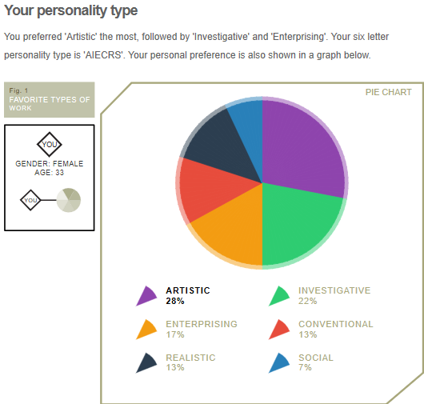

Career development

Career development is an important aspect of many lives, growing into successful people takes time and effort to work on yourself. This process dose takes, determination and commitment to reach your goals and aspirations. A Career is defined as all the experiences you have had like employment, extracurricular activities and learning/training throughout your lifetime. Career development is defined as the process of learning about yourself, exploring new things, making plans and acting them out to reach your goals/targets. Career development is a continuous process, where you can go back and build on yourself further with knowledge you acquired along the career journey.

discovering yourself, strengths, weaknesses, what motivates me, career aspirations, skills, values, personality and personal preference, this can be done with diary writing, to then reflect on or career quizzes, swot analysis and diagrams, see appendix.

Exploring options within further education, training, work placements, and volunteer work all add up to understanding yourself. When exploring employment choices and skill capability a shortlist of industries should develop. the experience that comes from meeting people within your industry and learning abut processes first hand, weather it is voluntary or part time the experience will give a understanding to what is expected of me and if this is the right path to take in my career.

Making a choice about the job role or industry and commit to reaching your goals. While taking any new job, experience is important and to keep my options open, allowing knowledge to know what job roles are suited to building my career. having a good think about possibilities and decide the value it would add to my career.

Taking -action, looks different for everyone, planning the journey, making sure to reach every goal along the way, this could mean further training and qualification requirements, the plan will be to apply for further education or looking for a work placement the plan would be to have a work strategy where you will master your role and knowledge of the job/industry cited on Moodle.

Personal advancement

My career has given me experience in being a leader, a director of a company learning the complex procedures and rules to maintain a running company, a security officer understanding conflict situation to resolve issues without incidents occurring and above all customer service procedures.

Through further roles within the retail industry or managing my own company with mentoring I will develop my skills to effectively run a company, the job center provides a referral service to receive mentorship to become self-employed. If I was to look for employment it would be within the network marketing industry as this is a fast-paced exciting role with flexibility and compensation schemes.

Establish employment goals

My action plan is to further my skills and knowledge within the sales industry while gaining the strategies to run a successful company of my own. To do this I will be seeking employment within marketing online LinkedIn is one of the best choices to search for employment. Refine my business plans and set targets to launch and reach sales targets for each month.

Get a job within marketing to gain experience and knowledge of the industry firsthand.

Prepare steps to launch business when funds are available from job.

REFLECTIVE REPORT

Reflective report 2000 8 ref

Importance of the job advert/ description

When advertising a position/vacancy, employers must state specific skills required and what tasks are required. When searching for a job applicant must compare the job description and skill sets to see if they match up, it wouldn’t make sense to apply for a manager’s position within a bank if the applicant has no finance qualifications. understanding companies’ goals and values can be a great way of building rapport within the interview as there is a common interest.

Employers often welcome applicants to ask questions, this shows the employer how much the applicant has researched the company and vacancy. Asking the right questions can prove beneficial in gaining employment, by proving how interested they are in bringing something to the company.

Reflection

I need to practice on my confidence, most important is to know the role in detail.

the application of cover page and personal statement

when applying for a job the preparation of the curriculum vitae (CV) is important to present your skills and knowledge, presenting your skills and experience is also important, the CV should be easy to read and well laid out, this show the employer further skills while being able to flick to the relevant pages of interest easier.

Providing a personal statement will allow the employer to get to know you, your values, hobbies, life experience and how much you have grown by these experiences. This is where you can inspire empower and add value to your interview.

Recruitment and selection process

Recruitment Is defined as the action of finding new people to join an organization or support a cause oxford dictionary (2020) this would be done with job advertisements online or in papers and he job Centre. Each company searching for applicants have a need to improve something weather its performance or production, by locating identifying and attracting capable applicants Robbins and coulter (2012) knowing where to post an advert can make all the difference.

Selection is defined as the action or fact of choosing someone or something as being best/most suitable oxford dictionary (2020)

preparation before interviews

There are many forms of interviews, phone calls, one on one, panel, and group interviews. All of which require professional manner and attitude. It is vital to be prepared for interviews, this shows the employer you are proactive, take the job seriously, and will be a good match for the role. Knowing background of a company will show you have studied the company and have views on being a part of their mission to improve or learn from the industry.

All interviews must be consistent, being smart dress, well mannered, confident, listen to the employer contently, and don’t over talk be brief and to the point when answering questions and if there is employers writing be confident in the silence and have patience for the next question. Making sure the applicant has all the information of the job vacancy, will prepare for any questions asked by employer.

Looking your best will also improve chances of employment when dressed for the occasion, suit tie, or office attire will show professionalism and effort in presentation. Gathering clothes well in advance will save a lot of time on the day, also Know your route and time to arrive as being late will cost the job, plan the journey with time to get there early or prepare for unexpected incidents like traffic or break down.

Check timetables of transport and set an alarm to wake up of leave the house this will keep you on time and less stressed out or nervous.

Lessons drawn from mock interviews and how it will influence career development.

APPENDIX

Career development cycle.

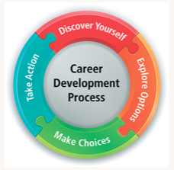

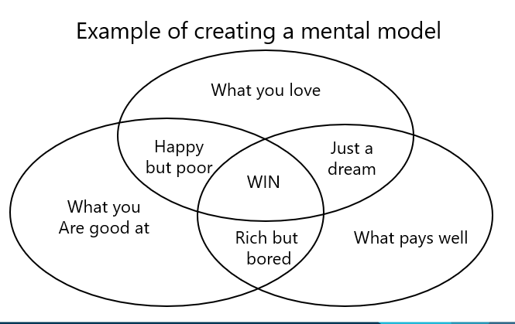

the model of understanding your -self

Reference list

- Luft, J. and Ingham, H., 1961. The Johari window. Human relations training news, 5(1), pp.6-7.

Roberts, G., 1997. Recruitment and selection. CIPD Publishing.
- Shenton, A.K., 2007. Viewing information needs through a Johari Window. Reference Services Review, 35(3), pp.487-496.

- Oxford dictionary 2018 definition of self-awareness cited on Moodle PowerPoint presentation

- Harvard business review, Career development, video
Available at: https://hbr.org/video/2226820990001/the-art-of-career-development
Accessed on 3rd Feb 2020

- Alain Morini 2011 definition of self-awareness cited on Moodle PowerPoint presentation

- The future of work, jobs and skills in 2030,

- Recruitment process, people in business, Bitesize video.
Available at: https://www.bbc.co.uk/bitesize/guides/zn6hyrd
accessed on 3rd Feb 2020

