ASSESSMENT 1: ESSAY (PROJECT PLAN)

Programme: BA in Business Management
Module: Project Management
Module code: LCBB5005
Lecturer(s): Sadeque Shaikh, Dr. Xavier Matieni

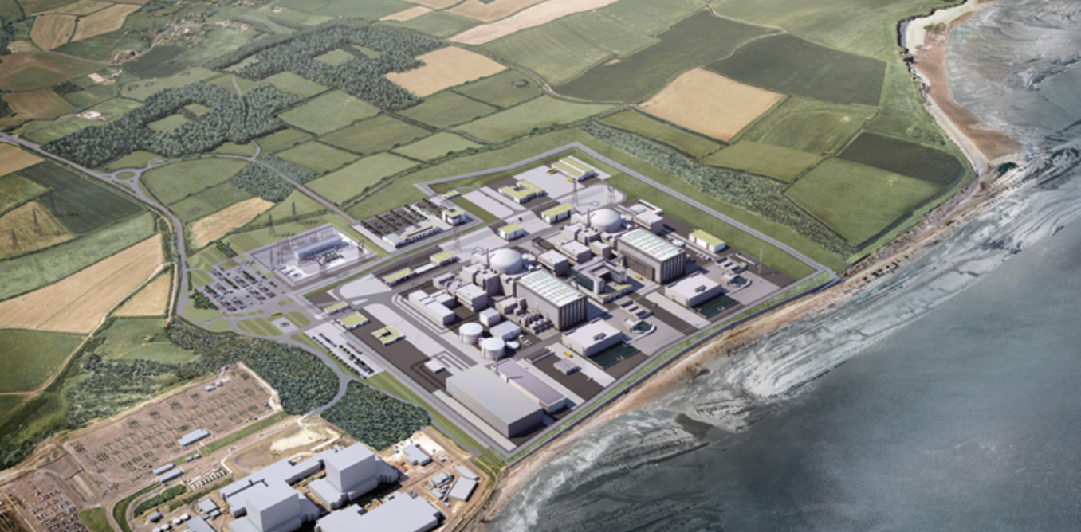
This Photo by Unknown Author is licensed under CC BY-ND

Student Name: Valeria Peeva
Student Number: 2029005

Table of Contents
INTRODUCTION 3
PROJECT SCOPE 4
BUDGET ASSUMPTIONS 4
ASSUMPTIONS 4
CONSTRAINTS 5
STAKEHOLDERS AND THEIR INVOLVEMENT 5
PROJECT ORGANISATION STRUCTURE AND ROLES AND RESPONSIBILITIES 5
PROJECT CONTROL MECHANISM 7
REPORTING FRAMEWORK 7

INTRODUCTION
The main modern atomic energy base designates constructed and allocated in United Kingdom in longer than 2 decades is Hinkley which should deliver low-carbon control aimed at about 6 million residences, generate thousands of vacancies, and create enduring gains in the market of United Kingdom. Building and processing of Hinkley Point C will produce 25,000 production prospects, and up to 1,000 internships, and 64% of the plan's production amount is expected to go to Great Britain businesses. Celebrating a major achievement in reviving the nuclear power production, Hinkley Point C will make a significant impact on the Great Britain’s effort to decrease carbon releases. The energy created from the two EPR containers should compensate 9 million tonnes of carbon emanations annually or 600 million loads completed in 60-year life cycle.
The Hinkley Connection Project is a recent high-energy power link among Bridgwater and Seabank nearby Avonmouth. It is a substantial asset in the area's energy system and will allow us to link original supplies of low-carbon power to houses and firms, as well as Hinkley Point C, EDF Energy’s modern power base in Somerset. We are through a power transformation, and it is a main responsibility to participate in this rapidly shifting power environment. The project will meet aspiring low-carbon power goals, attach extra supplies of force to the individuals who use them, and discover advanced techniques to allow the decarbonization of heat and transportation.
Established on recent improvement the expectation is to examine the underlying aspects of the development such as the budget, time, quality stakeholders, and risk considerations. The assessment emphasis on the preliminary development proposal and establish what went wrong that caused in such massive overruns and interruptions.

PROJECT SCOPE
System and transportation Project summary the 57km, high-level power Hinkley Connection between Bridgwater and Avonmouth in the Southwest will give low carbon, household power to six million residences and industries within the UK. It will perform a crucial task in providing energy securely, effectively, and consistently, and maintain the UK’s desire to reach its net zero by 2050 aim. The latest joint will be 57 kilometres lengthy – comprising of 48.5 kilometres of above field and 8.5 kilometres of undercover wire beyond the Mendip Hills Area of Outstanding Natural Beauty (AONB).
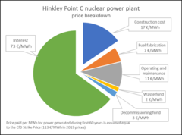
This Photo by Unknown Author is licensed under CC BY-SA-NC

BUDGET ASSUMPTIONS
According to EDF, the atomic energy place being made at Hinkley will twitch up a year later than expected and price an additional £3 billion. The place in Somerset's new operational window is presently June 2027, and full budget are anticipated to scope between £25 billion and £26 billion. EDF said that it would not cost British taxpayers or customers anything. The outbreak's force was mostly blamed for the interruptions by the French power, which created the area. EDF has printed the outcomes of a study on the expense and delivery timetable of the energy base that took the Covid-19 virus's continuing effects into account.

It was disclosed that additional half a million times of significant effort had failed in 2020 and 2021 because of a decrease in the number of personnel permitted on position because of Covid protection procedures. According to Stuart Crooks, the managing director, estimates had to be abruptly reduced from more than 5,000 to roughly 1,500 on the spot. He said that the trade association also attacked hard, leaving little choice except to become less effective. 180 suppliers had entirely collapsed by April 2020, however comparable to later in the year in February, more than 60 contractors were still operating but at a lower efficiency due to the pandemic.

ASSUMPTIONS
Energy requirement could double up by 2050 as we stimulate our lifetimes, and UK has only gotten a fourth of the means to developing the power structure necessary to sustain such expansion. Hinkley Point C’s dependable low-carbon energy will improve United Kingdom reach Net Zero and safeguard the atmosphere from the danger of weather shift. It is an important component of a mixture of wind speed and solar that will grant UK to stimulate its transportation, houses, and industries exclusive of reliant on fossil fuels. With no nuclear-powered, United Kingdom will not stop the fossil fuel reliance. All power tools generate about carbon releases in their process and structure, but recent findings prove that Hinkley Point C’s effect is even less significant than wind and solar.

CONSTRAINTS
An outline of the development's principal objective, recognizing danger and additional limitations that affected the development. In distinguishing the major consequences to the plan, the utilize risk assessment and build a strong risk list. Concerns around possibly high-level ground rates of energy generated at the factory, ecological protection, national safety, and economic threat equally to shareholders and taxpayers have troubled the development. In 2016, two EDF executives fought to the building of Hinkley accepting in dispute before a critical board vote that time.
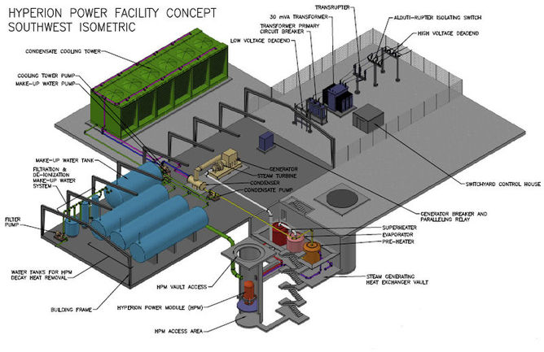
This Photo by Unknown Author is licensed under CC BY-ND

STAKEHOLDERS AND THEIR INVOLVEMENT
The Hinkley Group is overseen by Jane Davidson and has seven additional representatives with experiences and occupation in university, atomic power, ecological and biological preservation, eco-friendly law, and community wellbeing.
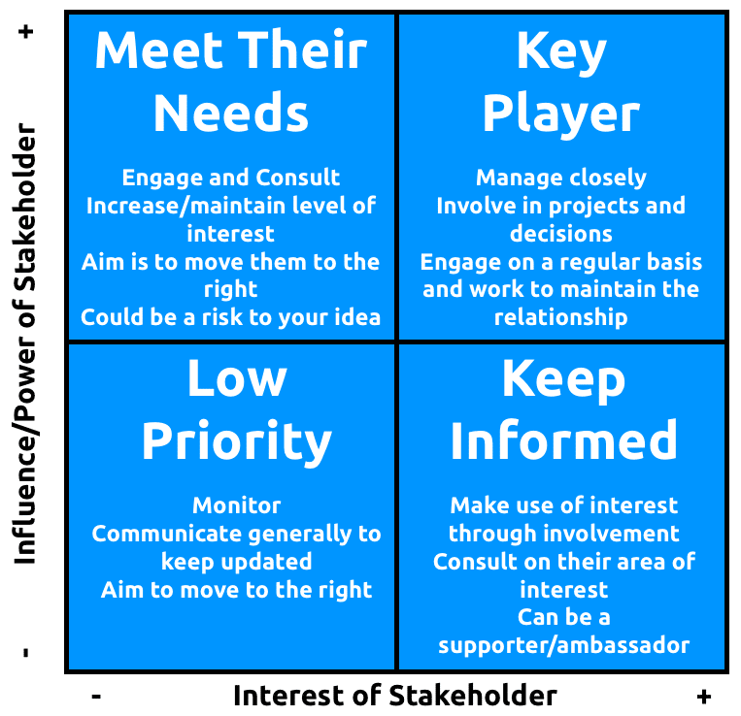

Jane Davidson is the University of Wales Trinity Saint David's Pro Vice-Chancellor Emeritus. From 2000 to 2011, Jane served as the Welsh Government's Minister for Education, Environment, and Sustainability, where she developed legislation to make sustainability the primary guiding principle. In 2015, the Well-being of Future Generations (Wales) Act came into effect because of her efforts. She implemented the first plastic bag fee in the UK, and her recycling initiatives propelled Wales to third place globally. She established the Wales Coast Path, the office of Sustainable Futures Commissioner, and the Climate Change Commission for Wales. During training, she adjusted the overall programme, implemented the Welsh Baccalaureate and merged global citizenship and education for sustainable development into the Welsh curriculum.

PROJECT ORGANISATION STRUCTURE AND ROLES AND RESPONSIBILITIES
The UK's modern nuclear-powered base is on track to begin June 2027, the business developing it has said. Hinkley Point C in Somerset has been beneath creation by EDF Energy for five years. Nigel Cann, who oversees the development, told the BBC his team was "totally concentrating" on turning the factory on within that timetable. The supreme purpose of the Board is to offer a managing support in which EDF runs to the ultimate moral and wellbeing and security requirements and its assets are maintained and improved beyond creating a society of no damage and no reception to corruption and dishonesty.
The Board's goal is to deliver EDF with appropriate leadership, delivering dream and management to monitor the organisation of EDF's corporate, to develop worth sensibly and sustainably, to ensure that EDF's financial and legal duties are encountered, and to protect and enhance stockholder value. Non-executive directors Xavier Ursat, Veronique Lacour, Etienne Dutheil, Luc Remont, Sylvie Jehanno, Christophe Carval, Xavier Girre, and Pierre Todorov are among the most recent board delegates. Rob Guyler serves as the chief financial officer and Simone Rossi is the executive director.
Except from those retained by the Board for decision-making and/or agreement, all daily operations of EDF are directly and operationally managed by the EDF Management Group, under the direction of the CEO and below consultant of the Committee. The Managerial Group is made up of Chairwoman Simone Rossi, Managing Director - Generation, and Chief Executive Officer Matt Sykes. Thomas Crooks The managing director of Hinkley is Philippe Commaret. Chief Legal Officer Joe Souto, Chief People Officer Carol McArthur, Chief Financial Officer Rob Guyler, and Director of Tactic and Commercial Dealings Paul Spence.
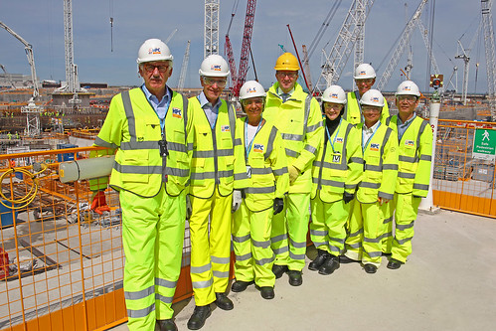
This Photo by Unknown Author is licensed under CC BY

PROJECT CONTROL MECHANISM
There are substantial modifications to the community energy system by eliminating 67 kilometres of overhead line. Latest and inventive methods to reduce the effect of the development on the local public and the ecosystem. This will be a production which will be the planet's first operating T-pylons with unique, further environmental methods to building that decrease traffic and influence the atmosphere.
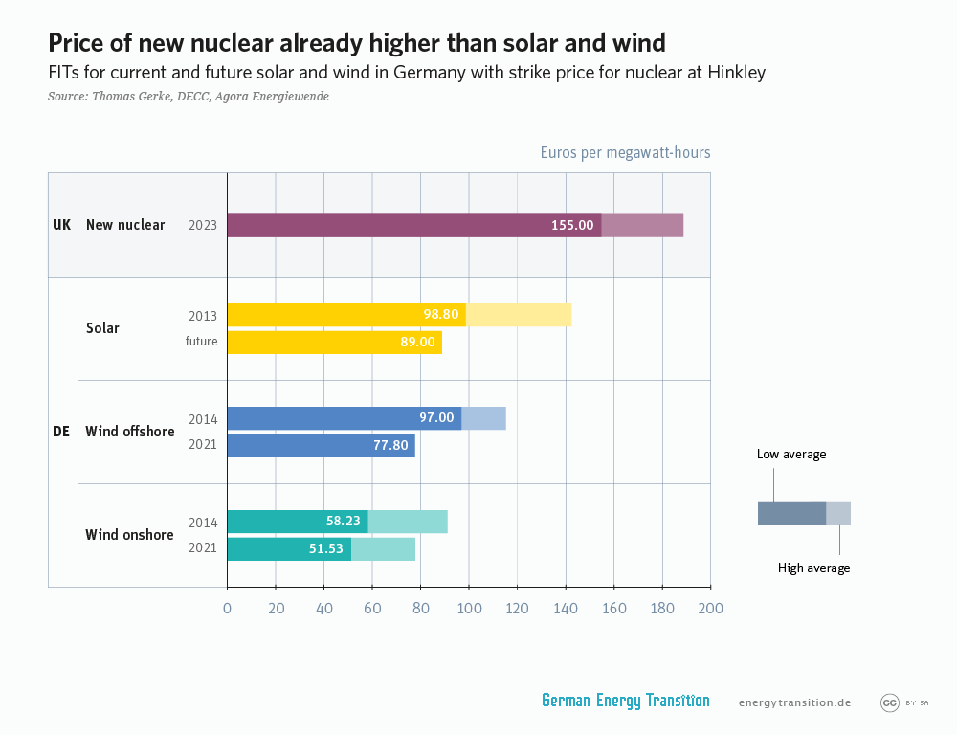
This Photo by Unknown Author is licensed under CC BY
PROJECT PLANNING WITH MILESTONES
All plans go across a time phase from beginning to close, evaluation, and assessment. Identifying the plan goals; this is a valuable approach of ensuring that crucial actions happened on stage. The 49,000-tonne ground for the second reactor at Hinkley Point C has been finished on calendar - meeting a goal time set further than four years ago. The last solid pour of 8,991m3 setting a recent UK recording for a separate, constant pour. It exceeds 37m3 the prior recording throughout the building of the ground for Hinkley Point C's first part in June 2019. This key breakthrough in atomic production was done by crews who have got to adjust to recent Coronavirus operating circumstances.
Their accomplishment, well-known as “J-zero”, happens fewer than a year when the achievement of the first reactor’s stand in June 2019. It is the next main objective in 2020 and the effective achievement of both respects the success of all the development targets in 2019. The period for reaching J-zero on Unit 2 was put further than four years prior to the last financing ruling was shown. Achieving the subsequent reactor basis also gained from knowledge achieved on the first equal component – which has managed to substantial boosts in efficiency all through measures such as improved usage of prefabrication. This will promote the planned follow-on development at Sizewell C in Suffolk.
Production throughout the recent Coronavirus disaster was capable to remain after the development brought a full variety of measures to safeguard the protection of employees and the public. This involved decreasing figures on location to allow community detaching and focusing on the highly important fields of building. Various wellbeing procedures continue in power to avoid the place of disease. Where public hostility is not likely, employees have remained applying additional defending gear.
WHAT WENT WRONG THAT CAUSED IN SUCH MASSIVE OVERRUNS AND INTERRUPTIONS
The Covid-19 virus, named after its creator, might delay the building of Hinkley atomic plant through half year and increase the budgets with £500 million. Corresponding to EDF Energy, the latest nuclear energy plant in the UK would cost £23 billion to build and won't be operational until the summer of 2026 because of the recent delays. Prior to the coronavirus outbreak, Hinkley Point was slated to open at a cost of between £21.5 billion and £22.5 billion by the end of 2025. But the sickness caused outages of three months last year and occurred predicted to cause comparable interruptions in 2021, according to EDF Energy, maintained from French government.
Stuart Crooks, management manager at Hinkley, disclosed in a tape communication to personnel that "ten months after it started, we are still fighting the whole power of the virus." Even though there were more than 5,000 personnel working at the 160-hectare (400 acre) facility in Somerset, he claimed that the natural separation conditions "even restrain the number of persons we be able to securely need on-site at any given moment." As EDF announced in 2019 the production expenditures grown with £2.9bn after postponements, the Covid-19 interruptions managed to cause another significant price hike for Hinkley in under two years.
The costs of Hinkley Point have increased by £5 billion over the last five years. It will take nearly twice as long to build as was anticipated in 2008, and it won't begin producing power until over ten years after the intended launch day of 2017. None of this additional expenditure is brought by British clients, according to Crooks. EDF Energy will be responsible for covering the rising cost of the project after agreeing to pay a fixed cost of £92.50 for each megawatt-hour of power supplied from Hinkley. Even with the obstacles, that value is unaltered.
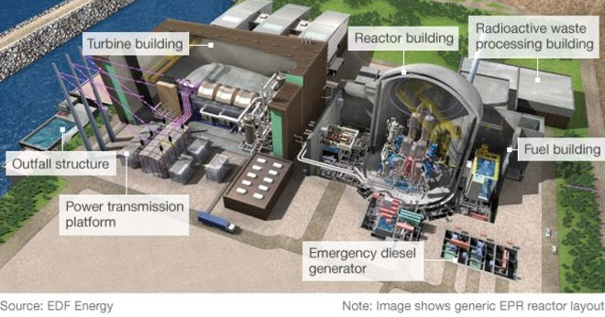
This Photo by Unknown Author is licensed under CC BY
THE NEED OF EXTRA PEOPLE FOR THE PROJECT
When the energy location project was initially accepted, EDF expected the workers would point at about 5,000. Even though building never ended at Hinkley throughout the epidemic, production reduced down. Each day, thousands of laborers are taken in by convoys of trucks, but required community avoiding reduce the totals on every car, creating it faster to have them in. On-site, original Covid protection regulations suggest each work gets a bit retentive. Businesses providing ingredients and natural resources have also dropped after. General, EDF acknowledged the plan has gotten around six months backside timetable. Factory is scheduled to start in 2026 and not in 2025 as proposed and should be among £22bn and £23bn.
The people designing structure of the project need furthermore altered the methodology. Initially, they arranged the development of various kinds of effort in structure: several huge foundations, then political business like massive physical buildings, then electrical and technical structures. Currently they can do several of these vacancies at the same time, running up growth, but forcing more individuals. The firm agreed that at minimum a third of its workers would be regional.
Challengers contended that regional people would merely create ignorant, underpaid openings during the original debate over preparing for Hinkley. EDF promised to employ and teach associates in Somerset, working closely with regional academies to fulfil their promise. In 2016, the company qualified 14,000 people using strategies including a different bonding skills city centre at Bridgwater College. One of the best current apprentices is Tracie Skinner. She has had several different job openings at age 45, but she thinks the soldering requirement will start to boost her career possibilities.
CONCLUSION
Hinkley Point C’s impact to combat temperature adjustment indicates that throughout its 60 years of process, it will have a huge, constructive effect on the atmosphere. Sustainability and ecological security are also important elements in the building itself. Latest methods are being applied while a squad of conservation experts is assisting to improve regional biodiversity and environments, support wildlife to flourish on property that had been intensively employed in farming. This assignment has showed us all the steps of the project and what exactly went wrong and what was it needed to be extended and by how long. We have looked at the reasons of the delays of the project and the expected new schedules for completion. This report has concluded that unexpected events could slow down any outgoing project.

REFERENCES
Board of Directors and Executive Team, Available at: https://www.edfenergy.com/about/governance/corporate-governance (Accessed on 21/03/23)
Burke, Rory., (2013). Project management: planning and control techniques, John Wiley & Sons Inc
Contract wins announced for Hinkley Point C, Available at: https://www.newcivilengineer.com/latest/contract-wins-announced-for-hinkley-point-c-10-07-2020/ (Accessed on 15/03/23)
EDF's UK nuclear reactor faces whopping £32billion bill as project hit with funding woes, Available at: https://www.express.co.uk/news/science/1736954/energy-fury-edf-uk-nuclear-reactor-32-billion-hinkley-point-sizewell-funding-woes (Accessed on 18/03/23)
Highsmith, Jim., (2009). Agile project management: creating innovative products, Pearson Education Limited
Hinkley C: Hundreds more needed to finish nuclear power station, Available at: https://www.bbc.co.uk/news/uk-england-somerset-57227918 (Accessed on 16/03/23)
Hinkley Point C costs may rise by £500m on back of Covid crisis, Available at: https://www.theguardian.com/uk-news/2021/jan/27/hinkley-point-c-costs-may-rise-by-500m-covid-crisis-nuclear-power-plant (Accessed on 20/03/23)
Hinkley Point C delayed by a year as cost goes up by £3bn, Available at: https://www.bbc.co.uk/news/uk-england-somerset-61519609 (Accessed on 19/03/23)
Hinkley Point C on track to reach key milestone, Available at: https://www.edfenergy.com/energy/nuclear-new-build-projects/hinkley-point-c/news-views/hinkley-point-c-on-track-key-milestone (Accessed on 17/03/23)
Hinkley nuclear power station on track for 2026 opening, Available at: https://www.bbc.co.uk/news/uk-england-somerset-58724732 (Accessed on 14/03/23)
Institute, Project., (2013). A guide to the project management body of knowledge (PMBOK guide), Project Management Institute
Lock, Dennis., (2013). Project Management, Gower
Simon, Peter., (2018). Starting out in project management, Association for Project Management

