
COMPONENT 2
Poster and Pitch

Name | Sofia Jabeen | ID Number | 2309199
Programme | BSc Health and Social Care
Module | Changemakers: Creativity and Value Creation
Module code | BMHP5014
Tutor’s Name | Tsiwani Khumalo


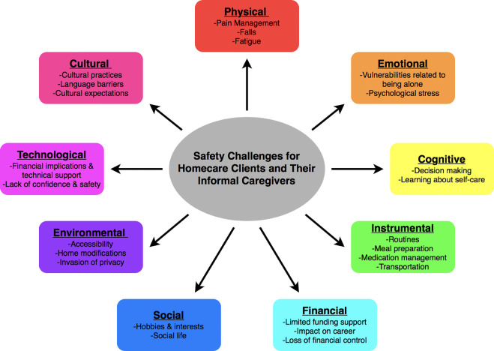

Care Link UK complies for regulation and development:
- NHS Digital Standards Framework 2023
- Data Protection Act 2018
- Accessibility Standards
- Medical Device Regulation
Promotion Channels:
- Social Media
- Workshops and Webinars
- Digital toolkit distribution
- Collaboration with UK NHS, Carers, local councils
- National launch Event 2026

Conclusion: Take care of yourself as you take care of others. To improve healthcare interventions, encourage professionals and carers to sign up and use the app.

- 24/7 AI-powered support
- Access to verified H&SC resources
- Peer Support
- Consolidation with NHS services/App

mental wellbeing
continuity of care
digital literacy
patient outcomes

Targeted Audience: Informal Carers age 18-45

Digital App
Facts
Care Link UK Provide Support to Informal Carers (Digital Platform).
Used centralizing resources, communication & wellbeing tools to remove these gaps.

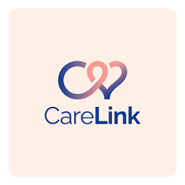
Pitch (CareLink Digital App for Informal Workers)
- Catchphrase "Take care of yourself as you take care of others"
According to the 2023 survey of Carers UK, despite providing unpaid care worth over £161 billion annually, they continue to get inadequate assistance and are vulnerable to physical and emotional lethargy. To amend this discrepancy, CareLink UK App suggested as a digital revolution that combines technology, policy alignment, and community empowerment to enhance upshots for carers and the people they serve.
Core Problem
In 2023, Halliwell explained that UK’s healthcare system faces multiple problems like: rising care necessities coupled with a shrinking professional workforce. Home carers void off these disparities, often without training or access to concerted efforts. According to the ONS,2024 research, seventy-three percent of carers reported as having mental health issues and around 45% are struggling with reliable information support.
Discrepancies
- A lack of coordination between the social care and NHS systems.
- Ineffectively directing people to nearby services.
- A small number of technical instruments designed to meet the demands of caretakers.
- Inconsistent informational and emotional assistance (The STARR, 2024).
Solution
By offering carers a safe, evidence-based, and easily accessible digital ecosystem, CareLink UK a digital platform directly addresses these dilemmas.
Its three core parts are:
- Community Network: Professionally managed peer support symposium to bring up experience sharing and lessen feelings of seclusion.
- Information Hub: Confirmed recommendations from social workers and the NHS, including advice on self-care, medicine, and condition management.
- Care Assistant Powered by AI: Virtual help with Chatbot that respond to queries and offer tailored suggestions.

Data Security and Technology
CareLink UK app employs following factors that are useful in its subscription.
- Two-factor authentication and end-to-end data encryption.
- Hosting on cloud servers that have ratified by the NHS digital resources.
- Open permission for data sharing by following GDPR limitations.
- Guaranteed an accuracy and safety.
- AI systems trained only on UK health information.
CareLink UK complies with following policy regulations and development.
- NHS Digital Standards Framework 2023
- Data Protection Act GDPR 2018
- Accessibility Standards
- Medical Device Regulations
- The White Paper on Adult Social Care Reform (2021), which emphasises the use of technology in person-centred care approach.
Implementation Strategy Steps
- Partnership Working: The innovation will be conveyed by a collaborative working among the NHS, digital health companies and local authorities.
- Pilot Stage: Test usability in three Integrated Care Systems of England such as Greater Manchester, Southwest London, and Leeds.
- Professional Training: To promote and integrate the instrument, social prescribers, general practitioners, and care coordinators received training.
- Evaluation: Ongoing input based on carer satisfaction surveys and approved wellbeing measures (Young,2014).
Anticipated Results for Carers
- Better information and assistance availability.
- Enhanced self-esteem and mental health.
- Less despondency and emotional strain.
For Professionals
- Improved interaction with caretakers.
- Better patient upshots and disease management.
- Enhanced the treatment procedures and follow up.

For Society
- Less tensity on the NHS because of prior intervention strategies.
- Groups that have the authority to support one another.
- Stimulate the Societal Interaction regarding health issues.
Civic Participation and Info Sharing
CareLink UK will employ a multiple digital platform distribution strategy to increase reach with support from NHS England and Carers UK, launch during Carers Week 2026 by promoting it through social media, BBC Health, Partnership Working, Guardian Health and by holding the training workshops and webinars with digital toolkit distribution (Awareness Days, 2025).
Inference
An important disparity in the UK's healthcare system filled by CareLink UK app, an innovative, moral, and inclusive solution to support the informal care assistants who can easily seek help from online resources while conducting care at home. It achieves national goals for welfare, equity, and sustainable care by utilising technology and teamwork to empower informal carers. It is a movement towards connected, compassionate care for everyone with initiative-taking approach by apply better intervention strategies into practice setting.

References
Awareness Days. (2025). Carers Week 2026. [online] Available at: https://www.awarenessdays.com/awareness-days-calendar/carers-week/ [Accessed 23 Oct. 2025].

Care Act (2014). Care Act 2014. [online] Legislation.gov.uk. Available at: https://www.legislation.gov.uk/ukpga/2014/23/contents.

Carers UK (2023). State of Caring Survey 2023 - The impact of caring on: health. [online] Carers UK. Available at: https://www.carersuk.org/reports/state-of-caring-survey-2023-the-impact-of-caring-on-health/.

Department of Health and Social Care (2021). People at the Heart of Care Adult Social Care Reform White Paper. [online] Available at: https://assets.publishing.service.gov.uk/media/6234b0a6e90e0779a18d3f46/people-at-the-heart-of-care-asc-reform-accessible-with-correction-slip.pdf.

GOV.UK (2018). Data Protection Act 2018. [online] legislation.gov.uk. Available at: https://www.legislation.gov.uk/ukpga/2018/12/contents.

Guymon, D. (2014). The 5 Steps of Effective Technology Integration. [online] Getting Smart. Available at: https://www.gettingsmart.com/2014/02/13/5-steps-effective-technology-integration/.

Halliwell, A. (2023). What the Care Quality Commission deems outstanding for a well-led service: an analysis of four care homes. Nursing and Residential Care, 25(11), pp.1–5. doi:https://doi.org/10.12968/nrec.2023.0046.

Linkedin.com. (2025). Care and Support Services | LinkedIn. [online] Available at: https://uk.linkedin.com/company/care-and-support-services.

Ons.gov.uk. (2024). Understanding health outcomes of unpaid carers and unpaid care expectancy in England - Office for National Statistics. [online] Available at: https://www.ons.gov.uk/releases/unpaidcareexpectancyinenglandandwales [Accessed 23 Oct. 2025].

Salamon, M. (2023). Blasting through mental health misperceptions. [online] Harvard Health. Available at: https://www.health.harvard.edu/mind-and-mood/blasting-through-mental-health-misperceptions.

Sun, W., Ashtarieh, B. and Zou, P. (2020). The Safety Challenges of Therapeutic self-care and Informal Caregiving in Home care: a Qualitative Descriptive Study. Geriatric Nursing, 42(2). doi:https://doi.org/10.1016/j.gerinurse.2020.07.013.

The STARR Coalition - Stakeholders in Treatment, Advocacy, Research and Recovery. (2024). Filling a Gap in Care - The STARR Coalition. [online] Available at: https://thestarr.org/news/filling-a-gap-in-care/ [Accessed 20 Oct. 2025].

Young, C. (2014). Digital First: Community Health & Wellbeing project (An NHS England widening participation flagship). International Journal of Integrated Care, 14(8). doi:https://doi.org/10.5334/ijic.1841.

