Unit Title: Digital Surveying & Highway Design
Module Code: ACBA4017
Assignment Title: TW Building Surveying
Student Name: Tomi Williams
Student Number: 2506045

Table of Contents
- Planning the Survey
1.1 Purpose of the Survey……………………………………………………………………………
1.2 The Survey Area……………………………………………………..
1.3 Site Assessment and survey logistics…………………………………………………………………………..
1.4 Survey Outcomes…………………………………………………………………
1.5 Risk assessments……………………………………
2. Practical
2.1 Survey Execution Summary……………………………………………………………………………
3. Compare traditional and modern measuring
3.1 Traditional Measurements ( Evidence )……………………………………
3.2 Modern Laser scan with measurements imputed…………………………………………
3.3 Comparison of Modern and traditional measuring techniques………………………………………
4.0 Harvard Referencing list

Part 1 – Planning the Survey
Purpose of the Survey
The purpose of this survey was to accurately record the existing internal arrangement and physical characteristics of a chosen building, being the first floor of the UWTSD IQ building, the survey will provide a reliable measured record of the floor layout for use in architectural design, planning, refurbishment, building maintenance, coordination or for future construction works in the building.
The main objective is to capture the internal layout, any significant architectural and structural features of the selected floor, this will include the location and dimensions of walls, partitions, doors, windows, openings, columns, beams, changes in level, stair access points, service boxes and other features that may influence the existing building layout or future design proposals.
The survey will establish a dimensional/measured record of the surveyed floor, including room sizes, wall thicknesses, ceiling heights where accessible, opening sizes, sill and head heights, door widths and heights, and the position of structural elements such as beams or columns.
The final survey information will hopefully be sufficiently accurate and detailed to allow the existing floor plan to be reproduced using an appropriate CAD or BIM software, the survey is intended to document the building conditions and layout at the time of the survey.
Survey Area
The survey area will comprise a large, accessible section of the First floor of the UWTSD IQ building , including all rooms, circulation spaces, corridors, lobbies, stair access areas and other internal spaces forming part of the floor under survey.
The survey will capture the following:
- Overall floor dimensions and key structural dimensions where identifiable.
- Wall and partition positions, including approximate wall thicknesses.
- Door locations, opening widths, door heights where measurable
- Window locations, widths, heights, sill levels and head levels
- Internal and external openings, including service openings
- Columns, beams and other visible structural elements
- Changes in floor level, steps and ramps etc.
- Staircases and main access routes connecting to the surveyed floor
- Fixed items and obstructions that influence the measured layout
- Visible mechanical, electrical and plumbing features where relevant to the survey brief

The survey will prioritise accuracy, completeness and coordination, all measurements will be completed to a consistent survey control system. Where a laser scanner or total station is used, scan positions will be planned to provide adequate overlap and visibility of all relevant surfaces to ensure accuracy and best results. Areas that cannot be surveyed due to restricted access, furniture, equipment or other constraints will be recorded and noted in the survey documents.
Site Assessment and Survey Logistics
Prior to commencing the survey, the survey team will complete a site assessment and confirm the extent of the survey area with the client, in this case the UWTSD representative, the assessment will identify the principal access point, available parking or unloading arrangements, security requirements, welfare facilities and any restrictions on working hours. Being a university building these are easily identifiable and gathering information on these will not be overly extensive.
Access to the floor will be established through the building's designated entrances, lifts and staircases, the survey team will confirm whether access to the floor can be maintained throughout the survey and whether any rooms require separate keys or permits
Survey positions using the 3d laser scanner will be selected to provide clear coverage of the floor, scanner positions will typically be located at room entrances, circulation spaces and open areas where maximum visibility can be achieved. Additional positions will be used in larger rooms, areas with complex layouts and in locations where walls or structural elements obstruct the line of sight. Sufficient overlap between scans will be maintained in order to ensure an accurate and complete scan Is completed.
For manual measurements, the survey team will use calibrated laser distance meters, tapes and appropriate measuring equipment, measurements will be taken from suitable positions and then later cross-checked against the scan data where available. Whilst two individuals are measuring, another will be documenting the measurements on a surveying sheet.
Lighting conditions will be assessed before and during the survey, poor lighting may affect manual observation, photography and some scanning equipment. Portable lighting may be used where permitted and where it does not create a trip hazard or interfere with building occupants. Reflective surfaces such as glass may affect scanning quality/data outcomes and may provide data issues following the survey.
Site logistics will be planned to minimise disruption to building users, where the floor is occupied, the survey team will coordinate access and may work in sections to maintain safe circulation routes. Survey equipment will not be left unattended in public or operational areas. As the UWTSD building is a live university, other building users will likely be present meaning the need to be organised is highly needed.

Expected Survey Results
Following the completion of the field survey, the captured scan data can be processed using specialist software to register individual scans into a single, coordinated point cloud, quality assurance checks are then undertaken to ensure that registration errors remain within acceptable tolerances and that there are no significant gaps in the dataset.
The main outcome of the survey will be a high-resolution, colourised 3D point cloud highlighting the internal layout of the first floor. This digital model will provide an accurate and permanent record of the building, allowing measurements to be extracted directly without requiring further site visits.
The processed point cloud can then be used to generate a range of things such as:
- A registered 3D point cloud in industry standard formats
- Accurate measured floor plans showing walls, doors, windows, corridors and internal spaces. .
- Precise measurements for rooms, wall lengths, ceiling heights and structural elements.
- A digital record suitable for Building Information Modelling or CAD applications.
These models provide valuable information for architects, engineers, facilities managers and contractors undertaking refurbishment, maintenance or future development works in the building. By using 3D laser scanning technology, the survey delivers a highly accurate representation of the building while reducing the need for repeat site visits, minimising human error, and improving the efficiency of possible future construction processes.

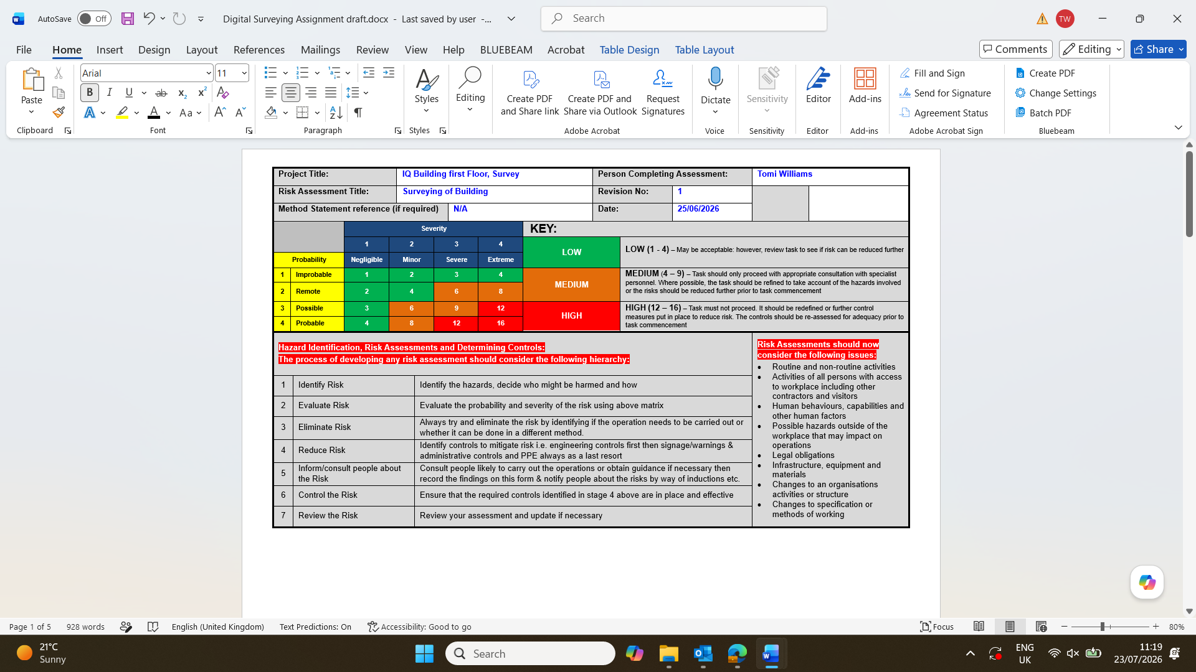
Risk assessment
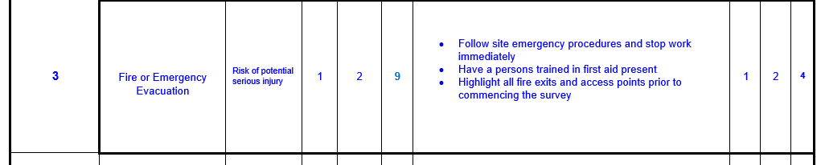
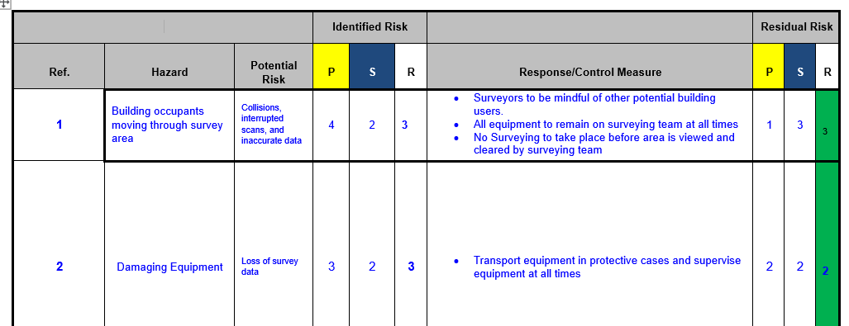
Health and Safety Executive (2024) Managing risks and risk assessment at work: Steps needed to manage risk

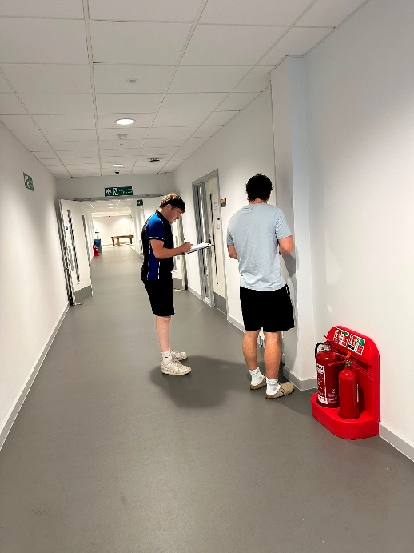
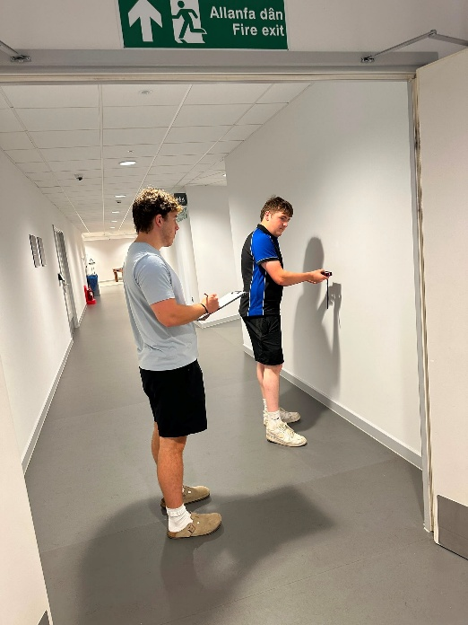
Part 2 – Practical
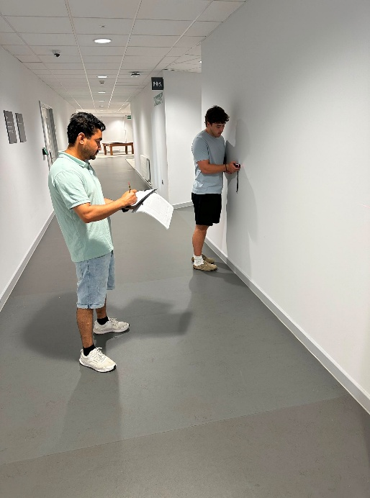

Survey Execution Summary
The survey was completed successfully and, overall, proceeded largely as planned, the survey team followed the agreed methodology and maintained a professional/systematic approach to capturing the required information for the survey area. The objective was to produce an accurate record of the internal layout, including wall dimensions, openings, doors, windows and other relevant features. This objective was achieved with minimal disruption and only minor changes to the original plan.
A key positive aspect of the survey was that there was no pedestrian interferences during the survey operation, the survey area remained clear, allowing the team to position the laser scanning equipment effectively and complete the data capture without interruption. This enabled the survey team to maintain a consistent workflow and avoid delays associated with managing building occupants or temporarily clearing areas.
The laser scanning equipment was correctly calibrated before use, ensuring that the collected data, ( using both modern and traditional methods ) was suitable for producing an accurate representation of the surveyed space. The equipment was positioned strategically to provide adequate coverage and visibility of the relevant surfaces and features. As a result, an accurate layout scan of the survey area was successfully produced, the collected data provided a reliable basis for recording the existing internal layout of the surveying area and developing accurate survey information.
Problems Encountered
Although the survey was generally successful, real-world site conditions required a change to the original survey plan, excessively high temperatures on the day of the survey created a potential health and safety concern for the survey team. Working for an extended period in the original location would have resulted in uncomfortable and potentially unsafe conditions, particularly when operating technical equipment and carrying out prolonged survey activities.
In response, the survey location was changed to an alternative area with greater ventilation, this decision was made to protect the health and safety of the survey team while still allowing the survey to proceed. The change demonstrated the importance of adapting the survey plan to actual site conditions rather than continuing with the original arrangements when they may create unnecessary risk.
The change of location did, however, have a minor operational impact, the team had originally prepared to survey a different building and had therefore planned the survey around the expected layout, access arrangements and characteristics of that building. Moving to the alternative location meant that the team had to adapt to a different building layout and reassess the survey environment before commencing work. This required flexibility and a short period of adjustment to ensure that the survey methodology/plan remained suitable.
Despite this change, the survey was completed effectively, the alternative location provided improved ventilation and allowed the work to continue safely. Overall, the survey went as planned with minimal issues, and the only significant change was successfully managed through appropriate and effective decision making. The final laser scan provided an accurate layout of the survey area and met the primary objectives of the exercise.

Part 3 – Compare traditional and modern measuring
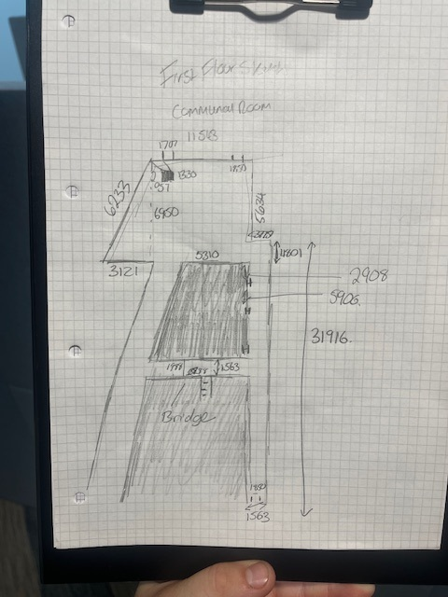
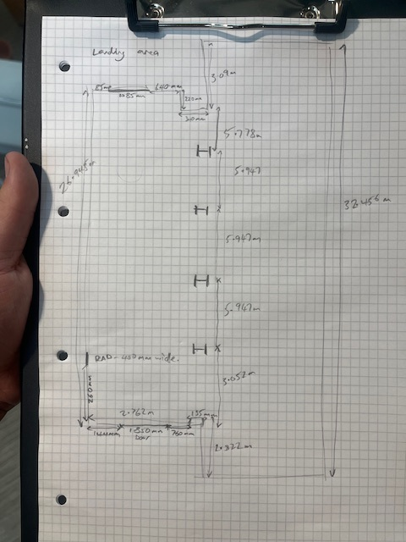
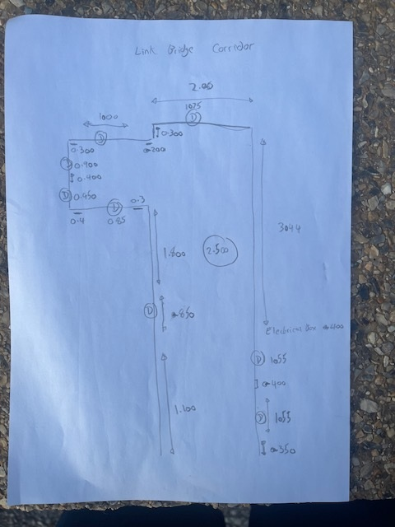
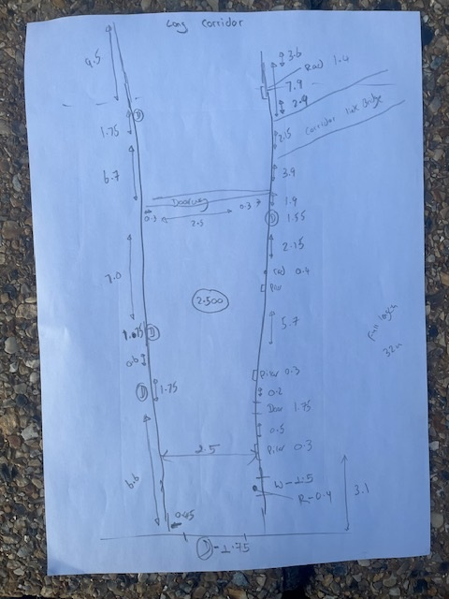
Traditional measurements
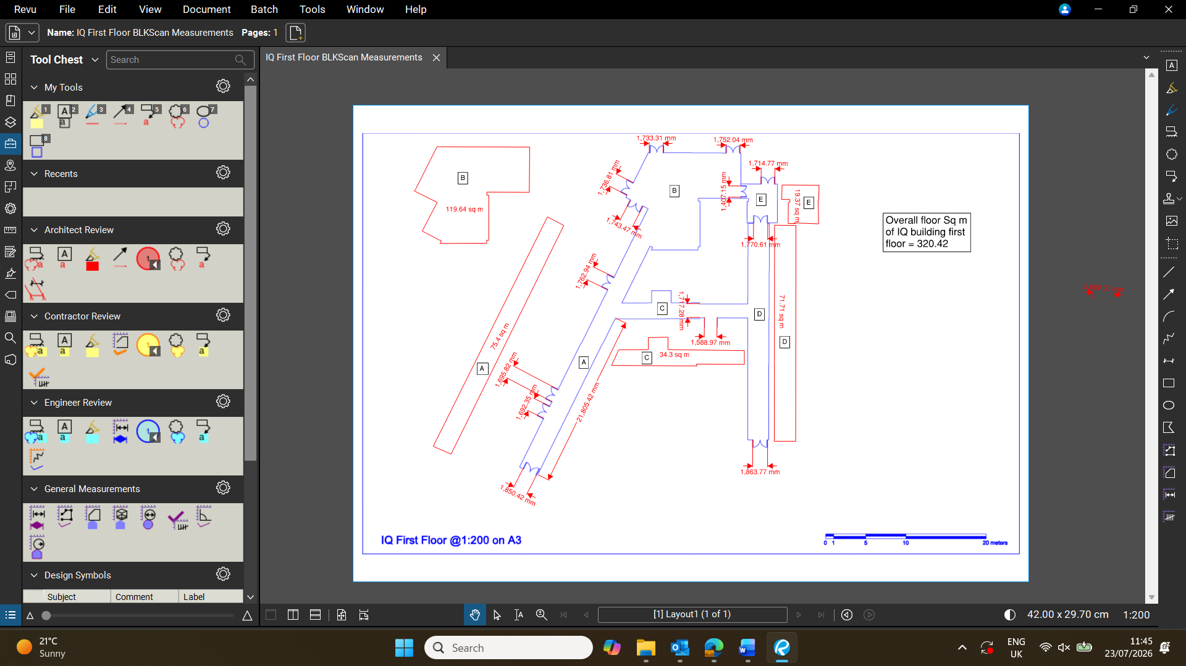
Modern Laser scan with manual measurements imputed

Modern 3D terrestrial laser scanning provides significant advantages over traditional manual measurement methods when surveying a building, the main differences relate to the time required to complete the survey, the accuracy of the measurements and the completeness of the information captured.
In terms of time, traditional surveying methods such as tape measures, laser distance meters and manual recording can be relatively slow, particularly when surveying a large or complex building, each measurement must be taken individually and recorded manually, increasing the time required on site. Measurements may also need to be repeated if an error is identified later. In comparison, a 3D laser scanner can capture millions of individual points within a relatively short period, once the scanner has been positioned and activated, it records the surrounding environment rapidly, allowing an entire building area to be captured efficiently. Although processing and registration of the point cloud are required after the survey, the overall process can be considerably faster for complex spaces. Abd-Elmaaboud, A.M., El-Tokhey, M.E., Ragheb, A.E. and Mogahed, Y.M. (2019)
Laser scanning also generally provides greater accuracy and consistency, manual measurements are affected by human error, including incorrect positioning of the tape, inaccurate readings, transcription mistakes and difficulties measuring inaccessible areas. A laser scanner records spatial coordinates automatically, reducing the need for manual data entry. When multiple scans are correctly registered, the resulting point cloud can provide highly accurate measurements of walls, rooms, openings and other building features.
The greatest advantage of terrestrial laser scanning is possibly the completeness provided, traditional measurement methods normally record only selected dimensions considered important at the time of the survey due to time constraints etc. This means that information may be missed, requiring a return visit if additional measurements are later needed. In contrast, laser scanning captures a comprehensive 3d record of the surveyed environment, measurements can subsequently be extracted from the point cloud, including dimensions that were not originally required/deemed important.
However, traditional methods remain useful for small surveys, simple measurements and verification, laser scanning also requires specialist equipment, software and technical knowledge which can be costly to a smaller subcontractor or student learning the trade of building surveying. Overall, for a complex building survey, modern laser scanning is generally faster, more accurate and more complete than manual measurement, making it particularly suitable for producing reliable digital records and supporting future design, refurbishment and Cad models.

Harvard referencing List

Abd-Elmaaboud, A.M., El-Tokhey, M.E., Ragheb, A.E. and Mogahed, Y.M. (2019) ‘Comparative assessment of terrestrial laser scanner against traditional surveying methods’, International Journal of Engineering and Applied Sciences, 6(4). Available at: https://www.ijeas.org/comparative-assessment-of-terrestrial-laser-scanner-against-traditional-surveying-methods (Accessed: 16th July 2026).
Health and Safety Executive (2024) Managing risks and risk assessment at work: Steps needed to manage risk. Available at: HSE risk assessment guidance https://www.hse.gov.uk/simple-health-safety/risk/steps-needed-to-manage-risk.htm?utm (Accessed: 15th July 2026).

