

Changemakers: Creativity and Value Creation
Professions (BMHP5014)

Component 1: Online portfolio of set exercises

Student name: Narcisa Bernardo
Student number: 2332208
Lecturer’s name Laila Surani

Introduction
This assignment explores the crucial concepts of creativity, innovation, value creation; and change explores the context of heath and social care. As the landscape of healthcare evolves, understanding these concepts becomes essential for improving patient care and enhancing operational efficiency. By examining academic sources and real-world example, this assignment aims to highlight the significance of these concepts and their interrelatedness in practice.
Task 1: Defining key Concepts in Practice
Innovation
Innovation refers to the process of translating ideas or inventions into goods and services that create value or for which customers will pay. According to Rogers (2003), innovation is not merely about creating new products; it also involves the adoption of new practices within organizations. This concept is vital in health and social care as it leads to improved patient outcomes and operational efficiencies. For instance, the introduction of telehealth services during the COVID-19 pandemic illustrated how innovation can quickly adapt to meet urgent healthcare needs. Rogers’ Diffusion of Innovation Theory provides a framework for understanding how new ideas spread within healthcare settings, thereby facilitating change and improving service delivery.
Creativity
Creativity is defined as the ability to produce new and valuable ideas. Amabile (1996) posits that creativity arises from the interaction of three components: domain-relevant skills, creativity-relevant processes, and intrinsic task motivation. In health and social care, fostering a creative environment can lead to innovative solutions for complex challenges, such as resource allocation and patient care protocols. For example, creative problem-solving techniques can help teams develop new strategies for managing chronic diseases. This aligns with Amabile’s Componential Theory of Creativity, which emphasizes the importance of a supportive environment that encourages innovative thinking.
Value Creation
Value creation in healthcare refers to process of enhancing patient outcomes while optimizing costs. Porter (2010) explains that healthcare services should focus on delivering high-quality care that improves patient health relative to its costs. This concept is crucial for ensuring that resources are used efficiently and effectively. An example from practice is the use of integrated care pathways that streamline patient treatment processes, and enhancing outcomes and reducing costs. In this context, Porter's value-based healthcare model serves as a foundational framework for understanding how value can be created in health services.
Change
Change in healthcare involves the transition from current practices to new methods or systems. Lewin’s Change Management Model (Burnes, 2017) describes this process as consisting of three stages: unfreezing, changing, and refreezing. Understanding change is essential in health and social care, as it helps organizations adapt to new regulations and emerging technologies. A pertinent example is the implementation of electronic health records (EHRs), which require significant changes in workflow and data management. By employing Lewin’s model, healthcare leaders can effectively guide their teams through the change process, ensuring that improvements are sustainable.
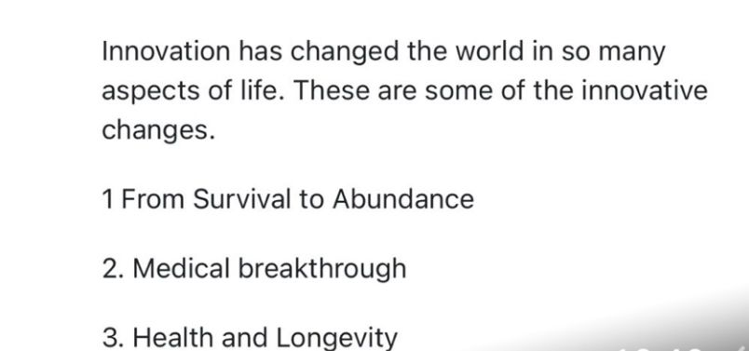

Task 2 : Mind Map
Problem: Staff Burnout in Health and Social Care
Staff burnout is a pervasive issue in health and social care that significantly impacts the quality of care provided to patients. It matters because high levels of burnout can lead to decreased staff morale, increased turnover rates, and ultimately poorer patient outcomes.
Key Ideas in the Mind Map:
Causes : High workloads
Emotional exhaustion
Lack of support
Impacts: Reduce quality of care
Increased medical errors
Higher staff turnover
Possible Solutions
Implementing mental health support services
Reducing administrative burdens
Promoting work-life balance
Grounding this analysis in the **Social Determinants of Health**, we recognize that staff burnout is influenced by broader organizational and systemic factors, highlighting the interconnectedness of health and social care issues (Meadows, 2008). Addressing this problem is vital; failure to do so could lead to a compromised healthcare system, impacting service delivery and patient safety.

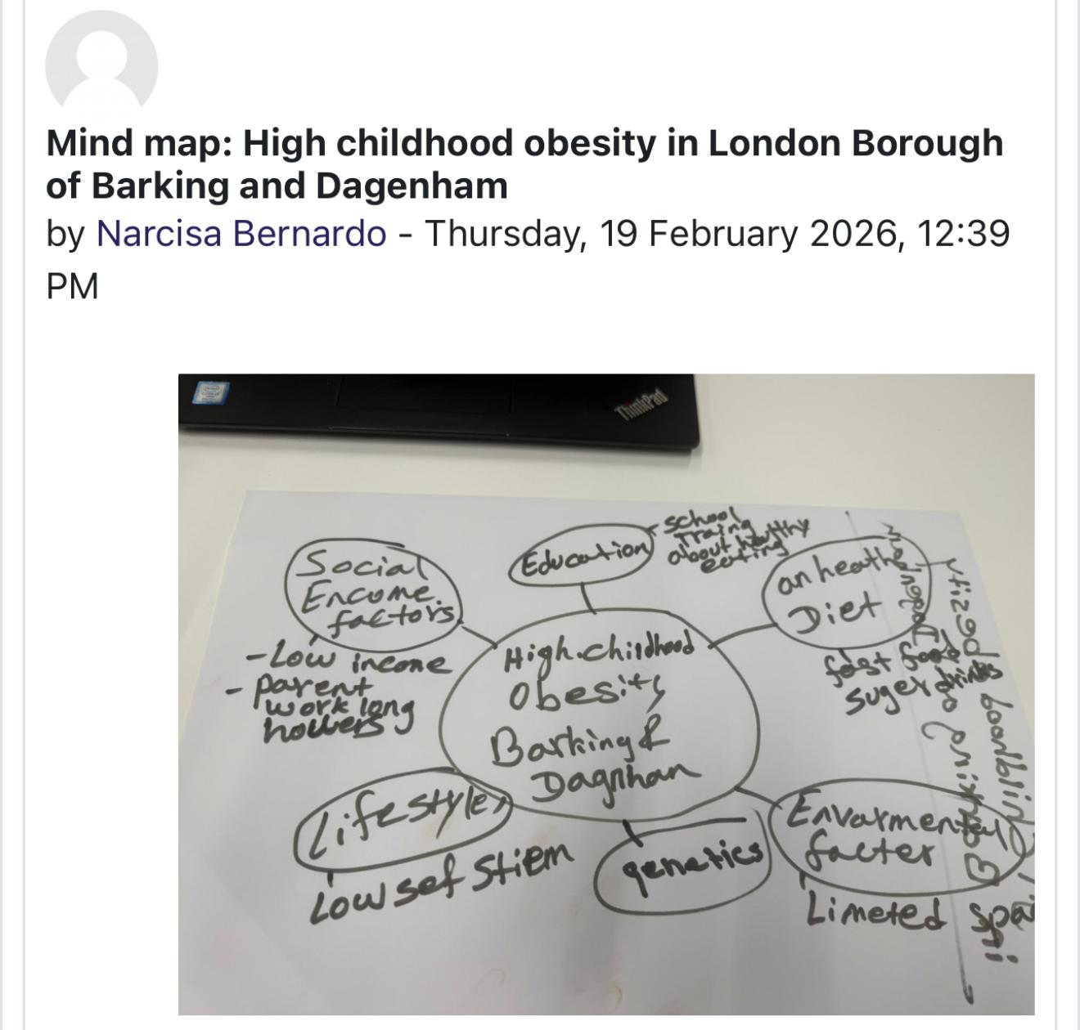

Task 3: Self-Reflection of Group Activity
In our recent class activity, we engaged in both convergent and divergent thinking styles. Convergent thinking focuses on finding the single best solution to a problem, while divergent thinking encourages the generation of multiple solutions (Fisher & Frey, 2008).
During the activity, I noticed that I naturally gravitated towards divergent thinking when brainstorming ideas. For instance, when our group faced challenges in agreeing on a solution, I suggested creating a pros and cons list to evaluate our options. This approach facilitated a more structured discussion and allowed us to converge on the best solution collectively.
Through this experience, I learned that my strength lies in facilitating open dialogue and encouraging diverse viewpoints. However, I also recognized the need to enhance my convergent thinking skills for better decision-making. In future group activities, I would aim to balance both thinking styles more effectively.
Using Gibbs' Reflective Cycle, I analysed my experience: from the initial feelings of confusion to the actions taken during the activity, and the subsequent learning. Future collaborations will benefit from my improved understanding of these cognitive processes.
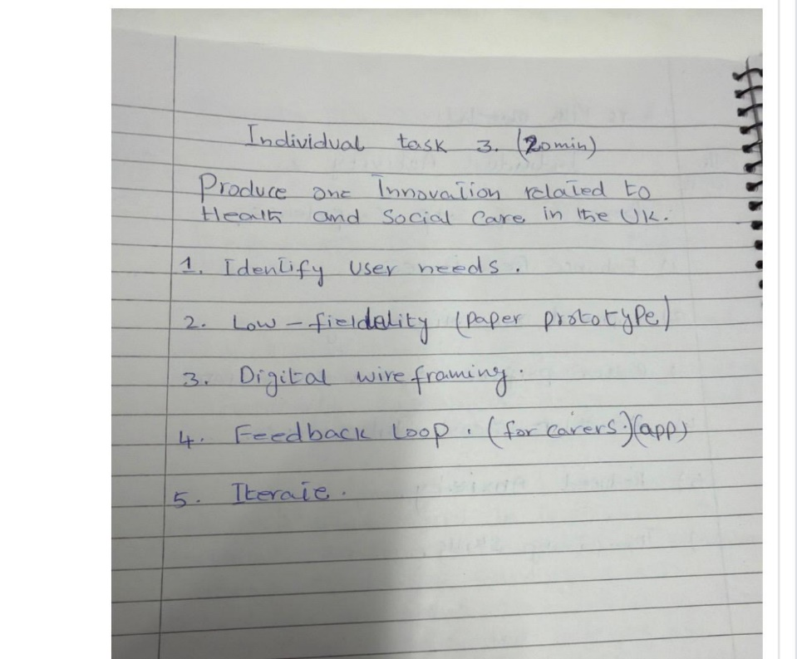

Task 4: Case Study Analysis of a Uk Innovation
One notable innovation in the UK NHS is the implementation of **virtual wards**, which address the need for remote patient monitoring and reduce hospital admissions. This innovation arose from the increasing demand for healthcare services and the necessity to manage resources efficiently.
Creativity played a pivotal role in developing virtual wards, as healthcare professionals combined existing technologies with novel care delivery methods. This approach allowed patients to receive care from home while being closely monitored by healthcare teams.
The value created through virtual wards includes improved patient outcomes, enhanced satisfaction, and reduced strain on hospital resources. Reports indicate that patients benefit from more personalized care, while staff experience a more manageable workload (NHS England, 2021). The **Diffusion of Innovation Theory** supports this innovation, illustrating how healthcare organizations have adopted these practices to enhance service delivery (Rogers, 2003).
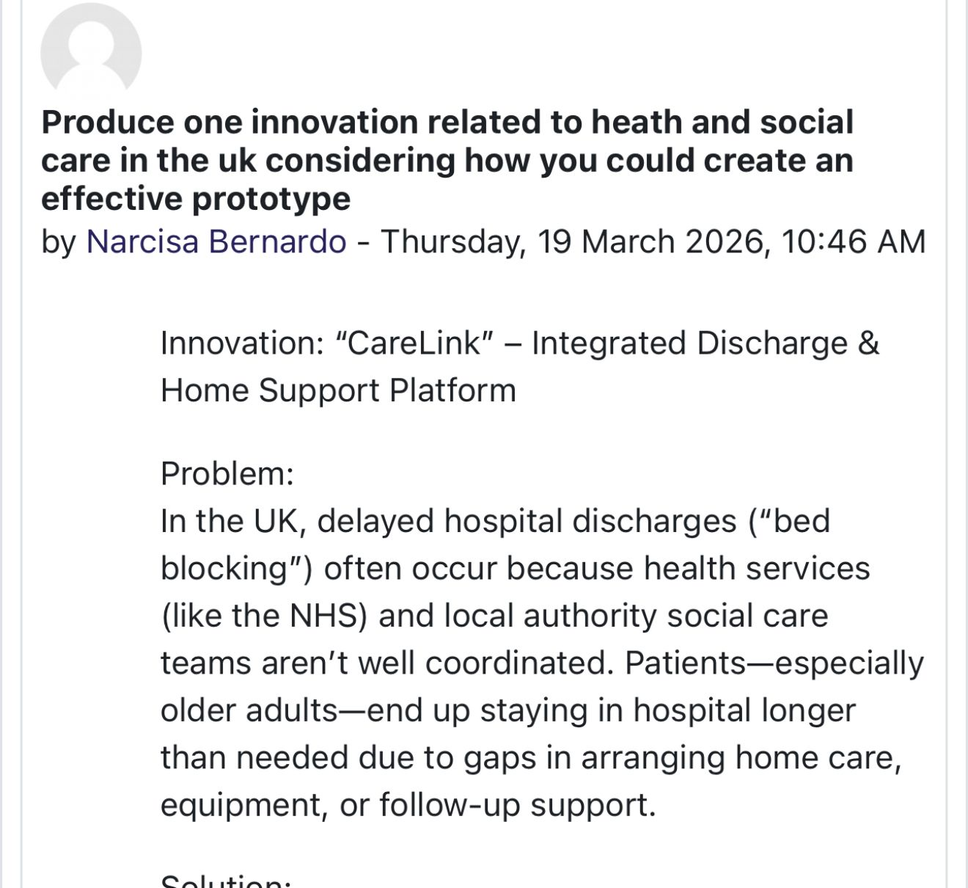

Task 5 Research Task
Article 1: Staff Stress in Health Care
In their study, McHugh and Ma (2014) identify high workloads and emotional demands as primary causes of staff stress in healthcare settings. They highlight that these factors lead to burnout, impacting both staff well-being and patient care quality. This article underscores the importance of addressing workload management and providing emotional support to healthcare professionals.
Article 2: Digital Auricle Inequality
The research by Tuffrey-Wijne et al. (2020) discusses how digital exclusion exacerbates stress among healthcare workers, particularly during the transition to digital tools. They argue that inadequate training and access to technology hinder staff effectiveness, contributing to increased stress levels. This article complements McHugh and Ma’s findings by demonstrating how systemic issues related to technology can compound stress.
Both articles agree that organizational factors significantly contribute to staff stress, yet they differ in their focus, with the first emphasizing workload and the second focusing on digital inequalities. Together, they provide a comprehensive understanding of the multifaceted nature of staff stress in health and social care.
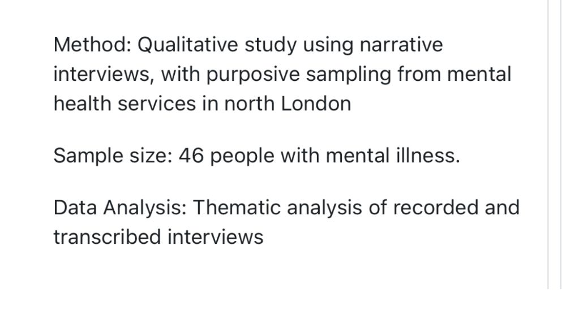
Task : 6 Exploring Digital innovation in Heath and Social Care
Benefit of Wearable Health Technologies
Wearable health technologies, such as smartwatches, offer significant benefits in managing chronic health conditions. They enable continuous monitoring of vital signs, allowing patients and healthcare providers to track health metrics in real time. This proactive approach can lead to timely interventions and better health outcomes. For instance, studies have shown that patients with diabetes who use wearable devices experience improved glycemic control (Hwang et al., 2020). The **Technology Acceptance Model** suggests that the usefulness and ease of use of these devices enhance patient engagement and adherence to treatment (Davis, 1989).
Electronic Health Records (EHRs)
Electronic health records (EHRs) have revolutionized communication and collaboration among healthcare providers. By centralizing patient information, EHRs facilitate seamless information sharing, reducing errors and improving care coordination. Research indicates that EHRs enhance clinical decision-making and streamline workflows, resulting in more efficient care delivery (Buntin et al., 2011). This interconnectedness aligns with the **Systems Thinking Approach**, emphasizing the importance of holistic views in health and social care improvement.
Digital Technology for Preventative Care
Digital technology can significantly bolster preventative care and health promotion. For instance, mobile health applications can provide tailored health advice and reminders for vaccinations or screenings, engaging patients in their health proactively. An example is the use of a mobile app that encourages physical activity among elderly populations, leading to reduced incidences of chronic diseases (Bodenheimer & Berry-Millett, 2009). This approach underscores the relevance of the **Technology Acceptance Model**, as users are more likely to adopt technology that they find beneficial and user-friendly.
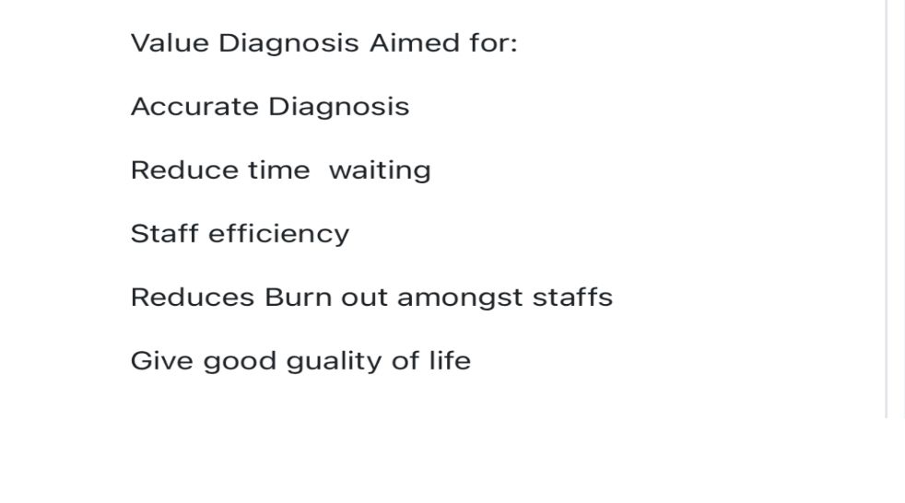

-Task 7: Understanding the NHS Leadership Framework
Summary of NHS Leadership Framework
The NHS Leadership Framework outlines essential leadership behaviours necessary for effective healthcare delivery. Key components include inspiring shared purpose, leading with care, and evaluating information. This framework is vital as it guides leaders in fostering a culture of collaboration, innovation, and patient-centred care. By emphasizing these behaviours, the framework helps ensure that healthcare organizations remain responsive to the needs of patients and staff alike, ultimately improving service quality (NHS Leadership Academy, 2016).
Encouraging Creativity through Leadership
One crucial leadership behaviour is **inspiring shared purpose**. A leader who effectively communicates a vision can motivate staff to embrace innovative practices and contribute to improved patient care. For example, a leader who articulates the benefits of adopting new technology can foster a culture of creativity and enthusiasm among staff, leading to better patient outcomes. This aligns with **Transformational Leadership Theory**, which emphasizes the role of leaders in inspiring and empowering their teams (Bass & Avolio, 1994).
Reflective journal Entry
Throughout this module, my understanding of creativity and value creation in health and social care has deepened significantly. Initially, I viewed creativity as merely the generation of new ideas; however, I now appreciate its role in fostering innovation and improving patient outcomes. Engaging in discussions and activities around real-world challenges highlighted the importance of collaboration and diverse perspectives in driving change.
This learning experience will shape my future professional practice by encouraging me to adopt a more innovative mindset. I aim to leverage creativity in problem-solving and collaborate effectively with colleagues to enhance patient care.


Task 8: Self Reflection Journal Entry
Reflecting on this module, I gained valuable insights into creativity, innovation, and value creation. Engaging in group activities and discussions helped me realize the importance of fostering creative environments in heakthcare settings. One particular discussion about the integration of technology into patient care shifted my perspective on innovation; I now see it as an essential component of effective healthcare delivery.
Moving forward, I plan to apply these insights in my future roles by advocating for innovative practices and promoting an inclusive culture that encourages creativity. By leveraging the Reflective Model of Kolb I can continuously evaluate my experiences and adapt my approach to meet the evolving needs of the healthcare sector.

Reference List
Amabile, T. M. (1996). *Creativity in Context*. Westview Press.
Bass, B. M., & Avolio, B. J. (1994). *Improving Organizational Effectiveness Through Transformational Leadership*. Sage Publications.
Buntin, M. B., Burke, M. F., Hoaglin, M. C., & Blumenthal, D. (2011). The Benefits of Health Information Technology: A Review of the Recent Literature Shows That Technologies Can
Improve Care Quality. *Health Affairs*, 30(3), 464-471.
Burnes, B. (2017). *Managing Change*. Pearson Education.
Davis, F. D. (1989). Perceived Usefulness, Perceived Ease of Use, and User Acceptance of Information Technology. *MIS Quarterly*, 13(3), 319-340.
Hwang, H. F., et al. (2020). The Role of Wearable Devices in Diabetes Management: A Systematic Review. *Journal of Diabetes Science and Technology*, 14(6), 1167-1177.
McHugh, M. D., & Ma, C. (2014). Work Environment Solutions for Hospital Nurse Retention and Quality of Care. *Health Affairs*, 33(2), 185-192.
Meadows, D. H. (2008). *Thinking in Systems: A Primer*. Chelsea Green Publishing.
NHS England. (2021). *Virtual Wards: A Guide for Providers*. NHS England.
NHS Leadership Academy. (2016). *The NHS Leadership Framework*. NHS Leadership Academy.
Porter, M. E. (2010). What Is Value in Health Care? *New England Journal of Medicine*, 363(26), 2477-2481.
Tuffrey-Wijne, I., et al. (2020). Digital Exclusion and Its Impact on Mental Health Among Healthcare Workers. *Social Psychiatry and Psychiatric Epidemiology*, 55(8), 1079-1085.
.

