STUDENT NAME: LOREDANA CORNELIA ROSU
STUDENT ID: 2310027
MODULE TITLE: LEADING AND IMPLEMENTING CHANGE (LCLM6003_BIRM)
LECTURE NAME: STEPHEN MALONE

A Strategic Change Management Plan for ASDA in the UK Grocery Retail Sector

Table of Contents
1. Introduction to the Organisation 3
2. Environmental and Organisational Analysis 4
2.1 External Environment Analysis (PESTLE) 4
2.2 Internal Environment Analysis (SWOT) 6
2.3 Triggers for Change 8
3. Review and Evaluation of Change Management Models 8
4. Leadership and Organisational Culture in Change 11
5. Proposed Strategic Change Management Plan 13
5.1 Change Vision and Objectives 13
5.2 Stakeholder Analysis 13
5.3 Implementation Framework 14
5.4 Communication Plan 14
5.5 Financial and Resource Plan 15
5.6 Risk Assessment and Mitigation 15
5.7 Evaluation and KPIs 15
6. Discussion and Critical Reflection 16
7. Conclusion 17
Reference List 18

1. Introduction to the Organisation

Over the last few years, organisations in the UK retail industry have been exposed to rapid and sustained change driven by digitalisation, evolving consumer demands, and intensifying competitive pressures. The increase in online shopping, data-driven decision-making and the introduction of artificial intelligence to the supply chains and customer-facing processes is challenging traditional operating models. Consequently, change management has become a strategic managerial skill rather than an infrequent intervention. The academic literature also highlights that organisations that do not actively respond to changes in the external environment face a risk of strategic drift and deteriorating performance (Burnes, 2020).

This is more so in the UK grocery retail business, where organisations operate in a competitive and dynamic environment. The retailers must not only cope with cost pressures and consumer demands, but also constantly innovate in how they deliver their services and operate their businesses. Consequently, strategic change is no longer an option, as it is required to stay afloat in the market and remain sustainable.

Change management is quite essential, especially in large retail organisations, where change also impacts not only technology and processes but also people, leadership practices, and the culture of the organisations. According to Kotter (1996), a successful change initiative must have a sense of urgency, leadership commitment as well as a commitment of employees towards a common vision. Resistance to change may manifest at various levels in complex organisations and structured change frameworks can be paramount in maintaining the long term change as opposed to its short term solutions.

The case in this report concerns ASDA, one of the largest supermarket chains in the UK, operating in a highly competitive grocery retail market. ASDA has millions of customers in its physical stores network and is expanding its online presence. The organisation has always found itself in the value-for-money and operational efficiency position but lately, there are new strategic challenges posed by the transformations in the retail environment. These encompass heightened price competition, growth in online grocery shopping, escalating operational costs, and increased dependence on digital technologies to enhance forecasting, logistics, and consumer interaction.

The reason behind the choice of ASDA is its size and the complexity of changes that it is going through right now. The UK grocery market has experienced significant disruption due to increasing consumer demand for seamless omnichannel communication, tailored offers, and trusted home delivery services. Studies of digital transformation in the retail industry indicate that it requires organisations to reconsider their operating models, introduce digital capabilities across their functions, and provide staff with opportunities for continuous adaptation (Verhoef et al., 2021). In the case of ASDA, a systematic, planned change process is required that will bring together leadership, culture, and organisational capabilities.

This report is aimed at creating a strategic change management plan of the ASDA that addresses external and internal change triggers. The report will examine the organisation's operating environment, assess change management models relevant to the organisation, and evaluate the importance of leadership and organisational culture in facilitating change. It is on this basis that an overall change plan will be suggested, with clear objectives, steps to be implemented, communication mechanism and evaluation measures aimed at supporting the long-term organisational resiliency and competitiveness of ASDA.

2. Environmental and Organisational Analysis
Retail organisations are strongly influenced by external environmental conditions and internal capabilities. Understanding these factors is essential when planning strategic change because organisational performance is shaped by economic conditions, technological development and competitive pressures. Environmental analysis therefore helps organisations identify drivers of change and determine appropriate strategic responses. According to Johnson et al. (2020), analysing both internal and external environments enables organisations to better understand industry dynamics and adapt their strategies to emerging opportunities and threats.

2.1 External Environment Analysis (PESTLE)

Factor | Impact on ASDA
Political | UK regulations on food safety, employment law and sustainability increase compliance costs and influence operational decisions.
Economic | Inflation and rising energy costs increase operational expenses and make customers more price-sensitive, reinforcing ASDA’s low-cost strategy.
Social | Growing demand for convenience, online shopping and ethical sourcing pushes ASDA to adapt its service model.
Technological | Adoption of AI, automation and data analytics improves forecasting, logistics and customer experience.
Legal | Compliance with labour laws, competition law and consumer protection is essential to avoid penalties.
Environmental | Pressure to reduce carbon emissions, food waste and plastic packaging influences ASDA’s sustainability strategies.

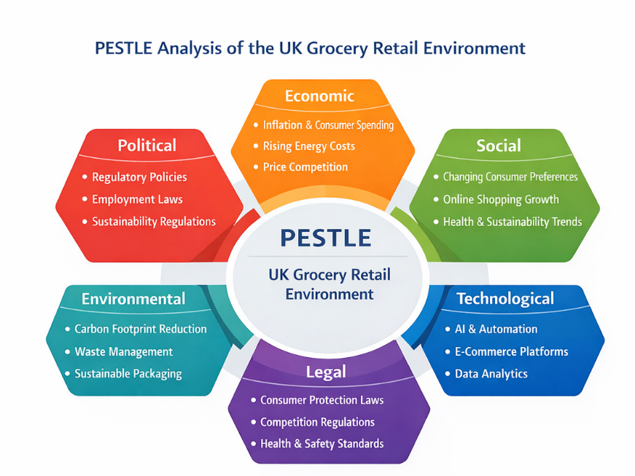
Figure 1: PESTLE Analysis of the UK Grocery Retail Environment
Source: Adapted from Johnson et al. (2020).

2.2 Internal Environment Analysis (SWOT)
Although the industry environment is influenced by external factors, the internal capability defines the effectiveness of organisations in dealing with the challenges. A SWOT analysis thus aids in assessing ASDA's strategic stance.
ASDA has a strong brand awareness in the UK grocery market, which is a major strength that it has. The company is reputed to provide good value and reasonable prices and this appeals to price-sensitive consumers. Moreover, ASDA enjoys a large presence of stores and extensive supply chain that promotes operations across the country.
The high level of operational efficiency and cost leadership strategy, as another strength, permits ASDA to compete well in the value segment of the retail market (Fernie and Sparks, 2019).

Nevertheless, the organisation has a number of weaknesses as well. It has become very complicated to manage the physical stores and online retailing platforms as the behaviour of consumers towards online shopping increases. To stay competitive, retailers are to invest a lot in digital infrastructure and logistics technologies (Verhoff et al., 2021).

Operation costs are also a challenge. The costs are also going to rise due to the labour issues and the disruption of the supply chain, diminishing profit margins, and forcing retailers to become efficient and embrace innovative technologies.

Simultaneously, ASDA possesses a number of opportunities. The online development of grocery and digital services can enhance customer options and comfort. The supply chain efficiency and decision making can also be elevated with the help of technological innovation, especially artificial intelligence and automation.

Still, there are a number of threats. The grocery market in UK is a competitive market with leading retail stores like Tesco, Sainsbury and Aldi competing in the market. High price competition, and shifting consumer expectations demand that retailers never cease changing their strategies (Johnson et al., 2020).
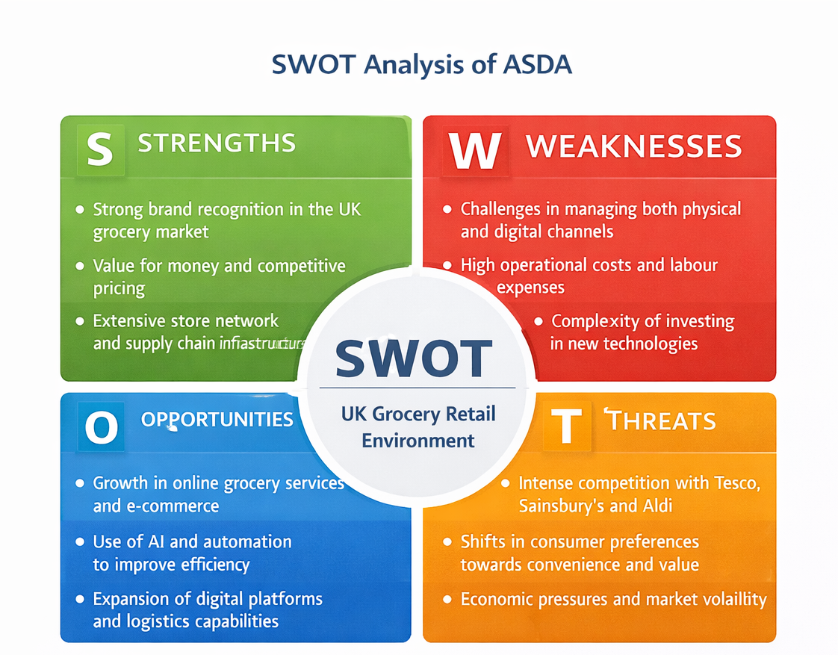
Figure 2: SWOT Analysis of ASDA
Source: Author’s own analysis based on Fernie and Sparks (2019).

2.3 Triggers for Change

The external and internal environment analysis shows that there are numerous drivers of organisational change in the ASDA. The fast development of online grocery shopping is one of the key factors. Consumers are demanding rapid and convenient and digitally interactive shopping experiences.

Another trigger is technological innovation. Artificial intelligence can be used to enhance the efficiency of operations and decision making through prediction, inventory control and logistics. Without the use of some advanced technologies, organisations may lose their competitive advantage (Verhoff et al., 2021).

Secondly, high competition in the UK grocery market makes retailers to be innovative as a measure of keeping its customers and market share. This presupposes the strategic investment in digital transformation and better customer experience.

All these pressures show that ASDA must have a systematic and well-thought strategy towards organisational change to stay competitive in the changing retail environment.

3. Review and Evaluation of Change Management Models
Organisational change is an important component of strategic management, particularly in industries experiencing rapid technological development and changing consumer behaviour. Retail organisations must continuously adapt their operations and technologies in order to remain competitive. Change management frameworks therefore provide structured approaches that support organisations in implementing transformation while reducing disruption and resistance from employees (Burnes, 2020).
Several models have been developed to guide organisational transformation, including Lewin’s Change Model, Kotter’s Eight-Step Model, the ADKAR Model and the McKinsey 7S Framework. Each model offers a different perspective on how organisational change can be planned and managed.

Lewin’s Change Management Model

One of the earliest methods of organisational change is the three stage model by Lewin. It is based on three phases that are unfreezing, changing and refreezing (Lewin, 1951). The unfreezing phase equips the organisation with the change by questioning the current practices, and creates awareness of the necessity to change. Change stage entails implementation of new processes, technologies or behaviours. Lastly the refreezing phase stabilises the organisation by making new practices a part of the daily operations.

Even though the model developed by Lewin offers a straightforward method of viewing organisational change, critics believe that the model simplifies the processes of transformation. The contemporary environment in which most organisations are run in is usually one that is constantly changing, not one that happens in distinct phases (Burnes, 2020).

Kotter’s Eight-Step Change Model

Kotter (1996) formulated an elaborate model of eight steps that could be used to lead the transformation of an organisation. These activities involve the development of sense of urgency, forming a guiding coalition, developing a vision of change and spreading the vision throughout the organisation.

Empowering employees is also an important aspect in the model as it creates short term wins and makes change a part of organisational culture. The framework by Kotter is extensively utilized since it emphasizes the significance of leadership, communication, and involvement of workers during alteration.

Nevertheless, other researchers suggest that the model presupposes that the change is implemented in a linear manner with consecutives stages, when contemporary organisations have more intricate and interconnected change processes (Cameron and Green, 2019).
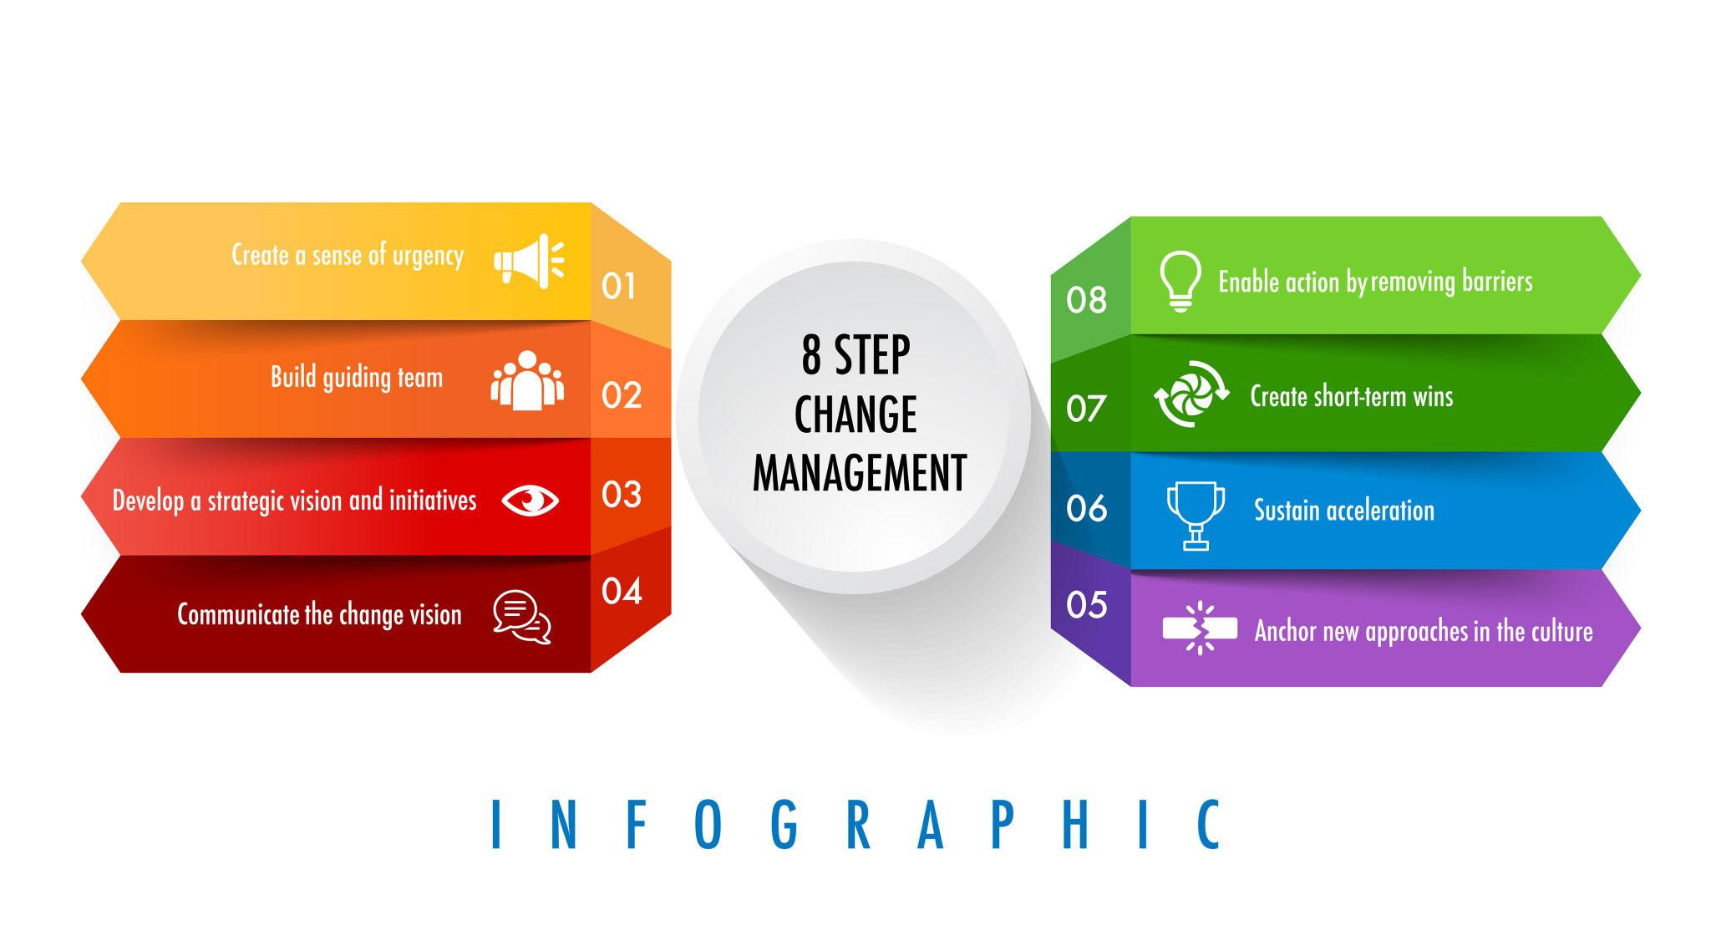
Figure 3: Kotter’s Eight-Step Change Model
Source: Kotter (1996).

ADKAR Model

ADKAR model is concerned with individual behavioural change and it recognises five main aspects essential to successful change: awareness, desire, knowledge, ability and reinforcement (Hiatt, 2006).

The model highlights that the change in an organisation eventually rests on the willingness and capability of the employees to embrace new practices. Communication and reinforcement mechanisms are important in making sure that the implementation is successful.

Although the ADKAR model is effective to approach the human side of change, it offers fewer directions to the larger-scale organisational strategy and structural change.

McKinsey 7S Framework
The McKinsey 7S Framework focuses on the alignment between seven organisational elements: strategy, structure, systems, shared values, skills, style and staff (Waterman et al., 1980).
The model emphasises that successful transformation requires coordination between both structural elements and cultural factors. When these components are aligned, organisations are more likely to achieve sustainable performance improvements.
However, the framework functions primarily as a diagnostic tool and does not provide a clear sequence of steps for implementing organisational change.

Justification of the Selected Model for ASDA
Given the intricacy of the UK grocery retail industry, as well as the fact that ASDA requires a digital transformation, the combination of Kotters model and McKinsey 7S Framework is suitable.
Kotter model offers a systematic guide to the transformation process, with the focus on leadership, communication and employee involvement. Such factors are required in huge retail companies where operational transformations touch a large number of workers.
Simultaneously, McKinsey 7S Framework should make sure that the organisational factors like the organisational structure, systems, leadership, and employee skills are in place and coordinate throughout the transformation. Digital innovation means that there is a need to make changes in technology, organisational culture, and capabilities as well.
Integrating these models thus gives a solution that is balanced in the sense that it helps both in the deployment and sustainability of strategic change at ASDA.

4. Leadership and Organisational Culture in Change
Effective organisational culture and leadership should not be forgotten as organisations can only change successfully on the basis of the strategic planning and operational changes. Resistance to change is often experienced in large organisations since the workers might be unsure of new systems or duties. Leadership has thus been pivotal in steering employees during the process of change and also in making change efforts to succeed. Northouse (2021) argues that leadership affects organisational behaviour by defining motivation, decision-making and collaboration in times of uncertainty.
The leadership styles within organisations may have a significant impact on the effectiveness of change programs in a retail area where organisations deal with big work forces and complicated systems of operation. Transformation leadership is generally accepted as one of the efficient leadership styles in the process of organisational change as it is aimed at establishing the common vision and promoting employee participation. Bass and Riggio (2006) opine that transformational leaders inspire employees by encouraging innovation, purpose and professional growth of an organisation. Transformational leadership could assist employees in ASDA to adjust to digital technologies and new procedures of the digital transformation initiatives.
Transactional leadership on the other hand focuses on performance control, procedures and reward systems. This will help achieve efficiency in the working situations in the retail outlets where the employees have to comply with clear procedures. Nevertheless, the effectiveness of transactional leadership can be lower in those cases when it comes to being creative and innovative in organisational transformation.
Situational leadership offers a chance to have a flexible leadership by modifying the leadership behaviour based on the competence and preparedness of the employees (Hersey and Blanchard, 1988). This strategy can be used in organisations like ASDA to help in managing changes as the managers can offer guidance to employees that need training and give more autonomy to the more experienced employees.
Organisational culture is also significant in whether the success or failure of change initiatives. Culture can be defined as common values, beliefs, and behaviours that shape the interaction and ways employees handle their work. According to Schein (2010), organisational culture can be found at various levels such as visible practices, common values and unspoken assumptions that determine behaviour.
Team work, customer service and operational efficiency are some of the cultural values that are normally stressed in retail organisations like ASDA. These values can be used in supporting transformation as long as employees know how change initiatives relate to organisational goals. Culture can also be a source of barriers though when new systems threaten current practices or bring about uncertainty on the role of employees. According to Cameron and Green (2019), change can be met with resistance because employees tend to think that any new practice is a threat to the norms or employment.
With ASDA, the team of efficient leadership and favourable organisational culture will play a key role in executing the digital transformation. A clear strategic vision and encouraging employees to use new technologies can be conveyed with the assistance of transformational leadership whereas a culture of collaboration, learning and innovation will minimise resistance and assist organisations to adapt.
All in all, the interplay between leadership and organisational culture is important in the establishment of whether strategic change initiatives can bring sustainable changes in the organisational performance.

5. Proposed Strategic Change Management Plan

Retail organisations that are situated in highly competitive environments ought to constantly adjust their strategies to ensure that they stay competitive and also address the changing consumer expectations. According to the analysis of the internal and external environment of ASDA, the main factors of organisational change are digital transformation, technological innovation and growing competition. To address these pressures, this section presents a strategic change management plan to enhance the digital capabilities of ASDA and make the company more efficient. Kotter (1996) points out that an effective organisational change must have a strategic vision, commitment and effective communication with leaders across the organisation.

The outlined change is aimed at enhancing the digital retail environments and supply chain efficiency of ASDA with the help of artificial intelligence and high-level data analytics. The technologies are able to improve demand forecasting, optimise logistics, as well as general customer experience within the online and real retailing processes.

5.1 Change Vision and Objectives

Having a clear vision contributes to a transformation in an organisation and will centre employees on the reason behind the change process. The vision of ASDA that is proposed is to be a digitally integrated grocery retailer that will integrate technological innovation with efficient operations in retail to provide customers with more value and convenience.

The strategic goals of the change project are the enhancement of the efficiency of the supply chain, the empowering of the ASDA digital retailing platform and data-driven decision-making. The AI-based forecasting systems can examine the purchasing trends and market trends to enhance improved inventory management and minimisation of inventory shortages. Moreover, the online services at ASDA can be reinforced through the enhancement of digital ordering systems and the delivery coordination that will facilitate the development of the e-commerce in the grocery industry.

5.2 Stakeholder Analysis

The key to successful organisational change is the involvement of various stakeholders that contribute to the change or are influenced by the process. The stakeholder groups that have been identified as the key to the change initiative in ASDA are the customers, senior management, suppliers and the employees.

The introduction of new technologies and working procedures has a direct effect on the employees. There is need therefore to train and communicate effectively to allow the employees to feel engaged and lessen the resistance to change. The other stakeholder group of interest is those who are customers as customers satisfaction and loyalty are directly linked to the enhancement of digital services and supply chain efficiency.

Suppliers are also noteworthy since the digital transformation might demand a better data exchange and coordination throughout the supply chain. Besides that, the top management and shareholders offer strategic focus and funds to the transformation programme. They need to be on board in ensuring that the change initiative is effectively implemented on board.

5.3 Implementation Framework

The change implementation at ASDA could be based on the Eight-Step Model of Kotter where each step could be adjusted to the operational environment of the organisation.

To begin with, the sense of urgency may be established by embracing the growing competition from Tesco, Aldi, and online stores like Amazon Fresh, as well as the rising demand for digital grocery services. Second, a guiding coalition is to be established which would comprise senior managers, IT specialists and supply chain executives to aid the transformation.

The third step is to create a rational digital transformation vision that emphasises enhancing online platforms and AI-driven supply chain systems. This vision must be relayed on all the levels of the organisation using internal methods of communication and management briefs.

Training programmes to digital tools and new systems of operations should then empower the employees. For example, it is possible to train logistics and inventory management staff to operate AI-based forecasting systems.

Short term victories may involve shortening of delivery time or cutting down stock deficits in chosen areas. Such outcomes may then be used to support additional investment and growth in digital activities.

Lastly, the changes ought to be instilled in the organisational culture at ASDA through incorporating digital practices in routine operations, and performance review systems.

5.4 Communication Plan
Effective communication plays a key role in reducing uncertainty and encouraging employee participation during organisational change. ASDA should use multiple communication channels including internal meetings, digital communication platforms and training sessions to keep employees informed about the progress of the transformation initiative.
Leadership communication is particularly important because employees often rely on managers for guidance during periods of change. Clear and consistent messaging from leadership can reinforce the purpose of the transformation programme and encourage employee engagement.

5.5 Financial and Resource Plan
Digital transformation requires financial investment in technology infrastructure, employee training and organisational development. ASDA must therefore allocate resources for advanced data analytics systems, improvements to online retail platforms and digital training programmes for employees.
Although these investments may increase costs in the short term, they can generate long-term benefits through improved operational efficiency, reduced waste and stronger competitive positioning (Verhoef et al., 2021).

5.6 Risk Assessment and Mitigation
Organisational transformation programmes involve several potential risks. One key risk is employee resistance to change, particularly when new technologies alter existing working practices. This risk can be mitigated through effective communication, training programmes and leadership support.
Technological implementation challenges may also occur during the introduction of new systems. Careful planning and phased implementation can help minimise operational disruption. In addition, organisations must address cybersecurity risks by implementing strong data protection systems and security policies.

5.7 Evaluation and KPIs
To evaluate the effectiveness of the change initiative, ASDA should establish clear performance indicators. Important KPIs may include improvements in inventory accuracy, reductions in supply chain costs, growth in online sales and improvements in customer satisfaction.
Regular performance reviews will allow ASDA to monitor the progress of the transformation programme and identify areas for further improvement. Continuous evaluation ensures that the organisation remains adaptable and responsive to changes in the retail environment.

6. Discussion and Critical Reflection

The strategic change plan presented to ASDA focuses on the need to achieve digital transformation in order to be competitive in the UK grocery retail market. The analysis above revealed that technological innovation, shifting consumer behaviour and high market competition are some of the driving forces of organisation change. With the growing digitalisation of retail markets, organisations are being compelled to implement modern and innovative technologies and adaptable strategies in responding to these forces.

The incorporation of digital technologies into the work processes can be seen as one of the strengths of the proposed plan. Supply chain management can be enhanced to generate better demand forecasting, inventory planning and logistics coordination using artificial intelligence and the latest data analytics. These can also minimize the inefficiency in operations and increase the availability of the products both in the physical stores and online stores. The studies also suggest that when organisations invest in digital technologies, they tend to perform operations and become more strategic (Verhoff et al., 2021).

The focus on leadership and organisational culture is also another strength. Change efforts are bound to fail when organisations treat change as an area of technology and fail to consider the human aspect of change. The plan acknowledges that transformational leadership and engagement of the employees are essential in ensuring successful transformation since behavioural change and technological advancement are important in the process.

The proposed plan, however, also has a number of challenges. The use of digital technologies will entail a lot of expenditure in terms of money, potentially subjecting the company to financial stress in the short run. The organisations should thus strike a balance between the investment in technology and long-term benefits.

The resistance of change among the employees is also another challenge that may be encountered. The implementation of innovative technologies may cause confusion in the work of the employee who is accustomed to the current systems. There is hence need to have effective communication and leadership support and training programs to enable workers to adjust to the new practices in working.

Digital transformation initiatives also apply to the consideration of ethics. Artificial intelligence and data analytics necessitate organisations to be responsible in the management of data and good cybersecurity measures. Besides, sustainability issues are becoming more crucial in the retail industry. The environmental goals that should be assisted by digital transformation include waste reduction and efficiency in supply chains.

In general, the suggested plan accentuates that the successful organisational change needs strategic planning, successful leadership and high employee engagement.

7. Conclusion
This report discussed the strategic change that was required in ASDA due to the changing dynamics in the UK grocery retail sector. The high rate of technological advancement, intense competition in the marketplace and evolving consumer demands have posed a lot of challenge to the conventional models of retail operation.
The environmental and organisational analysis proved that digital transformation and technological innovation are the key change agents in the retailing sector. The change management models analysis has put in evidence the applicability of models like the Change Model by Lewin, the Eight-Step Model by Kotter and McKinsey 7S Framework in the transformation of organisations.
Another factor that was also found to play a significant role in determining the success of change initiatives is leadership and organisational culture. Transformational leadership would be useful in facilitating change in the organisation by ensuring that the workers feel involved in transformation and share a common vision of the change.
The findings indicated a strategic change management plan which the report suggested to support the digital transformation at ASDA. The developed strategy is aimed at the implementation of artificial intelligence technologies in supply chain processes and enhancement of digital retail environments to increase the efficiency of operations and customer satisfaction.
In sum, change management has emerged as a crucial competence to the contemporary retail organisations. ASDA can position itself better to the changing world of retailing by aligning leadership, technology and organisational culture to strategic goals to adopt changes in the retail environment effectively.

Reference List
Burnes, B. (2020) Managing Change. 8th edn. Harlow: Pearson.
Bass, B.M. and Riggio, R.E. (2006) Transformational Leadership. 2nd edn. Mahwah, NJ: Lawrence Erlbaum Associates.
Cameron, E. and Green, M. (2019) Making Sense of Change Management. 5th edn. London: Kogan Page.
Fernie, J. and Sparks, L. (2019) Logistics and Retail Management: Emerging Issues and New Challenges in the Retail Supply Chain. 5th edn. London: Kogan Page.
Hersey, P. and Blanchard, K.H. (1988) Management of Organizational Behavior. 5th edn. Englewood Cliffs, NJ: Prentice Hall.
Hiatt, J. (2006) ADKAR: A Model for Change in Business, Government and our Community. Loveland, CO: Prosci.
Johnson, G., Whittington, R., Scholes, K., Angwin, D. and Regnér, P. (2020) Exploring Strategy. 12th edn. Harlow: Pearson.
Kotler, P. and Keller, K.L. (2016) Marketing Management. 15th edn. Harlow: Pearson.
Kotter, J.P. (1996) Leading Change. Boston: Harvard Business School Press.
Lewin, K. (1951) Field Theory in Social Science. New York: Harper & Row.
Northouse, P.G. (2021) Leadership: Theory and Practice. 9th edn. Thousand Oaks, CA: Sage.
Schein, E.H. (2010) Organizational Culture and Leadership. 4th edn. San Francisco: Jossey-Bass.
Slack, N., Brandon-Jones, A. and Johnston, R. (2023) Operations Management. 10th edn. Harlow: Pearson.
Verhoef, P.C., Broekhuizen, T., Bart, Y., Bhattacharya, A., Qi Dong, J., Fabian, N. and Haenlein, M. (2021) ‘Digital transformation: A multidisciplinary reflection and research agenda’, Journal of Business Research, 122, pp. 889–901.
Waterman, R.H., Peters, T.J. and Phillips, J.R. (1980) ‘Structure is not organisation’, Business Horizons, 23(3), pp. 14–26.

