Maisie Clapham
2404102
BA Illustration
Research In Practice ADAD5004/C
Delyth Lloyd Evans
Word Count: 2735

The importance of character design in visual storytelling

Character design is in everything. Every show you have ever watched the characters appearance has been meticulously thought about and planned, what colours go best together, how do you show a characters’ personality throughout their design. People never really stop to think about how important it really is when consuming different media, always focusing on different things like the story and quality etc. A character’s design is the first impression viewers get of them. It displays their personalities, where they came from, where they are going and where they are currently. A good character design shows the viewer all that they need to know about them as well as highlighting how they will evolve later down the story. Every story that gets translated to a visual medium involves character design, comics like Batman, animated shows like Demon slayer or even live action movies like Star Wars. Every character is designed and thought about before you see them. Every small detail being intentional to let you know about that character and what they stand for.
‘When we are introduced to a character, their environment can communicate useful detail and depth. Personality is suggested through tools including space, light, colour and dressing’ (Jane Barnwell, Production design for screen, Page 68.)
In my proposal I will be talking about why character design is so important and will go into depth about what I think are the three fundamentals of character design. Silhouette, Archetype and Colour are my three key words for this project, as when looking for a good character design these are the three main bases. Researching into character designers like Bryan Tillman who wrote ‘Creative Character Design’ with his experience in the industry and what he has learned and how it goes into depth with each aspect. As well as Dan Seegmiller with his book ‘Digital Character design and painting’, who wrote a beautiful book that talks about character design and gives exercises to help the reader improve. I will also be looking into character design of different mediums to compare and see what works well.
‘Character design is all about ideas and how to put those ideas together. Anytime you need to design a character, your mind starts spinning and the cogs start turnings.’ (Dan Seegmiller, Digital Character Design and Painting, Preface XVI.)

According to Grammarly, ‘an archetype is a symbol, pattern, plot or character template in literature that appears in multiple stories from across culture.’ They are familiar tropes in fiction that represent collective experience and perceptions. Think of the Hero from a fairytale, we can recognise that type of character in many ways, like how they act, being brave, fearless, and always willing to do the right thing. How they look, sometimes a knight in shining armour. These are things seen across many different mediums and is something that a lot of character designers use as a template when starting. You must think of their role in the story and how to best show that to the audience. Of course, as times passes, archetypes evolve and change with how each era perceives them. In a lot of modern-day media, we see more diversity in these archetypes, more creative ways to perceive them and less stereotypes within them. No longer are women in the stories devolved into just being a damsel in distress, they can be the hero instead, the one who slays the dragon. Or the villain is not some disfigured monster that lives in a tower bathed in black, a lot of modern stories have the villain in positions of power to reflect modern day circumstances, or some modern stories decided not to have a true villain anymore.
‘When dealing with character design, always remember that the character exists as a result of the story.’ (Bryan Tillman, Creative character design, page 12)
Archetypes are used as the starting off point for designing a character, to understand where they begin and what their purpose is in the story.
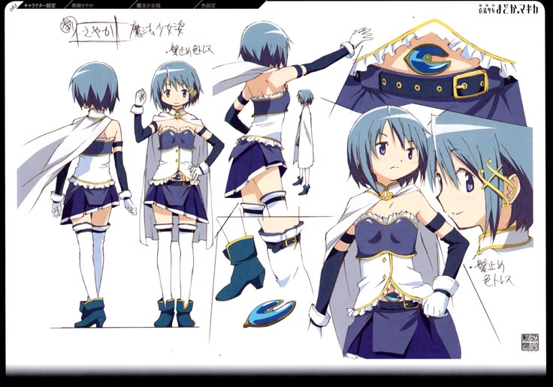
Figure 1: Sayaka Miki Character Sheet, Madoka Magica, 2011.
Madoka Magic is a dark fantasy magical girl anime which really utilise archetypes in the character designs and likes to twist them on their heads, many characters have a clear archetype to them that reflects parts of their personalities with additional motifs as well. We can tell parts of her personality just by how she looks, the white knight motif makes us already associate different traits to her like we would with hero characters, being brave, selfless, a saviour type while other parts of the character shows different things when we look beyond a surface level, her armour doesn’t fully cover her, showing either her pride or her weakness, not caring much for what happens to her in the fight.
In Fig:1 it highlights all the several aspects of the design, very typical of the archetype that she is based off, the armour, the long flowing cape and her main colour palette being a royal blue and a pristine white everything leads back into this royal/knightly aesthetic. In the show, the designs are supposed are also a reflection of the characters deeper personality and how it can either fit in or clash with her archetype. Sayaka’s reflects everything she wants to be and what you would expect of her archetype, she wants to be the white knight, but her design also shows how she fails to fit into the role. Sayaka still has some frills on her outfit, her skirt and long stockings reflect a more naïve impression. She isn’t head to toe in armour because she doesn’t have the experience or the knowledge to know that. Parts of her outfit do not make sense for the archetype she is assigned but in doing so it highlights how there is room for her to grow and allowing there to be more to her character within that role.

Colour is one of the most important things when talking about art in general, how we perceive different colours makes us feel different things. We often associate distinct colours with different meanings. For example, the colour red is often associated with feelings of rage, anger, dangers or even love.
In character design, we use this preset knowledge of colour to help display a character’s personality, character designer uses this preset knowledge to help you learn about the character. Even by just having brighter or more neon colours in their palette, as well as in black and white features how they choose to use the limited colour palette help push the narrative of the characters. Often villains are bathed in these dark colours while the heroes are bright and colourful. Colour can tell you so much about a character, where they come from and how they act.
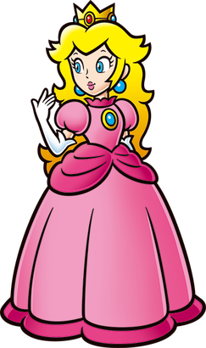
Figure:2 Princess Peach, The Mario Franchise, 1985-Present
The Mario franchise is known for its bright, expressive character designs with these loud colours symbolising each character. Princess Peach is one of the most recognisable Mario characters, sporting this bright pink gown since her first appearance back in 1985, although back then she had red hair instead of the golden blonde. She has her signature pink dress which is the main colour that we associate with her, we see it all around her kingdom, her accessories. She just wouldn’t be Princess Peach without the iconic pink.
What does this colour tell us about Peach’s personality? Well ‘Pink is often linked to feelings of calm, warmth, and kindness. The colour pink can symbolise things like femininity, innocence and romance.’ (What the Color pink Means, According to Color Psychologists, Kendra Cherry.) She is seen as this kind, all-loving princess to the mushroom kingdom. Princess Peach was one of the earliest characters in the franchise and often played the damsel in distress role in a lot of the games, the pink highlights her feminine side and her personality. As well as her relationship to Mario with his signature colour being red, making them nice to look at while standing next to each-other. In the modern games, Princess peach takes on less as a damsel in distress role, becoming her own character. Something I love is that they did not change her design to do this or else it would have destroyed the decades old image that Princess Peach has. She still has that signature bright pink, but it highlights her femininity as one of her strengths. She is still this kind and loving princess but now she has more to her. Something that is also important alongside having a signature colour is to choose secondary and third colours that match with the main colour, these help break up the design and helps it avoiding look like a blob of one colour. Peach’s golden and blue details, work wonderfully with the pink. Keeping with this elegance with her character design, with the golden detail of the jewel on her design and the crown that matches her hair elevates her royalty. We associate these colours with real life jewellery and royalty which brings in that colour associate with her character, you could tell she was a princess by the palette. While the blue is thrown in as a nice pop of colour, it helps break up the other colours and adds some nice contrast to her. They keep the palette limited but that why it works.

Silhouettes are especially important when designing a character. You want the character to stand out not only against other characters that you have designed but to stand out against the millions of other characters out there.
‘Silhouettes are important in characters design for one reason: Recognisability’ (Creative Character Design, Bryan Tillman, page 75.)
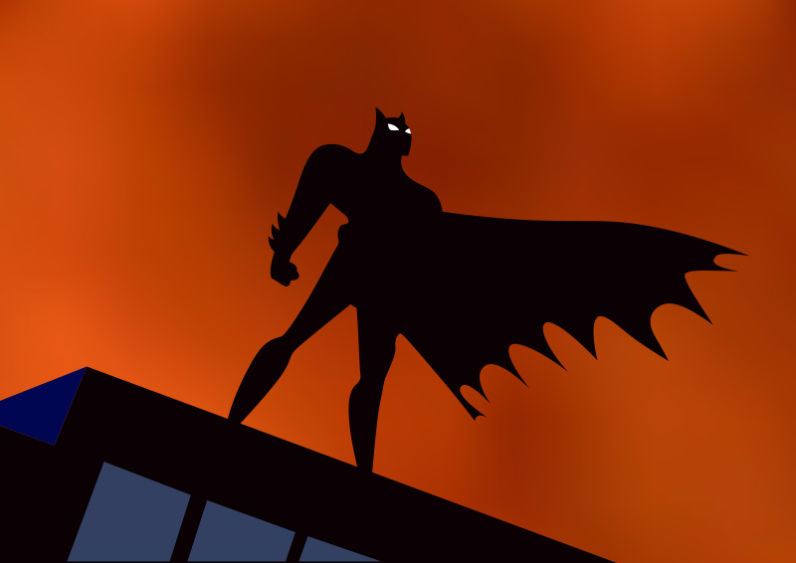
Would Pikachu still be recognisable without that lightning bolt tail? Would you be able to recognise Sonic the Hedgehog if he didn’t have his untamed set of quills and bare feet? You want a character silhouette to be bold and eye-catching. That instant recognisability that comes with it. It’s important that you utilise negative space in silhouettes, to avoid the character from just looking like a blob, giving them a dynamic pose.
Figure 3: Batman, Batman the Animated Series, 1992.
In Figure 3, it highlights the use of silhouettes when it comes to Batman, one of the most recognisable characters in history. There are so many features that cause him to stand out. The ears, the long cape, the use of the shape angles, the jawline. These features give him such a strong silhouette, you can instantly recognise him. In Batman the animated series, they simplified a lot of the design from the previous Batmans; in doing so it gets rid of a lot of busy details that overcomplicates the design and in doing so, overcomplicates the silhouette. His silhouette shows his strength, with how he stands, the sharper angles, you can feel his power and resilience. A good silhouette is so important when it came to designing Batman due to the fact he keeps mostly to the shadows, so every-time we see this silhouette, it needs to be bold and rememberable. In the many different versions of batman, the strong silhouette is constant, even the live action movies keep this iconic silhouette of the long cape, the jaw, and the ears. The staples that make him recognisable across so many different mediums.
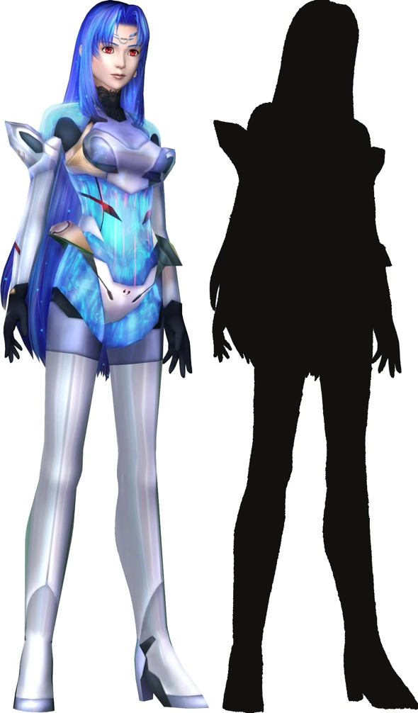
Figure 4: KOS-MOS, Xenosaga Episode 2, 2004.
This is an example of a bad silhouette in character design. There is no visual interest to her design, nothing that makes her stand out. If you put the silhouette in a crowd of other characters, you wouldn’t be able to tell who it is. She has no main shape language or interesting features that could enhance her silhouette. For a futuristic design, they don’t capitalise much on the sharp angles, she has two sharp points on the top of her gloves that just look awkward as the others are drowned out by her hair. This is why a good strong silhouette is important, over-exaggerating certain features to make them more eye-catching. A character may have unique patterns and colours, but without a strong silhouette it won’t go far. In Figure:4, you can really see how the silhouette fails the character, with the brightness of the design you can really get the sense of this futuristic world the game is set in while her hair seems to swallow up most of her design which is the problem a lot of the time when giving a character longer hair. You must be careful how you style it and how it will affect the other features in the design. A lot of mediums tend to have character with shorter hair so that it doesn’t affect the way the silhouette looks, but long hair can be done right by adding more action into the hair or by giving it less of a flat shape to it.
In conclusion, a strong silhouette makes a strong character design. It helps viewers retain the character more and has that instant recognisability. There a lot of ways a good character design can have a bad silhouette which is something I will need to think about in my practice. As I am creating multiple characters, I would need to have them all stand out against each-other.

From researching, what I believe are the 3 main qualities in character design, archetypes, colour, and silhouette I have built my idea for what to do for third year’s practice. In my practice, I will be creating a set of concept art character design for a dark fantasy MMO RPG (Massively Multiplayer Online Role-Playing Game) video game. I will be producing 5 different characters that will all be of different class sets, these designs will include: Full Body Renders, Turnarounds, Poses, Expressions, Setting, and written backstories for each. I will use my 3 keywords as the fundamentals of the project and what I have learned from analysing different characters. Character design is my biggest interest as an artist, and I think combining it with my knowledge of video games will make a fun and interesting project.
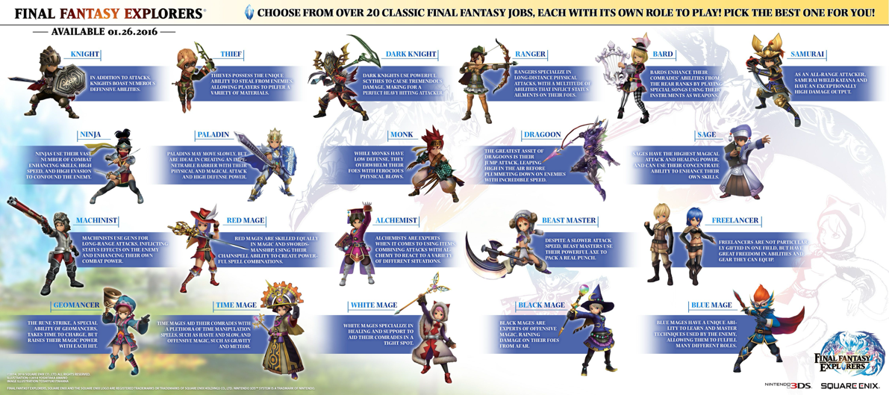
Designing for a fantasy RPG game means that there is a lot more creative freedom with the character designs as you can tap into mythical creatures like demons, elves, ogres etc. It makes it so that I have more that I can experiment with to create unique characters. I want to include things like the environment they were born in just to add more to the characters backstories and to practice environmental art more.
Figure:5 Final Fantasy Classes, Final Fantasy Explorers, 2014.
Taking examples from the Final Fantasy Explorers, a part of the Final Fantasy franchise which is one of most popular MMORPG franchises. A class list like this is something that I would choose from to create my characters. All of the classes have different abilities, different strengths and weaknesses that apply to them which makes them all unique. As well as having different game mechanics that tie into them so players have a different range of mechanics to try out, making the game be easily repayable. For this project, Final Fantasy is my biggest inspiration as Final Fantasy has become such a staple of the genre.
In Figure:5 you can see there a lot of classes that have similar names and mechanics to each other, for example the different mages being most just a distinct colour i.e. the red mage, the blue mage, the black mage. It’s a lot of similar character designs and mechanics, that would end up creative a boring set of characters if I were to go in that direction. Have the characters so similar to each other ends up making none of them stand out.
‘It is important to maintain freshness and originality even if the brief has a number of restrictions, such as a narrow target audience or seemingly ‘uninteresting’ subject matter’ (Alan Male. Illustration: A Theoretical and contextual perspective. Page 28.)
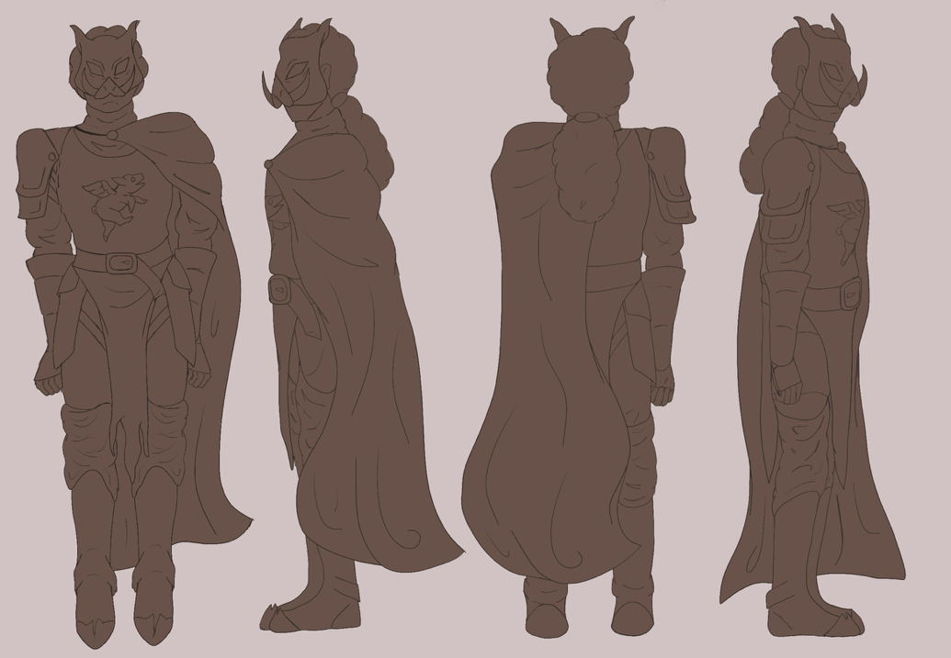
The project will draw from previous works I have done when designing characters for personal projects and university projects. As that is what I like to draw and want to pursue after university.
Figure 6: Together, The Boar Turnarounds, Maisie Clapham, 2026.
In Figure:6 is an example of a turnaround I did for a picture book project I did for university when I was designing my characters. Just to highlight how I would similarly do this for the characters I would create for my practice next year.

Bibliography:
Barnwell, J. (2017) Production Design for Screen: Visual Storytelling in Film and Television. Bloomsbury Publishing.
Cherry, K. (2025) The color psychology of pink: What the color pink means, What the color pink means, according to color psychologists. Available at: https://www.verywellmind.com/the-color-psychology-of-pink-2795819 (Accessed: 20 April 2026).
Male, A. (2024) Illustration: A theoretical and Contextual Perspective. London: Bloomsbury Visual Arts.
Seegmiller, D. (2004) Digital character design and painting: The photoshop CS edition. Hingham, Mass: Charles River Media.
Tillman, B. (2019b) Creative character design. CRC Press.
What is an Archetype? Definitions and Examples (2024) Grammarly.com. Available at: https://www.grammarly.com/blog/literary-devices/archetype/#:~:text=An%20archetype%20in%20literature%20is,our%20collective%20experiences%20and%20perceptions. (Accessed: 20 April 2026).

List of Figures:
Figure 1: Sayaka Miki Character Sheet, Madoka Magica, 2011.
Figure:2 Princess Peach, The Mario Franchise, 1985-Present
Figure 3: Batman, Batman the Animated Series, 1992.
Figure 4: KOS-MOS, Xenosaga Episode 2, 2004.
Figure:5 Final Fantasy Classes, Final Fantasy Explorers, 2014.
Figure 6: Together, The Boar Turnarounds, Maisie Clapham, 2026.

