

Marketing Fundamentals
Volkswagen

Name: Jabir Abdulqadir Nur
Student number: 1909644
Module: LCBB4004
Submitted to: Mr. Rexon Nthing
April 2020

Task 1 A
Marketing is a process in which exchange of product and services is been done in order to create value for consumers with an aim to gain maximum profitability. Marketing revolves around four fundamentals that are product, price, place and promotion (Thakur, 2020). Understanding of this lead an organisation towards taking advantage of quantitative and qualitative information into marketing process through which they can subsequently maximise profitability at higher rate. Present report has been conducted on Volkswagen, company corporate their services in automotive industry and was established in the year 1937(Volkswagen Chronicle, 2020). Organisation offers their services worldwide and provides high quality services and products to customers. In these report formative discussions has been made on process and stages of marketing, along with role of marketing as to create value for consumers. Along with this in this report discussion has been made on stakeholder engagement and their impact upon organisational marketing activities.

Processes and stages of marketing including the role of the marketing mix

4P’s of Volkswagen
Product: It has been identified that Volkswagen products are of high quality with having significant brand na. me. In addition to this, entity also offers wide range of product choices to its customers (Brands & Models, 2020).
Price: Volkswagen price range for its products and services range within affordable to expensive. But somehow due to its high manufacturing cost cars of company proves to be bit costlier in most of Asian market segment like, India (Parkin, 2019).
Place: Volkswagen mainly offer their products and services to maximum parts of the world and serve customers effectively (Harlan, 2020). Along with this, it has been determined that company is significantly looking forward to penetrate in India as it is one of the largest markets in world. For this company is looking forward to make many new improvements as to gain maximum profitability in Indian market.
Promotion: In order to strength their brand image company is undertaking use of different promotional mediums such as Internet, social media, TV, Radio, corporate events and more as to increase awareness among costumers.

SWOT of Volkswagen
STRENGTH | WEAKNESSES
- Volkswagen offers their customers with wide range of cars choices that act as major strength for entity in respective market segment.  - With more than 350, 000 highly qualified, skilled, talented and potential employees globally Volkswagen conduct their business services in a best effective way (Levin, 2020). | - High price of current models acts as major weaknesses for Volkswagen that allows its competitors to gain strategic edge.  - Most of the cars models of Volkswagen is expansive to be afford by average income individuals (Brands & Models, 2020)..
THREATS | OPPORTUNITIES
- Major threat that can impact upon Volkswagen business operations is continuous increase in price of fuel.  - Competitors of Volkswagen, Hyundai, BMW. Chevrolet, Honda engages in the process of bringing innovative features in their products and services that creates threat of respective organization (Brands & Models, 2020). | - By taking advantage of the opportunity of creating long-term relationship with German car manufacturers Volkswagen can gain maximum benefit.  - Implementation of continuous innovation in cars significantly provides opportunity of Volkswagen to gain maximum competitive advantage.

The role of marketing in creating value for customers
Marketing is defined as a set of activities that an organisation undertakes as to promote their products and services in marketplace. In this there are different type of elements included that are selling, advertising, delivering of products or services to consumers or other businesses. For this organisations take number of actions to draw attention of consumers towards organisational offerings and further aim towards maintaining formative relationship with them with strong networking in order to ensure ultimate profitability (Khurram, Fatima and Khurram, 2020). With the help of marketing research Volkswagen effectively identify needs and demands of consumers and further take advantage of evaluation to identify marketing opportunities while overcoming problems in order to generate maximum revenue.
While on the other hand consumer value is defined as a perception of what a product or service is worth to a Customer versus the possible alternatives. It has been identified that simplistic equation form of consumer value is, Benefits-Cost (CV=B-C). According to The Economist and Harvard Business School professor, it has been identify that main purpose of all business organisation is to identify and keep consumers with the help of marketing instrument. In this it has been evaluated that marketing significantly generate value for customers by creating connection between people and product, consumers and companies. Main role of marketing is to properly offer satisfaction and retain consumers for long period of time in order to provide value to consumers (Karlan, Osman and Shammout, 2020). It is essential for an organisation to identify prospective needs and demand of customer in context with the product or service and further satisfy them by delivering same to them in best effective manner. In order to ensure consumer satisfaction, company is required to identify that consumer feel benefited from the product and services offered by entity. Consumer satisfaction is most important element for an organisation as they are the king of marketplace. Along with this it has been determined that effective marketing does not stop by offering product and services to customers but it is also important for organisation to retain their customers for long period of time by undertaking new opportunities to offer effective after sales services to them in order to ensure maximum consumers loyalty.
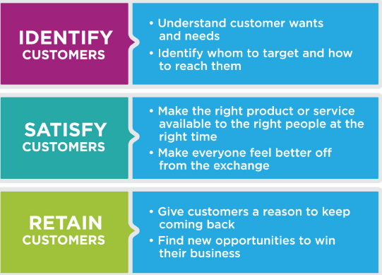
Figure 1Role of Marketing

There are different type of marketing activities that are required to be undertaken by organisation in order to accomplish role and objective of marketing. In this it is important for an organisation to conduct their day today marketing activities by making major expenditure in marketing. Volkswagen undertakes use of effective marketing in order to make their business successful in marketplace. For this entity undertake advantage of efficient organisational strategies and operations as to overcome high competition in market place. In order to satisfy customers it is important for entity to deliver high value to their consumers, in this value is defined as a measure to benefit customers from service or product related to the full cost of item. Consumer is defined as marketing cornerstone; it is essential for an organisation to effectively pay attention towards the meeting satisfaction level of consumers and engage in extensive research on daily basis in order to evaluate their need and want. It has been identified that consumer relationship manager and marketing manager of Volkswagen effectively identify consumer’s perception and further satisfy them with quality product and services in order to retain their existence for long period of time (Patel and Ghanshyam, 2020). In this digital age as to ensure the relationship between company and consumers Volkswagen provide social media and another internet platforms to their customers through which they issue ensure regular communication with customers. In this company provide effective post delivery services, resolve queries of customers 24/7 in order to manage consumer relationship and maintain the existence for long period of time in order to maximize consumer lifetime value. Mentioned below there are different type of marketing activities that are being undertaken by Volkswagen at different relationship stage in order to provide and create value for customers:
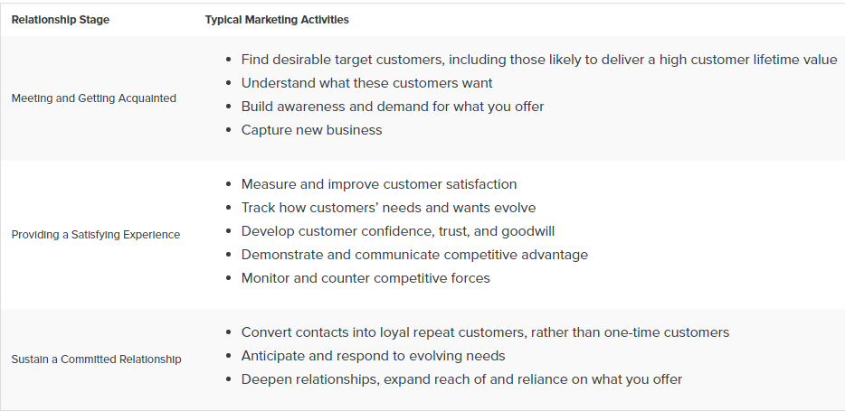

According to the evaluation it has been identified that marketing provide significant advantages to consumers, as in this entity under take advantage of different type of unique facilities as to retain them for long period of time. In this entity take advantage of different type of additional benefits, discount coupons as to attract maximum number of consumers and provide each and every detail of product and services as maximise consumer satisfaction. This provides significant benefit to customers in number of ways.

Stakeholder engagement and their impact on the marketing activities of an organisation
Marketing is termed as an activity in which process related to creation, communication, exchanging and delivering of product and services between consumers, suppliers, companies and society at large is being undertaken. While in terms with stakeholder’s engagement it is defined as a process within which organisation communicate and inform stakeholders of entity with all the essential and required information, as they are the most important part of entity and have significant impact upon business decisions. By increasing stakeholders engagement into Organisation Company can ensure smooth operations and can further gain long term benefits like brand perception in marketplace. For this it is essential for entities to undertake advantage of stakeholder’s engagement strategies in order to engage with different stakeholders and ensure fundamental accountability towards them as to provide necessary information related to issues and other concern. It has been identified that by engaging stakeholders in business decision making and other essential aspect organisation can effectively undertake activities and decisions in a well define manner. It has been identified that stakeholder engagement aid entity to effectively meet tactical and strategic decisions in a well define manner. With stakeholder engagement organisation can also increase transparency and can further build trust between company and stakeholders in a well-defined way. Stakeholders act is a crucial element for an organisation as they get affected by organisation product and services, activities and other associated performance. Engagement of stakeholders at different level can increase positive and healthy environment within an organisation (Agarwal, Gao and Kannan, 2020). In context with Volkswagen main stakeholders of company include local communities, formal representatives, local government authorities, national government authorities, civil society, organisation, politicians, employers, customers trade Association, NGOs, labour Union, suppliers, investors and policymakers.
Thus, it is essential for an organisation to effectively undertake advantage of stakeholder engagement strategies and policies in order to create a positive environment and maintain effective relationship with stakeholders through which they can maximize their goodwill and transparency in marketplace. Stakeholder’s engagement provides different type of benefits to organisation and it is one of the most important functions that are required to be effectively undertaken by an organisation (Gregory, 2020). Stakeholder’s engagement is most important as it allow organisation to identify emerging trends and act as a first mover in order to ensure maximum competition in marketplace. With the help of engagement of stakeholders in organizational different aspects Volkswagen ensure positive public image and aim towards improving entity reputation in marketplace. Along with this it also benefits Volkswagen, as it provide social licence to company to expand, operate and innovate while assuring maximum benefits. In context with Volkswagen entity engage their stakeholder by taking advantage of stakeholders mapping which is a collaborator process of research, debate and discussions that further draw different type of perspectives to determine key list of stakeholders across overall stakeholder’s spectrum. With the help of stakeholder engagement Volkswagen not only conduct their operations in an effective manner but also maintain their significant positioning in respective industrial sector and further satisfy customers with best. It has been identified that stakeholder engagement develops transparency that also act as a tool that attract attention of large base of customers towards company product and services. This benefits entity to maximize their profitability at great extent.
Thus according to the evaluation it has been identified that engagement of stakeholders is identified as most important aspect for organisational success through which entity can assure maximum competitive advancements in respective industrial segment and can increase their goodwill simultaneously (Scott and Rutner, 2020). By understanding importance of stakeholders engagement entity can effectively able to accomplish organisational goals in a well effective manner and can take advantage of pool of knowledge, expertise and experience to create viable solutions to accomplish organisational goals.

Task 1 B
As per the above-mentioned report it has been concluded that, marketing is a significant process that an organisation undertakes in order to offer organizational offerings to customers in order to encourage their buying decision. I have gained an extensive knowledge while conducting the research and learn various marketing theories to place the product in target market for selling purpose. The research is based on the automobile industry, but the similar tactics and tools can be used in other businesses. In this process company take advantage of different type of marketing elements, strategies and plans in order to gain maximum competitive advantages. A company can manufacture a unique product but to sell the product a firm require extensive research of the market by using various research tools to collect data from consumers to identify relevant market for the manufactured product. Marketing play a significant role in order to create value for consumers as in this by taking advantage of different type of process company identify need of consumer and further satisfy them with high quality product and services and undertake strategies measures in order to retain them for long period of time. Stakeholder engagement is an essential aspect through which entity can take advantage of pool of expertise, knowledge and experience through which they can maximize their profitability and productivity. A company can also take competitive advantage if company has formal strategy to deal the stake holders to ensure their support for the pending and upcoming projects Stake holders have great powers.

REFERENCES
Agarwal, R., Dugas, M., Gao, G.G. and Kannan, P.K., 2020. Emerging technologies and analytics for a new era of value-centered marketing in healthcare. Journal of the Academy of Marketing Science, 48(1), pp.9-23.

Boros, E. and Papasava, A., 2020. Referral Marketing in Online Higher Education. Journal of Marketing Communications for Higher Education, 1(3).

Gregory, A., 2020. The Fundamentals of Measurement and Evaluation of Communication. The Handbook of Public Sector Communication, pp.367-382.

Harlan, G.A., 2020. The Fundamentals of Financial Accounting: A Compilation of Case Studies.

Karlan, D.S., Osman, A.M. and Shammout, N.M., 2020. Increasing Financial Inclusion in the Muslim World: Evidence from an Islamic Finance Marketing Experiment. World Bank Policy Research Working Paper, (9200).

Khurram, A., Fatima, S. and Khurram, S., 2020. ENGLISH-BACK TO FUNDAMENTALS: IS ETHICAL LEADERSHIP SUFFICIENT OR WE ALSO NEED ISLAMIC WORK ETHICS TO KEEP EMPLOYEES PERFORMING?. The Scholar-Islamic Academic Research Journal, 6(1), pp.1-23.

Leposky, T., Arslan, A. and Dikova, D., 2020. Value Co-creation in Multinational Enterprises’ Services Marketing at the Bottom-of-the-Pyramid Markets. In International Business and Emerging Economy Firms (pp. 89-116). Palgrave Macmillan, Cham.

Levin, A., 2020. Influencer Marketing for Brands. Springer Books.

Parkin, B., 2019. India’s deepening car sales slump spreads alarm. Financial Times, [online] Available at: <https://www.ft.com/content/6c8c5e6e-d303-11e9-8367-807ebd53ab77> [Accessed 4 May 2020].

Patel, M.K. and Ghanshyam, C., 2020. Fundamentals of electrostatic spraying: basic concepts and engineering practices. In Environmental and Agricultural Informatics: Concepts, Methodologies, Tools, and Applications (pp. 79-107). IGI Global. [Accessed 7 May 2020].

Scott, R.A. and Rutner, S.M., 2020. Using an Ocean Shipping Game to Teach Transportation Fundamentals to Supply Chain Management Students. Information Systems Education Journal, 18(3), p.71.

Thakur, P., 2020. Influence of customer loyalty program on customer buying Behavior at Pantaloon in Bilaspur”(CG). Studies in Indian Place Names, 40(69), pp.370-373.

Tyulin, A. and Chursin, A., 2020. The Fundamentals of Product Life Cycle Economics. In The New Economy of the Product Life Cycle (pp. 1-50). Springer, Cham.
Volkswagen. 2020. Brands & Models. [online] Available at: <https://www.volkswagenag.com/en/brands-and-models.html> [Accessed 9 May 2020].
Volkswagen. 2020. Volkswagen Chronicle. [online] Available at: <https://www.volkswagenag.com/en/group/history/chronicle/1937_1945.html> [Accessed 7 May 2020].

