Global Business Environment
LCBB4016_BIRM

University of Wales Trinity Saint David (UWTSD)
Student name: Juliana Kotlarova
Student number: 2326556
Lecturer name: Kareem Sani

Table of Contents
Introduction 3
Main Body 3
Conclusion 6
Reference List 7
Appendices 10

Introduction
Stobierski (2021) defined globalisation as the increased volume of flow of goods, services, capital, and people across international borders. The author stated that even though there are various positive impacts of globalisation, the net impact is generally negative. The essay will therefore gauge the benefits and challenges offered by global forces to international businesses like AstraZeneca. It aims to analyse how the global business environment impacts AstraZeneca's international strategy and operations and offer strategic recommendations. AstraZeneca is a global pharmaceutical company which has expanded its operations in numerous countries in regions like Europe, Africa, Asia-Pacific and the Americas (AstraZeneca, 2025).

Main Body
AstraZeneca's global operations, especially the supply chain and market access, can be disrupted significantly due to the global geopolitical tensions. International trade gets halted due to conflicts like the Red Sea crisis, which shows that regional conflicts lead to longer transit times and higher shipping costs for companies relying on this key route. The situation has increased the average transit time by 39% between Asia and the Mediterranean (Aprile, 2025). Such situations increase the operational expenses and even create potential delays in delivering life-changing medicines, which eventually damages the competitiveness of global companies like AstraZeneca. On the other hand, the situation also provided the company with the opportunity to create independent drug supply chains for the U.S. and China (Liu, 2024). Although a costly move, this is a beneficial investment, as it allows AstraZeneca to mitigate political risks and ensure resilience in the future. This strategic move also allows the firm to position itself sustainably and attain long-term competitiveness in these major markets.
The overall economic performance of the countries in which AstraZeneca operates is also influenced by the Macroeconomic factors like GDP, inflation, and interest rates. Geopolitical tensions like the China-Taiwan issues have a negative impact on these factors. Appendix 1 reveals that the world inflation rate is at 4.3%, including 5.5% for emerging markets and 2.5% for advanced economies (IMF, 2025). As a result, the profit of Astra decreased from $23,331 million in the first quarter of 2023 to $11,9841 million in the second quarter (refer to Appendix 2). This could be attributed to the increase in the cost of raw materials and operational expenses due to reduced healthcare spending and high inflation. Further, risks from changing the exchange rate threaten the operations of international trade, which again influences the profitability of international sales and investments. Hence, there are challenges for AstraZeneca in terms of market positioning, as such an environment affects the pricing strategies and the financial feasibility of expansion into new regions. The ability to navigate these economic forces effectively is directly linked to a company's competitiveness and ability to invest in innovation. Labiak (2025) supports this by stating that AstraZeneca has paused its £200m Cambridge investment plan due to the significant blow to the pharmaceutical industry.
The socio-cultural environment influenced by these global forces and technological development has presented both challenges and opportunities for companies like AstraZeneca in talent management. The rapid advancement of artificial intelligence (AI), complemented by the proliferation of other technologies, has driven a tech talent shortage across multiple industries. For instance, as of 2024, the AI talent gap has been gauged at 50% (Hu, 2024). This has created a race for global talent, where AstraZeneca has to compete with other nations and businesses to attract and retain skilled workers, such as engineers and researchers, to maintain its innovation pipeline and long-term competitiveness. On the other hand, new sustainability demands, including the EU’s Corporate Sustainability Reporting Directive (CSRD), are creating an opportunity for AstraZeneca to attract and retain talent who prioritise corporate social responsibility.
The technological landscape, specifically Artificial Intelligence (AI), has presented various opportunities to AstraZeneca. The company has started to embed AI in every organisation’s strategic and operational decisions, starting from R&D to employee hiring. For example, AstraZeneca has focused on sourcing top talent and enabling positive candidate/employee experience by investing in eightfold.ai (AstraZeneca, 2025). The firm is also using the technology to make crucial decisions in operations like treatment delivery and clinical trials (AstraZeneca, 2025). Hence, with the use of AI, AstraZeneca has gained benefits like gaining a better understanding of diseases and predicting which molecules to make. Furthermore, the company has improved their supply chain while delivering medicines through AI systems (AstraZeneca, 2025). AstraZeneca is also using AI for talent management, where the firm is augmenting the work of scientists, liberating them from routine tasks and allowing them to focus on more complex, high-value problems through AI instead of replacing them. However, Arif, Khan and Khan (2024) acknowledged the fact that the increasing reliance of companies on AI is serving as a breeding ground for threats like cyber-attacks. As a result, AstraZeneca will be required to safeguard its systems from such drastic attacks.
Companies like AstraZeneca have also been served with both challenges and opportunities due to new environmental demands and regulations. For example, the EU’s Corporate Sustainability Reporting Directive (CSRD) requires both EU and non-EU companies to disclose detailed information on their environmental, social, and governance (ESG) performance (European Commission, 2025). AstraZeneca has been addressing this need for environmental protection through its sustainability strategy, which aims to reduce its absolute Scope 1 and 2 greenhouse gas (GHG) emissions and achieve 100% renewable electricity consumption (AstraZeneca, 2025). The requirement of significant investment for addressing these objectives becomes a major challenge for the company. However, Islami, Rahyuni and Rukayyah (2024) stated that companies can improve their market positioning and brand reputation by demonstrating leadership in sustainability. It also influences the innovation and talent management practices of the company. Therefore, it can be stated that AstraZeneca tries to hire employees who have a passion for the environment and also focuses on innovation that assists them in reducing their carbon footprint.
AstraZeneca's operations and reputation are also influenced to a significant extent by the legal environment. A variety of legal risks, including government policies, laws, and judicial systems, affect international trade and business expansion. AstraZeneca's response to geopolitical tensions such as the Red Sea crisis and China-Taiwan issues, by establishing separate supply chains for the U.S. and China, will require compliance with evolving trade laws, sanctions, and export controls. This refers to regulations like the Export Administration Regulations (EAR) and the International Traffic in Arms Regulations (ITAR) in the US, and the Export Control Law and the Cybersecurity Law of China (Bureau of Industry and Security, 2025; Data Guidance, 2025; Directorate of Defense Trade Controls, 2025; NPC.GOV, 2025). AstraZeneca could face fines, operational restrictions, and damage to market access and positioning if it fails to comply with these specific legal frameworks. Further, a new legal compliance challenge has emerged for the company in the form of the EU's Corporate Sustainability Reporting Directive (CSRD), which requires companies to publicly report on their environmental and social impacts (European Commission, 2025). This makes sustainable reporting a mandatory legal requirement instead of a voluntary measure, as it holds companies accountable for their sustainability claims.
Based on the above analysis, AstraZeneca is recommended to diversify and localise the supply chain to mitigate risks from geopolitical tensions and trade disruptions. This may require them to transition to a more resilient, multi-regional network from a single, centralised manufacturing and distribution model. According to Dunaway (2024), companies can reduce vulnerability to single-point failures like the Red Sea crisis by diversifying their supplier base and thereby complying with specific local regulations and export controls. AstraZeneca is also recommended to address the significant legal and ethical risks associated with AI adoption by investing in a comprehensive AI governance framework. The company can ensure its AI applications comply with global data privacy laws like GDPR and address intellectual property rights by establishing a robust governance framework. Utilisation of such a framework enhances the company’s reputation as a responsible innovator by mitigating legal risks and building public trust.
AstraZeneca is also advised to treat sustainability as a mandatory business imperative rather than an optional add-on by integrating sustainability and corporate social responsibility into its core strategy. Starting from R&D to operations, this strategy will require the firm to make a public and demonstrable commitment to environmental protection and ethical governance. By selecting sustainability as a core business strategy, the company can develop a competitive edge in the market, demonstrate its long-term viability and enable a proactive response to industry changes (Forbes, 2024).

Conclusion
In the essay, it has been found that geopolitical tensions like the Sea crisis translate to operational issues for AstraZeneca in terms of longer transit times and higher shipping costs. This situation also negatively impacts the macroeconomic environment of the businesses. Furthermore, elements like increasing use of AI and the emergence of CSRD have created both opportunities and challenges for AstraZeneca’s market positioning, innovation, talent management, and competitiveness. Therefore, it can be stated that this understanding of global dynamics, like the Red Sea crisis and the China-Taiwan conflict, is important for businesses as it allows them to take a proactive approach against issues like disruption of global trade, supply chain vulnerabilities, and increased costs.

Reference List
Aprile (2025). THE LATEST FROM APRILE. Available at: https://www.aprilenet.com/en/red-sea-crisis/ (Accessed: 23 September 2025).
Arif, A., Khan, M.I. and Khan, A.R.A. (2024). An overview of cyber threats generated by AI. International Journal of Multidisciplinary Sciences and Arts, 3(4), pp.67-76.
AstraZeneca (2025). 2024 Sustainability Highlights. Available at: https://www.astrazeneca.com/content/dam/az/Investor_Relations/events/2024-Sustainability-Highlights.pdf (Accessed: 23 September 2025).
AstraZeneca (2025). AstraZeneca data and AI ethics. Available at: https://www.astrazeneca.com/sustainability/ethics-compliance/data-and-ai-ethics.html#:~:text=At%20AstraZeneca%2C%20we%20are%20embracing,patients%2C%20faster%20than%20ever%20before. (Accessed: 23 September 2025).
AstraZeneca (2025). AstraZeneca results: H1 and Q2 2025. Available at: https://www.astrazeneca.com/content/dam/az/PDF/2025/h1q2/H1-and-Q2-2025-results-announcement.pdf (Accessed: 23 September 2025).
AstraZeneca (2025). Our Global Locations. Available at: https://careers.astrazeneca.com/locations# (Accessed: 23 September 2025).
AstraZeneca (2025). Renewable energy. Available at: https://www.astrazeneca.com/sustainability/climate-change/renewable-energy.html (Accessed: 23 September 2025).
Bureau of Industry and Security (2025). Export Administration Regulations (EAR). Available at: https://www.astrazeneca.com/sustainability/climate-change/renewable-energy.html (Accessed: 23 September 2025).
Data Guidance (2025). cybersecurity law of the people’s republic of china. Available at: https://www.dataguidance.com/sites/default/files/en_cybersecurity_law_of_the_peoples_republic_of_china_1.pdf (Accessed: 23 September 2025).
Directorate of Defense Trade Controls (2025). The International Traffic in Arms Regulations (ITAR). Available at: https://www.astrazeneca.com/sustainability/climate-change/renewable-energy.html (Accessed: 23 September 2025).
Dunaway, C. (2024). Navigating Uncertainty: Building Supply Chain Resilience. Available at: https://www.forbes.com/councils/forbesbusinesscouncil/2024/05/21/navigating-uncertainty-building-supply-chain-resilience/ (Accessed: 23 September 2025).
European Commission (2025). Implementing and delegated acts - CSRD. Available at: https://finance.ec.europa.eu/regulation-and-supervision/financial-services-legislation/implementing-and-delegated-acts/corporate-sustainability-reporting-directive_en (Accessed: 23 September 2025).
Forbes (2024). 18 Reasons Why Sustainability Can Be A Strategic Business Advantage. Available at: https://www.forbes.com/councils/forbesbusinesscouncil/2024/06/07/18-reasons-why-sustainability-can-be-a-strategic-business-advantage/ (Accessed: 23 September 2025).
Hu, C. (2024). AI skills gap. Available at: https://www.ibm.com/think/insights/ai-skills-gap (Accessed: 23 September 2025).
Islami, M.M., Rahyuni, S. and Rukayyah, A. (2024). Strategic branding: Building market positioning and business growth through integrated management practices. Advances in Business & Industrial Marketing Research, 2(2), pp.110-122.
Labiak, M. (2025). AstraZeneca pauses £200m Cambridge investment. Available at: https://www.bbc.com/news/articles/cderlg227j4o (Accessed: 23 September 2025).
Liu, A. (2024). AstraZeneca plans independent drug supply chains for US and China, CEO says. Available at: https://www.fiercepharma.com/manufacturing/astrazeneca-builds-separate-drug-supply-chains-us-and-china-ceo-says (Accessed: 23 September 2025).
NPC.GOV (2025). Export Control Law of the People's Republic of China. Available at: https://www.astrazeneca.com/sustainability/climate-change/renewable-energy.html (Accessed: 23 September 2025).
Stobierski, T. (2021). 4 Effects of Globalisation on the Environment. Available at: https://online.hbs.edu/blog/post/globalization-effects-on-environment (Accessed: 23 September 2025).

Appendices
Appendix 1
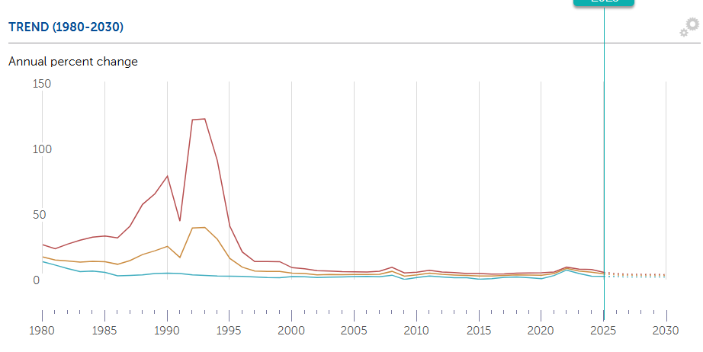
Figure 1: world Inflation rate
(Source: IMF, 2025)
Appendix 2
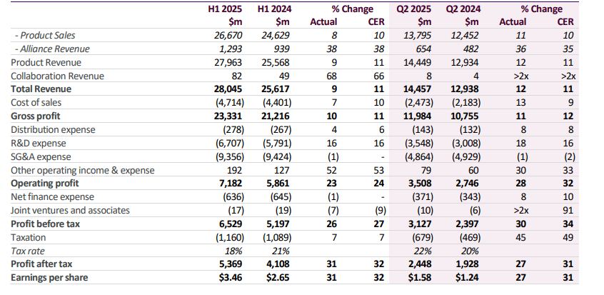
Figure 2: Financial performance of AstraZeneca
(Source: AstraZeneca, 2025)

