Student Name: [enter]  Student ID: [enter]  Module Title: Foreign Languages & Cultural Awareness  Module Code: BMIH5003  Lecturer: [enter]  Date: [enter] | 
ASSIGNMENT 1: PORTFOLIO
(4 Components)

Component 1: Professional Reflection

At the Titanic Chaussee Berlin hotel restaurant where I work as a server, one of my customers recently had a cultural misunderstanding with me. This occasion provided me with crucial information about the importance of developing culture consciousness and competence. On the Saturday dinner rush, I was given a table with four people who were speaking a language that I did not recognize. Although I greeted them in English and German warmly, they were confused. While I was trying to describe the specials in English, one of the guests interrupted me. They were conversing animatedly in their own language about the specials. When I was flustered, I recognized that it was quite possible that they did not understand English. I felt humiliated that I had not had the opportunity to clarify their language requirements before beginning my prepared server script.
Hand gestures and pointing at items on the menu were used instead of vocal communication for the remainder of the engagement, which was particularly difficult. During the time that I was struggling to satisfy the customers' requirements and make sure that they had a pleasant dining experience at the hotel, I could feel their frustration. The argument that Hofstede (2001) makes is that culture has a significant impact on the actions and attitudes of individuals (Masoud, et al., 2023). If one fails to comprehend the cultural norms of one’s visitors, one may end up embarrassing them, offending them, or providing bad service. Even though we were able to get through the lunch despite the language barrier, both of us shared the sentiment that the level of service was not satisfactory. After some time had passed, I came to the realization that this cultural misunderstanding might have been easily prevented if I had taken the time to inquire about the language that they liked, get a menu that was translated, or contact our staff members who are fluent in other languages for assistance. Cultural insensitivity can lead to dissatisfied customers which can lead to bad reviews for the hotel, this is why training for cultural sensitivity is very important in the hospitality industry (Sarfraz, et al., 2023). From this point forward, I will make it a point to proactively check the language preferences of our visitors, utilize our translation resources, and make use of the cultural variety that exists within our staff. The hospitality industry is rife with the possibility of cultural misunderstandings due to the presence of visitors from all over the globe; yet, by demonstrating empathy, flexibility, and preparedness, I can assist in ensuring that everyone feels appreciated, understood, and cared for.
In today's increasingly international hospitality business, it is essential for workers to cultivate cultural competency. Observation, active listening, and the ability to suspend judgment are three of the most important abilities that individuals need to develop in order to be able to adapt their service approach to the various requirements of the visitors (Saputra, et al., 2023). In addition, I want to broaden my cultural understanding by learning about the traditions, modes of communication, and languages of the people who are in the same demographic as our guests. Lastly, I will work on adapting my approach to customer service to the specific indications that each unique client provides rather than depending on predetermined interactions.

References:
Masoud, R.I., Liu, Z., Ferianc, M., Treleaven, P. and Rodrigues, M., 2023. Cultural Alignment in Large Language Models: An Explanatory Analysis Based on Hofstede's Cultural Dimensions. arXiv preprint arXiv:2309.12342.
Saputra, K.A.K., Subroto, B., Rahman, A.F. and Saraswati, E., 2023. Sustainability Performance in Hospitality Industry: Interaction of Strategic Sustainability Management and Sat kerthi Culture. Jurnal Ilmiah Akuntansi and Bisnis, 18 (1), pp.147-162.
Sarfraz, M., Khawaja, K.F., Khalil, M. and Han, H., 2023. Knowledge-based HRM and business process innovation in the hospitality industry. Humanities and Social Sciences Communications, 10(1), pp.1-17.

Component 2: Training Plan

Identified cultural misunderstanding (in a few words) :
Language Barrier and cultural insensitivity.

Training plan (Why/What//Who/Where/When):
At the Titanic Chaussee Berlin, it is essential for all of the hotel personnel to have regular training in cultural sensitivity in order to have the ability to provide consistently exceptional service to the customers from all over the world. For the purpose of enhancing the workers' knowledge, abilities, and mentalities in order to minimize cultural misunderstandings and recover gracefully from them, a comprehensive training program consisting of three parts will be executed.
In the first phase of the training, the primary focus will be on ensuring that the staff has a comprehensive awareness of the cultural backgrounds of the people that constitute the bulk of the visitor demographics. A variety of mediums, such as presentations, films, articles, and debates, will be utilized in order for the staff to acquire knowledge regarding the cultural values and conventions, communication methods, eating habits, religious views, political situations, and other socioeconomic aspects that have an impact on the experiences and expectations of the visitors (Bhardwaj, et al., 2023). It is feasible for staff members to get insight into the requirements of visitors and reduce misunderstandings that are the consequence of inaccurate assumptions if they do in-depth study into the perspectives of significant cultures that workers often welcome. This will allow people to better comprehend the needs of visitors.
Following this, the course will focus on developing essential skills for successfully communicating across cultural boundaries. By role playing, scenarios, and interactive workshops, employees will have the opportunity to practice observing verbal and nonverbal signals, actively listening, speaking clearly and calmly, proactively addressing language barriers, adapting their approach based on guest cues, and refraining from making assumptions. If the staff has acquired the necessary skills for cross-cultural communication, they will be able to communicate with many visitors of different cultural backgrounds, understand their needs, and provide excellent service (Yang, et al., 2023).
In the end, but certainly not least, the staff will cultivate attitudes of cultural humility, inquiry, and flexibility via the use of activities and discussions that provide opportunities for reflection. Personal preconceptions will be addressed, staff will be encouraged to approach customers with an open mind, employees will be dedicated to continuously learning from guests, employees will be recognized for their diverse points of view, and setbacks will be regarded as opportunities to improve operations (Pratama and Sari, 2023). Through the cultivation of these flexible attitudes, workers will be able to prevent the occurrence of misunderstandings in cross-cultural service encounters and gracefully recover from them if they do occur.
Continuing training refresher, orientation seminars for newly recruited staff and incorporation of cultural awareness component in performance appraisals will serve as a vehicle through which the required knowledge skills and attitudes would be enhanced. Due to their commitment to lifelong learning our employees will acquire the necessary self-confidence and adaptability to communicate successfully across cultural boundaries. This will ensure that every customer is treated courteously, understood, and handled accordingly.

References:
Bhardwaj, B., Kalia, N., Chand, M. and Sharma, D., 2023. Engaged Organizational Culture as a precursor to job performance: An evidence from the hospitality industry of Himachal Pradesh. International Journal of Hospitality & Tourism Systems, 16(4).
Pratama, A.D. and Sari, S.N., 2023. The Role of the Human Resource Development (Talent and Culture) Department in Implementing Chse for Employees in the New Normal Era at Novotel Cikini Jakarta. Hospitalitas: Journal of Tourism, Leisure and Hospitality Management, 1(1), pp.1-11.
Yang, M., Luu, T.T. and Qian, D., 2023. Linking extroversion diversity to group service innovation among Chinese and Australian hospitality employees: The roles of adhocracy culture and creative role identity. Journal of Hospitality Marketing & Management, pp.1-25.

Component 3: Student Self-Reflection
Description: This is the first stage of the Gibbs Reflective cycle in this part, the whole situation is described in order to truly reflect on the situations (Nurlatifah, et al., 2023). Before this encounter, I had little understanding of the great importance that cultural sensitivity plays in the hospitality industry. Somehow, I thought that a pleasant universal service would suffice. This was however different due to a major cultural blunder that took place whereby visitors from other countries were present in the restaurant of my hotel. My failure to communicate effectively, even though I tried my best, left me unhappy.
Feeling: My inability to speak well affected the experience that visitors received. I felt embarrassed of myself. I was disappointed with myself because I had not checked the visitors’ demands aggressively. The language barrier can cause miscommunication, this is a negative thing because miscommunication can lead to negative customer experience and poor customer service (Watson and Wu, 2023).
Evaluation: In retrospect, it is very obvious that the true cause of this cultural gap was my lack of cultural sensitivity. This cultural misunderstanding was at the root of it. I arrived at wrong conclusions because I did not have time to think about the clues that the guests were giving me. I responded to their requests instead of relying on linguistic exchanges that are specified in English. This way, this interaction made me aware of the gaps in my cultural understanding, communicative competence and attitudes. I have changed my understanding that cultural competence is an integral aspect because it should be treated in a fair manner in the international hospitality industry.
Analysis: There were a number of factors that contributed to this unfavorable meeting. The first problem is that I did not get enough training in proactive cultural awareness and adaptive services delivery across cultures. The second problem is my unsupported prior beliefs about visitors, that rely on the lack of knowledge of other cultures. Thirdly, I was unwilling to involve coworkers who are better at interacting with people coming from other cultures. It was not enough for me to have good intentions if I did not possess the ability to notice the indications that visitors gave me, to verify my assumptions, and to modify my approach.
Conclusion: It was brought to the attention of the writers that this event eloquently emphasized the need for hospitality workers to prioritize cultural knowledge while serving visitors from varied backgrounds (Uher, et al., 2023). It is now clear to me that cultural competency is something that must be gained by direct experiences, continual training, and a commitment to personal development. My attitude to providing service will be altered because of these lessons to ensure that visitors of all ethnic backgrounds have great experiences.
Action Plan: As I go ahead, I am dedicated to making improvements on an ongoing basis. I will seek out training in cultural awareness, work on improving my observational and communication skills, research the cultures of our visitors, and consult with my coworkers for advice on how to successfully connect with people from other cultures. When the inevitable misunderstandings take place, I can recover gracefully because I have a mentality that is open and adaptable, and it is centered on the experience of the visitors. My goal is to become a culturally competent hospitality professional, and this serves as motivation for me to work toward that goal.

References:
Nurlatifah, L., Purnawarman, P. and Sukyadi, D., 2023, December. The implementation of reflective assessment using Gibbs’ reflective cycle in assessing students’ writing skill. In AIP Conference Proceedings (Vol. 2621, No. 1). AIP Publishing.
Uher, A., Fisher, M.H. and Josol, C.K., 2023. Cultural competency training for the social service professions: A systematic literature review. Multicultural Learning and Teaching, (0).
Watson, B.M. and Wu, X.I., 2023. Sentinel events and miscommunication what do we know in 2021: A language and social psychology framework. Health Communication, 38(9), pp.1770-1779.

Component 4: Training Presentation

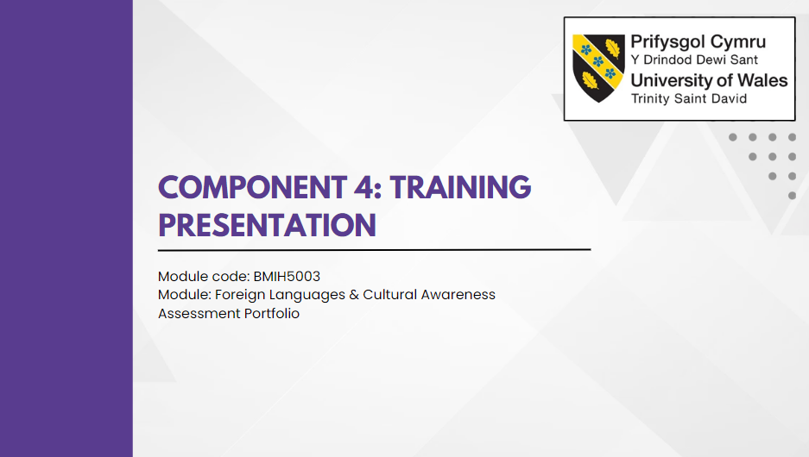
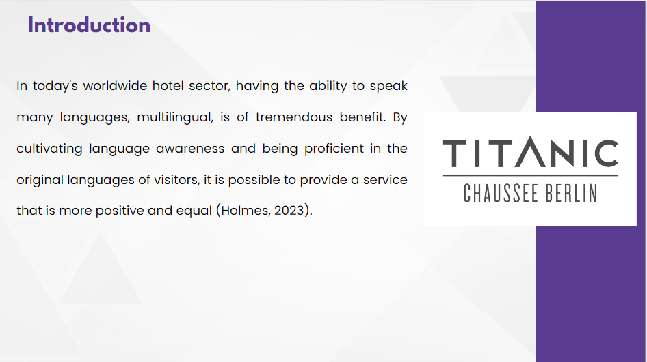
Introduction
In today's worldwide hotel sector, having the ability to speak many languages, multilingual, is of tremendous benefit. By cultivating language awareness and being proficient in the original languages of visitors, it is possible to provide a service that is more positive and equal (Holmes, 2023).

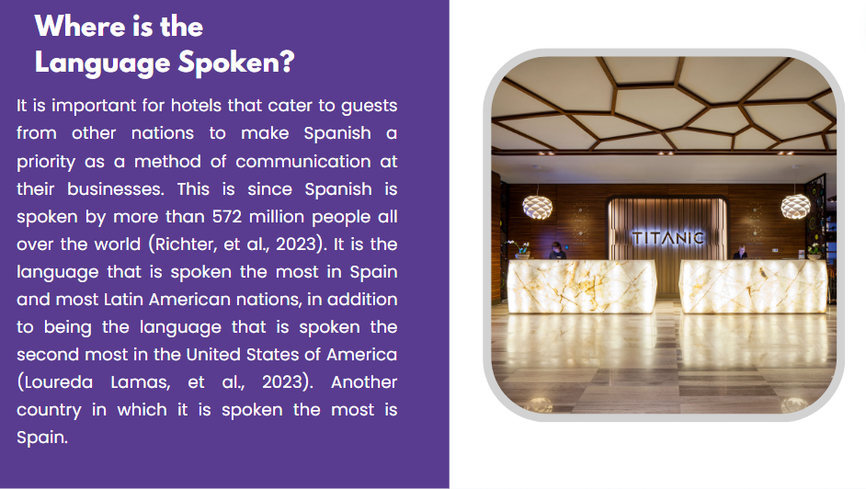
Where is the Language Spoken?
It is important for hotels that cater to guests from other nations to make Spanish a priority as a method of communication at their businesses. This is since Spanish is spoken by more than 572 million people all over the world (Richter, et al., 2023). It is the language that is spoken the most in Spain and most Latin American nations, in addition to being the language that is spoken the second most in the United States of America (Loureda Lamas, et al., 2023). Another country in which it is spoken the most is Spain.

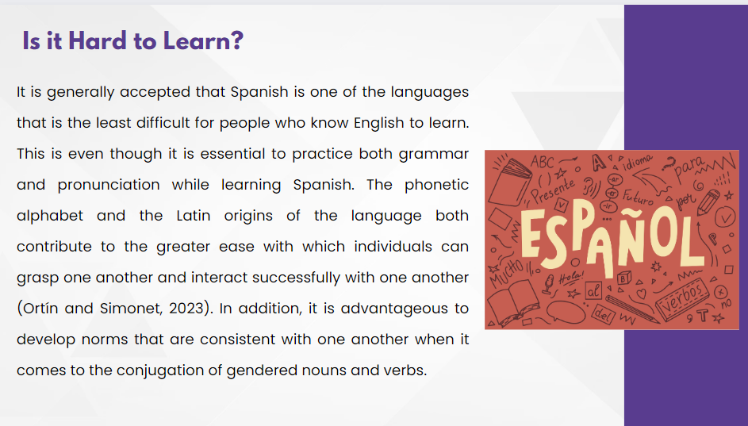
Is it Hard to Learn?
It is generally accepted that Spanish is one of the languages that is the least difficult for people who know English to learn. This is even though it is essential to practice both grammar and pronunciation while learning Spanish. The phonetic alphabet and the Latin origins of the language both contribute to the greater ease with which individuals can grasp one another and interact successfully with one another (Ortín and Simonet, 2023). In addition, it is advantageous to develop norms that are consistent with one another when it comes to the conjugation of gendered nouns and verbs.

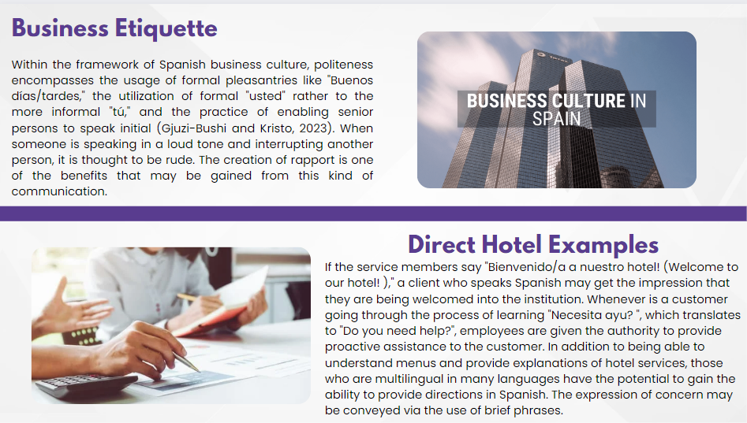
Business Etiquette
Within the framework of Spanish business culture, politeness encompasses the usage of formal pleasantries like "Buenos días/tardes," the utilization of formal "usted" rather to the more informal "tú," and the practice of enabling senior persons to speak initial (Gjuzi-Bushi and Kristo, 2023). When someone is speaking in a loud tone and interrupting another person, it is thought to be rude. The creation of rapport is one of the benefits that may be gained from this kind of communication.
Direct Hotel Examples
If the service members say "Bienvenido/a a nuestro hotel! (Welcome to our hotel! )," a client who speaks Spanish may get the impression that they are being welcomed into the institution. Whenever is a customer going through the process of learning "Necesita ayu? ", which translates to "Do you need help?", employees are given the authority to provide proactive assistance to the customer. In addition to being able to understand menus and provide explanations of hotel services, those who are multilingual in many languages have the potential to gain the ability to provide directions in Spanish. The expression of concern may be conveyed via the use of brief phrases.

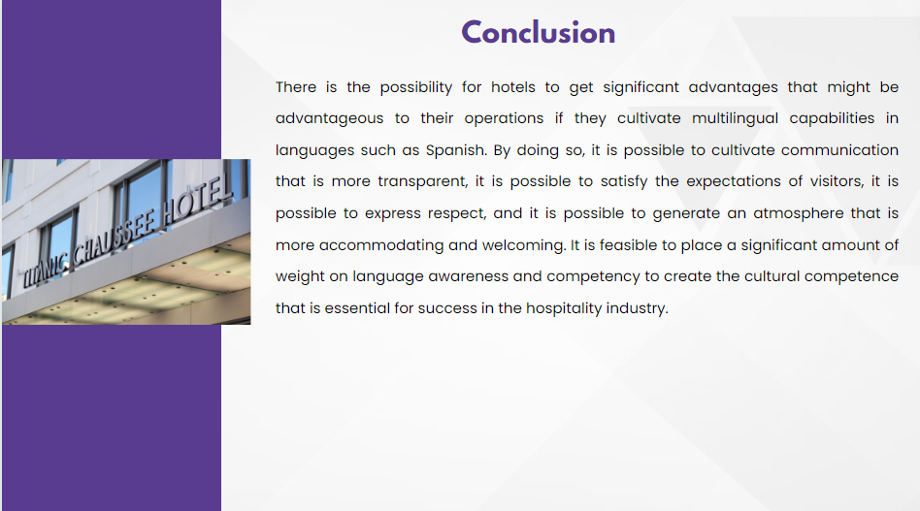
Conclusion
There is the possibility for hotels to get significant advantages that might be advantageous to their operations if they cultivate multilingual capabilities in languages such as Spanish. By doing so, it is possible to cultivate communication that is more transparent, it is possible to satisfy the expectations of visitors, it is possible to express respect, and it is possible to generate an atmosphere that is more accommodating and welcoming. It is feasible to place a significant amount of weight on language awareness and competency to create the cultural competence that is essential for success in the hospitality industry.

References:
Gjuzi-Bushi, J. and Kristo, E., 2023. Didactics of intercultural communication and business German language. Academic Journal of Business, Administration, Law and Social Sciences, 9(2), pp.21-28.
Holmes, L., 2023. Language, hospitality, and internationalisation: exploring university life with the ethical and political acts of university administrators. Current Issues in Language Planning, 24(1), pp.42-59.
Loureda Lamas, Ó., Moreno-Fernández, F. and Álvarez Mella, H., 2023. Spanish as a heritage language in Europe: a demolinguistic perspective. Journal of World Languages, 9(1), pp.27-46.
Ortín, R. and Simonet, M., 2023. Perceptual sensitivity to stress in native English speakers learning Spanish as a second language. Laboratory Phonology: Journal of the Association for Laboratory Phonology.
Richter, M., Agren, P.H., Besse, J.L., Coster, M., Kofoed, H., Maffulli, N., Steultjens, M., Alvarez, F., Espinal, L., Metsna, V. and Raukas, M., 2023. EFAS Score-Validation of Spanish and Estonian Versions by the Score Committee of the European Foot and Ankle Society (EFAS). Foot and Ankle Surgery.

