

LCBB5005: PROJECT MANAGEMENT
CRITICALLY EVALUATE THE HINKLEY POINT C PROJECT OF UK
Assessment 2
Student’s number: 2113318
Student’s name: Paolina Markova
Lecturer’s name: Dr Xavier Matieni
Date: 07/08/23

Table of Contents
Introduction 3
Discussion 3
Conclusion 7
References 9
Appendices 11
Appendix 1: Estimated budget of Hinkley Point C 11
Appendix 2: Opportunities created by Hinkley Point C 12

Introduction
Hinkley Point C is a nuclear power project in the UK that aims at developing a new power station to fulfil the requirements of energy in a more sustainable way. Electricity de France is the developed project that holds a lion's share of the stake. It is seen that this project work is funded with private investment along with debt financing and equity contribution (Edfenergy, 2023). With the help of this project, numerous employment has been provided within several years, additionally, it creates opportunities for local suppliers that can help in dealing with the supply chain activities as well. This project adheres to safety protocols associated with the environment that helps in minimizing the negative impact of waste management and other harmful constructional activities. Changes in budget and project plan along with the current demand influence the project with its activities that sometimes result in significant delays as well.
It is seen that there are some significant factors that resulted in significant delays and overruns of the project. Moreover, the significant impact on the energy prices for consumers is an influential factor in the project's failure. This project faced significant issues in its supply chain and project activities that prevent the project from meeting estimated deadlines. This essay is going to present a significant discussion on the project along with its recent status with project initiation, benefits and challenges as well. In this context, it will help in developing great underlining of the project that fruit helps in underpinning its success or failure aspect.

Discussion
Detailed discussion on the current progress of the project
The construction of Hinkley Point C has progressed through various stages such as site preparation, and dealing with necessary permits and legal approvals as well. In the Bristol Channel, a summer of engineering is underway as the project’s offshore activities nears completion. Six giant steel casings 40m long and 6m wide, weighing 350 tonnes have been installed for marking an effective step in the cooling water system of the construction project. With the help of these 5,000-tonne structures, circulating water to the nuclear reactors can be done in a better way (Edfenergy, 2023). It is suggested that, in present times, 30,000 training spaces are available for the accomplishment stage of the project, apart from that Hinkley Point C invested £24 Million into education and employment skills. It is seen that vessels such as “Neptune” and “Sea Challenger” are used for installing vital components for the cooling water system of the project (Edfenergy, 2023). [Referred to appendix 2]
After the installation of the vessels, a horizontal connection between the tunnel and the bottom of the shaft has been done that can help in circulating water in these nuclear reactors. The contribution of Hinkley Point C to the fight against climate change mainly focuses on having a large, and positive impact on the environment during the sixty years of its operation (World Nuclear Report, 2022). It will nourish Sustainability and environmental protection as the key features in the construction as well. In present times, new techniques are used along with the team of environmental specialists who help in enhancing the local biodiversity and habitats that support nature that had been used in agriculture as well. Sir Keir Starmer MP, The Leader of the Labour Party visited Hinkley Point C and stated the requirement for more nuclear power. The leader also stated the contribution of this project work with its crucial role in relabelling low-carbon electricity and maximization of energy security aspects (Barbiroglio, 2020).
Grant Shapps, “the secretary of state for energy security and net zero”, has chosen the venue for this nuclear programme. Additionally, the commitment to building nuclear power with a capacity of 24 gigabytes is suggested to be completed by 2025 (Newbery, 2021). The governmental small for small modules of the reactors is crucial in order to achieve net zero emission. The current projection highlights the retirement of the existing reactors and the making of new ones; however, the estimated time and budget have already been delayed several times. Hence, changes regarding such reactors may expand the delays as well (The Guardian, 2023). Electricite de France (EDF) revised the cost and schedules of the Hinkley Point C project. EDF stated that the main aspect of this project is to build two 1630 MWe EPR reactors that take time for their final testing (World Nuclear News, 2022). The company has already announced a one-year deal on the project and pays attention in order to further delays due to the pandemic situation.
It is seen that due to the COVID-19 situation, this project was delayed for about 18 months in total. EDF announced a rise of GBP 3 billion in the cost of this project (Attwood, 2016). It is seen that due to the governmental contracts, it will not put any significant impact on the consumers. The project life cycle of Hinkley Point C includes several stages: the first stage, the project initiation stage involves the planning along with preparation of the project. In this context, feasibility studies, approvals of the governmental regulations and other activities and securing the project objectives have been done in terms of achieving the goals and objectives. This project work includes EDF Energy and China General Nuclear Power Group (CGN), in order to plan the financial arguments of the project (Haas and Lutz Mez, 2019). After the initial planning of the project designing and engineering activities are done. [Referred to Appendix 1]
In this context, effective development of structural design, architectural plans, electrical, and mechanical systems, along with environmental assessments has been done. Here, the main aim is to ensure the technical specifications in order to make the project a successful one. Furthermore, Newbery (2021) stated that the procurement and Construction stage focuses on procuring the materials, services and equipment that are required for construction. In this construction phase, the building of nuclear power plants such as cooling systems, turbine halls, and reactors along with other infrastructure components is done. Apart from that additional construction activities such as installation of specialized equipment along with implementing safety measures are taken into account. Buongiorno et al. (2019) stated that the testing stage involves activities such as verification of equipment, processes and systems in terms of making them work efficiently by maintaining safety measures standards. In this context, the project has dealt with functional testing, performance testing and integration testing, of the different components of this power plant.
After the testing phase, the project of the power plant enters the operational phase. This particular stage includes some commercial operations of the plant. In this context supervising the reactors along with the coolers is required. Additionally, frequent inspections and maintenance activities help in ensuring the safety and efficiency of the operation. Moreover, the project continued after two years of the pandemic situation without leading to any disruption. Apart from that with the help of poor supply chain activities, the project was prevented from achieving its milestones as well. EDF stated that resources, people, and supply chains have been constrained along with their restricted efficiency; it was hard for the project management team to deal with the project activities (Harvey, 2020). It is seen that over time the cost of materials along with the quality of work has been greatly influenced. Due to the pandemic situation, the construction activities had paused that expanded the estimated time of the project. Apart from that changes in the estimation budget also created issues in the budget allocation.
It is seen that the project has gone through significant changes within its activities, after rectifying several issues in the constructional activities such as supply chain management along with a hike in prices of the raw materials and other resources budget planning has been done. The report suggested that the energy company EDF of the project Hinkley Point C focuses on making changes regarding the “Secretary of State’s Development Consent Order '' that requires the device. However, they are proposed for the installation activity as a part of the environmental protection package but now it is proposed to avoid it (Barbiroglio, 2020). It is observed that removing such protection may hamper the biodiversity factor involved in the project. Apart from that the estimated closure year of the project is pushed back to 2026, in which the pandemic outbreak plays a crucial role. Moreover, with the help of two developed reactors, this project work focuses on completing within this estimated time.
Success or failure aspect of the project
Hinkley Point C is one of the controversial construction projects in the UK as this project aims at providing low-carbon electricity for six million houses. Hinkley Point C focuses on achieving environmental goals by switching to cleaner energy sources. This project is also expected to enhance the UK's energy security by promoting the use of reliable sources of electricity by nuclear power generation. In this regard, maintaining a sustainable way of energy resourcing can be promoted that helps in the betterment of life and the environment as well. Glasson et al. (2020) stated that switching to venerable energy consumption can help people lead a sustainable lifestyle. Here, the preservation of energy will be done for the future generation as well. It further helps in boosting the energy supply activities of the country; hence, it is believed that such focus not only helps the project work to get success but also the country with additional benefits.
In this context, building two reactors helps in achieving milestones of the project work. It is seen that with the help of Hinkley Point C is a large project that created jobs. Construction and operation have the greatest potential to create different types of jobs that not only help the country to enhance its employment rate but also economic growth. It further benefits the local and national economy as well. This project invested in creating 25000 jobs in the UK (UK Government, 2016). In this regard, this project work benefits the country by developing skilled employees who can help in dealing with project activities in the most effective and productive way. Furthermore, Hinkley's point C focuses on the transition to a low-carbon future, which further helps in meeting climate commitments in a better way. Additionally, achieving a carbon footprint with the help of this initiative can be done that is beneficial for everyone.
The project has faced various issues due to high costs along with subsidies provided to significant developers. In this context, the financial burden is considered the main factor that leads to significant delays in the project work. Glasson et al. (2020) stated that complexity in a project plan hampers the outcomes of the project. It is seen that this project is considered a large project that required expertise to deal with each stage of the project. Apart from that huge delays and cost overruns are yet another factor affecting the project that further impacted the timeline along with the financial aspects of the project. Apart from that, the lack of concern regarding environmental activities creates issues in the dependency of the project as well. In this context, it is observed that a lack of concern about such aspects prevents the project from gaining success.
The appropriate description of Hinkley Point C is considered risky and technologically unproven before the start of the construction project; its implementation was slow in this rapidly changing energy world. Additionally, it faces significant criticism as it is stated that this project is ill-designed and the expense of the project was not estimated with the concerns of such rise and changes in demands (World Nuclear Report, 2016). Safe disposal of waste, long-term environmental impacts and potential accidents are some significant concerns associated with the nuclear power project, Hinkley Point C. Radioactive wastes including spent reactor fuel, uranium mill tailings, and other materials are dangerous to the health of humans. due to significant concern on the waste management regarding the nuclear project plan hampering the ecological stability as well. Apart from that the controversial design of the project work also created significant issues that further created constructional problems as well.
Hinkley Point C is an ongoing project that is estimated to complete by 2025 (World Nuclear Report, 2022). It has some success factors along with some disadvantages that lead to a clear failure of the project work within its complements. However, the overall discussion highlights some of the significant benefits behind the project work such as providing a more sustainable source of energy, a rise in employment along with margining sustainability as well. On the other hand, a lack of concern regarding waste management and the complexity of the project creates significant issues that lead to project delays and overruns. In this context, on the basis of the current scenario, Hinkley Point C is considered a successful project as it has already created two reactors and provides employment to the population that further helps the country with its economic stability as well.

Conclusion
Hinkley point c is one of the biggest construction projects in the UK that focuses on providing electricity to the country in a more sustainable way. However, the overall discussion on the Hinkley point c has been provided, which includes the benefit of the project to the government and other authorities as well. Apart from that, it has highlighted some of the most significant backdrops of the project that is the reason behind such delays and overruns. In this regard, after analysing the project from various aspects, it is seen that it is an ongoing project and does not finish till now. However, it somehow met some of its milestones by developing the reactors and creating employment facilities as well. In this context, this project is considered successful till now, but due to the significant delays and overruns, this project faced various issues that can be mitigated by developing effective strategies.
An effective project management plan consists of well-defined aims, objectives, goals, a timeline, estimated resources and a budget plan that needs to be developed by the project team. In this context, addressing the challenges at the very time is vital in order to deal with the project delays. In this regard, effective risk management activities can be developed along with frequent monitoring of the project as well. The complexity of the project needs to be measured before dealing with the project plan, such lack may impact the project delays and other issues as well. In this context, project plans along with an analysis of the potential risk and opportunities need to be done. Apart from this, in the time of developing the best estimation plan, it is very important to look into the potential in the future. Here an effective cost-control measure can be taken into account by the project team, in this context, identifying cost-saving opportunities need to be rectified by exploring different financial models. From the overall analysis, it is observed that maintaining environmental compliance is very important in order to avoid any kind of negative impact on the environment.

References
Attwood, C. (2016). for Sustainable Development Richard Bridle It’s Official: The United Kingdom is to subsidize nuclear power, but at what cost? GSI REPORT. [online] Available at: https://www.iisd.org/system/files/publications/united-kingdom-subsidize-nuclear-power-at-what-cost.pdf [Accessed 13 Jul. 2023].
Barbiroglio, E. (2020). Nuclear Plant And Sound Projector Developers Fight Over Acoustic Fish Deterrent In The Severn Estuary. [online] Forbes. Available at: https://www.forbes.com/sites/emanuelabarbiroglio/2020/07/11/nuclear-plant-and-scientists-fight-over-acoustic-fish-deterrent-in-the-severn-estuary/?sh=30a8ab4b791c [Accessed 13 Jul. 2023].
Buongiorno, J., Corradini, M., Parsons, J. and Petti, D. (2019). Nuclear Energy in a Carbon-Constrained World: Big Challenges and Big Opportunities. IEEE Power and Energy Magazine, 17(2), pp.69–77. doi: https://doi.org/10.1109/mpe.2018.2885250.
edfenergy (2023). New video shows Hinkley Point C’s offshore progress. [online] EDF. Available at: https://www.edfenergy.com/energy/nuclear-new-build-projects/hinkley-point-c/news-views/new-video-shows-hinkley-point-c-offshore-progress [Accessed 13 Jul. 2023].
Glasson, J., Durning, B., Broderick, M. and Welch, K. (2020). Monitoring and auditing the local socio-economic and environmental impacts of the early stage construction of Hinkley Point C Nuclear Power Station, UK. Impact Assessment and Project Appraisal, pp.1–12. doi: https://doi.org/10.1080/14615517.2020.1838237.
UK Government. (2016). 5 reasons why we are backing Hinkley Point C. [online] Available at: https://www.gov.uk/government/news/5-reasons-why-we-are-backing-hinkley-point-c#:~:text=Hinkley%20will%20give%20a%20boost. [Accessed 13 Jul. 2023]
Haas, R. and Lutz Mez (2019). The Technological and Economic Future of Nuclear Power Energiepolitik und Klimaschutz Energy Policy and Climate Protection. [online] Available at: https://library.oapen.org/bitstream/handle/20.500.12657/23165/1006988.pdf?sequence#page=261. [Accessed 13 Jul. 2023]
Harvey, P. (2020). Radiation as social relation. Anthropology Today, 36(6), pp.13–16. doi: https://doi.org/10.1111/1467-8322.12618.
Newbery, D. (2021). The Cost of Finance and the Cost of Carbon: A Case Study of Britain’s only PWR. Economics of Energy & Environmental Policy, 10(2). doi: https://doi.org/10.5547/2160-5890.10.2.dnew.
The Guardian. (2023). Hinkley Point C | UK news | The Guardian. [online] Available at: https://www.theguardian.com/uk-news/hinkley-point-c [Accessed 13 Jul. 2023].
World Nuclear News (2022). EDF revises Hinkley Point C schedule and costs : New Nuclear - World Nuclear News. [online] www.world-nuclear-news.org. Available at: https://www.world-nuclear-news.org/Articles/EDF-revises-Hinkley-Point-C-schedule-and-costs. [Accessed 13 Jul. 2023]
World Nuclear Report (2016). Politico (Belgium): OPINION: The pros and cons of Hinkley Point [Tim Yeo/Mycle Schneider]. [online] World Nuclear Industry Status Report. Available at: https://www.worldnuclearreport.org/Politico-Belgium-OPINION-The-pros-and-cons-of-Hinkley-Point-Tim-Yeo-Mycle.html#:~:text=Unprecedented%20%E2%80%94%20that [Accessed 13 Jul. 2023].

Appendices

Appendix 1: Estimated budget of Hinkley Point C
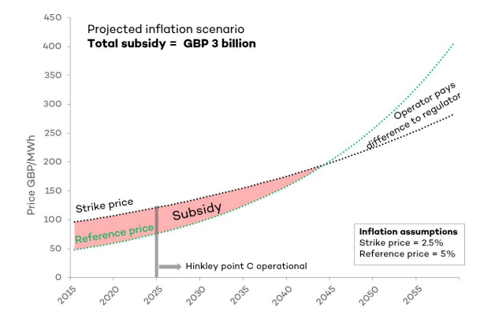
(Source: Attwood, 2016)

Appendix 2: Opportunities created by Hinkley Point C
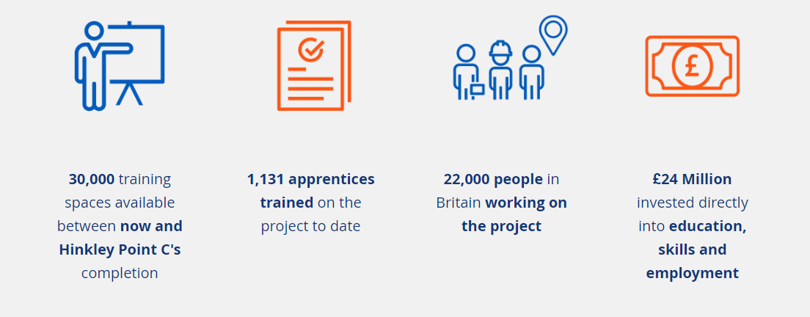
(Source: edfenergy, 2023)

