
[Document title]
[Document subtitle]

[Date]
University of Wales Trinity Saint David
[Company address]

Table of Contents
Task 1 E-commerce web builder 2
Wix 2
Shopify 2
Tasking mind Map 3
Task 3 Microsoft 3
pivot Table 3
Creating PivotTable 3
Task 4: Online communication and collabration 4
Task 1. e-Commerce 5
Website builders/software solutions (Approx. 500 words and 2/3 sources) 5
Task 2. Mind-map 6
Task 3. Office Applications 6
Task 4. Communication and Collaboration applications (Approx. 1000 words and 2/3 sources). 7

Task 1 E-commerce web builder

Wix
abc

Shopify
abc
Table 1E-commerce web builder comparison
Features | Wix | Shopify

Figure 1Aston Villa Foot Ball

For the university web click here

Tasking mind Map

Table

Task 3 Microsoft

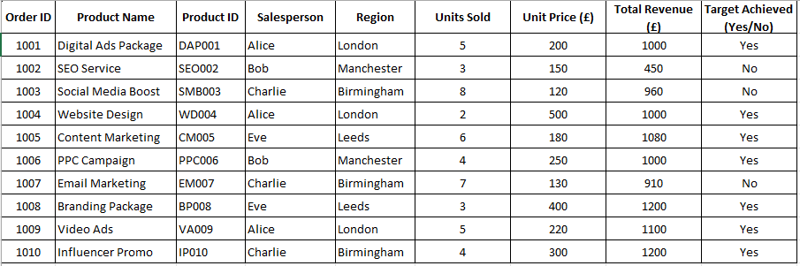
pivot Table
Table 2 Sample data using for testing

Creating PivotTable
This section I would like to section I would like to creating apivot for each item in

Table 3 Creating of pivot table
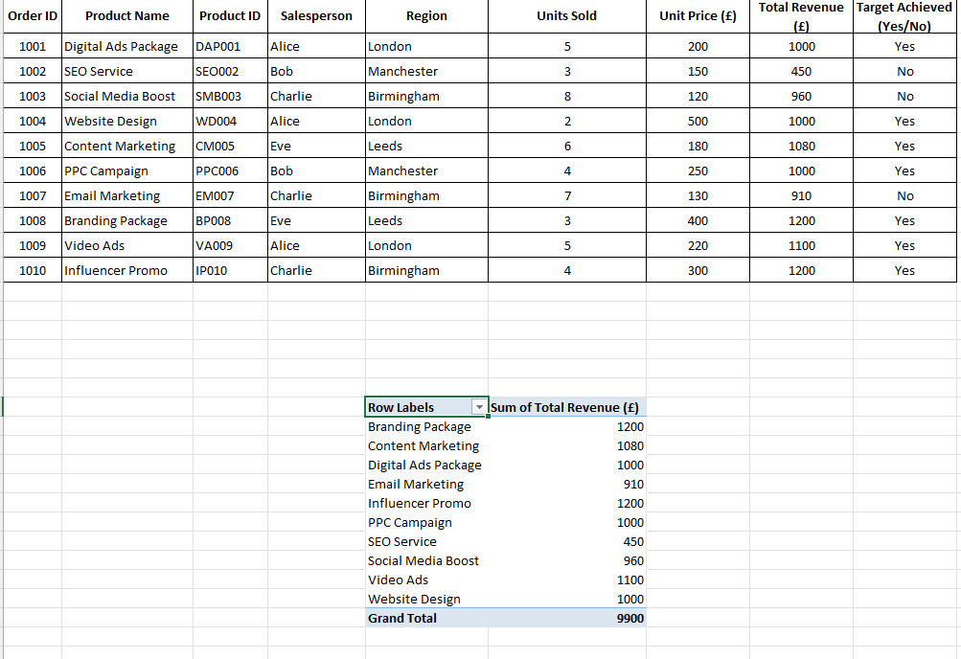

Task 4: Online communication and collabration

For business solution link here

Task 1. e-Commerce

Website builders/software solutions (Approx. 500 words and 2/3 sources)
Write a brief summary (Minimum 10 -12 lines each) on any two freely available website builder application.
In the summary include history, features, advantages and limitations of the application

Task 2. Mind-map
of contemporary software applications (Approx. 750 words and 2/3 sources).
- Write a brief summary ( minimum 10-12 lines) about mind mapping technique.
- Create a mind map of any business scenario of your choice.

Task 3. Office Applications
for creating, storing, presenting, and analysing information/data (Approx. 1750 words and 4/5 sources).

- Write brief summaries of 12-15 lines each on MS Word, MS PowerPoint and MS Access. In each of their summaries include major features, benefits, and limitations. To support your understanding of these application, you may also use some screenshots in addition to tex.

- Test any two features of MS Excel from the following:
Mail merge, IF Function, VLOOKUP, Pivot Table and Goal Seek.

Please provide the screenshots with accompanying description as an evidence of the practical use.
Note: This task is based on your own practical activities.

Task 4. Communication and Collaboration applications (Approx. 1000 words and 2/3 sources).

- Write a brief summary of any one Communication and one Collaboration tool.
- Test two features of the Communication and Collaboration tool you have summarized. Provide sscreenshot of the usage and write by a brief description explaining the screenshot

Additional supporting information:

- Please note the assignment should be submitted as one Microsoft Word document.
- Your work must include a title page with your full name, student ID number, the program of study, module name, module code, Lecturer’s name, date of submission and the university name with relevant campus name.
- The references should be properly cited and listed. You need to employ proper in-text citations and references list according to IEEE Referencing Style.
- Your work should be typed in Arial font, size 11.
- Your work should be typed with 1.5 line spacing.
- Your work should have an appropriate structure including page number, table of contents, tasks answers, and references list. Different sections should incorporate headings and subheadings. Figures and tables need to be captioned.

Ms Access



