ROUTER
Nasko-Router#show running-config
Building configuration...

Current configuration : 3577 bytes
!
! Last configuration change at 13:00:38 UTC Wed May 9 2001
!
version 16.9
service timestamps debug datetime msec
service timestamps log datetime msec
platform qfp utilization monitor load 80
no platform punt-keepalive disable-kernel-core
!
hostname Nasko-Router
!
boot-start-marker
boot-end-marker
!
!
enable secret 5 $1$RAdU$yhz4Bg/gAngBFh4Wp6IjZ.
!
no aaa new-model
!
no ip domain lookup
ip admission watch-list expiry-time 0
!
!
!
!
!
!
!
!
!
!
subscriber templating
multilink bundle-name authenticated
!
!
!
crypto pki trustpoint TP-self-signed-1020466531
enrollment selfsigned
subject-name cn=IOS-Self-Signed-Certificate-1020466531
revocation-check none
rsakeypair TP-self-signed-1020466531
!
!
crypto pki certificate chain TP-self-signed-1020466531
certificate self-signed 01
30820330 30820218 A0030201 02020101 300D0609 2A864886 F70D0101 05050030
31312F30 2D060355 04031326 494F532D 53656C66 2D536967 6E65642D 43657274
69666963 6174652D 31303230 34363635 3331301E 170D3031 30353039 30393333
33355A17 0D333030 31303130 30303030 305A3031 312F302D 06035504 03132649
4F532D53 656C662D 5369676E 65642D43 65727469 66696361 74652D31 30323034
36363533 31308201 22300D06 092A8648 86F70D01 01010500 0382010F 00308201
0A028201 0100BE43 B75E8E19 DFE3C8A9 6694A193 487BC7E3 89D9E332 1E65A67F
79F7C71B F2407ED4 6F0887FD 4AEE3802 F1976E27 87D84AA4 8C004831 C01055CA
B7EA28B9 34B85E7C 3B1C0A5B 00C06A9B 2AFA9CB2 3F09B5E1 E83177FF 9A620FC2
73FF1626 3AFE5BE3 F5B34F13 05C9AEAF 87E54446 D6307B45 5AC35210 1029B941
4A9E7A10 683957B0 CC2109F5 13D86973 A4BEC9C8 CB3A2359 C207CA5B 93301824
DBD01CBD 0AD6415B 850D4512 38EE3AD2 D4BFB6B6 72982CBE 4DEC8CD5 98AA556E
1077A5FC 3905D324 584903B3 8B64881C 10B130B8 09F1469E 13A664F8 2B6C7B77
5DF20F6F D1274D5F 39AEDECB CAF5F6A9 FBADE03B 54C5111B 3FD91800 400F0E09
D0C1FD60 2F870203 010001A3 53305130 0F060355 1D130101 FF040530 030101FF
301F0603 551D2304 18301680 14068CE3 0F5599C0 00C9EB07 6FA18BF7 9F119F86
2F301D06 03551D0E 04160414 068CE30F 5599C000 C9EB076F A18BF79F 119F862F
300D0609 2A864886 F70D0101 05050003 82010100 3A173BB7 D5F31495 41DF5015
E73CA58C 648CFE18 77D30B9E 10284BB1 3CDE3B9C B8545257 31E48634 B98DA285
78D3A2F5 F821F2F4 CA9A121C 6E308351 6AF97B9C 3015EBAA 3D2EB63D 46AD8E4E
D6D1D131 3F7A3CA2 BF112055 BFFE70AA 8C74FD98 12B6FC6B 68F70706 D6527C34
1B0A40CE 28CAE24A FC6AF06C 43DA0E2E 61A00546 46A69C7D 9C797AAD 154FD66E
CE4119EF 3ECB55DE 93EA96C8 112AD528 678B4DBF 951C4E7E 8E5845F2 7C31CA21
622E3073 D45F9B54 493DDF53 B86BD382 9D428DB4 2F548E05 F17EC869 62D78D81
8A1F4CD2 536BB89F D64CAFE9 7A257FC7 C4774B5A 68B62500 65749D00 D9DA6C44
B5F571B7 590C95F9 93907A3C 79F48E92 D9323CC4
quit
!
license udi pid ISR4221/K9 sn FGL224190DM
no license smart enable
diagnostic bootup level minimal
!
spanning-tree extend system-id
!
!
!
!
redundancy
mode none
!
!
!
!
!
!
!
!
interface GigabitEthernet0/0/0
description Router_PC-B connection
ip address 153.99.10.1 255.255.255.0
negotiation auto
!
interface GigabitEthernet0/0/1
description Router_Switch connection
ip address 153.99.11.1 255.255.255.0
negotiation auto
!
interface Serial0/1/0
no ip address
shutdown
!
interface Serial0/1/1
no ip address
shutdown
!
ip forward-protocol nd
ip http server
ip http authentication local
ip http secure-server
!
!
!
!
!
!
control-plane
!
banner motd ^CAny unauthorized access is prohibited^C
!
line con 0
password cisco
login
transport input none
stopbits 1
line vty 0 4
password cisco
login
line vty 5 15
password cisco
login
!
!
!
!
!
!
End

Nasko-Router>show ip interface brief
Interface IP-Address OK? Method Status Protocol
GigabitEthernet0/0/0 153.99.10.1 YES manual up up
GigabitEthernet0/0/1 153.99.11.1 YES manual up up
Serial0/1/0 unassigned YES unset administratively down down
Serial0/1/1 unassigned YES unset administratively down down

SWITCH
Nasko-Switch#show running-config
Building configuration...

Current configuration : 1500 bytes
!
! Last configuration change at 21:28:49 UTC Mon Mar 1 1993
!
version 15.2
no service pad
service timestamps debug datetime msec
service timestamps log datetime msec
service password-encryption
!
hostname Nasko-Switch
!
boot-start-marker
boot-end-marker
!
!
no aaa new-model
system mtu routing 1500
!
!
!
!
!
!
!
no ip domain-lookup
!
!
!
spanning-tree mode pvst
spanning-tree extend system-id
!
vlan internal allocation policy ascending
!
!
!
!
!
!
interface FastEthernet0/1
!
interface FastEthernet0/2
!
interface FastEthernet0/3
!
interface FastEthernet0/4
!
interface FastEthernet0/5
!
interface FastEthernet0/6
!
interface FastEthernet0/7
!
interface FastEthernet0/8
!
interface FastEthernet0/9
!
interface FastEthernet0/10
!
interface FastEthernet0/11
!
interface FastEthernet0/12
!
interface FastEthernet0/13
!
interface FastEthernet0/14
!
interface FastEthernet0/15
!
interface FastEthernet0/16
!
interface FastEthernet0/17
!
interface FastEthernet0/18
!
interface FastEthernet0/19
!
interface FastEthernet0/20
!
interface FastEthernet0/21
!
interface FastEthernet0/22
!
interface FastEthernet0/23
!
interface FastEthernet0/24
!
interface GigabitEthernet0/1
!
interface GigabitEthernet0/2
!
interface Vlan1
ip address 153.99.11.10 255.255.255.0
!
ip default-gateway 153.99.11.1
ip http server
ip http secure-server
!
no vstack
banner motd ^CAny unauthorized access is prohibited^C
!
line con 0
line vty 0 4
password 7 045802150C2E
login
line vty 5 15
password 7 045802150C2E
login
!
End

Nasko-Switch#show ip int brief
Interface IP-Address OK? Method Status Protocol
Vlan1 153.99.11.10 YES manual up down
FastEthernet0/1 unassigned YES unset down down
FastEthernet0/2 unassigned YES unset down down
FastEthernet0/3 unassigned YES unset down down
FastEthernet0/4 unassigned YES unset down down
FastEthernet0/5 unassigned YES unset down down
FastEthernet0/6 unassigned YES unset down down
FastEthernet0/7 unassigned YES unset down down
FastEthernet0/8 unassigned YES unset down down
FastEthernet0/9 unassigned YES unset down down
FastEthernet0/10 unassigned YES unset down down
FastEthernet0/11 unassigned YES unset down down
FastEthernet0/12 unassigned YES unset down down
FastEthernet0/13 unassigned YES unset down down
FastEthernet0/14 unassigned YES unset down down
FastEthernet0/15 unassigned YES unset down down
FastEthernet0/16 unassigned YES unset down down
FastEthernet0/17 unassigned YES unset down down
FastEthernet0/18 unassigned YES unset down down
FastEthernet0/19 unassigned YES unset down down
FastEthernet0/20 unassigned YES unset down down
FastEthernet0/21 unassigned YES unset down down
FastEthernet0/22 unassigned YES unset down down
FastEthernet0/23 unassigned YES unset down down
FastEthernet0/24 unassigned YES unset down down
GigabitEthernet0/1 unassigned YES unset down down
GigabitEthernet0/2 unassigned YES unset down down

PC-A ipconfig/all

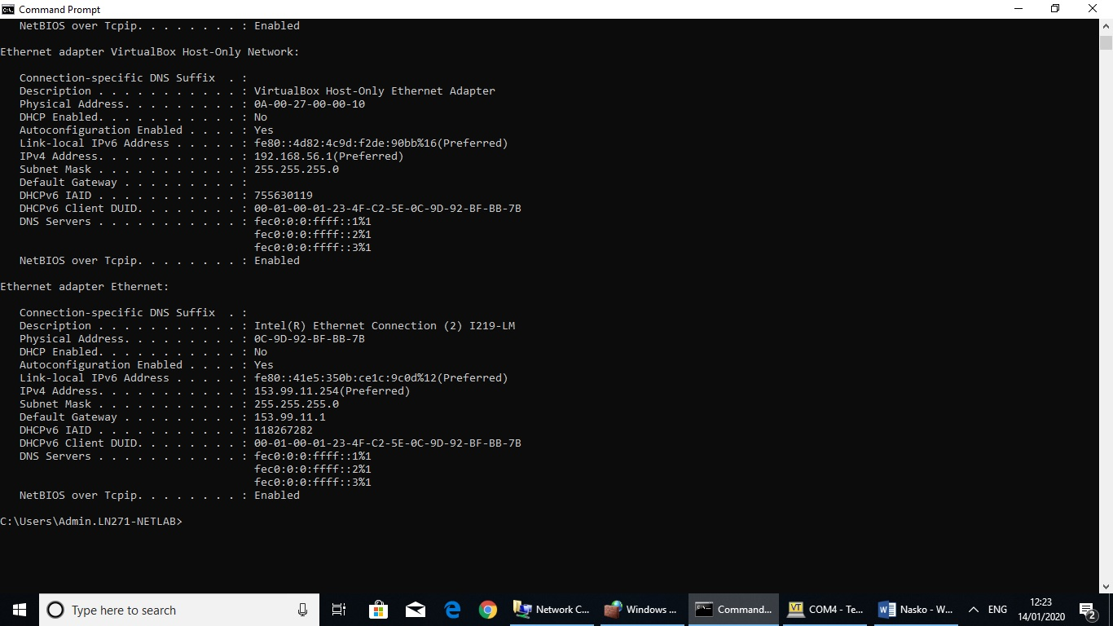
Ping form PC-A to PC-B
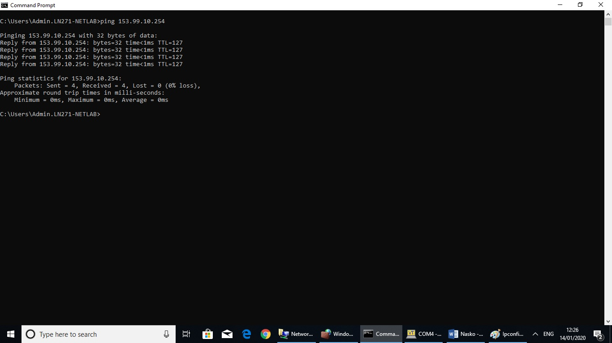

PC-B ipconfig/all


