Executive Summary

Nowadays businesses have to face various numbers of challenges resulting from different factors. This includes economics and threats resulted from the external environment as well as the limits and weaknesses of the internal organization. Business can be further developed through its strengthen and opportunities. Samsonite International S.A. is a well-known lifestyle bag and travel luggage company in Hong Kong. Problems faced by Samsonite has been determined and evaluated the marketing strategies to ensure its business continuity.

Outbreak of COVID-19 created a sudden change in daily lives of people in a short time while badly affecting global economy and resulting widespread of panic. Samsonite’s business was hardly hit due to the pandemic. Macroeconomic environment factors and industry competitiveness of Samsonite has analyzed through PEST analysis and Porter’s Five Forces Model. Luggage and travel bag industry is still competitive. However, the strong brand awareness of Samsonite enhance the company’s competitive strength and it remains flag as the largest lifestyle bag and travel luggage company.

Through STP and Marketing Mix model, it is noted sSamsonite is targeting the business professional as their major customers and the company is using hybrid marketing channel as their promotion mix. The promotion mix seems to be effective as Samsonite has managed to perform well according to the company’s annual report 2018. However, there is still room to grow in the e-commerce channel due to the raise of digital technologies.

Business growth alternatives of Samsonite has been explained and discussed via ANSOFF matrix. Recommendations have been provided for business continuity. In order to support the business growth and maintain the position of Samsonite as the key player in the lifestyle bag and travel luggage industry, Samsonite has to explore O2O business models and further enhancement the penetration of female customer segment with development of digital personalization.

- Introduction

Samsonite International S.A. is a well-known lifestyle bag and travel luggage company in Hong Kong, their business is closely related to travel and tourism industry. During the past decade, travel and tourism industry became one of the major pillars of the economy of Hong Kong. The appearance of COVID-19 pandemic has affected the worldwide economies and resulted a tremendous impact on global business. Arrival of tourists was sharply decreased due to the travel restriction and city lockdown since 2019 (Tourism Commission, 2020). Travel and tourism industry is highly impacted which directly crashed the business of Samsonite.

In order for business continuity, the challenges faced by Samsonite were identified. Through PEST analysis and Porter’s Five Forces model, macroeconomic environment and the industry competition on Samsonite was studied. STP and Marketing Mix model help to find out Samsonite customer segment and assess its effectiveness. Finally, a position in the marketing future development plans will be recommended for its business continuity.

2. Samsonite’s business analysis

Existing external and internal environment factors on Samsonite will be studied through macro environment and micro environment analysis. PEST analysis matrix will be used to examinate the macro-economic impact on Samsonite and Porter’s Five Forces Model will used to identify the competitiveness of the industry.

2.1 Company background of Samsonite
Samsonite International S.A is a renowned leading lifestyle bag and travel luggage company in Hong Kong and it was founded in 1910 with a heritage of 111 years (Samsonite International S.A., 2021). It involves design, manufacture, sourcing and distribution of their products under their licensed brand of Samsonite®, Tumi®, American Tourister®, Speck®, Gregory®, High Sierra®, Kamiliant®, eBags®, Lipault® and Hartmann® (Samsonite International S.A., 2021).

Samsonite runs their business through different product segments including travel bag and luggage, causal bags and business bags. Their products were sold in over 100 countries with about 37,000 points of sales with various wholesales and retails distribution channels (Samsonite International S.A., 2021). The company’s sales regions cover North America, Asia, Europe and Latin America (Samsonite International S.A., 2021). Hong Kong is one of its operation and sales region in Asia. In this report, we aim to analysis Samsonite’s business and marketing strategy in Hong Kong.

2.2 Macro environment impact

With the help of PEST analysis, we can further understand the threats of the external factors on Samsonite. This tool was created by a Harvard professor, Francis J. Aguilar, in 1964. This analysis was initially used as ETPS – Economics, Technical, Political and Social Influences to analysis the macro-environment (Aguilar, 1967).

Figure 1. PEST analysis matrix of Samsonite
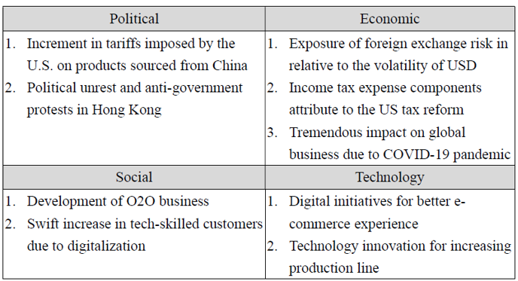
Source: Illustrated by writer

The US-China trade war resulted in six times increment in tariffs rate since 2018 and it is with an average of 19.3 percent in tariffs on imports from China (Bown, 2021).
Samsonite’s raw material are mainly sourced from China, increase in tariffs result in decrease in company’s profit margin.

Tremendous impact on global economy due to COVID-19 pandemic has a severely impact on Samsonite. Its business is highly related to the travel and tourism industry. During the past decade, Hong Kong travel and tourism industry has evidenced notable growth and its economy of Hong Kong is closely linked to travel and tourism. In 2018, Hong Kong’s Gross Domestic Product (GDP) is around USD 361.7billion (The World Bank, 2021). According to Tourism Commission in Hong Kong, travel and tourism sector contributed to around 4.5% of Hong Kong’s GDP in 2018 (Tourism Commission, 2020). With the presence of COVID-19 pandemic, daily lives of people faced unexpected changes. Travel restriction and city lockdown imposed around the globe causing total tourist arrivals of Hong Kong in 2019 surged down by 14.2% to 56million (Tourism Commission, 2020).

Further than that, the development of O2O business and swift increase in tech savvy customers for better e-commerce experience is also influencing Samsonite’s current and upcoming business strategies. In order to drive future growth, the company has to initiate digitalization development and usage. We will further discuss Samsonite’s future development in this area of marketing in the coming sections.

Other than the macroeconomic environment, demographic aspect is also highly related to the future business plan. Gender is an elemental aspect of economic and demographics trend is important for analyzing the global trends (Mester, 2017). Change in demographics can impact the economic growth rate, consumption and investment decisions (Mester, 2017).

When we are studying Samsonite’s customer segments, it seems its products are mainly target to male customers. However, according population projection announced by the Census and Statistics Department, the sex ratio on males per 1000 females in Hong Kong with notably drop from 838 in 2019 to 685 in 2069 (Census and Statistics Department, 2020). Both macroeconomic environments aspect mentioned are influencing Samsonite’s current and upcoming business strategies.

  - Samsonite’s business in Hong Kong

Samsonite had its initial public offering in Hong Kong in June 2011 and raised USD 1.25 billion, the company listed on Hong Kong Stock Exchange as 1910 since then (Barreto, 2011). As of 11 June 2021, the shares of Samsonite International S.A. are trading at HK$17.60 resulting the company with a market capitalization of HKD 25.25 billion (Yahoo! Finance 2021). Samsonite is famous for its fine quality and durable luggage with broad choice of innovative designs. The company made seven consecutive annual increase in turnover till 2018. Graph 1 shows steady increment of net sales in Hong Kong since company listed in 2011.

Graph 1. Net sales of Samsonite in Hong Kong from 2011 -2020

Sources: Samsonite International S.A. Annual Report 2012, p.25; Annual Report 2014, p.30; Annual Report 2016, p.36; Annual Report 2018, p.46; Annual Report 2019, p.48; Annual Report 2020, p.54

In 2016, there is a significant increase in net sales due to the acquisition of Tumi. However, the company’s net sales slowed down in 2019 and reported a marked decline in 2020, it recorded USD 43.6 million with a 71.3% considerable drop when compared with 2019 (Samsonite International S.A., 2021). The business of Samsonite is adversely impacted and this reflects a decrease in demand for the company's products and services.

  - Industry overview

The level of competition within the luggage and travel bag industry will be further analyzed with Porter’s Five Forces Model. In 1979, Michael E Porter of Harvard Business School developed an analyzing tool to determine the industry attractiveness. This model helps to identify the state of competition through bargaining power of suppliers, bargaining power of buyers, threat of new entrants, threat of substitute products and rivalry among existing competitors (Porter, 1980).

Figure. 2: Porter’s Five Forces of competitive position
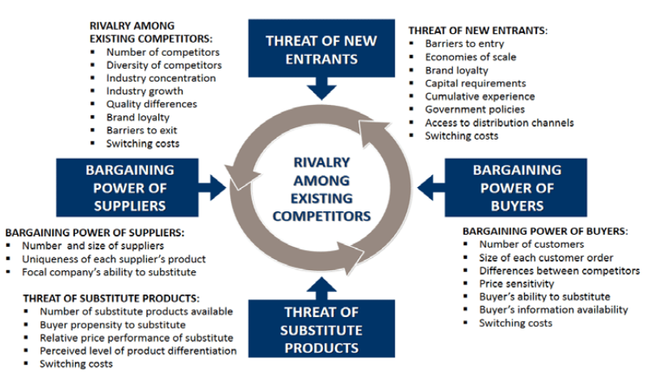
Source: Huisman, J. and Pringle, J. (2011)

While analysis the luggage and travel bag industry, the bargaining power of this industry is low to medium due to different supplier base with lots of original equipment manufacturer in China and South East Asia, however, source of certain raw material and product components of this industry are limited. Considering lots of brands in the market, e.g. Louis Vuitton, Delsey, Rimowa, VF Corp, etc., this industry maintains a high bargaining power of customers.

However, threat of new entrants and substitutes are low. Low entry barrier results the fragmented nature of industry and challenges in building up the brand awareness. Due to the specific functionality and durable requirement of luggage and travel bags, it makes this industry unlikely to be replaced.

Even though this industry is highly fragmented and competitive, strong brand awareness and wide points of sales should enhance the company’s competitive strength. Hence, rivalry among existing competitors is medium in luggage and travel bag industry.

Graph 2: Global market share of luggage and travel bag industry in 2015
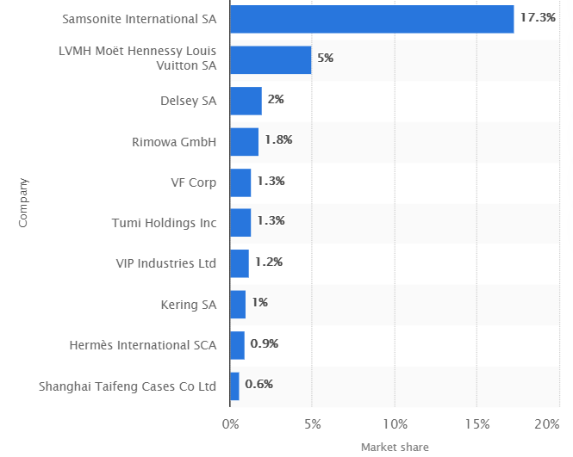
Source: Statista, 2021

In 2015, Samsonite has achieved around 17% market share in this industry, considering Samsonite acquired Tumi in 2016, it is believed Samsonite able to maintain its position as the largest luggage company by market share. However, given the weakened tourism industry, Samsonite’s business is highly impacted.

3. Samsonite’s marketing strategy overview

Samsonite’s current adopted market strategies will be reviewed with STP model and Marketing mix. Target segment customer of Samsonite and the product positioning strategy of those segment will be identified in below section.

3.1 STP Analysis on Samsonite

STP marketing is a widely used three-step marketing framework. Target marketing strategy involves four stages: Segmentation, Targeting, Positioning and Planning (Chaffey and Chadwick, 2016). In order to understand the targeting market segment of Samsonites business, STP model will be used to find out its customer segment to provide a clear position in the market.

Figure 3: Stage of target marketing
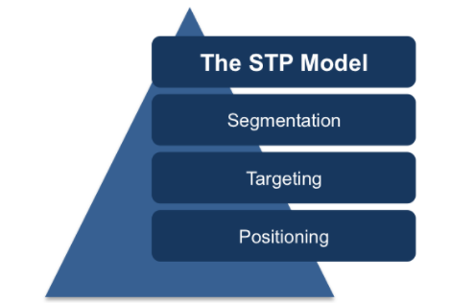
Source: Free management ebook

Samsonite’s product profile mainly divided into three product segments. The travel bag segment involves travel products likes suitcases and carry-on luggage including hard-side, soft-side and hybrid luggage; the casual bag segment involves daily use backpacks and shoulder bags; the business bag segment involves business use lifestyle bags including rolling briefcase and laptop bags. Based on the existing product lines of Samsonite, currently, it seems that the company uses demographic approach to segment its customer through personal attributes which are gender, age group and occupation.

Through understanding the company’s target segment, we can further tailor marketing offers to them. Samsonite’s brand is famous for luggage and travel bags, their product category in their company seems targeting on savvy male business traveler with aged greater than 35. In order to enhance the sales growth and generate profit, Samsonite should also extend its customer segment to young female customers.

There are various luggage and travel bags companies among the market and this market is classified into value, mid-market, premium and luxury market which determined by the price of their products. Samsonite’s products are traded at premium prices (Samsonite International S.A., 2011). Their products are made with fine quality and tested for strength, durability and performance (Samsonite IP Holdings S.a.r.l., 2021). Among the peers as mentioned, the positioning of Samsonites is illustrated with a perceptual map with price against quality of product. As shown in Graph 3, an overview of the market position and market shares of various global brands. It is noted that Samsonite is competitive advantage among the peers in the markets due to its price and quality.

Graph 3. Positioning of Samsonite among various competitors 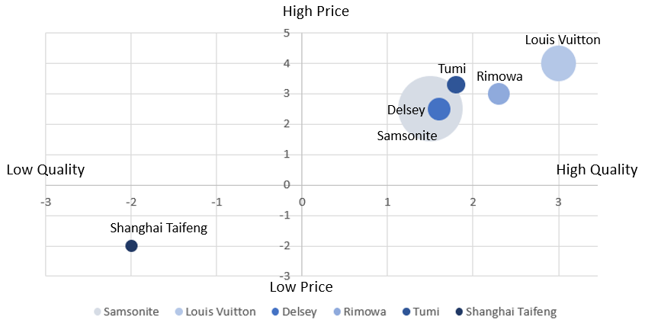
Source: Illustrated by writer

Samsonite maintains a global branding and offers its fine quality product at a premium price. The company has a unique selling proposition as the largest luggage and travel bag company. It aims to achieve the on-the-go lifestyle needs of the business professional (Samsonite IP Holdings S.a.r.l., 2021).

3.2 Marketing Mix Model

Marketing mix is a marketing activity use to sate the customers and to distinct the position of company. It is the combination of controllable marketing variables in pursuit the company’s growth in the target market. It is also known as 4Ps marketing mix which was proposed by Edmund Jerome McCarthy in 1960. Marketing mix is a fundamental model for marketing decision making in Product, Price, Place and Promotion (MaCarthy, 1964).

In order to understand the specifying marketing objectives and strategies of Samsonite, we will rely on marketing mix model for analyzing.

Figure 4. Marketing Mix Model of Samsonite
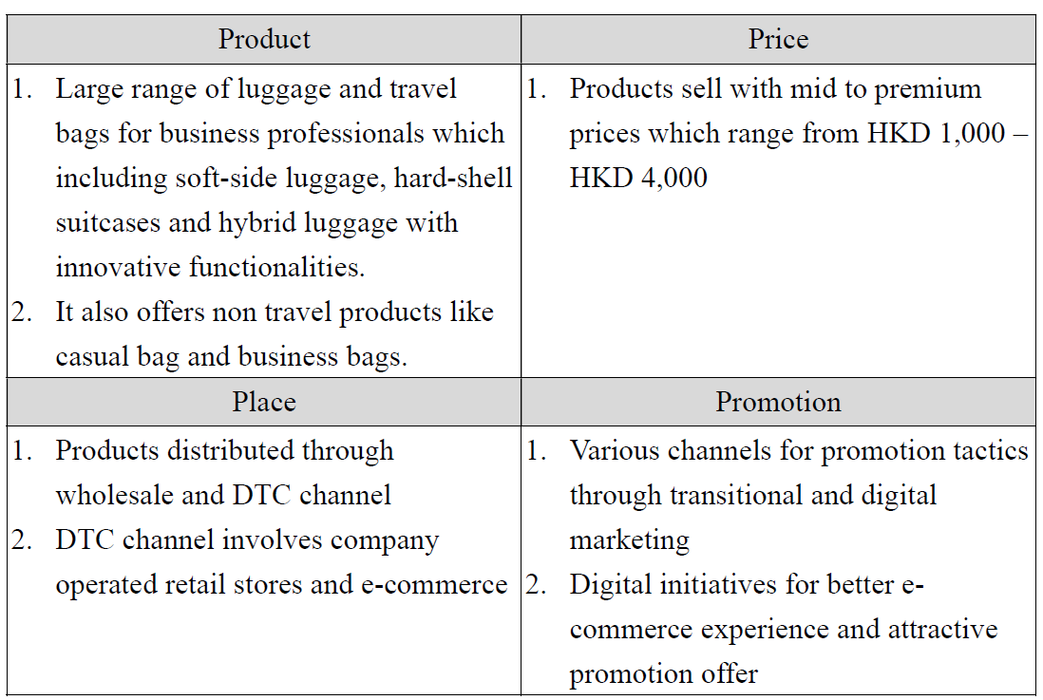
Source: Illustrated by writer

Samsonite’s product profile mainly divided into travel bag segment, casual bag and business bag segment. Travel products of suitcases and carry-on luggage are their core business. The company offers wide range of luggage and travel bags for business professionals. However, company’s business of travel related products experienced significant downturn due to the COVID-19 impacts, net sales of travel related products recorded 64.7% decrease when compared with 2019 (Samsonite International S.A., 2021). The company is also focus on non-travel products in the coming future while waiting the rebound in global travel and tourism.

The company sells its product with a wide price range from mid value to premium price at price range between HKD 1,000 and HKD 4,000. Samsonite’s products provide durability, fashion and value covering a diverse set of categories and price points. In average, Samsonite’s products are at an affordable price.

Samsonite distributes their products through wholesales and direct-to-customer (“DTC”) channels. All of the distribution channels recorded net sales decreases in 2020 because of COVID-19 pandemic. In 2020, 62.4% of net sales were generated from wholesales channel and DTC channel represented 37.5% of net sales (Samsonite International S.A., 2021). DTC channels involve company-operated retail stores and e-commerce. Due to COVID-19, it caused a shift of customer’s shopping behavior, there is a significant acceleration towards e-commerce channels. The company’s net sales through this channel surged to 22.1% of the net sales from 16.4% in 2020 (Samsonite International S.A., 2021). However, there is still grow room for development in the e-commerce channel for Samsonite.

Samsonite offers their promotion tactics through hybrid marketing channel which includes traditional marketing and digital marketing. The company relies on both pull and push strategy on promotion mix. On pull strategy, Samsonite promote their luggage products through advertising on billboards, printed magazines and television, in-store/ e-commerce sales promotion as well as public relation for engaging KOLs. The company welcome several KOLs included author Daisy Wong to share their travel experience (Marketing Interactive, 2018). On push strategy side, Samsonite involved personal selling through strong interaction between customer and their staffs with its company-operated retail stores. Due to the rise of e-commerce, Samsonite undergoes digital initiative to enhance the e-commerce experience and it also focuses on innovative digital transformation. The company relies on its company webpage, Facebook, Instagram, YouTube and App Store, etc, as promotion channel. The promotion mix seems to be effective as Samsonite has managed to perform well according to the company’s annual report 2018.

- Marketing future development plan and recommendation

Samsonite need to maintain its strengthen as part of its business growth plan, below section will advise the marketing development for Samsonite and provide recommendation for the company through optimize its opportunity to remedied its weakness and minimized the external economic threats.

4.1 Future development
Digital and e-commerce are growing fast nowadays, customers are more connected and use to purchase through digital channels. Marketing communication changed dramatically. With the help of digital technologies, the company can extend its business to new customers. Felix, Hinsh and Rauschnabel (2017) mentioned new technologies spread among the media exposure with a unique expansion of communication channel. New internet report stated about 78% of population are active on social media and 70% are willing to purchase online (AsiaPac Net Media, 2020).

As discussed in the pervious section, Samsonite’s e-commerce channel only generated 22.1% of total net sales in 2020 (Samsonite International S.A., 2021). Various companies in Hong Kong have been exploring different marketing strategies through the online platform. Hansen (2015) emphasized O2O business provide a unique competitive niche for Hong Kong’s retail business to promote their products and services. This business module can help Samsonite to scale up their business without incurring a higher cost for rental or adding sales staff at their stores. With the benefit of development of big data analysis and the surge in usage of online purchasing, Samsonite can extend their business from offline to online, this will be able to significantly increase its sales volume and the brand awareness.

4.2 Recommendation
In this section we will analysis Samsonite’s product portfolio and provide recommendation on digital marketing.

4.2.1 Ansoff analysis
In this section, Samsonite’s product portfolio will be analyzed with Ansoff Matrix. This business strategy tool was first evolved by Igor Ansoff who initially published in the Harvard Business Review. The company’s growth alternatives are recommended and determined with whether they are new or existing market through market penetration, market development, product development and diversification (Ansoff, 1957).
Figure 5. Ansoff matrix
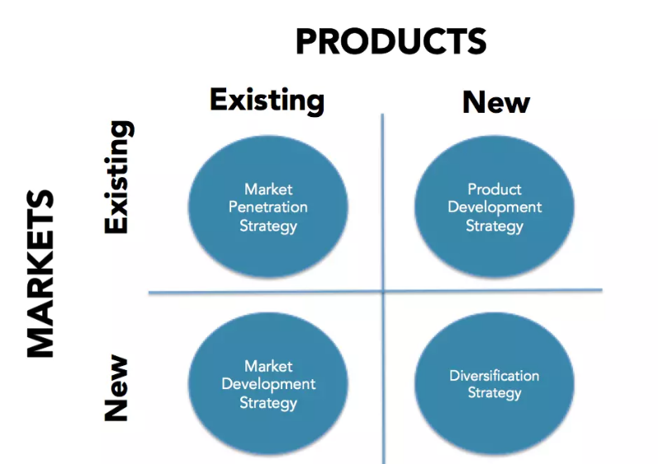
Sources: Oxford College of Marketing
Samsonite’s business is expected to be recovered after travel relaxation, however, in order to plan for business continuity, we have to further explore other business opportunities for business growth.

Figure 6. Ansoff matrix of strategic options for Samsonite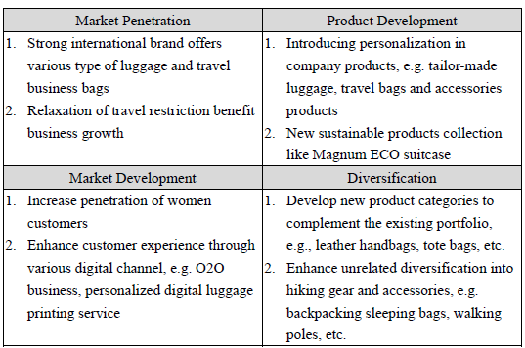
Source: Illustrated by writer

Ansoff matrix has been constructed as shown in Table 3, it is recommended to use ‘Market Development’ strategy which involves taking existing products into new market. A new market is recommended to implement through expanding its business into O2O platform and increasing the penetration of female customer segment. Samsonite has various distribution channel, as mentioned in previous section, its e-commerce market should be enhanced.

With the help of R&D department of the company, it can be further extended to ‘Product Development’ strategy which involved introducing the personal and sustainable luggage.

    - Market development and action plan

Women purchase power should not be underestimated, it is growing and become a driving force of spending. Female regard 85% of all purchases and they drive 70-80% of all consumer spending (Matthews, 2019). More females are get used to online shopping now. Digital transformation technologies are being adopted by organizations as part of their transformation effort (De, Pal and Pandey, 2020). Samsonite should ride on these changes as an opportunity to enhance their penetration of female customer through offering personalized colorful digital luggage.

Personalization has become the trend in recent years and helps the customer to navigate the offerings for a faster purchase decision (Khusainova, 2020). Samsonite can make use of this trend to extend their business with genuine design of colorful luggage. Customer can express their own ideas or nature through personalized printing artworks. This approach not only to attract customer who look for individuality by customizing their own luggage, but also attract young female who like colorful luggage. Female are always attracted to softer or bright colors. With the help of enhancement in e-commerce channel, Samsonite’s business is expected to increase 10% -15%.

- Conclusion
In Conclusion, Samsonite faced adversely challenges on its business performance due to the disruptive impact of COVID-19 on travel and tourism industry. The company’s weakness on its e-commerce channel and the penetration of customer segment were determined. Samsonite is a global leading travel bags and luggage company, its strengthen need to be maintained as part of its business growth plan and optimize its opportunity to remedy its weakness. Business growth alternatives of Samsonite through implementation of O2O business and enhancement on its female customer segment with development of digital personalization were recommended. This will help to promote and maintain Samsonite’s position as an international reputable player in lifestyle bag and travel luggage industry.

