

Assignment

Student Name: Magdalena Urbanska

Student ID: 2245520

Module: Digital Marketing

Module Code: LCMB7010

Lecturer’s Name: Amitave Banik

Submitted on: 25.12.2023

The Table of Contents

1. Introduction.........................................................................................................................3
1.1 The Objectives of The Report......................................................................................3
1.2 The Case Study of IKEA..............................................................................................3

2. IKEA’s Digital Transformation.............................................................................................4

3. A Critical Analysis of IKEA’s Digital Assets.........................................................................7

4. IKEA’s Internal and External Communication Structural Flows........................................11

5. Digital Marketing Strategy – A Critical Analysis of IKEA...................................................16
5.1 The Segmentation, Targeting, Positioning Marketing Model.................................16
5.1.1 Segmentation.........................................................................................................16
5.1.2 Targeting................................................................................................................16
5.1.3 Positioning..............................................................................................................16
5.2 The Marketing Mix Strategy – 7 Ps........................................................................17
5.3 The PR Smith’s SOSTAC Marketing Planning Model............................................20
5.4 The Sweet Spot Strategy.......................................................................................22

6. IKEA’s Digital Technologies – A Critical Analysis.............................................................24

7. The Role of Artificial Intelligence and Machine Learning in Digital Marketing...................31

8. IKEA’s Artificial Intelligence and Machine Learning in Digital Marketing..........................32

9. Recommendations............................................................................................................33

10. Conclusion......................................................................................................................33

References.............................................................................................................................29

1. Introduction

  - The Objectives of The Report

The aim of this report is to introduce the case study of IKEA and outline the company’s on line and off line operations globally.

The report will begin with elaborating on IKEA’s digital transformation and the increase in its on line sales over the years. A critical analysis of IKEA’s digital assets, technologies as well as internal and external communication structural flows will be presented. The Digital Marketing Strategy will be discussed with a specific focus on the Segmentation, Targeting, Positioning Marketing Model, the Marketing Mix Strategy – 7 Ps as well as the PR Smith’s SOSTAC Marketing Planning Model and the Sweet Spot Strategy.

The report will then elaborate on the role of Artificial Intelligence and Machine Learning in Digital Marketing, especially IKEA’s Artificial Intelligence and Machine Learning in Digital Marketing, followed by some possible future recommendations for the company as well as conclusion of findings.

1.2 The Case Study of IKEA

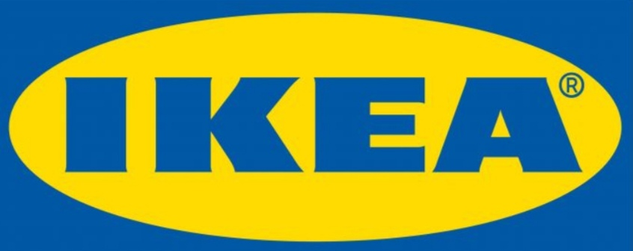

IKEA’s logo re designed in 1983

Source: Alzghool, 2020, p.4

IKEA was founded in 1943 by Ingvar Kamprad in Älmhult in Sweden. He grew up on the farm. He had always had a superb entrepreneurial spirit and mind, and only one ‘dream to create a better life for as many people as possible – whatever the size of their wallet (...)’. (IKEA Global, 2023) Ingvar ‘made frequent incognito visits to his own stores to ensure consistency of operations and superior service delivery.’ (Kotler, Keller and Chernev, 2022, p.450)

IKEA has grown to be one of the most successful global furniture retailers. ‘According to Kantar Millward Brown's "Brandz Top 100 Most Valuable Global Brands 2020", not only is IKEA the most valuable furniture retailer brand in the world, it is also the fourth most valuable retailer in the world, valued at around 48 billion U.S. dollars. The business operates 433 stores and is present in the major world markets. There are more than 800 million customer visits to IKEA stores every year.’ (Statista Research Department, 2023)

IKEA’s Vision Statement

IKEA’s vision is ‘to create a better everyday life for the many people’. (IKEA United Kingdom, 2023)

IKEA’s Mission Statement

’Our business idea supports this vision by offering a wide range of well-designed, functional home furnishing parts at prices so low that as many people as possible will be able to afford them.’ (Kotler, Keller and Chernev, 2022, p.56)

2. IKEA’s Digital Transformation

In the financial year 2022, the UK was rated as the fifth in the global ranking in terms of selling of IKEA products, accounting for 6.6 percent of IKEA’s total sales. (Statista Research Department, 2023)

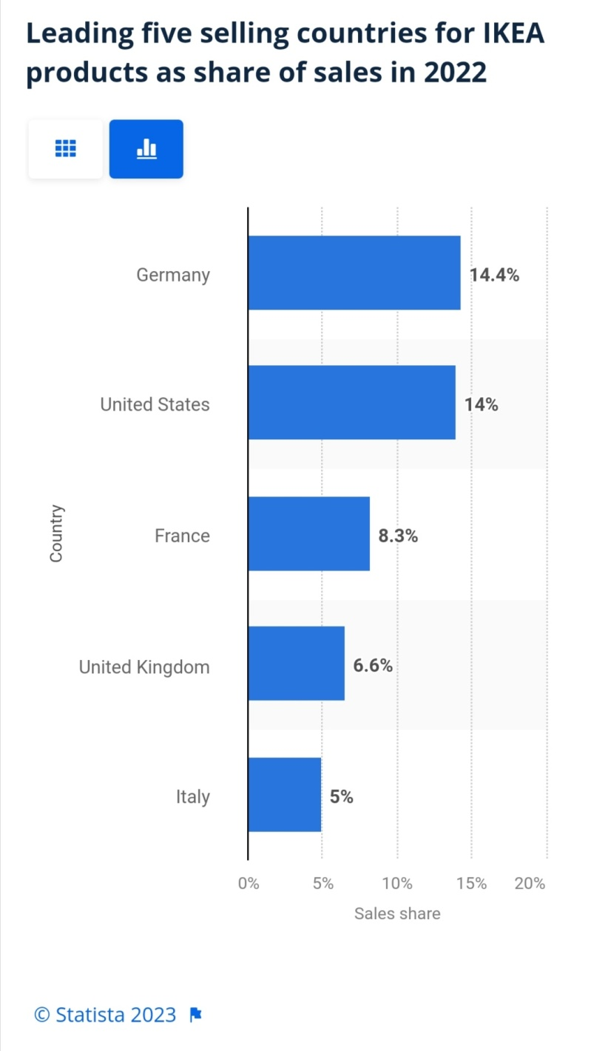

Source: Statista Research Department, 2023

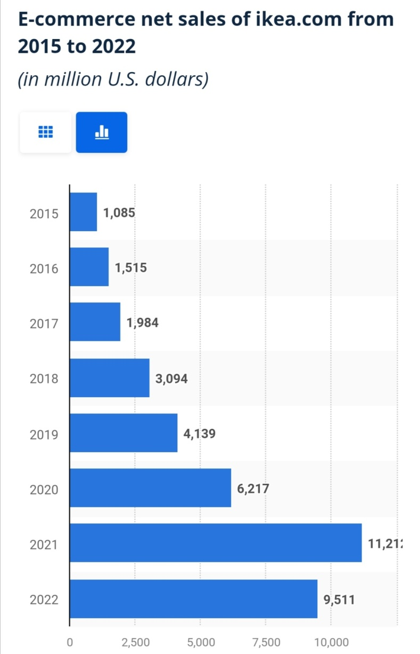

Source: Beyrouthy, 2023

‘In 2022, it was estimated that Swedish furniture retailer IKEA generated approximately 9.5 billion U.S. dollars in e-commerce net sales worldwide.’ (Beyrouthy, 2023)

IKEA has been increasing the sales on line through a very successful digital marketing strategy (Cezim, 2023):

- On line campaigns
- On line advertising
- 24/7 service
- Digital posters
- Social media marketing
- Digital marketing channels
- Content marketing
- Brand strategy

‘(...) We are revamping customer interactions both digitally and, in the store, and we’re connecting them. For instance, you might start planning your new kitchen by yourself at home on ikea.com, and then you come to the store or connect with a remote customer meeting point, and we should be able to meet you where you are. Another example is the “Shop & Go” feature in the IKEA app (...) which allows you to use your own mobile device to scan, pay for items and skip the checkout line in the store. That requires a complete modernization and reengineering of all the tech landscape within IKEA. (...) It requires reengineering of the full value chain, which needs to be governed by data and become more flexible than before. The result is meant to be a seamless, consistent customer experience.’ (Stackpole, 2021)

3. A Critical Analysis of IKEA’s Digital Assets

Website

One of the most important, if not the most important, IKEA’s digital asset. The company is not able to do business without a website.

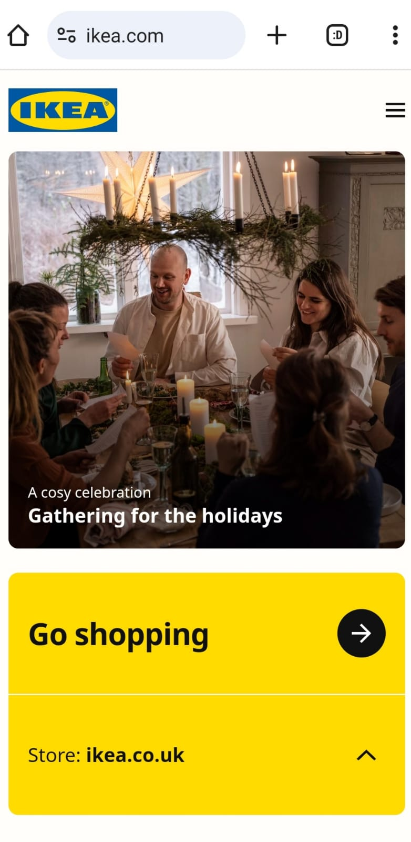

IKEA’s Corporate Website

Source: IKEA’s Corporate Website, 2023

Google Analytics

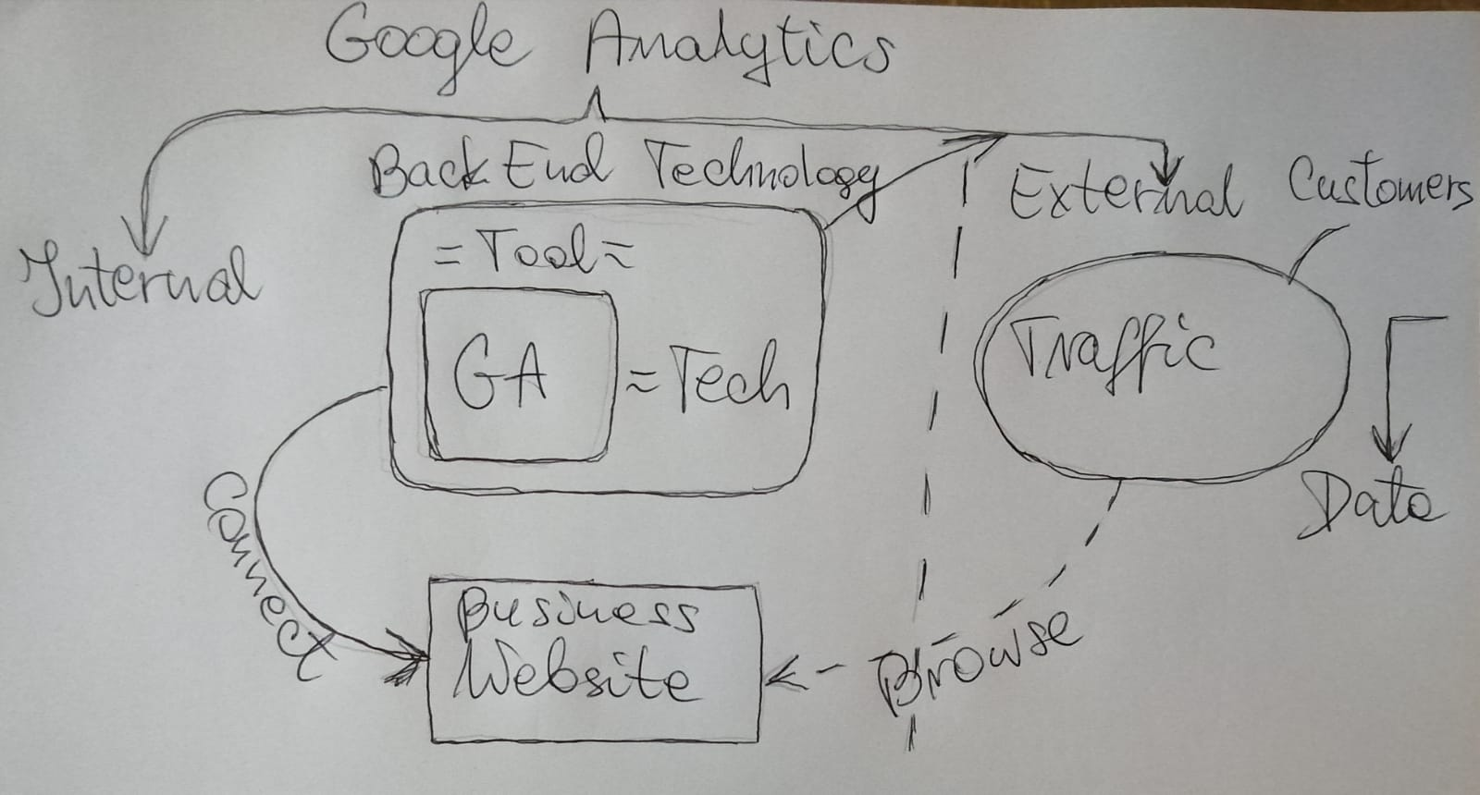

Google Analytics

Source: Author’s Creation

Customer Relationship Management (CRM)

CRM can play an operational or analytical function.

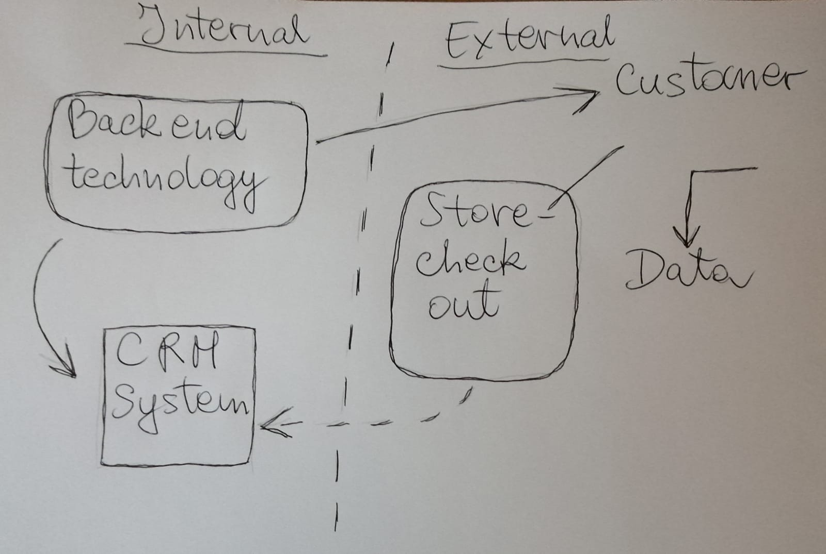

Customer Relationship Management System (CRM)

Source: Author’s Creation

Electronic Customer Relationship Management (E CRM)

CRM – desktop, off line
E CRM – on line

Enterprise Resource Planning (ERP)

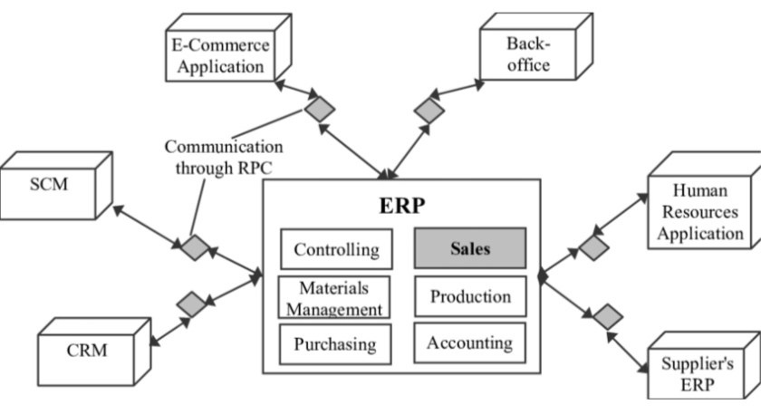

Enterprise Resource Planning System and Extensions

Source: Jankowska and Kurbel, 2005, p.381

Data

Collected.

Marketing Information System (MIS)

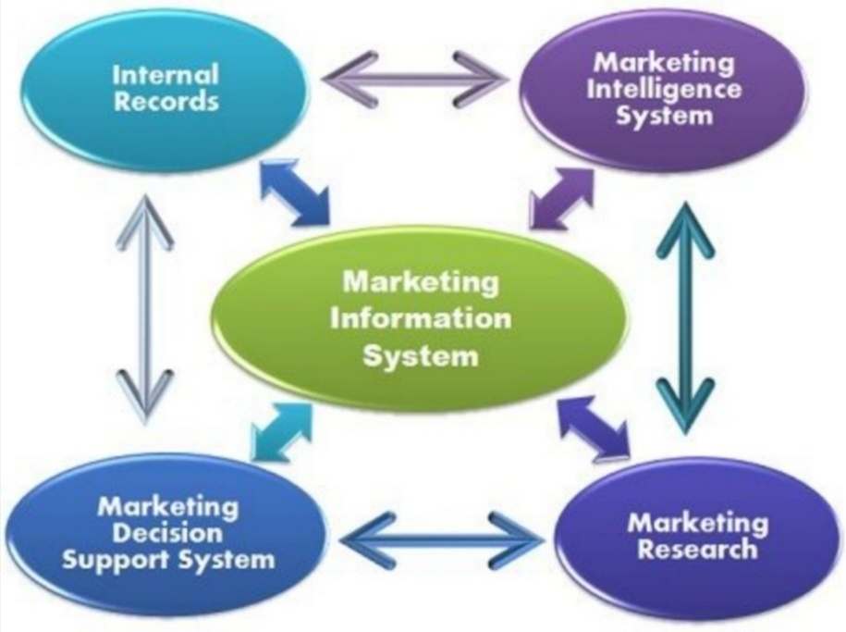

Components of Marketing Information System

Source: Business Jargons, 2023

IKEA do not use the Marketing Information System. The company uses Customer Relationship Management System and Enterprise Resource Planning System.

4. IKEA’s Internal and External Communication Structural Flows

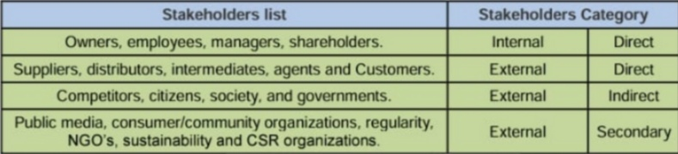

IKEA’s Stakeholders

Source: Alzghool, 2020, p.6

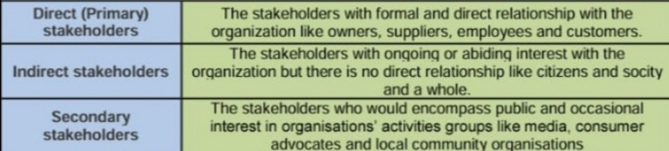

IKEA’s Stakeholders

Source: Alzghool, 2020, p.6

IKEA’s clients or suppliers are the external stakeholders. IKEA’s staff, at all levels, are the internal stakeholders. Internal and external stakeholders can influence as well as be influenced by the organisation.

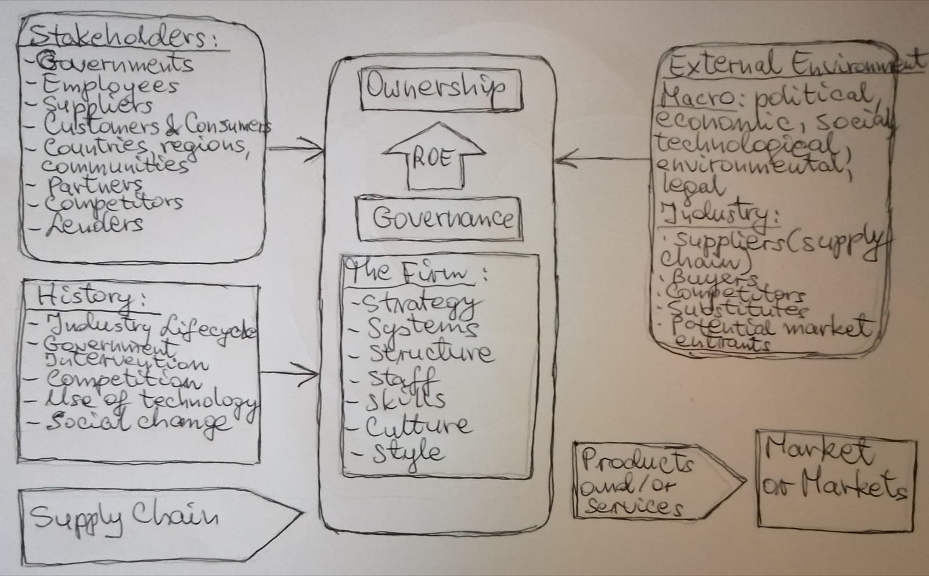

Source: Author’s Creation, 2023

Customer touchpoints – the way the company connects with the customers.

There are pre sale, during sale and post sale touchpoints.

A customer inside IKEA store scans their products at a check out point. The machine and self service are the touch points. The customer is the external communication structural flow who through a touch point gives the data about their purchase into IKEA’s Customer Relationship Management (CRM) system. The data given and now in the system is the internal communication structural flow and the company’s asset. The company can target the customer with advertising, asking for a feedback, etc. A blog content – another way to advertise a product.

IKEA’s Internal and External Communication Structural Flow

Source: Author’s Creation, 2023

IKEA’s systems: CRM and ERP

CRM

‘IKEA Sweden partnered with Capgemini, a Microsoft Gold Partner, to build a Dynamics 365 and Power Platform solution for its sales staff to improve the kitchen buying experience for individual customers (B2C) and businesses (B2B).‘ (Bhangar, 2020)

ERP
‘IKEA, the home furnishings business, has named K3 Retail, a provider of retail solutions based on Microsoft technology, as its sole outsourced provider of retail enterprise retail planning (ERP) software packages for its franchisee network on a global basis. After a comprehensive review of its global IT requirements, IKEA has decided that all its franchisees must adopt an IKEA standard IT platform. K3’s retail software operation based in Holland is already IKEA’s software partner of choice for 10 of its franchisees, with K3 having developed the IKEA master version of Microsoft Dynamics for these countries.’ (Retail Technology, 2023)

Internal communication structural flow: data in CRM and ERP
CRM stores employees, production, sales, marketing, research and development or customer service data.

ERP stores sales, production, accounting, controlling, materials management, supply chain or purchasing data.
Data in both CRM and ERP are IKEA’s assets.

Enterprise Resource Planning System and Extensions

Source: Jankowska and Kurbel, 2005, p.381

Search Engine Optimisation (SEO) is a touch point on line.

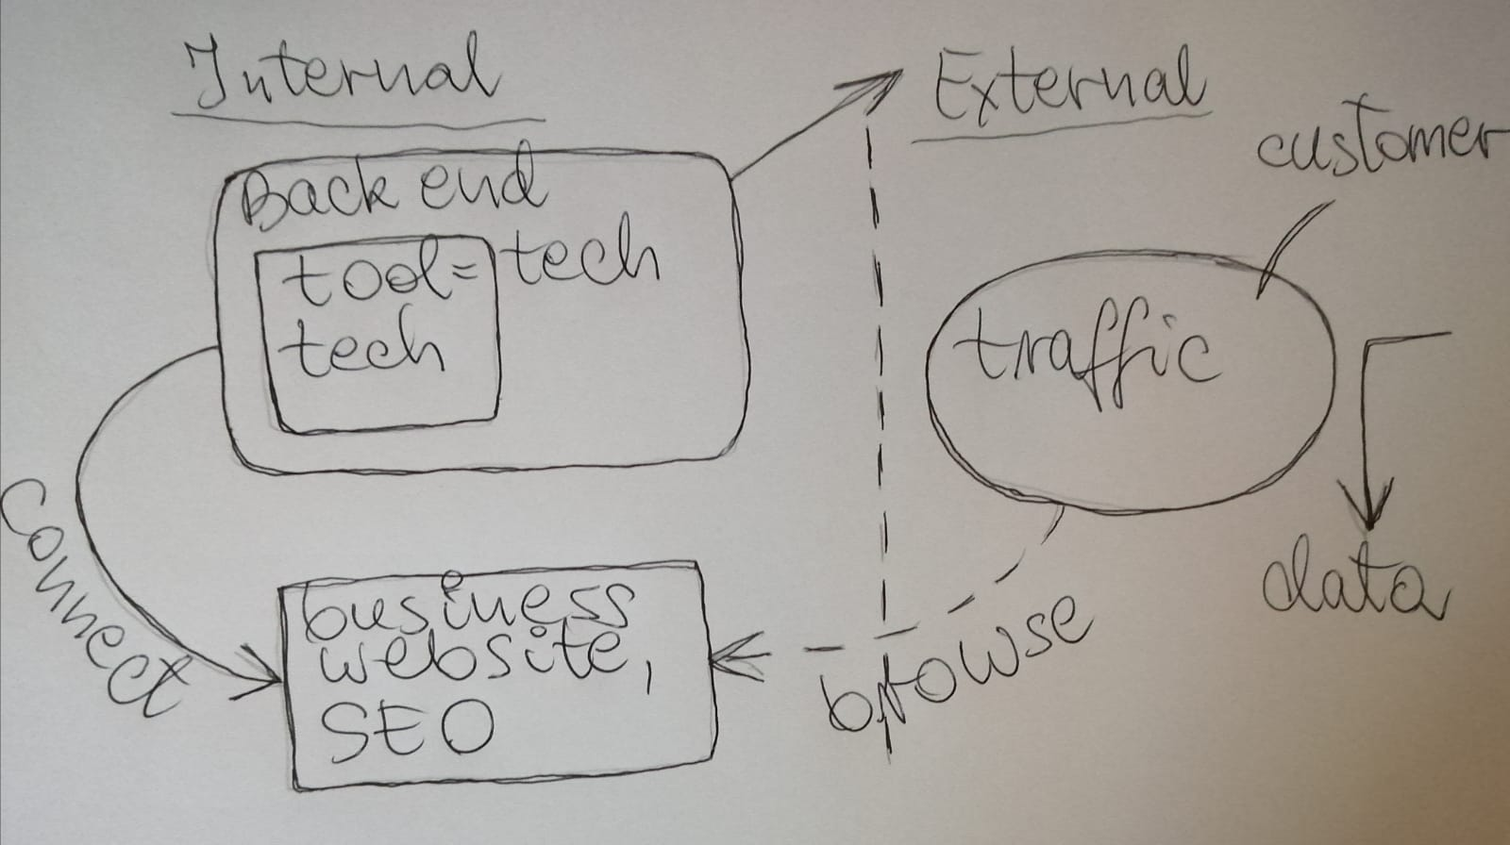

Search Engine Optimisation (SEO)

Source: Author’s Creation

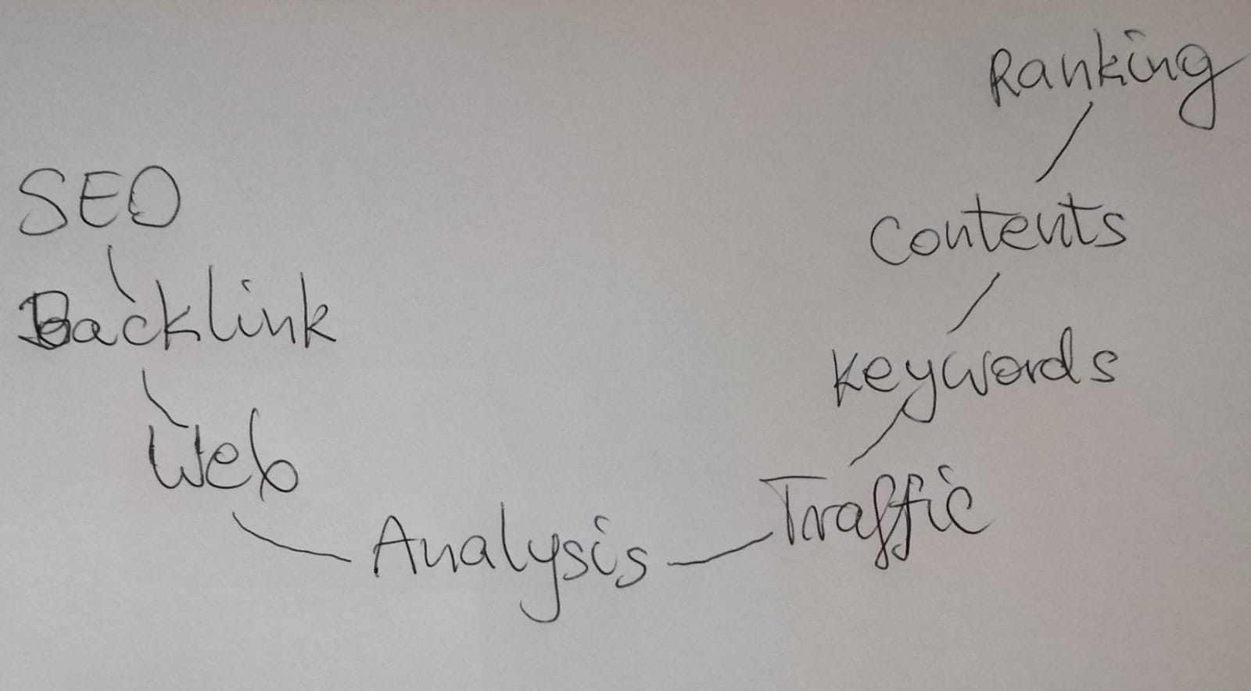

Search Engine Optimisation (SEO)

Source: Author’s Creation

Search Engine Optimisation (SEO) is linked with other e marketing technologies such as pay per click or affiliate marketing.

5. Digital Marketing Strategy – A Critical Analysis of IKEA

5.1 The Segmentation, Targeting, Positioning Marketing Model

By segmenting/ grouping the market, the needs and wants of the customers can be identified more effectively. After that, the marketing mix elements can be created more easily.

5.1.1 Segmentation

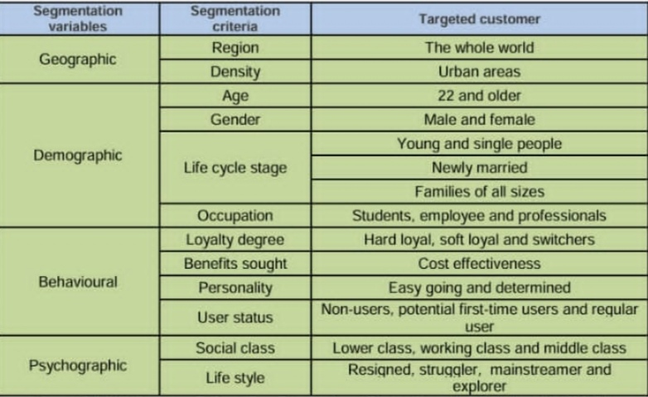

IKEA’s Segmentation

Source: Alzghool, 2020, p.16

5.1.2 Targeting

IKEA applies mass marketing (undifferentiated) strategy – the same offer for everyone.

5.1.3 Positioning

Positioning is the brand image created in the minds of consumers. Value proposition is the key.

IKEA uses strategic positioning. The company ‘targets young furniture buyers who want style at low cost.’ (Porter, 2011, p.9)

5.2 The Marketing Mix Strategy – 7Ps

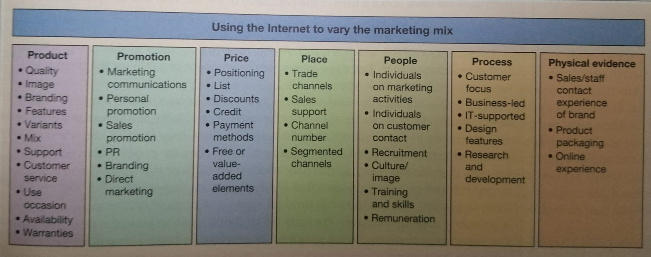

The Extended Marketing Mix Strategy – 7Ps – and The Use of The Internet

Source: Chaffey, Hemphill and Edmundson-Bird, 2019, p.341

E Marketing Mix – Electronic Marketing Mix

Product

Product is defined by its packaging, design, quality and brand.

Price

The factors that can influence the products prices are: demand, supply, taxes, inflation, the political or economic situation of a country or competition.

IKEA has applied economy pricing as a pricing strategy and ‘targets young furniture buyers who want style at low cost.’ (Porter, 2011, p.9)

Place

IKEA uses a direct channel of distribution.

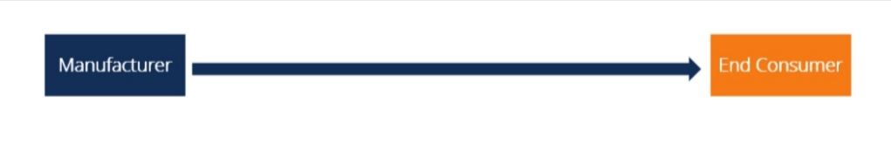

Direct Distribution Channel

Source: CFI Education Inc., 2023

The company sells the goods in stores and on line directly to customers.

IKEA owns its factories and suppliers, therefore, the company can manufacture the products cheaper than the competitors and it can also control the costs – the vertical marketing system and forward vertical integration strategy.

‘Rather than rely solely on third-party manufacturers, Ikea designs its own low-cost, modular, ready-to-assemble furniture to fit its positioning.’ (Porter, 2011, p.11)

IKEA has been applying franchising as the market entry method. ‘Today, IKEA is a franchise business, with many companies operating under one IKEA brand. Inter IKEA Systems B.V. is the franchisor, responsible for continuously developing the IKEA Concept and ensuring its implementation in new and existing markets.’ (IKEA United Kingdom, 2023)

Promotion

Promotional Mix – Business to Business (B2B)

- All IKEA’s websites, including the global one, are in English.

- ‘IKEA for business’ global site. (IKEA United Kingdom, 2023)

- Tmall – Alibaba’s B2B e commerce platform for global trade – an indirect channel of distribution. (Inter IKEA Systems B.V., 2023)

- Direct marketing – sending informative e-mails and text messages about the products and company’s announcements.

- Digital marketing – collecting and monitoring the business partners’ data in the database, using the CRM system.

- Search Engine Optimisation (SEO) – improving the visibility in Google and being at the top of searches in the search engine.

- Public Relations – sending press releases to business partners about special events and products launches.

- Promotional coupons, vouchers or free gifts, especially to loyal partners.

- Collaborating with design, furniture or fashion magazines.

- Involvement in the sponsorship and charity. (IKEA United Kingdom, 2023)

- Partnership with London’s Design Museum and the creation of IKEA’s ‘Home Futures’ exhibition – a brand influencer. (Cornish, 2018)

Promotional Mix – Business to Customer (B2C)

- All IKEA’s websites, including the global one, are in English.

- Direct marketing – sending informative e-mails and text messages about the products and company’s announcements.

- Search Engine Optimisation (SEO) – improving the visibility in Google and being at the top of searches in the search engine.

- Digital marketing – collecting and monitoring the customers’ data in the database, using the CRM system.

- Promotional coupons, vouchers or free gifts, especially to loyal customers.

- Public Relations – sending press releases to clients about special events and products launches.

- Creating displays in stores, where the customers can test the products before purchasing.

- IKEA posters inside underground stations.

- Traditional stores (off line).

- Designated places in stores, where the consumers can use the computer simulation of furniture and design the spaces on their own or using an on line app instead – the use of AI.

- Over the next three years, IKEA is going to invest £1bn in London, mostly in retail, innovation, ecommerce and omnichannel. (Rigby, 2022)

- The IKEA Hammersmith store (London) is the first cashless store in the UK with 1,800 of stock and additional 4,000 available for ordering. (Rigby, 2022)

- Relationship marketing – database, loyalty card.

- Customer Relationship Management (CRM) system and Enterprise Resource Planning (ERP) system – internal data for planning and forecasting.

- Social media marketing – on line advertising on social media platforms such as Facebook, Twitter, TikTok or Instagram or a YouTube channel, for example. Adapting a message quicker and cheaper.

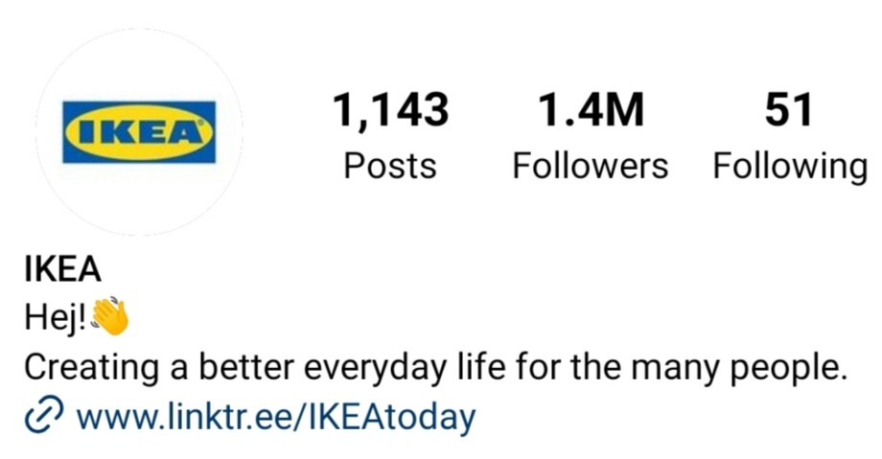

IKEA’s Instagram Followers Count

Source: Instagram, 2023

People

- In 2022, IKEA employed 231,000 workers globally – an increase of approximately 80,000 staff since 2013. (Statista Research Department, 2023)

- IKEA Retail operates ‘more than 482 IKEA stores and planning studios in 31 countries around the globe.’ (Ingka Holding B.V., 2023)

Process

- IKEA uses a chatbot Billie and customer services to deal with customers’ complaints on line. (IKEA United Kingdom, 2023)

- To help answer the customers’ questions, IKEA introduced a chatbot/ avatar in the ‘Ask Anna’ feature that uses AI and connects to all the brand’s products. (Chaffey and Ellis-Chadwick, 2022)

Physical Evidence

- Content on the website (on line).
- Physical stores (off line).

5.3 The PR Smith’s SOSTAC Marketing Planning Model

The SOSTAC Marketing Panning Model was developed by PR Smith in the 1990s. The SOSTAC marketing planning refers to Situation analysis, Objectives, Strategy, Tactics, Action and Control.

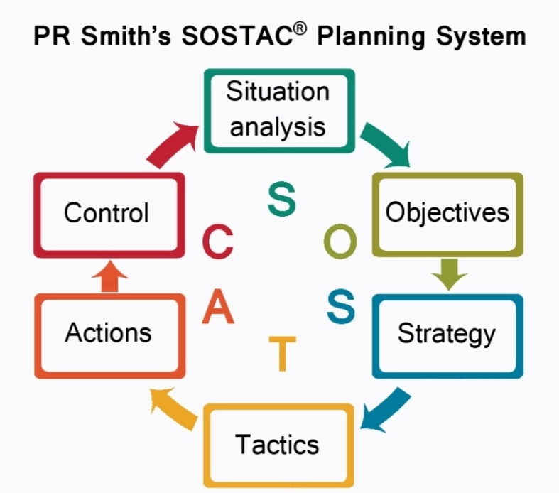

Source: PR Smith Marketing Ltd, 2023

Situation Analysis

Where are we now?

Objectives

Where do you want to be?

Strategy

It summarises how you are going to fulfil the objectives.

Tactics

They are the details of strategy.

Actions

They are the details of tactics.

Control

How do we know we are getting there?

The RACE (Reach Act Convert Engage) Growth System and TOWS form of SWOT analysis supports The SOSTAC Marketing Panning Model.

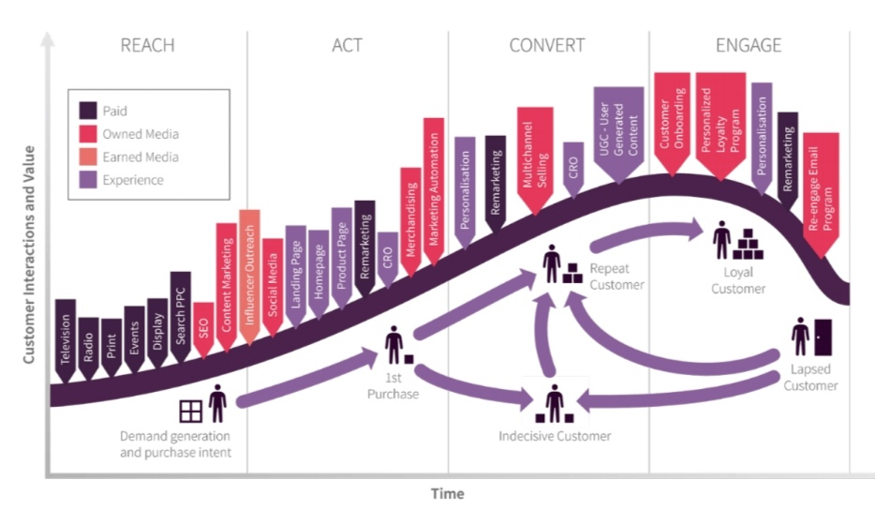

The RACE (Reach Act Convert Engage) Growth System

Source: Chaffey, 2022

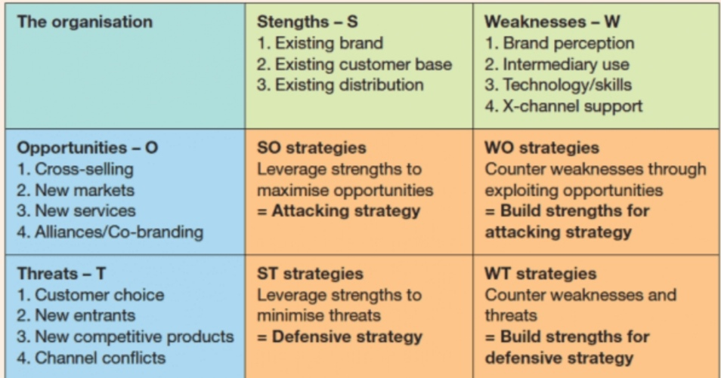

The TOWS Form of SWOT Analysis

Source: Chaffey, 2022

5.4 The Sweet Spot Strategy

IKEA applies the Sweet Spot Strategy both on line and in store (off line), aiming to obtain its customers’ maximum satisfaction.

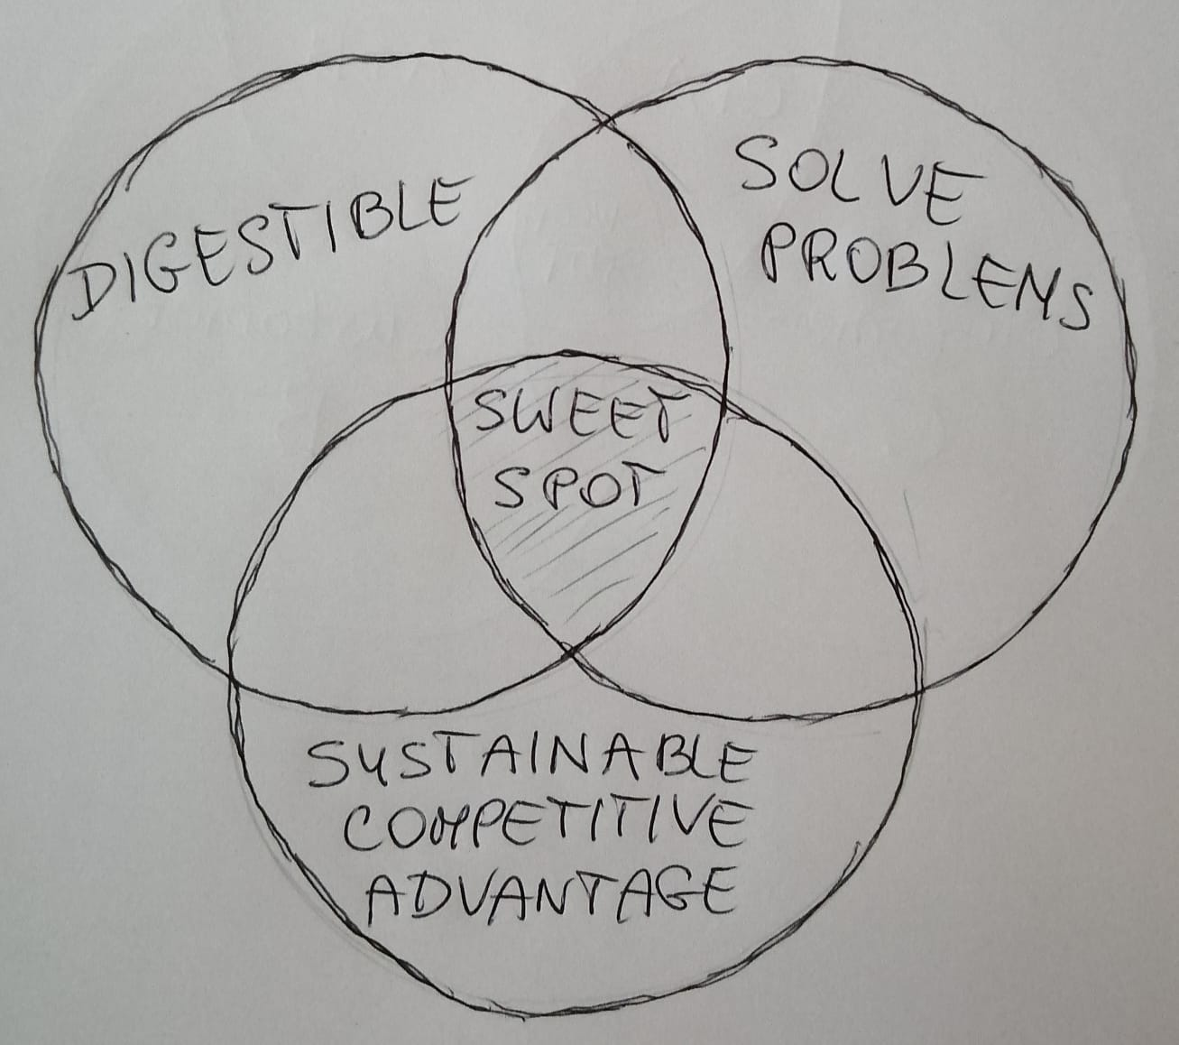

The Marketing Sweet Spot

Source: Author’s Creation, 2023

Digestible (Atkins, 2019)

To break the boundaries between art and design, IKEA launched the Art Event Collection, involving international artists presenting the range of domestic objects. (UNITED DIRECTION Team, 2021)

Solve Problems (Atkins, 2019)

IKEA has introduced ‘buy now, pay later (BNPL)’ service – ‘Pay in 4’, which ‘(...) lets customers pay for products in four payments over a six-week period.’ It is available on line and in store (off line). ‘(...) the mobile conduits and QR codes that had become staples of the digital shift spurred by the pandemic are now favored by IKEA’s “sweet spot” of 20-40-year-old consumers.’ (PYMNTS, 2023)

Sustainable Competitive Advantage (Atkins, 2019)

‘One of the key competitive advantages IKEA has is its extensive knowledge about the customers. The company understands the purchasing factors that influence customers to buy and implements the best practices to induce that decision. Low prices are the cornerstone of the IKEA business idea and the company always tries to do things as efficiently and cost-effective as possible.’ (Statista Research Department, 2023)

6. IKEA’s Digital Technologies – A Critical Analysis

Website
Website is IKEA’s asset, but also IKEA’s technology.

IKEA’s Corporate Website

Source: IKEA’s Corporate Website, 2023

Landing Page

A standalone page on a website that is designed to influence a visitor to take a certain action.

Landing page is IKEA’s technology, but it is also IKEA’s strategy.

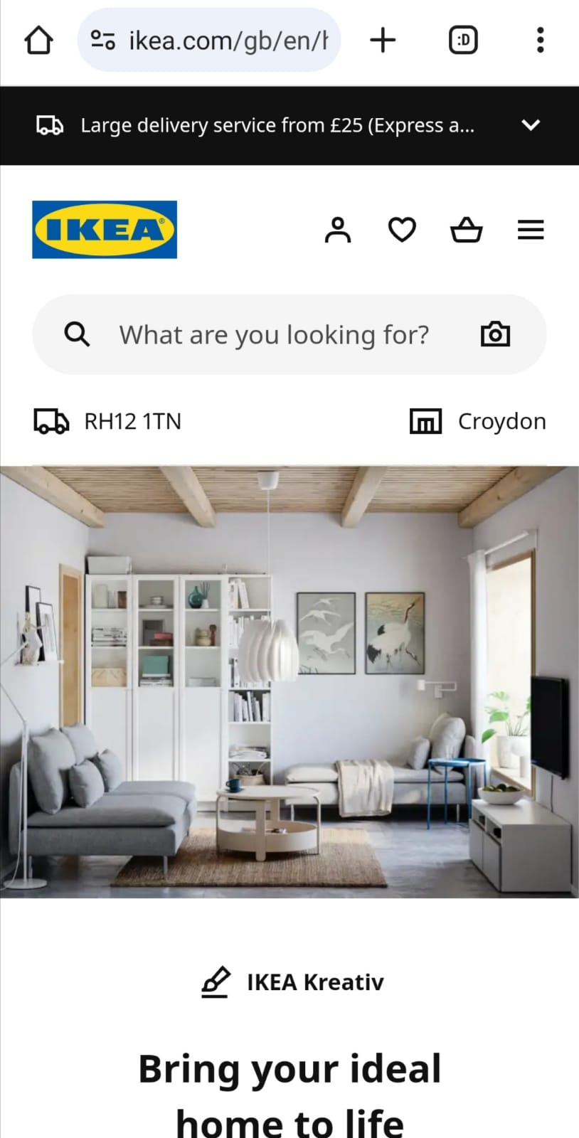

IKEA’s Landing Page

Source: IKEA United Kingdom, 2023

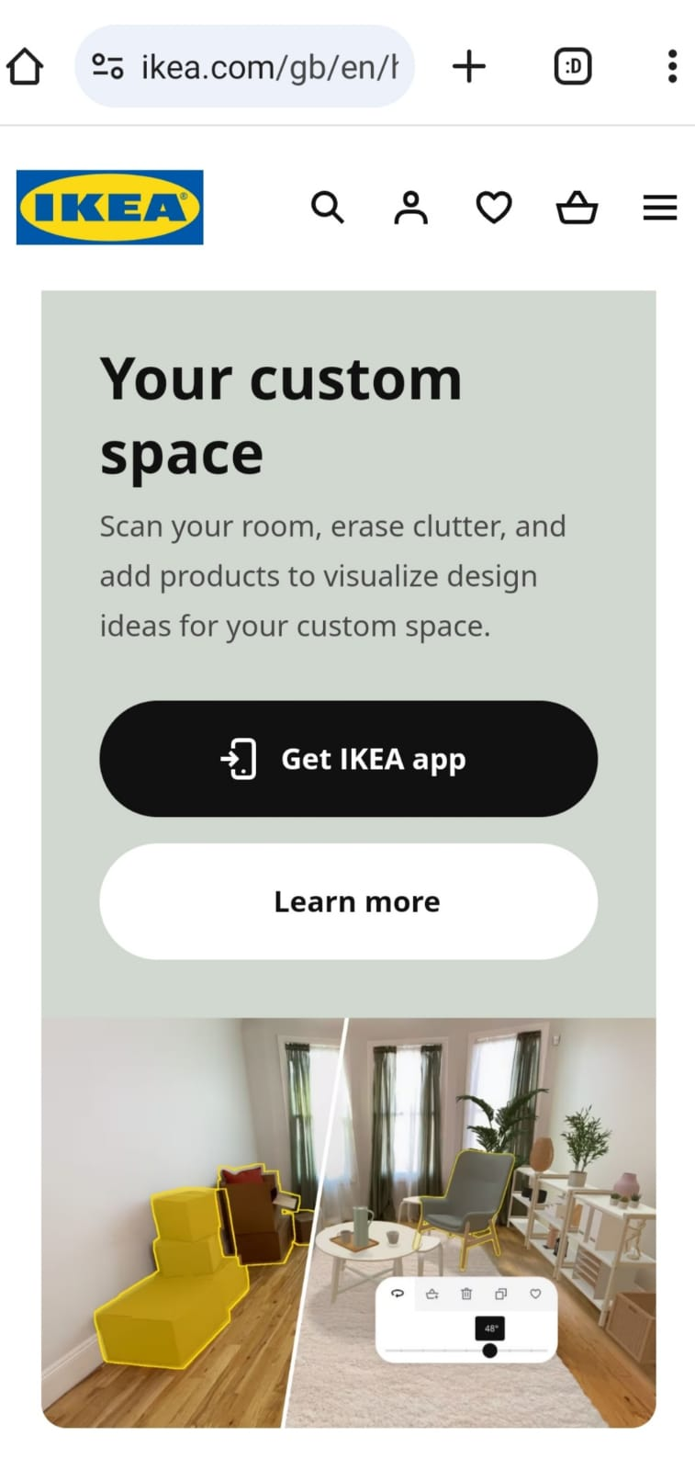

IKEA’s Landing Page

Source: IKEA United Kingdom, 2023

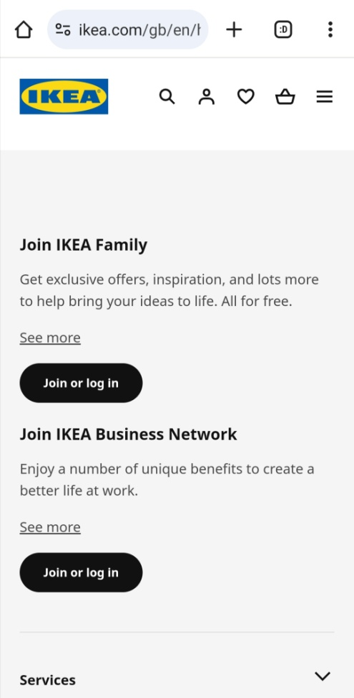

IKEA’s Landing Page

Source: IKEA United Kingdom, 2023

Pop Up Ad
Search Engine Optimisation (SEO) is a touch point on line.

Search Engine Optimisation (SEO)

Source: Author’s Creation

Search Engine Optimisation (SEO)

Source: Author’s Creation

Google Analytics

Google Analytics

Source: Author’s Creation

Pay Per Click
Affiliate Marketing
Apps
IKEA mobile apps developed: IKEA app, IKEA Kreativ app, IKEA Place app, IKEA Home smart app or IKEA Finance app. (IKEA United Kingdom, 2023)

Chatbot

Cookies

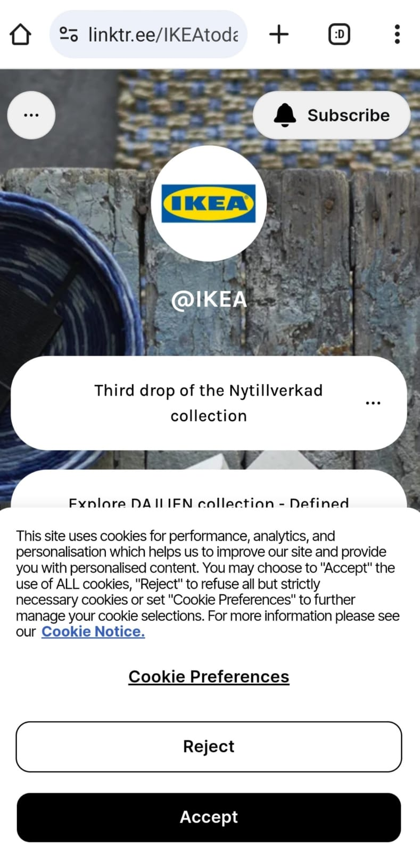

IKEA Cookies

Source: IKEA’s Website, 2023

Web Beacons

AR (Augmented Reality)

‘In e-commerce, AR applications are allowing online shoppers to download holograms of products. (...) IKEA (...) offer libraries with thousands of 3-D product images and apps that integrate them into a view of an actual room, enabling customers to see how furniture and decor will look in their homes. IKEA also uses its app to collect important data about product preferences in different regions.’ (Porter and Heppelmann, 2019, p.65)

‘Some AR experiences involve more complexity than others. Experiences that allow people to visualize products in different configurations or settings – like those created by IKEA (...) – are a relatively easy place for companies to start. Consumers just need to be encouraged to download and launch AR apps, and only a mobile device is needed to use them.’ (Porter and Heppelmann, 2019, p.70)

A collaboration between Warpin Reality – an extended reality (XR) company and Meta Platforms and IKEA to create an AR app that functions as an app filter on Instagram. It aims to educate about pollution and litter on the ocean’s delicate ecosystem. (Today Digital, 2023)

VR (Virtual Reality)

‘They are important new technologies that we need to test and try. We’ve been testing VR in the store, to visualize how a piece of furniture fits in a room. We recently acquired a California company by the name of Geomagical Labs. With their new AI technology, we will bring home visualization to a different level. By letting you scan your home, one room at a time, and turn it into a 3D model in which you can try out the IKEA home product range from any location. It’s a tool for democratizing home design, and that means it must be accessible to everyone. You will be able to access it via any smartphone — iPhone or Android; it needs to be simple enough for people to use it.’ (Stackpole, 2021)

7. The Role of Artificial Intelligence and Machine Learning in Digital Marketing

Artificial Intelligence

‘Artificial intelligence leverages computers and machines to mimic the problem-solving and decision-making capabilities of the human mind’ (IBM, 2023)

Machine Learning

It is a sub field of Artificial Intelligence. ‘(...) machine learning is more dependent on human intervention to learn. Human experts determine the hierarchy of features to understand the differences between data inputs, usually requiring more structured data to learn.’ (IBM, 2023)

Why is Machine Learning powerful?

Segmentation in Machine Learning

Artificial Intelligence and Machine Learning has revolutionised the data analysis by developing very important and powerful algorithms such as k-means clustering. ‘K-means clustering, a part of the unsupervised learning family in AI, is used to group similar data points together in a process known as clustering.’ (Sharma, 2023) Grouping data points into clusters help analyse and understand the data.

K-means clustering algorithm is used in customer segmentation in machine learning across various industries, including banking, sales, e commerce or advertising, to name a few. (Sharma, 2023)

Artificial Intelligence and Machine Learning in Digital Marketing
There are a number of applications of Machine Learning in Digital Marketing to Maximise ROI and ROS:

- Dynamic Pricing
- Predictive Analytics
- Behaviour Analysis
- Content Creation
- Creation at Scale
- Search Engine Optimisation
- PPC Ad Optimisation
- Customer Service Chatbots.

8. IKEA’s Artificial Intelligence and Machine Learning in Digital Marketing

IKEA uses both Artificial Intelligence (AI) and Machine Learning (ML).

- IKEA Kreativ, an AI-driven digital design experience, has been created to enable the customers to design and visualise their living space. It can be done from a computer desktop or by using a smartphone. (Inter IKEA Systems B.V., 2023)

- IKEA Kreativ combines the extensive experience and knowledge of homes as well as ‘spatial computing, machine learning and 3D mixed reality technologies.’ (Inter IKEA Systems B.V., 2023)

- IKEA Kreativ was developed by Geomagical Labs, the Silicon Valley AI specialists, acquired by Ingka Group in April 2020. (Inter IKEA Systems B.V., 2023)

- ‘Customers can explore IKEA products, combinations, and design ideas in a gallery of more than 50 inspirational 3D showrooms, available from the new Design page of IKEA Kreativ. Customers can easily browse the IKEA catalogue and try out products in lifelike spatial settings – quickly swapping, moving, rotating, stacking, and hanging IKEA products to select the perfect product options.’ (Inter IKEA Systems B.V., 2023)

- A Demand Sensing tool – the forecasting system – to predict future demand, based on sales and demand from past years. ‘(...) Demand Sensing can make use of up to 200 data sources for each product to calculate forecasts and predict the future demand more smartly and effectively. The tool can use several influencing factors, such as shopping preferences during festivals, the influence of seasonal changes on purchase patterns, and weather forecast, among others.’ Demand Sensing is a fantastic example of using AI for supply chain planning. (Inter IKEA Systems B.V., 2021)

- Automation. In November 2022, the IKEA Tokyo-Bay warehouse became the first automated IKEA store in Japan. (Inter IKEA Systems B.V., 2023)

- The improvement of IKEA’s logistics operations. ‘IKEA views the entire Kanto region as a single market (One Tokyo Market) and aims to maximise seamless coordination and fulfilment capabilities between shops.’ (Inter IKEA Systems B.V., 2023)

- The acceleration of the omni channel approach. ‘In Japan, in addition to nine IKEA stores (Standard store), three city shops and customer support centres, IKEA has opened an e-commerce site (IKEA Online Store) and launched the IKEA App, expanded IKEA Pick-up Points around the country and opened IKEA pop-up stores to increase the number of touch points for customers.’ (Inter IKEA Systems B.V., 2023)

9. Recommendations

-Your recommendation for your chosen organization (AI and ML).

- To further innovate IKEA’s supply chain management, using AI.

- To develop and grow more various prediction models which could forecast different supply chain scenarios, for example the length of the lead time or the price of a new product to sell for.

- To design more and more sophisticated and complex planning parameters, using AI.

- To further innovate IKEA’s supply chain planning – planning and problem solving – using AI.

- To start registering the solutions to the problems solved. ‘‘‘With this corporate memory, we will bring in automation. We call it as digitalized decision making. So, that’s a big area that we are exploring right now.”’(Inter IKEA Systems B.V. 2021)

10. Conclusion

To sum up, the report has detailed a number of IKEA’s on line and off line operations globally as well as it suggests some possible future recommendations for the company, using Artificial Intelligence.

After a critical analysis of IKEA’s operations, it can be concluded that the amount of on line activities outweighs the amount of off line ones for the company all over the world. The organisation has managed to adjust its operations and services to the bespoke conditions of the countries worldwide. IKEA’s digital transformation has become a global success.
The findings in the report present that IKEA’s products have undoubtedly preserved the highest quality and at affordable price. With new innovative strategies and plans in place the future of IKEA’s Artificial Intelligence and Machine Learning in Digital Marketing is looking brighter than ever.

References

Alzghool, M. Z. (2020) ‘An evaluation of IKEA's global position and marketing standing’, ResearchGate, p.4, 6 and 16. Available at: https://www.researchgate.net/publication/346059671_An_evaluation_of_IKEA's_global_position_and_marketing_standing (Accessed: 26 November 2023).

Atkins, J. (2019) ‘Marketing Sweet Spot’, Vantage Strategy, 3 July. Available at https://m.youtube.com/watch?v=tb2gwB1eMJA (Accessed: 11 December 2023).

Beyrouthy, L (2023) ‘ikea.com: e-commerce net sales 2015-2022’, Statista, 1 December. Available at https://www.statista.com/forecasts/1218317/ikea-revenue-development-ecommercedb (Accessed: 23 December).

Bhangar, S. (2020) ‘IKEA Sweden – Reimagining the customer experience with Microsoft Power Platform’, Microsoft Power Apps, 6 May. Available at https://powerapps.microsoft.com/en-us/blog/ikea-sweden/ (Accessed: 23 December).

Business Jargons (2023) ‘Components of Marketing Information System’. Available at https://businessjargons.com/marketing-information-system.html (Accessed: 22 December 2023).

Cezim, B. (2023) ‘IKEA’s Digital Marketing Strategy: Top Things to Know About the Company’s Success’, Digital Agency Network, 31 March. Available at https://digitalagencynetwork.com/ikea-digital-marketing-strategy/ (Accessed: 26 November 2023).

CFI Education Inc. (2023) ‘Distribution Channel’. Available at https://corporatefinanceinstitute.com/resources/valuation/distribution-channel/ (Accessed: 6 December 2023).

Chaffey, D. (2022) ‘SOSTAC® marketing planning model guide and the RACE Growth System’, Smart Insights (Marketing Intelligence) Ltd, 20 October. Available at https://www.smartinsights.com/digital-marketing-strategy/sostac-model/ (Accessed: 23 December 2023).

Chaffey, D., Hemphill, T. and Edmundson-Bird, D. (2019) Digital Business and E-Commerce Management. 7th ed. Harlow: Pearson Education Limited, p.341.

Chaffey, D. and Ellis-Chadwick, F. (2022) Digital Marketing: Strategy, Implementation and Practice. 8th ed. Harlow: Pearson Education Limited.

Cornish, N. (2018) ‘IKEA’s ‘Home Futures’ exhibition opens at London’s Design Museum’, House Beautiful, 9 November. Available at https://www.housebeautiful.com/uk/lifestyle/a24841063/ikea-home-futures-exhibition-london-design-museum/ (Accessed: 18 December 2023).

IBM (2023) ‘What is artificial intelligence (AI)?’. Available at https://www.ibm.com/topics/artificial-intelligence (Accessed: 23 December 2023)

IBM (2023) ‘Deep learning vs. machine learning’. Available at https://www.ibm.com/topics/artificial-intelligence (Accessed: 23 December 2023)

IKEA’s Instagram Followers Account, 2023.

IKEA’s Corporate Website (2023). Available at https://www.ikea.com/ (Accessed: 16 November 2023).

IKEA Global (2023) ‘The story of IKEA’. Available at https://www.ikea.com/global/en/our-business/how-we-work/story-of-ikea/ (Accessed: 10 December 2023).

IKEA’s Website (2023) ‘Cookie Preferences’. Available at https://linktr.ee/IKEAtoday (Accessed: 10 December 2023).

IKEA United Kingdom (2023) ‘About IKEA UK’. Available at https://www.ikea.com/gb/en/this-is-ikea/about-us/about-ikea-market-pub3c09f721 (Accessed: 26 November 2023).

IKEA United Kingdom (2023) ‘IKEA’s Landing Page’. Available at https://www.ikea.com/gb/en/home-design/ (Accessed: 10 December 2023).

IKEA United Kingdom (2023) ‘IKEA for Business’. Available at https://www.ikea.com/gb/en/ikea-business/ (Accessed: 18 December 2023).

IKEA United Kingdom (2023) ‘About IKEA UK’. Available at https://www.ikea.com/gb/en/this-is-ikea/about-us/about-ikea-market-pub3c09f721 (Accessed: 26 November 2023).

IKEA United Kingdom (2023) ‘Sponsorship and Charity Requests’. Available at https://www.ikea.com/gb/en/this-is-ikea/community-engagement/sponsorship-and-charity-requests-pub9adfdae1 (Accessed: 18 December 2023).

IKEA United Kingdom (2023) ‘IKEA mobile apps’. Available at https://www.ikea.com/gb/en/customer-service/mobile-apps/ (Accessed: 26 November 2023).

Ingka Holding B.V. (2023) ‘IKEA Retail’. Available at https://www.ingka.com/what-we-do/ikea-retail/ (Accessed: 10 December 2023).

Inter IKEA Systems B.V. (2023) ‘IKEA partners with Alibaba for first virtual IKEA store on Tmall’. Available at https://www.ikea.com/global/en/newsroom/retail/ikea-partners-with-alibaba-to-open-the-first-virtual-ikea-store-on-tmall-210408/ (Accessed: 16 December 2023).

Inter IKEA Systems B.V. (2023) ‘IKEA launches new AI-powered, digital experience empowering customers to create lifelike room designs’. Available at https://www.ikea.com/us/en/newsroom/corporate-news/ikea-launches-new-ai-powered-digital-experience-empowering-customers-to-create-lifelike-room-designs-pub58c94890 (Accessed: 23 December 2023).

Inter IKEA Systems B.V. (2021) ‘Using IA for smarter demand forecasting’, 27 May. Available at https://www.ikea.com/global/en/stories/design/using-artificial-intelligence-for-smarter-demand-forecasting-210527/ (Accessed: 20 December 2023).

Inter IKEA Systems B.V. (2023) ‘IKEA to automate IKEA Tokyo-Bay warehouse from November 2022 for the first time in Japan’. Available at https://www.ikea.com/jp/en/newsroom/corporate-news/20221128-autostore-in-ikea-tokyo-bay-pub22ea0eb0 (Accessed: 9 December 2023).

Inter IKEA Systems B.V. (2021) ‘Using AI for smarter demand forecasting’, 27 May. Available at https://www.ikea.com/global/en/stories/design/using-artificial-intelligence-for-smarter-demand-forecasting-210527/ (Accessed: 23 December 2023).

Jankowska, A. M. and Kurbel, K. (2005) ‘Service-Oriented Architecture Supporting Mobile Access to an ERP System’, ResearchGate, p.381. Available at https://www.researchgate.net/publication/221201164_Service-Oriented_Architecture_Supporting_Mobile_Access_to_an_ERP_System (Accessed: 23 December 2023).

Kotler, P., Keller, K. L. and Chernev, A. (2022) Marketing Management. 16th ed., global ed. Harlow: Pearson Education Limited, p.56 and 450.

Porter, M. E. (2011) ‘The Five Competitive Forces That Shape Strategy’, HBR’s 10 Must Reads on Strategy. Boston: Harvard Business School Publishing Corporation, p.9 and 11.

Porter, M. E. and Heppelmann, J. E. (2019) ‘Why Every Organization Needs an Augmented Reality Strategy’, HBR’s 10 Must Reads on AI, Analytics, and The New Machine Age. Boston: Harvard Business Publishing Corporation, p.65 and 70.

PR Smith Marketing Ltd (2023) ‘SOSTAC® Official Site’. Available at https://prsmith.org/sostac/ (Accessed: 2 December 2023).

PYMNTS (2023) ‘IKEA Says the Time’s Right to Bring BNPL In-Store and Online’, 20 September. Available at https://www.pymnts.com/buy-now-pay-later/2023/ikea-says-the-times-right-to-bring-bnpl-in-store-and-online/ (Accessed: 23 December 2023).

Retail Technology (2023) ‘Microsoft-based technology provider inks franchise supply chain software contract with Nordics retailer’. Available at https://www.retailtechnology.co.uk/news/1015/ikea-strengthens-relationship-with-k3-retail/ (Accessed: 23 December 2023).

Rigby, C. (2022) ‘Ikea set to invest £1bn in becoming more convenient and accessible to shoppers in London and the wider UK’, InternetRetailing Media, 24 February. Available at https://internetretailing.net/ikea-set-to-invest-1bn-in-becoming-more-convenient-and-accessible-to-shoppers-in-london-and-the-wider-uk-24457/ (Accessed: 11 December 2023).

Sharma, P. (2023) ‘The Ultimate Guide to K-Means Clustering: Definition, Methods and Applications’, Analytics Vidhya, 3 November. Available at https://www.analyticsvidhya.com/blog/2019/08/comprehensive-guide-k-means-clustering/ (Accessed: 23 December 2023).

Stackpole, T. (2021) ‘Inside IKEA’s Digital Transformation’, Harvard Business Review, 4 June. Available at https://hbr.org/2021/06/inside-ikeas-digital-transformation (Accessed: 26 November 2023).

Statista Research Department (2023) ‘IKEA: top selling countries of IKEA products 2022’, Statista, 1 December. Available at https://www.statista.com/statistics/255583/leading-5-selling-countries-of-ikea-products/ (Accessed: 25 December 2023).

Statista Research Department (2023) ‘IKEA: employee count worldwide 2013-2022’, 1 December. Available at https://www.statista.com/statistics/241825/number-of-employees-of-the-ikea-group-worldwide-by-function/#:~:text=IKEA%3A%20employee%20count%20worldwide%202013%2D2022&text=In%202022%2C%20the%20number%20of,staff%20members%20compared%20to%202013. (Accessed: 23 December 2023).

Today Digital (2023) ‘Warpin Reality, Meta Take ‘Deep Dive’ for IKEA AR App’, 24 February. Available at https://www.xrtoday.com/augmented-reality/warpin-reality-meta-take-deep-dive-for-ikea-ar-app/ (Accessed: 23 December 2023).

UNITED DIRECTION Team (2021) ‘Ikea’s latest collection explores ‘the sweet spot between art and design’’, UNITED DIRECTION PTE. LTD., 26 March. Available at https://www.uniteddirection.com/post/ikea-s-latest-collection-explores-the-sweet-spot-between-art-and-design (Accessed: 23 December 2023).

