Selected domain

Dementia
The World Health Organisation (WHO) considers dementia to be a global public health priority. Current figures suggest that 55 million people are living with dementia and, due to people living longer worldwide, this figure is set to rise to 78 million by 2030. Dementia is largely seen in those over 65 years of age, accounting for 91% of cases (WHO – Dementia 2020).
Monmouthshire is a rural county in south Wales which, according to 2020 population estimates from the Organisation for National Statistics (ONS), has a higher proportion of people over the age of 65 (25.6%) as compared with Wales (21.1%) and more broadly the UK as a whole (18.7%). This in turn would suggest a higher prevalence of dementia within the county.
Dementia affects not only the people who are living with the disease, but also their family and friends who care for them. In the majority of dementia cases both the person with dementia and their caregiver would rather the person with dementia is able to remain in their own home for as long as possible.
Sixty one percent of people living with dementia in the UK are cared for within the community rather than in a residential nursing facility (Prince et al., 2014). Caring for someone with dementia will take a toll on the emotional and, potentially, physical wellbeing of the carer. It may also have financial implications (Wakefield, 2020). If we are to successfully support people’s desire to remain at home for as long as possible, we will need to support caregivers in their role. In doing this we will be acting in the best interests of the people concerned whilst also saving local authority money as it is more costly for someone to live within a residential setting than at home (Prince et al., 2014).

Respite
One way in which family caregivers can be supported is through the use of respite. Respite is defined as “a short period of rest or relief from something difficult or unpleasant” (Stevenson, 2010). This can take place within someone’s home or outside of their home and can vary in length of time. Respite provision outside of the home may take the form of e.g. attendance at a day centre or residential respite for a longer period of time. A study looking into respite from the perspective of the caregiver suggests that a longer period of respite was a better way of rebuilding resilience. Shorter periods of respite were more often used to achieve daily chores. Even in cases where a shorter respite period was used for something more enjoyable than achieving chores, the person felt the time pressure on them whilst doing this activity (Strang and Haughey, 1999).
It would be expected that use of respite should lead to fewer permanent residential admissions or these admissions happening later in someone’s dementia journey. Some studies however do not support this notion (Cohen and Pushkar 1999; Strang and Haughey 1999) and suggest that use of respite can be a pre-cursor to longer term residential care.
It would, however, be difficult to measure delay in long term care due to respite. When someone enters care would be measurable but knowing when this might have happened without the respite isn’t measurable. The decision for a family carer to hand over their care-giving role is complex and personal and will be influenced by a variety of things e.g. impact of the disease on the person, health of the caregiver, safety of the person with dementia, safety of the caregiver, sense of duty and/or guilt associated with giving up a carer role, time etc. (Brandão, Ribeiro et al. 2016; Leocadie, Roy et al. 2018). It would therefore be difficult to attribute causality between respite usage and later long-term residential care.
It would also be expected that residential respite, in giving the carer a break, would reduce what is known as carer burden but again data within studies is mixed and has not necessarily shown a link between use of residential respite and reduced carer burden. (Vandepitte et al. 2016)
Seeking to better support the caregiver might reduce burden and prevent them being hospitalised. This is beneficial not only for the carer but also for the person they look after, as the carer being hospitalised will often also lead to the looked after person’s hospitalisation too (Cohen and Pushkar 1999). Hospitalisation of those with dementia can be particularly detrimental due to the change in environment and reduced function whilst in an acute setting (Cohen and Pushkar 1999; Cox and Verdieck 1994). It would be thus be preferable to manage these instances within a respite setting.

Accessibility and Use of Respite
Despite the significant burden placed on informal carers of those with dementia, there is low uptake in use of services (Brodaty, Thomson et al. 2005). The reasons for this include not recognising their own need for it, not knowing the support is there, and/or not knowing how to access it (Donath, Winkler, Grabel. 2009; Macleod, Tatangelo et al. 2017). It may also be associated with caregivers feeling it is their duty to look after their loved one (Brodaty, Thomson et al. 2005; Brandão, Ribeiro et al. 2016; Macleod, Tatangelo et al. 2017).
Ease of accessibility of care within the NHS has been shown to be important to patients. A previous study showed that poor organisational aspects of accessing care, (such as booking systems and availability) received particularly negative feedback. Availability of appointments, wait times, and the quality of the online booking system were reported as the top 3 areas of concern in a patient feedback study. (Brookes and Baker, 2017).
This is likely due to the increasingly digital nature of our everyday lives where we are used to accessing any number of services digitally, and with ease. It is likely that these expectations are higher now than at the time of the study cited above (data collected between 2013 and 2015) as digital use and access has only increased in the intervening years.
An online booking system is likely to improve access, and therefore satisfaction for those who use it (El-Miedany 2017) and will provide administrative time savings too (Yang, Chu et al. 2019; de Lusignan, Mold et al. 2014).
Accessing respite in a known place, with known carers, as a regular support should allow for a more comfortable respite experience for both the person with dementia and their usual family caregiver (Strang and Haughey 1999). Creating a relationship with people early in the dementia journey is also thought to reduce barriers to accessing respite (Stephan, Bieber et al. 2018). Improving accessibility for family caregivers should allow them to plan the respite they require in advance and ensure it is appropriately spaced to best support their wellbeing.
Achievement of this would be in line with the Social Services and Wellbeing Act 2014 (Social Services, 2017) creating the ability to operate in a preventative, collaborative way which will empower carers to be in control of the support they need and when they need it. It would also align with two of the Future Generations (Wales) Act 2015 goals of a resilient Wales and a healthier Wales, (Future Generations 2015). The seven goals of the Future Generations (Wales) Act 2015 can be seen in Figure 1.
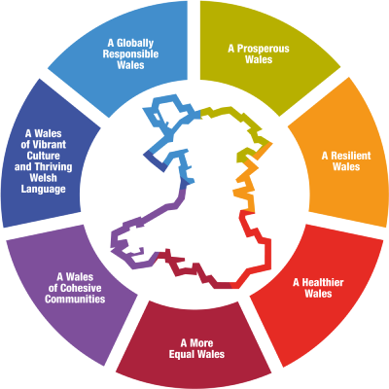
Figure 1: Goals for the Future Generations (Wales) Act 2015

Whilst planned respite may be preferable for all involved, any solution will need to be able to cope with both planned and emergency admissions.

Covid 19 and respite
The pandemic has led to a decrease in the amount of support available for carers. A number of respite options have been removed, or the accessibility of them altered (Greenberg, Wallick, et al. 2020). Day centres have not been able to operate at certain times during the pandemic and residential respite was used far less too with cancellation rates being considerably higher. Within the local authority dementia residential home these cancellations during the year 2020/21 were entirely due to Covid-19, with either the home being closed due to cases within it or the person due to come in testing positive.
Implementation of open access won’t necessarily help with Covid-19 related cancellations and previous studies have not shown that open access scheduling reduced cancellations (Sivanesan, Lubarsky et al. 2017), however it will be interesting to see if cancellations for reasons other than Covid-19 are reduced by an online booking option.
The pandemic has also led to additional steps in the business process to ensure a negative Covid-19 test is present prior to admission to ensure residents and staff are protected.

Literature Review
A systematic literature review was conducted into evaluations of online booking systems, Lean implementations within health and social care, and access to respite. The UWTSD discovery tool and ProQuest Database were searched. The PRISMA statement 2020 principles were used to ensure transparent reporting of the literature search. Research since 2020 was sought due to the increased use of online tools within health and social care in this time. The search will be refined by full text and peer reviewed literature.

Search terms
Online booking:
- “online booking” AND NHS
- “e-booking” AND social care
- Online appointment booking (in the title)
Results were screened to only include those relating to online booking within a social care or health environment.
Access to respite:
- “use of respite” AND dementia
- “respite care” and “dementia” (in the title)
- “accessing respite” AND “dementia” NOT “children
Results were screened out if they weren’t specifically about dementia, weren’t generic (i.e. not a particular cohort of people), weren’t about residential respite, weren’t about accessing residential respite.
Lean implementation / streamlining process:
- “lean implementation” AND “social care”
- “lean implementation” AND NHS
Results were screened out if they weren’t related to patient flow, time savings or access.
Figure 2 show the Prisma diagram resulting from these searches.
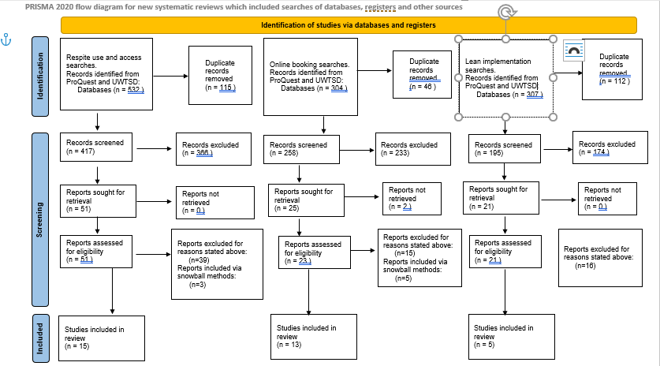
Figure 2: Prisma 2020 flow diagram for the Literature Review

The problem
Local authorities, such as Monmouthshire Council, are consistently being asked to achieve more with less funding. As such there is a need to maximise the use of the resources available, be this staff time or respite beds.
Monmouthshire County Council has a residential home for people with varying stages of dementia. Three of its four wings are home to long term residents whilst the fourth wing has six respite beds. The current respite booking system involves a number of different people and various processes to ensure a safe respite admission. This process has become even more involved during the pandemic as Covid-19 testing and results need to be factored in.
Currently, the person coming in for respite will need to come through a social worker, who will assess them. Due to being a local authority home, with respite stays often funded by the local authority, any provision is needs based with this need assessed by the social worker. If someone has previously stayed with the home and is known to them, they needn’t necessarily come through the social worker as their need as been previously shown.
The social worker contacts administrative staff in the home to see what is available in the diary. They will often book this to hold it and then check if the dates suit with the person. If it doesn’t it will need re-booking, cancelling the former date. This makes recording difficult and can lead to confusion and potentially double bookings.
Pre-pandemic an officer would go out and meet any new people in their own home prior to admission, this is currently replaced by asking them to complete a comprehensive paper document describing who they are, their likes and dislikes, their needs, their medication etc. This is used to understand them in advance of their stay.
For safe admission, the person needs a social work assessment dated within the last 12 months, any moving and handling plans, the family pack, a negative PCR test 48 hours prior to admission, a complete document checklist, and a key worker assigned.
A Personal Support Plan and Risk Assessment is drawn up from the information provided by the family and these are live documents which are added to during their stay.
The complexity of the process and the various people involved increase the potential for duplication or omission at the different stages. This can lead to delays in admission which in turn will reduce occupancy levels, increase carer burden, and increase stress around an admission.
Pre-pandemic occupancy levels within 2019/20 sat at 78%, this dropped to 25% in 2020/21, and has recovered to 60% for the year to date in 2021/22.
This project will look to automate the safe respite admission process where possible and allow for online booking of respite. This will streamline and improve the admissions process for everyone involved whilst not compromising on safety.
This change will free up administrative time and create greater flexibility around when bookings can be made as shown by the implementation of an online GP booking system in Norway (Asbjørn Johansen Fagerlund, Holm, and Zanaboni, 2019).
The intervention will also look to improve occupancy levels to pre-pandemic levels or higher.

Aims & objectives
The overall business aim is to simplify the respite admissions process whilst not compromising on safety, to improve access to respite, and improve occupancy levels. This will:
- to reduce administrative time
- to enable social workers to book directly
- to enable carers to book respite directly
- to maintain/improve rigour around the procedures needed for safe respite admission.
- increase occupancy levels
- improve access to respite which in turn will improve caregiver wellbeing
- reduce the time taken for the pre-admission work to take place
- reduce delays to admissions due to the necessary pre-admission criteria not being met
- reduce number of nights cancelled
- reduce late cancellations

Methodology
In order to streamline the respite admissions process and allow online booking it is anticipated that we will implement an online booking system and link this to an app. The app will automate aspects of the business process to save time whilst not compromising on the safety of admissions. It will also improve communication/provision of information as staff will be able to see where they are in the admissions process, and what remains to be done. The online booking system will improve accessibility and once fully implemented will empower carers to be in charge of their own respite needs.
Stakeholders of the process have been identified as the person coming in for respite, their usual caregiver, social workers, residential home officers, residential home administrative staff, and residential home carers.
Representatives for each of these stakeholder groups will be interviewed and workshops carried out to fully understand the current process and what their needs and roles are within this process.
The current business process will be studied and streamlined using a Lean QI methodology. Lean process improvement was developed in the Toyota factory and has since been used in a variety of other arenas to reduce waste within a system and allow for continuous improvement.
The Lean process seeks to identify and eliminate waste (Muda), to remove causes of unevenness or bottlenecks within a process (Mura), and to avoid over-burden (Muri). It is also linked to improved customer value (Radnor, Holweg et al. 2012).
Customer value streams i.e. parts of the process which add value to the customer will be identified during the stakeholder workshops and unnecessary steps removed. There will be different perspectives from which to view this process and it is likely to be helpful to view each stakeholder as a customer in order to understand their particular value streams.
It is often not possible to remove all waste within a process as some aspects of it will be necessary. Looking at the process from the point of view of multiple customers, as opposed to one, will likely show aspects of the system which don’t add value for one customer (and are thus deemed as purely necessary waste) do add value for a different customer.
This type of quality improvement methodology is appropriate for a small-scale business process change taking place in stages. The process is not overly complex in that there is a pre-determined set of criteria that will need to be met prior to any admission. This criteria may vary according to type of admission, but is stable within these types. The complexity stems from understanding the person, their carer, and their respective needs prior to admission however this element will not be dealt with by the implementation, aside from the scheduling of the meeting which achieves this forming part of the business process to be completed prior to admission.

Wastes (Muda)
There are 7 forms of waste identified within the Lean model. These can be seen in the Table 1 below with an explanation of their meaning and a suggested example of where this type of waste might exist in the current respite admission process.
Waste | Description | Possible example in respite admission process
Transportation | Movement of resources without adding value | Less likely to be relevant but possibly unnecessary travel to meetings with people.
Inventory | Holding excessive stock “just in case” | Beds held empty in case of emergencies.
Motion | Unnecessary movement of employees | Physical booking diary in different part of the home from officers or admin staff
Waiting/Delay | Whenever tasks are not moving leading to a loss of time in the process | People waiting for respite booking  People waiting for respite  People unable to come in as waiting for documentation/meetings to take place  People waiting on Social Worker (SW) appointments
Over-production | Exceeding customer demand | Not likely to exist within the process but possibly creation of file too far in advance when there’s a risk that person doesn’t come in
Over-processing | Work that doesn’t bring additional value or is more than is necessary | SW book stays to hold them whilst finding out if it suits.  SWs will therefore also have to then cancel those that don’t suit  Repeated information gathering for a person.
Defects | Defects in the process adding time | Documentation incorrect leading to delayed admission and under occupancy  Meetings haven’t happened leading to delayed admissions and under occupancy  Unsafe admission
Table 1: Seven types of waste identified within Lean and possible examples

Mura – maintaining stable workflows, no bottlenecks etc.
This is less obviously manageable within the respite workflow as there is little control over when the demands for respite come in. The workflow will seek to adequately prioritise workflow stages dependent on when the actual admission is rather than when the request comes in to avoid e.g. a flurry of bookings leading to a bottleneck.
Muri – overburden
- This might result from not understanding the amount of time needed to gather correct documentation and for pre-admission meetings to take place. This period may vary if there are differing needs depending on the type of admission.
The booking system would be set up to prevent bookings too close to the admission date which wouldn’t allow adequate time to carry out what’s needed. If there is a bed available and an emergency admission requires booking the person/SW will need to contact the officers directly to ascertain capacity in relation to safe admission processes.
- Multiple people checking in would place unnecessary pressure on people and lead to a decrease in the quality of check in and lower satisfaction levels for the family and person coming to stay.
The booking system won’t allow people to arrive at the same time and will be set up to only allow e.g. one check in during the morning and one check in during the afternoon. The actual number here will be ascertained during interviews with employees in the residential home.
- Multiple new people on the same day may lead to carers finding it more difficult to fully understand the varying new care plans. It will also be more difficult to get to know the person in an environment where there are lots of new people. Coming into a less settled environment may also cause more agitation for the people coming in.
It will be necessary to understand the optimal admission patterns to avoid this and set the booking system up accordingly. This will also avoid efficiencies being sought at the cost of the quality of care (Leggat, Gough et al. 2016).
- Late notification to residential home carers of impending admissions may lead to inadequate time to read care plans, prepare the room, and be ready to welcome them.
The process and online booking system will be accessible for all staff such that they are fully informed in a timely manner. Possibly consider notifications to staff before someone comes in.

Implementation
The implementation will be carried out in several stages. This will allow for small changes to be embedded and tested for problems before moving onto the next phase of the implementation. This will aid the change management process as the approach is less disruptive and will build confidence in those involved in the change along the way. It will also mitigate any risks associated with broader scale change (Bamford, Forrester et al. 2015). The stages are anticipated to be the following:
- The process remains the same as it currently is, but the Social Worker is able to access an online booking system which triggers the remaining processes needed for a safe admission.
- The safe admission process is broken down into steps which are used to create the app containing the business process. This may involve approval procedures. The process may differ depending on previous use of respite, recency of that use, and changes in the person with dementia’s condition. All staff will have access to the app to allow everyone to be fully informed.
- The online booking access will be made available to previous users of respite to pilot and understand how this process works. Support will be available for people on how to use the system.
- Feedback from the above pilot will be used to potentially open access to respite further i.e. other referral sources such as GP/third sector/carers team. Feedback loops need to be maintained to ascertain whether the provision is being over-run / inappropriately used.
- Consider whether external access to the app would enhance the process by providing information on it to those accessing respite and also eliciting information in advance of the home visit or in place of the current family information paper form. This could improve efficiency and allow as much pertinent information as possible to be gleaned. This would involve user-based permissions and registration to access.

Change Management
Deming’s Plan – Do – Study – Act (PDSA) cycles will be carried out at each stage of implementation to allow for feedback from all those affected, understand the consequences of change, and identify any unforeseen negative elements to be ironed out. This constant communication will aid the change management process as the varying stakeholders’ voices will be heard and acted upon throughout. In addition to meetings specifically for feedback, a culture of feedback at the time will be encouraged so that people aren’t living with unforeseen frustrations within a system and losing their appetite for change and faith in the intervention.
It is anticipated that the process will change from that represented in Figure 2 to that represented in Figure 3.
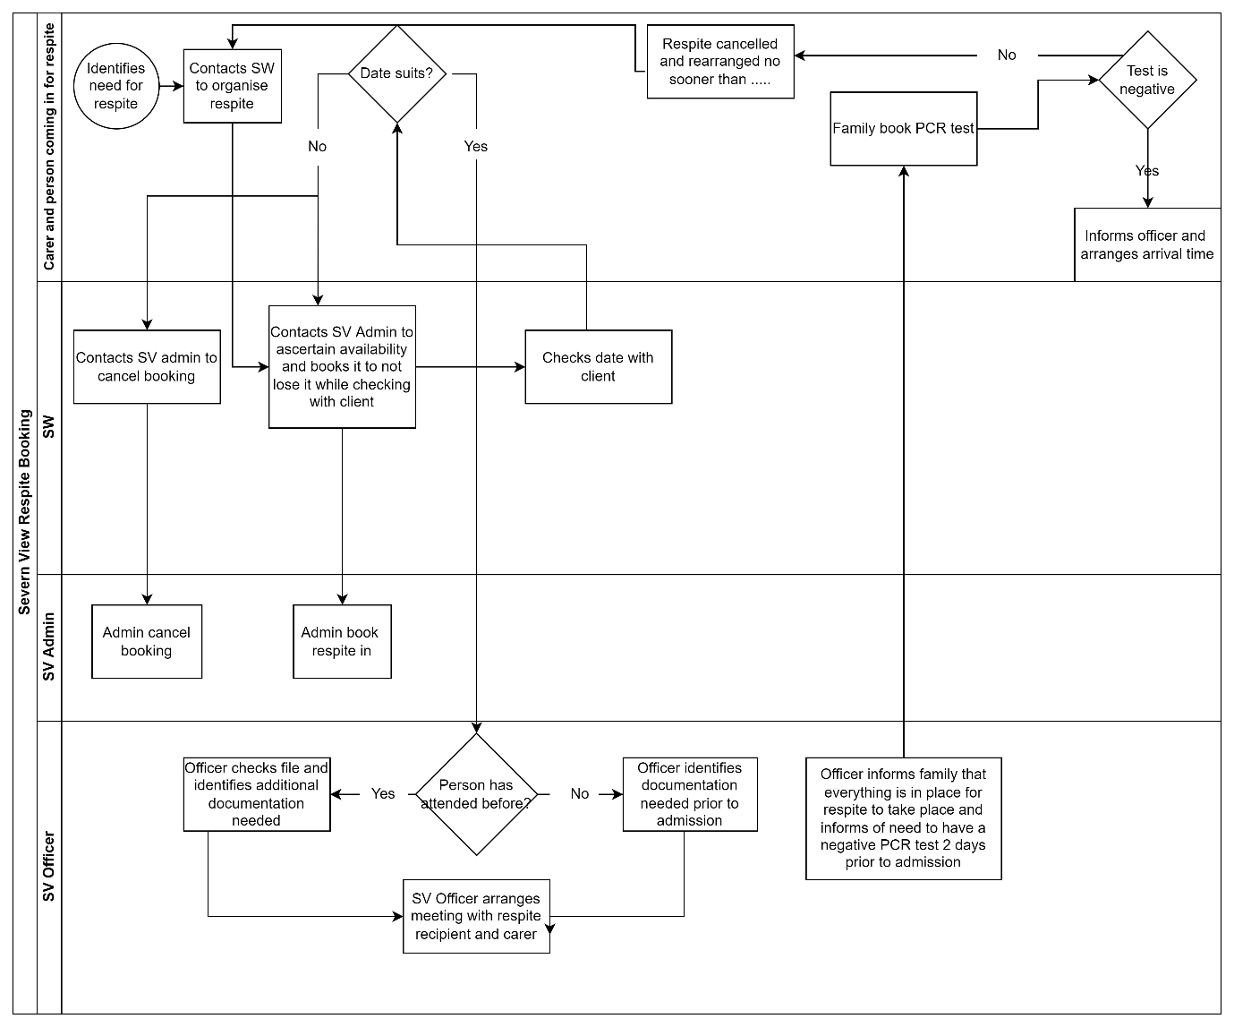
Figure 2: Current admissions process involving the various stakeholders
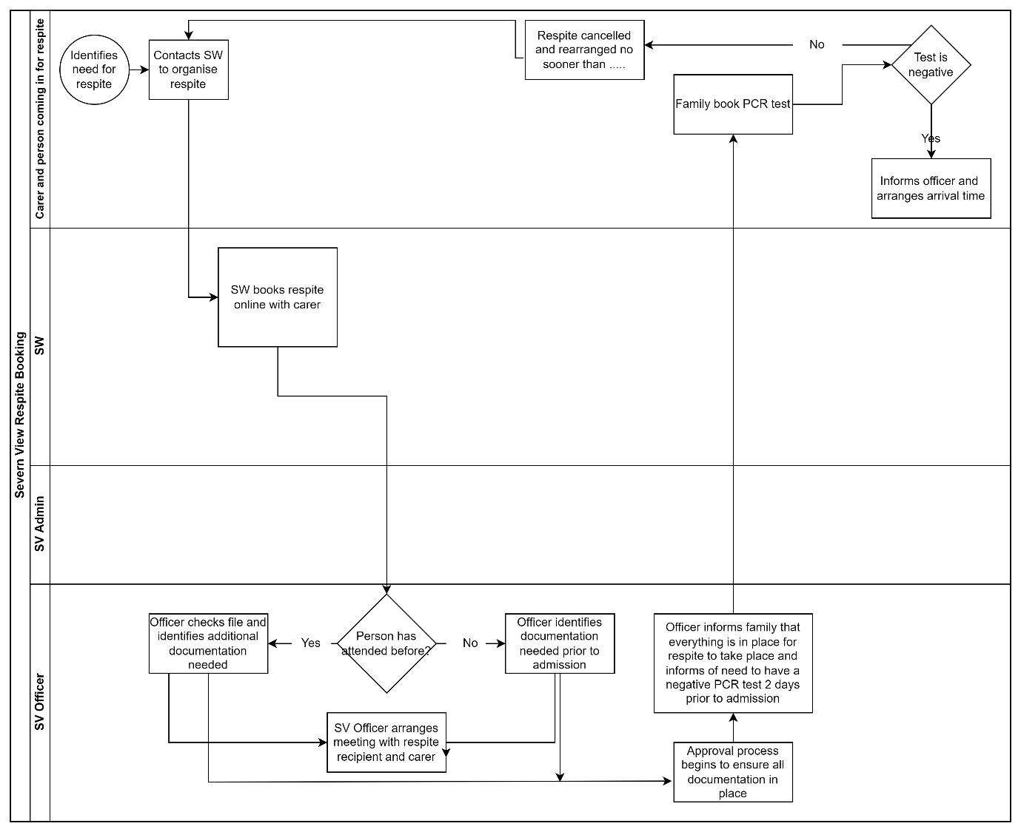
Figure 3: Possible future admissions process involving the various stakeholders
A Data Protection Impact Assessment will be carried out and scrutinised by our data protection officer alongside the technical team to ensure that the information held within the app is held appropriately and securely. If external access to the app is considered beneficial then registration and user-based permissions will be in place such that people can only access their own information.

Measures
Objective | How will this be measured?
Reduce administrative time | Administrative time spent on respite admissions will be measured before and after the various stages of implementation for equal periods and adjusted for occupancy, cancellations, and complexity of bookings (e.g. novel v. previously stayed)
Enable social workers to book directly | Create a report to understand who is booking using the system – percentage of stays booked by Social Workers
Enable carers to book respite directly | Create a report to understand who is booking using the system – percentage of stays booked by carers.
Maintain/improve rigour around the procedures needed for safe respite admission | Check against a checklist that all necessary documents are present on admission and that all necessary activities have taken place prior to admission.  Measure this for a defined period before and after implementation.
Increase occupancy levels | Percentage occupancy before and after implementation measured. This will be adjusted for instances of reduced occupancy caused by Covid-19 as this is beyond the scope of the intervention.
Improve access to respite which in turn will improve caregiver wellbeing | Survey carer groups of those with dementia before and after the implementation stage allowing them access to book directly.
Reduce the time taken for the pre-admission work to take place | Measure this as an average number of days for a period before and after the various stages of the implementation.
Reduce delays to admissions due to the necessary pre-admission criteria not being met | Count the number of occasions an admission has to be delayed due to pre-admission criteria not being met for a set period before and after the different stages of the intervention.
Reduce number of nights cancelled | This will be measured for an equal period pre and post implementation
Reduce late cancellations | Define what will be considered a “late” cancellation and count these for an equal period before and after implementation. Adjust the count for those not related to Covid-19 as these are beyond the scope of the intervention.

Any appropriate targets surrounding these measures will be decided by the stakeholders.
The majority of these measures will be qualitative, except for the Improved access to respite and improved carer wellbeing. Causality would be difficult to demonstrate in relation to this measure as a carer’s involvement in the study will improve awareness of, and potentially thus access to, respite. Causality will also be difficult to show in relation to occupancy, along with any of the measures related to cancellations as there are other variables which might impact on these.

Improvements

Future opportunities
There is a further respite facility within the council which might also benefit from implementation of a similar intervention.
There is the possibility that the financial aspect of respite could also be linked into the app which would allow for a more streamlined process for individuals and possibly also improved revenue collection for the local authority. Implementation of this would also remove waste produced by passing information between departments and paper invoicing.
Although all admissions in this home must come through a social worker this wouldn’t be the case for someone self-funding in the independent sector. If this system, or similar, were beneficial to them, the social work step could be removed, leading to open access and people booking directly. Depending on their processes this may look something like Figure 4.
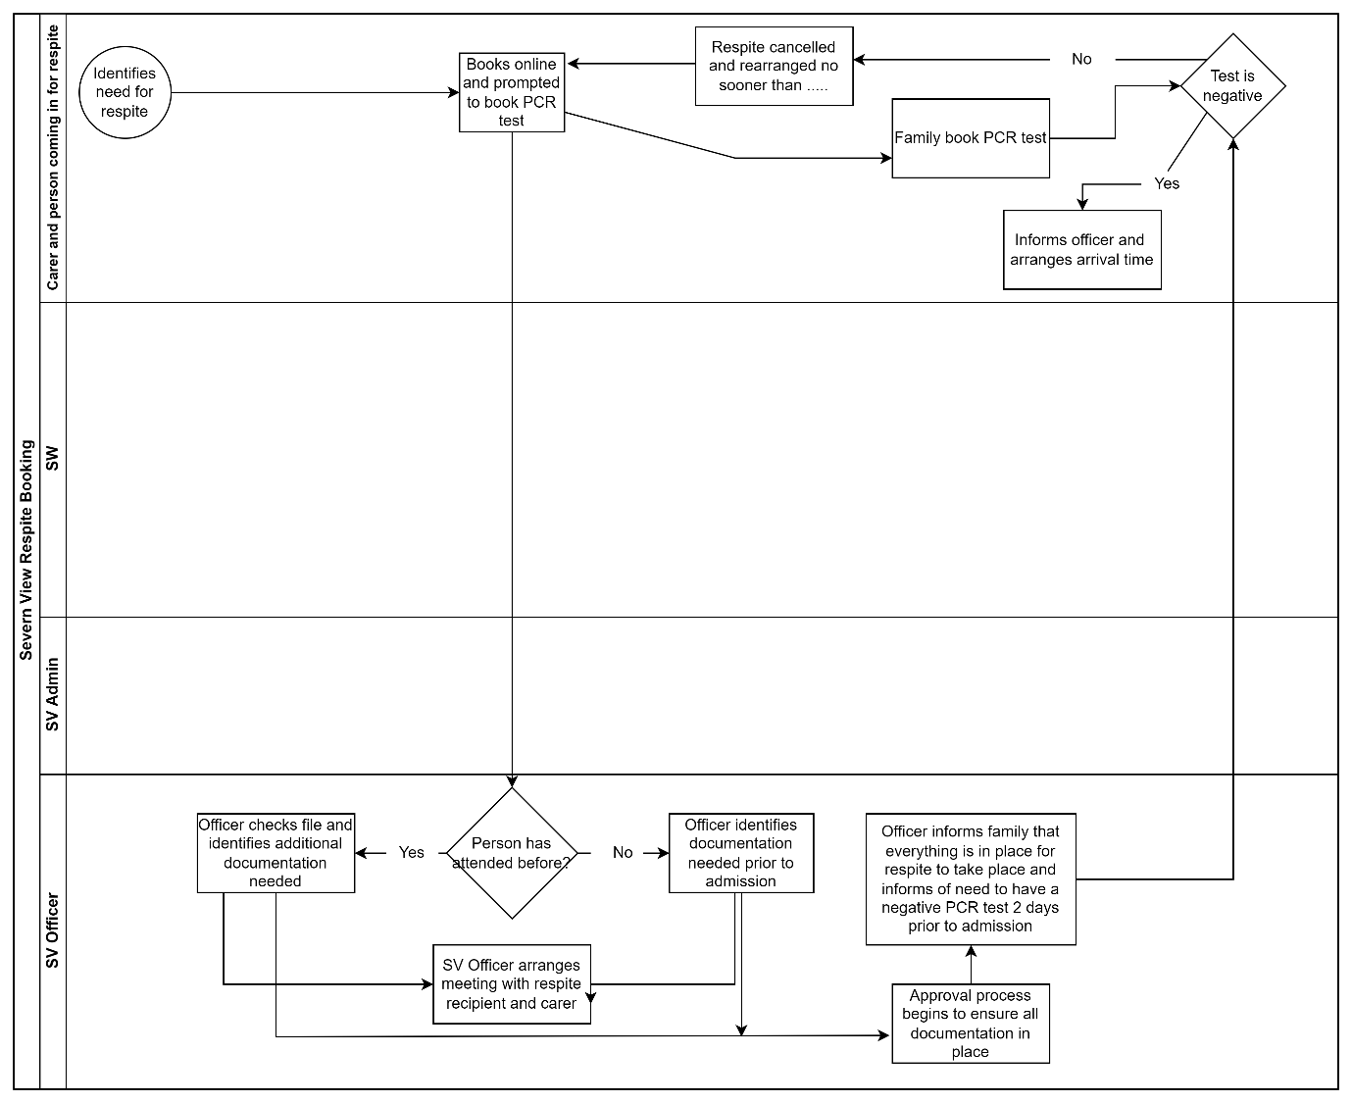
Fig. 4 A possible process for respite admission where a social work intervention is not needed.

Potential unintended consequences
Allowing wider access may cause greater strain on the system. Within the system itself the hope would be that the measures taken to prevent excessive burden on the system would work, but broadening access to a currently under accessed service may uncover an unmanageable level of demand for one care home. This might lead to conversations with independent care facilities around diversifying into respite care.
A shift to planned respite and greater occupancy would be welcome but we need to monitor how we are dealing with people hitting crisis.
We need to ensure that provision of services in this way doesn’t create inequality of access for those who are less digitally skilled or don’t have access to digital technology. This is particularly important as those accessing the support are likely to be older and it has been shown that this cohort are less likely to use or seek out digital forms of access (Gomez-Cano et al., 2020; Pangbourne, Aditjandra, and Nelson, 2010).
This lack of digital usage would also emphasise how important prospective user involvement would be in the design of any portal.

References
ASBJØRN JOHANSEN FAGERLUND, HOLM, I.M. and ZANABONI, P., 2019. General practitioners’ perceptions towards the use of digital health services for citizens in primary care: a qualitative interview study. BMJ Open, 9(5),.
BAMFORD, D., FORRESTER, P., DEHE, B. and LEESE, R.G., 2015. Partial and iterative Lean implementation: two case studies. International Journal of Operations & Production Management, 35(5), pp. 702-727.
BRANDÃO, D., RIBEIRO, O. and MARTÍN, I., 2016. Underuse and Unawareness of Residential Respite Care Services in Dementia Caregiving: Constraining the Need for Relief. Health & social work; Health Soc Work, 41(4), pp. 254-262.
BRODATY, H., THOMSON, C., THOMPSON, C. and FINE, M., 2005. Why caregivers of people with dementia and memory loss don't use services. International journal of geriatric psychiatry, 20(6), pp. 537-546.
COHEN, C.A. and PUSHKAR, D., 1999. Transitions in care: Lessons learned from a longitudinal study of dementia care. The American Journal of Geriatric Psychiatry, 7(2), pp. 139-46.
COX, C. and VERDIECK, M.J., 1994. Factors affecting the outcomes of hospitalized dementia patients: From home to hospital to discharge. The Gerontologist, 34(4), pp. 497-504.
DE LUSIGNAN, S., MOLD, F., SHEIKH, A., MAJEED, A., WYATT, J.C., QUINN, T., CAVILL, M., GRONLUND, T.A., FRANCO, C., CHAUHAN, U., BLAKEY, H., KATARIA, N., BARKER, F., ELLIS, B., KOCZAN, P., ARVANITIS, T.N., MCCARTHY, M., JONES, S. and RAFI, I., 2014. Patients’ online access to their electronic health records and linked online services: a systematic interpretative review. BMJ open; BMJ Open, 4(9), pp. e006021.
DONATH, C., WINKLER, A. and GRÄSSEL, E., 2009. Short-term residential care for dementia patients: predictors for utilization and expected quality from a family caregiver's point of view. International Psychogeriatrics, 21(4), pp. 703-10.
EL-MIEDANY, Y., 2017. Telehealth and telemedicine: how the digital era is changing standard health care. Smart Homecare Technology and TeleHealth, 4, pp. 43-51.
GOMEZ-CANO, M., ATHERTON, H., CAMPBELL, J., ECCLES, A., DALE, J., POLTAWSKI, L. and ABEL, G., 2020. Awareness and use of online appointment booking in general practice: analysis of GP Patient Survey data. British journal of general practice; Br J Gen Pract, 70, pp. bjgp20X711365.
GREENBERG, N.E., WALLICK, A. and BROWN, L.M., 2020. Impact of COVID-19 Pandemic Restrictions on Community-Dwelling Caregivers and Persons With Dementia. Psychological trauma; Psychol Trauma, 12, pp. S220-S221.
LEOCADIE, M., ROY, M. and ROTHAN-TONDEUR, M., 2018. Barriers and enablers in the use of respite interventions by caregivers of people with dementia: an integrative review. Archives of public health = Archives belges de santé publique; Arch Public Health, 76(1), pp. 72.
MACLEOD, A., TATANGELO, G., MCCABE, M. and YOU, E., 2017. "There isn't an easy way of finding the help that's available." Barriers and facilitators of service use among dementia family caregivers: a qualitative study. International Psychogeriatrics, 29(5), pp. 765-776.
PANGBOURNE, K., ADITJANDRA, P.T. and NELSON, J.D., 2010. New technology and quality of life for older people: exploring health and transport dimensions in the UK context. IET Intelligent Transport Systems, 4(4), pp. 318-327.
RADNOR, Z.J., HOLWEG, M. and WARING, J., 2012. Lean in healthcare: The unfilled promise? Social science & medicine (1982); Soc Sci Med, 74(3), pp. 364-371.
SIVANESAN, E., LUBARSKY, D.A., RANASINGHE, C.T., SARANTOPOULOS, C.D. and EPSTEIN, R.H., 2017a. Modified open-access scheduling for new patient evaluations at an academic chronic pain clinic increased patient access to care, but did not materially reduce their mean cancellation rate: A retrospective, observational study. Journal of clinical anesthesia, 41, pp. 92-96.
SIVANESAN, E., LUBARSKY, D.A., RANASINGHE, C.T., SARANTOPOULOS, C.D. and EPSTEIN, R.H., 2017b. Modified open-access scheduling for new patient evaluations at an academic chronic pain clinic increased patient access to care, but did not materially reduce their mean cancellation rate: A retrospective, observational study. Journal of clinical anesthesia, 41, pp. 92-96.
STEPHAN, A., BIEBER, A., HOPPER, L., JOYCE, R., IRVING, K., ZANETTI, O., PORTOLANI, E., KERPERSHOEK, L., VERHEY, F., DE VUGT, M., WOLFS, C., ERIKSEN, S., RØSVIK, J., MARQUES, M.J., GONÇALVES-PEREIRA, M. and BRITT-MARIE SJÖLUND, 2018. Barriers and facilitators to the access to and use of formal dementia care: findings of a focus group study with people with dementia, informal carers and health and social care professionals in eight European countries. BMC Geriatrics, 18, pp. n/a.
STRANG, V.R. and HAUGHEY, M., 1999. Respite--a coping strategy for family caregivers. Western journal of nursing research; West J Nurs Res, 21(4), pp. 450-471.
VANDEPITTE, S., VAN DEN NOORTGATE, N., PUTMAN, K., VERHAEGHE, S., VERDONCK, C. and ANNEMANS, L., 2016. Effectiveness of respite care in supporting informal caregivers of persons with dementia: a systematic review: Impact of dementia respite care in supporting caregivers. International journal of geriatric psychiatry, 31(12), pp. 1277-1288.
WAKEFIELD, C.J.,BSN MHS, 2020. Community respite service utilisation and dementia care: a review of literature. Australian Journal of Advanced Nursing (Online), 37(2), pp. 31-37.
YANG, P., CHU, F., LIU, H., SHIH, M., CHEN, T., CHOU, L. and HWANG, S., 2019. Features of Online Hospital Appointment Systems in Taiwan: A Nationwide Survey. International journal of environmental research and public health; Int J Environ Res Public Health, 16(2), pp. 171.
Prince, M et al (2014) Dementia UK: Update Second Edition report produced by King’s College London and the London School of Economics for the Alzheimer’s Society. Available at: dementia_uk_update.pdf (alzheimers.org.uk). (Accessed 10.12.21)
Social Services and Well-being (Wales) Act 2014 (2017) Available at: https://socialcare.wales/hub/sswbact (Accessed at 10.21.21)
Well-being of Future Generations (Wales) Act 2015 (2015) Available at: https://www.futuregenerations.wales/about-us/future-generations-act/ (Accessed:10.12.21)
WHO Dementia Factsheet (2021) Available at: Dementia (who.int) (Accessed: 10.12.21)

