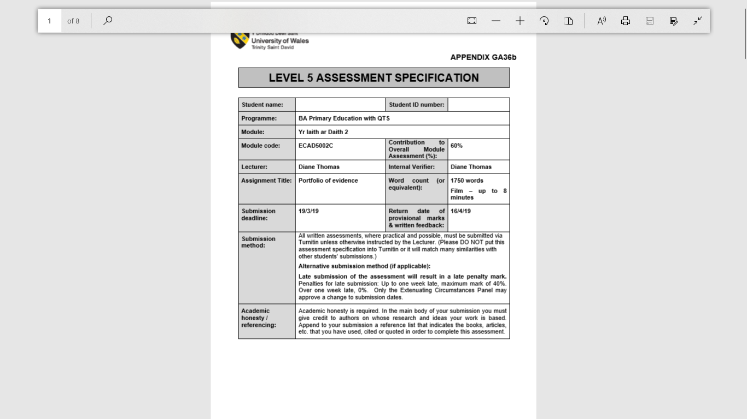
Molly Green
1701043

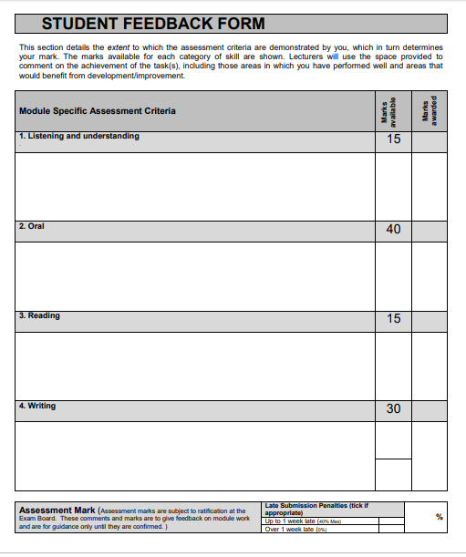

Task 1
  - The story book I have chosen to present is Nadolig Tedi Twt. It will be read to a reception class where the children are aged 4-5 years. Once a week the children will have one of the tedi twt stories read to them to promote Welsh language within the classroom. With Christmas being 4 weeks away, I chose this book because it features key words and phrases that children would use over the Christmas period. By using a well-known character and familiarising them with simple phrases such as “Ga i…” and “Os wyt ti’n dedi da” it will help to promote Welsh second language both in and outside of the classroom over this term. The story will be read the the whole class and will last for roughly 7 minutes.
  - The follow up activity will be to write their own letters to Siôn Corn using phrases and items in the book. The children will be shown pictures of the objects that Tedi Twt had for Christmas, then they will have to pick one to write on their Christmas list. The main objective will for the children to orally recognise and attempt to pronounce words and phrases in Welsh. The children will say the words aloud, find the sounds they can hear on the sound card, then write down what they think is correct. I will not be looking for correct spelling as this might make the task confusing as most words and phrases from this book will be new to the children.

Task 2: Video
https://www.youtube.com/watch?v=-FwLCBBs940

Task 3:
  - The story that was presented to the reception class was Nadolig Tedi Twt. The main learning outcome was for the children to listen to phrases and instructions and respond as appropriate. Some of the phrases included “Ga i…” and “Os wyt ti’n dedi da”. As mentioned in task 1, I decided to choose this book as it the phrases are relevant to the time of year and is suitable for this age group. Another reason for choosing this book was because the children are familiar with Tedi Twt, if I had decided to use an unfamiliar character on top of introducing new Welsh phrases to the children may have been distracted or overwhelmed with the new information. Some of the success criteria points that I shared with the children prior to the activity included; being able to speak clearly, and to use the correct pronunciation for tricky words such as “beic”, “cath” (depending on what they chose for their Christmas list) “Siôn Corn” and “os gwelwch yn dda”.
  - The first point of discussion is about how changes could have been made to further develop the learners reading skills. Estyn suggest that “children generally make less progress in reading and writing welsh” (ESTYN, 2013, p.8) due to the emphasis on developing good oracy skills. The activity followed by the story; Nadolic Tedi Twt, was to write a piece of emergent writing in the form of a Christmas list, which did allow children to develop their writing skills. The children were spelling the words phonically on their list, opposed to using the correct Welsh spelling. I decided not to introduce the correct spelling of the words into the activity as I felt this might cause confusion. Sound cards were also used to encourage them to look for the sounds they could hear. Unfortunately, both the story and the activity lacked in developing the children’s reading skills. The story was too small for all children around the carpet area to see the words and should have been projected onto the whiteboard. This would have encouraged them to read along with me and link the sounds with how the words look, overall developing their reading skills.
  - The Welsh Language Development document suggests that story telling can help “support the development of speaking skills” for Welsh second language (DCELLS, 2008, p.12), if it is supported by other activities. These activities include sharing and recounting information, and events that are important to the children. During the story reading activity, the children were asked to recount the items that Tedi Twt wanted on each page, however, this question was asked in English. If I had asked the children what Tedi Twt wanted for Christmas in Welsh e.g. Beth mae Tedi Twt eisiau am Nadolig? Then followed by the question in English, it would have introduced the children to other key phrases also related to this topic. This would have also encouraged them to ask this question to their peers leading up to the Christmas period. Another suggested activity to support story telling is recounting important information. A possible activity for this age group while the story is being read is to ask the children if they had any of the objects from the book last Christmas where they should answer yes or no in Welsh.
  - Non-verbal communication and body language are another two important strategies to be considered when teaching a second language. The Welsh government defines non-verbal communication as a language that “takes on different forms such as facial expressions (smiling), gestures/body movements (shoulders slouching and eye contact)” (DCELLS, 2008, p.55). Pie Corbett discusses the impact on storytelling to children on his website; TalkforWriting. Daily storytelling using the Talk for writing approach can have a dramatic influence on progress in composition. Research carried out on a reception class found that at the start of the year just 2% of the class could retell a story, however by the end of the year 76% were able to retell the whole story (Corbett, 2019). Using gestures linked to the vocabulary in the story helped the children to retain new words and phrases in the book which will be especially useful when learning a second language. Very few gestures were used when reading Nadolig Tedi Twt, this needs to improve by linking movements to at least each phrase and key word to improve retainment of the words and pronunciation. Shoulder movement and slouching is also mentioned in the definition of non-verbal communication. Unfortunately, as mentioned in paragraph one, the story used was a small printed version, rather than one projected onto the smartboard. By projecting the story onto the smartboard not only would have encouraged the children to read along with the story but, doing so would have vastly improved my body language. Opposed to sitting down for the children to see the pages, I could have stood up to point to each word also enabling me to make eye-contact with all the children. Standing at the front of the class would have also improved behaviour management during the story. Having one had free would have enabled me to use 3 claps, or to give Dojo points for good behaviour to get the children’s attention.
  - This section discusses the inclusion of ‘child A’ during the storytelling activity. Child A is Autistic and finds it hard to sit down for long periods of time. Despite this, after a discussion with the classroom teacher it was decided that child A would participate in the story with the rest of the class, however, he would not be asked to sit down if he decided to leave the carpet area. While the story was being read child A walked away from the carpet area and came back in his own time but still managed to answer one of the questions. Colin Baker suggests in his book; Foundations of Bilingual Education, that “inclusive education may increase positive expectations of special needs students by their teachers, peers, and them-selves” (Baker, 2006, p.356). I decided to include child A within the whole class approach when telling the story as their Autism does not affect their ability to learn a second language, he is just as capable as the other children in the class. The proof was seen when he was able to answer one of the questions about what Tedi Twt wanted for Christmas. Child A also has a competitive personality, by asking the class questions from the story that they can answer, meant that he was keen to come back to join in.
  - The last point to be discussed is about role modelling quality language. During both the story and the side activity my pronunciation for certain words was not always correct. For example, “lyfr lliwio” and “beic”, with a large pause being taken before reading them due to uncertainty, despite practicing the book prior to reading the story to the class. Uncertainty on these words influenced my enthusiasm for this section. The Welsh Language Development document states that in order to progress in their Welsh language development children should be taking part in “quality listening and speaking” (DCELLS, 2008), this links with one of the aims from the Welsh Language Development in the Foundation Phase document which is “to establish high-quality work in Welsh Language Development” (ESTYN, 2013, p.49). Neither can be achieved without high-standard and accurate teaching. Without this, the children will not have confidence with their language skills, and they will not be able to produce high-quality work in the development of Welsh second language. To help achieve this, the Welsh in education action plan (2017-2021) includes several courses and projects to ensure all teachers and support staff have enough training and confidence to provide quality teaching to develop Welsh second language. The action plan states that: “there are approximately 435 ongoing projects to develop quality-assured teaching” and the Welsh Government are “providing funding to local authorities to raise standards in the teaching and learning of Welsh” (Welsh Government, 2017, p.13).
  - To conclude, there are several elements to both the activity and the storytelling that require improvement to further develop my teaching skills. Some of the main areas for development are language accuracy, confidence, body language and improvement of incidental Welsh e.g. questions and praise. However, I felt that most children enjoyed the story and the majority enjoyed the follow up task. The One Million Welsh Speakers work programme (2017-21) states that in order to achieve the aim of one million Welsh speakers by 2050 “our education system is dependent on the workforce – teachers, early years practitioners, trainers and lecturers.” (Welsh Government, 2017, p.7). This suggests that it achieving this goal heavily relies on todays teachers and the quality of their teaching and resources. However, by improving the quality and and frequency of my Welsh in the classroom I will help to contribute to this target.

  - Reference list
  - Baker, C (2006) Foundations of Bilingual Education, 4th edition.
  - DCELLS (2008) Welsh Language Development.
  - ESTYN (2013) Welsh Language Development in the Foundation Phase.
  - Corbet, P. (2019) (TalkforWriting) Available at: https://www.talk4writing.co.uk/about/
  - Welsh Government (2017) Welsh in education action plan (2017-21).
  - Welsh Government (2017) Cymraeg 2050: A million Welsh speakers, work programme (2017-21).

