
Master of Business Administration
International Business pathway



Contemporary employability skills
Assessment 1: Individual report. Weight: 50% Module Module name: Strategic Management
Module code: LCMB7003
Lecturer name: Hoang Nguyen

Student name: Arpit Khatra
Student ID: 2526504

Word count: 5,181
Submission date: 12 august 2026

AI use acknowledgement

I confirm that I have not presented any AI generated text as my own work.

I confirm I have copies of my drafts, notes, and other resources I used before, and after the use of AI tools which I may be asked to provide in evidence.
Executive Summary

This report has critically analysed the proposed international market entry of Walmart Inc. in Poland. The analysis has specifically included an evaluation of Walmart's organisational power, analysis of the international strategy as well as analysis of the attractiveness of the retail sector and Polish macro-environment, from which it follows the appropriate expansion strategy for Walmart. According to the framework developed by Bartlett and Ghoshal, a transnational strategy is best. It is so because Walmart can keep its efficiency in procurement, technology and supply chain and customize products, promotions, and customer services to meet the conditions of Poland.
Foreign direct investment is further supported by the Dunning's OLI paradigm, as Walmart has a technology and operational advantage, Poland is a favourable location, and internalisation would ensure that Walmart would retain its technology and operational skills. The report offers the idea of a 100% owned subsidiary, with strategic partnerships with Polish suppliers and logistic service providers. Proposals also entail a phased entry, as a mitigation for cultural, competitive, regulatory and financial risks. Overall, the situation in Poland may be a promising market to expand into for Wal-Mart provided they can deliver value to customers in the countries while holding down prices in the country.
Table of Contents

Section 1: Report 5
1. Introduction 5
2. Organisational Classification and Global Strategy 5
2.1 Walmart Overview 5
2.2 Bartlett and Ghoshal Framework 6
2.3 Global Configuration and Competitive Advantage 7
3. Macro Environmental Appraisal and Market Attractiveness 7
3.1 Political Environment 7
3.2 Economic Environment 9
3.3 Legal Environment 10
3.4 Cultural Environment 12
3.5 Industry Attractiveness 14
3.6 Dunning's Eclectic (OLI) Paradigm 15
4. Entry Mode Strategy and Strategic Synthesis 18
4.1 Walmart's Historical Entry Patterns 18
4.2 Recommended Entry Mode 18
4.3 Risk Assessment 19
5. Conclusion and Strategic Recommendations 19
Section 2: Reflective Account (Gibbs Reflective Cycle) 21
Description 21
Feelings 22
Evaluation 22
Analysis 22
Conclusion 23
Action Plan 23
References 24

Section 1: Report
1. Introduction
Walmart's internationalisation is an important one in the European retail sector, and plans to enter the Polish market have been proposed. It offers a well-established consumer market, a maturing retail market in Poland and a strategic European location. Internationalisation is not just an export of a successful domestic model to the international market. Polish consumers' preferences will require Walmart to consider how they can operate on a global scale, remaining cost effective and competitive. This section examines Walmart's organizational classification, international strategy, competitive advantage and road to Poland. It argues that sustainable development will flow best from a transnational approach combined with a high control entry system and connections to the local partners.

2. Organisational Classification and Global Strategy
2.1 Walmart Overview
Walmart may be considered a multinational enterprise since it is involved in international retailing, sourcing, logistics and technology-enabled activities beyond its home market. Its financial size provides an ownership benefit. According to Mrozek (2022), Walmart made a total revenue of around US$572.754 billion and operating income of around US$25.942 billion in the fiscal year 2022. This financial capacity provided adequate resources for international investment and also enabled Walmart to utilise some parts of the costs and risks of entering a new market. Walmart's competitive offer is mainly cost efficiency, product availability and customer convenience. A strong purchasing capability enhances negotiating power with suppliers, and advanced logistical management facilitates inventory access and helps reduce costs.
According to Vorzhakova and Redko (2022), a way to enhance the competitiveness of international business is to mesh firms' capacities and leverage them across international boundaries, adapting them to foreign environments. Technology is another factor which is significant in the organisation. Walmart's adoption of blockchain showcases its capacity to leverage digital technologies for intricate supply chain tasks. Pawlicka and Bal (2021) pointed to improvements in traceability, information visibility and the coordination of the supply chain in Walmart's use of blockchain. These functionalities might assist in food traceability, supplier management and inventory management in Poland. That being said, scaling up in organisations does not equate to international success. DesRoches (2022) revealed that it is important to recognise local conditions to which organisational strengths are being transferred internationally.
2.2 Bartlett and Ghoshal Framework
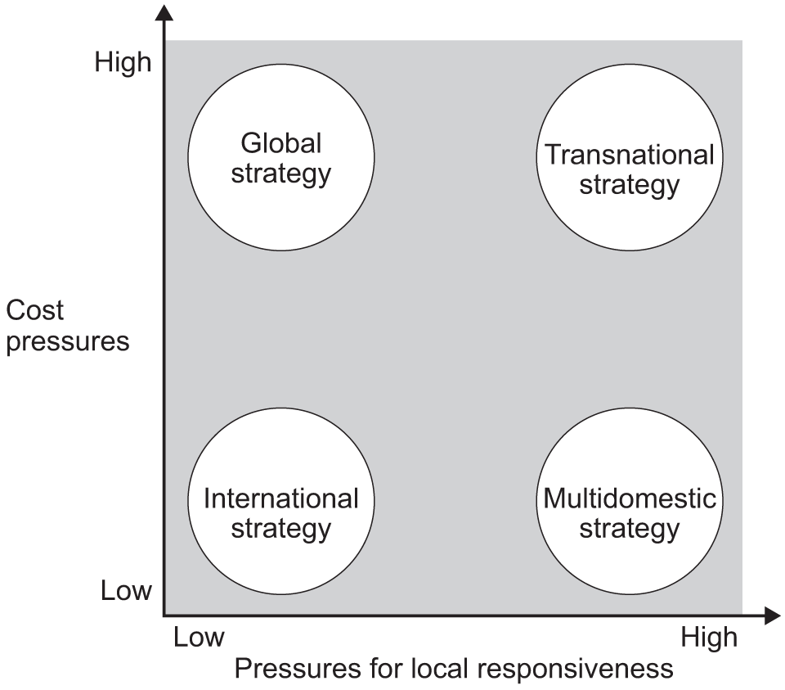
Figure 1: Barlett and Ghosal Model
(Source: AQA, 2026)
The Bartlett and Ghoshal approach clusters different international strategies into pressures for global integration and pressures for local responsiveness (AQA, 2026). To assess two more likely strategies for expansion to Poland, the transnational strategy is the most interesting for combining global efficiency with adaptation. A global approach would allow Walmart to rationalise purchasing, logistics planning, technology and operations, creating economies of scale. A high level of standardization might have made it harder to respond to Polish consumers. Kormakova et al. (2023) tend to the view that businesses must contend with the nature of foreign markets while going global. On the other hand, the international approach would give local responsiveness, but might lead to higher costs due to distribution and duplication. A transnational approach would create a better balance. Walmart might keep global procurement, technology and supply chain management in its own hands and adjust its stock offerings, promotions and customer services. This is especially applicable to Poland, where preferences of local consumers shape retail competitiveness. Navickas (2023) demonstrates the importance of local positioning and market characteristics within Poland. Walmart should, therefore, stick to its EDLP offer and adjust its product range and its supplier relations to the market in Poland.
2.3 Global Configuration and Competitive Advantage
In Walmart's International deployment, big shopping markets with integrated logistics and digital technologies are bundled together. This set-up ensures economies of scale and the ability to share knowledge and systems between markets. Brzeziński (2024) believes that sustainable enterprise development is now more dependent on efficient resource management, innovation, and organisational adaptation. However, there is a lot of organisational capability as well from Walmart's financial statements. Its net sales increased from around US$555.233 billion in fiscal 2021 to US$567.762 billion during fiscal 2022 (Mrozek, 2022). While the risk in foreign markets cannot be eliminated, Walmart's brand strength gives it the resources to invest in developing foreign markets, technology and infrastructure. This puts it ahead of the competition, bolstered by digital transformation. Rogaczewski (2025) referred to digitalisation as a significant driver of international business as it enhances operational efficiency, engagement and responsiveness. With brick-and-mortar outlets and an online presence, Walmart's data and automation can create an 'omnichannel' proposition. There is another benefit to supply chain technology. Bal and Pawlicka (2021) highlight transparency, coordination and resilience as three key values of today's supply chains. The use of blockchain would be able to enhance operational resilience in the Polish part of Walmart. However, one should not think that the company is limited to cost leadership, as local retailers have their expertise and customer base.

3. Macro Environmental Appraisal and Market Attractiveness
3.1 Political Environment
Indicator | Latest Figure | Strategic implication
EU membership | Since 2004 | Access some 450 million European consumers
Population | 37.5 million | Strong domestic consumer base for potential national growth
GDP growth (2025) | 3.4% | Demonstrates resilient economic performance
Retail sales growth (2025) | 4.4% | Indicates expanding household expenditure
Prime retail vacancy (Q1 2026) | Below 3% | Reflects strong retail property demand
Supermarket sales | Positive monthly growth throughout 2025 | Supports Walmart's grocery-led retail strategy
Table 3.1 Key Political and Economic Indicators Supporting Walmart's Expansion into Poland
Political climate is one of the important determinants of Walmart's global expansion as it provides certainty and encourages investment for sustainable business development. The Polish economy is also considered one of the most politically stable economies in Central and Eastern Europe, making it attractive to multinationals that have retail interests. Multinationals can achieve sustainable competitive advantage by minimizing uncertainty if there is apolitical stability and institutional transparency (Shenkar et al. 2021). All these made Poland an enticing place to invest as it became an EU Member State in 2004, providing access to the EU Single Market with around 450 million consumers, free movement of goods and services, and capital (Republic of Poland, 2026). The connection will streamline Walmart's procurement and logistics in Europe as well as decrease trade hurdles. The government's encouragement of foreign direct investment (FDI), along with its push for digital infrastructure and innovation also helps Walmart's plans for expansion. Salamaga (2023) claimed that FDI helps enterprise innovation via technology transfer and productivity improvement. The development of renewable-energy infrastructure in Poland also creates opportunities for Walmart to incorporate sustainability considerations into the design and operation of retail and distribution facilities (Kurowska et al., 2022).
The environment would provide Walmart a chance to build new advanced distribution centres and to deepen its regional supply chain network. Moreover, Poland remains very proactive in pushing digital transformation in all sectors of the economy. According to Rogaczewski (2025), with increased investment in technological infrastructure by governments, digitalisation is a new source of international competitiveness. For Walmart, therefore, knowledge about artificial intelligence, automated fulfilment centres, and omnichannel retailing fits in well with the priorities in Poland's development. Political restrictions are also a problem, though. The restrictions on Sunday trading have led to less availability of supermarkets and changed consumer behaviour. These rules have spurred retailers to diversify and increase sales in digital channels and improve performance during the weekdays (Silva, 2023).
3.2 Economic Environment
Poland boasts some advantages for Walmart's intended market entry, including a robust economy, a rise in retail spending and an increase in consumers' purchasing power. Aytekin et al. (2023) believed that the markets with long-term economic growth are the markets where investment risk is reduced and long-term profitability is enhanced due to economic performance. In general, Poland has consistently been economically strong, growing GDP by approximately 3.4% in 2025 amid general European economic uncertainty (TE, 2025). On the other hand, retail sales are recording consumer spending growth, with an increase of around 4.4% for the year, thus signalling retail demand and prospects (TE, 2025). The numbers suggest that consumer demand is good enough to support Walmart's EDLP strategy. Supermarket sales also remained positive on a month-on-month basis during 2025, indicating continued demand within the grocery retail segment (Statista, 2025). The trend is crucial, given that the grocery industry is Walmart's main industry abroad. The broader retail and wholesale environment continues to present opportunities for firms capable of integrating physical retailing with digital channels, efficient distribution and technology-enabled operations (R&M, 2026). Walmart would then get the opportunity to set up stores strategically close to modern fulfilment centres.
Competence in digitalisation automatically increases the competitiveness of the Polish market. As per Grabiwoda and Mróz (2022), the Internet is an important channel for eCommerce products in Central and Eastern Europe, driven by the tendency of consumers to value convenience, competitive prices and home delivery. Likewise, Reardon et al. (2021) suggested that in doing so, e-commerce has lowered the barriers to market by enhancing accessibility on digital platforms and reaching consumers more widely. In the meantime, Walmart is investing in AI and automated logistics and omnichannel marketing, which may help it merge offline locations with online channels. Industry forecasts for the long term add to the investment case. The wider retail environment is also being reshaped by technological innovation, changing consumer expectations and the increasing importance of omnichannel business models, creating opportunities for retailers with strong digital capabilities (Deloitte, 2026). The Polish consumer-goods and retail sector offers a substantial market opportunity, supported by evolving consumer demand and the continued development of modern retail formats (ISIM, 2026). While the retail shelf-scanning and inventory robots market is anticipated to grow at a 15.2% CAGR (FMI, 2026). The trends bolster Walmart's technology-based approach. Competition from established retailers at home and abroad, however, clearly prevents the company from simply having the lowest prices, and instead it must differentiate itself by being more efficient, innovative with digital tools, and having a better customer experience.
3.3 Legal Environment
Legal Area | Opportunity | Challenge
Competition Law | Transparent EU regulatory framework encourages fair competition | Compliance with EU competition rules and supplier agreements
Data Protection | Strong consumer trust through GDPR compliance | Higher investment in cybersecurity and data governance
Supply Chain Regulation | Blockchain improves traceability and food safety | Continuous monitoring of supplier compliance
Supply Chain Finance | Greater transparency strengthens operational resilience | Increased reporting and coordination requirements
Environmental Regulation | Supports Walmart's sustainability strategy and circular economy initiatives | Additional compliance costs for environmental standards
Table 3.2: Legal Opportunities and Challenges for Walmart's Entry into Poland
Poland's legal system is secure and transparent for foreign investment, with a well-established landscape of competition and digital governance, and consumer protection. Poland has integrated laws concerning competition, employment law, environment protection and ecommerce and is a member of the European Union (EU) (Republic of Poland, 2026). This regulatory chord helps dispel legal uncertainty and ease the way for cross-border business for MNCs. Clear, unambiguous legislations in Poland help raise investor confidence and allow for long-term strategic investments by MNCs, without the fear of ambiguity. In terms of legal entities, there are better scopes for limited liability companies in Poland due to its liability protection and low capital requirement (Leinonen Poland, 2025). Implementation of the EU harmonised legal environment would be easier for Walmart in their sourcing, logistical and retail operations. A large challenge is GDPR compliance, which involves collection, storage and processing of customer data in the European Union. In the current digital age where data is central to user analytics and ecommerce, progressive info control is essential to permitting customers to rely upon Walmart. According to Pytka (2022), one of the greatest solutions to improve cyber security, electronic communications security and legal compliance risk when running a digital business is data protection. In doing so, Walmart will certainly put itself into a strong position with regard to complying with Poland's data protection regulations. Walmart should also maintain strong anti-bribery and ethical compliance mechanisms because multinational operations can expose firms to differing standards and risks relating to foreign business conduct (Fernando and Mardin, 2025).
Legislation includes transparency and sustainability in terms of supply chain. European regulations call for improved food safety, food traceability, responsible sourcing through retails in the supply chain. Bal and Pawlicka (2021) revealed that accessible financing of the supply chain will enhance a company's operational resilience by aligning its relationships with retailers and suppliers. Walmart's blockchain use provides advantages to food traceability, supplier verification, inventory visibility and tracking, leading to improved regulatory compliance and business efficiency. Contrarily, Rajput et al. (2025) argued that blockchain technologies would be effective in reducing food waste, optimizing food resources, and increasing food supply chains transparency, which would contribute to reaching the objective of the CE. As a result, Walmart's digital sophistication would aid in Poland's shifting legal and environmental requirements while also building consumer trust and sustainable business operations.
3.4 Cultural Environment
Attitude, shopping habits and value orientation of the consumer also influence buying decisions which affect Walmart's expansion not to mention cultural aspects. Poland is a relatively homogenous cultural state, with growing urbanisation and changing lifestyles, thus providing good conditions for modern retail formats. The market acceptance level of multinational companies is higher if they adapt their products, marketing strategies, and customer experiences according to the culture of the target country (Parboteeah et al., 2024). The level of price consciousness among Polish customers, and their high standards for quality and convenience, closely follows Walmart's Everyday Low Price (EDLP) strategy. Virtually shopping is also a user's behaviour. Grabiwoda and Mróz (2022) found that online shopping has a positive image among consumers in Central and Eastern Europe because it is convenient, offers competitive prices and a wider choice. The mobile preferences have helped Wal Mart's omnichannel model that integrates physical stores, e-commerce and home delivery. CSR is an important strategic lever that helps build consumer trust and loyalty, as this factor becomes more relevant in their daily buying habits.
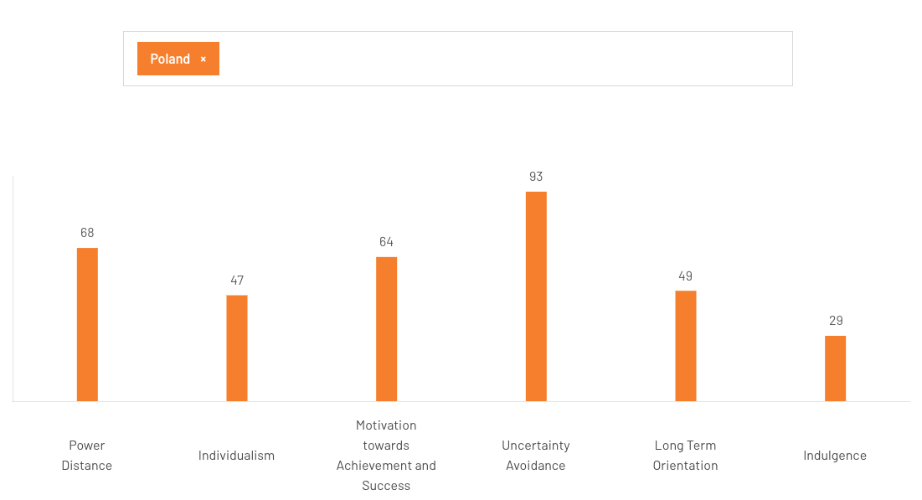
Figure 2: Hofstede Cultural Dimension of Poland
(Source: TCF, 2026)
In context to behaviour of Polish consumers, the Hofstede's cultural dimensions are assessed. It was evident that Poland, with high Power Distance (68) and High Uncertainty Avoidance (93), meant consumers might prefer clear information, reliability, security and trusted brands. Individualism score 47 reflects a balance with social influences, Achievement and success 64 reflects an appreciation of quality, performance, and value. Hence the relatively low levels of the indices of Long-Term Orientation (49) and Indulgence (29) suggest that Walmart needs to pay more attention to providing useful value, affordability and responsible consumption rather than overstimulation in the promotion of their experiences (TCF, 2026). Such traits help support Walmart's EDLP proposition but will require cultural adaptation as Polish consumers can prove their loyalty to well-known domestic supermarket brands. Successful retailers offer locally relevant product mix, quality of service and customer trust. Therefore, Walmart should cooperate with Polish suppliers and adjust its product range and retain a cost-leadership position. Increased choice for grocery deliveries also indicates demand for convenience and flex fulfilment (Romanowski and Lemańczyk, 2022). The fact that prices of organic and conventional products differ even more confirms the need to reconcile price and food value aspects (Smoluk-Sikorska, 2024).
3.5 Industry Attractiveness
Indicator | Latest Figure | Strategic Implication
Poland's population | 37.5 million | Large consumer market supporting retail expansion
Global retail market growth (2025–2035) | 5.8% CAGR | Indicates sustained long-term industry expansion
Global consumer products and retail market | USD 48.1 trillion by 2030 | Demonstrates expanding global retail demand
Prime retail vacancy (Q1 2026) | Below 3% | Reflects strong retail property demand
Worldwide retail outlook | Growth projected through 2030 | Supports long-term investment opportunities
Table 3.3: Retail Industry Attractiveness Indicators for Walmart's Entry into Poland
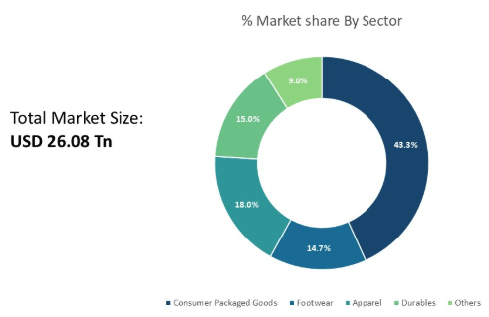
Figure 3: Consumer Product and Retail Market Size
(Source: CMI, 2026)
The retail sector in Poland shows impressive growth potential and is a desirable location for Walmart's global expansion. Foreign market selection should also take into account the size of the market, degree of growth and competitive intensity, as these factors shape long-term profitability (Aytekin et al., 2023). Between 2025 and 2035, the global retail market is expected to hit a compound annual growth rate (CAGR) of 5.8% (EMR, 2026). Similarly, the consumer products and retail sector is projected to become a global USD 48.1 trillion market by 2030 (CMI, 2026). Poland's retail property environment also provides opportunities for new market participants, although Walmart would need to select locations carefully according to accessibility, consumer demand and distribution efficiency (CBRE, 2026).
The retail industry of Poland is once more augmented by e-commerce. Végh et al. (2025) noted that Amazon has helped make digital retailing more convenient and accessible in the marketplace worldwide. Likewise, Jürgensmeier et al. (2024) point out that cross-border e-commerce platforms allow retailers to grow in an efficient way. These advances are good news for Walmart, owing to its advanced omnichannel capabilities and digital supply chain. However, rivalry is intense as a result of well-established local and international retailers. According to Mika and Winczewski (2024), technological platforms are still driving the reformation of commerce because they are increasing the concentration of the market. Thus, Walmart has to integrate technology to create a competitive advantage, a dynamic supply chain with cost leadership and excellent customer service. However, online grocery retail also creates market-entry challenges because retailers must develop efficient fulfilment systems, reliable delivery capabilities and competitive service models (Seuri, 2024).
3.6 Dunning's Eclectic (OLI) Paradigm
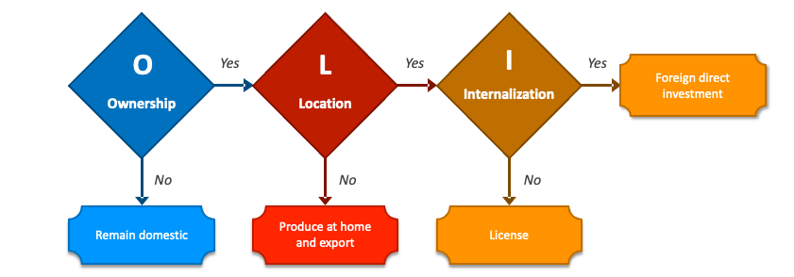
Figure 4: OLI Framework
(Source: Collidu, 2026)
The theoretical framework that best fits the assessment of Walmart's intention to expand FDI into Poland is Dunning's Eclectic (Ownership- Location-Internalisation) Paradigm model. It examines why multinationals select FDI as an entry mode (Collidu, 2026). Firms invest abroad when they have ownership advantages, discover attractive location-specific advantages, and recognise that they can achieve greater efficiency if they internalise them, instead of licensing and franchising them (Shenkar et al., 2021).
Walmart has fulfilled the three conditions in the OLI framework, which confirms the right expansion decision in the direction of Poland. Ownership (O) advantage is the unique resources and competitive capabilities that the concerned firm possesses which cannot be easily matched by any other competitor. Walmart has some significant ownership advantages, which include its worldwide brand, more than 10,750 locations in 19 countries, sophisticated supply chain execution systems, and buying strength (BW, 2026). The firm's investment in AI, automation and omnichannel retailing adds to these enhancements in operational efficiency and customer experience. According to Brzeziński (2024), the development of sustainable enterprises relies on ongoing enhancement capabilities, innovation and strategic resource utilization. Such ownership-related assets allow Walmart to benefit from economic scale, advance an advantageous supplier contract and secure its Everyday Low Price (EDLP) policy in the Polish retail sector.
OLI Component | Evidence | Strategic Implication
Ownership (O) | - 10,750+ stores across 19 countries (BW, 2026)  - Global brand, and AI-enabled supply chain | Strong competitive advantage and economies of scale
Location (L) | - 37.5 million population (EMIS, 2026)  - 3.4% GDP growth, with 4.4% growth of retail sales (TE, 2025)  - Prime retail vacancy below 3% (CBRE, 2026) | Attractive consumer market with favourable investment conditions
Internalisation (I) | Blockchain-enabled traceability, integrated logistics and direct operational control Rosado-Serrano and Navarro-García (2022) | Protects technology, ensures quality and improves supply chain efficiency
Table 3.4: Application of Dunning's OLI Paradigm to Walmart's Expansion into Poland
The second element, Location (L) advantages, evaluates whether or not Poland provides adequate market advantages to warrant foreign investment. Poland boasts solid location potential with more inhabitants and the presence of a dynamic retail sector in the European Union (EU) (EMIS, 2026). Further, commercial activity in prime retail remained strong in the first quarter of 2026, with no retailer confidence lost at less than 1% prime retail vacancy (CBRE, 2026). In today's globalized world the selection of markets has become more vital as "economic stability, favourable investment conditions and long-term growth potential" are combined (Kormakova et al. 2023). Poland has these attributes, which make it an appealing destination for Walmart's European expansion.
Finally, Internalisation (I) advantages considers whether Walmart should maintain its direct control rather than use licensing or franchising formats. With internalisation, the company can safeguard its proprietary technologies, maintain product quality and ensure consistent customer services in various geographies. Wholly controlled entry modes are those that minimize strategic risks of contractual dependence and enhance organisational flexibility in facing unexpected changes in the market (Rosado-Serrano and Navarro-García, 2022). To optimise operational efficiency, Walmart's blockchain-based supply chain, sophisticated inventory systems and integration with logistics demands a centralised management situation. Besides, Pawlicka and Bal (2021) illustrated an example of how blockchain technology makes traceability, food safety, and supplier verification easier, thus helping Walmart to be consistent with its operations abroad. The OLI Paradigm strongly indicates that Walmart is likely to invest in Poland through FDI. The unique ownership benefits of the company, conditions favouring the economic and strategic position of Poland and the need for centralised development of technology-intensive retail outlets as a whole justify the creation of wholly-owned enterprises.

4. Entry Mode Strategy and Strategic Synthesis
4.1 Walmart's Historical Entry Patterns
The Wal-Mart internationalisation experience illustrates the need to consider entry mode based on your control needs, local knowledge and market conditions. The strategic goals of multinational companies can be achieved through wholly owned subsidiaries, acquisitions, JVs, partnerships or franchising. Novel strategies of foreign-market entry are needed because globalisation generates different opportunities and risks among countries (Kruhlyanko et al., 2023). There is a compromise between exposure and control when it comes to entry mode. As explained by Rosado-Serrano and Navarro-García (2022), alternative entry modes allow firms to achieve varying degrees of control and be vulnerable when the unexpected occurs. Walmart should, therefore, not use the same entry structure in all countries. It is essential for Walmart to integrate global assets and local expertise for Poland's functioning. Tan (2024) illustrated that success in international market entry requires an integration of organisational capabilities and adaptation to the competitive conditions in the market.
4.2 Recommended Entry Mode
It is advised that Walmart's expansion into Poland be achieved through a wholly owned subsidiary supported by strategic local partnerships. This organisation would offer clear control of brand management, pricing, technology, procurement and supply chain management and enable the involvement of Polish suppliers and logistics services. For Walmart, its competitive advantage relies on organisational systems, so a high-control structure is the most suitable. The advantages of franchising would be rapid market entry and reduced direct investment, while the disadvantages would include problems with standardising and safeguarding proprietary assets. When risk and uncertainty are present, and companies must retain strategic resources, having more control can benefit (Rosado-Serrano and Navarro-García, 2022). Control over digital technologies would also allow Walmart to maintain that ownership. Its blockchain-tracked supply chain is a vital organisational ability, which can enable tracing and supplier coordination (Pawlicka and Bal, 2021). The case is that it is a good idea to find partners with Polish suppliers for Walmart. Local sourcing would increase awareness of consumers' preferences and help cultural adaptation without assuming control of key items that surround Walmart.
4.3 Risk Assessment
Walmart's move into Poland may have a few challenges ahead. Competitive risk is also high due to the competitive nature of the environment in which Walmart would operate. The company would then have to prove their value by offering them by way of price, convenience, product quality and digital services. Another developmental risk factor is cultural risk. A common model of retail values in the United States might not meet all Polish consumer expectations. Navickas (2023) highlights that local positioning is important in the Polish consumer market. Walmart should then adjust their product mix and promotions without altering its global cost position. As Walmart continues to grow in its e-commerce business, digital and regulatory issues would arise. Good governance is the key to data protection and secure electronic transactions.
Pytka (2022) mentioned how vital data protection is in electronic businesses. Walmart needs to hence put in place suitable cyber security and compliance mechanisms. Besides, there are other risks in the supply chain, such as disruption, information asymmetry and coordination issues. There is a growing complexity in today's supply chains (Bal and Pawlicka, 2021). Walmart's blockchain experiment might reduce the risks by increasing visibility and transparency. Lastly, there is the cost of investing in stores, distribution systems, technology and marketing. The phased entry approach would minimise exposure for Walmart because it would help gauge how the market will react before putting in a large investment nationally.

5. Conclusion and Strategic Recommendations
Walmart has good organisational resources for operational expansion into Poland. It has robust resources in terms of financial capacity, cost-leading model, supply chain and technological skills for a global competitive position. These strengths need to be business-oriented simultaneously, being sensitive to local conditions, which are unique in Poland. The approach we recommend is therefore transnational and involves establishing a full-fledged subsidiary supported by strategic local partnerships. Walmart is expected to maintain its own core segment and adjust products, its relationship with suppliers and marketing and customer services to suit Polish market requirements. A phased expansion would enable the firm to gain local knowledge, with limited financial and competitive risk. The central guiding objective needs to be to be globally efficient while maintaining local responsiveness. The strategy would allow Walmart to leverage its best organisational capabilities in Poland and foster local networks and expertise for future sustainable competitive advantage.

Section 2: Reflective Account (Gibbs Reflective Cycle)
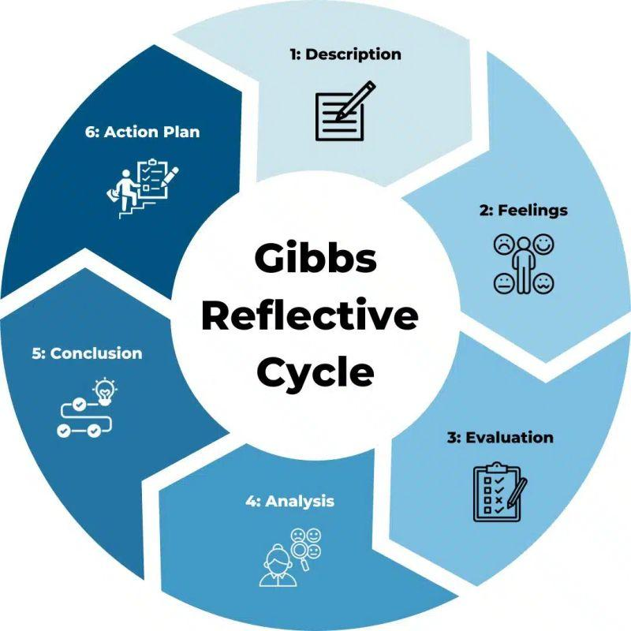
Figure 5: Gibbs Reflective Cycle
(Source: LinkedIn, 2026)
Description
When working on my international business analysis of Walmart's plan to expand in Poland, I had a chance to evaluate my research and my analytical and decision-making abilities in relation to the assignment. I was required to show an understanding of the political, economic, legal and cultural context in Poland, consider the attractiveness of the different industries, the Bartlett and Ghoshal framework and the OLI paradigm of Dunning, before making a recommendation for a market entrance strategy. The first thing I did was get information from academic as well as industry literature. I gained an insight, however, that collation of information is less demanding than its incorporation into a coherent strategic argument. I had to differentiate between giving a description of evidence and critically summarising what they mean for Walmart. Ingham-Broomfield (2021) outlines that reflective models offer a systematic framework for learning from experiences and saying how things might be better. Gibbs' model was hence used to analyse my approach and my learning.
Feelings
At first, I thought I knew what I was looking for and had a general idea of Walmart and International Business. My confidence went down the drain when I found out that it is not just about writing a description of a company, but also requires theoretical application. The linkage between evidence relating to Poland and Bartlett and Ghoshal, and OLI presented a real difficulty. I was frustrated when I was given opposite information from various sources. I used primarily to collect numbers at first so as to build up strength in analysis based on numbers. I began getting the sense that figures have little value unless there is a good explanation of what they mean strategically. As the research advanced, I became more sure of my evidence analysis and conclusions. Gibbs' reflective cycle is used to train learners to reflect on their experiences and consider how they can improve (Ocampo et al. 2025).
Evaluation
A great asset was using existing theoretical models. I have been greatly assisted by the insights from Bartlett and Ghoshal on the idea of global integration versus local responsiveness, and OLI in structuring my approach for assessing Walmart's ownership advantage, Poland's location and internalisation advantage. I also further developed my skills in source selection and analysis. I made more effort at sustaining numerical information which supported an argument. This helped to make my work more credible. When I began analysing, I was too descriptive, however. I have given information without explaining its significance for Walmart's strategic decision at times. I wasted too much time gathering information and didn't critically assess the information. Among the various positive outcomes, they illustrate how reflective writing and feedback can enhance students' deepening of their reflections in the context of their studies (Pieper et al., 2021). This emphasised the need for feedback and self-evaluation during the process of research.
Analysis
The experience has shown that theory, evidence, and judgment should be integrated to be effective for international business analysis. At first, I split PESTEL, Bartlett and Ghoshal and OLI into separate requirements. While performing the task, I realised that they could be more useful when used together to help with strategic decisions. For instance, the level of opportunities and risks identified in Poland was macro-environmental analysis, and Bartlett and Ghoshal assisted in planning how Walmart dealt with global efficiency vs local adaptation. OLI would then give a theoretical explanation of the choice of a suitable entry mode. Linking these models lent more cohesion to my suggestions. It resulted in the development of transferable skills of critical thinking, evaluation of evidence and strategic decision-making. According to Mello and Wattret (2021), transfers of skills can be facilitated by reflection. The skills are transferable outside of academic use, as managers need to interpret information, evaluate alternatives, and make decisions with uncertainty. Then I appreciated the need for good communication as well. There must be logical flows of links between evidence, analysis and conclusion in a strategic recommendation. According to Ahmadpour et al. (2025), narrative writing that utilises Gibbs' reflective model can be used to assist communication skills. It has been helpful to me to understand that good business writing involves believable proof coupled with good interpretation.
Conclusion
This experience has seen the development of my understanding in international business analysis and reflective learning. I learned that I have to assess the evidence and use theory to support my inferences and what I conclude. I also understood that there will be no direct transfer between countries of international strategies if there are cultural, institutional and competitive differences affecting the performance of business. Learning the most was the need to strike the right balance between global organisation capability and the necessity to be locally responsive. I also found out that the critical evaluation should take place at every phase of the research process and not just at the conclusion.
Action Plan
The development of an analytical framework is the practice I will take to begin future assignments, rather than collecting sources. I will determine the evidence I need for each section and favour industry and academic sources that are relevant. There will also be a table that records all the sources and evidence to make sure that all numerical information is credible and pertinent. Second, I will ask "What does this mean for the organisation?" after showing evidence to apply critical analysis. This will take me from a descriptive to evaluative perspective. Thirdly, I will continue to take short reflective comments during large assignments to help identify weaknesses at an earlier stage. Finally, I will use feedback as a means to strengthen reflective learning and enhance the potential of future academic performance, actively seeking feedback regarding my analytical structure and my writing.
References
Ahmadpour, N., Shariati, A. and Moghadam, M.P., (2025). Effect of narrative writing based on Gibbs’ reflective model on the empathy and communication skills of nursing students. BMC medical education, 25(1), p.10. https://link.springer.com/article/10.1186/s12909-024-06593-7
Aytekin, A., Görçün, Ö.F., Ecer, F., Pamucar, D. and Karamaşa, Ç., (2023). Foreign market selection of suppliers through a novel REF-Sort technique. Kybernetes, 52(11), pp.4958-4992. https://www.emerald.com/k/article/52/11/4958/459246
Bal, M. and Pawlicka, K., (2021). Supply chain finance and challenges of modern supply chains. LogForum, 17(1), pp.71-82. https://bibliotekanauki.pl/articles/1835528.pdf
Brzeziński, Ł., (2024). Enterprise development management. Encyclopedia, 4(4), pp.1396-1410. https://www.mdpi.com/2673-8392/4/4/91
BW, (2026). Worldwide Retail Industry to 2030. Available at: https://www.businesswire.com/news/home/20210816005430/en/Worldwide-Retail-Industry-to-2030---Featuring-Walmart-Amazon.com-and-Target-Among-Others---ResearchAndMarkets.com [Accessed on 01.08.2026].
CBRE, (2026). Poland Retail Market Figures Q1 2026. Available at: https://www.cbre.com/insights/figures/poland-retail-market-figures-q1-2026 [Accessed on 05.08.2026].
CMI, (2026). Consumer Product And Retail Market Size & Forecast 2026. Available at: https://www.coherentmarketinsights.com/market-insight/consumer-product-and-retail-market-4759 [Accessed on 10.08.2026].
Deloitte, (2026). 2026 Retail Industry Global Outlook | Deloitte Insights. Available at: https://www.deloitte.com/us/en/insights/industry/retail-distribution/retail-distribution-industry-outlook.html [Accessed on 01.08.2026].
DesRoches, K.L., (2022). Competing in International Markets. Emergence of a Strategic Leader. https://pressbooks.usnh.edu/ld823/chapter/19/
EMR, (2026). Retail Market Size, Share, Value & Forecast 2035. Available at: https://www.expertmarketresearch.com/reports/retail-market [Accessed on 02.08.2026].
Fernando, Z.J. and Mardin, N., (2025). The Urgency of Addressing Foreign Bribery in Indonesia: A Comparative Analysis. Krytyka Prawa, p.323. https://access.heinonline.com/hol-cgi-bin/get_pdf.cgi?handle=hein.journals/cqeolwidt2025&section=91
FMI, (2026). Retail Shelf-Scanning & Inventory Robots Market. Available at: https://www.futuremarketinsights.com/reports/retail-shelf-scanning-and-inventory-robots-market [Accessed on 04.08.2026].
Grabiwoda, B. and Mróz, B., (2022). The Economics of Digital Shopping in Central and Eastern Europe. Cambridge University Press. https://www.cambridge.org/core/elements/economics-of-digital-shopping-in-central-and-eastern-europe/77F0E03F179BB4DD6CE28435A47AE428
Ingham-Broomfield, B., 2021. A nurses' guide to using models of reflection. The Australian Journal of Advanced Nursing, 38(4), pp.62-67. https://search.informit.org/doi/abs/10.3316/informit.191541276970614
ISIM, (2026). Poland Consumer Goods and Retail Sector Report 2025-2026. Available at: https://www.emis.com/php/store/reports/PL/Poland_Consumer_Goods_and_Retail_Sector_Report_2025-2026_en_893949086.html [Accessed on 07.08.2026].
Jürgensmeier, L., Bischoff, J. and Skiera, B., (2024). Opportunities for self-preferencing in international online marketplaces. International Marketing Review, 41(5), pp.1118-1132. https://www.emerald.com/imr/article/41/5/1118/1224020
Kormakova, I., Kruhlyanko, A., Peniuk, V., Ursakii, Y. and Verstiak, O., (2023). Actual strategies for businesses penetrating foreign markets in the modern economy: Globalisation aspect. International Journal of Professional Business Review: Int. J. Prof. Bus. Rev., 8(5), p.117. https://dialnet.unirioja.es/servlet/articulo?codigo=8957050
Kruhlyanko, A., Peniuk, V., Ursakii, Y. and Verstiak, O., (2023). Actual Strategies for Businesses Penetrating Foreign Markets in the Modern Economy: Globalisation Aspect. http://rps.chtei-knteu.cv.ua:8585/jspui/handle/123456789/1800
Kurowska, K., Kryszk, H. and Bielski, S., (2022). Location and technical requirements for photovoltaic power stations in Poland. Energies, 15(7), p.2701. https://www.mdpi.com/1996-1073/15/7/2701
Leinonen Poland, (2026). Choosing the Right Legal Entity in Poland: A Guide for Foreign-owned Businesses. Available at: https://leinonen.eu/pol/news/choosing-the-right-legal-entity-in-poland/ [Accessed on 07.08.2026].
Mello, L.V. and Wattret, G., 2021. Developing transferable skills through embedding reflection in the science curriculum. Biophysical reviews, 13(6), pp.897-903. https://link.springer.com/article/10.1007/s12551-021-00852-3
Mika, B. and Winczewski, D., (2024). The work-on-demand platform as a part of monopoly capital: the example of a global ride-hailing company. Polish Sociological Review, (1 (225)). https://www.ceeol.com/search/article-detail?id=1244767
Mrozek, M., (2022). Walmart Inc. in light of COVID-19 pandemic: the financial assessment. Catallaxy, 7(1), pp.23-32. https://www.ceeol.com/search/article-detail?id=1081379
Navickas, P., (2023). Polish beauty and personal care market-industry analysis and hebe-s competitive positioning. https://run.unl.pt/entities/publication/8b2bbdac-51a2-4d78-b5fd-9447d432344f
Ocampo, F.A., McIntyre, B.G., Massey, D. and Saunders, R., 2025. Nursing student reflections on a research internship: A reflective discussion following the Gibbs' reflective cycle. Nurse education today, 145, p.106481. https://www.sciencedirect.com/science/article/pii/S0260691724003915
Parboteeah, K.P., Cullen, J.B. and Kim, S., (2024). International Business: Perspectives from developed and emerging markets. Routledge. https://www.taylorfrancis.com/books/mono/10.4324/9781003312932/international-business-john-cullen-praveen-parboteeah-sahrok-kim
Pawlicka, K. and Bal, M., (2021). Blockchain in supply chain finance-a case study of Walmart. In Cezayirlioglu Haluk, R.(red.) 18th Logistics and Supply Chain Congress: Conference Proceedings Book: The Importance of Digitalization in Industry an Logistics Sector (pp. 14-25). https://cdn.loder.org.tr/loder/production/uploads/files/2023/12/5aff907ae9b3630.pdf#page=15
Pieper, M., Roelle, J., vom Hofe, R., Salle, A. and Berthold, K., 2021. Feedback in reflective journals fosters reflection skills of student teachers. Psychology Learning & Teaching, 20(1), pp.107-127. https://journals.sagepub.com/doi/abs/10.1177/1475725720966190
Pytka, A., (2022). Data protection for e-invoicing in Poland: case: Pagero. Available at: https://www.theseus.fi/handle/10024/787053 [Accessed on 06.08.2026].
R&M, (2026). Retail and Wholesale Market Report 2026. Available at: https://www.researchandmarkets.com/reports/5939074/retail-wholesale-market-report?srsltid=AfmBOopN-r90JpCuE2fyQmQe-i0SW8FODY3OdF5HRPnQm-Ra5xLORoDj [Accessed on 07.08.2026].
Rajput, D.V., More, P.R., Adhikari, P.A. and Arya, S.S., (2025). Blockchain technology in the food supply chain: a way towards circular economy and sustainability. Sustainable Food Technology, 3(4), pp.930-946. https://pubs.rsc.org/fb/article-abstract/3/4/930/892647
Reardon, T., Belton, B., Liverpool‐Tasie, L.S.O., Lu, L., Nuthalapati, C.S., Tasie, O. and Zilberman, D., (2021). E‐commerce's fast‐tracking diffusion and adaptation in developing countries. Applied Economic Perspectives and Policy, 43(4), pp.1243-1259. https://onlinelibrary.wiley.com/doi/abs/10.1002/aepp.13160
Republic of Poland, (2026). 22 Years of Poland in the European Union - A Balance of Benefits. Available at: https://www.gov.pl/web/qatar/22-years-of-poland-in-the-european-union--a-balance-of-benefits [Accessed on 06.08.2026].
Rogaczewski, R., (2025). Digital transformation as a factor in the development of international business in the era of digital globalization. T. Cherniavska, Economy in the era of digital transformation: trends, opportunities and perspectives, pp.144-167. https://www.researchgate.net/profile/Robert-Rogaczewski/publication/393325102_Economy_in_the_era_of_digital_transformation_trends_opportunities_and_perspectives_Monograph/links/686ec6ec39c3583512083dec/Economy-in-the-era-of-digital-transformation-trends-opportunities-and-perspectives-Monograph.pdf#page=162
Romanowski, R. and Lemańczyk, J., (2022). The dynamics of new delivery forms development of grocery products in Poland-Frisco case study. Zeszyty Naukowe. Organizacja i Zarządzanie/Politechnika Śląska, (156), pp.441-455. https://bibliotekanauki.pl/articles/27313638.pdf
Rosado-Serrano, A. and Navarro-García, A., (2022). Alternative modes of entry and unexpected events in franchising. Journal of Global Business Insights, 7(2), pp.94-108. https://digitalcommons.usf.edu/globe/vol7/iss2/1/?trk=public_post_comment-text
Salamaga, M., (2023). Study on the influence of foreign direct investment on innovations in enterprises in Poland using the ECM model. Argumenta Oeconomica, (1 (50)). https://journals.ue.wroc.pl/aoe/article/view/1046
Seuri, J., (2024). The impact of online grocery retail on market entry challenges. https://aaltodoc.aalto.fi/items/fae8af43-afb9-4506-bcd0-46d744abb446
Shenkar, O., Luo, Y. and Chi, T., (2021). International business. Routledge. https://api.taylorfrancis.com/content/books/mono/download?identifierName=doi&identifierValue=10.4324/9781003034315&type=googlepdf
Silva, G.A.D.G.F.D., (2023). Jerónimo Martins equity research the polish sunday trading ban-impact on biedronka and food retail industry. https://run.unl.pt/entities/publication/cb60ffc7-c903-44de-9e23-4ce54a879312
Singh, K. and Misra, M., (2021). The evolving path of CSR: toward business and society relationship. Journal of Economic and Administrative Sciences, 38(2), pp.304-332. https://www.ingentaconnect.com/content/mcb/jeas/2021/00000038/00000002/art00006
Smoluk-Sikorska, J., (2024). Differences between prices of organic and conventional food in Poland. Agriculture, 14(12), p.2308. https://www.mdpi.com/2077-0472/14/12/2308 https://www.mdpi.com/2077-0472/14/12/2308
Statista, (2025). Month-on-month retail sales change in supermarkets 2025. Available at: https://www.statista.com/statistics/1043206/poland-month-on-month-retail-sales-change-in-supermarkets/?srsltid=AfmBOorWNJ2hD1Y-dXLY6MRfnQJt0XKCC5hwn4l7JJYiTiCCtSNBqRLD [Accessed on 08.08.2026].
Tan, Y., (2024). Market Entry Strategies of Temu and Shein: A Comparative Analysis. Available at: https://www.researchgate.net/profile/Yizhi_Tan2/publication/391980758_Market_Entry_Strategies_of_Temu_and_Shein_A_Comparative_Analysis/links/682f3ba7d1054b0207f0e2c7/Market-Entry-Strategies-of-Temu-and-Shein-A-Comparative-Analysis.pdf [Accessed on 04.08.2026].
TCF, 2026. Hofstede Cultural Dimension of Poland. Available at: https://www.theculturefactor.com/country-comparison-tool?countries=poland [Accessed on 05.08.2026].
TE, (2025). Poland Retail Sales YoY. Available at: https://tradingeconomics.com/poland/retail-sales-annual [Accessed on 05.08.2026].
Végh, K., Gerván, R. and Malatyinszki, S., (2025). Amazon's Impact on the Development of E-Commerce. Journal of Cultural Analysis and Social Change, pp.4959-4976. http://jcasc.com/index.php/jcasc/article/view/4159
Vorzhakova, Y. and Redko, K., (2022). Fundamentals of international business: practice. https://ela.kpi.ua/bitstreams/77bf8387-b9fa-476c-97ba-5040d12d01c3/download

