DISSERTATION PROPOSAL

An investigation into student police officers’ experiences while undertaking the Police Constable Degree Apprenticeship.

Introduction – Research Background

The Police Constable Degree Apprenticeship (PCDA) was introduced in 2018 by the College of Policing as a view to professionalise the police service and has now been adopted by all UK home forces.
It was thought that by bringing the profession in line with ones such as nursing, teaching and law that police officers would be more educated and therefore raise the standard of service.
The PCDA is one of 3 new entry routes available to prospective police officers under the Policing Education Qualifications Framework (PEQF). The PCDA enables recruits that don’t already have a degree to join the police service as a police constable.
Recruits on the PCDA work full time and train to be full time police officers whilst studying and gaining an undergraduate degree in partnership with a university.
This will all fall into a 3-year probationary period. The officers choosing this route will all be attested and have full police powers and responsibilities.

Although it was introduced in 2018 and has been running for 4 years at the time of writing, the first cohorts of the PCDA will have completed the degree just last year in 2021.
To date due to the infancy of the PCDA, there is limited research that has been undertaken to analyse if the route is beneficial to officers and the force.
In comparison to the degree holders entry programme (DHEP) route the PCDA will involve an extra year of probation and study and is arguably more intense for student officers.
It is so far unclear what effect, if any, the demands of the PCDA have had on officers undertaking it.

This piece of research aims to explore and examine the experiences of both student officers currently on the PCDA route and officers that have completed the PCDA and obtained their degrees.
Opportunities will be considered to speak to officers that left the programme prior to its completion and the reasons for this.
The effect on student officers could potentially have a domino effect on their shift, their sergeants, and the force as a whole.
Student officers on the PCDA route are allocated protected learning days within their shift pattern. Officers use this time away from response work to complete university work as part of the PCDA.
What effect if any does this have on other officers on the shift and how do experienced officers who have qualified via different routes view the PCDA?
Evaluation of this route and exploring the benefits and effects of the PCDA on officers is important for its evolution and future.

Review of Literature

Professionalising the UK Police Force has been discussed and debated since 2011 when in a review of Police Leadership and training, Neyroud (2011), suggested that ‘the police service needs to move from being a service that acts professionally to becoming a professional service.’ In the same report, Neyroud made recommendations to enable the police to achieve this, by the creation of a professional body, developing framework of accredited qualifications across the forces and adopting a code of ethics.
In 2012, The College of Policing was launched as a professional body in order to develop professionalism required by police officers. In a review of the ‘College of Policing – three years on’ (House of Commons, Home affairs committee, 2016) suggested that training for UK forces needs to be more consistent and that the College of Policing should be at the Centre of an officer’s career from the outset. It was in this review that Policing Education Qualifications Framework was raised and mentions it was being developed by the CoP as well as the proposed new entry routes for officers joining the Police, similar to the vocational concepts used in teaching and nursing.
In 2018 The CoP introduced the PEQF, the adoption of the code of ethics and a strong need to adopt evidence-based policing as noted by Sherman (2013), who claimed that graduates would be better equipped to utilise research, critical thinking, innovation, communication, and decision making. Even some time ago, Bittner (1980), suggested that Police officers with a higher level of education would be better equipped to deal with the complex needs of policing.
Wood & Tong (2009), outlined some of the challenges with educating and training officers in partnership with Universities and suggested that a higher degree apprenticeship would result in officers being abstracted from their workplace around 20% of the time.
M.Mahruf et al (2020), reviewed the challenges of Police Education in the UK. This study briefly mentions the 20% abstraction from duties in order to carry out study for the PCDA.
The College of Policing (2020), released an ‘Evaluation of the PCDA.’ In this study, student officers raised the issues of combining study with external commitments. Many officers reported the workload as ‘hard but manageable’ and that homelife had become ‘stressful and disorganised.’ The balance of workload was raised by students, and they questioned where their priorities lay with not knowing whether to prioritise study or police work. Although not spoken to directly in this study, existing officers were mentioned as feeling undervalued and being hostile to student officers on the PCDA.
Looking at nursing where a similar degree apprenticeship was introduced to professionalise the industry, M. Pulido-Martos, et al (2011), conducted a study into sources of stress in nursing students. This study found that the subjects that were spoken to reported stress relating to study. There are various other studies that have also researched the topic of stress in student nurses and how study while working in a very demanding job role can have a negative effect on students.

Due to the PCDA being in its infancy, there has been limited research to date conducted on the programme along with the benefit and effect on student officers.
It is unknown at this time if the implementation of the new entry routes into policing can be viewed as successful and if the changes made by The College of Policing have satisfied its objective to professionalise the service.
It is clear, as time goes on there are gaps in the research into the PCDA. Although this research proposal aims to research a small part of the PCDA, there are lots of potential for further studies to be carried out.

Objectives

1. Examine effects/benefits of the PCDA on student officers?
2. Examine the effects/benefits of the PCDA on other officers on the students shifts? Do existing officers now feel undervalued by the new entry requirements stipulating that all officers will either have a degree or undertake one.
3. Examine the effects/benefits of the PCDA on sergeants?
4. Explore if student officers are using the PCDA as an opportunity to gain a degree while working and not having the cost implications?
5. Investigate if given the choice would officers opt for the PCDA or the IDPLDP which is the previous training route for student officers?
6. Discuss the PCDA and if it is beneficial to the police force in the long term?
7. Determine if the PCDA is detrimental to officers’ wellbeing.

Methodology

This study will make use of a number of literature sources, including books, studies, reports and government publications.
This study will gather and collate research through anonymous questionnaires and interviews.
Quantitative research will be carried out through questionnaires that will be sent out to officers of Gwent Police. The same questionnaires will also be sent to officers of other forces UK wide that have completed the PCDA, to gather insight from other forces and to increase the quantity of replies received.
Interviews will be conducted with officers that have left the force as student officers while at different stages of the PCDA.
Questionnaires will be distributed to current serving response officers who trained through a different programme to the PCDA to analyse their thoughts about the current entry route.
Sergeants will be interviewed to gather their experiences and views regarding the PCDA and having to supervise a growing number of inexperienced officers on their shift that have joined through that entry route.
I am aware that time constraints may cause issues when attempting to interview sergeants as this could be time consuming and may conflict with their schedules, therefore it might be necessary to introduce a questionnaire for them to complete in their own time.
Freedom of Information requests will be sent to different UK forces to analyse how many student officers each force has on the PCDA route and how many have left prior to completion of the 3 years and also how many, if any, have left the job after completion of their degree.

Ethical issues and risks

There are no ethical issues within this proposed research which will require approval from the University’s ethical committee. Officers and students will be interviewed or asked to participate as part of the research, but this will be entirely voluntary, and responses will be anonymous. No personal data will be collected, and Data Protection principles will be followed at all times.
A potential risk for the collection of information related to this research is the risk of covid.
Covid risks, advice and regulations are continuously changing week to week. This may be the case for the timeframes in which this research will be carried out. There should be no issues with covid relating to the surveys as these will all be carried out digitally from a computer or mobile device. Covid may become an issue with any face-to-face interviews. A contingency for this and to limit the risk of any exposure for myself and subjects would be to carry out the interviews over digital meetings.

Plan of work (timescales)

Chart below to show projected timescales for sections of work, including submission dates for each section.

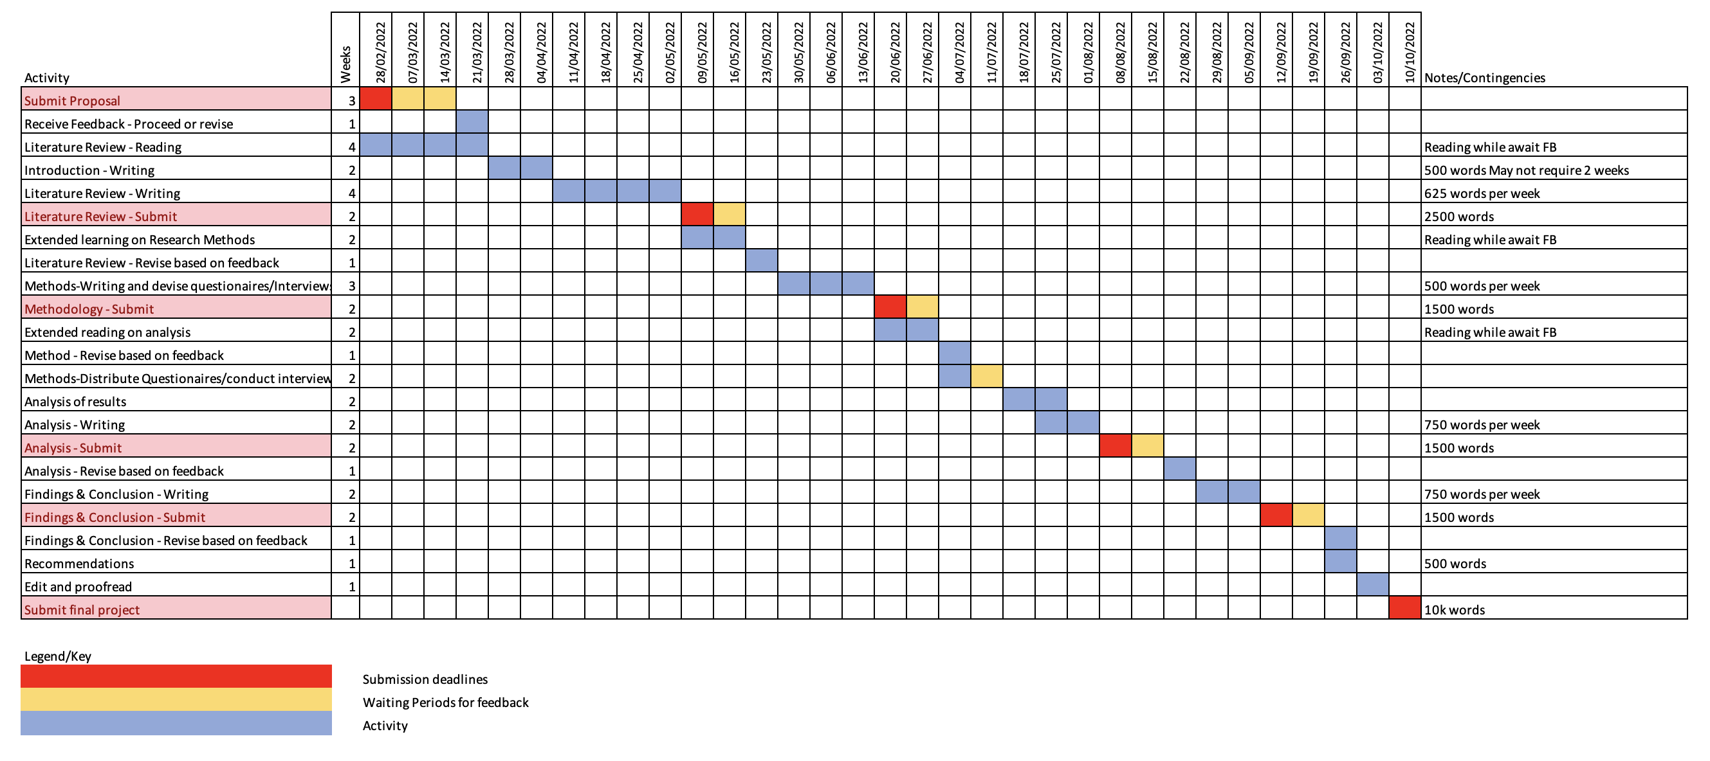

(Word count, 1632)

References

Bittner, E. (1970) The Functions of the Police in Modern Society: A Review of Background Factors, Current Practices, and Possible Role Models. National Institute of Mental Health, Centre for Studies of Crime and Delinquency.

College of Policing (2020) Evaluation of the Police Constable Degree Apprenticeship (PCDA) First interim report. Available at: https://whatworks.college.police.uk/Research/Documents/PCDA_evaluation.pdf (Accessed: 15 February 2022).

House of Commons – Home affairs committee (2016) College of Policing: three years on.

Neyroud, P. (2011) ‘Professional Policing in Times of Change’, Policing: A Journal of Policy and Practice, doi:10.1093/police/par051.

Pulido-Martos (2012) Sources of stress in nursing students: a systematic review of quantitative studies - International Nursing Review. Available at: https://onlinelibrary.wiley.com/doi/full/10.1111/j.1466-7657.2011.00939.x (Accessed: 15 February 2022).

Sherman, L.W. (2013) ‘The Rise of Evidence-Based Policing: Targeting, Testing, and Tracking’, Crime and Justice. doi:10.1086/670819.

Shohel, M.M.C. et al. (2020) Police Education in the United Kingdom: Challenges and Future Directions, Education, Human Rights and Peace in Sustainable Development. IntechOpen. doi:10.5772/intechopen.92705.

Wood, D. and Tong, S. (2009) ‘The Future of Initial Police Training: A University Perspective’. doi:10.1350/ijps.2009.11.3.131.

