
Assessment
Programme: Master of Business Administration
Module: Strategic Management
Title: Apple's Strategic Position and Growth Strategy for iPhone 17 in the Indian Smartphone Market
Module Code: LCMB7003
Lecturer: Gladius Kulothungan
Student Name : Amreliya kunjal Ghanshyambhai
Student ID: 2531260

Table of Contents
Section 1 - Strategic Consultancy Report 4
1. Organisational Context and Overview 4
1.1 Company Background 4
1.2 Mission, Vision and Core Values 5
1.3 Business Model 5
1.4 Indian Smartphone Industry Overview 5
2. External and Internal Strategic Analysis 6
2.1 External Environment Analysis 6
2.1.1 PESTEL Analysis 6
2.2 Industry Analysis 8
2.2.1 Porter's Five Forces 8
2.3 Internal Analysis 10
2.3.1 VRIO Framework 10
2.4 SWOT Analysis 13
3. Comprehensive and Holistic View of Apple 14
3.1 CSR Strategy Analysis 14
3.2 Balanced Scorecard Analysis 16
4. Strategic Choices and Implementation 18
4.1 Current Competitive Strategy 18
4.2 Strategic Options 19
4.3 Strategic Evaluation Frameworks 20
4.3.1 Ansoff Matrix 20
4.3.2 SAFe Framework 21
4.4 Recommended Strategy 23
4.5 Implementation Challenges and Risk Mitigation 23
Section 2 - Reflective Account 25
1. Description 25
2. Feelings 26
3. Evaluation 26
4. Analysis 26
5. Conclusion 27
6. Action Plan 27
References 28
Appendixes 34

Section 1 - Strategic Consultancy Report

1. Organisational Context and Overview

1.1 Company Background
Apple was formed in 1976 and ever since has dedicated all its efforts to keep evolving within the customer electronics, software and digital services of the business to become one of the companies of higher valuations in the world. Events like Macintosh, the iPod, the iPhone and Apple Silicon processors represent a turning point in the several industries (Apple.com, 2026). Now, Apple operates across more than 175 markets globally, utilizing a blend of retail stores, an online store, and official third-party retail partner stores (Apple Inc., 2025). The strategic decision by Apple to commence production in India, establish flagship stores, and inject important capital resources will reinforce the brand, positioning the iPhone 17 in a strong development category-the lucrative premium smartphone marketplace in India refer in figure 1.
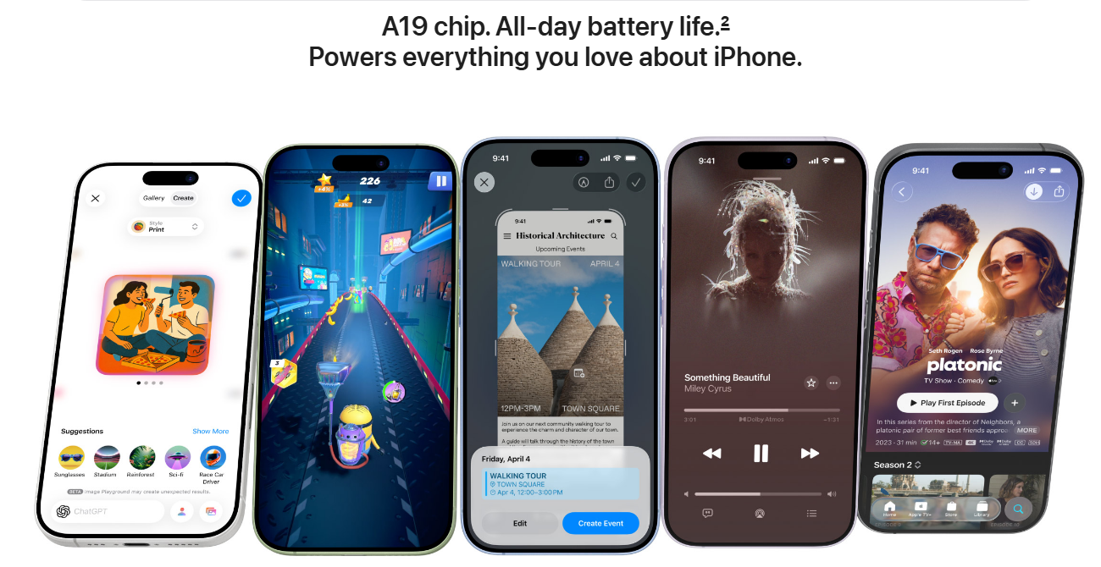
Figure 1: iPhone 17 premium smartphone segment in India
(Source: Apple.com, 2026)

1.2 Mission, Vision and Core Values
Apple company's mission to give the top tier customer experience with state of the software, service, hardware and its mission make things that make peoples lives better technology. Apple's values are seen within its products such as privacy, quality, service, sustainability, simplicity and ease of use. These values influence the direction for the Iphone 17s strategy in india to use high end and advanced technology and quality (Goggin, 2025). On this customer led pursuit Apple can grow and secure its customer base to compete with competitors and gain a stronghold on the premium smart phone market in India and beyond.

1.3 Business Model
Apple has a premium differentiation business model which relies on the unique combination of ground-breaking hardware, bespoke software and a wide-ranging digital services ecosystem. Connecting the iPhone 17 with iOS, Apple Intelligence, iCloud, Apple Music, Apple Pay and Apple Store gives the phone high customer switching costs, improves the user experience, and mixes with them (Bryła and Abdusattarov, 2025). Revenue comes from sales of devices, subscription programs, digital content, fittings and warranty programs. According to Akhonzada (2025) found that Apple's ability to produce and retail its products locally in India further enhances its profitability and aligns with the premium aligning strategy and the company's commitment to retain customers for the long-term.

1.4 Indian Smartphone Industry Overview
The surge in disposable incomes, a growing 5G network infrastructure, and India's quickly adopting digital landscape, India is among the greatest smartphone markets in the world. While the mid-range section contributes to the larger share of total sales, the premium smartphone market is showing high growth rates, as users are becoming more demanding of the smartphones and looking for additional sophisticated features, AI-driven apps and user experience (Chen, 2024). Figure 2 shows that India smartphone market size in 2023 stood at approx. SD 41.31 billion and it is predictable to reach USD 77.23 Billion by 2032 (Zionmarketresearch.com, 2026). The iPhone 17's release is perfectly timed for these trends, containing groundbreaking technology, a new and improved ecosystem, and the high-value added of the brand (Beathalter, 2026). While the digital transformation is continuing, the government's policy favouring domestic production, and the growth in online sales, delivers an ample growth opportunity for Apple in India.
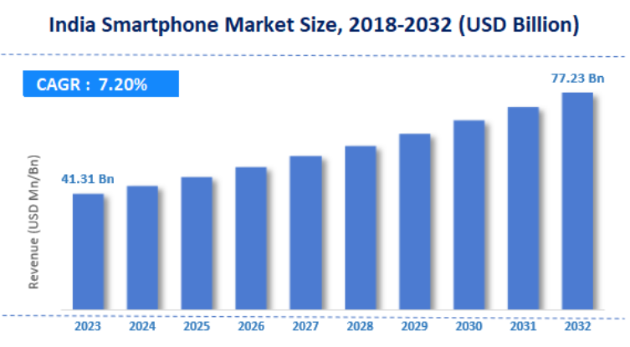
Figure 2: India Smartphone Industry
(Source: Zionmarketresearch.com, 2026)

2. External and Internal Strategic Analysis

2.1 External Environment Analysis

2.1.1 PESTEL Analysis
The PESTEL analysis is a tool used to analyse the macro-environment that might affect Apple's iPhone 17 strategy in India. It defines external opportunity and threat to the competitiveness, investment decisions, market expansion and long-term strategic performance.
Political Factors: Making in India and PLI schemes were initiated by Indian Government for local factory production and sales which have caused in the lesser number of imports and have served as the enabler for Apple in further expansion of production capabilities. This brings a larger scope of opportunity for India to achieve their targets for electronics manufacturing as far as to US$300 billion in the year 2026 (Apple Inc., 2026).
Economic Factors: "The economy of India is all set to increase by 6–7% each year supported by a rise in disposable income as well as increasing middle class which leads to higher expenditure capability (Apple Inc., 2025) [refer in figure 3]. As expected, the premium segment will continue to do better than the marketplace which would directly benefit the iPhone and the iPhone 17 will be more luxurious due to rise in price in terms of exchange rate as well as rise which could give them trouble against Samsung or android phone.
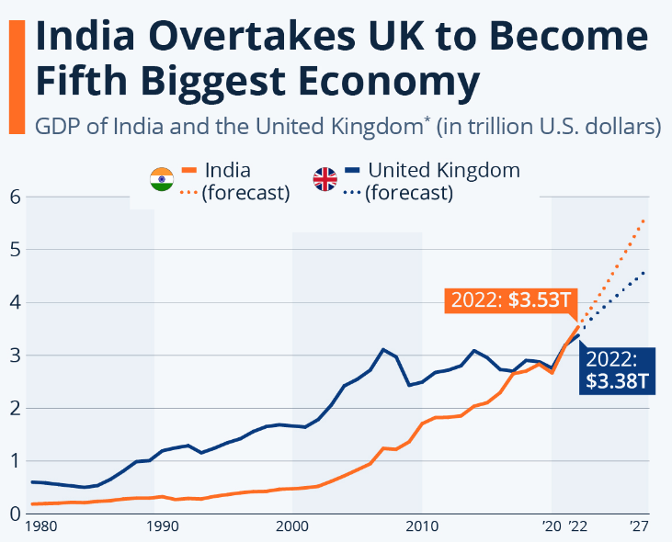
Figure 3: India Fifth Biggest Economy
(Source: Armstrong, 2024)
Social Factors: India population numbers over 1.4 billion People – the young populace are very technologically competent being smartphone users (Idc.com, 2025).The addition of top-notch brands as well as of that of AI powers with the social media integration will for surely adds "Rocket fuel" to the mix and definitely blow that doors down- on behalf of Apple company's latest Apple iPhone 17 product. However, This Cupertino company would present different kinds of financing due to expansion problems it can have with so many pending tasks for it to expand and continue developing (Gupta, 2026).
Technological Factors: The Demand for sophisticated smartphones has been booming, driven by a fast-expanding 5G network, AI, cloud computing, and online payments system. Prangon and Wu (2024) identified that Apple's Apple Intelligence composed with iOS system and ecosystem obtainable a major distinction with its latest iPhone 17 product. However, with the pace of technology and risks of cyber security as well as intensive competition, incessant R&D and innovation strategies should be put in the works.
Environmental Factors: To position itself as a more environmentally conscious firm Apple intends to brand all of its supply chains carbon neutral in 2030, which would give the brand a further reputational lift (Herrlich et al., 2025). Recycled components, usage of renewable power and environmentally approachable manufacturing methods conform with the general rising environmental awareness in India.
Legal Factors: Indian government regulations like Digital Personal Data Protection Act (2023) and customer protection acts are asking to be good when it comes to privacy, cybersecurity and data governance processes (Malhotra and Malhotra, 2024). Maintaining focus on user privacy ensures obedience with such regulations and gains consumers trust, but the customer smartphone industry in India face the risk of facing compliance issues, altering competition law regimes.

2.2 Industry Analysis

2.2.1 Porter's Five Forces
Porter's Five Forces is used to determine the competitive intensity of India's smartphone industry, and can be used to assess Apple's iPhone 17 market position by looking at factors that affect profitability, competition and strategic decision making.
Threat of New Entrants: Competition from new players is not a concern as it will take a lot of investment in research, manufacturing, market and distribution. Figure 4 shows that Apple's research and growth expenditure for 2025 was more than US$44.6 billion, resulting in high technological barriers (Gupta, 2026). Unparalleled brand loyalty, intellectual property rights, and ecosystem locking are all additional preventions for new players from taking on the iPhone 17 in the high-end market in India.
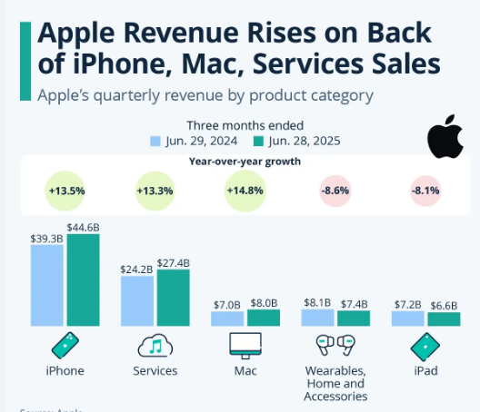
Figure 4: Apple Revenue by Product Category
(Source: Statista, 2026)
Supplier Power: Apple's supplier power is medium to high due to the fact that Apple relies on specialty suppliers for the high-tech components such as processors, OLED displays, camera sensors and semiconductors (Pradhan, 2025). The company has diversified into additional than 200 key suppliers around the world, so that Apple is not too dependent on any one supplier.
Buyer Power: Buyer power is moderate as top-notch smartphones with similar features are becoming prevalent in the market. Annually, more than 150 million smartphones were shipped into India which offered customers a wide range of products (Prasad, 2026). However, Apple's premium price has been helped by the fact that it has a strong brand image, an exclusive iOS ecosystem.
Threat of Substitutes: The threat from substitutes is moderate since consumers will opt for premium Android smartphones, refurbished smartphones or prolong the smartphone replacement cycle. Replace one in an average of 3.5 years compared to 2.5 years likened to the year before so annual replacement needs have lightened (Apple Inc, 2025). Their method to curb the problematic of slower replacement times? Throw in more features and functions driven by artificial intelligence, make everything faster, and a seamless tie by Apple’s ecosystem to get customers eager to promotion to the iPhone 17.
Industry Rivalry: Samsung, Xiaomi, Vivo, OnePlus, and Google are violently competing for pole position in India's extremely premium smartphone category - which remains Apple's domain. India ships over $50bn smartphones annually - it's a playground of creation, pricing and advertising - and the tech battle to get to be a number one brand has never been tighter (Gupta, 2026). The Apple 17 faces a stiff task fast but should still be a main success.
Competitor | Competitive Strength | Primary Competitive Focus
Apple (iPhone 17) | Premium ecosystem | Innovation, AI, brand loyalty
Samsung | Flagship smartphones | Foldables, AI, wide portfolio
Xiaomi | Value for money | Competitive pricing, features
Vivo | Camera technology | Youth market, offline retail
OnePlus | Premium Android | Performance, fast charging
Google (Pixel) | AI-powered smartphones | AI features, Android integration
Table 1: Key Competitors of Apple iPhone 17 in the Indian Smartphone Market
(Source: Self-Created)

2.3 Internal Analysis

2.3.1 VRIO Framework
The VRIO framework analyzes essential strategic resources and capabilities of Apple to see if they offer them with a sustainable competitive advantage in India's competitive premium smartphone market for the iPhone 17.
Resource/Capability | Valuable (V) | Rare (R) | Inimitable (I) | Organised (O) | Competitive Implication
Brand Reputation | ✔ | ✔ | ✔ | ✔ | Sustained competitive advantage
Innovation Capability | ✔ | ✔ | ✔ | ✔ | Sustained competitive advantage
Ecosystem Integration | ✔ | ✔ | ✔ | ✔ | Sustained competitive advantage
Financial Resources | ✔ | ✖ | ✖ | ✔ | Temporary competitive advantage
Retail Network | ✔ | ✖ | ✖ | ✔ | Competitive parity
Global Supply Chain | ✔ | ✔ | ✖ | ✔ | Temporary competitive advantage
AI Capability (Apple Intelligence) | ✔ | ✔ | ✔ | ✔ | Sustained competitive advantage
Table 1: VRIO Framework for Apple iPhone 17 in India
(Source: Self-Created)
Valuable Resources: Value based approach Apple has a strong value for its brand, product’s quality and integrates hardware and software so that can be identified as worth more than around $574.5 billion Apple products have valued asset which can be seen valuable resources (Idc.com, 2025). The helpful to make product for customers trustworthy and it ropes making a premium pricing and the final is to rise long-term earnings in favor of competitor.
Rare Resources: Apple’s prowess in implanting proprietary technology like Apple Intelligence, iOS, an in-house A-series chipset and select digital services into a single device is tough to match (Pradhan, 2025). This creates typical, desirable user experiences that also contribute to maintaining the premium awareness of the iPhone 17 in the Indian market, thus defensive its uniqueness.
Inimitable Resources: The innovative skills, patent portfolio and advanced global supply chain of Apple are expensive for other players to replicate. The business has more than 90,000 patents around the globe that cover technological inventions and product designs (Prasad, 2026). The features allow for ongoing product innovations, which will help India's leading smartphone manufacturer, Apple, maintain a competitive edge in the luxury category of smartphones.
Organisation: Apple's resources are well coordinated by efficient leadership, good financial skills, expansion of its retail stores, coordination of its supply chain and strategic savings in artificial intelligence. Figure 5 shows that the company earning around US$3051 billion in annual revenues, allowing it to continue investing in innovation, manufacturing locally, and high-quality retail labors that would boost the iPhone 17's market results in India (Apple Inc., 2026).
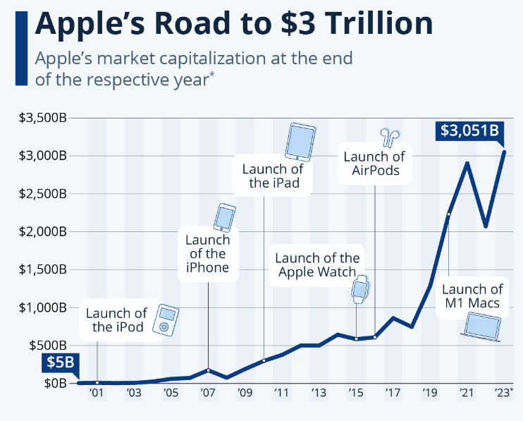
Figure 5: Apple's market capitalization
(Source: Statista, 2024)

2.4 SWOT Analysis
A SWOT analysis helps reveal Apple’s strategic competitive advantage and disadvantage along with avenues and potential risks and treats which the company could exploit of the iPhone 17 in the market in India.
Strengths: The superior brand equity, products and user base, Apple continued to grab additional revenue from the premium end in the industry and compared to Android in Q1 2025 captured roughly 23 percent of global smartphone revenue, though it shipped fewer devices than the Android segment (Apple Inc, 2026). The strengths of an iPhone 17 allow the builder to command a premium product and enjoy user trust.
Weaknesses: The expensive Price of iPhone17 would be unaffordable in India seeing budget customers (Tandel and Aithal, 2025). In any given month 8% to iPhone users in India that does not include budget customers by low outlets (than rivals in android). It makes Apple’s market limited for feast and sales growth and targeting premium people only.
Opportunities: The total market volume in India’s leading customer devices segment would grow at 12% CAGR in this decade with factors such as rising income, adoption of 5G and AI would make a important impact on the increasing demand (Farman et al., 2025) With development in domestic manufacturing of apple to increase their investment on iPhone 17, avail funding through EMI with multilingual AI abilities, enhance customer desire of iPhone.
Threats: Figure 6 shows that Samsung, Xiaomi, Vivo, OnePlus & Google are all chasing quickly at Apple by their own flagship with AI enabled products in the pipeline (Karim and Ernawati, 2025). India saw more than 190 million customers purchasing products on-line apiece year as a result improving the transparency of pricing along with aggressive opposition to compare. Even however the iPhone 17 faces opposition not just coming from new regulations.
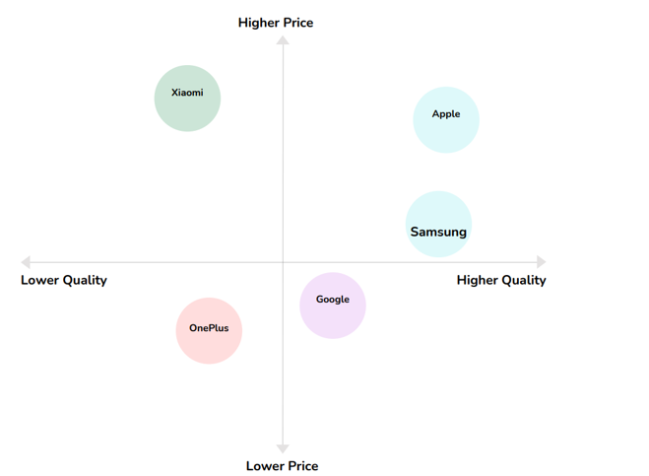
Figure 6: Apple Competition in the Smartphone Market
(Source: Self-made, from Canva)

3. Comprehensive and Holistic View of Apple

3.1 CSR Strategy Analysis
Apple’s Corporate Social Responsibility CSR policy corresponds to sustainable business practices that integrates ESG strategies for business models of the iPhone 17. It strengthens business trust for all stakeholders which is also crucial for the competitive future in India.
Environmental Sustainability: Apple aspires to reach 100 percent carbon neutrality with renewable energy and circular economy labors within its value chain by 2030 (Schoordyk, 2026). Such sustainability supplementary to the iPhone 17 enhances its practices contributing to request for sustainability-inclined Indians and the overall worldwide ESG objectives of Apple.
Responsible Supply Chain and Labour Standards: Apple routinely scrutinizes and evaluates its supplier partners to satisfy stringent labor rights and workplace safety standards as well as the standards obligatory of responsible supply chain sourcing. More than 900 supplier ability reviews have already been done so far in 2024 worldwide. Such operational discipline and assiduousness is not just necessary for supply chain transparency; it not only abridged the operational risks but also strengthened the belief of Indian customers in morally made premium phones like iPhone 17 (Sharma and Suri, 2026).
Privacy, Security and Customer Trust: The Privacy Protection that the iPhone 17 offers combined with Intelligent On-device and secure data management that no other Smartphones offer; It can be expected meanwhile apple invests approximately USD300 Billion in invention and cybersecurity as the in 2023 the business also engaged this investment fund (Apple Inc., 2025) [refer in figure 7]. The facilities likewise reveal today's digital economy of India in instruction to develop sureness between customer base, supplementary meet Apple's long-term company commitment as well as governance duties.
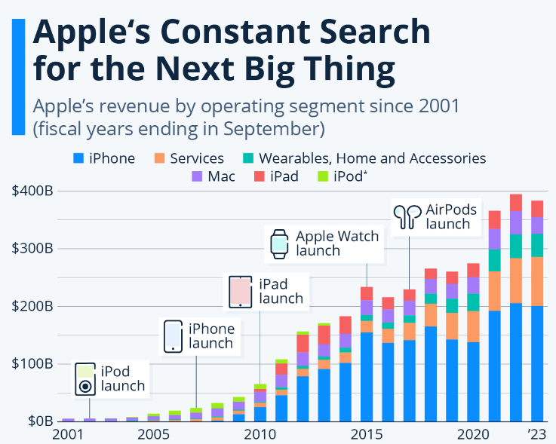
Figure 7: Apple's Constant Search for the Next Big Thing
(Source: Richter, 2024)
Community Investment and Strategic Alignment: The Partnerships at Apple we support education, workforce, and community achievement emerging digital skills and opportunities. We are deepening our social impact by more than $100 million of new investments to be made over five years to our Racial Equity and Justice Inventiveness globally (Apple Inc., 2026). These investments help build relations with stakeholders, contribute to inclusive development in India and resonate with Apple's purpose, business goals, and ESG method to the iPhone 17 strategy.

3.2 Balanced Scorecard Analysis
Balanced scorecard would serve as the instrument of transformation of the strategy into tangible financial and none-financial measures, so that it can help them to perform with positive output, their iPhone 17strategy in the Indian ferociously contestable market.
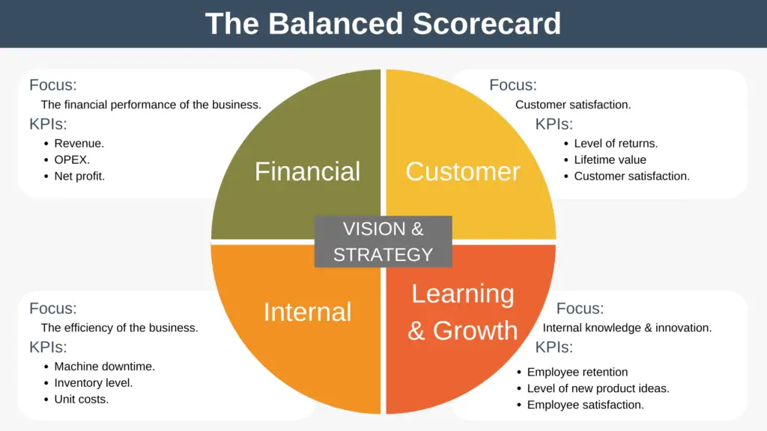
Figure 8: Balanced Scorecard
(Source: Expertprogrammanagement.com, 2022)
Financial Perspective: The key aim of Apple's financial goals is to generate more revenue and profit from the iPhone 17 and build its higher-end market share in India. Some KPIs are revenue development, operating margin, average selling price (ASP), return on investment (ROI) (Dachawar et al., 2025). It is a goal to double the revenue in the premium segment of smart phones every year in India. Strategic projects involve improvement of local production, establishment of more Apple Stores, flexible financing and trade-in schemes, and the development of subscription services like iCloud and AppleCare (Acharya, 2025). Such projects rise profitability, lower production costs and increase shareholder value in the long term.
Balanced Scorecard Perspective | FY2021 | FY2022 | FY2023 | FY2024 | FY2025
Financial (Revenue, US$ Billion) | 365.8 | 394.3 | 383.3 | 391.0 | 416.2
Customer (Active Devices, Billion) | 1.80 | 2.00 | 2.20 | 2.35 | 2.50
Internal Business Process (R&D Investment, US$ Billion) | 21.9 | 26.3 | 29.9 | 31.4 | 34.6
Learning & Growth (Employees, Approx.) | 154,000 | 164,000 | 161,000 | 164,000 | 164,000
Table 2: Balanced Scorecard Performance Indicators for Apple
(Source: Self-Created)
Customer Perspective: Apple's goal with the iPhone 17 is to ensure the greatest possible customer satisfaction, build brand loyalty and boost ecosystem adoption. Net Promoter Score (NPS), customer retention, repeat purchases, ecosystem subscriptions and customer satisfaction ratings are some of the key performance indicators used (Dissanayake et al., 2026). According to Elsas (2025) found that several surveys conducted in dissimilar countries, the satisfaction rate of iPhone users is currently estimated to be higher than 98% for Apple. Some of the strategic initiatives involve upgrading the multilingual AI features, consolidation after-sales service and support, extending retail experiences, and adding services like Apple Music, Apple TV+ and Apple Pay (Gupta, 2026). These steps help to maintain customers' loyalty and set Apple separately from high-end Android rivals in India.
Internal Business Process Perspective: To enable the success of iPhone 17 business, Apple put focus on continual innovation, manufacturing excellence, high-quality products, the strength and viability of the supply chain and sustainability. According to Rietveld and Schilling (2025) found that Product defect rates, manufacturing lead time, supplier complacence, production capability, use of recycled material etc are sure kips where Apple is working towards green manufacturing 100% recycled material (e.g. 100% recycled cobalt for intended batteries of certain Products). Creativities taken by apple will work on bettering local get-together operations; local relations by the suppliers; quality system; and automation and green manufacturing (Sharma and Suri, 2026). This exertion will go a long way for sustainable excellence and high-quality competitiveness to be preserved by the Premium Product business in India on long-term basis.
Learning and Growth Perspective: There are some five crucial success factors for Apple in the years ahead with the reliance on building a team, AI driven innovation, leadership development, transformation to digital enterprise and strong organizational culture. The metrics applied include employee’s involvement, management efficiency training, R& D of AI, and impact of innovation (Pal, 2025). Apple is home to nearly 164,000 employees across the globe whose training needs have frequently fulfilled for improving innovation capability at Apple. Some planned initiatives include the establishment of Leadership Growth programs, hiring for AI talent, Employee digital capability, fostering Cross functional team collaboration and expanding the Knowledge Sharing (Wang et al., 2025). With such investment Apple is going to innovate faster, achieve additional agile competence, create opportunities for launching its iPhone 17 in market, maintain its edge against Chinese makes in Indian smartphone.

4. Strategic Choices and Implementation

4.1 Current Competitive Strategy
By Apple with reference to iPhone 17’s price in India, the company will return to the playbook of differentiation and premium Ness; compete in prices will no longer come in use as Apple’s competitor not only offer quality, but also innovation; new iPhone 17 would consist of cutting-edge AI capabilities, latest hardware, second to none add-ins in Apple ecosystem, top of industry data security and safety (Li et al., 2026). The whole package delivers an unprecedented customer value and experience, the unique premium image strengthened by Apple store retail, native manufacture and after sale services.

4.2 Strategic Options
Cost Leadership: The cost leadership strategy is not suitable for Apple iPhone 17 because Apple's competitive advantage is based on the premium quality. In 2025, the average selling price of an iPhone was overhead US$900, compared with its competitors on Android which are in the hundreds (Apple Inc., 2026).
Differentiation: iPhone 17 will fit in India as differentiation is apple. Differentiating through technological innovation, brainy designs, focus on privacy, Artificial Intelligence (AI) and integration into the seamless ecosystem was an effective differential strategy of Apple as it has clutched nearly 85 per cent of the worldwide smartphone segment priced beyond $600 (Prasad, 2026).
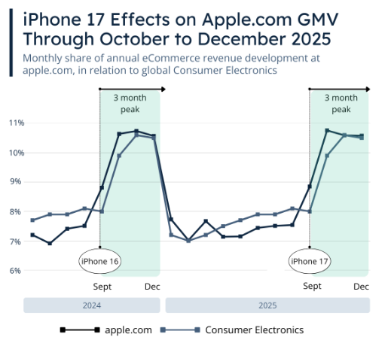
Figure 8: iPhone 17 Expect Largest Revenue Effects on Apple.com
(Source: Ecdb.com, 2026)
Focus Strategy: The focus strategy is also used by Apple, as the company focuses on the high-income population, tech geeks, and smartphone users in India who are looking for high specification gadgets (Guttena et al., 2026). The top-of-the-market smartphone category reported for around 11% of smartphone shipments in India during 2025 but accounted for a much larger proportion of industry revenue.

4.3 Strategic Evaluation Frameworks

4.3.1 Ansoff Matrix
The Ansoff Matrix is a strategic tool used to analyze potential growth opportunities for Apple iPhone 17 in the Indian market, since the market penetration and product development strategies that can improvement competitiveness, profitability, and sustainable growth refer in figure 8.

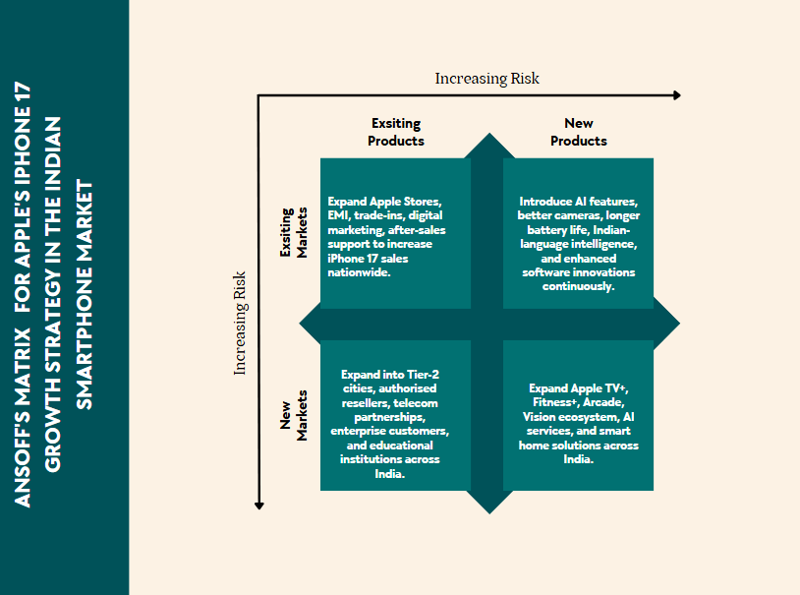
Figure 8: Ansoff Matrix
(Source: Self-created)
Market Penetration: The expanding presence in retail stores, facilitating financial packages (buyback, financing deals), digital marketing and additional promotions will expand sales in the premium Apple market for its upcoming Apple iPhone 17 in the existing market. In India’s complete smart phone’s, a total number of around 151 million shipments are in projection for 2025 (Dittmar et al., 2026). So, the market has immense scope for capturing additional market share by refining customer engagement with better aftersales service.
Product Development: The product development investment with Multilingual AI, improvements to Camera & battery will last for Apple catering to. Indian consumers, the company is slated to spend roughly $10bn in CapEx in FY2025 and continues to innovate and develop differentiation capabilities for product offerings and create value inside this Premium handset segments (Gupta, 2026).
Market Development: Apple stores and Apple authorized retailers along with apple.in crossways new tier 2 & 3 cities across India along with 17’ launch. Over 53% of Indian population reside in cities & will signify an emerging class of new affluent buyers and leveraging the wide network attention in the nation, they could drive extra revenue (Apple Inc., 2025).
Diversification: The iPhone 17 Apple also have plethora of other ecosystem services which they could extend AppleTV+, Apple Fitness+, Apple Arcade and smart home devices. As said earlier, Schoordyk (2026) Apple services business revenue around US$96billion, which highlights the diversified area which Apple can also leverage from hardware business while at the same time permitting to get steady revenue stream, customer retention and offer competitive advantage.

4.3.2 SAFe Framework
The framework is utilized in assessing the sustainability and flexibility of Apple's suggestion for the Indian market on the iPhone 17, as well as potential to offer competitive advantage over a lengthy time period.
Suitable: The differentiation strategy is a sound move given rising trends of Indian premium smartphones and Apple's innovating competence, the market value of the India smartphone pie signs the $12 billion mark and it is time to take it through the launch of premium contribution and introduction of AI powered feature for iPhone 17 as well as customer knowledge & ecosystem building (Beathalter, 2026).
Acceptable: The strategy wise a good strategy because it benefits the interests of Shareholders, customers and employees and stakeholders, with profitability as it supports a new kind of financial, continued profit that supports continued R&D and Innovation. With continued strong development performance Apple shows its potential for fiscal 2025 net income, approximately US $111 Billion provides opportunity for continued development, and delivery on customer prospects (Chai et al., 2025).
Feasible: The strategy has been considered viable as Apple has technological knowhow, manufacturing capability, finances, and organizational capitals required. It currently possesses 133 billion United states dollars in cash and marketable securities, which is a sufficient total for development (Apple Inc. 2024). AI development, production scaling, retail and retail and, supply chain progressions enabling Apple to market and implement I- Phone 17 successfully in India.
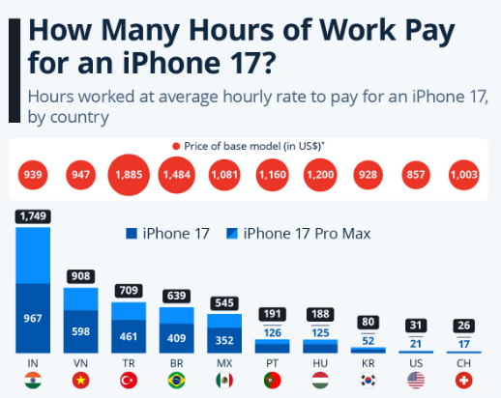
Figure 9: Apple's Installed Base Growth
(Source: Buchholz, 2025)
Evaluation: The company is seen as likely to recover its position in the market through innovation, premium positioning and ecosystem growth. Apple already has over 540 stores about the world, and it has already proven effective in its global expansion efforts and premium customer experiences (Chen, 2024). Therefore, this makes the strategy is predictable and useful for long term achievement, for the iPhone 17 to improvement the marketplace share as well as the brand.

4.4 Recommended Strategy
Market Penetration: iPhone 17 might also see greater penetration in the retail space, have the option for EMI funding or a trade-in deal, and an expanded online footprint, the devices will be relatively additional accessible, potentially raising Apple's stake in the increasing premium smartphone ecosystem in the country (Hai, 2023).
Differentiation Strategy: Apple’s counting on a premium model and customers that buy more into Apple's walled garden than those of rivals, for now. It suggests that Apple must get its AI in higher gear and keep updating its computers with faster AI-centric computer hardware too with future generation iPhones.
AI Ecosystem Expansion: The features for multiple languages, cloud, addition into Apple Watch, Mac and iPad-all packaged into “Apple Intelligence”-it will accelerate ecosystem adoption in India and then, the recurring revenue for the services bouquet (He, 2024).
Strategic Justification: Market Penetration (MP), Market Differentiation (MD) and AI Ecosystem Expansion (AI EE) will cumulatively contribute to increase share to Apple and allow customer hold and competitive advantage in the Indian market, thus safeguarding long-term sustainable iPhone 17 sales development (Li, 2023).

4.5 Implementation Challenges and Risk Mitigation
Risk | Likelihood | Impact | Mitigation Strategy
High pricing reduces customer demand | High | High | Introduce EMI, trade-in programmes, and student discounts
Intense rivalry from Samsung and Chinese brands | High | High | Differentiate finished AI, ecosystem addition, and premium facilities
Supply chain disruptions and component shortages | Medium | High | Expand local manufacturing and diversify suppliers
Regulatory and policy changes in India | Medium | Medium | Strengthen compliance, government engagement, and legal monitoring
Table: Risk Mitigation Plan for Apple iPhone 17 in India
(Source: Self-Created)
The proposed strategy for the iPhone 17 in India may encounter various hurdles, such as high pricing, strong local and international smartphone brands, disturbances in the supply chain, changing government policies, and the affordability of the device for consumers who are sensitive to price (Liu, 2024). By diversifying EMI and trade-in financing options, boosting local production through Make in India programs, improving retail and online distribution, founding strategic partnerships with telecom carriers and financial institutions, and adapting Apple Intelligence services to cater to the preferences and supplies of the Indian market, Apple can reduce these risks (Lu, 2024).

Section 2 - Reflective Account
The Gibbs' Reflective Cycle piece assesses my learning journey in creating the strategic consultancy report for Apple's iPhone 17 in India, stress how my research, critical analysis, and planned thinking contributed to my professional growth.

Figure 10: Gibbs' Reflective Cycle
(Source: Self-Created)

1. Description
For this assignment, I explored the 'strategic positioning of Apple' and the ‘launching of the iPhone 17 in the Indian smartphone market'. I gathered the data in academic publications, business annual reports, industry publications and market research databases. I used some of the strategic management frameworks, such as PESTEL, Porter's Five Forces, VRIO, SWOT, Balanced Scorecard, Ansoff Matrix and the SAFe. The structured research procedure allowed me to assess both Apple's external environment and internal capabilities, along with their competitive aligning and make strategic recommendations to the Board of Directors that were based on evidence.

2. Feelings
This assignment had my initial empathetic of strategic management but little experience in applying more than one of the strategic frameworks within the same consultancy report. Initially found it difficult to relate theory to practical situations in the business world (Shen, 2024). As I dissected Apple's approach, and tried to make sense of the latest market information, I slowly developed more confident. Independent research and the comparative analysis of various strategic options enhanced my analytical skills and boosted my self-assurance in making knowledgeable professional recommendations based on sound academic and industry research.

3. Evaluation
A good feature of my research was the use of more recent published academic research and industry reports to contribution with strategic analysis. By using multiple strategic models, a clear picture of Apple's competitive position in India was obtained. But getting the latest data for a particular region, for the iPhone 17, was difficult as some profitable data was scarce (Simic and Jovicic, 2023). It was a learning experience that I will remember forever, and it has made me understand the need to gather information from several credible sources, to validate the data and look disapprovingly at the evidence, and to be aware of any limitations of the data that I use in developing any of my strategic consultancy recommendations for the real commercial organisations.

4. Analysis
This task truly helped to further equip with applied ability on the management planning theories. I used PESTEL, VRIO, SWOT, Balanced Score Card, Ansoff Matrix, as well as SAFe tools are applied to analyse the strategy for Apple deliberately, thoughtfully and systematically (Wang and Hu, 2023). I was Instead of believing anything unquestioningly, critical examination on alternative choices is developed. In addition, by referencing cutting-edge research, new trends in the industry as well as the skills competences of the organisation in India, evidential-based choice making is realized and to contribute to the long-term competitive benefit of Apple.

5. Conclusion
Overall, this assignment has helped me to gain a better understanding of strategic consultancy, competitive analysis and corporate decision making. I had the opportunity to learn about the theoretic ideas and apply them in a global organization in a changing market. I also developed my research, analytical and academic writing skills, and my capacity to provide practical suggestions for business. These learning outcomes have helped me to be more self-assured in my strategic analysis and in preparing consultancy reports, based on evidence-based management values, to support organisational decision making.

6. Action Plan
In future assignments, I will build up my strategic consultancy skills through the creation of advanced strategic analysis techniques and further development of the knowledge of data analytics software counting Power BI and Excel. I also wish to improve my ability to write consultancy reports, reference my Harvard references and critically analyse academic literature (Ahmed et al., 2024). Moreover, I will apply responsible use of AI-powered research tools and reputable research sources to improve research effectiveness and maintain academic honesty to create and present more robust evidence-based strategic recommendations to address complex commercial problems.

References
Acharya, A., (2025). Analysis of Standard Essential Patents under the Lenses of Indian Commercial Laws. Journal of Intellectual Property Rights, 30(6), pp.745-753.
Ahmed, K.A., Damodharan, V.S. and Kumaraperumal, S., (2024). Factors affecting mobile coupon acceptance through smartphone app. International Journal of Business Information Systems, 46(1), pp.140-164.
Akhonzada, Z., (2025). Managing Quality in Apple’s Products and Services: A Comparative Analysis of Excellence and Ongoing Challenges. Journal Home Page, 4(2), pp.01-15.
Apple Inc. (2024). Apple inc. - annualreports.com. [online] www.annualreports.com. Available at: https://www.annualreports.com/Company/apple-inc [Accessed 2 Aug. 2026].
Apple Inc. (2025). Annual Report of Apple Inc. on Form 10-K for the fiscal year ended September 27. [online] Available at: https://s2.q4cdn.com/470004039/files/doc_financials/2025/ar/_10-K-2025-As-Filed.pdf [Accessed 2 Aug. 2026].
Apple Inc. (2026). Apple - Apple Investor News. [online] Apple.com. Available at: https://investor.apple.com/investor-relations/default.aspx [Accessed 2 Aug. 2026].
Apple.com (2026). iphone 17. [online] Apple. Available at: https://www.apple.com/iphone-17/ [Accessed 2 Aug. 2026].
Armstrong, M. (2024). India Overtakes UK to Become Fifth Biggest Economy. [online] Statista Daily Data. Available at: https://www.statista.com/chart/28258/gdp-of-india-and-united-kingdom/?srsltid=AfmBOor9Dx2qQuGPUzo0B5R0g-X-_CgTWHtdsSxdLIeZJMzLWe5rtQaq [Accessed 2 Aug. 2026].
Beathalter, S., (2026). Apple in 2025, with and beyond the iphone-India: a new production home base and market frontier for apple.
Bryła, P. and Abdusattarov, S., (2025). Apple’s strategy success factors and challenges in Europe: a case study of apple’s business model and international marketing.
Buchholz, K. (2025). How many hours of work pay for an iPhone 17? [online] Statista Daily Data. Available at: https://www.statista.com/chart/35143/hours-worked-at-average-hourly-rate-to-pay-for-an-iphone/?srsltid=AfmBOor-pP7DBW-KNg-gfmkBc_gBqUEGoC8iDvaTELKnO14dxdPGiElc [Accessed 2 Aug. 2026].
Chai, F., Lie, Z.S. and Dharma, H.R.C., (2025), September. Japanese Language Learning Application Development Using SwiftUI on iPhone Devices. In 2025 International Conference on ICT for Smart Society (ICISS) (pp. 1-6). IEEE.
Chen, Z., (2024), August. Business strategy analysis: Evidence on Apple Inc. In 4th International Conference on Enterprise Management and Economic Development (ICEMED 2024) (pp. 104-112).
Dachawar, M., Iyer, L., Moolya, R. and Sancheti, N., (2025), June. Technological Advancements and Market Segmentation in the Smartphone Industry: an Analytical Study. In 2025 6th International Conference on Inventive Research in Computing Applications (ICIRCA) (pp. 1-12). IEEE.
Dissanayake, K., Kularatna-Abeywardana, D., Patel, N. and Kularatna, N., (2026). A review of smartphone energy management: Power distribution, battery technologies, fast charging, thermal management and challenges. Energy Conversion and Management: X, p.101735.
Dittmar, Y., Stephan, M.J., Völkl, T., Hollick, M. and Classen, J., (2026), June. Unlocking Apple's Private Cloud Compute: An Analysis of Privacy-Preserving Artificial Intelligence. In Proceedings of the 19th ACM Conference on Security and Privacy in Wireless and Mobile Networks (pp. 63-73).
Ecdb.com (2026). iPhone 17: When to Expect Largest Revenue Effects on Apple.com | ECDB.com. [online] Ecdb.com. Available at: https://ecdb.com/blog/revenue-effects-of-the-new-iphone-17/5147 [Accessed 2 Aug. 2026].
Elsas-Nicolle, A., (2025). Threats, bans, and competition: Ripple effects in the global smartphone market.
Expertprogrammanagement.com (2022). The Balanced Scorecard - Expert Program Management. [online] expertprogrammanagement.com. Available at: https://expertprogrammanagement.com/2022/12/the-balanced-scorecard/ [Accessed 2 Aug. 2026].
Farman, H., Shamim, M., Mughal, M.H. and Ali, M., (2025). Machine Learning–Driven Insights into Pricing and Review Dynamics of iPhone Listings in the Indian E-Commerce Market. Journal of Computing & Biomedical Informatics, 10(01).
Goggin, G., (2025). Mobile AI: Communication and mobility after the smartphone. Communication and Change, 1(1), p.5.
Gupta, S.M. (2026). Apple’s iPhone 17 Leads India Smartphone Volumes For First Time. [online] Gadgets Now. Available at: https://gadgetsnow.indiatimes.com/tech-news/apples-iphone-17-becomes-indias-best-selling-smartphone-amid-market-decline/articleshow/131038779.cms [Accessed 2 Aug. 2026].
Guttena, R.K., Bhattacharyy, A.K., K, H., Kondapaka, P. and Rodriguez, R.V., (2026). When rivals become brain partners: Strategic options for Apple with Google Gemini. Journal of Information Technology Teaching Cases, p.20438869261462962.
Hai, D.H., (2023). Comparative analysis of market and product development potential of Apple and Samsung. International Journal of Advanced Multidisciplinary Research and Studies, 3(1), pp.723-734.
He, Z., (2024). Analysis of Apple’s Marketing Strategy: Strengths, Challenges, and Future Directions. In SHS Web of Conferences (Vol. 207, p. 01020). EDP Sciences.
Herrlich Abayo, A.D., Kembou Keumoe, I.M., Epee Pense, F.S. and Ondoua Mbida, S.D., (2025). Intelligent and Secure Communication Systems: Signal Processing, AI, and Cloud-Enabled Architectures for Next-Generation Networks. AI, and Cloud-Enabled Architectures for Next-Generation Networks (May 25, 2025).
Idc.com (2025). India’s Smartphone Market Hits Five-Year High in Festive Q3 2025, Up 4% YoY on Premium Demand. [online] IDC: The premier global market intelligence company. Available at: https://my.idc.com/getdoc.jsp?containerId=prAP53921425 [Accessed 2 Aug. 2026].
Karim, A. and Ernawati, A., (2025). Uncovering Smartphone Brand Strategies through Specification-Based Clustering and Classification. Buletin Ilmiah Informatika Teknologi, 4(1), pp.24-32.
Li, E., Larsen, A.B.L., Zhang, C., Zhou, X., Qin, J., Yap, D.A., Raghavan, N., Chang, X., Bowler, M., Yildiz, E. and Peebles, J., (2025). Apple intelligence foundation language models: Tech report 2025. arXiv preprint arXiv:2507.13575.
Li, Z., (2023). Strategic Marketing-Marketing Analysis of Apple Company. International Journal of Management Science Research, 6(4), pp.19-26.
Liu, Z., (2024). A financial analysis of Apple based on its external and internal environment. channels, 30.
Lu, Y., (2024). Financial statement analysis and revenue forecast for Apple Inc. In SHS Web of Conferences (Vol. 181, p. 02020). EDP Sciences.
Malhotra, C. and Malhotra, U., (2024). Putting interests of digital nagriks first: digital personal data protection (dpdp) act 2023 of India. Indian Journal of Public Administration, 70(3), pp.516-531.
Neglur, I.S. and Rajeswari, P.S., (2025). Case study Apple: Exploring the effects of brand power through nudge theory. Journal of Information Technology Teaching Cases, 15(2), pp.265-272.
Pal, R., (2025). Strategic Management of Technological Innovations for Competitive Advantage. Journal of Contemporary Science and Technology Management, 1(01), pp.31-39.
Pradhan, B. (2025). iphone shipments in india set to hit record 15 million units in 2025. [online] @bsindia. Business Standard. Available at: https://www.business-standard.com/india-news/iphone-shipments-in-india-set-to-hit-record-15-million-units-in-2025-125091100475_1.html [Accessed 2 Aug. 2026].
Prangon, N.F. and Wu, J., (2024). AI and computing horizons: cloud and edge in the modern era. Journal of Sensor and Actuator Networks, 13(4), p.44.
Prasad, P. (2026). iPhone 17 Series Dominates Apple’s India Shipments in Q2 2026, Captures 44% Share as Company Eyes Festive. [online] Walia News Network. Available at: https://walianewsnetwork.com/iphone-17-series-dominates-apples-in-india/ [Accessed 2 Aug. 2026].
Richter, F. (2024). Infographic: Apple’s Constant Search for the Next Big Thing. [online] Statista Daily Data. Available at: https://www.statista.com/chart/17862/apples-annual-revenue-by-operating-segment/?srsltid=AfmBOooqbxc-j5IgeTincTYjTdXceHOAMq9Ld6iKXEqPr9Hv4ohXZ0O3[Accessed 2 Aug. 2026].
Rietveld, J. and Schilling, M.A., (2025). Hypercontinuous innovation and demand-side learning: Why digital platforms enjoy longer and more expansive market leadership positions. Academy of Management Perspectives, (ja), pp.amp-2023.
Schoordyk, N., (2026). Apple in 2025, with and beyond the iphone-Apple's strategic opportunity in the refurbished iphone market.
Schoordyk, N., (2026). Apple in 2025, with and beyond the iphone-Apple's strategic opportunity in the refurbished iphone market.
Sharma, G. and Suri, R., (2026). Dimensions Of Experiential Marketing And Their Effect On Consumer Loyalty In The Smartphone Retail Industry. Adolescência e Saúde, 21(4s), pp.371-379.
Sharma, G. and Suri, R., (2026). Dimensions Of Experiential Marketing And Their Effect On Consumer Loyalty In The Smartphone Retail Industry. Adolescência e Saúde, 21(4s), pp.371-379.
Shen, Y., (2024). Analysis on Apple TV+: Future Development Direction of Streaming Media Platform. In SHS Web of Conferences (Vol. 181, p. 04004). EDP Sciences.
Simic, N. and Jovicic, T., (2023). Fundamental analysis of the Apple Company. Economic and Social Development: Book of Proceedings, pp.97-106.
Statista (2024). Infographic: Apple’s Road to $3 Trillion. [online] Statista Daily Data. Available at: https://www.statista.com/chart/14953/apple-market-capitalization/?srsltid=AfmBOornrrl2XyGGrDrd0Qsd6nAkuutD61_9Vf4zBzNJug-uBY87Qras [Accessed 2 Aug. 2026].
Statista (2026). Apple Revenue Rises on Back of iPhone, Mac, Services Sales. [online] Voronoiapp.com. Available at: https://www.voronoiapp.com/business/Apple-Revenue-Rises-on-Back-of-iPhone-Mac-Services-Sales-6056 [Accessed 2 Aug. 2026].
Tandel, K. and Aithal, P.S., (2025). Technological Strategy of Apple in India: Business Challenges and Growth Opportunities. Poornaprajna International Journal of Teaching & Research Case Studies (PIJTRCS), 2(2), pp.259-291.
Wang, X., Yusof, R.N.R. and Jaharuddin, N.S., (2025). Driving SMEs’ sustainable competitive advantage: The role of service innovation, intellectual property protection, continuous innovation performance, and open innovation. Sustainability, 17(9), p.4093.
Wang, Y. and Hu, W., (2023). A Study on Advertising Translation from the Perspective of the Skopos Theory—A Case Study of Apple Inc. Journal of Research in Social Science and Humanities, 2(8), pp.51-60.
Zionmarketresearch.com (2026). India Smartphone Market Industry Size, Share, Trends & Forecast 2023 – 2032. [online] Zion Market Research. Available at: https://www.zionmarketresearch.com/report/india-smartphone-market [Accessed 2 Aug. 2026].

Appendixes
Appendix A: PESTEL Summary Matrix
Factor | Key Issue | Opportunity | Threat
Political | Make in India, PLI Scheme | Local manufacturing | Policy changes
Economic | Rising disposable income | Premium market growth | Inflation
Social | Young digital population | Higher smartphone demand | Price sensitivity
Technological | AI, 5G, Cloud | Innovation leadership | Fast technological change
Environmental | Sustainability expectations | Green branding | Compliance costs
Legal | Data privacy regulations | Customer trust | Regulatory risks

Appendix B: SWOT Matrix
Strengths | Weaknesses
Strong global brand | Premium pricing
AI innovation | Limited market share in India
Ecosystem integration | Smaller retail footprint
High customer loyalty | High dependence on premium customers

Opportunities | Threats
Growing premium segment | Strong Android competition
AI demand | Regulatory uncertainty
Local manufacturing | Supply chain disruptions
Digital transformation | Price-sensitive consumers

Appendix C: Porter's Five Forces
Force | Intensity | Impact on Apple
New Entrants | Low | Low threat
Supplier Power | Moderate | Moderate risk
Buyer Power | Moderate | Customer choice increasing
Substitutes | Moderate | Android alternatives
Industry Rivalry | High | Strong competition

Appendix D: Balanced Scorecard
Perspective | Objective | KPI | Target
Financial | Increase revenue | Sales growth | Double-digit growth
Customer | Improve satisfaction | NPS | Above industry average
Internal Process | Manufacturing efficiency | Defect rate | Reduce annually
Learning & Growth | AI capability | Employee training | Annual improvement

Appendix E: Ansoff Matrix
Strategy | Application to iPhone 17 India
Market Penetration | Retail expansion and EMI offer
Product Development | AI-powered iPhone features
Market Development | Expansion into Tier-2 and Tier-3 cities
Diversification | Apple services ecosystem growth

Appendix F: SAFe Evaluation
Criteria | Assessment
Suitable | Supports premium strategy
Acceptable | Meets stakeholder expectations
Feasible | Strong financial capability
Evaluation | Sustainable competitive advantage

