UWTSD
University of Wales Trinity Saint David

Global Business environment – LCBB4005

Elena Sotirova
student number:2028225
Dr. Uwaoma Ochonogor
2nd December
(Written examination)

1.(a) Discuss the importance of international trade for PepsiCo
International trade is the exchange of goods and services between countries. People and nations are exposed to commodities and services that are unavailable or more expensive in their native countries through global commerce. Intercontinental trade refers to the movement of goods and services from one country to another. Raw minerals, materials and food, as well as consumer products like as television sets and clothing, are frequently traded. Living standards, employment opportunities, and a wider range of commodities are all depend on international commerce.
Export, import and commerce are all sorts of international trade. Goods from one nation are brought into the United States, where they are enhanced and them exported. Good example for international trade / export/ are some brand for soft drinks like PepsiCo. Due to the global value chain these days PepsiCo can be found in many countries around the world and couple continents. For a brand like PepsiCo it is very important to expand constantly their markets and to try new markets as well. Hence that the company will keep a bigger profit and build long-term relationship with exist or new costumers.
1.(b) International strategy for PepsiCo
International strategy is the most challenging plan that any firm can attempt. This method is anticipated to become increasingly essential. Owing to the expanding market globalization, even family SMEs-traditionally concentrated on their home markets – may have to face this strategy. Therefore, it is preferable that greater effort should be given to studying models of international expansion for small and big enterprises and how to improve them (Fernandez at al. 2005).
International strategy, by definition, is a strategy by which a business sells its goods or service outside of its native market. International markets present numerous new growth options for each organisation: market entry strategy; target market strategies; timing strategies; allocation strategies; coordination strategies , are the five central elements of internationalisation strategies ( Schmid 2018).
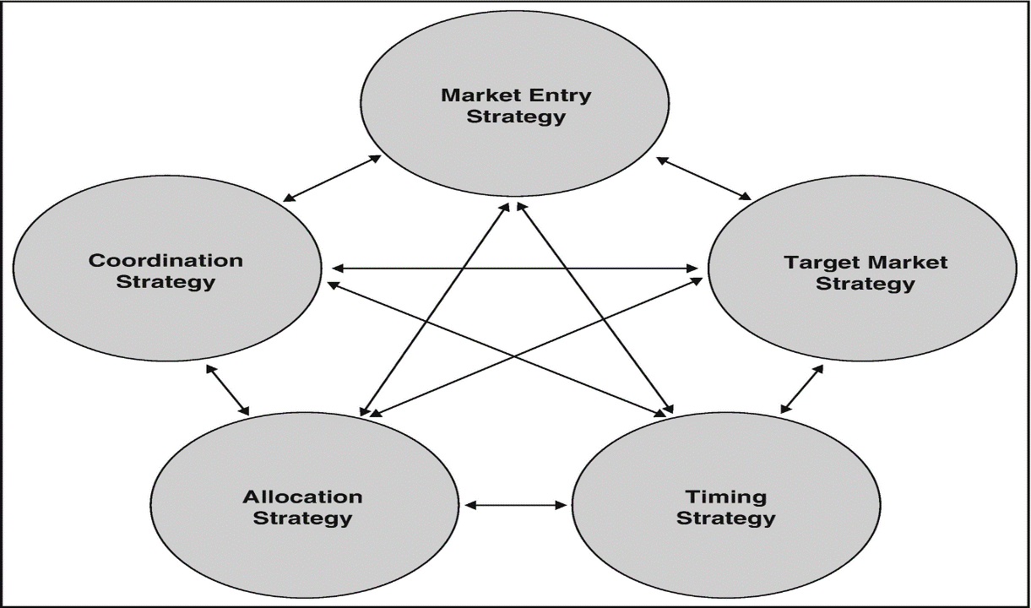
An international product like the soft drinks of PepsiCo, is one that can be consumed in a wide range of countries, and this process is called internationalization. Business that aim to expand their worldwide reach use this strategy to account for the fact that consumers in various countries may have different interests or habits. When it come to conducting business beyond national boundaries, expanding their audience, and increasing their revenue, our global world has made it easier then ever. The most prevalent methods of entering the market are:
- export
- opt for Foreign direct investment (FDI)
- adopt a licensing strategy
- set up a Franchising
-built a Joint venture with a company.
In our case PepsiCo can use the export method. Exporting is without doubt the most common method of internationalizing a firm. The corporation might participate directly in the process (direct export) or contract with a commercial operator to negotiate and market its product internationally 9indirect export). Indirect exports are the least resource-intensive but also the most dangerous option for internationalization. They are particularly advantageous because they do not involve direct contact with the outlet market or ultimate consumers, in contrast to direct export, which requires a higher level of investment, particularly financial.

3.(a) Explain the term Market Failure
What is market? Market consists of two players buyers and sellers. Buyers represent the demand for products, and sellers represent the supply of products on the market. These two elements are completely independent but interact with each other in different ways.
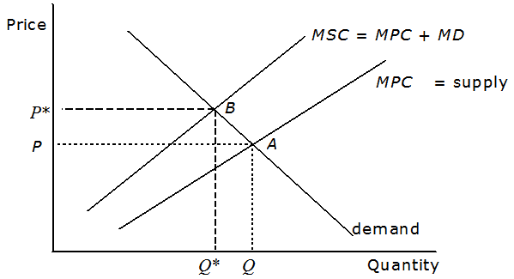
(aoas.ac.uk 2021)
Market failure is an economic term applied to a situation where consumers demand does not equal the amount of a good or service supplied, and is, therefore, inefficient. Market failure occurs when is an oversupply or undersupply, or where full cost are not incorporated into the final price. Therefore, a third party may have a cost imposed on them. In economic jargon, we say is an inefficient allocation of resources. We can look at the market failure in two way. Firstly, through supply and demand. In other words, if supply and demand never meet, there is market failure. Second, we can look at the market failure from the side of pricing. This is where the good or service produces external benefits or cost that are not reflected in the final price to the consumer. These are also known as externalities.
Some of the most common form of market failure include:
- air and noise pollution
- education
- healthcare
- water supply and other utilities

2.(a) Using examples of two products, explain Elasticity of Demand
Elasticity is most frequently used to refer to an economic indicator that quantifies the change in the quantity demanded of a good or service in response to changes in its price. For example, when demand is elastic, the price of an item has a significant effect on its demand. Using demand as an example, if the price of a good decreases by X percent, the amount that people want to buy increases proportionately. If the price were to increase by X percent, the amount that individuals would want to buy would fall even more.
Multiple factors influence the quantity requested for a product, including people’s income levels, the product’s price, the price of other products in the segment, the tastes and preferences of consumers, the consumers’ expectations, the numbers of consumers in the market and more.
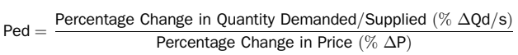
Demand for a product can be elastic, inelastic, or unitary, based on the rate at which demand changes in response to changes in the product’s price.
It is classified as “elastic”, “inelastic”, or “unitary” based on the amount of fluctuation in the quantity desired of an item ( analyticssteps.com 2021).
Elastic demand is defined as a demand that indicates a greater fluctuation in the quantity required of a product in response to even a small change in another economic variable. For instance, soft drinks are not an essential, and a significant price increase would force people to stop purchasing them or seek out alternative brands. However, a significant price reduction would undoubtedly draw additional purchasers. Another example may be automobiles. While many people look for a specific make or model of car, there are numerous makes and models. When the price of a vehicle increases, consumers will consider comparable vehicles. On the other hand, if the price drops, more individuals will consider purchasing the vehicle.
A demand that is inelastic is one that exhibits relatively little variation in the quantity required as a function of another economic variable. Petrol or diesel are two example of this.
2.(b) Demand and Supply of the bread
Another example for inelastic demand will be in UK, if the Consumer Protection Association issues a warning that the particular brand of bread is not good for the health of the people. Automatically the demand of this product will decrease, even if the producers decrease the price of it. Then consumers will try to buy another brand, which will be healthier and again we will have inelastic demand. The new popular brand of bread will increase its demand, even if the generator decide to increase the price.
Unitary elasticity exists when the variation in a single variable and the quantity requested are equal.

References:
Analyticssteps.com (2021) Elasticity of Demand and its Types, Available at: https://www.analyticssteps.com/blogs/elasticity-demand-and-its-types (Accessed: 2nd December 2021).
Aoas.ac.uk (2021) Unit1 An Introduction to Environmental Economics & Economic Concepts, Available at: https://www.soas.ac.uk/cedep-demos/000_P570_IEEP_K3736-Demo/unit1/page_29.htm (Accessed: 2nd December 2021)
Fernandez et al.(2005) ‘Internationalization Strategy of Small and Medium – Sized Family Businesses: Some Influential Factors’, Scholarly Journal, 18(1), pp.77-89
Schmid, S. (2018) Internationalization of Business, Case on Strategy Formulation and Implementation. SpringerLink

