

Postgraduate/Distance Learning
Assignment Coversheet & Feedback Form

[Please insert this coversheet as the first page of the assignment you are submitting]

For completion by the student:
Student Name: Jane Manley
Module code: HPEN7020 | Student University Number:  0202616 |  | Educational support needs:  Yes/No  Y
Module title: Writing Workshop: Researching and writing place and context |  |  | Educational support needs:  Yes/No  Y
Module tutor: Ros Hudis
Assignment title: Creative assignment – Whelk Walking
Assignment due date: 29th May 2021
I confirm that this is my original work and that I have adhered to the University policy on plagiarism.

Name ……J. E. Manley……………………………………

Assignment Mark
1st Marker’s Provisional mark
2nd Marker’s/Moderator’s provisional mark
Agreed Internal Mark
External Examiner mark (if relevant)
Final Mark

NB. All marks are provisional until confirmed by the Final Examination Board

For completion by Marker 1:
Comments:
Marker 1 signature: |  | Date:
For completion by Marker 2 / Moderator:

Comments:

Marker 2 / Moderator signature: |  | Date:
External Examiner’s comments (if relevant):

External Examiner signature: |  | Date:

Jane E. Manley 0202616

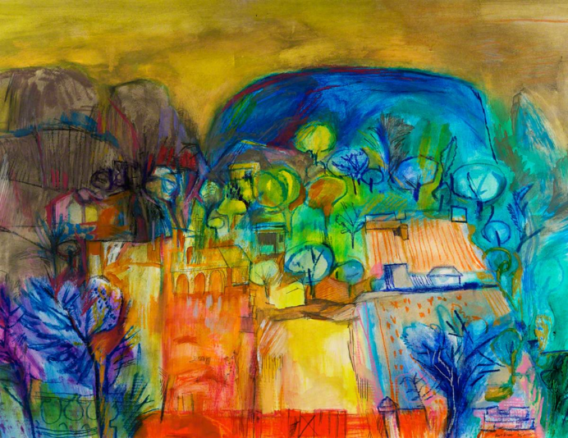
Writing a Sense of Place
HPEN 7020

Word count
Whelk Walking | 5610
Contents

Whelk Walking
Epigraph | 6
On this bed | 7
Before today | 9
This is today | 12
Before today 2 | 15
This is another day | 18
The Day | 21
The day + 1 | 24
Today’s conversation | 25
Three sisters defined | 28
The beach on my terms | 31
Teleportation | 34
I jump | 37
The other side | 39
Life carries on | 43
Bibliography | 45
Image directory | 48

Whelk Walking
There is Always Tomorrow

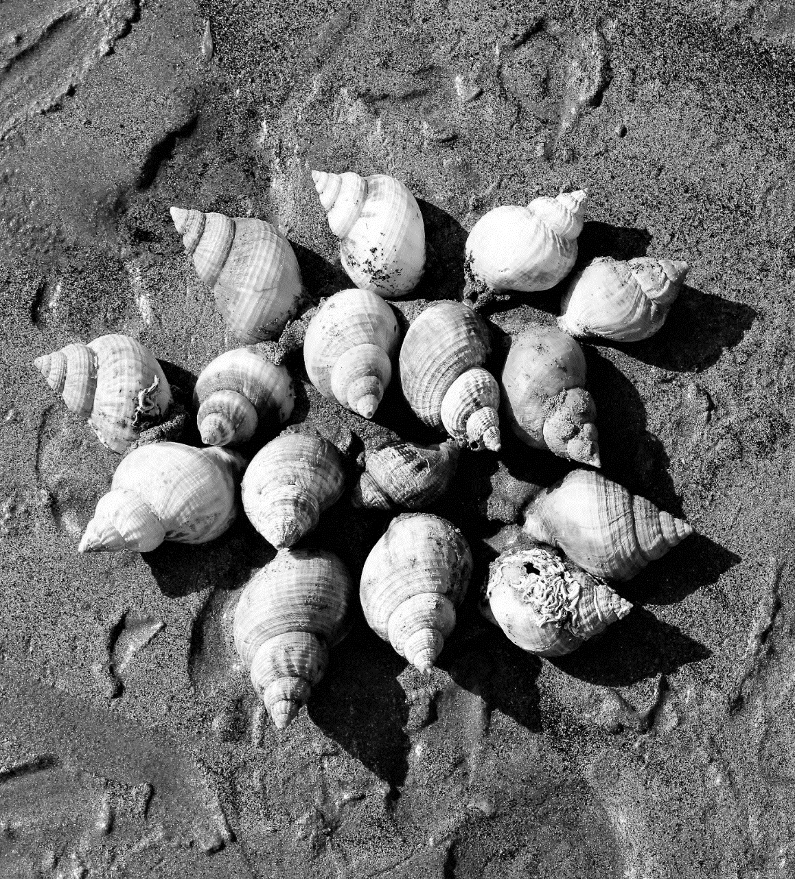

Jane E. Manley
Epigraph

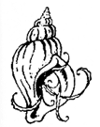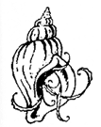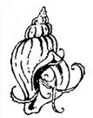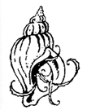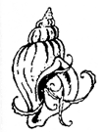
Whelk shell

Dog whelk shell

Nucella lapillus shell

Cragen gwichiaid cŵn

Atlantic dog winkle shell

Predatory sea snail shell

Carnivorous gastropod shell

Species – nucella lapillus

Genus – nucella

Family – muricidae

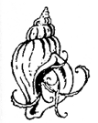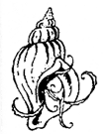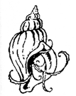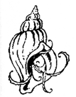

On this bed
Lying on this state of the art
cutting edge choose your cliché bed
my tetrapack body sanctions only
movement of the head
and the satisfaction of speech

Today I am a character from the Greek classics
because these four these tetra limbs are plegic
paralysed
sounds so sophisticated in the vernacular doesn’t it?

T e t r a p l e g i c

I prefer to roll the words nucella lapillus around my mouth
the vowels and consonants
give something substantial to bite down on
when the pain is too much to bear

This is no ordinary whelk shell
this is a Pendine whelk shell
an end of the dunes
Pentywyn cragen gwichiaid cŵn
my liberty my chalky organic cariad bach
Three shells sit  on the fugly institutional wipe clean bedside table  there is no pretence no symmetry nor charm  this is what you have become I heard in my head  Said to a woman who never wore black  or took a straight line when a curved one would do  sitting on the chair my leathers and helmet  dulled by dust a fantasy now  a relic from another dimension  But there are still a few choices not denied  I chose the three dogs that are set in a row  a triad the holy trinity  religion fuck no  sand sun and sea is and always was my theology  it’s the sisterhood  always was the three and me  They subvert the world of my dependency  Yes they are literally empty shells devoid of life  their sex obliterated by bleaching in the sink  after crabs and ravenous seabirds devoured their soft flesh  they are my kind of shell my kin  a cross-layered hard outer protective husk  that once cradled the nucleus of a life inside  Did you know they are pseudohermaphroditic?  neither did I but hey what a word  Before Today  This place is our place  we sit in the scullery  the long windows  braced against the wind  blowing in off the Irish sea  drinking welsh brew tea  mahogany stained mugs  witness to the years of  contentment and love  spent in this white house on the hill  No toys in the hall  or shrieks from the garden  but photographs of adventures  and other’s children  adorning the walls of our world  A toddler’s seascape takes pride of place  on the fridge door  exuding laughter  joy  uninhibited pleasure  at the feel of paint  squidging through fat fingers  colours clash like a deviant rainbow  Hockney would be proud  Cumulus nimbus clouds scud by  black grey paler then dark  now stratocumulus  elegant white and welcome  a porthole of blue punches through  No words spoken just a look  hats coats and boots plucked from the porch  running down through the garden  ‘don’t forget the gate  the sheep are out next door’  Down the path  slippery stone slows us  lichen is treacherous when wet  salt on the tongue now  the taste of Pendine sea  technically I believe it’s the Irish  but I’m claiming it as my own  Faster now we’ve reached the sand  low tide and the grains miss the brine of the water  as if a lover has fled  needing comfort or a caress  our boots are pulled down  into the viscous layers of the shore  But we are happy and disregard the plea  he runs and I chase | 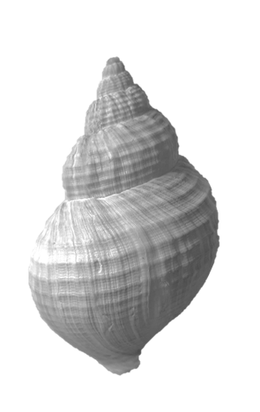
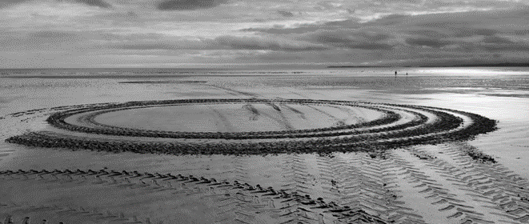

But I am easily seduced by light
and Rhodri from the range has been out
doing wheelies on the tractor
I stop and wonder at the sight

he says he must clear people from the beach
when the rockets are running
at full velocity down the track

and death on the sands
would prove catastrophic to the B & B income
(his own)

I stand still and stare
as the platinum silver blue patina
mirrors the sun
and silica answers back ‘look at my glory’

no rubber tyre imprints here I know it
instead a spectral fairy circle Cylch y Twyth Teg
gone at high tide and who knows when they’ll reappear
my magic result is a cwtch at Gilman Point
This is today
They tell me talking therapy will help
with what I’m not really sure
regrowing the damaged cells?
building an exoskeleton powered by thought?
letting me experience another orgasm?
to give him joy as he wipes away the faeces from the sheet?
not being at the epicentre of a care team?

removing the pity from others’ eyes?

This is one of the lost days

Hokosai’s wave has stolen Worm’s Head from view
but denied me death by drowning
my estimation of his art is diminished

it is a blue day today

Picassoesque
confusing with all his shades of blue
they overwhelm yesterday’s confidence
wipe it from memory like all blue days do
the rhythm of the ripple mattress echoes
the sound of my breath and nausea returns

I prefer not to dwell on the long list of cannot do
when the haar rolls in
I’ll illustrate so you don’t have to ask
This is what makes me me and you you
beautiful in a diagram
interesting constructed in plastic for scholars to admire
but sublime in situ

until it snaps

gone function gone
but still a gorgeous image for you to colour in
inside the mindfulness magazine
on a rainy afternoon in Spring

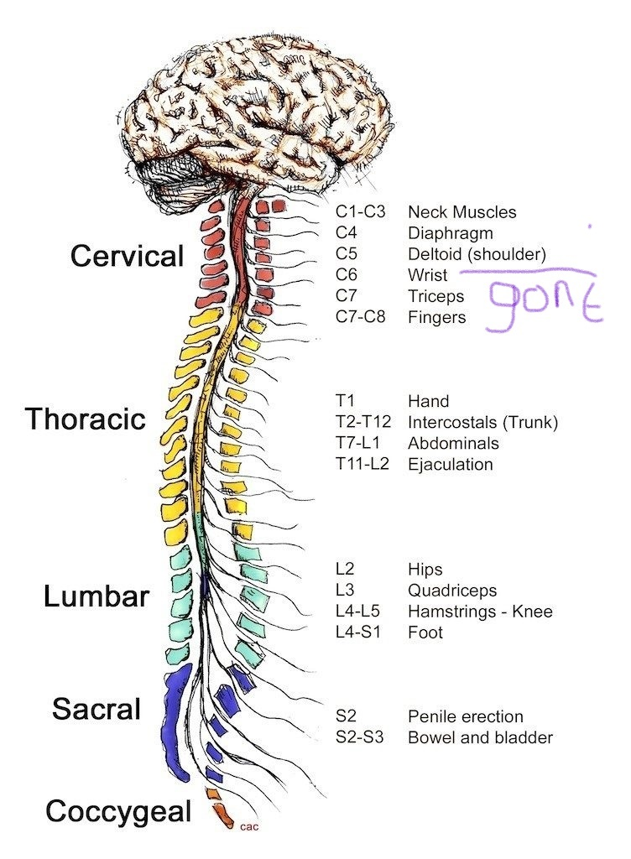

Understand and commit to memory
Tomorrow we will lie on the beach
a towel for him
for me?
an all-terrain beach chair
admired for its wide tread tyres
a deluxe off roader

or as I’ve heard it called
(because if you’re not whole you must be deaf)
fucking cracking cripple chariot that

from one of the donators to the crowd funding site
such generosity
but combined with such cruelty
cuts cuts deeper again
deeper than any physical pain

Two of them to hoist me into the van
two again for the chair
down the concrete slip-way
past the deckchairs where the oldsters fritter away time
and the restrained kids who wave from the pushchairs
surprised at the sight of a grownup imprisoned like them
and siblings asking for a ride

It is the parents paralyzed with embarrassment who offend
the kids unabashed ask their questions
oblivious to stares just curious and to the point
we will laugh together and move on
Before today 2
Gilman Point and the wind scatters his words into the air
his breath is sweet on my face
love and salt is a potent mix
and like teenagers without supervision
we kiss holding hands

The sands graze the horizon
a razor-sharp delineation between
earth and sky
the colours indefinable as
black flecks move in the distance
insignificant

mortals drawn in flawless proportion

Two hours before the moon does her duty
and sweeps the water back up
refilling rockpools
and mopping out the floors of caves and adits
as a cleaner with bucket and mop

In my head I see Amy taking off in Seafarer
her leather clad head peeking over the screen
was she convinced it was possible?
the Atlantic is a mighty wide sea
then his musing intervenes
‘as it was a dragon and a moth
twice the chance of making it and dragons never let you down’
This afternoon is a charmed one
look over there the forest is clear to see
its stumps exposed
coyly exposing ancient underpinnings
like a dowager duchess drunk at a ball

it is impossible to resist the soft cadaver
of a once blooming green world
the flesh is receptive to touch
our fingers indent and depress
then ocean seeps out a substitute for sap
chlorophyll and lost memories

I capture the image in my mind
back it up with a digital impression
that will never be printed
but it is there for when we want to reminisce
and remember the day we had

Into the cave searching through the debris
looking for treasure
one starfish one mermaid’s purse and a metre of frayed orange rope
they are left for the next tide
or exited child who will put them in a plastic tub
then explain to parents the importance of taking them home
to whatever place they return to
only remembered after the holiday
when the cause of the fetid smell in the car is revealed
as the treasure from Pendine beach and tears are shed
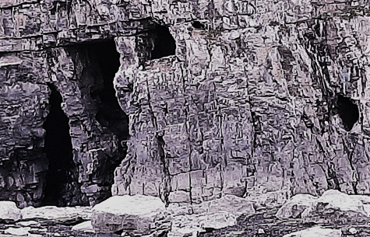

Our holiday home from home
only shared when the sea grants access
to its secrets
and the children from school
are trapped in the classroom
not free to roam and inhabit imaginary worlds
as fantastical as their imagination allows
doors an entry to Poseidon’s realm or
another planet where they always win the war
dressed in cossie or trunks
wetsuits as armour and thermals for spacesuits
these kids are tough and may be seen blue tinged
as they fly on a dragon or offer a slice of seaweed cake
to visitors from another place
the window and porthole too high to climb
when loved ones are watching
but tables are set on the rocks below
designed with care the razor clams and scallops laid down with precision
then picnics served with panache

we smile at what we have seen but sad at what we never had
then kiss on the cheek and walk home up the hill
This is another day
On the bed looking at the holy trinity
the girls don’t want to play today
whelk sulking is not conducive to raising my mood

I shout at Alexa to play something cheerful
‘Walking on Sunshine’ assaults my temporal lobe
it screams at me ‘rewire the connection’
essential for the sake of its neural pathways and my state of mind

too late

I am imagining Amazon’s worker drones laughing
at the distress in the non-American voice
‘these Brits need to make up their minds
let’s give her God Macarbe’

Ashes of Mourning Life

invades this cripple’s life
for god’s sake don’t be so bloody precious
I speak for myself
this vocabulary works for today
you will not use it in front of me
it is my language not yours

now I’m bilingual in disabled speak
who knew how easy it is to learn
and how a misplaced second makes it necessary new skill
the carer runs in ‘are you OK?’ she sees my frustration
speaks quietly to the aliens in the box then George M. serenades

as she empties the catheter bag the colour
of urine takes me back to the Rhine
drinking Gewurztraminer on the balcony
of a Gasthof in the evening

give me the lactulose in a wine glass tonight
lay the meds on a china plate
next to sausage with bacon and sauerkraut

I need pine scented candles and the sound of the river

to listen to laughter

without thinking
without planning
without the company of an entourage to care
without sympathy from others
without ‘sorry we can’t accommodate you here’
without the side glances from others

why would you want to live like that?
how does she crap?
how did it happen?
surely she shouldn’t be out?
I’d be embarrassed to be seen out like that wouldn’t you?
did her partner stay and do they have sex?
a double draught of sleeping potion tonight is requested and given he holds it to my lips with such compassion I want to cry but the tears never come they are long gone there is no energy nothing surplus to requirements is left

except the anger

anger that keeps me alive those that purport to know better assure me it will pass but then what is there to sustain my new days when the memory of the old will not fade? if my hands had the capacity to do as I bid

I would take needle and ink

and tattoo my hate on their cheeks an indelible raw gash my tag so no more words of encouragement or soothing froth could spew from such wounded unhealing flesh I realize this appears harsh

but then other’s empathy is exhausting

apart from those who know the ones who have had years of living another life not even life on the edges of normal but beyond the limits out there where the blue badge is your star of David

he still understands reads me as woman wife and lover

his loss would crucify me

The day
Obviously if I had known
I would have folded up the blue sky
into a shawl and put it in my pocket
then used it as a counterpane
for the grey days

He had a day off and the sun was high
dinner outside the Beach Hotel
dessert a double scoop from the Point café
tide half in plenty of sand
with a wind not capable of stripping skin
as it turned the sands into cheap exfoliator

I had a mission to finish
nephews begging for cockle razor clam and whelk shells
to send to the bit of Norfolk not bordered by sea
beachcombing orders always a delight to complete
location was specific
fussy buggers these primary school boys

Dolman Point by the caves
pick them up there they are always best
by the caves the instructions
a fool not to gather from anywhere on the strand
but a promise is sacred and we’d sealed it with a kiss
during the last family Zoom

the red plastic pail was half full of shells shining and luscious when found by the sun
we wrote a message in the sand
razor shells for nibs
‘Zakary and Jacob here are your shells
have fun we will see what you make when we visit’
captured for posterity in a handheld galaxy

to the water’s edge with the view to paddle
but too icy in May for feet to be exposed
instead a shot of a phantom
a shadow with the weight to darken ripples
while admiring their silhouette
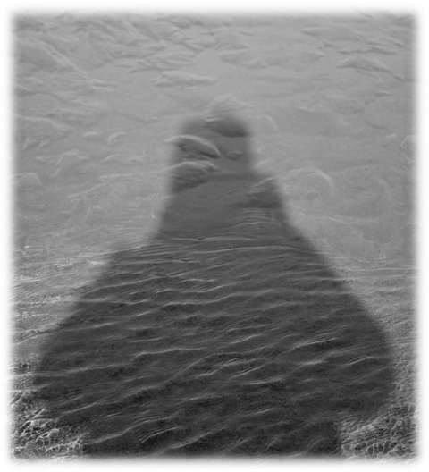

for the last time standing in the water
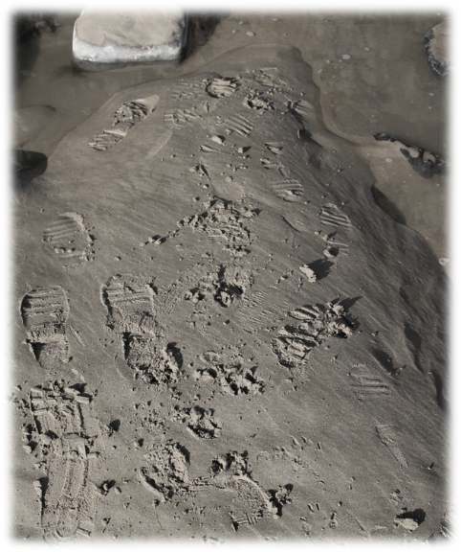
and the last footsteps to fossilize for the future
Turning for the last time I told him
to look at the stone face
it was no more than twenty centimetres long
a malevalent Brancusi head
smirking in the salty shadows
waiting to confuse an art lover like me
a benign beauty polished by the Atlantic
treasure trove to adorn our rooms
once lifted and surrepticiously walked up the hill
rules don’t apply to us
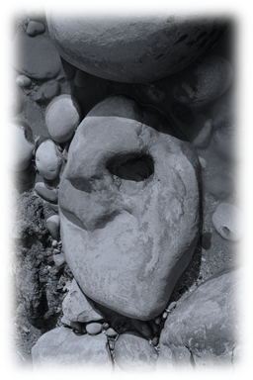
but the Brancusi had different ideas
laughing I tried to step over it
but the bastard bit my shin and I capsized
crunching down onto the unyielding sediment rock
arms too slow to cushion the fall
I knew I knew I was broken
the helicopter’s arrival advertised the bad news to the village
he was crying as he held my hand
I could not feel his touch
‘we forgot the shells’ I whispered
The day + 1
Llandough hospital
last time we were in Cardiff was at the wedding of friends
will I only see the world from the horizontal now?
I know the answer but the medics will not commit

I won’t dwell on the months that followed
stranded in this place full of strangers paid to care

for the shattered bodies held captive by misfortune and a bat’s vengeance

the smell of the place still permeates my soul
absorbed by osmosis through bruised skin
unable to repulse intruders

and always the noise clouding your vision

a haze of tears trapping pain
and the too loud laughter mixed with hope and desperation
in a miasma of forced bonhomie

the fraternity is an exclusive one
but none of us wanted to join
fees are exorbitant and few names are removed from the membership list
until dressed in favourite clothes and cosmetically improved by the mortician’s art
you’re wheeled silently down the aisle in your temple of choice

I told him I wanted a pyre at Gilman Point the wake in Pendine Palace
with a toast to life in seaweed gin - cockles in a glass - then dancing on the beach
Today’s conversation
This morning the stars have aligned
all is well in my new world
wellish anyway
the constellations have connected
and the tarot reading was good

I wait until he’s at work then carer 1 lays the cards
he doesn’t hold with superstition
neither do I but just in case

a world card looks up at me
‘your goal will be achieved inner peace is yours’ it says
today I choose to believe

the room is bright with blue light
a warm healing warmth
massages flaccid limbs
I can’t feel its touch but I still remember

the cat jumps up and nestles close
her purr vibrates
the sound waves break over this unresponsive carcass
her contented snore pleases me

this idyll of domestic bliss is interrupted by carer 2
I have no autonomy
routines are dictated by carers agencies from outside the state of my skin
catheter requirements the state of my bowels sorry no bath today the sling is torn
She says ‘ how are we today?
Smiling on the outside ‘we are OK’

‘Only OK on a beautiful day like today?’
You abled bitch ‘OK covers it I think’

‘Time for a washdown and turn my dear’
‘My dear’ affronts my sense of self

‘Happy for me to start you’ll feel fresher for it’
‘Sure my face will appreciate it and down to my elbow’

‘Got out of bed the wrong side this morning did we?’
Silence

‘Oh my god, I’m so so sorry, accept my apologies, I’m sorry’
‘Don’t worry you look after so many people it’s easy to mix us up’ - you bitch words cut deep

‘Are you sure you can forgive me?’
‘Of course don’t think about it again’ - I have no fucking option no choice no alternatives so yes

‘Shall I use the new moisturizer your sister-in-law sent? It smells beautiful’
‘Not today I’ll stick with the usual’ – because that smells of lilies and death

‘Any plans for later?’
‘My husband is home early today so down to the beach’ –swim in the sea dinner at Coast dance till dawn in the garden and make love on the lawn French toast for breakfast pick daisies with dew drops to put in a vase and feed each other strawberries in the sun those are my plans

‘That sounds nice dear’

What I have learnt in the past twenty-fours hours

tarot readings suck
my constellation has been dumped into a black hole and is irrelevant to this world
therefore astrology also sucks
I live behind a veil that is impenetrable to others
but the cat understands me
dreams are here to be snatched away
the Pagans were right worship what you see and don’t understand
this surely means I am a Goddess
with no authority except in the eye of the beholder
the mirror told me so
when he is away I have no defence from others indifference
apathy is always just one breath away
fury is exhausting

fuck fuck fuck I hate fucking Brancusi

Three sisters defined
Here are the fugly table residents
the sisterhood
my three siblings
the curators of secrets
they guard my sanity as best they can
absorb the fear when the levels threaten to overwhelm my medicated id

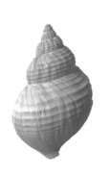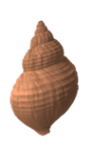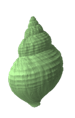
Sierra Alpha Papa

their pseudonyms are to protect them from the compassion of others

the colours the colours of childhood
blankets toothbrush hair brush rucksack and plate
an identity given to children in a brown 60s town

those that know me will have guessed mine was pink
pink for the first born the experimental child
no glitter then
that came later when the black and hard edges needed to soften

the shells are identical perfect chosen to accommodate the paint
but listen as they whisper at night
ferocious in their loyalty but give hell when provoked
a witches coven said cousins
more Peaky Blinders their father’s remark

we were and are tightly bound by the travellers gene

I watch them for hours when sleep is denied
fret when they are not in my line of sight

I don’t want to miss if they decide to call

the whelk shell is a fantastical creation
also a dead discarded dwelling deposited by the tide

delicacies for crab and gull to gorge

but nature loves cycles rhythms to keep an ordered balance sheet
my sisters have gorged on mussels and barnacles along with meat and two veg

drilling through shells spitting digestants
they stir ferment and wait for the soup

slurping the liquid like a fetid kimchi surprise

as all women they and i are a dichotomy
priestess and beelzebub

they decipher the words in my head with no need to explain or discuss

FYI
say the sisters
look at that exoskeleton
skeletor couldn’t be prouder
look at our layers
three
yes the holy bloody trinity again
crush that calcium in your fingers
inhale the dust what a high
and a protein shake for afters
three mantles
metal and concretion
with curves and spirals intertwined to die for
that so called architect Zaha Hadid?
we taught her everything she knew

apologies this was written after morphine but the girls insisted I kept it in
‘these words are from your place your own claustrophobic space they will be recorded’
all the words on these pages are still in my head
the contrary Dragon does not take me seriously as yet
‘ask him to arrange a poet’ it said
but if I speak them aloud then it becomes the truth
and I do not wish to acknowledge it

The beach on my terms
dawn the beach is mine

not even the dog walkers
are on manoeuvres slings to attention
doggy bags hidden in pockets
ready to fill with warm stinking excrement
then deposited in street furniture bins

or thrown into hedges as though exotic green and orange blooms

the sun is grazing the horizon
as the sea births the orange orb
today will be bright as her eager tentacles push higher
clouds splattered with vermillion daffodil and violet ready for admirers
cracks in the blue filled with fire

this beauty is fleeting
imperfect as a shattered porcelain plate
repaired with gold to enhance the imperfection
Wabi Sabi my aesthetic of choice reassures

walking to the edge of the sea
half a kilometre or more
hand on forehead to dim the glare
I stop to pan out the shot commit to memory
proportions texture shade and tone
to reproduce in oil charcoal or fabric
back in the house on the hill
today I’m granted entry to the liminal realm
when you desire it
it will be denied
although in this place with feet sinking into the wet sand
it is not a place
and this time is another time but not dawn at Pendine

a reflective time gone before you grasp it

the flaming triptych dims
sky sea and sun metamorphose back to normality
the lightness stays with you all day

retracing my steps
checking out the worm casts
and admiring the precision of their burrows
I trace ripple patterns with my finger
speculating on surface tensions
and other oceanographical conundrums
on the sand still unmarked by human boots

I pause to scrutinize a lost starfish
swept from its pool by the outgoing tide
still bright like a star ejected from the heavens by a passing rocket’s wake
I go into a fantasy where sea stars swim across the sky
and silver ones are scattered down here

yes I am the practical no nonsense biker
the one with a glitter habit and 1600 ccs of engine
both of which are polluting the planet
but deep down I’m a mermaid

at the beach face I sculpt my name
then his in a heart
with whelks razors and clams
such vanity is impossible to resist
the tide will erase it in a couple of hours

at the top of the hill my breathing is heavy
but heart light
ozone intoxication is an addiction to relish
and I do

as I brew coffee an overwhelming desire
for him to be here with me
with sisters sitting round the table
while the kids whooped and argued outside

I go to the window and look at the sea it is calm and the water rising
the opulent colours have faded the sky to blush
there are starfish up there
so I smile instead of cry

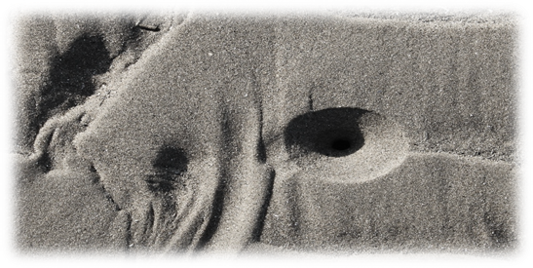
Teleportation
Night time the house is quiet
save for the gentle snoring from him in the next room
he moved downstairs to be near me even when the carers are here
he is loved
this room hums with motors and flashes with light
from my space age Star Trek bed
a mattress that undulates form storm force 1 to 10
depending on who turns the dial
I pray the RNLI may come and take me away
the inshore rib running at full throttle
before it slows down to deposit me in a fully serviced paradise

three handsets are lined up on the other table
amongst the paraphernalia required to keep me home
mission control but I have none
I never look to the left where its stands like a sentinel
an uninvited guest in the house
who you know will never leave

a red-light blinks on the wall
I try to unravel the code
‘just stay home just stay home you’re not getting out just stay home’

I start to cough phlegm thick in my throat
unable to speak now I want it to be over
the darkness is cold on my face
he wakes gently clears the airway
all the time whispering how lucky he is to still have me here
lying next to me to share his warmth
he stays until I feign sleep then tiptoes away

through tears I cannot wipe away
green lights flash
I have permission to go fire up the engine and leave
what are they telling me?
I move my head slowly to the right
‘come on then sister dearest move faster’
on the table my table where the whelk shells are
an aurora borealis hovers over the dancing sisters

close eyes open close open confused

still the aurora is whirling around the spinning blue green and yellow shells
‘yes we’re here you haven’t had a stroke or been overdosed with love and codeine
this is not a vision’
has to be or that water was spiked with LSD
‘come on give it a go’ the shells insist

Sierra has her I’m a scientist listen to me voice out now
‘we can get you out it won’t be permanent but it will be out’
I am trapped in The Matrix set
Keanu will fly through that screen and connect me to the web
where a brain with no body can create and have purpose

Alpha and Papa are levitating with barely contained agitation

‘listen you idiot always the same but you have to listen to us for a change’
tears are all dried but I cannot comprehend
talking to shells in an aurora this is insane

‘no it’s not’ the shout in unison
‘let go and go back to being a kid
where there were no limitations you believed you could do anything’

‘for fucks sake girls puberty was fifty years ago’

‘likewise but you have joined the conversation so you’re in with a chance’

‘think helter-skelters and remember what a stubborn bitch you can are and jump’

close eyes open close open still confused

the aurora has dispersed
girl shells in their normal orientation
and his sleeping speech floats through the door
rolling my shoulders it’s a party piece
my only physical offering since the day occurred

concentrating I go back as far as memory allows
the funfair at Stamford fields gaudy noisy an alternative world
clowns that terrified and the bearded lady I won a goldfish in a bag
four of us running feral around parents unable to round us up in one place
up and down the steps of the helter-skelter carrying coconut mats again and again
a fog of lights as we screamed down the slide

before we landed in a heap disorientated in a different world
I jump

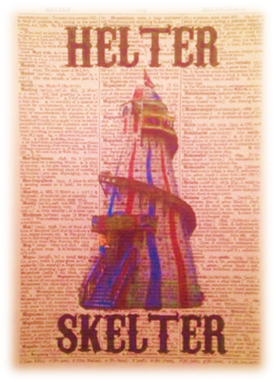
Look at that shape
that image a clone of the whelk
follow the lines with your eyes
and if they are able
trace with your fingers in the sand
or transfer to paper
as an exercise for fun
from the cap of the spire to the aperture
where children are disgorged
and the shell moves itself around
it is perfection
can a tetraplegic fly
with a functioning brain
but with a body of no consequence?
if a whelk can communicate with ease
damn yes I can jump

The three of them were still as the grave
caps pointing west towards my face
they were ethereal their substance displaced elsewhere
not assuming for one moment
the mission was possible
and rationality destroyed by injury
I stared at them
not blinking for an eternity
nothing
still tied down by gravity and a malevolent fiend
supressing tears is hard
when disappointment looms
a watered down stare now
concentrating so hard
I gasped for breath
on the out breath

everything changed forever

as after the fall
I knew this was for real
watching myself from over the bed
an etiolated me arms held as if in a dive
slipped through the cap of Papa
down into the kaleidoscopic coils of Alpha
then spewed out of Sierra’s softness
onto the sand at the entrance to Pendine Palace

how it happened if it happened I don’t care I am on the beach without a flotilla of helpers
The other side
Twilight here and a spring high tide

hesitantly I move limbs
they obey the command to move
wasted muscles renew and respond with vigour

I’m lying under the waves
ripples above and below
there is no panic as I stroll along the seabed and over rocks
converse with the pelagic community
and am invited to dine with a whelk
I decline having an allergy to mussels

she cannot help me when I ask how it is
I travelled here via empty shells
just a shake of her head and a smile
before she slimed off with eyes held high

I must talk to my mentor
the face I spoke to with candour
in the time before life changed
when no one else would listen
or didn’t have the time to care
absorbing all my gossip and complaints stoically

all women need a friend like him
kinder to the body than gin or fags
he never repeats a word or offers advice

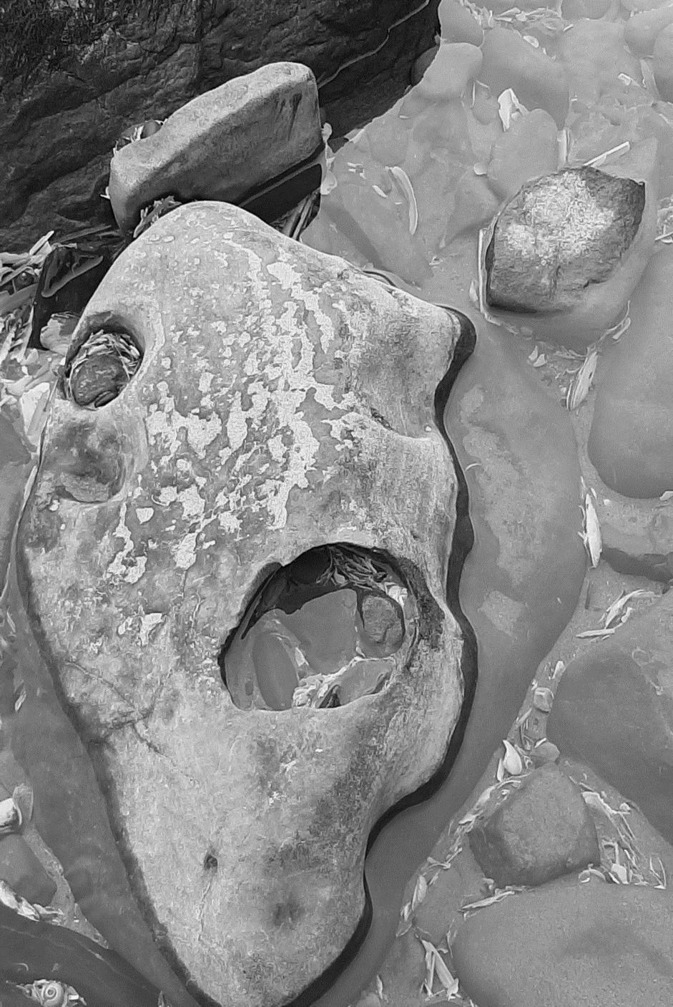
My best friend

‘Did you know I would be paralyzed?’ I demanded
an imperceptible change in his eye an answer
kneeling by his side I wept

‘fate is not to be thwarted it was written in the stones but you never read them
the script was plain to see scribed by lichen’
then he heaved and plain in his open mouth
‘she will fall’

‘if you wish you may return but each time it is harder to leave’

sitting cross legged in the cave
weightless and free I put my hand on the wall
feeling the aeons of time flashing by
the stone worn smooth by the relentless sea

the weak discarded long ago
ground down into grain and broadcast like chaff
the wind careless with its deposition

how long before I would be tossed aside?
a spirit denied her peace and space
left to wonder with the other discarded souls

the tide is receding it leaves a treasure trove of booty
I help myself to pockets full of empty whelk and razor clam homes
inhabitants moved on or perished
all pristine and ready to move into
apart from one
it is battered encrusted with barnacles
its structure denuded
integrity holed
but it has survived it is still a shell
gorgeously blue beneath the dereliction
a metaphor for me
telling my narrative we are both still extant

I tear a strip from my dress and wrap her carefully
placing it next to my heart

it is time to leave now
back to the new days I didn’t plan for
where I can indulge and reminisce about a life that was different to now
and some days catch a glimmer
of the previous life in a crumpled and torn photograph at the back of an album

I looked at my best friend
told him we couldn’t meet again in this life
but perhaps in the next
and please help me to return to the house on the hill

no theatrics this time
just a blink and I’m back to my bed

Life carries on
I’m still lying on my state of the art
cutting edge bed
swearing at this flaccid immovable body
but the carers have changed and he is still here

no longer playing my part in the past
I’ve taken to being a contemporary classic
cool and hip in an immobile genre
impossible to categorize by those fully abled

the sisterhood refused to leave
as obstinate as ever
now we are the full pack sitting on that table
one with life’s scars on view the others concealed
Sierra Alpha Papa and I
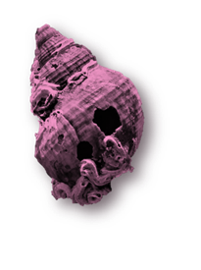
and he continues to adore me
I’m a lucky bitch
Twenty-five years now
through thick and thin crap
to mark it he told me
‘it’s time for a memento mori so you can dive into the sea whenever'
I cried and cried but didn’t say no
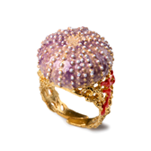

I was there
I know it
I can’t do the physics
never could
ungraded at ‘O’ level
but who cares?

As the young say today ‘it is my truth’

*****

Bibliography

Primary
Alexander, Neal and David Cooper, (eds), Poetry and Geography: Space and Place in
Post- War Poetry (Liverpool: Liverpool University Press, 2013)
Bachelard, Gaston, The Poetics of Space, 7th edn. (Boston: Beacon Press, 1969)
Burnett, Elizabeth-Jane, Swims (London: Penned in the Margins, 2017)
Hooker, Jeremy, The Poetry of Place, Essays and Reviews 1970-1981 (Manchester: Carcanet
Press, 1982)
Ingold, Tim, ‘The Temporality of the Landscape’, World Archaeology, 25(2) (1993), 152-174
Jones, Cynan, Cove (London: Granta Publications, 2016)
Jones, David, In Parenthesis (London: Faber & Faber Ltd, 1937)
Jones, David The Anathemata (London: Faber & Faber Ltd,1952)
Koran, Leonard, Wabi-Sabi for Artists, Designers, Poets & Philosophers (Point Reyes,
California: Imperfect Publishing, 1994)
Macfarlane, Robert, The Wild Places (London: Granta Publications, 2007)
Macfarlane, Robert and others, Holloway (London: Faber & Faber Ltd, 2013)
Macfarlane, Robert, Landmarks (London: Penguin Random House UK, 2016)
Odenwald, Sten / NASA Astronomy Café, part of the NASA Education and Public Outreach
Program, Gravity B Testing Probe Einstein’s Universe, date unknown,
< https://einstein.stanford.edu/content/relativity/a10758.html > accessed 13.04.2021
Oswald, Alice, Nobody (London: Penguin Random House, 2019)
Pretor-Pinney, Gavin, The Wavewatcher’s Companion (London: Bloomsbury Publishing Plc,
2010)

Prominski, Martin and Spyridon Koutroufinis, ‘Folded Landscapes: Deleuze’s Concept of
the Fold and Its Potential for Contemporary Landscape Architecture’, Landscape
Journal, 28.2 (2009) 151-165 < https://jstor.org/stable/43323843>
Shepherd, Nan, The Living Mountain (Edinburgh: Aberdeen University Press, 1977)
Thomas, Dylan, Dylan Thomas Omnibus (London: Phoenix, 2014)
Turner, Victor, The Ritual Process: Structure and Anti-Structure (Piscataway, New Jersey:
Aldine Transaction, 1996)

Secondary
Abulafia, David, The Boundless Sea (London: Penguin Random House UK, 2019)
Atlas, Plotting English-Language Novels in Wales, Cartographic Imaginaries: Interpreting
Literary Atlas, Dychmygiadau Cartograffig: Dehongli’r Atlas Llenyddol (Cardiff: Literary
Atlas Wales, 2019).
Casey, Edward, Representing Place, Landscape Paintings & Maps (Minneapolis: University of Minnesota Press, 2002)
Chamberlain, Lisa, Tarot for Beginners (London: Chamberlain Publications, 2015)
Hicks, Dan, ‘The Temporality of the Landscape Revisited’, Norwegian Archaeological
Review, 49.1 (2016), 5-22 <DOI:10.1080/00293652.2016.1151458>
Jamie, Kathleen, Surfacing (London: Sort Of Books, 2019)
LiteraSmith, P. Two Walks with Objects. Humanities 2017, 6, 51. https://doi.org/10.3390/h6030051ry
Literary Atlas, Cartographic Imaginaries: Interpreting Literary Atlas, Dychmygiadau
Cartograffig: Dehongli’r Atlas Llenyddol (Cardiff: Literature Wales, 2019)
Mansfield, Katherine, The Collected Works of Katherine Mansfield (Ware: Wordsworth
Editions Ltd, 2006)

Milton, John, Paradise Lost, An illustrated edition with an introduction by Philip Pullman
(Oxford: Oxford University Press, 2005)
Smith, Phil, ‘Two Walks with Objects’, Humanities, 6 (2017), 51 <doi:10.3390/h6030051>Thomson
The Gododdin, Lament for the Fallen, a version by Gillian Clarke (London: Faber, 2021)
William, The Book of Tides (London: Quercus Editions Ltd, 2016)
Williamson, David and Bill Proud, ‘The conch shell as a model for tougher composites’, Int. J. Mater. Eng. Innovat, 2 (2011), 149-164 < <www.sciencedaily.com/releases/2011/03/110322110026.htm>
Woolf, Virginia, The Waves (London: Wordsworth Editions Ltd, 2000)

Useful Sites

www.cardiffandvaleuhb.wales.uk/spinal-rehabilitation
https://www.aspire.org.uk
https://facingdisability.com
https://topdoctors.co.uk
https://www.brainandspinalinjury.org
https://www.backuptrust.org.uk/
https://medicainstitute.com/spine/

Image Directory for Whelk Walking

Page | Image | Information | Accessed
3 | Lost Garden by Bert Isaac | http://artuk.org | 02.04.2021
5 | Whelk Walking front cover | Personal photograph - March 2021
6 | Whelk stamp | Own collection of craft stamps
8 | Whelk shell | Personal photograph- March 2021
11 | Tyre track circle | Personal photograph - March 2021
13 | Brain and spinal cord | https://medicainstitute.com/spine/ | 14.02.2021
17 | Pendine Palace | Personal photograph -March 2021
22 | Shadow & footprints | Personal photograph -March 2021
23 | Brancusi head | Personal photograph -March 2021
28 | Whelk shells | Personal photograph -March 2021
33 | Worm hole | Personal photograph -March 2021
37 | Helter- skelter | https://www.etsy.com | 20.04.2021
40 | Best friend | Personal photograph -March 2021
43 | Sister whelks | Personal photograph -March 2021
44 | Sea ring | https://www.pa-pa.co.uk/shelljewellery.html | 01.05.2020

