Electronic Ignition & Fuel Injection Systems Report
Name – Danielle Haynes
Student Number - 1901219
Lecturer - Andrew Gibson

Contents
1.0 Introduction 3
2.0 Research 4
2.1 The L-Jetronic System 4
2.2 The Motronic System 4
3.0 Methodology 5
3.1 The Motronic System 5
3.2 The L-Jetronic System 6
4.0 Results 7
4.1 The Motronic System 7
4.2 The L-Jetronic System 9
5.0 Scope Patterns 10
5.1 Spark plug waveform 10
5.2 Rotary Idle Valve Waveform 11
5.3 Airflow Meter and Throttle Potentiometer 12
5.4 Standard Injector Pattern 13
5.5 Injectors During Acceleration and Deceleration 14
6.0 Analysis 15
6.1 Testing 15
6.2 The Motronic System 15
6.3 L-Jetronic System 16
7.0 Discussion 18
8.0 Conclusion 19
9.0 References 20

1.0 Introduction
The aim of this investigation is to examine and assess the operational efficiency of two engine management systems comprising of evaluation of electronic fuel injection and electronic ignition by using ordinary equipment manufacturer technology that is available to all reputable institutions.
To achieve a common goal, a small group will work together to collect data from various sensors on both a General Motors Motronic system and a Bosch L-Jetronic system. In a group, operational tests will be conducted on the two engines and explanations of the data sheets will be interpreted.
A report will be produced to show the outcomes of the test and main systems operational differences compared. This is critical as the information that is gathered will help to inform on qualities and defects in these systems. It is expected that the systems will be adequate to control the engines however reviewing their efficiency in comparison will give a better understanding into the management’s ability to adapt to different operating conditions.
From this investigation it is hoped that a learning experience can occur, the outcomes of which will be;
- Better theoretical knowledge of electronic ignition systems
- Improved theoretical knowledge of injection systems
- Additional experience in testing management systems
- Further understanding of a management systems capacity to adapt
- Increased confidence whilst using testing equipment
In preparation for this report, background research was completed so that basic knowledge was reviewed prior to beginning this assignment.

2.0 Research

2.1 The L-Jetronic System
Early Jetronic fuel injection systems have been used in everyday driving conditions and proved successful to improve the management system for more stringent emission control evolution ensued and was then adapted to D-Jetronic which was more efficient at controlling emissions. Over time changes in fuels led to a development into L-Jetronic which could manage fuelling and ignition more precisely.
(Kuhlgatz, 2006)
The L-Jetronic system has new circuitry so that the sensor signals could be evaluated, and it give the engine better operating characteristics. It controls the fuel supply whilst the electronic ignition system gives perfect ignition control. The exhaust gas legislation (Transport, 2020) has been considered by integrating a lambda sensor with a closed-loop control unit. This unit is controlled electronically for the fuel-injection system so that the fuel can be injected intermittently into the intake manifold. The fuel is measured so that the specific amount is injected into each cylinder for it to run efficiently. If the engine is receiving too much or too little fuel, then the injectors must adapt quickly so that the correct amount is delivered.
(Bosch, L-Jetronic, 1985)

2.2 The Motronic System
A Motronic system is different, it is seen as an advancement in technology as instead of separately controlling the fuel supply and the ignition system, they are jointly controlled. An internal program is used to control the injection and the ignition systems and by paying special attention to balancing the requirements for both criteria. The emissions regulations have been adapted on this system by installing a lambda sensor.
(Bosch, Motronic Engine Management, 1994)
The engine that will be used is a Vauxhall 2.0 litre motronic injection engine which was first introduced in 1987, this featured a Bosch Motronic 4.1 engine management system. This engine management system was upgraded to the 1.5 from the previous 4.1 in 1990 which had a difference of a throttle position sensor instead of a throttle position switch so that the movement and positions of the throttle can be recognized.
(Scholl, 2015)

3.0 Methodology
The group began by selecting whom would be carrying out each part of the testing and what equipment they would be using for the job. The PPE was all checked and tested prior to entering the lab which includes the steel toe boots, protective overcoats or overalls, the air extractor was working properly, the doors were left open and the air quality monitor was running fully. When testing running engines indoors, the CO exhaust fumes can be very harmful to the people working on or near, therefore close attention must be paid to the ventilation of the harmful exhaust gases.
(HSE, 2020, p. 8)

3.1 The Motronic System
Testing will be completed on a static engine. The multi-meter will be used to measure for live current with the ignition position off and on through the pins on the engine management breakout box. The following tests will be completed for resistance with a multi-meter:
- The kettering coil
- The rotary idle valve
- All the injectors will be checked for resistance to ensure that they are within tolerance of 10% of 16Ω.
- The injector rail pressure will then be tested to ensure that it is correct.
- The four High Tension leads will be tested by unplugging each and testing at each end of the lead.
- The throttle potentiometer
- Airflow sensor
- Coolant temperature sensor
- Air temperature will be measured
- Idle speed control valve
(Autodata-Group, 1995)
The oscilloscope will then be set up whilst the engine is cold so that readings can be taken across an operating temperature range. The oil temperature probe is to be inserted so that the reading could be taken at each stage. The leads are placed on the battery terminals and one of the channel leads will be set up on the secondary coil winding.
The first test that was carried out was on the engine, was the throttle switch check, this was done by disconnecting the multi-plug, connecting the ohmmeter between switch terminals 2 and 18, comparing the readings with that of the specifications and then connecting the ohmmeter between switch terminals 3 and 18. This sensor will indicate the high load positions at idle so that the fuelling of the vehicle is correct and monitors the idle speed control so that the injection cut off could potentially be executed.
The second test is the coolant temperature sensor test, this was done by disconnecting the multi-plug and release any of the pressure that is in the cooling system, removing the sensor, plugging up the ohmmeter between each of the terminals, submerging the sensor in coolant of a specified temperature and then comparing the data with that of the specified. This sensor measures the temperature so that the fuelling and timing corrections are put into place, it also assists with the idle speed control in order to adjust it for fast idle purposes.
The auxiliary air valve is tested at two different stages, one whilst cold, and one whilst hot. The cold test is completed with the engine idling, the air hose between the auxiliary air valve and the inlet manifold is squeezed and the engine speed should have noticeably dropped. During hot test, the auxiliary air valve should be closed, repeat the test for the cold test but the engine speed should not drop anymore than 50rpm. This device is basically a blocking plate operated by a bimetallic strip that adjusts during temperature fluctuations. When the engine is cold the gap is large but the warmer it becomes the smaller the hole becomes.
The injector valves are tested by disconnecting the multi-plugs, connecting the ohmmeter between the terminals and comparing the resistance. This device is used to control the pressure of fuel that is pumped into the car, the amount that is used is determined on how long the injector remains open.
The overrun air valve is checked by disconnecting the vacuum hose and connecting the vacuum pump instead. 635mbar is applied and it should be heard at 630 mbar, if this is not happening then the valve must be adjusted until it can be heard.

3.2 The L-Jetronic System
Whilst the engine was still at room temperature the NTC will be checked for resistance and voltage. The four injectors will be tested whilst the engine is cold and later when the engine has warmed up. The engine will be started at about 20˚C until the temperature of 80˚C, the next to be tested will be the time that the injectors will open, all four injectors and the NTC pins at points three and eight. Once these tests have been complete, they will all be tested again in 10˚C intervals until the engine reaches the highest safe working temperature.
Checks will then be completed on the ECU, amplifier and the airflow meter whilst the ignition is on and off to see a difference in resistance to these components when at starting temperature and full operating temperature. The throttle switch which sends a voltage to the ECU to show the throttle position for idle, acceleration or fully open will be checked to see that it is working efficiently. The coolant temperature sensor will be checked, this is used to verify when more fuel is needed for example when the engine is cold, as opposed to less fuel is needed when it is warm. The auxiliary air valve is tested. The four injectors will be tested one last time when the engine is at its highest safe running temperature.

4.0 Results

4.1 The Motronic System
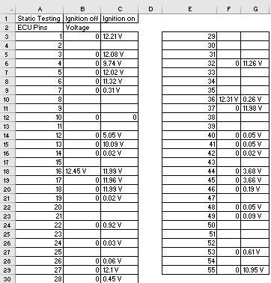
At the start of the test the group checked the voltage coming from the engine management breakout box. This test was carried out with the ignition off firstly and secondly with the ignition on so that the differences are highlighted. This will be discussed further in the analysis.

Figure 1. Engine Management Breakout Box, Pin Tests
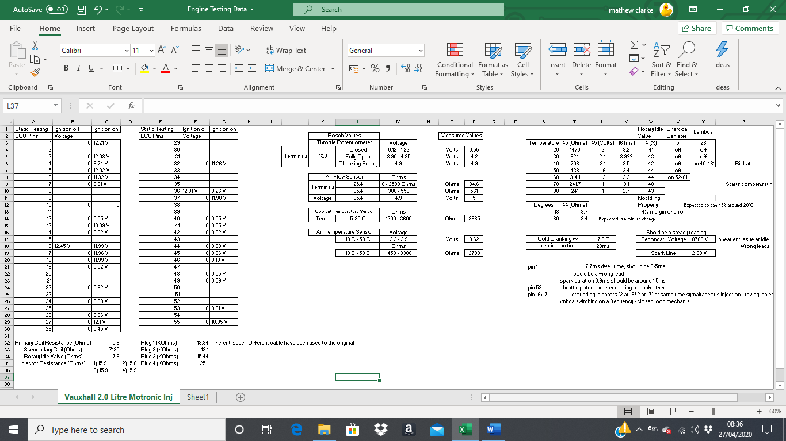
These are the values identified at the start of the test when the engine is still cold.
Figure 2. Cold Cranking
This data sheet shows the data collected from the Bosch book which shows what the figures tolerance should be on the left. On the righthand side were the values measured by the group.

Figure 3. Bosch Values/ Measured Valve

Here the information shows the test results for the rotary idle vale, charcoal canister and the lambda sensor.
Figure 4. Live Data Recorded at Increment Temperature
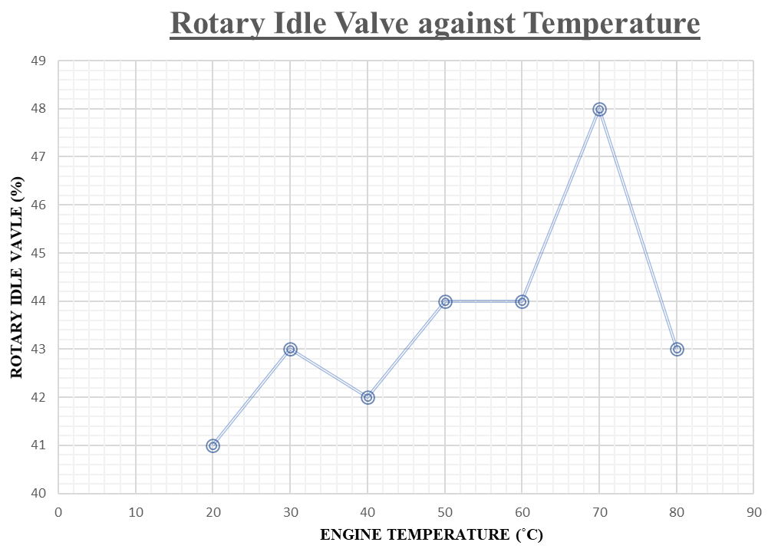

Here is a chart showing the percentage that the rotary idle valve is open in comparison to engine temperature.
Figure 5. Chart Data Showing Rotary Idle Vale Against Temperature

At the starting temperature and the final temperature, the resistance was taken to show the difference.
Figure 6. Resistance for Starting and Final Temperature
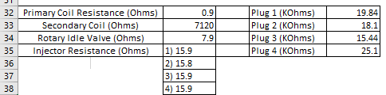
Figure 7. Resistance at Ignition and Injection components
Here the resistance was recorded at the ignition, and injection components as well as the rotary idle valve. More detail in the analysis.

4.2 The L-Jetronic System
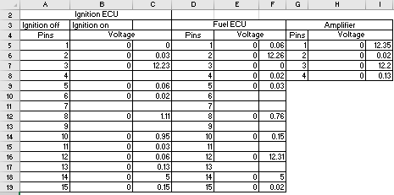
Figure 8. Engine Management Breakout Box and Amplifier, Pin Tests
The voltage was checked at the engine management breakout box. This test was carried out with the ignition off firstly and secondly with the ignition on so that the differences are highlighted. This will be discussed further in the analysis.
Figure 9. Cold Cranking
These are the values identified at the start of the test when the engine is still cold.
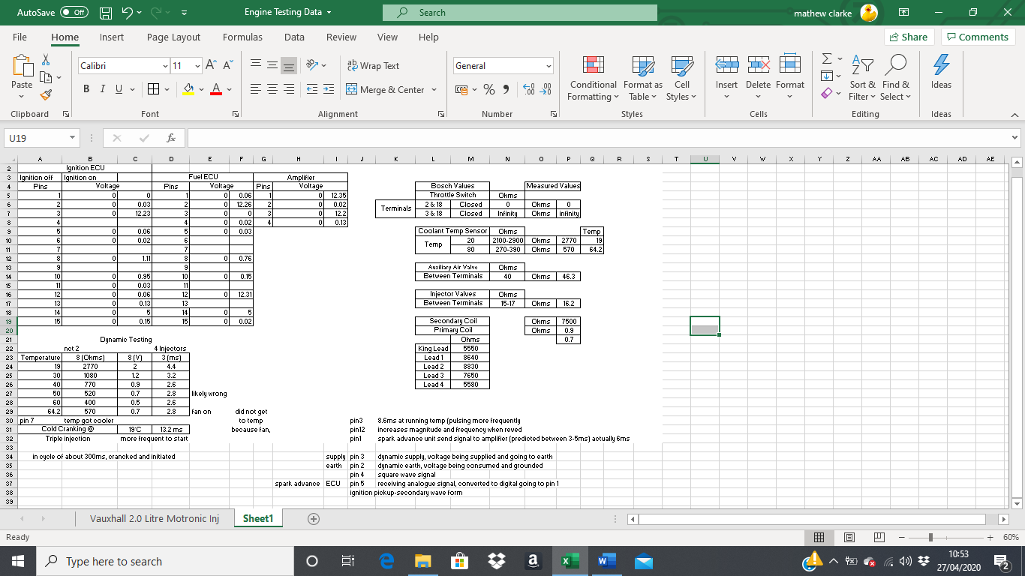
Figure 10. Bosch Values/ Measured Values
Here are the results from the Bosch operating ranges and the data measured by the working group for ignition and injection components.

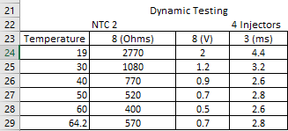
These are the results of the testing of the NCT 2 sensor and the four injectors, these will be discussed in the analysis.
Figure 11. NCT 2 Sensor Results

5.0 Scope Patterns

5.1 Spark plug waveform
At this point the rotor arm makes contact with the distribution point for a particular cylinder, this sends power through the HT lead to the spark plug where the spark occurs.
Here the contact breaker points are touching, and the power is going through the primary winding to the capacitor.

Oscillation occurs after the spark has finished as the contact breaker points are closing.

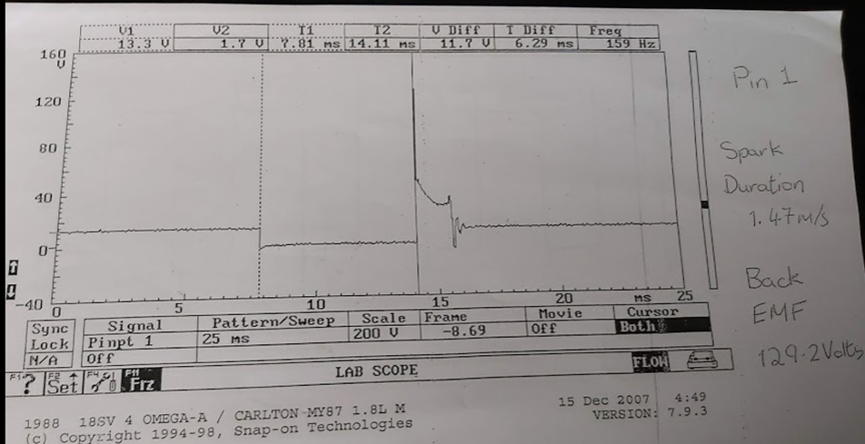

This is the burn time when the spark is occurring. The small peak at the end of this point is where the lobe in the distributor is continuing.
This is where the dwell period begins and the contact breaker points are no longer touching, this allows power to go through the secondary windings so that it can reach the distributors rotor arm.

(Markel, 2018)

5.2 Rotary Idle Valve Waveform

The distance between the opening and the closing of this valve is called the pulse width. The longer the pulse width the colder the engine. This is used to allow more air into the system to match the additional fuel given by the pulse width of the injectors.
This is where the rotary idle valve opens.

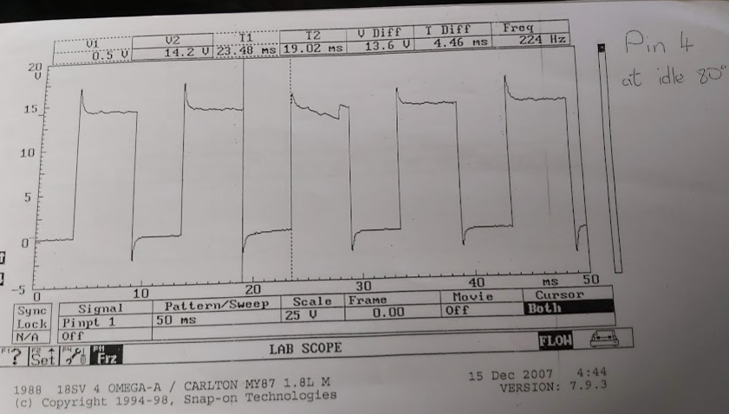

This is where the rotary idle valve closes.

(Unknown, www.picoauto.com, n.d.)

5.3 Airflow Meter and Throttle Potentiometer
These two waveforms mirror each other. When the throttle is activated the airflow meter measures the influx of air as a direct response to the amount of air let in by the throttle.
This is when deceleration happens as the voltage has dropped back to the same voltage as idle speed.
Blip acceleration is shown here, the difference is shown as the waveform fluctuates less but is taking in as much air as possible.
Here the acceleration can be seen slowly building for both graphs.
This is when the engine is at idle as the throttle and the airflow meter have a low output.

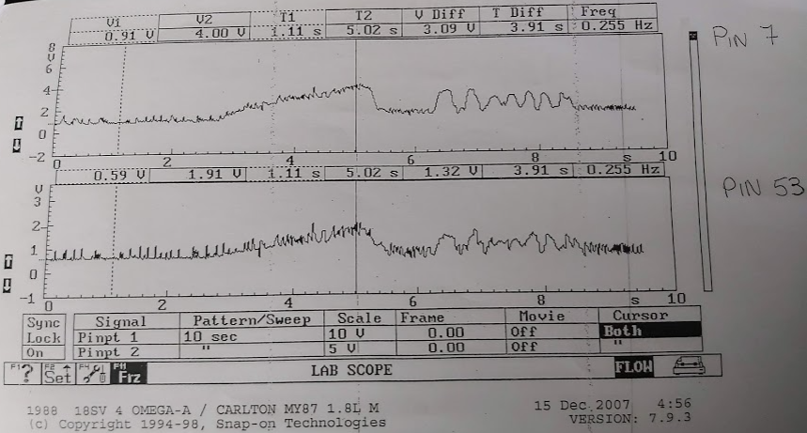

(Carley, 2019)

5.4 Standard Injector Pattern

The ECU stops the grounding of the injector which closes it. The EMF is shown by the spike.
Here the circuit is open and the injector is off.

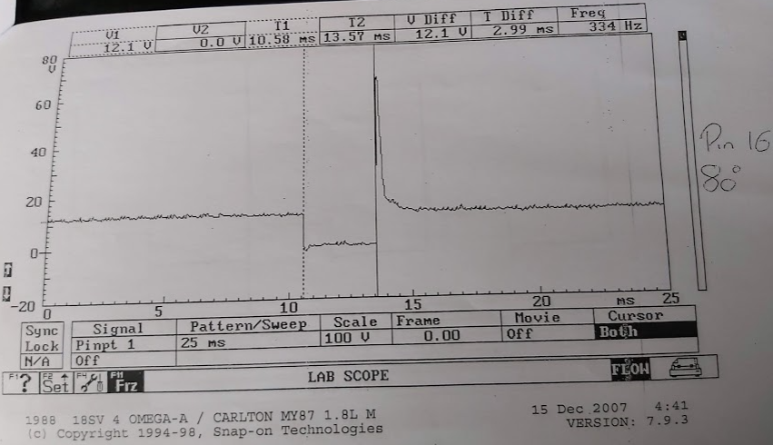

The ECU grounds the circuit and the injector is open.

(Unknown, Multi-point injection - injector voltage, n.d.)

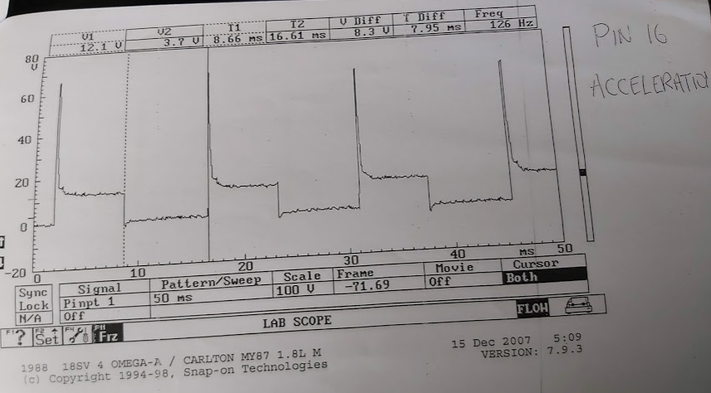
5.5 Injectors During Acceleration and Deceleration
In each wave forms the same pattern occurs however for acceleration the pulse width is much higher in frequency as more fuel is needed to maintain the correct air/fuel ratio. The deceleration shows a much lower frequency as little fuel is needed as the engine is being slowed down.
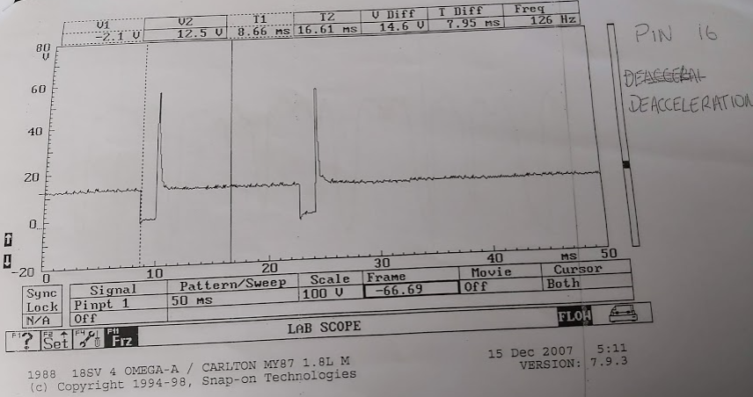

6.0 Analysis

6.1 Testing
At the start of the lab session the group checked out their own PPE, everyone made sure that they were wearing steel toe-cap boots, their overalls or overcoats were worn properly. The room was prepared for the group to start the testing by opening the doors for air ventilation, placing the exhaust gas extractor on the exhaust so that all of the harmful gasses such as NOx, CO and CO₂ are removed so that they are not a danger and two gas analysers were used and continuously checked throughout the experiment as safety is the highest priority.

6.2 The Motronic System
The test began on a static engine so that all the data could be collected from cold in intervals until the engine was at its operating temperature. The current was measured at the engine management breakout box with the ignition off and then with it on, the results are found in figure 1. Most of the pins have no voltage when the ignition is off, excluding pins 16 the pulse side of injectors and 36, the control circuit for supply to the auxiliaries and the ECU. Pin 16 has a voltage at ignition off because it's a permanent live and pin 36 is used when the ignition is off so that there is a supply ready for the ECU when the ignition is switched on and it also powers the auxiliaries whilst the engine is switched off.
In figure 2 the injection on timing is quite high compared to normal, this is because the engine is cold and has just been started. The lower the temperature the longer the injectors will stay open so that the engine can get more fuel into the intake.
The throttle potentiometer’s supply voltage from the ECU was first measured and then compared with that of the Bosch values and they both come up with the same reading, this shows that potentiometer is operating within the manufactures specificastion. The figures for it fully open and fully closed also appear within the Bosch guidelines. This is shown in figure 3.
The airflow sensor measured at the terminals 2&4 are within the large tolerance, 3&4 is slighlty above the guided tollerance, there are a number of reasons it could be slightly over which could be that this sensor is older and slightly degrading as appossed to a new component which would easily fall into the manufactured tolerance, there is also a possiblity of the group taking an inaccurate measurement. The voltage of the air flow sensor is supposed to be 4.9 volts however the recorded is at 5 volts, this could be becuause of the same reason.
The coolant temperature between the temperture 5-30˚C shows that the ohms should be between 1,300-3,600ohms and the measured figure is within tolerance at 2,665ohms.
Air temperature sensor voltage and the ohms recorded also fall within the specified data from the Bosch manual in the ranging temperatures.
Figure 4 and 5 is giving the data for the rotary idle valve compared to the engine running temperature. The resistance in this circulit are slowly dropping as the engine temperature rises, the amperage more continuous and the circuit becomes warmer. The ECU identifies the resistance from the voltage that is returned and therefore does not require such a high voltage output the higher the temperature. The pulse width for the injector being open should be longer when the engine is cold, this is because the wamrer the engine the less fuel and air is needed. When the temperature hits 70˚C the fan comes on to compensate the high temperature and cool the engine down, this is displayed on the rotarty valve data at 70˚C as the figure has risen by 4%.
The charcoal canister stays off at the lower temperature and when the engine hits 60˚C it is switched on in order to collect the fuel vapours and deposit them back into the engine instead of the atmosphere.
In figure 4 the lambda sensor information that is recorded shows that it is not switched on until the engine reaches 40˚C because it does not operate at cold temperatures.
Figure 6 shows resistance when the engine is at starting temperature (18˚C) and then tested again once the engine was at full operating temperature (80˚C). It shows that as the temperature has increased to its highest point the resistance has dropped slightly.
The resistance recorded at the primary coil shows that the data falls under the correct operating conditions from the Bosch book. The secondary windings are much higher as there is a greater number of windings as opposed to the primary. The resistance in each of the injectors are very similar which is correct. The resistance shown from the plugs shows spurious data as plug one shows considerably lower than the others as it is a shorter lead, the highest resistance is lead four however the data collected from lead three shows issuses, whilst testing the group made a note that this lead was from a different manufacturer than the other three, this could pose problems as it does not follow the manufacturers specification for this particular engine. This is shown in figure 7.

6.3 L-Jetronic System
The first test on the L-Jetronic System was checking the engine management box to see the data when the ignition is on and off. Shown in figure 8. When the ignition is off, all the pins show no voltage and when the ignition was switched on most of them came up with one. The data collected on the amplifier shows that pins one and three show the battery voltage and pins two and four only have residual voltage.
In figure 9 the pulse width of the injector on the L-Jetronic system is also quite high at cold cranking, this is because at initial ignition the engine requires a higher intake of fuel so that combustion can begin.
Figure 10 shows the results from the Bosch operating ranges as well as the measured data that was collected by the working group for the ignition and injection components. The values for the throttle switch for terminals 2 and 18 are both closed on the recorded data and the Bosch values and terminals 3 and 18 also show the same value as infinity.
The coolant temperature sensor at 20˚C shows the resistance is in the expected tolerance from the Bosch expected values although for the higher temperature of 80˚C the resistance should be between 270-390ohms, the figure recorded however was not within this tolerance as the engine temperature did not reach higher than 64.2˚C as the engine switched the fan on in order to keep the engine cooler and not overheat. This data would still fall under the correct tolerance as the higher the temperature reaches the lower the resistance so between 60-70˚C the number recorded would be at the resistance shown. This data is also shown in figure 10.
The auxiliary air valve data is shown in figure 10 of the resistance between the terminals and that it should be close to 40ohms and the recorded was 46.3ohms, this data falls with tolerance. This shows that the auxiliary air valve is working as it should.
The injector valves fall within the tolerance of the values given in the Bosch book for resistance. This shows that the injectors are working appropriately and are giving out the correct power output. This is shown in figure 10. Figure 10’s data for the primary and secondary coil are at the correct resistance.
The resistance given from the HT leads should show a higher resistance from lead one reducing through to lead four as the length of the HT leads become shorter. This however is not the case as the second HT lead has a higher than expected resistance, this could be because this is a different lead with a different manufacturer specification with a higher resistance allowance. This data can be found in figure 10.
In figure 11 the NTC 2 results are shown, the resistance at the lowest temperature is at its highest point and as the temperature increases the resistance drops, at the highest temperature the resistance is increased slightly, this is the same with the voltage as it slightly increases, this is because as the fan is switched on by the engine it is pulling extra voltage and creating a higher resistance in this circuit. The data for the four injectors at starting temperature has a longer opening period, this is because when the engine is cold the system requires more fuel to enter in order to start and heat the engine up, the higher the temperature reaches the less time the injectors are open for. One of the results shows a discrepancy when the engine reaches 50˚C, this could be that the data was poorly extracted by the group or that there was a momentary jump which is what was recorded. At the highest temperature, the figure has again increased slightly, this is to compensate for the fan being switched on.

7.0 Discussion
During this testing process both engines have performed as anticipated. Neither of them gave out perfect results which is to be expected as they are older and used engines as opposed to using a brand-new engine with each component being vigorously tested and all components extracted with the manufacturers operating conditions. Some of the data record however seems to have false readings and there are many reasons this could have happened, the group have never worked together prior to this testing so each member are unfamiliar with one another and unsure how they work, the testing equipment new to the group members so were unsure how to use it to the best ability. The testing conditions also could have been more controlled with room temperature and air density which could give more accurate results. The Motronic system is the better of each engine as it has been adapted where the L-Jetronic is only basic. There are a much higher number of sensors are recorded data that would help give more precise information to the ECU so that it can manage the fuel, air and ignition more accurately.

8.0 Conclusion
In conclusion, this assignment has given a better understanding in the different electronic circuits and engine components that are linked to the ignition and the injection systems. Recording data from the two engines that were used and using the tools, equipment and the technology in order to check these systems over to see if they are operating correctly and are running under the correct tolerances. Discovering the issues that may occur with different engine and electrical components and what the potential reason there may be for those problems.
Analysing the data that was recorded with that of the information given from Bosch book and discovering how much tolerance was allocated for each sensor or switch for it to work effectively and efficiently.

9.0 References
Autodata-Group. (1995). Autodata - Fuel Injection. Berkshire, England: Autodata Limited.
Bosch, R. (1985). L-Jetronic. In R. Bosch, Electronic Gasoline Fuel-Injection System with Lambda Closed-Loop Control (p. 1). Stuttgart: Robert Bosch GmbH.
Bosch, R. (1994). Motronic Engine Management. In R. Bosch, Engine managment for spark-igntion engines (p. 1). Stuttgart: Robert Bosch GmbH.
Carley, L. (2019). Mass Airflow MAF Sensors. Retrieved from aa1car: https://www.aa1car.com/library/maf_sensors.htm
HSE. (2020, Febuary 12). Health and safety in motor vehicle repair and associated industries. Retrieved from Health and Safety Executive: https://www.hse.gov.uk/pUbns/priced/hsg261.pdf
Kuhlgatz, D. (2006). A backbone of Automotive Electronics. 50 years of Bosch gasoline injection Jetronic.
Markel, A. (2018, June 07). autosuccessonline.com. Retrieved from Autosuccess: https://www.autosuccessonline.com/scoping-and-interpreting-secondary-ignition-wave-forms/
Scholl, D. H. (2015, 06 16). 50 years of automatics: how Bosch taught the car to change gear itself. Retrieved from BOSCH-Invented For Life: https://www.bosch-presse.de/pressportal/de/en/50-years-of-automatics-how-bosch-taught-the-car-to-change-gear-itself-42990.html
Transport, M. o. (2020, January 19). DVSA (Driver & Vehicle Standards Agency) - In Service Exhaust Emission Standards for Road Vehicles. Retrieved from www.uk.gov: https://assets.publishing.service.gov.uk/government/uploads/system/uploads/attachment_data/file/676700/in-service-exhaust-emission-standards-for-road-vehicles-19th-edition.pdf
Unknown. (n.d.). Multi-point injection - injector voltage. Retrieved from Picoauto: https://www.picoauto.com/library/automotive-guided-tests/multi-point-voltage/
Unknown. (n.d.). www.picoauto.com. Retrieved from Pico Technology: https://www.picoauto.com/library/automotive-guided-tests/rotary/

