Management Economics

Submission date: 03.03.2024
Student name and number: Mihaela Sandu Rizea / 2126225
Module code and name: LCBB5008/ Management economics
Lecturer’s name: Muno Zuwirai
Assignment title: Assessment Component 1: Individual Essay

Contents
Introduction. The UK Road Haulage and Courier industries challengies and opportunities 3
Main Body. Applied economic theories on the thematic of UK Road haulage and courier industries 3
1. PROFIT MAXIMIZATION
2. OTHER ECONOMIC THEORIES
Conclusion 9
References 11

Introduction
The Road Haulage & Courier Industries it is a vital sector of the UK’s industry through its contribution of the overall economy. The UK Road Haulage contribute to the transportation of goods by road in large vehicle, trucks and lorries, and the Courier it is focusing on the delivery of parcels and documents. In the past few years, the UK Road Haulage & Courier industries have been facing a series of challenges such as the shortage of qualified drivers, the fuel crisis, the Brexit, the pandemic, the effects of military conflicts in some parts of the world, the environmental concerns and opportunities such as the increasing of online shopping, the necessity of a sustainable transport. All this issues, lead to a continuously effort and adaptation in order to transform challenges in opportunities for growth.
In this essay, we will examine and analyze the overall challenges faced by the UK Road Haulage & Courier industries in the past few years, aiming to explain some aspects of the theory in a practical manner such as profit maximization, the demand - supply theory, business environment, business objectives, market structure and stakeholder issues. This companies holds at least 406,000 heavy goods vehicles to supply or transport everything from eatable food items to cloths or machineries, running their trucks and vehicles under a tightly regulated operator licensing regime to promote road safety (OPUS, 2023). In addition to this, demand-supply economic theories, and other issue which will help in sustainable growth of the industry will also be discuss in this report.

Main Body. Applied economic theories on the thematic of UK Road haulage and courier industries.
Profit maximization means maximization of profit by the organization using a proper strategy, planning and allocation of the resources. Profit maximization is an important objective of every organization, the main one, because without making higher profit it can become difficult to run the business, to give remuneration to employees, shares to shareholder, and develop its activity.
In this report, profit maximization and other economic theories will be applied on the realities of UK Road Haulage & Courier industry, analyzing how this affect the activity within this sector and help companies in sustainable growth. Also, understanding the demand-supply theory in the context of different events and difficulties faced by this sector, whit results in profit for this companies, helps to describes the basis of the environment, business objectives, market structure and the stakeholders.
Profit Maximization
Profit maximization it is an economic term used for the process of planning and finding the best solutions and strategies whit the main purpose to maximize organizations profits. The profit, which is the main goal for the organizations, it is equal with Total revenue minus Total cost. In order to maximizes its profits, an organization needs to make the MC – marginal cost to be equal with MR – marginal revenue, phase in which the MC curve is rising (Coskeran, 2012) and the organization can maximize its profit. This goal achieves by doing less expenditures and equalize marginal cost of the company with marginal revenue which is generated by producing goods or services, in our case study, by the transportation of goods and correspondence. Profit maximization is the prime goal of every company because it is necessary for every company’s financial position and liquidity (Sabot and et.al., 2020). But for profit maximization, the companies cannot decreases their quality of products or services. If management make decision to lower the quality in order to increase its profits, the result can be negative for the business. Therefore, management should not use bad techniques to increase its profit. They can maximize profit by reducing their cost of production, selling price and output levels of goods and services.
Profit is the true measurement of the capability of an organization’s success. If company does not earn profit than the organization will face losses and its key goals and objectives cannot be achieved. In the context of UK Road Haulage & Courier industries understanding financial aspects such as revenue calculation, profit calculation and profit margin, cost analysis, efficiency and cost reduction, pricing strategy, the influence of the external factors, are important for the process of explaining the theory of profit maximization. Therefore to calculate the total revenue of a business from this sector, we have to take into consideration the income resulted from the transportation of goods, special correspondence or services. Also, it is very important to know what specific costs are associated with running this businesses in the transportation of goods and courier delivery, such as the maintenance of vehicles, fuel price, drivers salaries, insurance(Cole, 2005). Other aspects that are very important in order to maximize the profitability of the business for this sector, it is related to the pricing strategy. In order to attract customers, the business has to find solutions to minimize the cost for example, by reducing the empty trips or to find the best route. Other solutions, such as the decrease of fuel tax with 15 pence/litter which will help with cutting costs, also the governments should continue to invest in the quality of roads in order to make transportation easier (RHA,2023).
According to a report of National Statistics from 2023, the UK road haulage it is the fifth largest industry which counts over 60,000 haulage businesses and 1.57m employees in 2022 and 2.56m in 2023, working in haulage and logistic industry (RHA, 2023). There are 406,000 heavy goods vehicles or trucks, to supply or transport everything from eatable food items to cloths. In UK, 89% of all goods and products are transported and supplied by this companies on road. The statistics shows that there are 303,885 licensed HGV drivers in 2023. As a result of the Brexit, the sector struggle to find enough drivers, also because of natural causes such as retirement, therefore the management should spend money on training programs, better working conditions or others rewording schemes in order to solve the crisis of drivers(OPUS, 2022).
The productivity and competitiveness of this companies is dependent on many internal and external factors because road transport is highly competitive and low profit business. In this companies from the UK Road Haulage, the transport companies contributed with £13.6 billion or 2% to UK’s GDB in 2019 (Yuan and Zhou, 2020). According to this statistics, road haulage is worth 33.5bn in revenue terms.
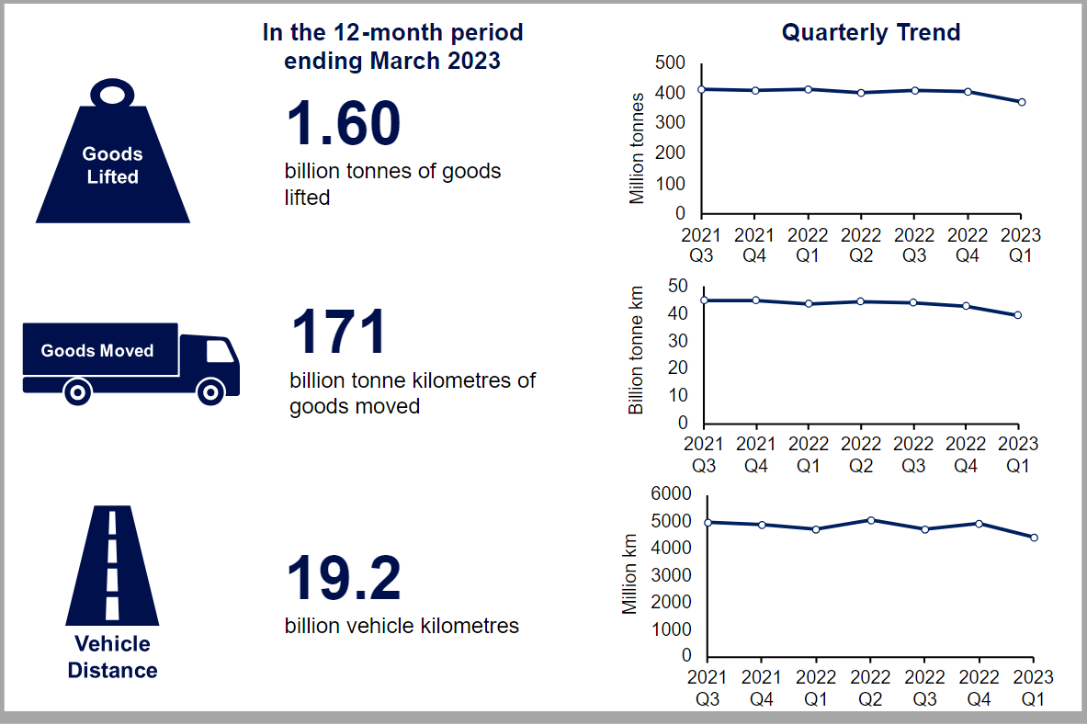
Figure 1 Infographic 1: Total amount of domestic goods lifted, goods moved, and vehicle kilometres travelled by GB-registered HGVs in the 12-month period ending March 2023. (National statistics, 2023)
At the time of peak season, this transport companies should focus on fast delivery and better customer experience. During this period courier companies must hold millions of parcels every day. This companies proves to be more expensive than profitable because of its unpredictable difficulties and customer interaction. It became difficult for these type of industries to prepare an optimized and strategic way to maximize efficiency and profitability. Because there are issues such as decline in the number of heavy goods vehicle (HGV) by almost 53.000 between 2016 to 2021 (in the past) and also their drivers leaving employment due to the falls in the industry (Yasir, 2016). Companies from this sector had to adapt to this challenges at the time of peak season with proper strategies and efficient planning in order to assure profitability. Because some goods which are perishable, can be delivered with delay, because of the shortage of staff for example, that’s why companies had to take into consideration solutions such as the construction of new sub-hubs (Lipton, 2023). Thus companies start making profits from its planning and new policies. Construction of new hubs and sub hubs are difficult because of the duration. During peak time this organization have to focus on the increasing of revenue instead of constructing new hubs. Companies should focus on the resources which are available for delivery and transportation and also make adjustment to the organization’s policies and strategies according to their needs. By combination of these adjustment and policies company can work effectively and efficiently. By applying these adjustments this companies are also, able to adapt to the market fluctuation(Wang and et.al., 2023).
OTHER ECONOMIC THEORIES
Economic theories are concepts which explain how the economy is working. The economic theories are used to explain economic events such as demand-supply, business environment, business objectives, market structure, or stakeholders issues. This theories are helping to understand and make prediction of the behavior of financial markets and any organizations, also of the governments (Sloman and et.al., 2019).
The demand-supply theory can be defined as the connections between the purchasers and sellers, describing how shifts in price can impact the economy. The relation between demand-wants, which is unlimited, and supply-what can be produce or given, which is limited, can be considered the center of the economics, according to Sloman (2019). The cost of the production is determined by the needs of customer demand and its convenience or availability according to the supply and demand balance. The low of the demand and supply, explain how it is determinate the volume of the productions, and actual market price (Weersink and Fulton, 2020). Therefore, if the price rise, supply increases and demand decreases, but if supply decreases in response to a reduction of the price, demand increase. In the context of the UK road haulage and courier industries, because of the way this market is organized, where a small numbers of big organizations dominate the market and control the prices, can be challenging to represent a supply curve. However, we can observe how the quantity of goods supplied can be influenced by the changes in the price. For example, if the price for transportation of some goods increase, then the organizations will try to transport as much as possible. In this circumstances, we can observe an elastic supply curve. If we consider the capability of transportation as a barrier, then the curve can become inelastic. There can be other factors that can influence the supply chain, such as technological factors and regulatory requirements. The UK Road Haulage & courier industries, by providing better services they can make more profit. We can use this graphic representation to explain how the changes in price can influence the quantity supplied by them.
Curves for the demand and supply curves
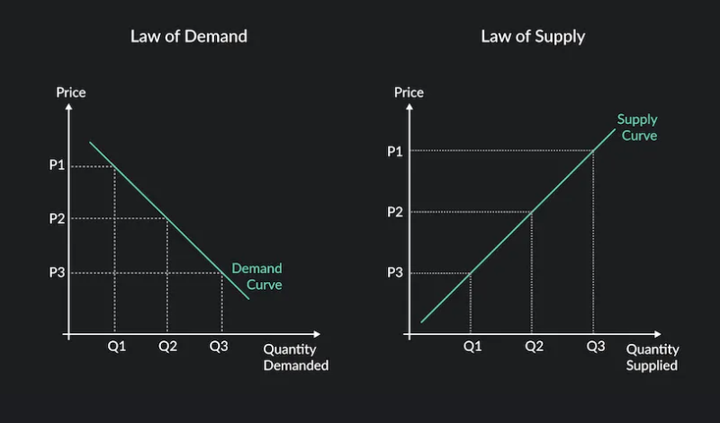
FIGURE 2. (Source- online through the link https://articles.outlier.org/5-things-that-shift-a-demand-curve )
When the price of the freight increases then the demand of the services will be mitigated as the consumers will shift to some other option and vice versa. Simultaneously the supply of the services is impacting due to the rise in prices, supplied quantity will go upward in the slope and on the other hand if the price decreases, the willingness of the transporters will decrease.

Business environment.
In the context of UK Road haulage and courier industries, we are going to analyse the business environment impacted by the four dimensions: political, economic, social cultural and technological (Sloman et. Al., 2019), and also legal. We can conclude that the business environment is the result of the influence of all this factors internal and external, over the suppliers, customer’s needs, supply and demand, employment, management, social trends, economic changes and market trends. By understanding the business environment helps to analyse and measure the business opportunities, plan its activity in order to increase the performance and profitability, and in consequence help to the development - growth of the business. The business environment it is the space within all the organisations perform their activity and helps to make an organisation to proceed competitive. It is by analysing or identifying their small and large competitors helps with the understanding of the business environment and planning of their actions.
The Economic environment - All the features of the global and local economic environment have an impact on the organisation and their operations (Hemmati and et.al., 2020). For example in our case, when the economy grows, the transportation sector plays a very important role by helping to move all sorts of goods from food, clothes, machineries or correspondence around the country or outside, which can be translate in the demand increase of transportation services.
Political environment - The political conditions are influencing the stability of the business environment and also, influences the activities of the organisations. We can remember here how the economic environment has been affected by the Brexit rising new challenges for this sector and impacted the activity of this organisations (OPUS, 2022).
Social environment – It refers to the social context and social environment in which population is living and the economy is running. For example, the transportation can be affected by what population wants, and demand can change with the season – the demand for more goods and services increase around Christmas, or what population is doing – holiday time when people travel more, and also by social events such as strikes. Also the Covid Pandemic put a pressure on this sector’s activities by the increased demand of goods to be transported, which shown even more the shortage of drivers. The disruption in the goods supply chain it was affected in the past few years by the retirement of an estimated third of its total drivers (The Guardian, 2021), the Brexit and a short time visa scheme which made even harder the recruitment of overseas workers.
Technological environment. The supply capacity of this organisations which are active in the sector of transportation of goods, it is most influenced by technological factors, and the necessity of investments in the modernisation of the fleet, GPS and software.
Legal environment - The legal environment is referring to the regulations and rules applied by the governments in order to regulate the activity of this organisations (Griffiths and Stuart, 2011). The activity of UK road haulage and Courier industries it is regulated by many policies and rules, in order to create an safe environment for its actions, such as control on car emissions, licensing or safety standards.

Market structure. The market structure it is a concept what analyse and categorised the economic players based on how they compete. There are four main types of market structure which including monopoly market, monopolistic market, perfect competition, and oligopoly (McDowell and et.al., 2023). A report of the Transport Statistics Great Britain published in 2024, shown that there are more than 60,000 road freight businesses activating in the UK, and from this around 31,524 are UK registered companies (Transport Statistics, 2024). Analysing the UK road haulage and courier industries, we have observed that there are many organisations, but just few of them seems to be main players, such as DHL Group, FedEx, DPD, UPS, Royal Mail, Turners Limited, Culina Group. This has lead as to the conclusion that this sector can be considered an oligopoly. An oligopoly is a market structure characterized by the domination of a small number of large organisations, which control and influence the price and the competition, and makes hard the entry of new organisations. This is a type of imperfect competition, when the market is dominated by major companies which control the game, compete with each other, take strategic decisions which affect the industry as a whole.

Stakeholder issues. The stakeholders role and implication over the business in order to achieve the organisation’s goal it is crucial, it is not only due to the managers and the owners of the business. However who they are, those who need the goods to be transported, or those who receive those items, those that operate the fleet or those that look after the administrative part of the transportation, and the political side represented by governments and the legal policies which regulate the sectors activity, they all are collaborating in order to help the whole activity of this vital sector (Transport Committee, 2022).

Conclusion
From this report, it is concluded that by applying the proper economic theories related to the demand and supply we can understand aspects of profit maximization, business environment, market structure and the role of the stakeholders. The demand level for the product is hold by the low of demand and also helps to find how to the price is raised or drops. The free competition on the market price has been observed in the interactions of the both supply and demand and how the quality supplied it is related to the price relation for the production or trade goods.
Also we have observed how by analyzing the data about all situations of the outsides of the businesses defined as the business environment, impacts the activity from the transportation sector. It is concluded that in order to increase the companies profitability there should be proper planning and strategies which increase the efficiency.
In order to improve the way that are working and solve the issues that we have found, the UK road haulage and courier industry should consider to solve the shortage of drivers and skilled workers by launching training courses and offering internships, to came with clear regulations in order to help the businesses to operate safely and legally and help a fair competition, and improve the technology in order to help them to be more sustainable.

References

Cole, Stuart, 2005, Applied Transport Economics. Policy, Management & Decision Making, p.146-161.
Coskeran, T., 2012. Economics: A complete Introduction: Teach Yourself. Kindle Edition, 352p, p.25-167.
Griffiths, A., Stuart, W., (2011) Economics for Business and Management. Third Edition, Prentice Hall, p.301-352.
Sabot, M.E., De Kauwe, M.G., Pitman, A.J., Medlyn, B.E., Verhoef, A., Ukkola, A.M. and Abramowitz, G., 2020. Plant profit maximization improves predictions of European forest responses to drought. New Phytologist, 226(6), pp.1638-1655.
Sloman, J., Garratt, D., Guest, J. And Jones, E., 2019. Economics for business. Eighth Edition. Pearson, p.4-651.
Yuan, H. and Zhou, M., 2020. Profit-maximized collaborative computation offloading and resource allocation in distributed cloud and edge computing systems. IEEE Transactions on Automation Science and Engineering, 18(3), pp.1277-1287.
Lipton, M., 2023. Game against nature: theories of peasant decision-making. In Rural development (pp. 258-268). Routledge.
Wang, R., Zang, C., He, P., Cui, Y. and Wu, D., 2023. Auction-based profit maximization offloading in mobile edge computing. Digital Communications and Networks, 9(2), pp.545-556.
Weersink, A. and Fulton, M., 2020. Limits to profit maximization as a guide to behavior change. Applied Economic Perspectives and Policy, 42(1), pp.67-79.
Hemmati, M., Mohammadi-Ivatloo, B., Abapour, M. and Anvari-Moghaddam, A., 2020. Day-ahead profit-based reconfigurable microgrid scheduling considering uncertain renewable generation and load demand in the presence of energy storage. Journal of Energy Storage, 28, p.101161.
Mohammad, A., Zamora, R. and Lie, T.T., 2020. Integration of electric vehicles in the distribution network: A review of PV based electric vehicle modelling. Energies, 13(17), p.4541.
McDowell, E., Pepper, M. and Munoz Aneiros, A., 2023. Towards a theory of self‐organizing supply chain clusters. Systems Research and Behavioral Science, 40(1), pp.88-100.

J. Partridge, HGV driver shortage: UK firms embark on the long road to plug the gap. The Guardian, 4 September 2021, accessed on 1 March 2024 on HGV driver shortage: UK firms embark on the long road to plug the gap | Supply chain crisis | The Guardian

OPUS, 2023., The UK road haulage sector report – challenges continue in 2023., UK Road Haulage Sector Report - endurance and challenges (opusllp.com), last consulted February 26, 2024.

What industry-specific challenges are being faced by haulage companies?, By Nick Bradley,19th July 2021, What industry-specific challenges are being faced by haulage companies? | Logistics Manager

National statistics. 2022, Road freight statistics: 2022 - GOV.UK (www.gov.uk)

Yasir, S., Postal and Courier activities industry review, 2016. Full Report. Author: Samia Yasir, Office for National Statistics. 23 March 2016. This document is also available on our website at www.ons.gov.uk

Haulage Cost Movement 2023. Survey on the movement of costs., RHA_Haulage cost movement 2023_Final.pdf
TransportStatisticsGreatBritain.2024, https://www.gov.uk/government/statistics/announcements/transportstatistics-great-britain-2024.

L. Wood, Research and Markets, United Kingdom Freight and Logistics Market Report 2021-2026: Growth, Trends, COVID-19 Impact, and Forecasts - ResearchAndMarkets.com, June 16, 2021, accessed on March, 2024 United Kingdom Freight and Logistics Market Report 2021-2026: Growth, Trends, COVID-19 Impact, and Forecasts - ResearchAndMarkets.com | Business Wire

Transport Committee, 29 September 2022, UK Parliament. Road freight supply chain: Government response to the Committee’s First Report., This is a House of Commons Committee Special Report., last accessed on March 2024 Road freight supply chain: Government response to the Committee’s First Report - Transport Committee (parliament.uk)

