Analyzing the culture of improvement and the role of innovation
within the healthcare sector.
Strategies for homecare settings.

Student Name: Mihaela Sandu Rizea
Student ID: 2126225
Module code: LCBB6000_BIRM Dissertation
Assignement section: Dissertation
Lecturer’s name: Dr. ERIC OSEI

ACKNOWLEDGEMENT
I would like to extend my sincerely gratitude to everyone who supported me through this journey of completing the dissertation.
Firstly, I am profoundly thankful to my advisor, Dr. Eric Osei, for their invaluable guidance, expertise, and encouragement. Their insights were crucial in shaping this work.
I would also like to express my appreciation to my manager and colleagues which agreed to take part and support my research work, providing valuable insights about their work experience.
To my family and friends, your patience, and belief in me were a constant source of motivation. I could not have done this without your understanding and permanent support.
Lastly, I would like to acknowledge my colleagues and peers for their thoughtful discussions and camaraderie during this process. Your encouragement made this experience truly enriching.

ABSTRACT
The study explored the culture of improvement and the role of innovation in healthcare, particularly within care home settings, focusing on identifying strategies to attract innovations which would enhance care delivery. The research addressed the increasing challenges faced by private care homes, such as resource constraints and expertise, by examining how innovation could drive sustainable improvements. The primary aim was to investigate the factors influencing a culture of continuous improvement and to identify effective strategies that foster innovation in care. The research questions centered on understanding how organizational culture impacts improvement efforts, identifying the main barriers for adopting innovation, and the practical strategies that could be adopted in care homes to become attractive for employees and achieve high performance. A single method approach was applied, analyzing qualitative interviews of care home staff to provide insights about the problematic and obtain a comprehensive understanding of the issue. Key findings revealed that a supportive organizational culture, proactive leadership, good management practices and staff engagement were critical in fostering innovation. Additionally, the study highlighted the significance of tailored strategies, such as staff training programs and implementation of technology, in enhancing care quality. The primary contribution of this research lay in highlighting the importance of using a framework for implementing innovative practices in care home settings, with a focus on adaptability and collaboration. The conclusion emphasized that embracing a culture of improvement was essential for addressing the evolving needs for integrating innovation in practice for the benefit of their residents and ensuring high standards of care for the organization.

Table of Contents
CHAPTER 1: INTRODUCTION 6
1.1 INTRODUCTION 6
1.2 THE BACKGROUND OF THE RESEARCH 6
1.3 PROBLEM STATEMENT 7
1.4 AIM AND THE OBJECTIVES 8
A. THE AIM OF THE RESEARCH 8
B. THE OBJECTIVES 8
1.5 RESEARCH QUESTIONS 9
1.6 SIGNIFICANCE/ RATIONAL OF THE STUDY 9
1.7 OUTLINE OF THE STUDY 9
1.9 SUMMARY OF THE CHAPTER 10
CHAPTER 2: LITERATURE REVIEW 11
2.1 INTRODUCTION 11
2.2 LITERATURE REVIEW 11
2.3 IMPORTANCE OF INNOVATION. HOMECARE SETTINGS 12
2.4 ISSUES IN PROMOTING INNOVATIVE MANAGEMENT. ADOPTING INNOVATION BY THE CARE HOMES 13
2.5 KEY CONCEPTS, THEORIES, AND FRAMEWORKS 14
2.6 SUMMARY 16
CHAPTER 3: METHODOLOGY 17
3.1 Introduction 17
3.2 The Main Methods 17
3.3 Research philosophy 17
3.4 Research approach 17
3.5 Research design 18
3.6 Data collection method 18
3.7 Case study 18
3.8 Data analysis 19
3.9 Ethical considerations 19
Summary 19
CHAPTER 4: FINDINGS AND DISCUSSION 20
4.1 Introduction 20
4.2 Overall Results 20
4.3 Main discussions 23
4.4 Summary 26
CHAPTER 5: CONCLUSSIONS AND RECOMANDATIONS 28
5.1 Introduction 28
5.2 Conclusions 28
5.3 Recommendation 29
5.4 Limitations and recommendations for future research……………………………………………….30
REFERENCES 31
APENDIX 1 34
APENDIX 2…………………………………………………………………………………………………………………………….35
APENDIX 3…………………………………………………………………………………………………………………………….36

LIST OF TABLES
Table 1. Demographic information…………………………………………………………………….…..20
Table 2. The research questions key words results. Excel table……………………………………....21
Table 3. Word frequency…………………………………………………………………………………...24

LIST OF FIGURES
Figure 1: Number of Care Homes……………………………………………………………..…..……7
Figure 2 Search flow diagram for 2009-2021 – “innovat”……………………………………...……13
Figure 3 Generic implementation Framework (GIF)………………………………………….…..….15
Figure 4 – The Research Onion (adapted from Saunders et al. 2009, p. 138)……………..….…17
Figure 5. The cloud words…………………………………………………………………….….…….25
Figure 6. The PDSA cycle tool. A framework for improvement…………………………….….……26

CHAPTER 1: INTRODUCTION

1.1 INTRODUCTION
The culture of improvement and the role of innovation within healthcare organizations with a particular attention on private home care settings, is the main purpose of this study, analyzing how this are affecting the sector. As change came mostly through promoting the necessity of improvement (Friedel, 2007), by fostering a culture of improvement, the organizations can adapt to the challenges of the present times and ensure that they can deliver a high-quality patient care. The healthcare sector has been under pressure over the years having to find new solutions due to such problems as: population growth and ageing, increasing costs, staffing shortages, or a more newish problems such as telehealth, data security and cybersecurity (Doyel, et. all,2013), as well as Brexit and Covid-19 pandemic. Withall, the challenges faced, for the care settings, was even more mandatory to find modern and effective solutions. Overall, stands the need to improve their services, in order to improve patient experience (Millella, Minelli, Strozzi and Croce, 2021).
Aspects including values, principles, behaviors, environments makes the culture of an organization (Schein, 2010) and a culture of improvement appears to be the driven factor for adopting innovative solutions for the progress of the any organizations, as well within healthcare sector (Apekey, et.all, 2011).
This study aspire to reflect on a case study experience where a small organization, a Residential care home implemented an innovative system ERS – electronic recording system, analyzing what factors have been decisive in determining the initiative of promoting innovation within the organization, if there is a continue preoccupation for this modern measures, how this are reflected by the culture of the organization, and if there have been significant improvements of the service provided.
The chapter aims to present the background related to the subject of organizational culture of improvement in the health care field, with a particular focus on the care settings exemplified by the case study which make the objective of this research. In addition, the problematic related to the role played by the culture promoted by the organizations regarding adopting improvements and innovative practice or advance technological devices, it is presented by the problem statement and the rational of the study, and also demonstrated by the aim and the objectives of this research. The questions of this study are focused on clarifying how the culture of improvement is impacting the activity of the organization in regarding adopting and promoting innovation.

1.2 THE BACKGROUND OF THE RESEARCH
The increased attention for improving within health and social care sector, it was proved by the many and significant studies, clinical trials, secondary data, administrative data, and a reach specialized literature, which have demonstrate the necessity of change, replacing traditional models of care with more efficient and modern alternatives (Fitzgerald et al., 2001; Leeman et al, 2007). The specialized literature shown the numerous aspects that need attention, identifying areas where need to improve, coming also, with ideas and solution for such problems.
The challenges faced by this sector and also, the recently COVID – 19 pandemic, proved the necessity of change and implementation of innovative practices as argument it by many studies previously (Greenhalgh et al., 2004) and technologies within healthcare, as well as a new managerial approach (CQC, 2020).
According to statistics in Figure 1, supported by data offered by the Care Quality Commission (CQC) and the Department of Health and Social Care (DHSC), in 2024 across UK were registered approximately 17,000 care settings, residential care homes and nursing homes, in which are receiving support around 200,000 people just in England (Statista, 2024). The statistics shown that even there is a great need for technical improvements and around 60% from these settings adopted Electronic Recording System (ERS), just 12% from these care settings have digital experts and there is a need to build stronger digital leadership and change management within this organizations as there is a lack of clarity in how to access this technologies, the costs and, most important, which are the benefits (Adult Social Care Technology Review, 2022).
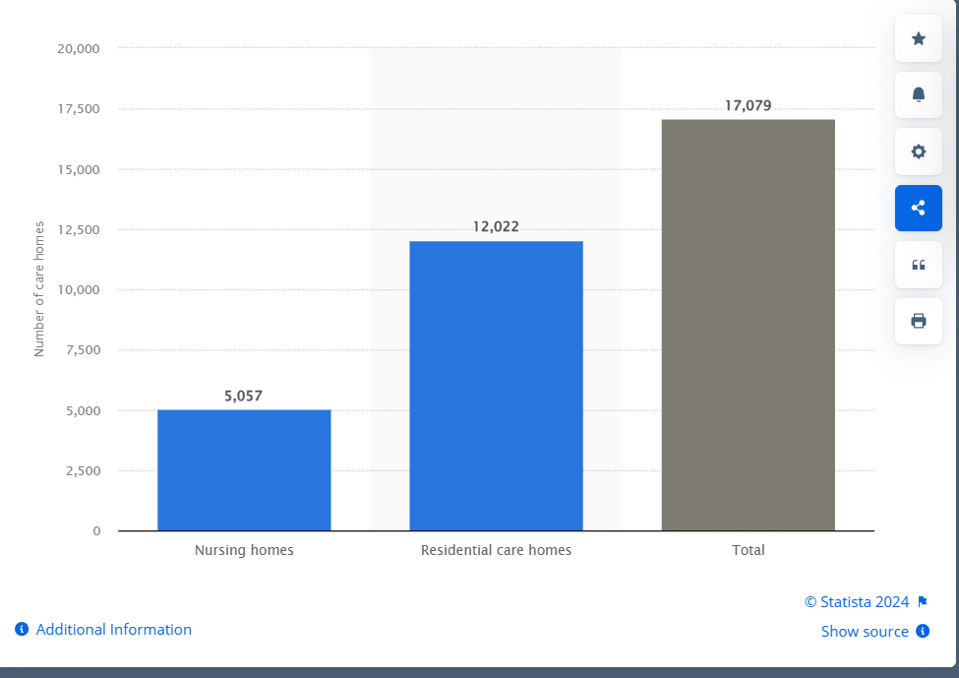
Figure 1: Number of Care Homes
Source: Statista (2024)

As stated by the CQC research report from 2020, the majority of the organizations from this sector, are small or medium businesses (CQC, 2020) which cannot afford such investments or do not have enough training to know how to attract such investments. The main aspect related to this problematic seems to remain the apprehension for the importance of improvements within organizational culture within this organizations, and the interest for the advance technological devices available to help improving the outcomes of the entire activity with real impact on the success of the organization overall. Also, if we relate the problematic to the Hofsted’s cultural dimensions, we might just observe that a field dominated by a feminine culture, lack in interest for competitiveness and continue achievement in order to stay ahead of the competition (Hofsted, 1980).

1.3 PROBLEM STATEMENT
Regardless of its importance and the recognition accorded by the numerous studies, and a reach specialized literature, which have demonstrated the necessity of change, the field seems to struggle to implement effectively a robust culture of improvement and innovation (Mannion, 2018). There can be observed many barriers such as resistance to change, inadequate resources, lack of expertise, lack of leadership support which hinder the success of adopting innovative practices or modern technologies. This research aspire to address the main following aspects which make it difficult to promote a sustainable change within the healthcare sector, such as:
- The impact of the organizational culture with a focus on the necessity of improvement and the adoption and implementation of innovative management practices and technologies in health care.
- Identifying the main barriers which make difficult fostering a culture of improvement and innovation.
- Determine which strategies are available for the health care leaders to promote continuous improvement and innovation making the industry performant and attractive for the employees.

1.4 AIM AND THE OBJECTIVES

A. THE AIM OF THE RESEARCH
The present study aims to investigate what are the connections between the culture of improvement and the understanding of the necessity to transform and modernize by implementing innovative practices and advanced technology ensuring a successful change within the healthcare organizations.
In order to identify how does a culture of improving influence the sector, and what is the role of innovation in care, the present research aims to assess the current culture in healthcare and care settings with a particular attention on a case study – the adoption and implementation of a ERS (Electronic Recording System), identifying key factors that can help adopting and implementing innovations, or if there any other possibilities (Akenroye, 2012). The study aspire to identify what are the barriers faced by the private care homes, providing insights into how effectively the healthcare organizations are promoting the innovation analyzing the example of a residential care home.

B. THE OBJECTIVES
The objectives of the present research are:
- To analyse the settings’ culture of improvement within healthcare sector and how this contributes to improve the organization’s performance and adopting innovation.
- To identify the possible barriers to effectively adopt a culture of improvement and innovation.
- To identify possible strategies which can help healthcare leaders to promote improvements within this sector and to increase the attractiveness of this sector for the employees.
As any transformation has positive or negative impacts on the organization, the study will analyse in what way this culture of improvement and the implementation of innovations will contribute to staff attractiveness in the healthcare sector and the care settings.

1.5 RESEARCH QUESTIONS

The research aims to answer the following questions:
1. How does a culture of improvement influence the adoption and implementation of innovative management practices and technologies in health care?
2. What are the main barriers to fostering a culture of improvement and innovation within health care organizations, in special within private care homes?
3. What strategies can be adopted by the healthcare leaders in order to foster a culture of continuous improvement and innovation, and make the sector high performant and attractive for employees?

1.6 SIGNIFICANCE/ RATIONAL OF THE STUDY
The concerns regarding the culture of improvement has been expressed by a NHS guide which was encouraging the leaders within healthcare sector even from 2005 'to create a culture … which celebrates and encourages success and innovation… a culture which recognises… scope for acknowledging and learning from past mistakes’ (NHS Guide, p.11). However, as highlighted by the CQC review study from 2020, there is a need for improving leadership practices, managerial approach, and teamwork with a special attention on fostering a culture of improvement, which also mention some of the perpetual barriers within the sector.
This research is significant because it is addressing the critical need for healthcare organizations to continuously improve and innovate in order to meet the demands of a rapidly changing environment as proved during Covid-19. Regardless what the numerous studies proved that the change and improving is necessary, or if after the pandemic the number of the organizations accessing innovative practices increased significantly to 60%, there seems to remain a number of barriers which are not compatible with progression and change (Adult Social Care Technology Review, 2022). This study aspire to identify some of the barriers and challenges faced by the care homes within UK, coming with possible suggestions by examining the case of a small organization from the healthcare sector, and analysing the results of an interview about how the organization understand to promote improvement and innovation within their activity (Cousins et al., 2016).
Appears as a necessary condition the understanding of the relationship between promoting a culture of improvement and adopting innovation, as the main factor that can lead to effective and consistent performance. By reflecting on a real case study, this research aim to provide valuable insights that can help healthcare leaders implement effective strategies for enhancing organizational performance and patient care.

1.7 OUTLINE OF THE STUDY
The study is structured as follows:
Chapter 1 will provide an Introduction, background of the research, problem statement, research aim and objectives, research questions, significance/rationale of the study, outline of the study, and summary of the chapter. Chapter 2 will also cover the Literature review on the culture of improvement in health care and the role of innovation in management practices and practical technologies. The research topic will be reviewed to identify the gaps.
Chapter 3 will focus on the Research methodology, including research design, data collection methods, interview analysis, and data analysis. Chapter 4 will be dedicated to the presentation and analysis of research findings and in Chapter 5 will discuss the research findings in relation to the literature. Chapter 6 will present the Conclusion, implications for practice, and recommendations for future research.

1.9 SUMMARY OF THE CHAPTER
This chapter introduced the research topic, highlighting the importance of a culture of improvement and innovation in health care. It provided background information on the research, identified the problem statement, and outlined the research aim, objectives, and questions. The chapter also discussed the significance of the study, provided an outline of the study, and summarized the content covered.

CHAPTER 2: LITERATURE REVIEW

2.1 INTRODUCTION
By conducting a literature review, we can identify key concepts, theories, practical examples from the field, and elaborate a framework for this study. The research over the existing literature about the healthcare sector and innovation, enable as to identify what are the problems covered by the previous research in this area, presenting any positives findings and new possibilities, as well as highlighting any gaps that still need further attention.
Within this chapter we will review some of the existing key concepts, theories and frameworks providing as with a profound understanding of how the culture of improving and the innovation can contribute improving the patience care, and also increasing the efficiency and performance within care settings.

2.2 LITERATURE REVIEW
When conducting a literature review few key findings can be observed and analysed. One aspect is the role of culture in the process of improvement, change or transformation. The culture is identified as a key element for quality and improvement (SQW, 2023). A good improvement culture relies on commitment, consistency, and sustainability, being characterized by reassurance and safety, quality and effectiveness, teamwork and collaboration, continuous measurement of impact, caring and person-centred approaches, learning organizations, and strong leadership (Mannion, 2018). Also, there can be observed some factors that are facilitating or enabling transformation and improvement, such as consistent and stable leadership. However the review provide as well examples of factors-barriers which can delay or obstruct the process of improvement: resistance to change, fear of blame, inadequate planning, and inappropriate goals. If the conditions are met, the existence of a good culture of improvement and the existing facilitating factors, then the results are high quality service for patients, enhanced staff engagement, and improving the performance of the organization.
Organisational Culture and Quality Improvement according to Mannion and Davies (2018), are those factors that impact service performance, quality, and the attitude towards adopting new practices and technologies. According to them, within the healthcare sector we still find multiple subcultures, which can either contribute to change and quality improvement, or constituting real barriers to innovation. They are presenting how the organizational culture within the healthcare sector and care sector can influence the approach towards change and the necessity for a cultural reform.
Backhouse and Ogunlayi (2020) explain why Quality Improvement is a principle-based regarding the approach for change and presents its role in problems solving, quality service and better outcomes for those using the services.
Within a review on innovations in healthcare sector, Sounderajah, et al. (2019) refers to disruptive innovations across various domains such as research, diagnostics, digital health, education and techniques criticizing the inconsistent use of this term, they have been suggesting a more appropriate term such as cost-effective innovation.
Speaking about design thinking in healthcare innovation, Oliveira, Zancul and Fleury (2020) focus on the application of this concept in different innovation projects across medical specialties, hospital innovations and healthcare management, and the need to increase focus on the inspiration phase and attract individuals in innovation projects. They are highlighting the fact that even the design thinking might increase the cost and time spent, the concept foster design changes.
The Care Quality Commission (2020) promotes the concept of enabling innovation within health and social care sector within a report, particularly in response to COVID-19 pandemic. The report present the role of the active providers within this sector in identification, management and service delivering, and how by adopting innovation these can improve the outcome for their patience.
On the Guide published by the Institute of Health Innovation West Midlands (IHIWM, 2025) is been made an important clarification when is coming to refer to improvements in healthcare sector, as improving quality is not the same with “Quality Improvement (QI) is the use of a systematic method to involve those closest to the quality issue in discovering solutions to a complex problem. It applies a consistent method and tools, engages people (staff/ residents/service users/families/ outside agencies) more deeply in identifying and testing ideas, and uses measurement to see if changes have led to improvement” (IHIWM, 2025).

2.3 IMPORTANCE OF INNOVATION. HOMECARE SETTINGS
For the healthcare sector, innovation is crucial. Through innovative practices and new technologies the sector can improve its services with crucial outcomes for the patients, reducing the costs and enhancing the quality of care. As pointed already, the innovation involves both: the creation-invention of new practices, products, services or models of care, and the adoption and effective implementation of these new ways of providing care. However if on overall, the sector of healthcare has been adopting innovation in their activity and continuously improving services with great outcomes for the patients (Millella, Minelli, Strozzi and Croce, 2021), within care homes, seems to struggle promoting, adopting and implementing innovation as many studies have revealed (CQC,2020). This research aim to look into the problematic and identify some of this issues that seems to affect the adopting and implementation of innovation in care homes.
As revealed by the many studies available, there are many innovative practices and technologies which has been adopted in the last years and used by the care settings to enhance the quality of their services (Burns, Hamblin, and Goodlad, 2022). Some of this practices refers to person-centred care focusing on individual needs, investing in staff and promoting training and development, or to community integration which focuses on reducing the social isolation by encouraging the residents to participate in community events (CQC, 2023). Technologies like Fitbits and Apple Watches which can monitor patients OBS in real-time, telehealth or online consultations which can reduce the visits and waiting time, Google nest, Amazon Echo and online recording apps such as Log My Care, which can act like reminders, emergency alerts and tracking the overall care services, or the robotics like Robear or Pepper which can assist the patients with some care tasks and reduce the physical strain on caregivers, are just few examples from the hall available innovations that can enhance the quality of care and positively impact the results within the care settings (CuraCall, 2025).
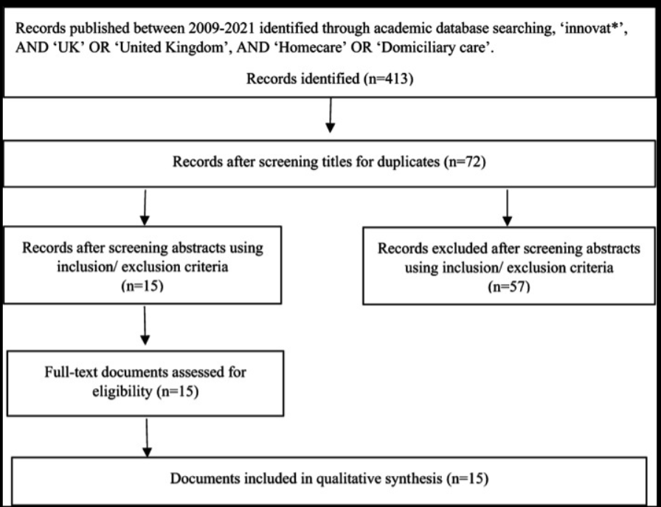
Figure 2 Search flow diagram for 2009-2021 – “innovat”.
Source: (Burns, Hamblin, and Goodlad, 2022).

2.4 ISSUES IN PROMOTING INNOVATIVE MANAGEMENT. ADOPTING INNOVATION BY THE CARE HOMES
The preoccupation for a culture of improvement and innovation has been a continuously preoccupation for all the sectors and even more so, for the healthcare sector. The culture of improvement, first mentioned in 2007 by Friedel, and a mandatory necessity of changing the healthcare sector as mentioned by previous studies ( Fitzgerald et al., 2001; Greenhalgh et al., 2004; Leeman et al, 2007), has been vastly investigated and many challenges have been observed by this studies. However, something appears not to facilitate the improvement and the adoption of new practices and technologies as resulted from the statistics offered by the Care Quality Commission (CQC) and the Department of Health and Social Care (DHSC), in 2024. According to these data, in 2024 were registered approximately 17,000 care settings just in England, and from this the majority where small or medium-sized businesses. This appears to explain a resource constraint which might result in limited financial and human resources, as quarry by the statistics above as example just 12% from these businesses had digital experts able to administer new digital applications available to enhance patients care. This might explain why the adoption of new innovations remains a slow process in this sector, and even after the pandemic Covid- 19, just 60% of the care settings have been implementing online systems of recording data. Other barriers observed by reviewing the existing studies, appears to be a poor culture of improvement, the resistance to change, staff and management might feel comfortable with existing practices and fearing the new innovative ways and changes. Also, insufficient training and support can prevent staff from effectively using new technologies and innovations, or the necessity to comply with some healthcare regulations, can slow down the process of implementation.
A very important aspect of this matter appears to refer to a technological barrier as some care homes may lack the necessary infrastructure to support advanced technologies, example old buildings where the weak signal reception made hard the utilisation of such online platforms and applications so important in registering data (CQC, 2024).
Not at last, the organizational culture that does not prioritize innovation can be a significant barrier as this might be the first step in order to promote change and transformation which can facilitate progress and improvement (Apekey, et.all, 2011).

2.5 KEY CONCEPTS, THEORIES, AND FRAMEWORKS
A framework provides a structured approaches to the process of implementing and facilitates evaluation of the hall innovative transformation, ensuring systematic and organized efforts. A framework is a step-by-step guide which offer tools and metrics to implementing changeable practices and technologies, help engaging the stakeholders and monitor the entire process, increasing the chances of success, and also explaining what works or doesn’t. It will provides effective tools which permit to continuous observe, adapting or changing where the case, allowing to enhance the entire process of adopting and implementing changes (Meyers et. All, 2012).
There are few frameworks which have been successfully applied within healthcare area of research. This includes:
1. Consolidated Framework for Implementation Research (CFIR). This framework identifies five domains (intervention characteristics, outer setting, inner setting, characteristics of the individuals involved, and the process of implementation) that can influence implementation outcomes. This can help to understand the factors influencing implementation in healthcare settings, mainly what are the attributes of the innovation, respective advantages, complexity, and adaptability; what are the external influences on the care home; which are the internal characteristics of the care home-culture, environment; which are the characteristics of the individuals involved such as knowledge, beliefs or qualities; what are the steps of the process.
Also, the framework helps to assess which are the barrier factors and the factors that can facilitate the process of implementation. For example, assessing the internal attributes can reveal if there is a supportive culture for innovation and transformation, or if there are structural barriers that need to be addressed before. If there is a lack of communication, strategies can be developed to help and improve the staff collaboration.
The framework provide a structured approach which can facilitate to monitor and evaluate the success of the implementation process. Elaborating evaluation metrics can help care homes to track and identify which area needs improving, and taking quick and effective decisions. (Damschroder et. All, 2009).
2. Exploration, Preparation, Implementation, Sustainment (EPIS). This framework emphasizes the importance of involving stakeholders at all levels and stages of the implementation process.
3. Promoting Action on Research Implementation in Health Services (PARIHS). This framework focuses on the interplay between evidence, context, and facilitation in successful implementation (Kitson et. All, 1998).
4. The Model for Improvement (Langley et. al., 2009), a framework which includes two main stages: first AIM-MEASURES-CHANGES, and second The Plan-Do-Study-Act (PDSA) cycle improvement which is used to test changes.
Selecting a framework is a challenging task. When an organisation is interested in implementing a particular innovation, first they must decide which framework is the most suitable, or if a framework or combination of frameworks must be considered. It is important to understand that selecting a framework should respond to the interests of the organization, depending on what is focusing: a specific step of the implementation, on a specific factor internal or external, or on the evaluation stage. An example it is a Generic implementation framework (GIF) which is not a new type of framework and was designed to structure the core concepts of implementation (Figure3). As represented in the Figure 3, the implementation process it is not a linear process, as indicated by the double arrows. Next, the process can be divided into a series of steps and in the centre is the innovation that needs to be implemented. The structure unable us to observe at each stage, what are the possible threats or obstacles-barriers, and elaborate strategies to overcame them.
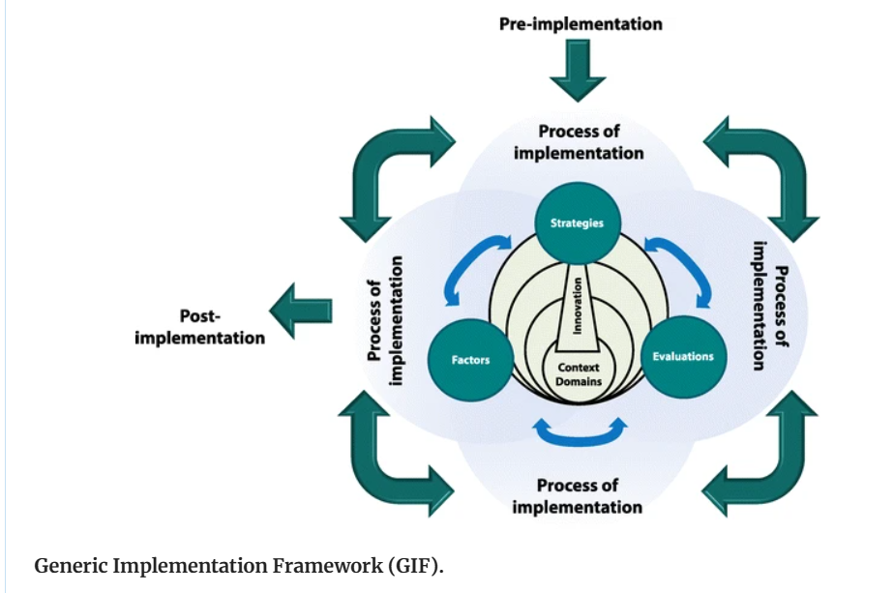
Figure 3 Generic implementation Framework (GIF).
Source : ( Moullin et al., 2015)

2.6 SUMMARY
The present chapter provides an introspection into the literature dedicated to this topic of research, namely a literature review of the culture of improvement and innovation in the healthcare sector, and in particular on the problematic of the home care settings. Also, the chapter is providing insights about the importance of innovation in the healthcare sector and innovations available for the care homes settings, presenting which are the issues that are affecting the process of improvement and innovation. A special attention is given to the presentation of some of the existing concepts, theories and frameworks available in order to help a better understanding of the topic of research.

CHAPTER 3: METHODOLOGY

3.1 Introduction

The current chapter is developed to examine the methodological available choices to accomplish the research process. This chapter explore the notion of philosophy, approach, design, collecting data method, analysis and ethical consideration.

3.2 The Main Methods
The study will focus on Sanders' Method, a framework witch will outline better the stages of the research methodology following the layers of the onion, as the process develops.
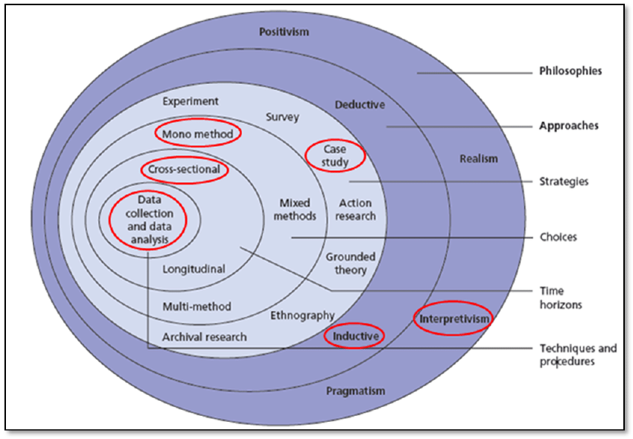

Figure 4 – The Research Onion (adapted from Saunders et al. 2009, p. 138).
Source: (Coenen, 2014).

3.3 Research philosophy
The present research aimed to analyse how the culture of improvement (NHS, 2023) impacts the adoption of innovation by the healthcare organizations, particularly within homecare settings, identifying which are the barriers faced by this sector (Akenroye, 2012).
Therefore the philosophy of interpretivism (Bryman, 2016), which is focusing on understanding human experiences, appears appropriate allowing the investigation and analysis of the matter which makes the main objective of this study: analysing the relation between a culture of improvement and the adoption of innovation by the care homes in their activity based on a case study of a care home adopting a Electronic Recording System (ERS).

3.4 Research approach
As the interpretivism is focuses on understanding individual experiences and perceptions, the research has concentrated on conducting interviews with five representative stakeholders of a private care home, analysing their perceptions about the matter of the study, and identify what are the barriers which makes the adoption of innovation such a slow process. The inductive research has helped drawing general conclusions by observing a particular case study and identifying patterns in the data obtained (Yin, 2018). Though the results may be based on a particular experience, analysing the insights provided by the interviews and correlate with other existing sources about the healthcare sector, the study has facilitated the understanding of obstacles faced by the sector presenting some observations and providing some possible solutions for the barriers identified.

3.5 Research design

For this study, a qualitative research paradigm (Guba and Lincoln, 1994) appears as appropriate, because allows us to explore in-depth specific aspects, experiences, and attitudes of the management approach within healthcare sector and care home settings. A qualitative research would help us understanding complex social phenomena and gaining insights into the "how" and "why" some projects have been initiated and completed (Bell, Bryman and Harley, 2022).
The research is based on a mono-method making utilisation of the qualitative research design in order to explore and understand underlying mechanisms and contextual factors which are linked with the research objectives (Creswell, 2014). The qualitative design helped to gather detailed data and descriptive information about the beliefs, attitudes, perspectives, and behaviours of the care home staff, through the method of interviews, in the context of their experience during a process of adopting and implementing a ERS.
Through the use of a rigorous qualitative research method, the present study has been able to understand the challenges and successes of ERS adoption, the impact on workflow, the perceptions of different stakeholders identifying potential barriers when adopting innovations, and also, quality measures and improvements which can be applied when adopting innovations (Sofaer, 2002). By understanding the different needs of the stakeholders the process of innovation can be tailored to be more effective and sustainable.

3.6 Data collection method
The present research made the use of primary data gathering information through conducting interviews with five representative stakeholders of a care home, analysing the process of adoption and implementation of ERS. In order to ensure a comprehensive understanding of the matter of research, the interview was conducted with a mix of representative stakeholders: management and staff on different positions. The research chose to interview 5 persons in order to avoid presenting just a person’s view about the topic, to avoid bias, to provide a more dynamic and diverse data enhancing the quality and the depth of the data analysed.

3.7 Case study
By using data obtained from conducting interviews with 5 representatives involved and affected by the process of adopting and implementing a ERS in a care home. By involving more than one interviewed person, the study aim to avoid bias, and provide a more diverse data. The research was able to presents valuable insights identifying barriers, challenges, and offering a deep understanding of how the culture of the organization can affect the process of innovation. In order to maximize the results, the study combine the method with other data sources offered by other studies on the same matter.

3.8 Data analysis
The present study was based on a cross-sectional research, analysing data from a specific case study, about an experience of adopting innovation by a care home at a specific point in time in order to understand the characteristics of a phenomenon: the slow adoption of innovation by the care homes.
The dissertation used the thematic analysis to understand the issue. The data analysis assisted in identification of the tools which were used for determining and examining the data. Considering that the current research has made a use of primary data collecting method and a qualitative design, the research has made effective utilization of the NVivo (Bazeley and Jackson, 2013). With the help of this data analysis software, the research has been able to organize and analyse the data obtained from the interviews, finding valuable insights linked to the objectives of this study. The NVivo software offers features like coding, text search, and visualization tools like charts, which help in interpreting the data and presenting the findings effectively. The data analysis has been conducted in line with the research questions.

3.9 Ethical considerations
The current study has adhered to ethical requirement (Muhammad, 2024) of the research by effectively reviewing the consideration linked with primary research. The researcher has ensured the confidentiality of the participants which were well informed regarding the purpose of the study and voluntarily agree to participate. The informed consent of the participant was obtained before collecting the research data. The participants were also ensured that their information will be stored in safe place and will not be disclosed to the public. Additionally, the research ensured that no participant has been harmed during the procedure of the research. The research has been conduct with honesty and transparency, avoiding fabrication or falsification of data, ensuring that the research remained fair and unbiased.

Summary
This chapter concluded that for current research, interpretivism research and inductive approach were suitable. This chapter also highlighted that in order to fulfil the aim of the present study, a qualitative research design is suitable, conducting interviews with 5 representative stakeholders of the case study organization. Furthermore, the data were analysed with the help of NVivo (interview questions in appendix 1).

CHAPTER 4: FINDINGS AND DISCUSSION

4.1 Introduction
In this chapter are presented the findings of this study, along with a discussion of their implications. This chapter has four different sections, the introduction, the overall results each of which addresses the research questions outlined in chapter one, the main discussion about the findings of the study, and the summary.
Hence, the results of the study are in line with the research questions which are as follows:

1. How does a culture of improvement influence the adoption and implementation of innovative management practices and technologies in health care?
2. What are the main barriers to fostering a culture of improvement and innovation within healthcare organizations?
3. What strategies can be adopted by the healthcare leaders in order to foster a culture of continuous improvement and innovation, and make the sector high performant and attractive for employees?

4.2 Overall Results
The qualitative data was obtained through interviews with 5 stakeholders of the chosen care setting, which from confidentiality reasons we agreed to name it, ‘The care home PRed’. The present study analysed the data obtain with the help of NVivo software, which helped to organized and find insights in the non-numerical data.
The stakeholders were five staff members from various roles, age and experience (manager, deputy, seniors and care staff) chosen to provide a diverse range of perspectives and avoid bias. The interview was conducted face-to-face and the interviewees had to answer to 16 questions addressing the three main thematic of our research evidenced by the questions of this study. By following a structured interview, the study become more effective being based on the analyse of personal experiences, attitude and feedback in relation with our three thematic research questions (Žukauskas et al, 2018). Participants have remained anonymous protecting their identity and being mentioned in data analysis as: VP, TJ, CP, FA, and HA. As resulting from Table1-Demographic information, few observations can be made: the majority of them are Gender F, the experience vary from 3 years to 10 years, and the participants are representative of staff from four different positions.
Table 1. Demographic information

Participant | Experience on position | Job title | Age/gender
VP | 9.5 years | manager | 62/F
TJ | 5 years/ deputy | deputy | 58/F
HA | 7 years/carer | carer | 56/F
FA | 3 years/carer | carer | 34/F
CP | 10 years/senior | senior | 65/F

Source: Field work

By analysing the qualitative data obtained, this research identified the main themes of discussion. The results found are in line with objectives and research questions of this research, and appears to be supported by the literature findings.

Table 2. The research questions key words results. Excel table.
Q. | participant 1 VP | participant 2 TJ | participant 3 HA | participant 4 FA | participant 5 CP | theme 1 | theme 2 | theme 3
1 | supportive culture | continuous improvement | not supportive | improvement | caring | organizational culture
2 | staff development | staff development | average standards | improvement | caring | organizational culture
3 | communication | communication | handover/ trainings | training | personal development | organizational culture
4 | high-care-standard | high-care-standard | average standards | promoting improvements | adopting innovations | organizational culture
5 | ERS | ERS | log my care(ERS) | I do not know | ERS | organizational culture
6 | costs/ provider willing to invest | costs | do not know | costs | costs |  | barriers/  challenges
7 | week internet connection | not enough training | not enough training | week connection | not enough training |  | barriers/  challenges
8 | investments/ county support | council support | do not know | investments | investments |  | Barriers  /challenges
9 | exited | exited | nervous | confident | confident |  | barriers/  challenges
10 | cooperation | cooperation/ interest | Interest  for new technologies | cooperation | resistance |  | barriers/  challenges
11 | accuracy | accuracy/ easy to make logs | helpful | easy to use | easy to use |  | Barriers/  challenges
12 | yes | yes/ interested | yes/definitely | yes | yes |  |  | staff attractiveness
13 | informal support | informal support | no strategies | no strategies | no enough support |  |  | staff attractiveness
14 | no strategies | offering information and support | no | no strategies | no strategies |  |  | staff attractiveness
15 | no/ experienced staff is content | yes/ interested | interested | not really | interested |  |  | staff attractiveness
16 | thank you vouchers | one pound / hour for extra | no | Christmas voucher | voucher |  |  | staff attractiveness

Source: Field work
Theme 1. The organization’s culture.
Research question 1 to 6 have provided us with valuable insights about the culture of the chosen organization, and how this influenced their activity. From the information gathered resulted that there is a continuous preoccupation for improvement (Shaw, 2019), as key element for their culture, where observed. The culture of the organization, as VP said emphasizing the importance of collaborating and supporting the staff to improve their skills and knowledges, and not so much promoting innovations, as they seems to understand as primary, having a duty to “provide high-care-standards” which in their view is not necessarily conditioned by technological improvements. The interview demonstrated different staff views, as there have been observed signs of misperception, HA and FA considered that there is not such culture considering that a home for elderly is not a place for innovation: “because it is a care home, a place for older people. I think, it is ok as it is at the moment”.
On the other hand, VP considered that:
“The culture of this organization is one collaborative and supportive, supporting the staff with learning, that is encourage them to better themselves and be better with the residents as the well-being of the residents and the quality of their life, it is our priority.”
Also, when asked to point out some key elements for the culture of the organization, VP said:
“All are important for us. But first, definitely high-care-standards, are the most important because you only as good as the care you give to your residents, and the feedback from the families about the care we provide.”
More key element were mentioned by TJ:
“We are an organization open and transparent, focused on collaborating in the best interests of our residents.”
Theme 2. Barriers and Challenges.
The questions 7 to 12 provided us insights about what barriers have been delaying the adoptions of innovations and what challenges have been observed when implementing innovations within the care home. The costs and the willingness of the provider – owner to make investments appears as principal barriers confirmed by the majority.
As TJ said:
“definitely we need more money, we need to improve the wi-fi connection, we need more devices such as performant tablets, and we need to organize more training for the staff”
The interview’s results confirmed as main challenges when adopting new technologies: lack of internet connection, as the care home is situated in the rural area, not enough training for the staff which struggle to use effectively the new system (ERS), or even staff rejection of new innovations, as some staff is characterized as “reluctant” when the management was trying to implement a new Emar system.
VP also pointed some barriers and challenges when said:
“Probably the costs, the owners been able to adopt the ERS because the local authority founded some of the costs and encourage them to adopt it.”
“The biggest challenge was to get the staff on bord, training them how to use it effectively, and the most important the availability of internet service because in the rural area it is an ongoing problem.”
The main problem, FA said:
“Financial investment, the provider to want to support new investments.”
Theme 3. Innovation as factor of attractiveness for employees.
The questions 12 to 16 offered insights about the effective understanding of “if” or “how” an organization promoting improvements and innovations it is more attractive for the employees, or if this contribute in any ways to retaining staff in the job. According to the interview findings, there are different views about the understanding of ‘how’ or ‘if’ innovations brought improvements for the organization’s performance, or if this is a factor to increase the attractiveness of the job.
As FA said:
“I don’t mind working with technology, as I am used with my phone, laptop…but if I have to choose, I will chose to work in a place were I don’t have to use digital recording.”
Also, the management seems to believe that the staff doesn’t manifest an increase interest in innovation, and the staff which have been for more than 5 years with them appears content with the way of doing things within organization.
VP said:
“No. They don’t show more interest, but that doesn’t mean that won’t come along. The advantage is that we have staff that have been with us for more than 5 years and they are quite content with what we have here and how we work.”
However, there were members of staff that considered important to adapt new technology, as CP considered “vital for the organization to work with modern technology”.

4.3 Main discussions
The interview questions focused on understanding the importance of a culture of improvement (Toulany, and Shojania, 2025) and how this concept influence the adoption of new practices and technologies such as the ERS or other innovations, analysing a real case, the experience of ‘The care home PRed’.
The importance of the culture of the organization was emphasized by the interview results. The respondents highlighted the need for continuous improvement in order to enhance the care quality. As one of the participants, PV stated: “you only as good as the care you give to your residents”, improving seem to be the main preoccupation within organization.
As confirmed by the interview, the key elements of this organization’s culture are collaboration, high standards, transparency, continuous learning and improving, elements highlighted by other studies before (Manion, 2018), which are key elements of the culture of improvement (SQW, 2023). As resulted from the ‘Table 3. The word frequency’, the NVivo analysis showed, that the most used word appears to be ‘staff’, which emphasise the importance of employee engagement and improving, seen as vital by the organization to support staff training and development. However, the interview results pointed out, that there is not enough training and the staff seems “quite content with what we have here and how we work”, as VP said.

Table 3. Word frequency
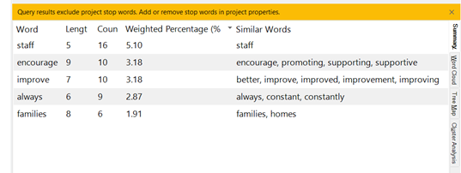
Source: NVivo
The majority of the interviewees pointed out that the ERS improved the efficiency and accuracy of the record-keeping, reducing the errors and offering quick access to more and accurate information about the residents, which is vital for the service quality offered by the organization. However, there have been observed some challenges, such as week internet connection and not enough training, which might explain why the staff remains “reluctant”, as PV said.
On the other hand, as observed from the demographic information, the majority of interviewees were Gender F, and age over 45, which might imply the Hofsted’s perspective on cultural dimensions, as observed that the field dominated by a feminine culture is lacking interest for competitiveness and continue achievement (Hofsted, 1980). Might explain why, VP consider that the staff is not interested in technological innovations saying that “The advantage is that we have staff that have been with us for more than 5 years and they are quite content with what we have here and how we work.”
As pointed out in 2024 by the statistics offered by the Care Quality Commission (CQC) and the Department of Health and Social Care (DHSC), a poor culture of improvement appears as a general issue for the healthcare sector, and the findings of the present study seems to confirm the same, as the staff seems not to have an understanding of an existing culture within the organization, as HA said “I don’t think there is such culture”.
Overall, there was a consensus that electronic recording systems positively impacted the quality of care provided, allowing for better monitoring and management of resident’s needs, even there have been observed similar barriers such as those suggested by other studies (DHSC, 2024): week internet connection, not enough trainings, not enough interest for investments from the providers side.
The results have confirmed that the organization’s commitment for adopting innovations appears to strongly depend on two factors: the willingness of the ‘provider’(owner) to invest, and the support of the West Midlands Care Association and the County Council.
The interviews demonstrated that there is an understanding for the importance of continuous improvement as showed in Figure 5. The cloud words in NVivo, which highlighted words like: ‘technology’, ‘constantly’, ‘new’, ‘improve’, however there have been observed signs of resistance to change, the staff being described as ‘reluctant’ by the management. Hence, poor management practices can be observed, as the staff straggle to understand the necessity of innovation.
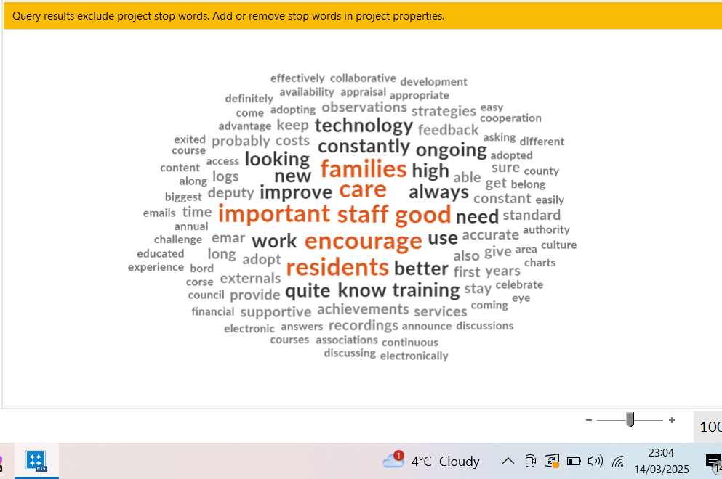

Figure 5. The cloud words.
Source: NVivo

There is also an understanding regarding the importance of establishing a culture of improvement in the organization, which can help to persuade skilful candidates (Syakur et al., 2018). The majority of those interviewed agreed that adopting innovations can contribute to making job more appealing by reducing workload, improving job satisfaction, and offering opportunities for skill development.
However, there seems to be a lack of strategies within organization in encouraging staff to attract and use innovation in their activity. As observed from the interviews, there seem to be unclear for the staff what innovation is, how this can help and what the management does in order to introduce effectively innovative practices and technologies. Having a good understanding of what quality improvement is, can help the healthcare organizations to implement and follow strategies to effectively improve the quality of their innovative projects. With the help of methods and tools as presented by the Figure 6. A framework for improvements (IHIWM, 2025), and engaging internal and external stakeholders to apply, test and measure, the management can evaluate if the changes made have led to improvements, and take action accordingly. By fostering good management practices, highlighting and measuring the benefits of innovations, the staff can be encourage to confidently use and improve working innovative.

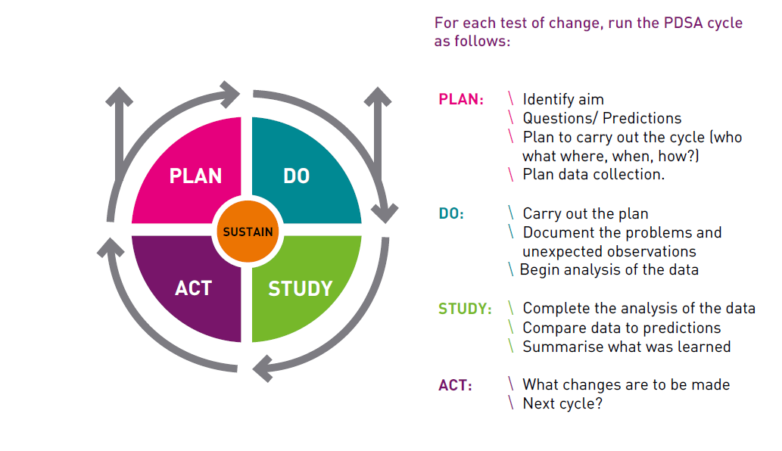
Figure 6. The PDSA cycle tool. A framework for improvement.
Source: (IHIWM, 2025)

4.4 Summary
The current chapter was developed for discussing the findings of the research analysing the data obtained through the use of interviews, highlighting the main conclusions of the present study supported by the literature review. The chapter explored the importance of promoting a culture of improvement and its impact on the capacity of an organization to attract, adopt and implement innovations.
There have been also revealed aspects about the process of adopting an innovative digital system ERS by the chosen organization ‘The care home PRed’, highlighting the main barriers and challenges faced during this experience, as well as the feedback regarding the effective results of the implementation process.
The study identified key elements of a the organizational culture focused on improving by supporting their staff to learn and develop. However, the study recognized signs of poor culture such as avoidance and resistance to change, preference for old technics, and lack of understanding new concepts, which suggest there is a need of improving management and communication (DiStefano, 2022).
From the overall literature findings, same as other small organizations, when is to adopt improvements and innovations they depend entirely on the willingness of the provider/ owner to invest, and the help of some local authorities such as West Midlands Care Association and the County Council, which can provide founding for new projects.

CHAPTER 5: CONCLUSSIONS AND RECOMANDATIONS

5.1 Introduction
This study has successfully analysed the culture of improvement and the implications on the process of adopting new practices and innovations by the organizations from the healthcare sector, according a special attention to the private care homes.
The present study aimed to analyse what are the connections between the culture of improvement and the understanding of the necessity to transform and modernize by implementing innovative practices and advanced technology. Following its three objectives, the research looked into the case of a private care home which moved from the written data on paper to the digital recording system.
The research identified some of the key elements which are influencing the organizational culture in order to be an strong culture of improving, as well as some of the barriers and challenges that can influence the adoption and implementation of new practices and technologies within healthcare and private care homes. This chapter concludes the research done on the topic analyzed presenting some of the main results obtained and making some viable recommendations.

5.2 Conclusions
The findings of the present research attested that within healthcare sector and care homes, is a preoccupation for improvements manifested also by the organizational culture of the case study which was analyzed.
However, same as previous studies presented, the management appears to straggle fostering a strong culture of continuous improvement encouraging the staff to embrace change and innovation. These is implying that there is a necessity of a change within the management practices. As leadership support and a strong training program is critical in building a culture of improvement and innovation, the present research identified some of the barriers which seems to persist within the healthcare sector and the private care homes, which are making the change a slow process. The findings of the present study highlighted that there is still not enough training or effective good communication, staff feeling comfortable with old practices remaining resistant to change (Tamkin, 2016).
Also, key factors were highlighted by the present study, such as understanding the importance of improving, collaboration, high-care-standards, transparency, continuous learning which emphasised the existing preoccupation of the management for change and improving. However, same as other studies presented, within the staff there is still a lack of understanding of what innovations is, and how they can use the technology in order to enhance efficiency and care quality, reducing the workload, which will also contribute to increased job satisfaction.
As suggested by the interviewees, the management (Blanchard, and Johnson, 1982) does not promote clear strategies in order to clarify new concepts and encourage the staff to use new and modern technologies. Furthermore, the challenges experienced when implemented the new system, contributed even more to an increased attitude of resistance within staff members. Such issues as week internet connection has been mentioned by the existing literature as an obstacle for the organizations situated within rural area, and the lack of appropriate training in order to help the staff to overcome possible issues is making the innovations even harder (CQC,2024).
It was proved that a strong culture of improvement is facilitating the adoption of innovations. Therefore, is not enough to promote improvements without creating an environment where staff feels confident to make informed choices, feels supported and valued by the organization. While innovation adoption can enhance job attractiveness, its effectiveness depends on how well it is integrated into the workplace culture and whether it addresses staff needs.

5.3 Recommendation
These recommendations aim to bridge gaps, ensure the effective implementation of innovation, and drive meaningful improvements in both the academic and practical aspects of care home management.
The permanent technological development in the present days, it makes difficult to stay updated which create a demand for the academic research to come with studies about examples of how the innovations can contribute to increase performance within healthcare sector and care homes. The academic research should conduct studies comparing care homes across different regions to identify how cultural and systemic differences influence innovation adoption and job attractiveness, contributing to organization’s performance (Kordowicz, and Siriwardena, 2023). The research studies should analyse qualitative insights and quantitative data in order to provide a more comprehensive understanding of innovation’s impact, helping the organization to adjust and build a strong culture of improving.
Based on this finding, it is recommended that the healthcare organization should focus on adopting clear strategies in order to enhance their culture of improvement and strongly promote key elements according with their preoccupation for change and innovation. Therefore, the healthcare organization should adopt policies and strategies which are focused not just on making improvements but also on quality improvement. This means that by making the use of new and modern tools and methods when implementing innovative projects, the care home’s managers, should engage their internal and external stakeholders to apply, test and measure these. Thus, the management would have the possibility to evaluate how the process develop making adjustments, and if the changes made led to improvements, to take actions accordingly. Also, the staff would feel empowered and valued, which will create an positive environment to foster innovation (IHIWM, 2025). A strong culture of improvement should foster open communication, feedback loops and a recognition program.
Therefore, focusing on stakeholders collaboration, incorporating matrix and other modern tools to permanent evaluate their activity, staying informed, and examining the long-term impact of such innovative projects, investing in appropriate training programs, and fostering a positive environment for the staff to develop, would help healthcare organizations to build a strong culture and become competitive. The management should also conduct regular assessments to ensure that the adopted innovations provide measurable benefits to both staff and residents.

5.4 Limitation and recommendation for future research
The present research has successfully analysed the topic of the culture of improvement relying on a limited number of participants, as mentioned five internal stakeholders, which resulted in a limitation of the perspectives and understandings provided. Further research should explore the possibility to observe and analyse cases from different healthcare organizations, from a large area, in order to obtain more valuable insights about innovative projects comparing how different environments affected the adoption and the process of implementation. Analysing qualitative insights and quantitative data, would increase the understanding of the topic offering possible disparities in access to innovative tools between care homes with different levels of funding or resources, or perspectives on different staff attitudes toward innovation, exploring differences by roles. Finding viable strategies which would contribute to an increase interest for adopting innovation and rapid implementation, will result in increased quality services through the use of modern technology.

REFERENCES
- Amalberti, R., Staines, A., and Vincent, C. (2022). Embracing multiple aims in healthcare improvement and innovation. International Journal for Quality in Health Care, 34(1), mzac006.
- Anderson-Wallace, M., and Downham, N., (2024). Improving Quality in Healthcare: Questioning the work for Effective Change., p.210.
- Backhouse, A., and Ogunlayi, F. (2020). Quality improvement into practice. National Library of Medicine. BMJ, 368, m865
- Barrett, D., and Twycross, A. (2018). Data collection in qualitative research. Evidence-Based Nursing, 21(3), 63.
- Batalden, P. B., and Davidoff, F. (2007). What is “quality improvement” and how can it transform healthcare? Quality and Safety in Health Care, 16(1), 2-3.
- Bazeley, P., Jackson, K., (2013). Qualitative Data Analysis with NVivo Paperback. SAGE Publication Ltd., Second Edition, 328p.
- Bell, E., Bryman, A. and Harley, B., (2022). Business Research Methods. Sixth Edition., Oxford. p.647.
- Benthala, B., Alla, L., (2024) Applying Qualitative Research Methods to Science and Management, 310p.
- Burns, D., Hamblin, K., and Goodlad, C. (2022). Innovation in UK independent homecare services: A thematic narrative review. Health and Social Care in the Community
- Causin, et.al., (2016). An overview of the challenges facing care homes in the UK Nursing Older People, 28(9), 18-21. Queen’s university Belfast.
- Creswell, J. W., (2013). Qualitative Inquiry and Research Design: Choosing Among Five Approaches. Sage.
- Charmaz, K., (2004). Premises, Principles, and Practices in Qualitative Research: Revisiting the Foundations. Qualitative Health Research, 14(7), 976-993.
- Collins, J. (2001). Good to Great: Why Some Companies Make the Leap and Others Don’t. Harper Business.
- CuraCall (2025). The future of Caregiving in 2025: Key Innovations, Challenges, and Opportunities Shaping 2025.
- Deutsch, E.S., Perry, S.J., and Gurnaney, H.G., (2021). Comprehensive Healthcare Simulation: Improving Healthcare Systems, p.240.
- DiStefano, B. (2022). When Leadership Fails: The Impact of Poor Workplace Management.
- Enakimio, B., (2025). The 5Ws Framework of Organisational Culture Paperback, 79p.
- Elizalde, J., Lumibao, J., and Lizarondo, L. (2024). Barriers and facilitators to health professionals’ engagement in quality improvement initiatives: a mixed-methods systematic review. International Journal for Quality in Health Care.
- Flick, U. (2018). The SAGE Handbook of Qualitative Data Analysis.
- Friedel, R., (2007). A culture of improvement. Technology and the Western Millennium., p.587.
- Gaglio, B., Henton, M., Barbeau, A., Evans, E., Hickam, D., Newhouse, R., & Zickmund, S. (2020). Methodological standards for qualitative and mixed methods patient-centred outcomes research. BMJ, 371, m4435.
- Greenhalgh, T., and Papoutsi, C. (2019). Spreading and scaling up innovation and improvement. BMJ, 365, l2068.
- Hofstede, G. H. (2001). Culture's Consequences: Comparing Values, Behaviors, Institutions and Organizations Across Nations. SAGE Publication, 616p.
- Israel, M., and Hay, I. (2006). Research Ethics for Social Scientists: Between Ethical Conduct and Regulatory Compliance. SAGE Publications.
- Kamaldeep, B., (2013). Elements of Culture and Mental Health. Critical questions for Clinitians, 104p.
- King's Fund. (2016). Understanding quality in district nursing services.
- Kordowicz, M., and Siriwardena, A.N., (2023) Quality Improvement in Healthcare: A Guide for Students and Practitioners, 176p.
- Mannion, R., and Davies, H. (2018). Understanding organisational culture for healthcare quality improvement. BMJ, 363, k4907.
- Mannion, R. (2022). Making Culture Change Happen: Elements of Improving Quality and Safety in Healthcare. Cambridge University Press.
- Marjanovic, S., Altenhofer, M., Hocking, L., Chataway, J., & Ling, T. (2020). Innovating for improved healthcare: Sociotechnical and innovation systems perspectives and lessons from the NHS. Science and Public Policy, 47(2), 283-297.
- Moullin, J.C., et al., (2015). A systematic review of implementation frameworks of innovations in healthcare and resulting generic implementation framework. Health Research Policy and Systems.
- Munson, S. (2025). Care home innovations: Transforming residential care. Care Home Advice Articles.
- Muhammad, R., (2024). Research Design Simplified: A Beginner’s Guide to Qualitative, Quantitative, and Mixed Methods Research (Mastering Research: Design, Execution, and Publishing Made Simple). 307p.
- NHS England. (2017). Building and nurturing an improvement culture. Improvement Leaders’ Guide.
- Newman, P.A., Guta, A., and Black, T. (2021). Ethical Considerations for Qualitative Research Methods During the COVID-19 Pandemic and Other Emergency Situations: Navigating the Virtual Field. Sage Journals. International journal Qualitative Methode.
- Neves, A. L., Freise, L., Laranjo, L., Carter, A. W., Darzi, A., and Mayer, E. K. (2018). Impact of providing patients access to electronic health records on quality and safety of care: a systematic review and meta-analysis. BMJ Quality & Safety, 29(12), 1019-1030.
- Neves, A. L., Carter, A. W., Freise, L., Laranjo, L., Darzi, A., & Mayer, E. K. (2018). Impact of sharing electronic health records with patients on the quality and safety of care: a systematic review and narrative synthesis protocol. BMJ Open, 8(8), e020387.
- Patton, M. Q. (2015). Qualitative Research & Evaluation Methods: Integrating Theory and Practice, 832p.
- Priestman, W., Sridharan, S., Vigne, H., Collins, R., Seamer, L., & Sebire, N. J. (2018). What to expect from electronic patient record system implementation: lessons learned from published evidence. BMJ Health & Care Informatics, 25(2), 92-102.
- Oliveira, M., Zancul, E., and Fleury, A. L. (2020). Design thinking in healthcare innovation: A systematic review. BMJ Open, 10(1), e034445.
- Parmar, J., et all. (2022). Facilitators, barriers and considerations for the implementation of healthcare innovation: A qualitative rapid systematic review.
- Porter, M. E., and Lee, T. H. (2013). The strategy that will fix health care. Harvard Business Review, 91(10), 50-70.
- Rasmussen, S. (2025). The role of digital tools in enhancing care home innovation. Digital Health Journal.
- Roberts – Turner, R., and Shah, R., (2021). Pocket Guide to Quality Improvement in Healthcare., p.348.
- Saunders, M., Lewis, P., and Thornhill, A., (2023). Research Methods for Business Students, p. 860.
- Schein, Edgar H., 2010. Organizational Culture and Leadership. Fourth Edition, p.436.
- Shaw, P.L., (2019). Quality and Performance Improvement in Healthcare. Theory, practice and management.
- Tabak, R. G., et al. (2012). Bridging research and practice: Models for dissemination and implementation research.
- Trisha, M., Bidewell, J., et all., (2019). Understanding Research Methods for Evidence-Based Practice in Health, p200.
- Toulany, A., and Shojania, K.G., (2025). Measurement for Improvement. Published by Cambridge University Press.
- Zhang, Y., and Huang, J. (2024). The role of innovation culture in transformational performance. Innovation Management Review.
- Statista, available on www.statista.com and UK: Number of care homes 2022 | Statista
- Williams, S.J., and Caley, L., (2020). Improving the Healthcare Service., p.192.
- Adult Social Care Technology Review, available on 8 March 2022 - Adult Social Care Technology Review - Future Care Capital
- NHS., (2005). Improvement Leaders’ Guide Building and nurturing an improvement culture. Personal and organisational development., Institute for Innovation and Improvement, available on ILG-3.3-Building-and-Nurturing-an-Improvement-Culture.pdf
- Care Quality Commission (2022). Innovation and why it is important.
- CQC, (2023). Using and sharing innovation to reduce health inequalities.
- CQC., (2023). Rapid Literature Review: Improvement Cultures in Health and Social Care., available on Rapid Literature Review: Improvement cultures in health and adult social care settings - Care Quality Commission, accessed at February 2025.
- IHIWM, (2025). A guide to Quality-Improvement in Care Homes., available on https://www.healthinnovationwestmidlands.org/wp-content/uploads/A-guide-to-Quality-Improvement-in-Care-Homes-v.Mar2025.pdf
- Ethical considerations associated with Qualitative Research methods, 2022, Ethical considerations associated with Qualitative Research methods – UK Statistics Authority

APENDIX 1
DEMOGRAFIC INFORMATION
Can you please introduce yourself by mentioning the following?
POSITION:
AGE:
GENDER:
EXPERIENCE ON THIS POSITION:
- How will you describe the culture of this organization?
- What do you think are some of the key elements of your culture? Can you explain?
- Can you give few examples of practices or rituals adopted by this organization in order to promote and reinforce its culture?
- Is any of the following considered a priority by this organization? Can you explain why?
- High care standards.
- Promoting improvements.
- Adopting innovations (practices and technology).
- Can you provide examples of recent projects or initiatives that in your opinion demonstrate the company's commitment to improvement/innovation?
- Can you name few factors that made the adoption of the ERS system not a priority earlier? Name few barriers.
- Are there any challenges noticed when trying to implement changes/ improvements/ innovations (the example of ERS) in the activity of the organization?
- Are there any factors that would contribute to a rapid adoption of new practices and technologies within the organization’s activity? Name tree factors.
- What was your initial reaction to the introduction of the electronic recording system (ERS) ?
- From the following, which are more likely to describe the staff attitude?
- Cooperation.
- Interest for using new technology.
- Resistance to new technology.
- Where any benefits noticed since the ERS was introduced? Can you give some examples?
- Do you consider that by promoting a culture of improving and innovating, the organization increases their attractiveness for the employees and clients? Please explain your opinion.
- How does the organization ensure that its employees have access to the latest tools and technologies to perform their jobs effectively? Please explain.
- Does the organization have any strategies to encourage employees to adopt innovative working practices and technologies?
- Have you observed an increased interest among employees for innovative working practices and technologies?
- Can you provide examples of how employees are recognized and rewarded for their contributions to the organization?
AGENDA
ORGANIZATION’S CULTURE
BARIERS/ CHALLENGES
JOB ATRACTIVENESS

APENDIX 2
TRANSCRIPT
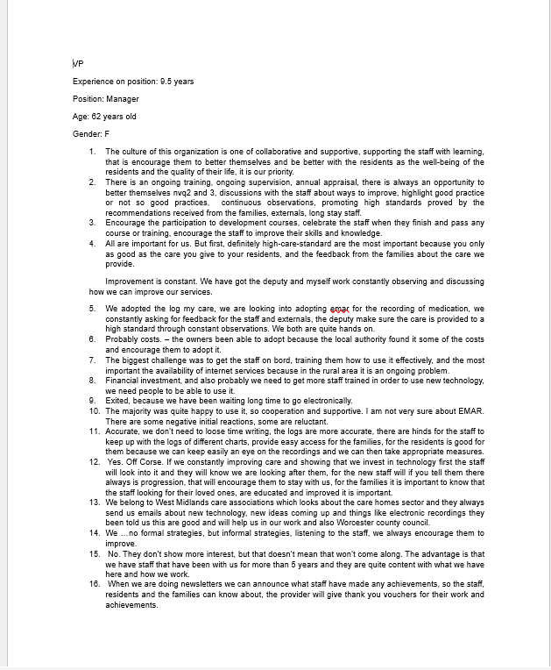

APENDIX 3
TRANSCRIPT


