A critical evaluation and the identification of next teaching steps focusing on a case study of an individual learner or a group of learners, based on an observed critical incident.
Ecad6007 | 27th October 2020
the learner: who am i teaching?
Cerys Elizabeth cole (p151440)
2020


Author’s Declaration
I declare that the work in this dissertation was carried out in accordance with the regulations of the University of Wales, Trinity Saint David. The work is original except where indicated by special references in the text and no part of the dissertation has been submitted for any other degree.
Any views expressed in the dissertation are those of the author and in no way represent those of the University of Wales, Trinity Saint David.
The dissertation has not been presented to any other University for examination either in the United Kingdom or overseas.
I hereby give permission for my work, if accepted, to be available for photocopying and inter-library loan, and for the title and summary to be made available to outside organisations.

Signed …………Cerys Elizabeth Cole………………………
Date ……………27th October 2020…………………………

Copyright statement

The copyright of this dissertation rests with the University of Wales, Trinity Saint David. No information derived from this dissertation shall be published without the prior written consent of the University.

Signature ……………Cerys Elizabeth Cole………………………
Date ……………………27th October 2020…………………………

Contents
List of Figures 2
1. Introduction 3
2. Observation 4
2.1 School and Class Context 4
2.2 Methodology 5
2.2.1 What is classroom observation 5
2.2.2 Types of Observations 6
2.3 Critical Incident 7
3. Literature Review 8
3.1 Behaviourism 9
3.2. Constructivism 11
3.3. Behavourism and Constructivism 12
4. Reflection/Evaluation and Next Steps 12
4. 14
4.1 14
5. Conclusion 15
6.References 15
7. Bibliography 18
8. Appendix 20

List of Figures
Figure 1: Illustration of the stages for reflective practice that educators use to highlight critical incidents and establish better practices (Team, n.d.) 4
Figure 2: Illustration of the concepts of positive/negative reinforcement and punishment (HubPages, 2018) 9

1. Introduction

Educators observe themselves, their pupils, and the system as a whole in order to establish any critical incidents to continually develop their personal and professional learning (University, 2020).
Critical incidents are significant to the person observing and thus not necessarily a sizeable issue within the setting (University, 2020). The critical incidents observed may draw queries on elements of the educators beliefs, values, attitude or behaviour within the professional and learning environment, and the educators reaction to this is how development of the professional practice is identified (Essays, 2020).
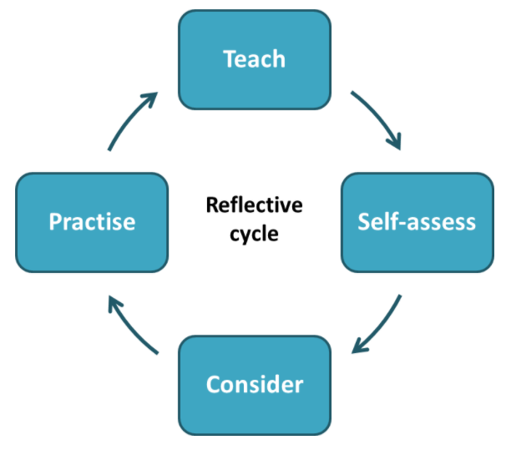
Reflective practice is a fundamental for educators in becoming proficient in critical thinking, the analysis and evaluation of the incidents, and their ability to subsequently prevent issues or negative impacts arising again (Figure 1) (Essays, 2018). This can be accomplished with the insight, opinions and perspectives of colleagues as they may have established a professional practice within their own reflections which has benefited them (Essays, 2018).

Figure 1: Illustration of the stages for reflective practice that educators use to highlight critical incidents and establish better practices (Team, n.d.)
The purpose of this is ultimately to ensure teachers continuously update and expand their knowledge within the professional capacity through revising and improving their practice (Team, n.d.). This aids the implementation of more effective learning for all students and to also cater to any specific learning needs they may have (Essays, 2020).
With curriculum reviews and new purposes for learning being established it is vital that educators adapt their knowledge and skills to ensure that professional knowledge is current and adapted for the future generations (Moon, 1999).
The author will attend a secondary school and follow a timetable of a class to observe for the day. The author will collect information regarding the lesson and record and critical incidents that occur and then reflect on these to develop her own professional development and learning.

2. Observation

2.1 School and Class Context

In accordance with the Ethical Guidelines for Educational Research (2018) the secondary PTE school, staff and individual pupils cannot be disclosed (BERA, 2018). The school is situated within South Wales and was built with future learning in mind and has advance educational technology. The intention is to improve the statistics for poor grades (and thus future unemployment levels) within the local area, and to ensure that the students have access to the high quality, 21st century teaching.
The school accommodates up to 1,500 pupils in a co-educational manner with approximately 1,200 of these being in secondary school. The atmosphere in the school is largely happy, excitable, and fast paced and the pupils are well behaved and respectable to everyone.
The age group within the school ranges from 11 to 16 and class sizes are typically 30. The pupils are generally set after their first term in the school in accordance with their learning ability. However, pupils learning is continuously being monitored through Class Charts and teachers can use this to move pupils up and down sets in effort to maximise the learning pupils are receiving.
Class Charts is a system that houses pupils’ progression, behaviour, any additional learning needs, any special educational needs, well-being etc in school, and at home. It allows teachers to essentially micro audit pupils week by week and track all the above to ensure that they are happy and progressing their learning.
2.2 Methodology

2.2.1 What is classroom observation
Observing pupils in lessons was described by Walliman as “a method of recording conditions, event and activities through the non-inquisitorial involvement of the researcher” (Walliman, 2011), and Kumar elaborated that observation is “a purposeful, systematic and selective way of watching and listening to an interaction or phenomenon as it takes place” (Kumar, 2011).
Menter (Menter, et al., 2011) and Moule and Goodman (Moule & Goodman, 2009) explain that observations can be useful for monitoring ‘behaviour or events’ and how often they occur but recognise that there are limitations with how time-consuming and intrusive it can be. However, these can be reduced if planned well (Menter, et al., 2011).
Observations were outlined by Cohen, Manion and Morrison as a unique method of producing “valid and authentic data” as it directly collects data and evidence from the real situations (Cohen, et al., 2011), and in summary they are crucial for research and establishing critical incidents within the educational environment in order to progress learning and professional standards (Punch & Oancea, 2014).

2.2.2 Types of Observations
There are two types of observations: participant and non-participant.
Participant observation would require someone to be in the educational environment and taking part in the activities by interacting with pupils and study them by becoming a member in the classroom (Library, n.d.).
Participant observation was defined by Goode and Hatt as “the procedure used when the investigator can go disguise himself as to be accepted as a member of the group” (Goode & Hatt, 1953). Coinciding with the above that to study the class you must integrate yourself.
Although participant observation has many advantages including, observation of natural behaviour, closeness with the group, studying the real character, better understanding, opportunity to learn more about the situation, it does have its negatives (Library, n.d.). These comprise of lack of objectivity, association brings bias interpretation, missing important issues, limited range of experience and limits of participant observation (Library, n.d.).
Non-participant observation is where the observer studies the class from a distance and does not participate in any activities (Library, n.d.). However, an observer being present is not the usual situation within the class and so that infers some level of participation as it often and very likely changes the dynamics of the atmosphere in the room i.e. pupils tend are more talkative/unsettled (Library, n.d.). Some practices are referred to as “quasi-participation” as it is easier for the observer to perform both roles than to disguise themselves completely (Library, n.d.).
Non-participant observation poses positives including objectivity and neutrality, command respect and co-operation, more willingness of pupils, careful analysis, freedom from group study (Library, n.d.).
For these reasons, the author took the non-participant route for observation as part of their bridging. It allowed the author to get a true reflection of the atmosphere throughout the school and how the pupils and teacher communicated throughout their lessons. Despite the advantages of this observation the author needs to keep in mind that it is highly subjective and inadequate observations can draw wrong evaluations and reflections.

2.3 Critical Incident
Professor Graham Donaldson’s new curriculum is forged around four purposes that signify the importance of progressing the educational system and the way pupils learn to equip them for society and a changing world (Dauncey, 2015).
The four purposes are that all children will be (Dauncey, 2015):
- Ambitious, capable learners who are ready to learn throughout their lives.
- Enterprising, creative contributors who are ready to play a full part in life and work.
- Ethical, informed citizens who are ready to be citizens of Wales and the world.
- Healthy, confident individuals who are ready to lead fulfilling lives as valued members of society.
When doing observations within the school, the only critical incident the author found was a pupil being continuously disruptive and progressively getting worse as the day went on. Primarily in the Geography lesson the pupil would shout out answers and as the lesson progressed the pupil became more agitated and began to swing on their chair. The teacher addressed this sternly and consistently throughout the lesson by calmly addressing the child and giving them warnings to keep their chair on the floor and to raise their hand to answer questions.
When the pupil’s behaviour deteriorated and started to affect the rest of the class the teacher issued a Stage 1 (negative points) on the pupil’s behaviour using the Class Charts system. The pupil had further warnings from the teacher and was told they would progress to Stage 2 if they did not carry on with work quietly. The pupil apologised and began to answer the task at hand, and although they became talkative once the task was completed, they did not interrupt the lesson again.
The author feels that this links with Donaldson’s ethical and informed citizen purpose as it was important for the pupil to understand and consider the impact of their actions when making choices and acting.
The disruptive or unfavourable behaviour in each lesson was dealt with consistently by all staff throughout the day and the pupil gained Stage 1 in only 2 of the 4 lessons. They did receive further warnings of more negative points being added but fortunately the prospect of more negatives changed the pupil’s behaviour and they were less disruptive.
The teacher persevered with the behaviour and was consistent in how he dealt with the pupil. Eventually the pupil realised that his poor behaviour was not achieving the desired outcome but at the end of the lesson the teacher did question the pupil about home and if he was getting the support needed for homework. This brought to the authors attention that the teacher was aware of circumstances at home that were likely a factor of the pupils’ disruptive behaviour and his stern but calm approach to addressing the issue promptly de-escalated the situation.

3. Literature Review
There are several challenges educators face when teaching students but the most challenging is being able to effectively manage behaviour within the classroom (Essays, 2017). For effective and proactive learning, teachers need to have expectations for behaviour in the classroom that are realistic and appropriate to ensure that if situations arise where learning is disrupted it can be managed effectively (Essays, 2017). Thus, behaviour management is imperative for teacher and students in the classroom environment (Walker, 1999).

3.1 Behaviourism
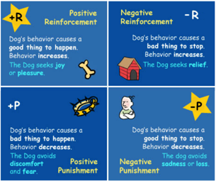
John B Watson and Ivan Pavlov had a behavourist approach to education, defining it as “classical conditioning that helps us to understand childrens phobias or anxieties” and that it “enables adults to consider positive reinforcement to manage behaviour” (Oelze, 2020). In laymans terms Watson described it as “both positive reinforcement and negative reinforcement increase the probability that the behavour will happen again, but, both postivie and negative punishment decreases the likelihood that the behaviour will happen again” (Oelze, 2020).

Figure 2: Illustration of the concepts of positive/negative reinforcement and punishment (HubPages, 2018)

This was implement within the school through the Class Charts system where good behaviour (answering the register in welsh or giving correct answers to questions) wass rewarding with positive points and inappropriate behaviour (being disruptive, shouting out, continuously talking when the teacher is talking) wass monitored by “rewarding” negative points. The system tracks the positive and negative points trend for individual pupils and it can also be viewed as a class and year group. It is used as an incentive to reward or punish behaviour within the classroom and has consistently used by staff across the school. This also feeds into Donaldson’s other purposes as it gives the pupils confidence and encourages them to be ambitious, capable learners (Dauncey, 2015). Through the experience it was effective in reducing the inappropriate behaviour and overall the lessons were very positive and productive.
Using effective behaviour management allows pupils to pay attention during lessons, develop positive interactions with teachers and peers, and it motivates pupils to behave in an appropriate and socially responsible manner which encourages them to complete their work (HubPages, 2018). Thus successful management instills a level of discpline and learning skills that are vital in becoming creative, informed and confident citizens and valued members of society who understand appropriate behaviour, which again, links back to the four purposes (Essays, 2017).
It is important to highlight that there are multiple reasons misbehaviour occurs and there are various strategies for handling the situations (Walker, 1999). Misbehaviour and disruptiveness may materialise when pupils are not engaged in tasks as they may find the task too hard, easy or uninteresting (Walker, 1999). This leads to the unwanted behaviour and can inhibit the pupils learning. Aside from the teacher there may be social or emotional issues such as poverty, abuse, parenting issues, self esteem, learning needs etc which could lead to the misbehaviour in the classroom (Essays, 2017).
In the school this was addressed by using Class Charts to establish if pupils had SEN’s or ALN’s and provided help for this where needed. If no additional needs were the route of misbehaviour then the pupil will have discussions with staff members in order to determine why they were acting inappropriately and how best both teacher and pupil thought to deal with the behaviour. This has proved effective in the school and time out cards have been given to some students who get overwhelmed by the weight of lesson’s sometimes and they can use this card to have 5 minutes outside the room to recompose themselves. This gives the pupils the trust and respect they need during times that can be difficult them and again this integrates back into the four purposes where they are healthy and informed citizens that are aware of the appropriate actions they need to take. Teachers encourage pupils to evaluate their behaviour and give chances to redeem themselves i.e. if on Stage 1 they can work hard and complete tasks and they will gain a positive point rather than a negative. This fair chance provides ambition for the pupils and enables them to become capable individuals as the perserverance shown by teachers allows pupils to recognise that determination to keep going and channelling their frustration can help them break through; “learning is often a slow and uncertain process” (Power, 2019)

3.2. Constructivism
Constructivism considers the way in which children and young people make sense of their environment and learn actively as a result (Camebridge, n.d.). The original theorists are Jean Piaget, Lev Vygotsky and Jerome Burner. Collectively what the believe is that “there is an importance to a childs development and appropriate acitivites and enabling educators to support a childs learning, when needed, expands their learning” (Camebridge, n.d.).
Constructivisim in the classroom addresses the independence and intiative of students through their peers and teachers, which must be accepted and encouraged as it strengthens intellectual identity (Essays, 1970). This coincides with Donaldsons purpose of supporting pupils in becoming confident individuals and valued members of society as it reinforces responsibility for their own actions and ensures that the feel that they are trusted, respected and listened to (Essays, 1970).
This has been demonstrated through the lesson where the teacher asked questions and all pupils were participating in answering. They didn’t show any reluctancy to answer questions and throughout the lesson if pupils had queries there was a strong sense that “no question is a stupid question” and pupils were confident in themselves.
The teacher also asked various open-ended questions to let pupils build upon each others answers until they reached the correct one. They were encouraged to analysis facts, justify and defend their reasons. The teacher then repeats the correct answer whilst praises the teamwork of the pupils. This allows pupils to gain knowledge and skills such as communication within the classroom with the hope of increasing their confidence, initiative and capability throughout their learning lives (Steffe & Gale, 1995).
The participation of pupils through discussion and collaboration engages in active thinking and discourages the old teaching style of passive listeners (Gleeson, n.d.). Pupils learn more and work better when problem solving and collaborating rather through memorisation and using this within class in practicals or question and answer sessions has proved this (Gleeson, n.d.).
The only negative to constructivism is that it is very easy to digress away from the task or conversational point unless the teacher is vigilant at keeping pupils focused (Gleeson, n.d.). This tends to happen due to how conversation natural progresses or pupils become bored of discussing the task and move on to other topics (Camebridge, n.d.).
In the classroom the teacher allowed pupils to answer discuss redevelopement and what they believed in encompassed. The pupils did not stray from the topic of discussion and asked very pretinent questions to further their understanding, illustrating how constructivism is beneficial within education.

3.3. Behavourism and Constructivism
Behaviourism and constructivism are both philosophies of learning that try to define and explain how pupils learn (Bush, 2006). All theorists related to behavourism, constructivism and social learning have had influences on the development of curriculum and how teaching materials are structures and presented (Bush, 2006). Both are pillars in the educational system and encompass important factors for methods and strategies which teachers will use and develop their professional learning, and the students learning, throughout their career (Cohen, et al., 2011). This was made evident by the way in which behaviour is enforced across the school as well as the encouragement of each pupil to develop themselves intellectually, personally and socially.

4. Reflection/Evaluation and Next Steps
The author has reflected over her experience and observation within the school and found that overall it was an outstanding insight into teaching and all of the challenges it comprises of.
The critical incident made the author reflect over the behavioural management of the school and the system it has in place to tackle the situations. The use of positive and negative rewards, as well as timeout cards and the use of SEN and ALN staff has a massive impact on not just the atmosphere of the classroom but the whole school.
The author also found many useful tips about how to structure the lesson and create engaging tasks for the pupils. For example, as the end of the lesson dawned and pupils were ready for their lunch break the teacher sensed this and let them pack away 5 minutes early, however, she then had them play a word association game which helps develop their cognitive thinking. This kept up the moral in the class and they asked their next teacher if they could play it at the end of their lesson provided they were all well behaved.
It demonstrated the type of activities during the lesson too that were appropriate to break up the passive learning. These included question and answering in a variety of formats including pairing the correct halves. This coupled with “could be” language, invites pupils to be more thoughtful, critical and imaginative about their learning.
All of the above provided flexibility within the pupils learning and allowed them to stay focused and on task throughout the duration of the lesson and day.
The author found herself returning to eight questions when reflecting and evaluating the observations:

Why? | What worked well?
Why not? | What did not work well?
So what? | What will I do the same next time?
Now what? | What will I do differently next time?
Thinking about a teachers educational role enabled the author to determine what questions she would need to answer upon her weekly reflections and targets to develop her own professional learning. These comprised of:
- what knowledge, skills or abilities are necessary to deliver a specific learning experience?
- to what extent do I possess those skills?
- what do I need to do to develop or enhance those skills?
- how will this affect the way I present that learning experience?
- what problems might this entail that I need to anticipate and overcome?

4.1 Next Steps
The next steps would be looking at how to develop reflective practive throughout the authors professional learning. This could be achieved via a learning journal where notes, observations and thoughts are collected and they can be refined into pertinent points and refers back to the above questions.
A student dialogue could also prove useful as they can carry out short reflections on how they felt the lesson went and can assess their own strengths within the subject area. They could then pose ideas for development going forward.
Then theres the possibility to have discussions with colleagues and obtain their insight of your lesson plans. It would help to develop the authors practive in providing innovative and improved lessons.

5. Conclusion
Reflective practice is a crucial aspect to the development of an engaged and forward-thinking teacher. Through observations the author has recognised various useful techniques to be more efficient in providing pupils with an education and managing behaviour.
The school was inspirational for the atmosphere in the classroom and the relationships between students and teachers. The author recognises that establishing a framework of rules and consequences that coincide with current and future curriculum is of great importance in ensuring that student receive the best education possible. The experience has allowed the author to understand potential causes of misbehaviour in the classroom and how to effectively address it.
The author can now relate her experience and development going forward to the Professional Standards for Teaching and Leadership as she can (HWB, 2020):
- set clear expectations about effective practice during her career including, where applicable, entry to the profession
- enable reflection on the practice, individually and collectively, against nationally agreed standards of effective practice and affirm and celebrate their successes
- support practitioners to identify areas for further professional development
- form a backdrop to the performance management process.

All the above not only benefits the author and other educators, but also the students as it is designed with their education as the main priority to maximise their learning and development.

6.References
BERA, 2018. Ethical Guidelines for Educational Research. [Online]
Available at: https://www.bera.ac.uk/publication/ethical-guidelines-for-educational-research-2018-online#privacy
[Accessed October 2020].
Bush, G., 2006. Learning about learning: from theories to trends. s.l.:s.n.
Camebridge, U. o., n.d. Constructivism as a perspective on teaching and learning. [Online]
Available at: https://www.educ.cam.ac.uk/people/staff/taber/constructivism/index.html#:~:text=Constructivism
[Accessed October 2020].
Cohen, L., Manion, L. & Morrison, K., 2011. Research Methods in Education. 7th ed. London: Routledge.
Dauncey, M., 2015. Donaldson Review: The ‘purposes’ and content of a Curriculum for Wales. [Online]
Available at: https://seneddresearch.blog/2015/03/17/donaldson-review-the-purposes-and-content-of-a-curriculum-for-wales
[Accessed October 2020].
Essays, U., 1970. Constructivism In The Classroom Education Essay. [Online]
Available at: https://www.ukessays.com/essays/education/constructivism-in-the-classroom-education-essay.php
[Accessed October 2020].
Essays, U., 2017. Behaviour Management in Classrooms. [Online]
Available at: https://www.ukessays.com/essays/education/the-behaviour-management-of-students-in-classrooms-education-essay.php
[Accessed October 2020].
Essays, U., 2018. Reflective Practice: why reflect?. [Online]
Available at: https://www.ukessays.com/courses/education/best-practice/reflective/2-lecture.php
[Accessed October 2020].
Essays, U., 2020. Introduction to the reflective practice education essay. [Online]
Available at: https://www.ukessays.com/essays/education/the-introduction-to-the-reflective-practice-education-essay.php
[Accessed October 2020].
Gleeson, P., n.d. The Advantages & Disadvantages of Constructivism in the Classroom. [Online]
Available at: https://www.theclassroom.com/constructivist-approach-teaching-8455246.html
[Accessed October 2020].
Goode, W. J. & Hatt, P. K., 1953. METHODS IN SOCIAL RESEARCH. New York: s.n.
HubPages, 2018. Negative Reinforcement Explained. [Online]
Available at: https://hubpages.com/education/Negative-Reinforcement-Explained
[Accessed October 2020].
HWB, 2020. Professional Standards. [Online]
Available at: https://hwb.gov.wales/professional-development/professional-standards/
[Accessed October 2020].
Kumar, R., 2011. Research Methodology: a step-by-step guide for beginners. 3rd ed. London: Sage.
Library, Y. A., n.d. Participant Observation and Non-Participant Observation. [Online]
Available at: https://www.yourarticlelibrary.com/social-research/data-collection/participant-observation-and-non-participant-observation/64510
[Accessed October 2020].
Menter, I. et al., 2011. A Guide to Practitioner Research in Education. London: Sage.
Moon, J., 1999. Reflection in Learning and Professional Development. London: Kogan Page.
Moule, P. & Goodman, M., 2009. Research: an introduction. London: Sage.
Oelze, P., 2020. John B Watson and Behavourism. [Online]
Available at: https://www.betterhelp.com/advice/psychologists/john-b-watson-and-behaviorism/
[Accessed October 2020].
Power, B. L., 2019. Amibitous Capable Learners. [Online]
Available at: https://www.buildinglearningpower.com/units/successful-futures/sessions/2-building-ambitious-capable-learners/part/building-the-habits-of-ambitious-capable-learners/
[Accessed October 2020].
Punch, K. F. & Oancea, A., 2014. Introduction to Research Methods in Education. 2nd ed. London: Sage.
Steffe, L. P. & Gale, J. E., 1995. Constructivism in Education. s.l.:s.n.
Team, C. I. E. T. a. L., n.d. Getting started with reflective practice. [Online]
Available at: https://www.cambridge-community.org.uk/professional-development/gswrp/index.html
[Accessed October 2020].
University, M., 2020. Reflective writing and critical incidents. [Online]
Available at: https://www.monash.edu/rlo/assignment-samples/medicine-nursing-and-health-sciences/reflective-writing-and-critical-incidents
[Accessed October 2020].
University, M., 2020. Reflective writing in Education. [Online]
Available at: https://www.monash.edu/rlo/assignment-samples/education/education-reflective-writing
[Accessed October 2020].
Walker, J. E., 1999. Behavior Management: A Practical Approach for Educators. s.l.:s.n.
Walliman, N., 2011. Your Research Project: designing and planning your work. 3rd ed. London: Sage.

7. Bibliography

Bolton, G.E.J. (2010) Reflective practice: writing and professional development. 3rd edn. London: SAGE Publications.
Cottrell, S. (2011) Critical thinking skills: developing effective analysis and argument (Palgrave study skills). 2nd edn. Basingstoke: Palgrave Macmillan.
Hillier, Y. (2005) Reflective teaching in further and adult education. 2nd edn. London: Continuum International Publishing Group.
Kennett, K. (2010) 'Professionalism and reflective practice', in Wallace, S. (ed.) The lifelong learning sector: Reflective reader. Exeter: Learning Matters, pp. 66-82.
Larrivee, B. (2000) 'Transforming teaching practice: becoming the critically reflective teacher', Reflective Practice, 1(3), pp. 293-307. doi: 10.1080/713693162.
Lawrence-Wilkes, L. and Ashmore, L. (2014) The reflective practitioner in professional education. London: Palgrave Pivot.
Meierdirk, C. (2012) The limitations of the reflective practitioner. Available at: http://www.leeds.ac.uk/educol/documents/214830.pdf (Accessed: 26 November 2016).
Petty, G. (2009) Teaching today: a practical guide. 4th edn. Cheltenham: Nelson Thornes.
Roffey-Barentsen, J. and Malthouse, R. (2009) Reflective practice in the lifelong learning sector. Exeter: Learning Matters.
Schön, D.A. (1991) The reflective practitioner: how professionals think in action (arena). 2nd edn. Aldershot: Ashgate Publishing.
Smith, M. (2013) Donald Schon: Learning, reflection, and change. Available at: http://infed.org/mobi/donald-schon-learning-reflection-change/ (Accessed: 26 November 2016).
Somogyi, K. (2010) Teacher education for inclusion: an international literature review. Available at: https://www.european-agency.org/sites/default/files/TE4I-Literature-Review.pdf (Accessed: 26 November 2016).
Zeichner, K.M. (1987) 'Preparing reflective teachers: an overview of instructional strategies which have been employed in preservice teacher education', International Journal of Educational Research, 11(5), pp. 565-575. doi: 10.1016/0883-0355(87)90016-4.

8. Appendix
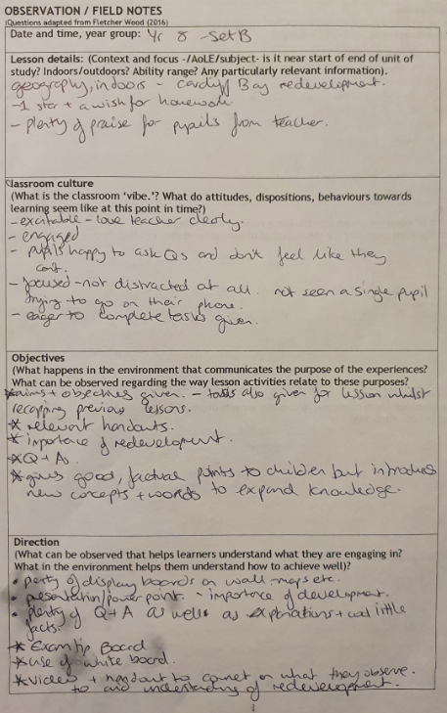

Critical Incident 1

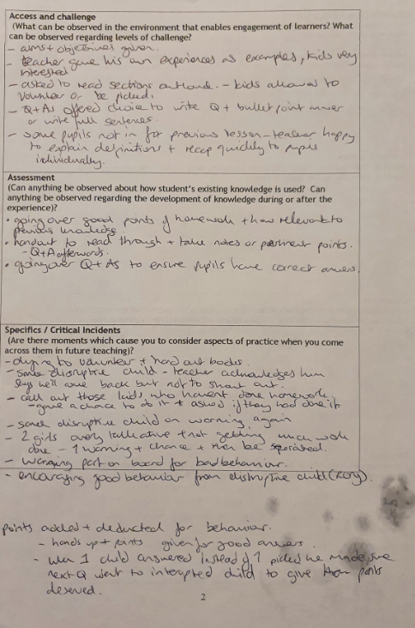

Critical Incident 1

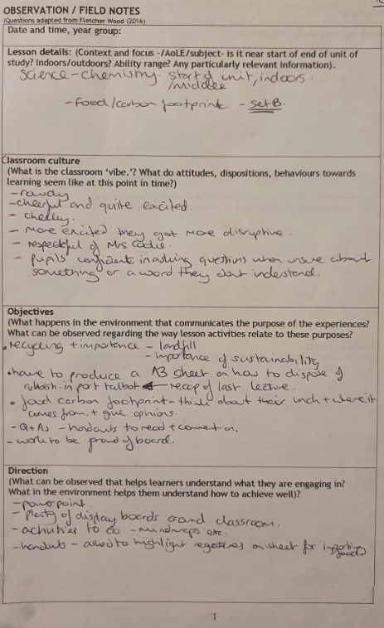

Critical Incident 2

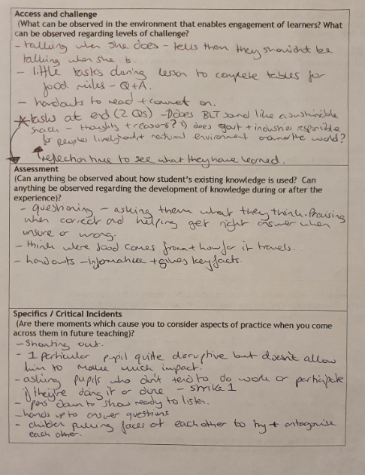

Critical Incident 2

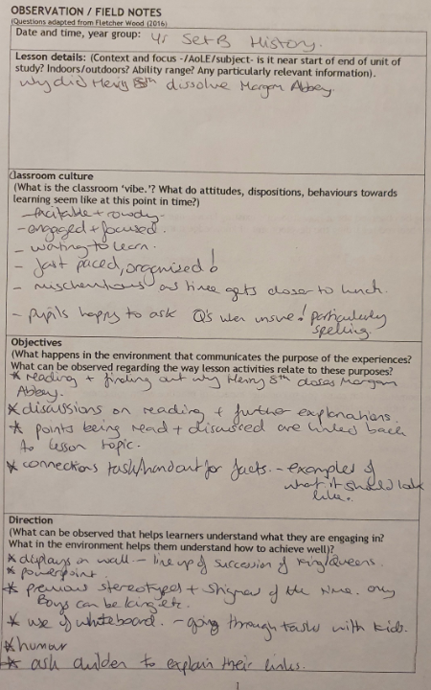

Critical Incident 3

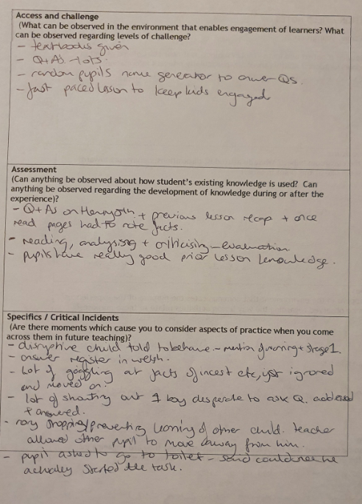

Critical Incident 3

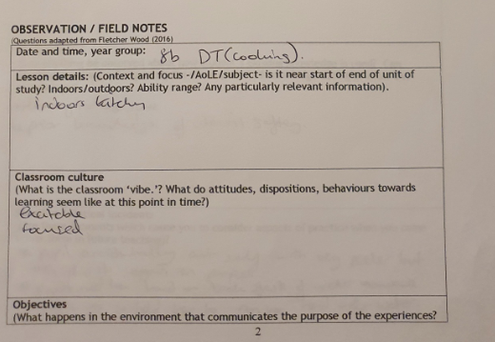

Critical Incident 4

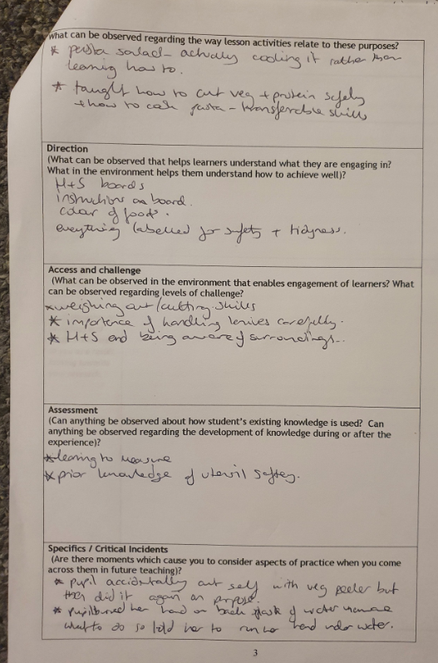

Critical Incident 4

