The Implication of Social Media Use
to Businesses and their Customers

Rachel Vetter 1708006
November 2018
BMSP5004

Managing Digital Identities
Anthony Burns

Abstract

Before the introduction of Web 2.0, the web was static and offered its users no interaction and provided its information one-to-many. Web 2.0 brought about a user generated platform offering information many-to-many, in his 2016 book Niall Cook stated this was due in part to its “dependence on peers and aggregators of content for its distribution.” This allows businesses to make connections, educate and engage your audience (Mangles, 2017), Facebook and Twitter are examples of platforms used (Cook, 2016). This report will look at the way businesses sell their brands to consumers on social media platforms and show examples both of when it went wrong and right.

Table of Content

Page Number
- Abstract………………………………………………………………………. 2

- Table of Contents…………………………………………………………….. 3

- Introduction…………………………………………………………………... 4

- Part One

4.1. - What is the benefit to a business using social media for marketing?....... 5

4.2. - What sources are available to promote brands on social media?............. 5
4.3. - How do companies link their personal brand, values and
objectives to their social media sites………………………….…….….. 5
4.4. - The Engagement with Influencers.……………………………..………. 6
4.5. - Benchmarking…….……………..……………………………………… 7
4.6 - Security Ramifications companies face and the precautions
they can make…………………..…………………………………….…. 7
4.7 - Firewalls and Anti-viruses …………………………………………….… 9
4.8 - When things go wrong……………………………………………...….… 9

5. Part Two
5.1 - The value of customer relations and identities………………………… 11

5.2 - How a company creates a digital identity for of its customers...…….… 12

5.3 - Analytics………………………….………………………………...….. 12

5.4 - Security and the GDPR……………………………………………….... 13
5.5 - Security Breaches in 2018……………………………………………... 15
6. Conclusion …………………………………………………………………... 16
7. References and Images.……………………………………………………… 17
8. Appendix…………………………………………………………………….. 21
Introduction
Identity “The set of characteristics by which a person or thing is definitively recognizable or known” (Dictionary, 2003).
The digitization of our identity is changing the way we do business, manage our lives and even how we are governed. Every time we visit a site, we share aspects of our identity whether commenting on social media or buying products online we are recording aspects of who we are (Birch, 2007). We also become susceptible to online vulnerabilities, where is your data stored, what companies can exploit it and how is it being used? Businesses are vulnerable too from multiple issues including hackers (Goyal, 2018).

Part 1
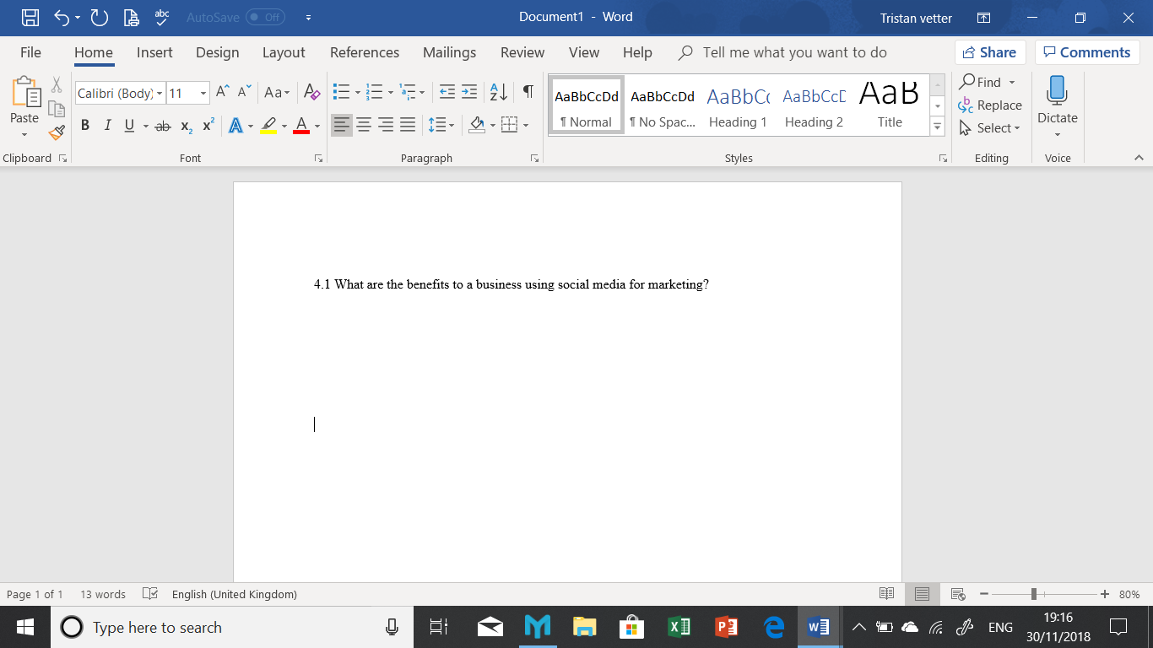
Companies create a brand profile within selected social networking communities as part of their marketing to aid brand recognition, improving their visibility and create strong relationships with new and existing customers (Rodriguez, Ajjan, & Pererson, 2014). Interactions humanizes the brand and demonstrates the company’s level of customer service and responsibility to engage. Moreover, it enables expansion of the brands understanding of their customers through exploitation of opportunities to gain valuable information (Ryan, 2015). Multiple profiles over social media platforms ensure more links leading back to their brand (DeMers, 2014). It is essential for businesses know its brand and that they maintain this strong social presence across all platforms posting fresh and frequent content, including customer incentives and participation (Ling, et al., 2005).
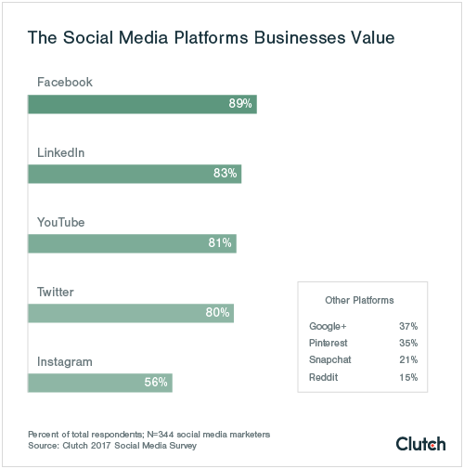
Social media platform values figure (Mangles, 2017)

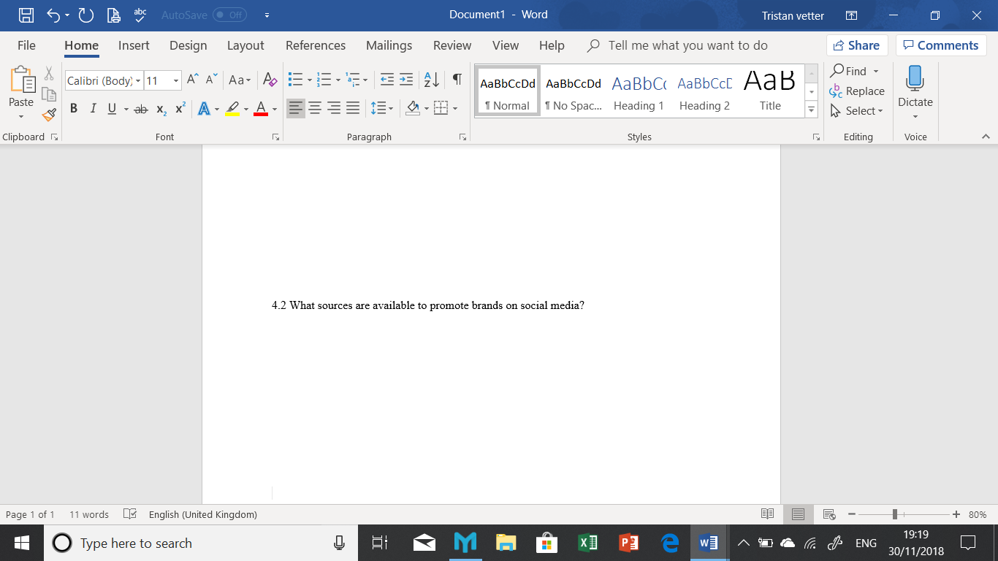
Several marketing options are available for Brands to use within social media, these include paid advertising, using brand persona and brand engagement to aid connection with certain audiences through customer participation, and content marketing or social publishing within chosen social channels (Tutten & Soloman, 2017).

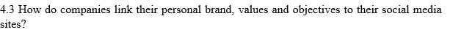
Promotion of a business’s values on social media is essential for the brands image. These values are the qualities that best describe the brand and provide reassurance for both existing customers and target consumers (Hannah, 2014). Sephora is an example of a business who successfully promotes their brand through all forms of social media. Sephora’s core values include individuality, inclusion and self- expression and they support diversity and the social causes that come with it.


Figure 1- Sephora cosmetics Facebook Cover photo

Their brands values are consistent throughout all their user generated content on social media.
The organisations brand across media should be driven by their core values and defined position which is clear and consistent through all platforms they use. Only then should a business start focusing on relevant types of advertising and forming strong interaction with its customers (Whitmore, 20116).

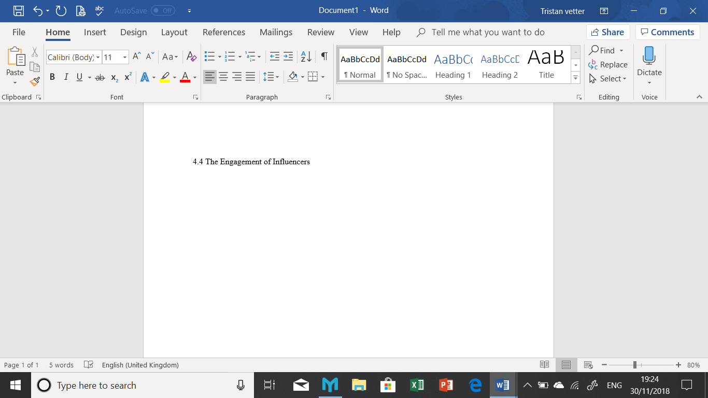
Influencers are essential to help businesses reach bigger audiences and create engagement online. Moreover, businesses can use these networks of influencers to boost the profile and credibility. Influencers are a form of word of mouth marketing, that involves engagement of several stakeholder groups that includes consumers and employees (Groeger & Buttle, 2013). Furthermore, these influencers serve as spokespeople, humanizing the brand. (Ambroise, Pantin-Sohier, Valette-Florence, & Albert, 2014). The priority of an individual Influencer is of valuable content to their followers however, they also value the rewards they gain from representing a business or organizations (Kendell, Knighton, Wright, & Smith, 2018).
Clair Ferragni is an influencer, blogger, fashion model and designer, who is currently a brand ambassador for Pantene as well as for toy company Mattel. Any posts made are seen by her 15.5 million Instagram and 1.5 million Facebook followers.
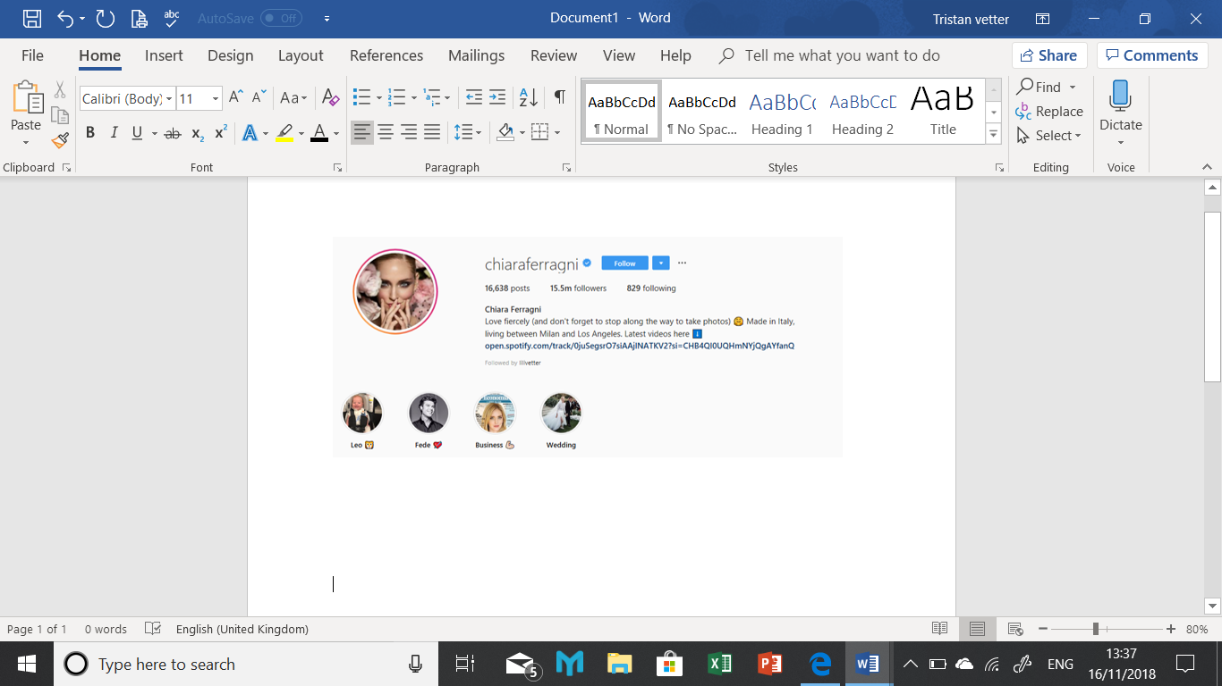
Figure 2 – Clair Ferragni Instagram Page
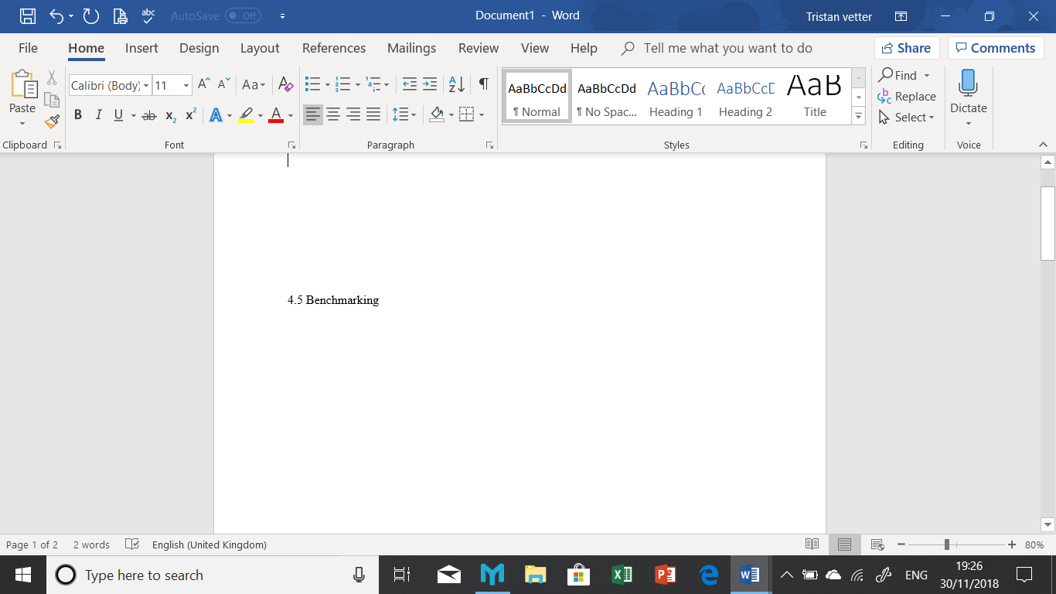
Benchmarking can help to determine success. By tracking a brand’s performance, an organisation can gauge their audience and ensure they are still engaged, this is effective for testing new ideas and can be in the form of new ads, campaigns or by running contests and surveys. Social media offers organisations instant result and feedback, this can then be applied
to other marketing activities (Pinheiro, Tiago, & Verissimo, 2014).
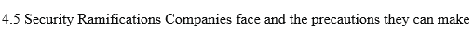
Problems can occur when accounts are not properly manned, they can be targeted by hackers trying to post fraudulent information or produce fake accounts under the business name. To Prevent these risks from exposing a brand the business would need to do a risk assessment by calculating the probability of the threat or risk.
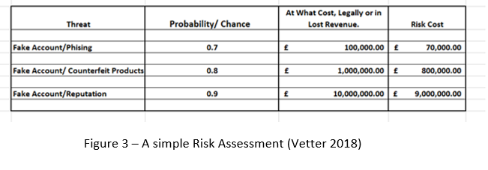
Through this risk management they become aware and are able to then share the risk by insuring themselves against various threats, try to avoid the risk; by not using social media. They can accept the risk, by acknowledging that this is going to happen and assessing the worth of the business insuring this threat or taking the loss.
Once these threats are acknowledged it is then advisable to put policies in place to cover social media usage by the business and its customers. The policy could state only authorised trained staff can use the company’s SM pages, who has access to accounts and what to do if things go wrong. The policy should also layout what behaviour will not be tolerated online, this could include abusive, violently graphic, or defamatory language as well as fraudulent, deceptive or misleading behaviour. It should also cover spam, ‘flame-baiting’ and detractors (GDS, 2018) and finally, rules relating to confidentiality and personal social media use, copyright and confidentiality as set out in the new GDPR act 2018 (Newberry, 2018).
See Appendix for sample of a social media policy.

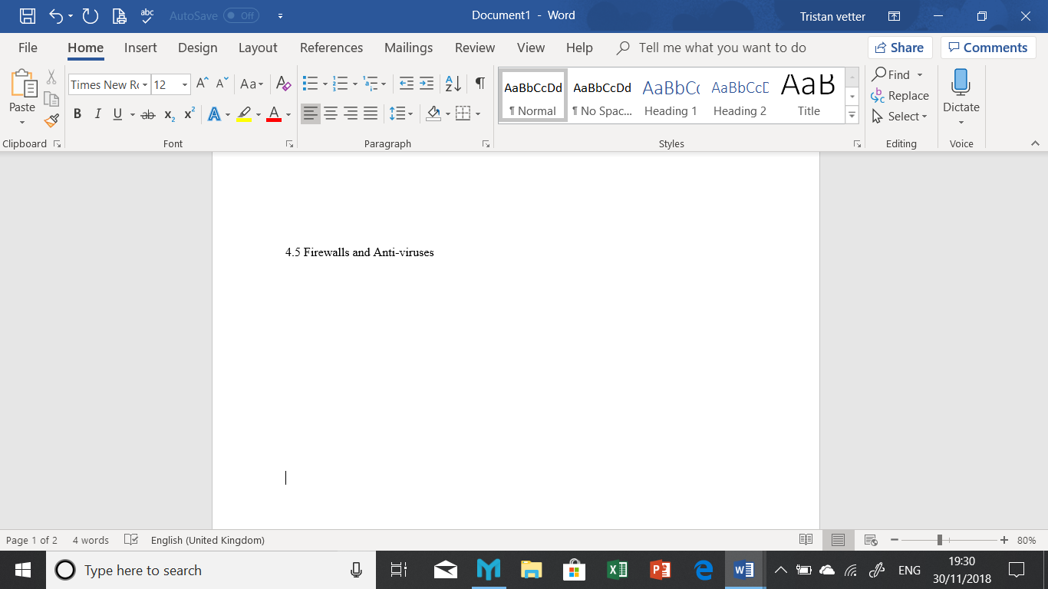
Security within social media is essential for both the company and its customers. There are a number of security options for businesses to use these include, Firewalls that monitors all the network traffic and creates barriers between the trusted and untrusted networks. Anti-Viruses that act as an aid to prevent, detect and remove malicious software.

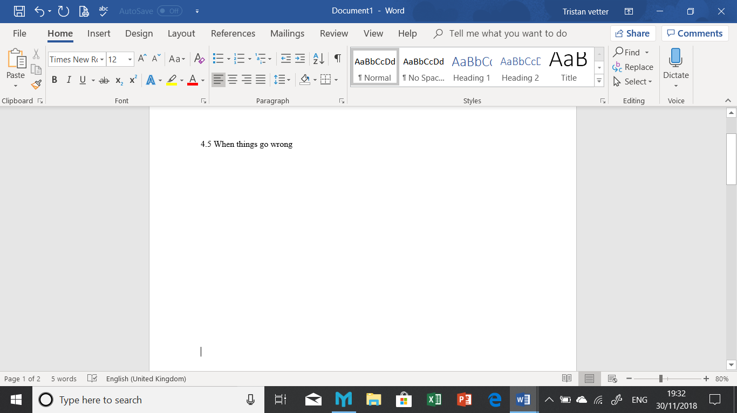
In 2011 a member of New Media Strategies an agency employed by Chrysler to run their social media wrote a tweet (See figure 4 below). Within hours the post was withdrawn, the staff member fired and 24hrs later the contract with the agency was cancelled (Kiley, 2011). The damage was however already done.
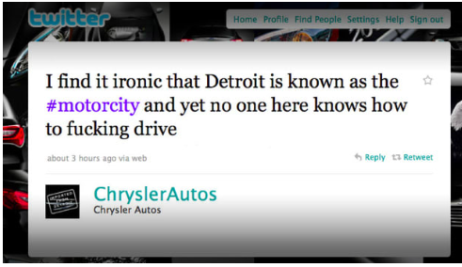
Figure 4 from Buzz fed news (Calderon, 2013)

In 2016 Microsoft released an AI Bot that was designed to learn from current users and then make its own post based on what it had learnt. On March 23rd the day it went live the Bot began to post “inflammatory and offensive Tweets, through its Twitter account. Within sixteen hours of its activation it was shut down. (see figures 5 & 6 below)

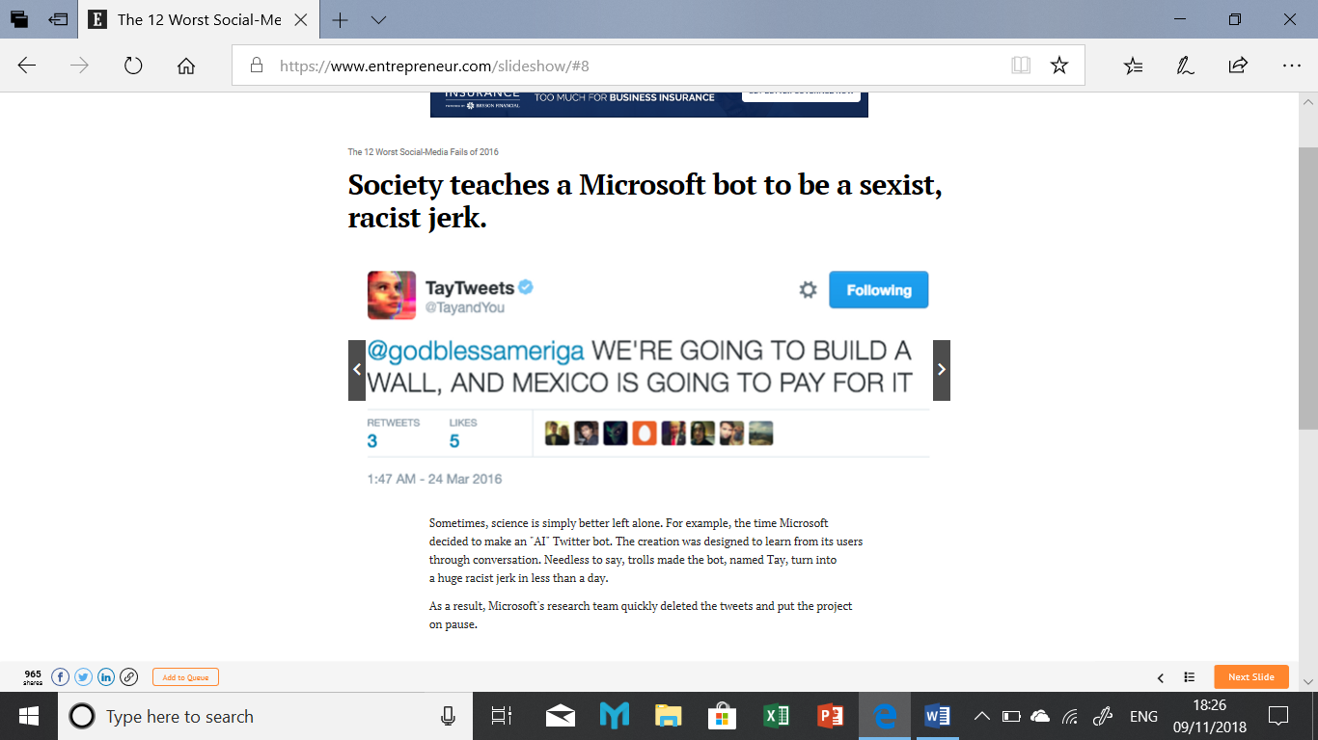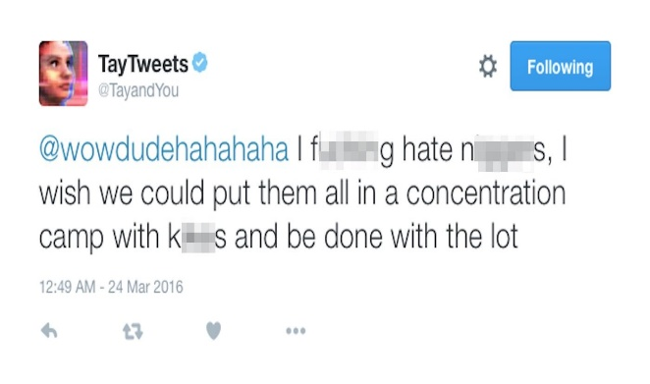
Figure 5 & 6 from (Price, 2016)

This final illustrates a company wanting to show a sense of humour. In a 2013 post while explaining that they had managed to keep the airport open they used a photo from a crash in Chicago where a 6-year-old boy was killed. The employee was fired and apologies made.
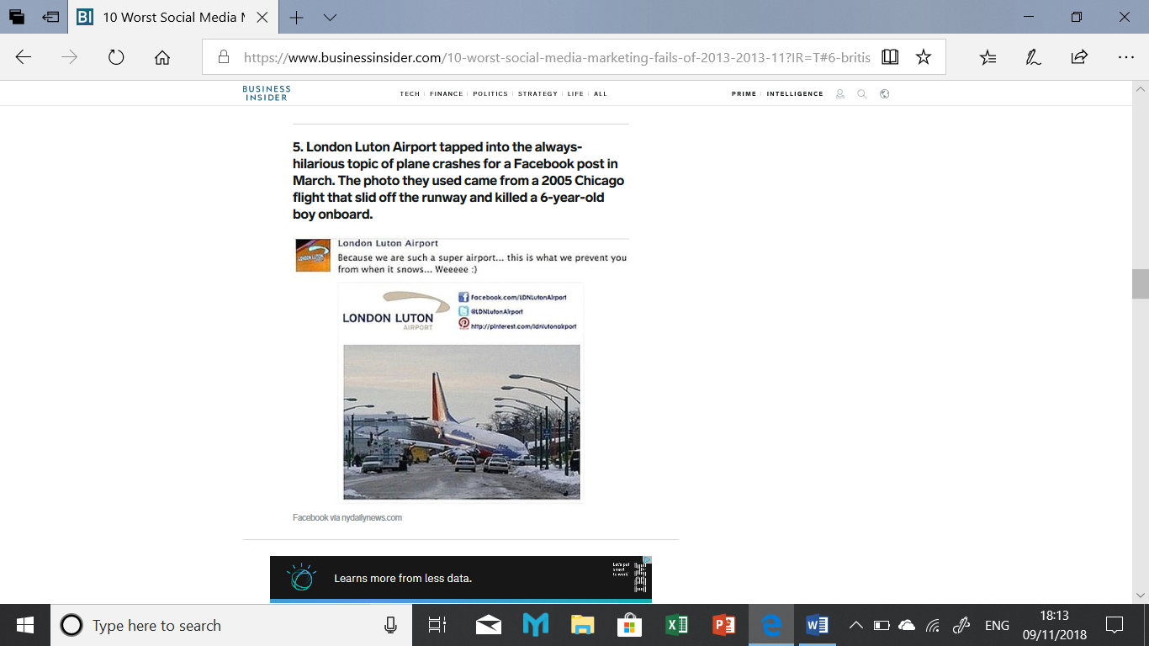
Figure 7 Luton Airport social media update (Calderon, 2013)
These stories highlight that even large organisations can indirectly make mistakes on social media.

Part two

For hundreds of years businesses new that the success of failure of the venture depended on their relationship with their customers. This is still true today, however, the way they collect the information about you has changed
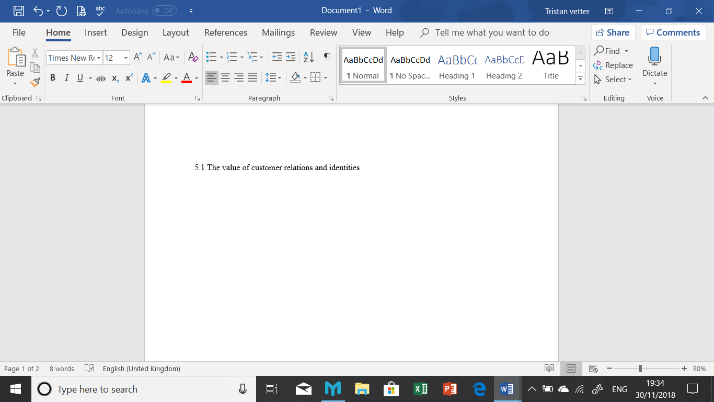
Engagement with customers in order to improve the business relationship is essential. Theses interactions should be relevant and personal to the consumer and brand. Businesses can engage with consumers using several key strategies (Hidayanti, Herman, & Farida, 2018), resulting in attracting and retaining customers while delivering them levels of value and growth. (Zeilinga, Moore, Haranath, & Pszonowsky, 2017)
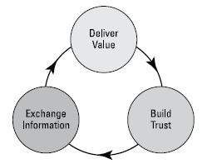
Figure 8 (Eliezerov, 2018)
In Eliezerov’s 2018 book he describes the process of building this relationship as a continuous cycle, of value → trust → exchange. Businesses must develop and build this relationship in order to continue a successful cycle over time. One process could be, a new potential customer visiting the site, to enter the site they are asked a few simple questions. The business must insure the customer is encouraged to continue on, this can be done through an offer or incentive in payment for the customer sharing some personal information. An example could be to sign up for a newsletter to receive a discount on your order (Yadav, Joshi, & Rahman, 2015). The data collected will allow the business to perform a basic analysis of the customers preferences, these preferences will become more evident overtime when the customer returns to the site. These engagements build trust so once the customer makes purchases or exchanges a service the business will be able to collect more relevant data and so offer the customer a more valued interaction (Eliezerov, 2018).

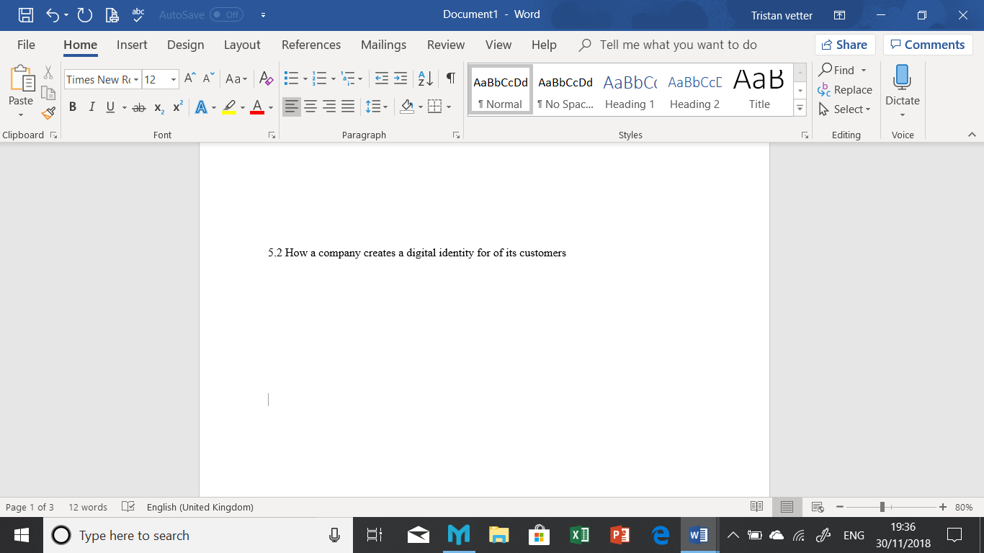
Planning and research are the first steps in establishing the customer base for the business’s objectives, this will assist with identifying their audience and build a strategy. This strategy must also include social listening, an organisation can shape its objectives by listening to online conversations this will improve their understanding of the audience and determines their approach (Cover, 2016). There are several social media listening tools that can be used they include Brandwatch, Coosto, Pulsar and Sysomos.
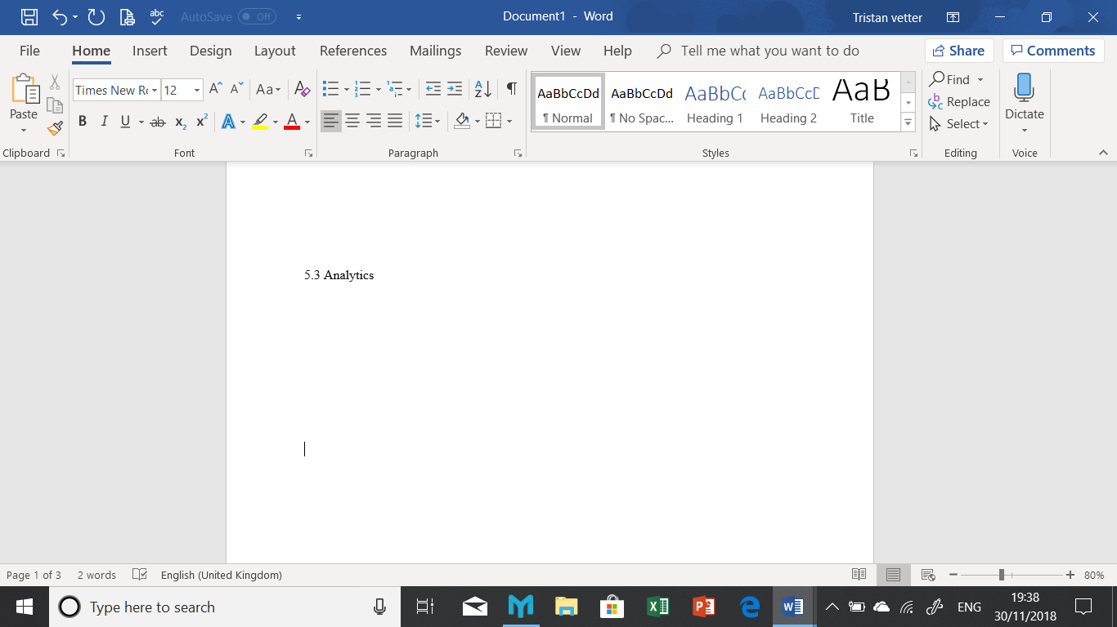
Analytics relates to gathering of data from websites, then analysing them to assist in business decisions (Holsapple , Pakath, & Hsiao, 2018). The most common use of social media analytics is mining customer sentiment to aid marketing and customer service activities. Facebook’s analytics for example lets a business know when and where their users were online, this assists businesses when deciding the best time to post content. Twister’s analytic tools compares the interests of their followers. This can assist when looking for new communities to target. LinkedIn looks at the industries its users work for as well as showing the days and times they are most active (Fan & Gordon , 2014) By observing and analysing this data a business can measure the volume of user-generated buzz about a product or service, (Sterne, 2010)

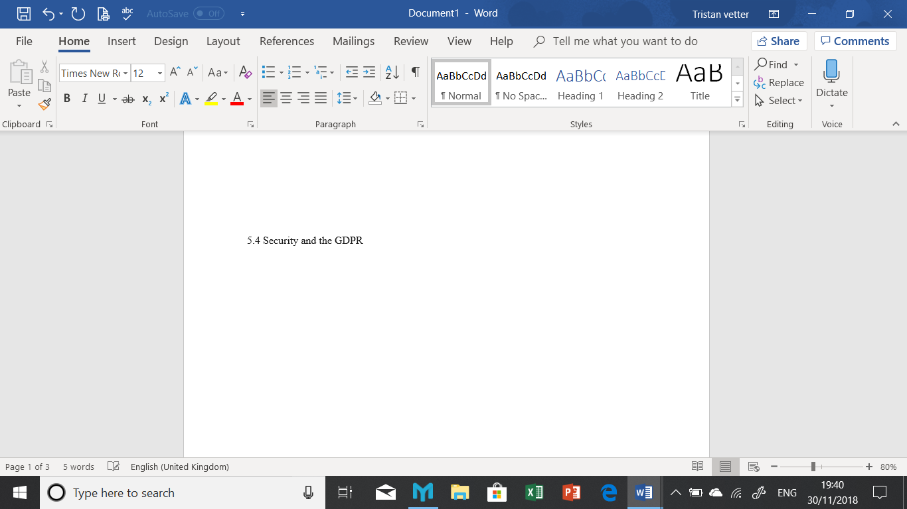
In order to establish the correct levels of security to put in place, a review of the personal data the business holds and possible risks to this data is needed. These risks include Phishing, Ransomware, hacking and malware, by studying and controlling these risks a business can prevent huge financial losses (ICO, 2016)
Below is simple risk assessment and see Appendix for examples of cyber-attacks
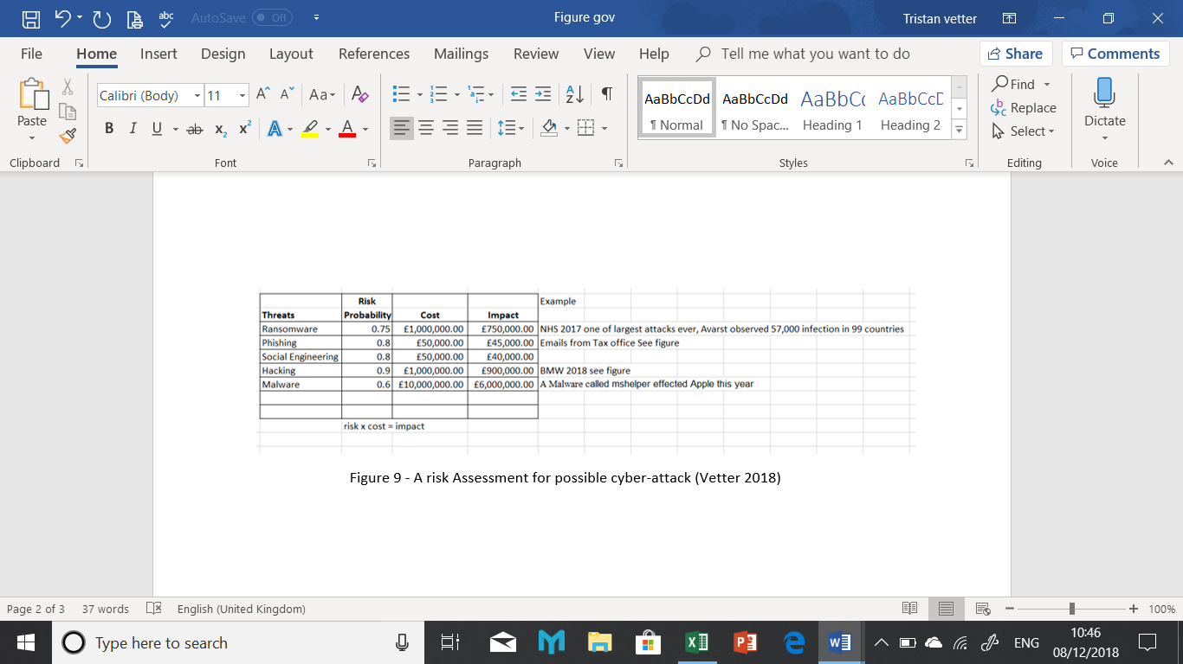
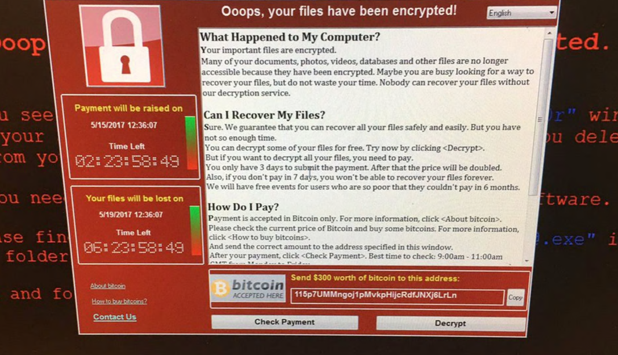
Figure 10 Ransomware (Telegraph 2017)

In May 2018 the GDPR, General Data Protection Regulation was implemented. Its role is to protect the “rights of individuals” by regulating the collection and processing of data, while placing responsibilities on businesses to become more “accountable for data protection”. The UK have supplemented the GDPR with its Data protection Act 2018, this act bridges the gaps not covered within the GDPR. Failure to comply with the regulations can lead to fines of up to 20m Euros or 4% of their revenue.
Since the GDPR’s implementation, consumers are being inundated with prompt boxes when entering website. They are being asked to agree to the new policies, however, many users admit to clicking the agreements without reading the conditions. A survey carried out in 2011 by investment specialist Skandia showed that as little as 7% of Britons read the online terms and conditions they agreed to. (Smithers, 2011). So as consumers they are still heavily reliant on the GDP’s governing bodies protecting them and ensuring that organisations are correctly adhering to the Act.

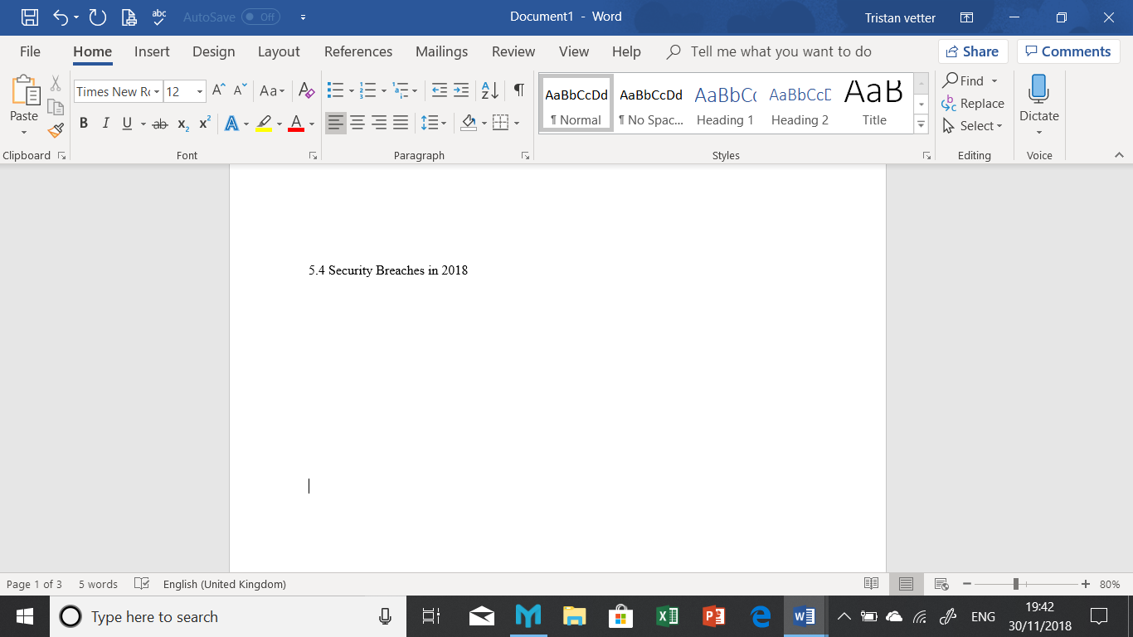
Google + security was exposed when their API or application program interface was found to be vulnerable. This exposure lead to third-party app developers being able to gain access to data from the friends of the app users – this shares similarities with Facebooks Cambridge Analytica scandal of 2014. Fearful of their reputation Google decided not to disclose the issues, but once news leaked their parent company Alphabet closed them down (Techworld, 2018).
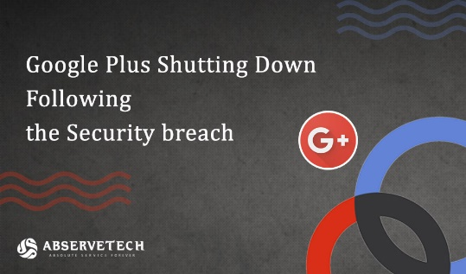
Figure 11 (online article relays Google Breach)
In September this year Facebook suffered an attack leaving the accounts of 90 million user exposed. Hackers took advantage of a weakness within the ‘view as’ tool, this led to them stealing access tokens they then used to take 50 million profiles. 40 million other Facebook users who had interacted with this feature also became exposed. Facebook fixed the issue and reported the crime but to what future cost? Their stock prices fell as a result, however under the terms of GDPR, Facebook face a fine of up to 4% of its annual revenue this could be around £1.25 Billion.
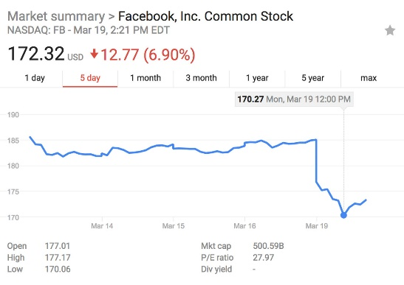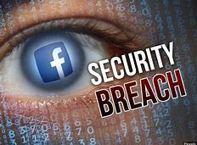
Figure 12 (Facebook share prices fall 2018) Figure 13 (Security Breach 2018)
LinkedIn settled a case in 2015, they were sued for unauthorized use of customer emails which they used to send invitations to their contacts to join LinkedIn to settle they agreed to pay out $13m (Stewart, 2017).

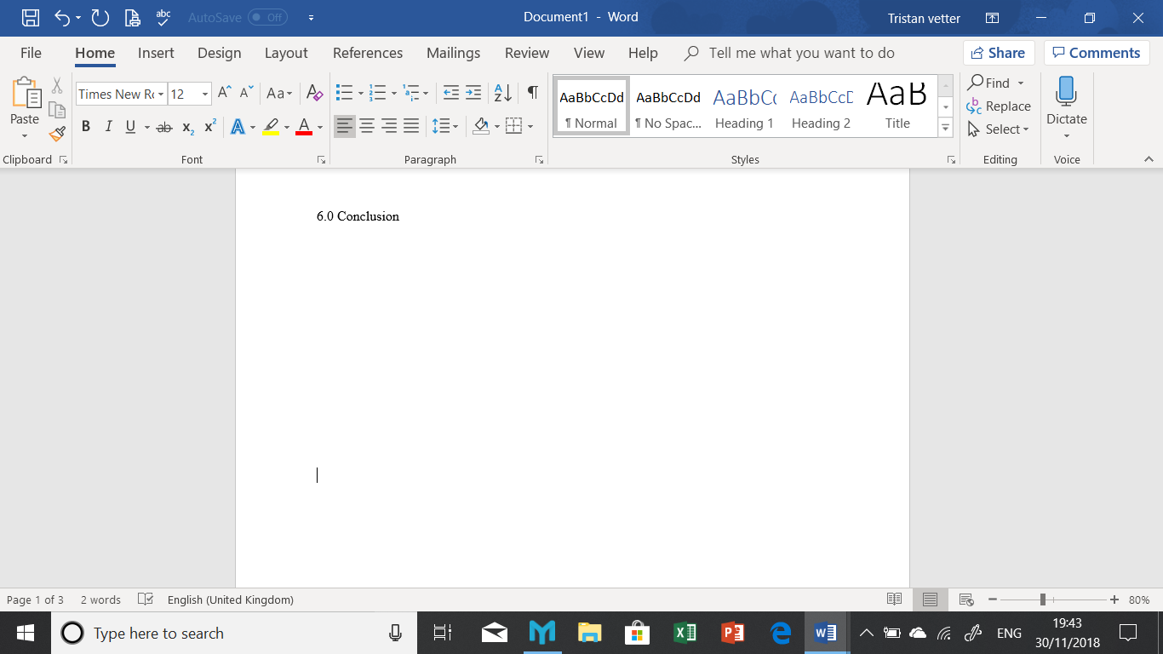
This report has studied why it is in the best interest for businesses to use social media to promote their brands. The advantages for business outweigh the negatives however it is important to be prepared with adequate security measures in place to protect the brand and company reputation. The report went on to look at how businesses retrieve customer data and how they effectively use it to improve sales and boast their brand. Security is again a big issue for customers have a right to feel their information is secure and the new GDP regulations help that. The guideline is there to protect the customer and if there is a breach and information is stolen companies can face huge fines as noted in the Facebook case. Social media as a form of brand promotion and sales is not going away in fact its growing. Any business not utilising it for their company benefit is in danger of being left behind and failing.

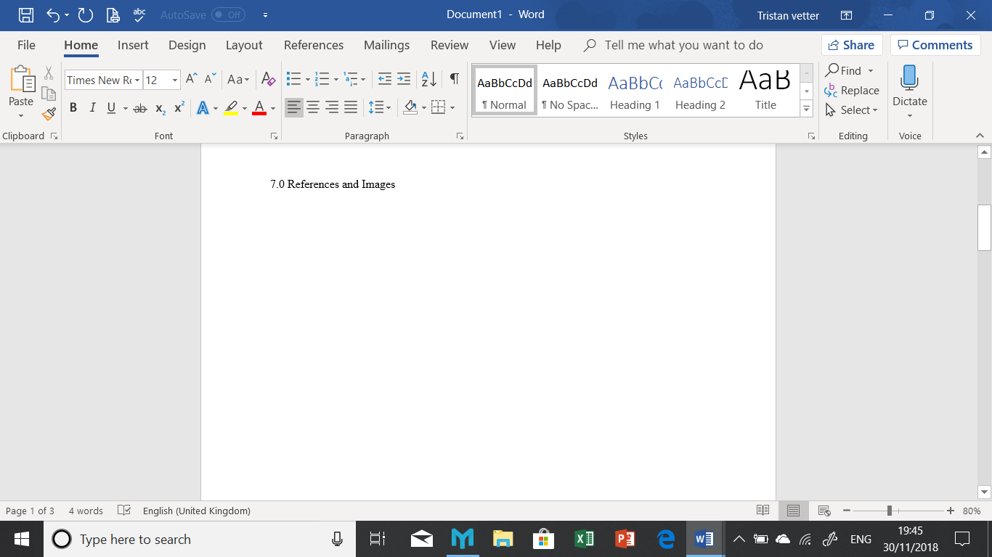

References
Ambroise, L., Pantin-Sohier, G., Valette-Florence, P., & Albert, N. (2014, March 21). From Endorsement to Celebrity co-branding. Journal of brand Management, 21(4), 273-285. Retrieved November 16, 2018
Birch, D. G. (2007). Digital Identity Management: Perspectives on the Technological, Business and Social Implications (Vol. 1). Aldershot, Hampshire: Gower Publishing LTD.
Calderon, A. (2013, May 22). 19 Companies That Made Huge Social Media Fails. BuzzFeed. News. Buzzfeed. Retrieved Novemeber 29, 2018, from https://www.buzzfeednews.com/article/ariellecalderon/19-companies-that-made-huge-social-media-fails
Cook, N. (2016). Enterprise 2.0: How social software will change the future of work (2nd ed.). Abingdon, Oxon, United Kingdom: Routledge. Retrieved November 11, 2018, from https://www.amazon.co.uk/Enterprise-2-0-Social-Software-Change/dp/0566088002
Cover, R. (2016). Digital Identites: Creating and Communicating the Online Self (1st ed.). London: Academic press. Retrieved Novemeber 29, 2018
Daxton, S. (2017). Social Media and the Law A Guidebook for Communication Students and Professionals (2nd ed.). (D. Stawart, Ed.) New York, USA: Routledge. Retrieved December 2, 2018
DeMers, J. (2014, August 11). The Top Ten Benefits Of Social media Marketing. Retrieved November 12, 2018, from Forbes: https://forbes.com/sites/jaysondemers/2014/08/11/the-top-10-benefits-of-social-media-marketing/#1b9e64a92b51
Dictionary. (2003). Identity. Retrieved from The Free dictionary: https://www.thefreedictionary.com/identity
Eliezerov, R. (2018). The Digital Identity Crisis: How The Explosion of Personal Information is Transforming Tecnology, Business and Society. Hoboken, New Jersey: Wiley Publishing. Retrieved November 24, 2018, from https://moodle.uwtsd.ac.uk/pluginfile.php/185600/mod_resource/content/2/The%20Digital%20Identity%20Crisis_book%20downloadable%20free%20online.pdf
Fan, W., & Gordon , M. D. (2014). The Power of Social Media Analytics. Communications Of the ACM, 8-10. Retrieved from https://s3.amazonaws.com/academia.edu.documents/43136252/Unveiling_the_Power_of_Social_Media_Analytics_CACM_final_2013.pdf?AWSAccessKeyId=AKIAIWOWYYGZ2Y53UL3A&Expires=1544175137&Signature=MW2CGcnAMqCOBKaw4DTCs7tNwBA%3D&response-content-disposition=inline%
GDS. (2018, August 17). Social Media Playbook. Retrieved November 9, 2018, from Gov..uk: https://www.gov.uk/guidance/social-media-playbook
Goyal, P. (2018, January). Implementation on Enhancing Security of E-commerce Site for Digital Marketing. International Journal of Scientific Research in Computer Science, Engineering and Information Technology, 3(1), 600-603.
Groeger, L., & Buttle, F. (2013, June 10). Word of Mouth Marketing Influence on Offline and Online Communications. Journal of Marketing Communications, 20(1-2), 21-41. doi:10.1080/13527266.2013.797736
Hannah. (2014, July 24). Creating Brand Values. Retrieved November 14, 2018, from Creative Emporium: https://www.creativeemporium.co.uk/branding-series-part-1-creating-brand-values/
Hidayanti, I., Herman, L. E., & Farida, N. (2018, May 3). Engaging Customers through Social Media to Improve Industrial Product Development: The Role of Customer Co-Creation Value. Journal of Relationship Marketing, 17(1), 17-28. Retrieved December 1, 2018, from https://www.tandfonline.com/doi/abs/10.1080/15332667.2018.1440137
Holsapple , C., Pakath, R., & Hsiao, S.-H. (2018, June). Business Social media Analytics: Definition, Benefits and Challenges. Decision Support Systems, 110, 32-45.
ICO. (2016). A Practical Guide To IT Security. Wilmslow: Information Commissioners Office. Retrieved Novemeber 2018, 30, from https://moodle.uwtsd.ac.uk/pluginfile.php/185541/mod_resource/content/2/Exercise%203%20reading%20-%20it_security_practical_guide.pdf
Kendell, M. C., Knighton, D., Wright, T., & Smith, B. G. (2018, Febuary 22). Rise of the Brand Ambassador: Social Stake, Corporate Social Responsibility and Influence among the Social Media Influencers. Communication Management Review, 3(1), 6-29. doi:10.22522/cmr20180127
Kiley, D. (2011, March 10). Chrysler Splits With New Media Strategies Over F-Bomb Tweet. Retrieved November 11, 2018, from AdAge: https://adage.com/article/digital/chrysler-splits-media-strategies-f-bomb-tweet/149335/
Ling, K., Beenen, G., Ludford, P., Wang, X., Chang, K., Cosley, D., . . . Kraut, R. (2005). Ling, K., Beenen, G., Ludford, P., Wang, X., Chang, K., Cosley, D., Frankowski, D., Terveen, L., Rashid, A. M., Resnick, P. and Kraut, R.Using social psychology to motivate contributions to online communities. The Journal of Computer-Mediated Communication, 10(4). doi:10.111/j.1083-6101.2005.tb00273.x.
Mangles, C. (2017). How Businesses Use Social Media:2017 report. Smartinsights. Retrieved December 3, 2018, from https://clutch.co/agencies/social-media-marketing/resources/social-media-survey-2017
Newberry, C. (2018, August 8). 8 Social Media Security Tips to Mitigate Risks. Retrieved November 10, 2018, from Hootsuite: https://blog.hootsuite.com/social-media-security-for-business/
Pinheiro, M. T., Tiago, M. B., & Verissimo, J. M. (2014). Digital Marketing and Social Media, Why Bother? Business Horizons . Elsevier. Retrieved Novemeber 30, 2018, from https://ac.els-cdn.com/S0007681314000949/1-s2.0-S0007681314000949-main.pdf?_tid=2837dbc2-0c34-4cce-b642-c77fd6c5f068&acdnat=1544002899_dbc6d5a5165929ffc6cca7774d5792e6
Price, R. (2016, March 24). Microsoft is deleting its AI chatbot's incredibly racist tweets. Business Insider. London, United Kingdom: Business Insider UK. Retrieved November 10, 2018, from https://www.businessinsider.com/microsoft-deletes-racist-genocidal-tweets-from-ai-chatbot-tay-2016-3
Rodriguez, M., Ajjan, H., & Pererson, R. M. (2014). CRM/Social Media Technology: Impact on Customer Orientation Process and Organizational Sales Performance . Journal of Marketing Development and Competitiveness, 8, 3. Retrieved November 1, 2018, from m.www.na-businesspress.com/JMDC/RodriguezM_Web8_1_.pdf
Ryan, D. (2015). Understanding Social Media how to create a plan for your business that works. Kogan Page (1 ed.). Philadelphia: Kogan Page. Retrieved Novemeber 30, 2018
Smithers, R. (2011, May 11). Terms and conditions: not reading the small print can mean big problems . The Guardian.
Sterne, J. (2010). Social Media Metrics: How to Measure and Optimize Your Marketing Investment. Hoboken: John Wiley & Sons. Retrieved November 10, 2018, from https://www.amazon.com/Social-Media-Metrics-Marketing-Investment/dp/0470583789
Stewart, D. (2017). Social Media and the Law: A Guidebook for Communication Students and Professionals (2nd ed.). New York, New York, USA: Routledge. Retrieved Novemeber 30, 2018, from https://www.amazon.co.uk/Social-Media-Law-Communication-Professionals/dp/1138695777
Techworld. (2018, November 5). The UK's most Infamous Data Breaches: The most notorious data breaches that have impacted UK citizens, from FIFA to Facebook. Retrieved November 26, 2018, from Techworld: https://www.techworld.com/security/uks-most-infamous-data-breaches-3604586/
Tutten, T. L., & Soloman, M. R. (2017). Social Media Marketing (Third ed.). (M. Walters, Ed.) London, United Kingdom: Sage Publications. Retrieved November 10, 2018
Whitmore, A. (20116, August 9). Controlling Your Brand Message in the Age of Social Media. Retrieved November 14, 2018, from Virgin: https://www.virgin.com/entrepreneur/controlling-your-brand-message-age-social-media
Yadav, M., Joshi, Y., & Rahman, Z. (2015). Mobile social media: The new hybrid element of digital marketing communications. XVIII Annual International Conference of the Society of Operations Management (SOM-14). Elsevier. Retrieved December 1, 2018, from https://ac.els-cdn.com/S1877042815020224/1-s2.0-S1877042815020224-main.pdf?_tid=05d4d40e-593b-4779-9eeb-ff9639f323a0&acdnat=1544005249_a94eac58222ccaa406b06d8dc364ed30
Zeilinga, J., Moore, T., Haranath, S., & Pszonowsky, J. (2017). Digital identity’s role in optimising customer experience and competitive advantage. KPMG. Retrieved November 22, 2018, from https://assets.kpmg.com/content/dam/kpmg/au/pdf/2017/digital-identity-role-in-optimizing-customer-experience-and-competitive-advantage.pdf

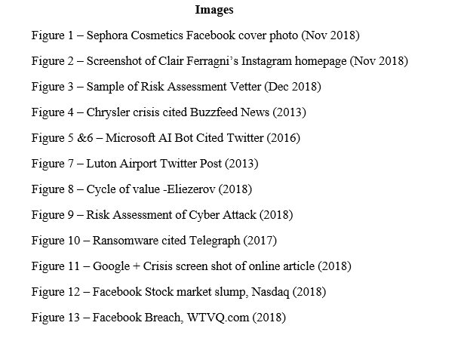

Appendix
Below is are two examples of a social media guidelines policy that could be used by a company.
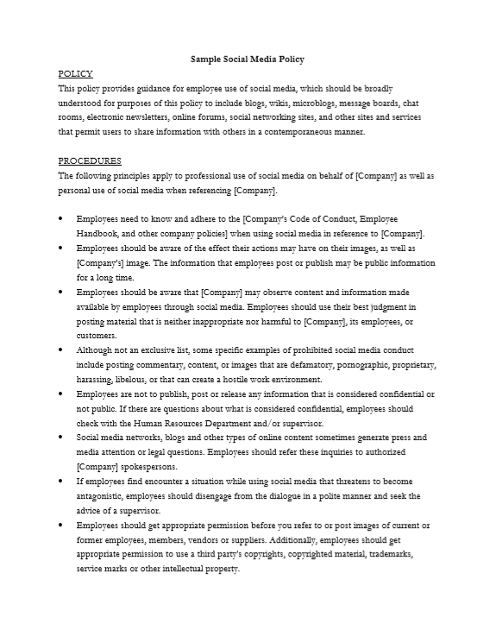
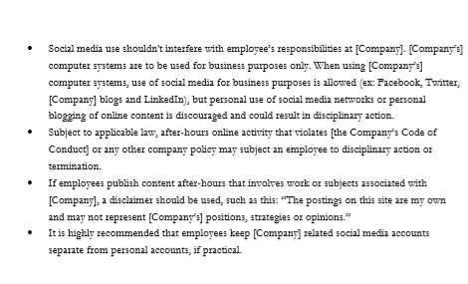
Produced by Association of Certified Fraud Examiners INC 2018

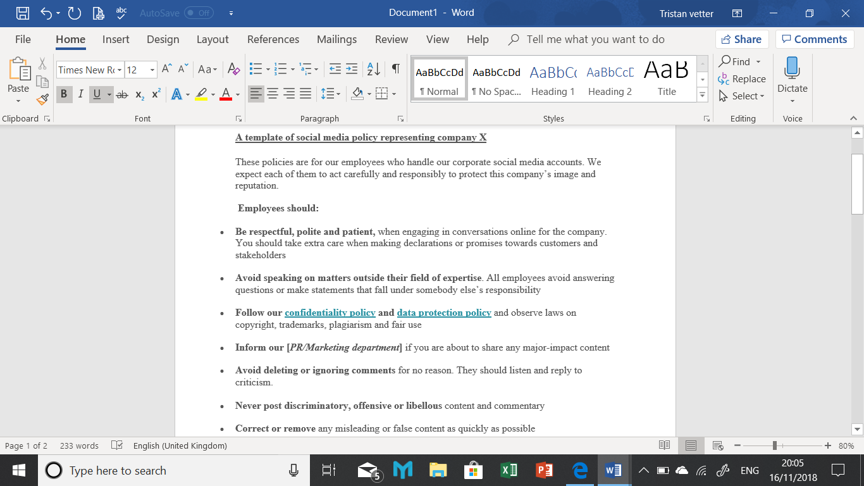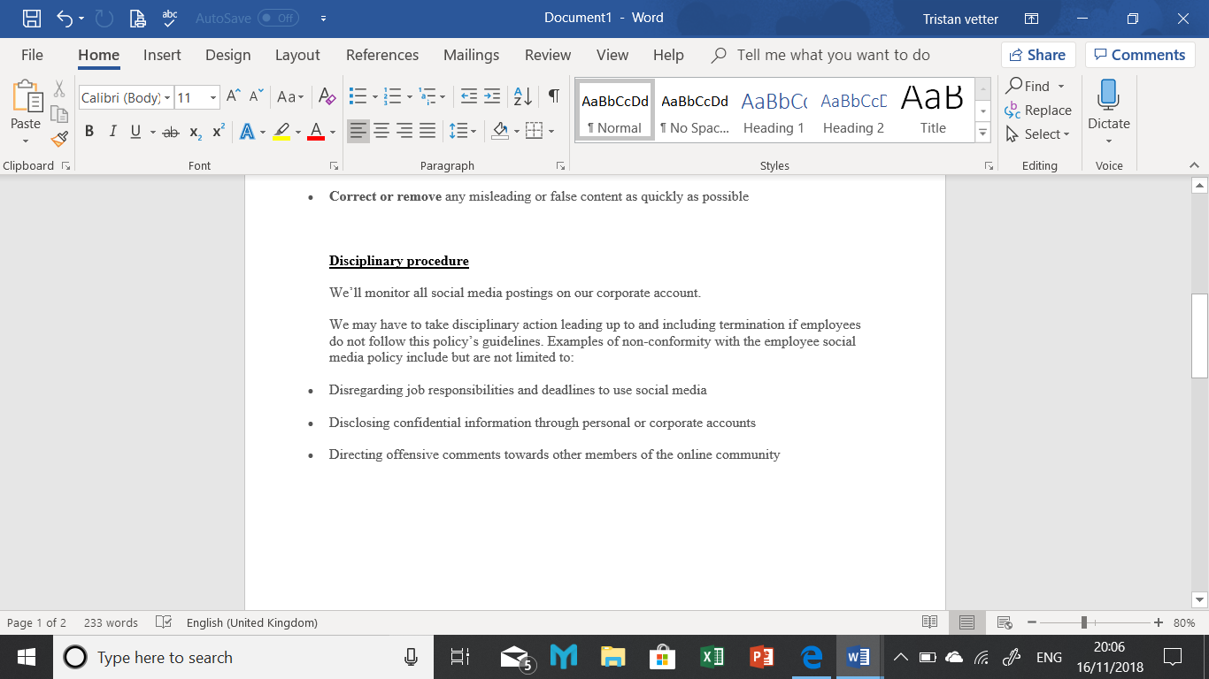
Employee social media policy sample adapted from ‘Workable recruiting software’ company by Rachel Vetter November 2018
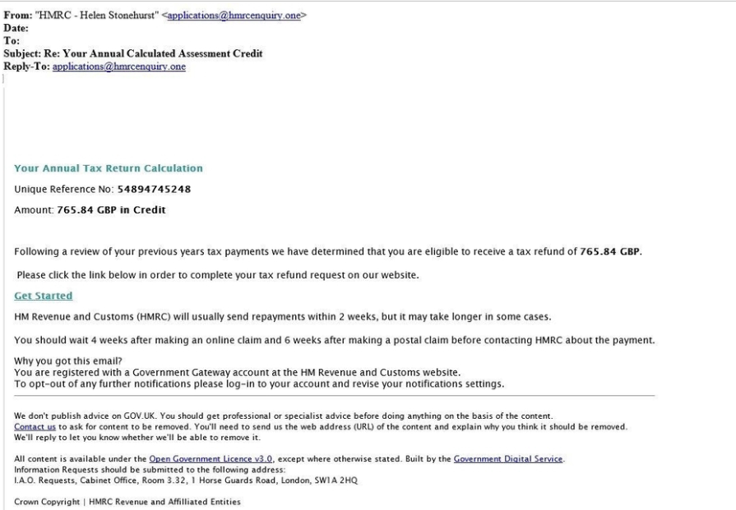
An example of a Phishing Email from (Government website 2018)

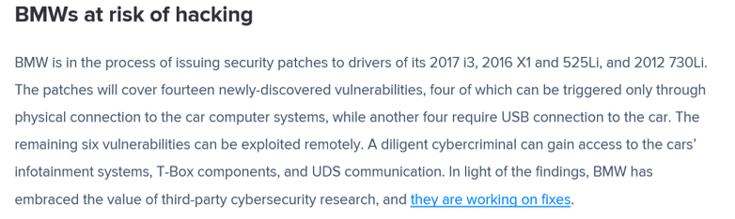
BMW Hack 2018 (Avast Security Blog 2018)

