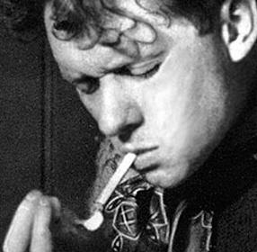
University of Wales Trinity Saint David
BSc (Hons) Architecture
Session 2016/17 - Year 1 (Level 4)
Architecture Studio 1A (Design Skills)
Module Code – M4X01969 (20 Credits)
A Room for Dylan

“It can be very important for the presenter of works of art to have a critical appreciation of them, because presentation can be a form of interpretation, of drawing attention to collocation – to the advantage of the works, naturally, not to the advantage of the presentation itself.” Carlo Scarpa

Introduction
The poet Dylan Thomas is widely regarded as Swansea’s most famous son.
He was born on October 27^{th,} 1914, in Uplands Swansea and died on November 9th, 1953, in New York.
Between 1925 and 1931 he attended Swansea Grammar School for Boys, part of which still occupies a prominent location on the Trinity Saint David’s Mount Pleasant Campus. He was Welshman who wrote exclusively in English. During his short life time he wrote, what are widely regarded, as some of the finest poems ever written in the English language. His poems engaged with the themes of a fondly remembered childhood, the cycle of life, death and renewal.
Ceri Richards was born in Dunvant, near Swansea, in 1903. He studied at Swansea School of Art, before winning a scholarship to the Royal College of Art, London. He is represented in many museums worldwide, and the Tate Gallery has a collection of over 90 of his works. Following the death of Dylan Thomas he created a number of drawings based on, or inspired by, Thomas’ poems.

This project involves the display of a bust of Dylan Thomas by Oloff de Wett, who was a member of Dylan Thomas`s social circle, six of Ceri Richards art works and six of Dylan Thomas’ poems. Images for the works of art and one of the poems are printed at the end of this programme. The other poems are readily available on-line.

The location is the studio space in which you will be based for the first year of this course.

Aims
The aim of the project is to produce proposals to transform an existing interior space. You start with a fairly utilitarian studio space – the aim is to propose a design which exhibits the objects referred to above. A distinct room for Dylan.

The project will introduce you to the basic skills of the architect – measuring, recording information on the existing fabric of part of a building, hand drawing, model making. It will also ground you in the conventions of architectural representation – the production of plans, sections, elevations and 3D drawings.

Objective
In the first instance you will make a measured drawing of the existing studio. This will entail drawing plans, sections and elevations of the existing studio along with making a 1:50 model of the space.

You will then produce a design to exhibit the artworks and poems. You can propose any modifications of the existing space in order to generate your proposal. Your design may involve the design of display screens or supports. The proposed exhibition can be an installation within the room (occupying only part of the space), or alternatively may be arranged to change the spatial quality of the room. It may even combine both.

Your proposals should be presented on plans sections and elevations along with a model (utilising the model of the existing space referred to above). If you wish you can supplement these key drawings with perspective drawings, collage, photoshop or any other media you wish. The material presented should both delineate clearly the spatial strategy and evoke the atmosphere of the room being created.

The object of this studio programme is to build basic skills in drawing and model making along with producing a design within an existing space.

Assessment will be based on both the quality of the drawings/models produced and the quality of the design.

Pu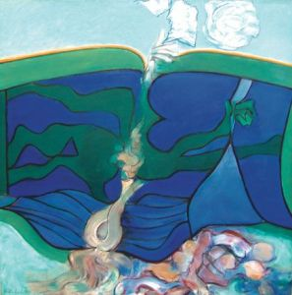blish for Free

The Force That Through The Green Fuse Drives The Flower 1270 x 1270 Oil on Canvas

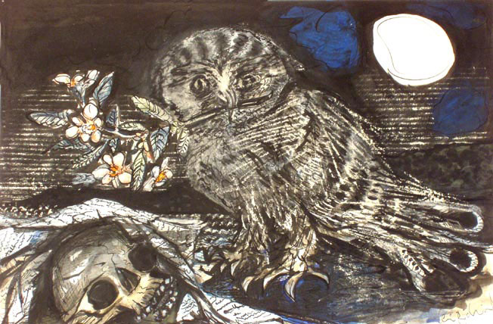
And death shall have no dominion 380 x 560 Mixed Media
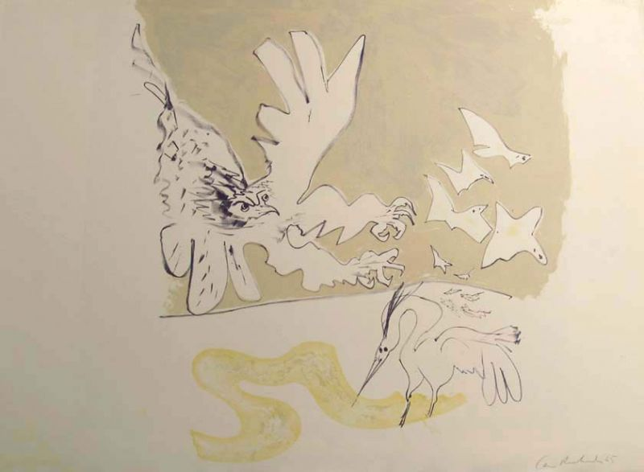
Over Sir John’s Hill 586 x 810 Lithograph
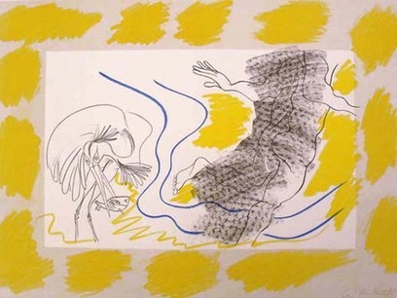
Poem on His Birthday 580 x 810 Lithograph
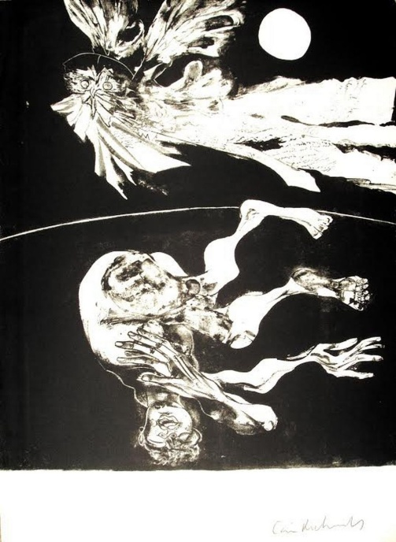
Do Not Go Gentle Into That Good Night 692x595 - Lithograph
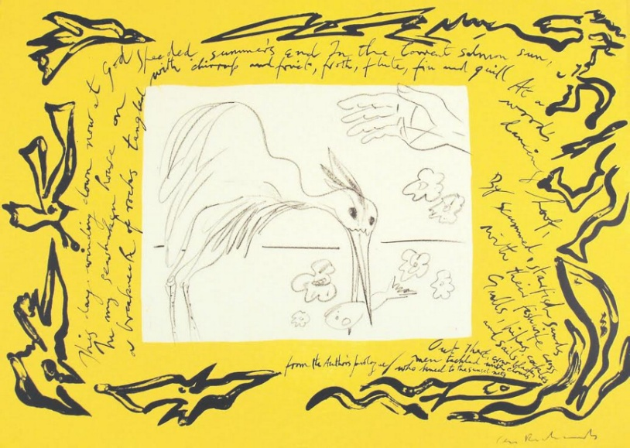
The Authors Prologue 580x810 Lithograph

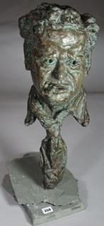
HUGH OLOFF de WET bronze cast bust of Dylan Thomas smoking a cigarette, raised upon his neckerchief,660 x 310mm

The force that through the green fuse drives the flower’ (1934)

Dylan Thomas

The force that through the green fuse drives the flower
Drives my green age; that blasts the roots of trees
Is my destroyer.
And I am dumb to tell the crooked rose
My youth is bent by the same wintry fever.

The force that drives the water through the rocks
Drives my red blood; that dries the mouthing streams
Turns mine to wax.
And I am dumb to mouth unto my veins
How at the mountain spring the same mouth sucks.

The hand that whirls the water in the pool
Stirs the quicksand; that ropes the blowing wind
Hauls my shroud sail.
And I am dumb to tell the hanging man
How of my clay is made the hangman’s lime.

The lips of time leech to the fountain head;
Love drips and gathers, but the fallen blood
Shall calm her sores.
And I am dumb to tell a weather’s wind
How time has ticked a heaven round the stars.
And I am dumb to tell the lover’s tomb
How at my sheet goes the same crooked worm.

Reading

Ching, F. 2009 Architectural Graphics. Hoboken NJ. Wiley
Zell, M. 2010 The Architectural Drawing Course. Thames and Hudson
McCarter, R. 2013 Carlo Scarpa. Phaidon – Chapter 3 – ‘Beauty, Art, Wonder”

