How digital technologies and social media platforms have influenced contemporary designers in a new digital age.

Hannah Beniamous
(P146486)

Surface Pattern Design: Textiles for Interiors

Supervisor: Ainsley Hillard
Module code: M6X01791
Word count: 6256

TABLE OF CONTENTS

List of illustrations: 3

Introduction: 4-6
Chapter One: 7-19

Chapter Two: 20-26

Conclusion: 27-29

Bibliography: 30-32

List of illustrations

Figure 1 & 2:

Ani O’Neill, The Buddy System, 2006.

Figure 3 & 4:

Re-form Studios: Goteborg, Interactive Cushion, 2003.

Figure 5 & 6:

SymbiosisO Voxel, Interactive Textiles, 2012.

INTRODUCTION

This dissertation aims to discuss the impact that digital technology has had on textile design in the 21st century and considers how contemporary designers have found new ways to respond to the importance of physical interactions. Designers today now have access to many digital outcomes such as, digitally printing fabric and laser engraving and alongside these new processes social media platforms like Facebook and Instagram have helped to facilitate the communication, promotion and marketing of their practices that help towards productive results. Arguably this can lead to many positive outcomes in design as it enables contemporary designers to integrate modern processes that can achieve unique results that hand rendered and traditional textiles cannot.

However, it is this accessibility to technology that designers are challenged by that may not allow them to fully appreciate the physical connections that are made when face to face interactions between designers and audiences occur. It is the engagement with processes, materials that tacit knowledge can only be achieved through experience itself. The reaction to these problems has led designers to actively respond and resolve these issues of distance and work towards finding new ways to engage and experience touch throughout the new generation we now live in.

Chapter One, will explore the intimate connections individuals may have through touch that have been shadowed by the continual growth technology has provided in textile design.
The motivation behind this essay has come from not only examining technology as a whole but looking at my own practices as an emerging designer and the growing awareness from the generation we now live in. As a keen social media and technology user, it is a factor that has now become something I find very hard to live without, which in reality, is a concern. The works of Shillito (2013), and Young (2012) explore how the extreme advances new technology now offer have become necessities in today’s society and how individuals have become conscious of how they are perceived. It’s this conscious behaviour that questions the influence of technology and social media and the negative impact it may have on a designers creative thinking. Social media has led designers to over-analyse their individual identities. As well as this unpicking what Donna Freitas (2017) explores about the impact of social media and how important it is in individual’s daily routines, I can unravel how this plays a role in the overall health and wellbeing of individuals

Undoubtedly physical interactions in textile design hold a vital importance that is needed when experiencing different materials and processes. Engaging with tactile materials proposes new properties through feel and touch, the weight, drape and surface texture is all experienced when physically manipulating the fabric. It is the result of contemporary designers predominantly using digital techniques that has led to the overall dematerialisation of tactile qualities.

Referring to Handley (1999), she suggests the idea that design is now becoming disembodied in our new digital age due to the influence of new technology. Thus, by investigating Ani O’Neill it expresses how designers have found new ways to integrate the importance of physical interactions into their own designs and installations. Approaching work in this way designers are able to avoid becoming passive users and instead actively respond. It creates a human engagement that explores the idea of ‘open work’. This idea is further supported by Bourriaud’s (1998) theory on relational aesthetics and the importance of engagements between artist or designers and the audience.

Even though there may be a concern of individuals becoming passive to technology contemporary designers have been able to adapt and find new ways of staying in control of their own design practices. By exploring the work of Elizabeth Emery (2017) she suggests how emerging feminist textile artists now work in a way that is completely digital in order to spread their messages in their work across a wider audience.

Chapter two aims to discuss the progression of new contemporary designers and show how they have worked to new outcomes that explores ideas of using technology alongside the traditional textiles. Designers such as, Re-form studio and SymbiosisO: voxel have created interactive textile installations that work alongside both the physical and virtual stimulations. The idea of linking traditional methods of textiles with new technology that also connects with the installation allows people to feel emotions through physically connecting. So, by crafting these new technological textile ideas in this way can respond to how designers are now more able to move forward in innovative ways to adapt their work to our new generation.

CHAPTER ONE

Virtual as a definition is seen to be almost or nearly as described, but not completely. Not physically existing as such but made by software to appear to do so.

“We are, it seems, crossing the final technological frontier, where designers will be able to navigate a whimsical journey through the immaterial realities of our digitally disembodied age” (Handley, 1999. In Braddock-Clarke, 2012, page 16)

Handley (1999) suggests that there is no sense of true existence in today’s digital age, she explains that designers have now been led to outcomes where they are left little or no choice but to encounter technology in order to produce something creative. This idea of individuals navigating themselves on a ‘whimsical’ journey can ultimately start to question if the outcomes that are produced in digital technologies are now becoming unpredictable, if these journeys are expressed to be curious and unknown it could affect the overall outcome. Handley (1999) is perhaps suggesting that the physical occurrences have become hard to distinguish in our new digital age. As a definition, whimsical is known as being unusual, playful and unpredictable, rather than a serious or practical response. This in itself shows how these journeys that Handley (1999) talks about express themselves in a manner that is very different to the normal, they are now being led by innovative technology in different directions that enable individuals to create their own unique pathways in design and textiles.

The ‘immaterial realities’ that Handley (1999) suggests, is possibly referring to the lack of face to face interaction and emotional engagement between the designer, the products and the audience. She emphasises the impact that designers face between the physical and non-physical realms that ‘reality’ virtual and/or digital technology may have on the impact on their experience, it argues the idea of being in touch but only being virtually allowed to exist. Reiko Sudo, creative director at Nuno textiles emphasises that,

“Textiles are not just a pleasure to look at, they are to be experienced with all five senses—the feel of textiles in the hand or on the body, the periodic rustling sounds, even their taste on the lips.” (Sudo, 2005. Sourced from https://www.jessicahemmings.com/2121-reiko-sudo-nuno/ Date accessed 8/12/17)

It explores the idea that textiles are meant to be experienced physically and even though she may integrate technology through her work Sudo continuously emphasises how important it is to communicate in this way. This leads to question how individuals could approach the idea that may begin to avoid the engagement of traditional processes and making as technology has been allowed to engross individuals into nothing other than forms of digital design. Handley (1999) suggests, as a result of this individuals are now becoming ‘...digitally disembodied', If something is ‘disembodied’ it is being separated from or not existing within the body, it is removed from the physical connection, which goes back to the notion that technology is now being used without any real understanding of the impact on human thinking and creativity itself.
Artists and designers are heavily dependent on digital communications and processes for their everyday life, it has now become something that is automatically integrated into the way they work. The demand that social media and technology now have on individuals has had a growing impact on textile design, the dominance from technology and platforms like Instagram enables designers to expose their designs in a wider spectrum. For example, the visibility of a designer’s work when using social media platforms gain access to new audiences that expand the outlook of their designs, not only for their own benefit but allows them to be seen more regularly as a new emerging designer. In an essay written by Elizabeth Emery as part of the Cut Cloth publications, she responds to the historical notions of subversive stitch and expresses how new feminist textile artists are now creating a new platform for themselves which allows them to direct their messages to a wider audience. She suggests that
“…whereas these subversions in earlier histories of needlework were created in private, domestic spaces, contemporary feminist textiles now utilise online space, the most public of platforms, to communicate.” (Emery, 2017, pg. 1: sourced from https://www.cutcloth.co.uk/publication Date accessed: 24/11/17)
This demonstrates how various social media platforms have led designers to create their artwork with technology in mind. It becomes apparent that in order for these designers to complete their work and effectively distribute their messages they need to have virtual interactions online for their work to be seen. They use the broadness of technology such as Instagram and Facebook to their advantage that enables them to create a new form of art, and in this sense, it has a positive impact on the way certain designers may work. Without this approach, these textile artists continue to be stuck in the historical and traditional methods of their work.
The stigma that follows technology and social media is the overpowering nature it has in comparison to face to face interactions, arguably there are many digital platforms like ‘Facetime’ and ‘Skype’ that enable face to face interactions albeit through a virtual interface however it is the sense of emotion and physical interactions that are lacking. Again, relating back to Handley’s (1999) idea of individuals being ‘…digitally disembodied’ it is an ongoing problem that people now face, it is interesting to explore how designers in the 21st century are now finding new ways of navigating around technology to prove the importance of physical interactions. For instance, if there is a constant need to meet expectations or particular trends within a design field this is something that can be the main focus of many designers and overall may lead to a loss of touch with the physical world if they are too concerned with what their ‘digital versions’ want to portray. If designers are continuing to disregard this relationship with the physical emotions, it questions if social media and technology are starting to narrow the mind-sets of designers by allowing them to only be concerned with their digital lives.

“The exchange of being personally together in the same room. You can’t get on the internet. You can’t get through technology” (Quote from anonymous knitter, 2013, page 161)

If artists and designers show an understanding towards the value of meaningful and physical encounters it can distinguish how important it is for designers to maintain the interactions between their work and their audiences. In 2006 Ani O’Neill’s exhibition The Buddy System carries out this concept of being 'in touch' physically as well as metaphorically. O’Neill allowed her audience and gallery visitors to be involved in the work themselves.

In figure 1, individuals that participate in the exhibition and given crochet/knitting needles and yarn that will allow them to create small scale floral patterns to be exhibited on the main wall. She integrates her own heritage into her work from what she has been taught herself, the hand skills that include crochet techniques learnt from her grandmother and the emphasis of the cultural importance that she carries through her installations. She expresses her individual story that she then teaches to others. This process of engagement itself shows the unique responses of each engagement that is different from the last. The idea of audience interaction and certain performance installations that designers use heavily responds to Umberto Eco and Nicolas Bourriaud’s theory on relational aesthetics and the idea of ‘open work’. Bourriaud (1998) sees relational aesthetics as,

“A set of artistic practices which take as their theoretical and practical point of departure the whole of human relations and their social context, rather than an independent and private space” (Bourriaud, 1998, page 113)

An open-ended installation like The Buddy System, relies solely on an audience to interact with it in order for the piece to be completed, not only does this particular piece allow individuals to perform alongside others and develop a bond between the designers and audiences but it also introduces teaching techniques and a learning environment that creates a whole new cycle of interaction in itself. The identity of the artist becomes integrated in amongst those who participate and in a sense, leads the audience to have the control over the final outcomes. In a sense, O’Neill acts as the mediator in this installation that provokes individuals to engage with her work.
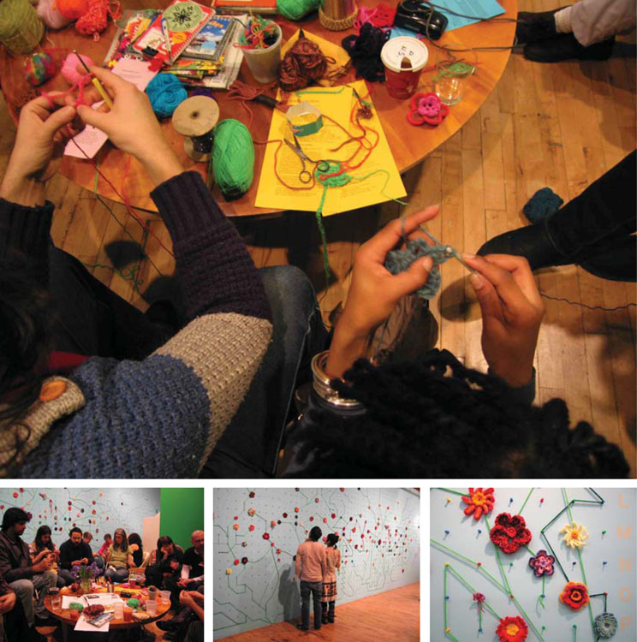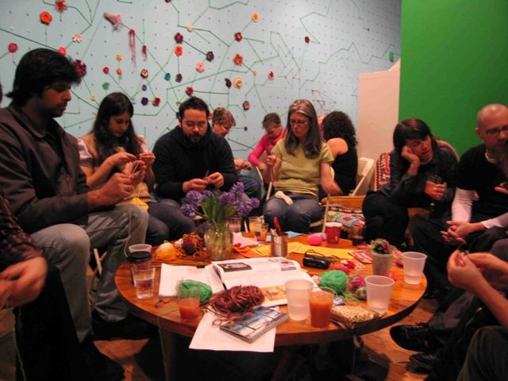
Figure 1 Figure 2
Ani O’Neill, The Buddy System. 2006

“Tacit knowledge is acquired through experience and it is the knowledge that enables you to do things as distinct from talking or writing about them” (Dormer 1997, page 147)

Again, as shown in figure 1, the physical interactions that the audience participate in are very close and intimate encounters, every new piece of work that is added along the course of her exhibition has been a physical engagement from a different individual. As Dormer (1997) states this involvement not only brings a unique outcome to her piece but also something that is personal and meaningful to each individual that participates showing that no two works would ever be the same. It questions the idea that the act of seeing is completely different to the experience of making, different objectives are included for different roles throughout the installation. Some viewers simply observe the work whereas others physically and actively engage in the process of making. She creates a sense of belonging in her work through a collective and social experience and in a way, it allows people to express their own inspirations and self-identity. By O’Neill ensuring there is an involvement in her work it teaches and expresses the notion that craft can be learnt and practiced in the physical world and arguably offers individuals a different knowledge of hand crafted processes.

In figure 2 it begins to show the outcome of the exhibition that covers a large-scale wall which starts to replicate the image of a map. This in a way expresses the journey of the intimate connections that are now made through the accessibility of technology and the interactions that people are now able to make. This installation almost provides the importance of valuing the physical act of encounters by touching and making rather than connecting through a virtual reality. In itself relating to her artwork as the “Buddy System” expresses the notion of being physically in touch with another person. People are now more independent when using technology in modern society they profile themselves in an individual manner. The idea of connecting strangers together to engage with this unique exercise offers a collective experience for whoever takes part and explores this ‘system’ O’Neill has created to have immediate physical encounters.

These connections are all different in however they wish to be perceived but have all started from a direct experience. Even though technology has allowed individuals to adapt to a whole new way of thinking, it has changed the relationship designers and audiences have when they experience human senses. If designers approach a relationship that only includes a virtual outlook this obsessive response can lead to designers and individuals becoming passive to technology itself.

In Digital Crafts (2013) Shillito explores how designers now value technology so much and this is what they now solely rely on. She continues to explore how new and upcoming designers in our digital age feel that technology has now become the only way to respond. Panneels (2013) states that, “…Knowledge of digital technology is no longer an option but a necessity”. (in Shillito, 2013, page 56)

Handmade textiles are still involved in the design process but are more often referred to as the starting point of design so in order for designers to become more innovative it is important for them to have a knowledge of hand crafted textiles and traditional processes which will enable them a better outcome when it is applied to digital textiles. Looking at Nuno textile design it explores the idea of integrating traditional methods with new technology. Their companies concept states that, “When we create our textiles, nature and tradition are woven with technology.” (Nuno, N,D. sourced from https://www.nuno.com/en/about/)
They embrace and harmonize traditional textiles with new technologies that allow them to produce new innovative outcomes, even though technology is an aspect to the companies aesthetics it values the importance of traditional processes just as much. In Techno Textiles 2, O’Mahony (2005) explores how design has been affected in our new technological era.

'Increasingly sophisticated materials and technologies have forced designers to re-examine many of their working practices. It is becoming more common for designers to work as part of multi-disciplinary design teams...”(O’Mahony, 2005, page 136)

This new way of working attracts designers to the variety that new design outcomes have to offer and the combinations of processes lead to an emergent hybrid knowledge is expressed through new techniques. There are now so many digital solutions in textiles, by using both hand rendered and digital techniques it creates a balance that allows designers to keep traditional textiles involved in contemporary design. Designers are less likely to lose touch with the physical tactile quality that textiles are known for if they embrace the importance of physical objects, however the growing necessity of technology has evolved into the main subject of everyday use and it has over taken the traditional hand rendered processes.

“By order to communicate something significant about the rapidly changing age we live in, artists and designers must frequently adopt new vocabularies, visual languages and codes.” (Braddock Clarke, 2012, page 33)
It’s this adaptation and frequent change that Clarke (2012) suggests that is becoming more and more apparent through new and upcoming designers' creative practices. In order to react and respond and create different outcomes with new technologies, designers are constantly changing their processes to keep up to date. The ‘rapid’ and ‘ever changing’ outlook expresses the speed in which designers have to respond to as there is always something new. Their visual language grows to express a volume of possibilities that has been completely influenced by new technology.
As digital technologies have now enabled design to adapt to a more technical version of the well-known processes, (for example using digital printers to print rolls of fabric instead of hand screen printed textiles) it is unlikely designers now turn to traditional methods when advanced options are so accessible and allow for faster production. As well as looking at technology in design, the idea of technology as a whole in modern society is something that individuals are now more inclined to use in their everyday routines.

“Humans creative narratives about who we are in order to communicate to ourselves, and to others what matters to us.” (Young, 2012, page 77)

Looking at the consciousness and thinking amongst designers and individuals is something that has also been influenced by technology and in particular social media platforms. As Young (2012) states, individuals now creative narratives of themselves in order for them to be perceived and viewed in a positive way. This begins to question whether or not individuals need to be responsive to the engagements they are surrounded by in order for them to react to what is expected of them. Having an ongoing communication can be productive but it could also supress a designer’s true identity if there is a constant need to update their online image. It is arguable that the persistence individuals now have with technology has allowed designers to adapt to a way of working that leads them to create a document of personal responses that can be integrated into self-improvement. This idea of communicating what matters to us as individuals as Young (2012) mentions can become lost due to the over analysis and the high demand of what designers are trying to achieve. Alongside this response the manifesto, ‘you are not a gadget’ by Jaron Lanier depicts the worrying reality of individuals adopting life with digitized minds. He suggests that,

“I fear that we are beginning to design ourselves to suit digital models of us, and I worry about a leaching of empathy and humanity in that process.” (Lanier, 2010, page 39)

Social media is no longer used for basic posts or friend requests, instead it has been hugely transformed into a route for self-expression. Technology has now become normalised to such an extent it emphasises what Lanier (2010) states that the only way individuals can now respond to digital encounters is to communicate through idealized versions of themselves in which he calls ‘a digital model’. These versions can be created to suit however an individual wants to be perceived and reveal a reproduction of the ‘true self’ that is performing in only a positive way. Lanier (2010) describes a lack of engagement as though it is percolating through any empathy or true connections in the physical world.

The recognition of emotion, empathy, feeling, and meaning is something that has become dissolved in modern society and overall is hard to achieve when technology has such an influence. Staying competitive to an audience can take its toll on a designer’s wellbeing. Donna M Freitas (2017) explores the idea of social media and the worries that steer towards an overall dominance from technology. In her articles ‘Beyond the warning signs of social media’ and ‘Instagrim’ she depicts the positive and negative impact that social media has had on individuals (in particular students). She begins by revealing the ways of thinking that individuals adapt to and explains the outlook that individual students and individuals have on how they see social media.
“By posting only about our successes, our triumphs and events that show our lives and achievements in the most positive light, we protect out reputations” (Donna M Freitas, 2017)

The dominance of technology that now surrounds people has now become a worrying reality, this idea of perfection that individuals strive towards is what Freitas (2017) starts to unpick. A protection of status is almost a marketing tool that individuals use in the process of promoting themselves as a designer. From a student interview, she quotes “I think of myself, my name, as a brand, I select when I share”. (Freitas, 2017) This emphasises how much social media has influenced individuals into being self-aware of everything they post online, in a sense Freitas (2017) states that the overall health and wellbeing of individuals is scarred by the life they live online by persistently being cautious of the image they choose to show. Dissonance is created when individuals adopt this way of thinking, in normality people are told to be themselves yet the image of themselves that is posted online is something very different to the normal. It is seen to be so important to be a part of social media and technology some find it very difficult to not be involved. When looking at social media from a designer’s perspective, a mental strain is almost forced upon designers to fulfil the creative pressures that they are now expected to reach and being innovative can take longer than some may anticipate. As Freitas (2017) suggests, social media is so active and responsive in certain creative fields it forces individuals to always change and adapt to suit the demand of their own audiences. This can have a damaging influence which can lead to constantly feeling a need to edit a version of one’s self that they think is the best outcome, and ultimately pushes them to perform a role that isn’t true to their identity.

It goes back to the necessity that Panneels (2013) talks about and shows that the over use of technologies and social media platforms can ultimately come at a high cost and alongside the benefits of technology promoting their business, there is a stress and anxiety that follows where designers feel the need to constantly perform.

CHAPTER TWO

“The loss of contact with the living world, and more particularly, the dearth of unmediated experiences with the natural, is a major source of many contemporary ills, psychological and social, ecological and environmental.” (Owen, 2011, page 86)

In Fabrication and Encounter, Owen (2011) discusses the work of Ann Hamilton. Her exhibition ‘Indigo Blue’ emphasises the importance of keeping in touch with our senses and how different materials have a story behind them that carry empathy and feeling that has been embedded in the cloth. This loss of contact that is stated can refer to the separation individuals now have with the importance of engaging with one another in the physical world. By people being out of touch, as Owen (2011) suggests with their own feelings has perhaps led to the underlying psychological problems many are now faced with. The lack of physical engagement that technology has created could be one of the many reasons why individuals now overlook the importance of what is right in front of them.

Undoubtedly there is now a process that individuals have become accustomed to where they value opinions of themselves at such a high standard it is as though a template has been created that they must fit into that relates back to Freitas’s (2017) article that expresses how cautious individuals have now become. These social and psychological problems have been something that many artists and designers have tried to overcome. The ongoing factor of textiles becoming dematerialised which is what Handley (1999) explores is something that has allowed designers to work towards keeping an interest in tactile and sensory emotions that can be the starting points that viewers may need.

By finding innovative ways that will allow individuals to communicate with one another as well as respond to the importance of engagement between people in today’s society it can use these problems that will then enable individuals to move away from the negative pressures they may feel, and start to re-connect people with their own independent physical senses and feelings.

“… the need for meaningful social connection, and the pain we feel without it, are defining characteristics of our species.” (Cacioppo and Patrick, 2008, page 7)

Loneliness and isolation is something that many individuals now experience when they are surrounded by the world of social media and technology and as Cacioppo (2008) suggests that the need for meaningful social interactions shapes us as a species and is an important aspect when feeling involved in something. As well as this, individuals that may not play a part in technology or are unaware of the changes in new generations and may often feel left behind. It is finding new ways that will overcome these feelings that become the challenging concepts. Looking at the works of Re-form Design studio at Goteborg and their project Interactive Cushion (2003) it can transmit a reassurance that interactive textiles are starting to build a groundwork for new designers to explore and mediate how emotions and physical interactions can be created through technology.

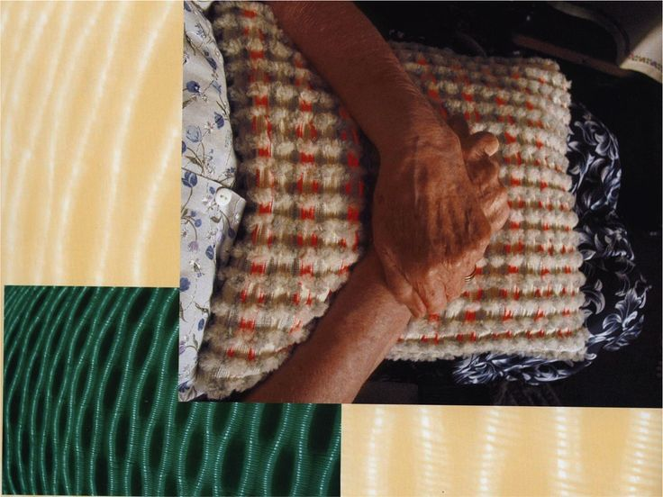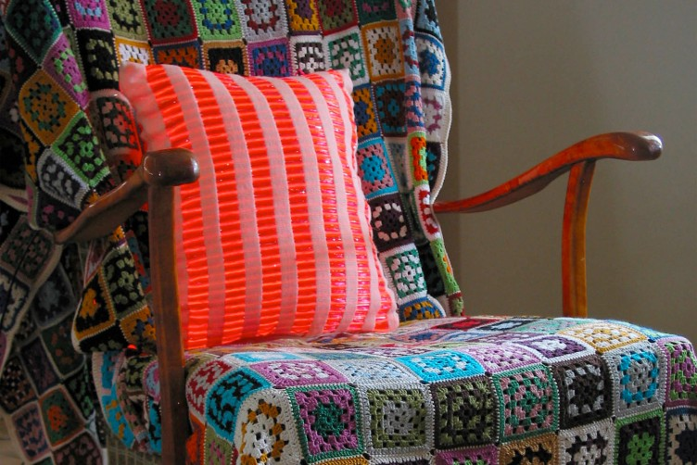
Fig 3 Fig 4
Re-form Studios: Goteborg, Interactive Cushion, 2003

“The act of wearing, using, or participating with an art object neutralizes the distance between the object and the viewer, allowing for the experience to be personal, ephemeral, associative and responsive, much like conversation.” (Paula Owen, 2011, page 86)

To touch is to come into or be in contact with something, the idea expressed through Re-form’s interactive cushion is a product that allows individuals to feel connected throughout long-distance relationships. This idea warrants a more comforting response to that of a phone call as it responds to touching what is in front of you and engaging with it. Within the cushion itself, fibres are activated from various ranges through internet connections and when the pillow is squeezed in one destination programmes it to light up somewhere else. Its enables two people to have a sensory experience over a geographical distance that sends a virtual message from one person to another and can create their own perception of what they wish to receive.

By using touch as the main source of these connections it replicates the idea of a ‘virtual hug’ from another person. Individuals receive and react to the emotional feelings they would have in reality. A hug expresses affection towards someone and to hold or grasp lies with firm pressure and carries support, these are all sensations that are produced through the act of touch. It gives a response that is fulfilling. The feeling is intimate and replicates love and comfort within the interactive cushion. Even though the physical interaction isn’t in human form this idea convinces the mind that it is truly there.

“These interfaces provide the sensation of touch by exerting accurately controlled forces on the fingers. By this means it is possible to simulate not only the feel of a virtual object, but also its texture and elasticity. Sharing these objects and properties over large distances, and being able to manipulate them virtually, encourages talk of ‘presence’.” (Paterson, 2007, pg. 127)

Re-form design studio have explored how innovative textiles that are embedded with information can replicate the sense of a physical reaction. Using the sense of touch throughout this process is like a therapy that allows individuals to respond to the interactions that come with human engagement. Technology has had such an influence over today’s society, the sense of touch has become overlooked. It is unvalued and taken for granted when it is only used for simple everyday actions that are not considered to be important.
In the textile reader, Bristow (2011) explores how touch is needed throughout textiles and the importance of touch and textiles and suggests that,
“Textiles have the ability to operate as a ‘silent witness’ and communicate through a thoroughly articulate material language of their own. To know this, you have to touch textiles, even when it looks like you shouldn’t.” (Hemmings, 2012, page 44)

The response from two individual’s connections with these virtual products makes long-distance relationships more bearable when they are initiated by touch, As Paterson (2007) suggests, it manipulates the feeling that someone is directly in front of you, this lack of engagement is replicated and is allowed to virtually exist at large distances. Providing a manual handling of something can carry a memory or feeling that an individual may recognise.

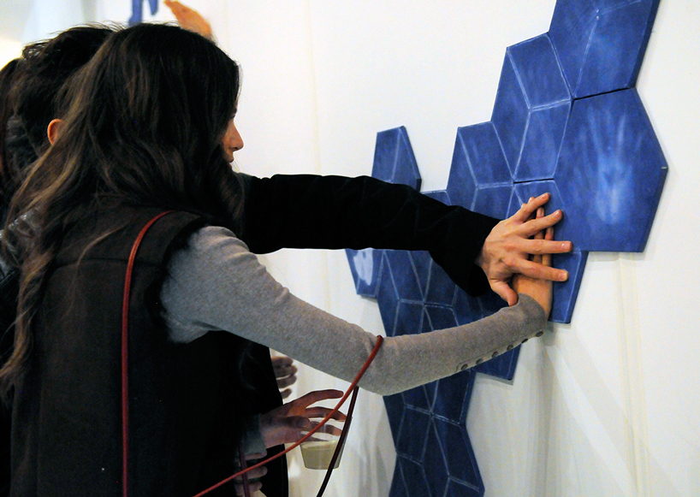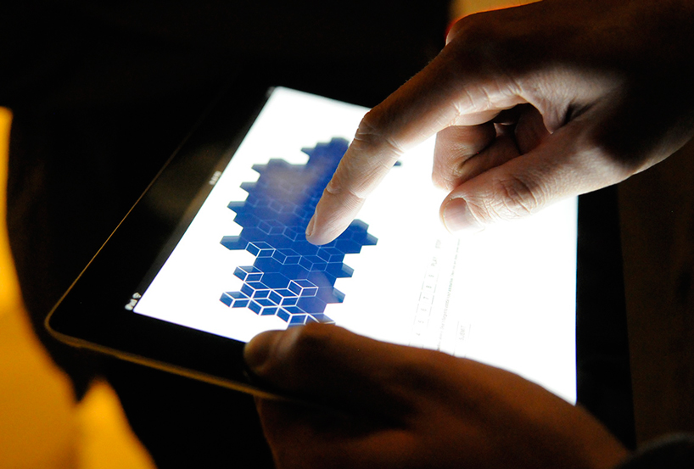
Fig 5 Fig 6
SymbiosisO: Voxel, Interactive textiles, 2012
This interactive installation enables its viewers to physically come into contact with the work itself that allows them to leave behind a piece of themselves.
"Suddenly, from a passive listener you become an important part of the installation and your displayed image becomes a part of the interior. I like the fact that you not only take something from the store but you leave a trace, a unique touch behind." (Eszter Ozsvald, 2012: sourced from http://www.coolhunting.com/culture/symbiosiso-voxel Date accessed 2/12/17)
Each individual section of the installation is made up from layers of silk and felt which has been dyed and treated with heat-activated thermochromic ink. This installation responds to body temperature and the heat pressure that is passed through physical touch, which is then directly exposed as a white relief print against the indigo fabric on top of the individual hexagons. In between the top layers is a middle section of wiring that is run from technological interfaces that is then connected into the individual pieces. Not only does this installation respond to the importance of physical touch but it also allows its viewers to explore the same response through web based technology. Whether it be pressing or touching the pieces to leave a physical imprint on the work or connecting and drawing patterns through digital interfaces, symbiosisO: Voxel has created a space that intertwine elements of traditional textiles and new digital processes into one installation.
Having the creative freedom to explore these types of installations is what technology has allowed designers to achieve. As Ozsvald suggests, allowing individuals to experience pieces of art by physically touching them leaves unique traces of every different person that encounters the piece itself, whether it be physical or through technology.
“Touch is not just a private act. It is a fundamental medium for the expression, experience and contestation of social values and hierarchies. The culture of touch involves all of culture. (Classen, 2005, page 1-2)
Classen (2005) suggests that touch is a fundamental sense that is needed in order to experience and express feelings throughout interaction. Modern technology has led to only representing a replica of what it may feel like to touch something and not truly experiencing it in ‘real life’. Interacting with artwork in an exhibition space is usually something people will not experience in a gallery setting as it has become a place where individuals are usually expected to not to touch what is in front of them and just passively observe. The visual image is not enough to fully engage with the installation and requires personal connections through touch to enable viewers to re-connect with themselves.
A sense of presence and interpersonal engagement is created throughout this interactive textile installation and this allows individuals to let go of consciousness and understand the importance of touch even through virtual interfaces. It removes a barrier to where audiences are now able to engage and participate which in this case, is the most important factor.

CONCLUSION
Technology has generated many benefits in textiles with the new processes it now enables contemporary designers to achieve, but in spite of that it still lacks the urgency of how important it is to engage physically with not only one another but materials also. That, in a sense, has left many designers in the 21st century unable to achieve something without using technology and could result in even more problems with the ‘immaterial reality’ that Handley (1999) suggests that now has a huge impact on textiles and physical encounters within the design experience and audience engagement.
Amongst the interactions people now miss, I have considered the importance of physical engagements. It explores how dexterity is a vital aspect needed in textile design. The idea of touching and holding something carries more purpose than what it would seeing materials through a virtual interface. These virtual engagements rely on ‘haptic’ responses, and instead can only imagine touch.
New processes like open ended installations have enabled individuals to adopt more knowledge of tactile qualities that have now created a sense of engagement. The installation ‘The Buddy System’ outlines the significance of human interactions, designers that have approached their work in an open-ended and performative manner have been more successful in integrating a balanced awareness that mediates the audience in the creation of the work.
It is this response that has counter acted the psychological problems individuals may face from being isolated in new technology. By engaging individuals with the installation, it allows them to feel secure and valued as though they have created the piece themselves and strive towards a sense of ownership.
By reflecting on how technology and social media have become an essential part of an individual’s life, it’s stems back to the notion of ‘disembodiment’ which has been explored by Handley (1999). The mass impact of the digital age has had a detrimental effect on creative output practices and led to the disconnection of feelings that people now face. Freitas (2017) unravelled how the consciousness and mind set of one’s self is now over-analysed in such a way it leads to worrying mental health problems, and a false identity is proposed when they use social media. These ideas and outcomes ultimately correspond with Owen (2011) and Lanier’s (2010) theories on new contemporary ills in our new digital age and a ‘...leaching of empathy...’ in amongst new ‘digital models’. It has shown that this issue is becoming more apparent with the growing disparity between physical encounters and experiences in the ‘living’ world. When you are physically interacting with something right in front of you it captures human senses, and the lack of empathy that Lanier (2010) suggests is the renunciation of physical encounters due to the influence from technology.
Nevertheless, it is still important to acknowledge that technology and social media platforms have allowed a huge amount of growth for certain designers in different ways. As Emery (2017) explored, new feminist textile artists now rely more on social media platforms than traditional methods as it has created a place for them to express their messages that can be seen on a global scale. It is this volume in which they are now able to extend their messages that has ultimately allowed them to grow independently as designers.
Overall, the interpersonal skills that are gained throughout touch have a vital importance throughout textile design. With the creative freedom that technology has enabled, many designers have adopted new outcomes of working to approach textiles in a way that joins technology and tacit knowledge together. These approaches that new emerging designers have taken on have led to new innovative ideas throughout different areas of textile design. It is the active response from designers that now works towards resolving the negative impact that various technologies and social media platforms have created and has empowered the ability to make people aware of the significance of tacit knowledge and human interaction in our new digital age.

BIBLIOGRAPHY

BOOKS

BRADDOCK CLARKE, S. and HARRIS, J. (2012) Digital visions for fashion and textiles: Made in code. United Kingdom, Thames and Hudson. Page 16.

BRADDOCK CLARKE, S. and O’MAHONY M (2005) Techno Textiles 2. United Kingdom, Thames and Hudson.

BUECHLEY, L. PEPPLER, K. EISENBERGM, M. KAFAI, Y. (2013) Textile Messages. New York, Peter Lang: Page 161.

BUSZEK, M (2011) Extra Ordinary, Craft and contemporary art: Fabrication and Encounter by Paula Owen. USA, Duke University press: Page 86.

CACIOPPO, J. and PATRICK, W. (2008) Loneliness: Human nature and the need for social connection. USA, W.W. Norton & Company. Page 7.

COLCHESTER, C. (2007) Textiles today. United Kingdom, Thames and Hudson

CLASSEN, C. (2005) The book of touch, New York, Berg.

HEMMINGS, J. (2012) The textile reader. Continuity of Touch – Textile as a Silent witness, Maxine Bristow. London/ New York, Berg. Page 44.

LANIER, J. (2011) You are not a gadget, A manifesto. USA, Penguin. Page 39

NIMKULRAT, N KANE, F. AND WALTON, K. (2016) Crafting textiles in the digital age. New York, Bloomsbury.

O’MAHONY, M (2011) Advanced Textiles for Health and Wellbeing. United Kingdom, Thames and Hudson.

PATERSON, M. (2007) The Senses of Touch: Haptics, Affects and Technologies. New York, Berg. Page 127

SHILLITO, A. (2013) Digital Crafts: Industrial technologies for applied artists and designer makers. United Kingdom, Bloomsbury: Page 56.

YOUNG, N. (2012) The Virtual self: How our digital minds are altering the world around us. New York, USA. McCelland & Stewart LTD. Page 77

E Books

AUTHOR: DORMER, P.
YEAR: 1997
TITLE: The Culture of Craft.
PUBLISHER: Manchester University press
ACCESSIBLE VIA: Google Books
DATE ACCESED: 24/11/2017
PAGE: 147
URL: https://books.google.co.uk/books?hl=en&lr=&id=wSZASV70krMC&oi=fnd&pg=PT8&dq=peter+dormer+tacit+knowledge&ots=SpCqz5Yaln&sig=U5JqZKS0BxvE52P1uLFy2r_qsgE#v=onepage&q=peter%20dormer%20tacit%20knowledge&f=false

AUTHOR: STERN, N.
YEAR: 2013
TITLE: Interactive art and embodiment: The implicit body as performance.
PUBLISHER: Gylphi Limited
ACCESSIBLE VIA: Google Books
DATE ACCESSED: 28/11/2017
PAGE: 82
URL:
https://books.google.co.uk/books?id=egLuQtqeOaQC&printsec=frontcover&dq=Interactive+Art+and+Embodiment:+The+Implicit+Body+as+Performance&hl=en&sa=X&ved=0ahUKEwiJhe-19vXXAhXDZlAKHVCsBU8Q6AEIKTAA#v=onepage&q=Interactive%20Art%20and%20Embodiment%3A%20The%20Implicit%20Body%20as%20Performance&f=false

IMAGES

Figure 1: Ani O’Neill, The Buddy System, 2006.

https://muse.jhu.edu/article/481371

DATE ACCESSED: 10/11/17

Figure 2: Ani O’Neill, The Buddy System, 2006.

http://www.tautai.org/ani-oneill-the-buddy-system-2004-melbourne/

DATE ACCESSED: 10/11/17

Figure 3: Re-form Studios: Goteborg, Interactive Cushion, 2003
https://www.pinterest.co.uk/pin/397301998349036832/

DATE ACCESSED: 27/11/17

Figure 4: Re-form Studios: Goteborg, Interactive Cushion, 2003.
https://www.tii.se/projects/ittextiles

DATE ACCESSED: 27/11/17

Figure 5 and Figure 6: SymbiosisO Voxel, Interactive Textiles, 2012.
http://www.coolhunting.com/culture/symbiosiso-voxel
DATE ACCESSED: 2/12/17

WEBSITES

https://www.cutcloth.co.uk/publication)
DATE ACCESSED: 24/11/17

http://www.coolhunting.com/culture/symbiosiso-voxel
DATE ACCESSED: 2/12/17

https://www.jessicahemmings.com/2121-reiko-sudo-nuno/
DATE ACCESSED 8/12/17

ARTICLES

FREITAS, D. Beyond the warning signs of social media. School Administrator: Arlington Vol. 74, Iss 4, April 2017.
FREITAS, D. Instagrim: Why Social Media makes students miserable. The Chronicle of Higher education: Washington, May 2017.

