Task one: ‘write a semiotic analysis’
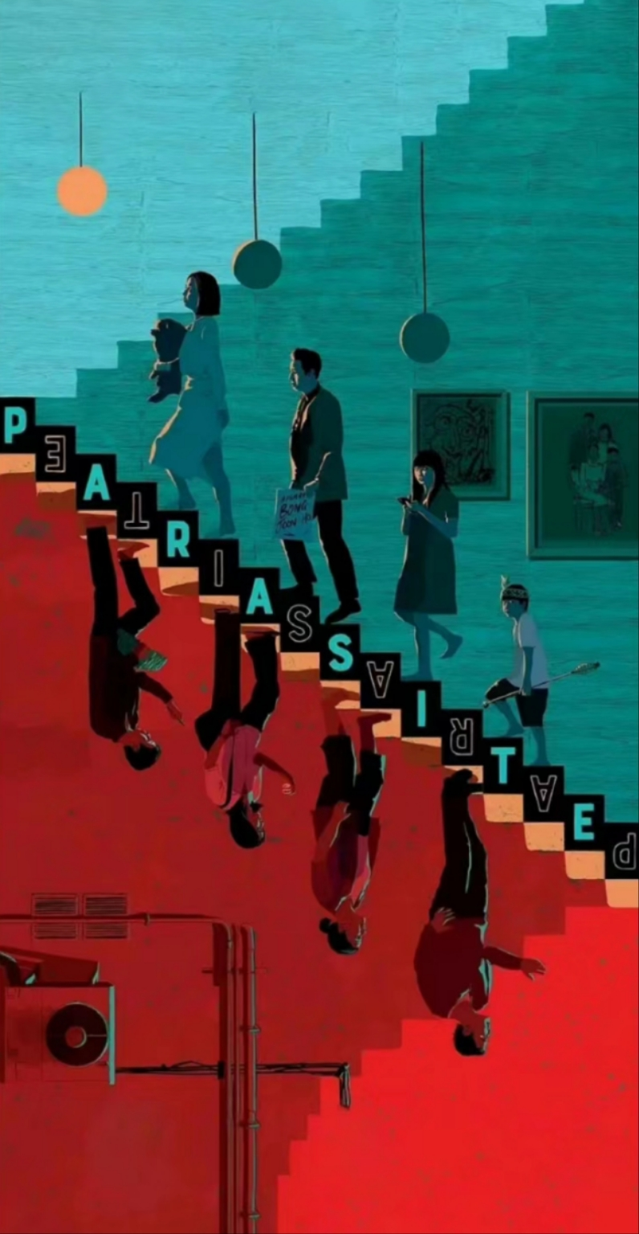

The promotional artwork for the Academy Award-winning South Korean film The Mosquito， skillfully achieved through the strategic deployment of coloration.The dim illumination generates an environment of darkness, which elicits an instantaneous perception of gloominess.The artistic composition adeptly segregates the visual plane into two demarcated zones by employing a chromatic contrast between varying hues of red and blue.Red, commonly associated with vigilance and peril, elicits a heightened state of alertness and psychological stress.Blue is commonly associated with tranquility and concord, symbolizing an ideal state of serene composure that may remain elusive.

The spatial metaphor of lower spaces and descending stairs not only signifies social hierarchy but also denotes a physical demarcation. In the cinematic context, the subterranean dwellings of the less affluent, positioned beneath the elite's living quarters, are accessed via stairs, Stairs can be associated with climbing, hard work, poverty, and exercise, and here they emphasize the difference between the upper and lower figures. The upper layer constitutes the affluent, whereas the lower layer comprises the indigent，The imagery of ascending and descending stairs symbolizes the divergent trajectories of wealth accumulation: the wealthy ascend effortlessly while the impoverished struggle to maintain their position, exacerbating the wealth gap. The squalid setting of the lower class, adorned with water pipes, air conditioning units, and stained surfaces, along with their disheveled appearance—manifested through the clasp of aged water cups and ill-fitting attire—aligns with the gritty ambiance depicted in the film The Mosquito. In contrast, the upperclass habitats are embellished with textured walls and ornamental artwork, reflecting a relaxed demeanor and contented lifestyle, These usually mean art, leisure, and exquisite life, while pets usually represent animals or a deep companionship for people, but in this poster it shows the lifestyle and quality of life of the rich.

The film's promotional poster exclusively depicts the affluent wearing shoes, shoes are usually just a means of transportation or a fashion, but here they are used to highlight the gap between the rich and the poor，symbolizing class entrenchment and a corresponding decline in social mobility. The stairs' central lettering and oblique imagery evoke a sense of precariousness, disrupting the equilibrium and stability typically associated with staircases. This dissonance is purposefully aligned with the thematic elements of turbulence, imbalance, and peril. The dark rectangular overlay on the characters' eyes in the poster is imbued with enigma, and its weightiness underscores the upper class's disdain for the inequitable social order. It questions the reasons behind the plight of the talented in poverty, highlighting societal irony where merit does not necessarily translate to material success.
Although this poster mainly shows the contradiction between the rich and the poor, this class is not a pyramid that can be touched and observed.

On the contrary, it is an invisible and imaginary existence. There is no absolute height, only relative height. The social ladder extending upward is endless. Behind human nature is desire, which can only be suppressed but not eradicated. The emergence of desire will rely on the most primitive, basic and natural internal motivation to constantly seek breakthroughs in good and evil, class or rationality.
Bibliography:
Wu, Y., 2023. Analyzing the Narrative Logic of South Korean Director Bong Joon-ho's Films as the Metaphor of Reality and Society. Journal of Education, Humanities and Social Sciences, 18, pp.249-254.
Schradie, J., 2020. The great equalizer reproduces inequality: How the digital divide is a class power divide. In Rethinking class and social difference (Vol. 37, pp. 81-101). Emerald Publishing Limited.
Wang, M., 2016. Toward the meaning of linguistic signs: A hierarchical theory. Language and Semiotic Studies, 2(1), pp.112-123.
Chandler, D., 2022. Semiotics: the basics. Routledge.
Keane, W., 2003. Semiotics and the social analysis of material things. Language & communication, 23(3-4), pp.409-425.
Jewitt, C. and Oyama, R., 2001. Visual meaning: A social semiotic approach. Sage visual methods, p.151.

List of Figures:
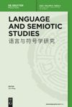
https://www.degruyter.com/document/doi/10.1515/lass-2016-020105/html?lang=en
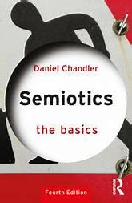
https://www.taylorfrancis.com/chapters/mono/10.4324/9781003155744-4/structures-daniel-chandler?context=ubx
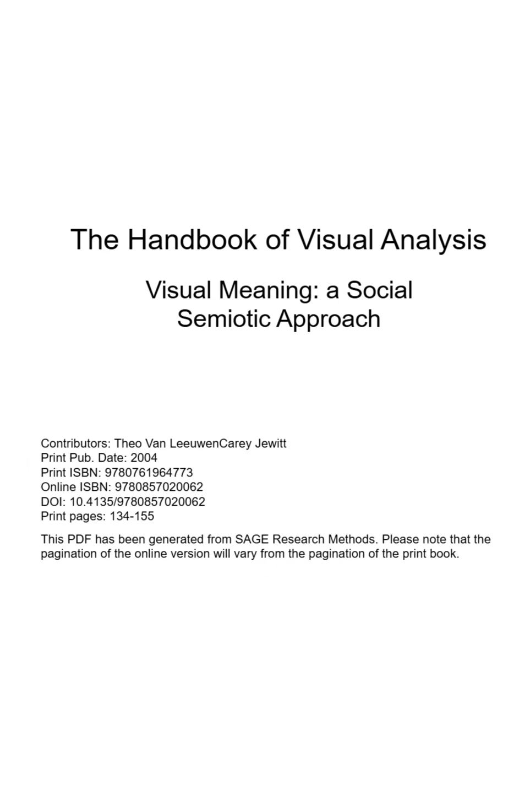

https://www.academia.edu/23095101/The_Handbook_of_Visual_Analysis_Visual_Meaning_a_Social_Semiotic_Approach

Task two: Manifesto Writing

Statement:
1.Beauty is everywhere. For our eyes, it is not the lack of beauty, but the lack of discovery. ——Rodin
2.Our painting is metaphor, not imitation. Form and color are not beautiful in themselves, only those created by the will of the mind are beautiful. ——Kirchner
3. Behind the oil painting, the pulse of the painter beats, and in the statue, the soul of the sculptor breathes——Rilph
4. Take a walk with a line. ——Paul Klee of Germany.
5. Painting is a silent and motionless declaration.
[France] Glaize "Selected Theories of Modern European Painting School"
6. Happiness should be sought from practice. ——Cezanne
7. Discovering the beauty of life is my greatest pleasure. ——Yang Zhiguang
8. Painting is an art that makes the plane vivid.
[France] Glaize "Selected Theories of Modern European Painting School"

Choose sentences 1, 2, and 3 to explain my thoughts

First of all, art is a form of expression of emotion. Through various means of expression, even all touchable objects, artists can transform their inner emotions into tangible forms, just like surrealism, abstract art, impressionism, etc., the reachable distance allows the audience to resonate and connect emotionally. Emotions and emotions are our direct response to the world around us. It can be joy, sadness, anger, or more complex emotions such as loneliness and depression. Visualizing emotions means using images, colors and composition to express these emotional states. For example, Van Gogh's "Starry Night" contains his awe of nature and inner loneliness. The viewer will be deeply moved when appreciating this painting, and further think about his relationship with the world.

Secondly, art is a way of communicating ideas. Art is a window to express the inner world, while graphic design is a language to communicate with the outside world. Graphic design is not only a visual art, but also a unique narrative method. It conveys information, stimulates emotions and triggers thinking through the interweaving of graphics and text. Art is a field full of creativity, in-depth exploration and use the power of design to influence and improve people's lives and increase artistic thinking. Artworks can also convey artists' thoughts and views on major issues such as society, humanity and life. For example, in literary works, writers use characters, plots and symbolism to explore human nature, social issues and moral concepts. When the problem is too sharp, artists use paintings to euphemistically express their views and transform difficult-to-understand text into more concise and clear paintings. For example, George Orwell's "1984" guides readers to think about the impact of political systems on personal freedom by revealing power and totalitarianism.

In addition, art is a creation of aesthetic experience. Artworks evoke the audience's sensitivity through elements such as form, structure, color, and arrangement. The colors and composition in paintings can also cause visual pleasure to the viewer. This aesthetic experience is not only a sensory enjoyment, but also a reflection on the meaning and existence of beauty. Art is also a carrier of cultural inheritance and innovation. Aesthetics is also a subjective understanding and cognition of objective things. There is no unified standard of beauty, and of course there is no unchanging ugliness. Beauty and ugliness are intuitive experiences that vary from person to person. There is no need to blindly follow the crowd. Anything that touches the visual nerves and makes oneself excited and happy can be defined as beauty. Only what you perceive is the real beauty. What you cannot perceive is just a noise to you, no matter how much praise you receive.

Everyone cares about different things, and beauty exists in different places. No matter what, what you think is beautiful and pleasing to the body and mind is the beauty in life. Of course, works of art not only reflect the social and cultural landscape of the time, but also provide important references and inspirations for the future. At the same time, artists also promote the development and progress of art through creation.

Bibliography:
Jin, Y. and Cao, L., 2016. Rethinking semiotics: Toward a theory of intentional sign. Semiotica, 2016(210), pp.167-189.
Shaviro, S., 1998. Beauty lies in the eye. symplokē, 6(1/2), pp.96-108.
Zeki, S., 1999. Art and the brain. Journal of Consciousness Studies, 6(6-7), pp.76-96.
Rogers, F.R. and Rogers, M.A., 1985. Painting and poetry: Form, metaphor, and the language of literature. Bucknell University Press.
Matravers, D., 2001. Art and emotion. Oxford University Press.
MacBean, A.C., 2013. Art and symbolism: The technique of applying hidden meaning and communicating specific ideas through art.
Sullivan, K., 2006. How Does Art'Speak,'and What Does it'Say?'Conceptual Metaphor Theory as a Tool for Understanding the Artistic Process. Conceptual Metaphor Theory as a Tool for Understanding the Artistic Process (January 20, 2006). THOUGHT TOOLS FOR A NEW GENERATION: ESSAYS ON THOUGHT, IDEAS, AND THE POWER OF EXPRESSION, pp.81-89.
Ramachandran, V.S. and Hirstein, W., 1999. The science of art: A neurological theory of aesthetic experience. Journal of consciousness Studies, 6(6-7), pp.15-51.

List of Figures:
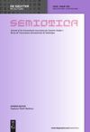
https://www.degruyter.com/document/doi/10.1515/sem-2016-0065/html
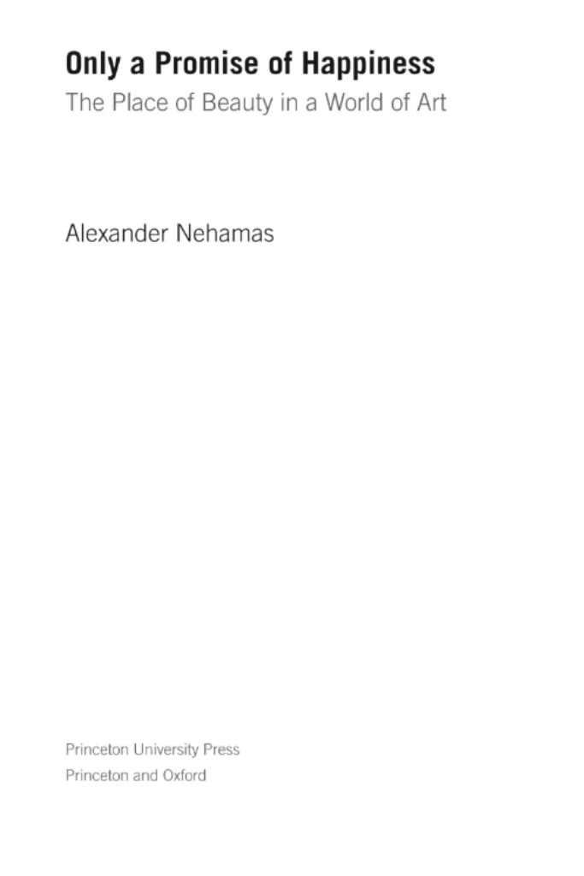
https://books.google.co.uk/books?hl=en&lr=&id=jOo9DwAAQBAJ&oi=fnd&pg=PP11&dq=Beauty+is+everywhere.+For+our+eyes,+it+is+not+the+lack+of+beauty,+but+the+lack+of+discovery.+&ots=d1pLOEOGZY&sig=R90q-zQ-FDdsNJSGQnBD-y1VrlY&redir_esc=y#v=onepage&q&f=false
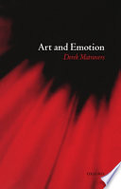
https://books.google.co.uk/books?hl=en&lr=&id=Xyc9mmC5shoC&oi=fnd&pg=PA1&dq=art+is+a+form+of+expression+of+emotion&ots=0astP1VlUD&sig=ctyztJR6NL46XOQJRjHgM-sFSJU&redir_esc=y#v=onepage&q=art%20is%20a%20form%20of%20expression%20of%20emotion&f=false
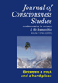
https://www.ingentaconnect.com/content/imp/jcs/1999/00000006/f0020006/949
Task three: Observational Writing
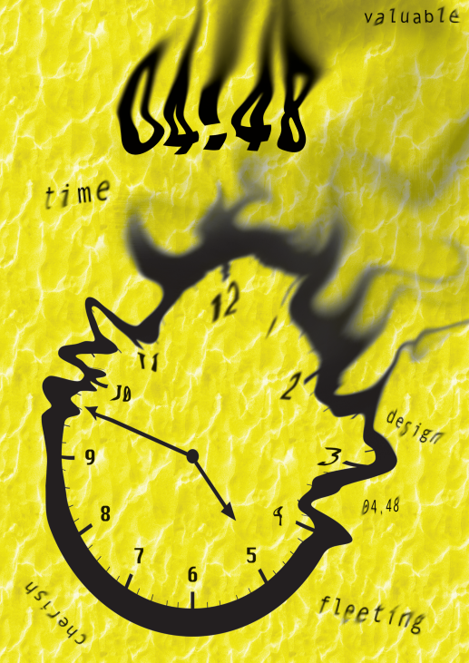
This is a painting I drew recently.

Initially, I wanted to design a poster about time. I struggled to choose the theme of time among the keywords such as saving, wasting, cherishing, etc. But one day I watched a movie called Interstellar, and suddenly I had an idea. I think time does not have to be static. Time is indeed a fixed answer. From an objective point of view, time is flowing and dynamic, just like in the poster, I used half of a clock that flows like sand to form a radial streamline. Through the gradual change of shapes and lines, I simulated various irregular and uncertain trajectories of time. They are bent or intertwined to create a dynamic and continuous visual effect, as if time is slowly passing through the picture.

But from another perspective, time is also an irreversible phenomenon. Every time time passes is a unique moment that cannot be copied. Just like there is an old Chinese saying that "there is no regret medicine in the world", so I combined its dynamic and streamlined, the most primitive clock shape with static, and the streamlined clock not only represents the passage of time, but also represents the helplessness of losing some time because it did not play the greatest role. Time is life, process, result or something else. Time is neither fast nor slow, and it has no cause and effect. It is people's subjective consciousness that determines what "it" is and gives "it" content.

When I decided to use a clock to depict the main object time, I struggled for a long time on the color of the subject. I thought of using a gradient blue, which can better express the passage of time like flowing water, but it lacks some precious meanings. I also thought of using black and white alone, a black dial, white scales and numbers. Black and white give people a sense of simplicity, elegance, and high-end. The combination of black and white reduces the sense of pressure visually, and it is easy for people to feel mysterious. It is easier to give the viewer a spiritual contemplation, but I think it may lack the impact that a color poster should have. In the struggle, I thought of yellow, like gold and sand. In my heart, time is as precious as gold, but it is also extremely easy to lose like sand. So the color of the subject is yellow and a water ripple base is added.

Finally, I wanted to make the poster more layered, so I chose to add some time elements. This reminded me of a play I watched before, "4.48 Mental Breakdown", and statistics show that 4:48 is the most vulnerable time for people. So I hope that the flowing number 4.48 will be like all the troubles people have at this time, which will fade away with time.

Bibliography:
Klasen, V., Bogucka, E.P., Meng, L. and Krisp, J.M., 2023. How we see time–the evolution and current state of visualizations of temporal data. International Journal of Cartography, 9(2), pp.392-409.
Ya-feng, N., Jin, L., Jia-qi, C., Wen-jun, Y., Hong-rui, Z., Jia-xin, H., Lang, X., Jia-hao, W., Guo-rui, M., Zi-jian, H. and Cheng-qi, X., 2022. Research on visual representation of icon colour in eye-controlled systems. Advanced Engineering Informatics, 52, p.101570.
Saunders, G., 2003. 'Just a Word on a Page and there is the Drama.'Sarah Kane's Theatrical Legacy. Contemporary Theatre Review, 13(1), pp.97-110.
Price, H., 2009. The flow of time.
Fleischer, L. and Skutella, M., 2007. Quickest flows over time. SIAM journal on computing, 36(6), pp.1600-1630.
YOUNG, A.T.A. and FROST, R., 2009. Sand and Gold. Mortgaging the Ancestors: Ideologies of Attachment in Africa, p.23.

List of Figures:
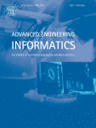
https://www.sciencedirect.com/science/article/abs/pii/S1474034622000428

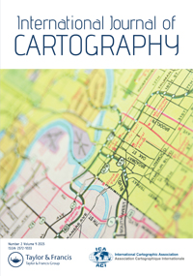
https://www.tandfonline.com/doi/full/10.1080/23729333.2022.2156316
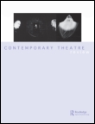
https://www.tandfonline.com/doi/pdf/10.1080/1048680031000077816

https://books.google.co.uk/books?hl=en&lr=&id=n9jZqdbAKa8C&oi=fnd&pg=PA23&dq=time+is+as+precious+as+gold,+but+it+is+also+extremely+easy+to+lose+like+sand&ots=bMdgQDkkJv&sig=zP-ogZrZyypAEqqeSjXME5cijxA&redir_esc=y#v=onepage&q&f=false
Student Name: Ai Zhang
P Number: 2405595
Programme of Study: Graphic Design
Module:ADAD4022 Ways Of Thinking

Tasks in the order I received them:
Task One Semiotic Analysis= 518words
Task Two: Manifesto =515 words
Task Three:Practice-based writing= 473words

