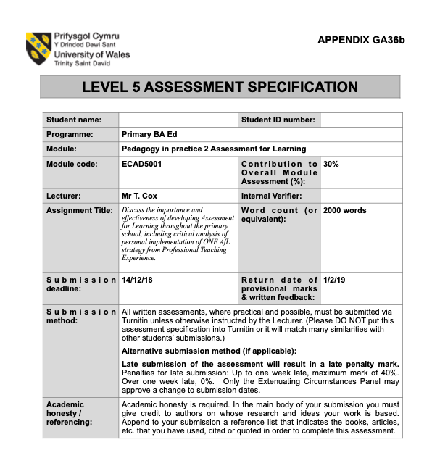
Nicholas Thomas
1702851
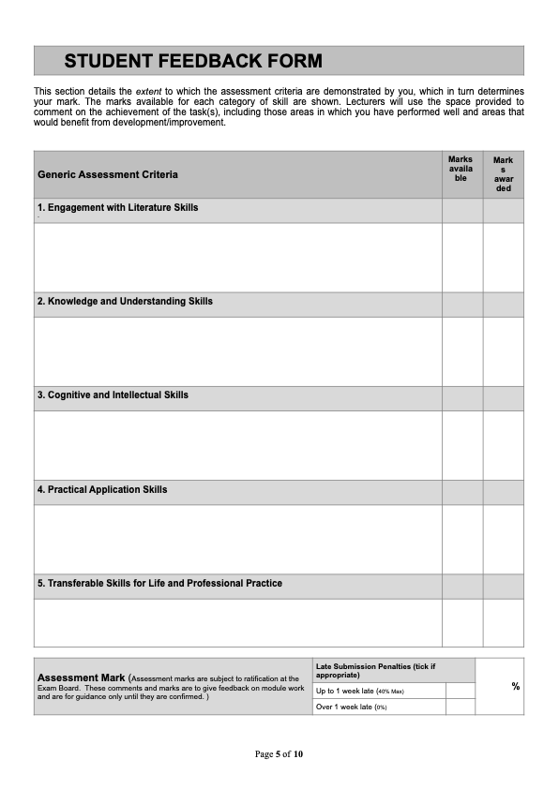
Discuss the importance and effectiveness of developing Assessment for Learning throughout the primary school, including critical analysis of personal implementation of ONE AfL strategy from Professional Teaching Experience.

‘Assessment’ is a divisive word that is used throughout the learning environment, compromising of many different variations and elements. Assessment has historically been a simple method of understanding where a student is in their attainment of knowledge. This form of assessment is now known as ‘Summative Assessment’ or ‘Assessment of Learning’ (AoL). These assessments take the form of essays, tests, and exams where a final grade or level is given and that ends the learning journey. Often students will be left with no clear method of improvement or the opportunity to do so. If the information gathered is used to modify the practitioners teaching and the learning activities undertaken by the pupils, then the assessment becomes ‘Formative’ (Black and William, 1998) and also known as ‘Assessment for Learning’ (AfL). There is a misconception that simply giving pupils feedback on these summative assessments will make them formative but the pairing of teacher feedback alongside grades or rankings has adverse affects on performance, Kluger and DeNisi (1996) found that a large percentage of well-designed studies showed teacher feedback on summative assessments had counterintuitive results. They note that this may be due to the pupils ignoring the feedback and focusing solely on the grade. Carol Dweck (2006) believes that focusing on grades and rankings has created an environment of ‘fixed mindsets’ where pupils believe that ability is innate and unchangeable. This self-belief hinders pupils ability to undertake challenging tasks and digest feedback as they believe they are naturally ‘bad’ at something and there is no way to significantly improve. It is key that assessment for learning should be carefully crafted (Black and William 2006) to reduce the focus that has been placed on summative assessments and to develop formative assessment as a learning tool. Recommendations by the Task Group on Assessment and Testing, (DES 1988) and the 1998 Education Reform Act have all placed large significance and importance on the effect of formative assessment in a students learning. The Welsh assembly government has also emphasised the need for developing AfL in its ‘Improving Schools – executive summary’ (Welsh Government, 2012) and the Assessment for learning and the National Literacy and Numeracy Framework (2013) where it offers guidance to developing AfL alongside the Literacy Numeracy Framework. The Framework advises that AfL strategies will be a continuous whole-school process with adaptive teaching and a clear focus on learning. Although many schools and practitioners use AfL strategies (Black and William, 2006; Welsh Government, 2012) there is still room for development as we begin to deepen our understanding of AfL and formative interactions (assessments). For formative interaction theory to take hold and become the dominant force in assessment practices Black and Wiliam (2009) state their aim for formative interaction to be located amongst the more comprehensive learning theories of pedagogy by re-evaluating their current work and working alongside practitioners and schools to adapt and develop their theory fully. The works of Boaler & Humphreys (2005) and McClain & Cobb (2001) resist a total change of status quo as their research highlights the importance of social norms on the creation of positive and efficient learning environments. Black and William (2009) accept this by understanding that their theory will also need a longstanding cultural change to be effective and not an overnight switch.
Black and Wiliam’s (1998) review examined over 200 research articles from 160 journals published over almost a decade, and from this research they discovered significant and quantifiable learning gains from AfL practices. Their research showed a 15-30% increase in performance as compared to control groups in their case studies.In John Hattie’s 2008 book ‘Visible Learning’ he discusses various learning interventions, he noted that interventions associated with formative assessment and interactions had the largest effect size and affected the pupils learning the greatest. Fuch and Fuch’s (1986) analysis investigating the affects of formative assessment contained over 3,800 participants and showed that formative assessment was of huge benefit to the learning of students and is often cited as evidence for the effectiveness of formative assessment.The validity of this analysis is sometimes called into question as firstly 83% of participants were additional learning needs(ALN), this alone is not the issue as it shows the benefits of formative assessment on ALN students, the issue is the misrepresentation of the data as a report of the benefits for all students. Secondly the data they collected came largely from ‘fair’ quality studies, these ‘fair’ studies can sometimes contain methodological issues which would affect the quality and reliability of the results. Another study that shows the benefits of formative assessment by Bergan, Sladeczek, Schwarz, and Smith (1991) showed that formative assessment had created significant gains in achievement of their participants, this study consisted of younger children from impoverished backgrounds. These studies and reports do show that there is some support to the impact of formative assessment on pupils learning but also shows the need for some further study and development of the theory. Formative assessment is a complex topic and is difficult to precisely study its effects without large elements of variability. Researchers have taken to investigating within specific study areas. Graham, Hiebert, & Harris, (2015) conducted a review of formative assessment techniques on students learning to write, this review showed the benefits of both formative assessment and that of specific study areas in research.

During a recent teaching experience the writer had personal experience of the implementation of one AfL strategy. This strategy was referred to as ‘I am a master of…’, where a pupil will demonstrate their knowledge of a topic or subject to a partner using any method or equipment they see fit.The strategy is an adaption of ‘I can’/ability statements. This strategy fits into two areas of the four elements of AfL which are;
-Sharing learning intentions and success criteria. Where pupils understand what they need to learn, what is expected of them, and what they need to do to be successful.
- Feedback. On what they can do and how they can improve.
- Good Quality Questioning and Talk. create and environment where pupils can create their own ideas, think for themselves, and explore their understanding of a topic.
- Peer and self-assessment and self-evaluation. To be able to recognise success in their own and others work, to understand how they are working and what they are learning.

Adapted from that found in (CCEA, 2007 Assessment for learning for key stages 1 & 2).

The strategy used fits into the questioning and self-evaluation elements as it requires the pupils to explain and regurgitate all that they have understood and learned during a topic to a peer.
This allows the pupils to reflect on what they have learnt and to receive feedback on their work by their peers. Little (2009) and Coombe & Canning (2002) have noted in their writings that the use of ability statements and self-assessment can help with learner autonomy and growth. Firstly to enable the pupils to use ability statements the practitioner must share the learning intentions with the pupils, D.R. Sadler (2013) writes that we must allow the pupils to know the learning targets and objectives to ensure pupils produce high quality work. The first experience using this technique the pupils were working towards halving three digit numbers. They understood the learning objective, being able to halve three digit numbers, and at the end of the topic the practitioner tasked them with demonstrating their knowledge and understanding to a working partner. The pupils used whiteboards and scrap paper to demonstrate their knowledge of the methods and techniques involved, the partner will then reciprocate and demonstrate their understanding. The pupils responded well to this first experience, they took the opportunity to display their knowledge and enjoyed demonstrating it to their partner. There was some difficulty with this technique as pupils who were self-conscious chose to ‘play it safe’ and choose digits that were simple for them or if they found the topic difficult they would copy the work of their partner. This enabled the pupils to understand were they are in their understanding of halving, which the practitioner may then use to advance their knowledge in the following session applying Vygotsky’s (1978) constructivist theory of proximal development. To counter pupils difficulty with the adoption of ability statements we must ensure they have a ‘growth’ mindset, which will enable them to significantly improve their behaviour and performance in the face of challenging situations (Dweck, 2006). Enabling a growth mindset will come from the practitioner praising effort, courage in attempting challenging tasks, and persistence in difficult situations. Following this advice the practitioner set out to promote a growth mindset during future lessons. The following lesson the practitioner took time to explain the positives of effort and courage in trying, and that partners may reward each other (DOJO points in this instance) for excellent demonstrations of understanding. The pupils engaged much better this time, pupils were pushing themselves and their knowledge during their demonstration giving a better understanding of where they are in their attainment. The next issue the practitioner faced was retaining records of the pupils ability statements. The statements consisted of both written and verbal explanations which would be difficult to record without the use of video recording devices. Using video recording devices is sometimes a privilege, the location of the practitioners teaching experience was of average affluence but still contained limited resources. Each classroom contained at most 10 devices capable of recording video, this restricted the number of pupils that may use the devices to record their statements. A solution to this the practitioner found was to place one device on each table that will record the whole table in the process of their demonstration. An additional solution found that would be of benefit to schools without recording devices would be for the pupils to write a short ability statement that can be counter-signed by their working partner. This will give a written record of their demonstration and work. The practitioner used both of the mentioned solutions with each table being recorded by one device, the pupils then wrote ‘I can’ statements in their ‘learning logs’ at the end of the day.
To implement the ability statements in a school would not be a large undertaking, it requires very little resources to apply. With regards to training, there is also minimal intervention needed, practitioners should be familiar with sharing learning objectives and from there the practitioner must simply allow time to perform the strategy. The practitioner will be advised to explain the purpose of the statements and the positives of engaging in the task. The largest issue will be creating a whole school environment of Carol Dweck’s (2006) growth mindsets, where the pupils will feel comfortable and confident enough to face challenging situations which will promote their performance in self-evaluations. This strategy also benefits from the ability of being used across both Foundation Phase and Key Stage 2, the strategy can be regressed to be used by younger and less able pupils were they can still show a peer what they have learnt by demonstration although they may not be able to create a written record. This creates a continuum of use throughout the school with the statements advancing in complexity and difficulty each year. Nursery pupils may show a peer how they ‘count on’ or that they can form basic letters, year 6 pupils may give examples of their understanding of pie charts or advanced writing techniques. In conclusion, following the advice given in Black and Wiliam(1998,2006,2009) we can as practitioners all aid in the development of formative assessment strategies by trialing and then developing our techniques. This will aid in the understanding of the pedagogical effects of formative assessment and how, if any, benefits it may yield. The evidence given in this piece should give enough credence to the positives of formative assessment strategies to convince practitioners to adopt assessment for learning and formative assessment practices.

Word count- 1,993

Reference list
Bergan, J. R., Sladeczek, I. E., Schwarz, R. D., & Smith, A. N. (1991). Effects of a measurement and planning system on kindergartners’ cognitive development and educational programming. American Educational Research Journal, 28, 683-714.

Black, P., & Wiliam, D. (2006) Developing a theory of formative assessment. In J. Gardner (Ed.), Assessment and learning (pp. 81-100). London: Sage.

Black, P. & Wiliam, D. (1998). Inside the black box. London: School of Education, King's College London.

Black, P., & Wiliam, D. (2009). Developing the theory of formative assessment. DOI: 10.1007/s11092-008-9068- 5

Boaler, J., & Humphreys, C. (2005) Connecting mathematical ideas: middle school video cases to support teaching and learning. Portsmouth, NH: Heinemann.

Coombe, C., and C. Canning. 2002. Using self- assessment in the classroom: Rationale and suggested techniques. Karen’s Linguistic Issues.

Dweck, C. S. (2006). Mindset: the new psychology of success. New York, Random House.

Education Reform Act (1998) Chapter 40. Available at: http://www.educationengland.org.uk/documents/acts/1988-education-reform-act.pdf. [Accessed:10/12/18]

Fuch, L. S., & Fuch, D. (1986). Effects of systematic formative evaluation: A meta-analysis. Exceptional Children, 53, 199-208.

Graham,S., Hebert,M.,Harris,K,R. "Formative Assessment and Writing: A Meta-Analysis," The Elementary School Journal 115, no. 4 (June 2015): 523-547.

Hattie, J. (2012). Visible learning for teachers: maximising impact on learning. London, Routledge.

Kluger, A. N., & DeNisi, A. (1996). The effects of feedback interventions on performance: A historical review, a meta-analysis, and a preliminary feedback intervention theory. Psychological Bulletin.

Little, D. 2009. Language learner autonomy and the European language portfolio: Two L2 English examples. Language Teaching 42 (2): 222–33.

McClain, K., & Cobb, P. (2001) An analysis of development of sociomathematical norms in
one first-grade classroom. Journal for Research in Mathematics Education, 32(3), 236-
266.

NICCEA (2007) Assessment for learning for key stages 1 & 2. Belfast: CCEA

Sadler, D. R. (2013) 'Opening up feedback: Teaching learners to see'. In Merry, S., Price, M., Carless, D., & Taras, M. (Eds.) Reconceptualising Feedback in Higher Education: developing dialogue with students. (Ch. 5, 54-63). London: Routledge.

Task Group on Assessment and Testing (1988). National Curriculum: A Report. London: DES.

Vygotsky, L. S. (1978). Mind in society: The development of higher psychological processes. Cambridge, MA: Harvard University Press.

Welsh Government (2012) ’Improving Schools – executive summary’ Available at: http://learning.gov.wales/docs/learningwales/news/121010executivesummaryen.pdf [Accessed:10/12/18]

Welsh Government (2013) ‘Assessment for learning and the National Literacy and Numeracy Framework’. Available at: http://learning.gov.wales/docs/learningwales/publications/131104-assessment-for-learning-and-the-nlnf-en.pdf [Accessed:10/12/18]

