The Global Busines Environment:LCBB4005

Assignment 1
Environmental Analysis of an electric vehicle car industry
Valentina Vasileva ,1909485
Lecturer: Dr. Kenny Tang

Table of Contents

Introduction 3
Pestle analysis 3
Porter’s five force analysis 8
A critical assessment of the organisational change 10
Reasons for the organisational changes 13
Conclusion 15
References 16

Introduction
Application of the strategy in the organisation context and responding to the request and needs of the customers is an integral requirement by the organisations to sustain and to develop an overall competitive advantage in the organisation (Barac et al, 2016). Thechangemanagement approach is the most important aspect associated here. Based on this approach, the change is the electrified engine in the electric vehicles in Europe. Based on this case study, this report has addressed the driving forces made possible electric vehicles to adopt the new product modification strategy of using the electrified engine rather than the combustion engine for better car functioning. The forces shaping the business environment of the car manufacturing industry also have been addressed using a few theoretical models. One of the examples of the Volvo car range opted this change can be stated as the Volvo V60 plug-in hybrid.

Pestle analysis
Some major forces are shaping the business environment of the car manufacturing industry, which will also be applicable for the electric vehicles manufacturing organisation. This forces can be discussed with the help of the PESTLE model analysis as below:
Figure 1: PESTLE analysis

Source: (Barac et al, 2016).
Political factor: The Governments of the global market along with the UK government have set the emission targets by the cars. They also have planned to provide a range of subsidies and other benefits mentioning the change should be brought in the organisation process, so that the CO2 emission can be controlled by the cars (Barac et al, 2016). The emission target by EUs is attractive than that of other countries. It has aimed 95 g CO2/km cap by 2020. The target of 68-78 g CO2/km has been proposed by the government for 2025 (McKinsey & Company, 2020). This is the important force that has compelled electric vehicles and also by the Volvo cars to think for the change to be adopted so that the political support can be availed and the political obligations can be managed.

Figure 2: Governments around the world are setting ambitious targets for light
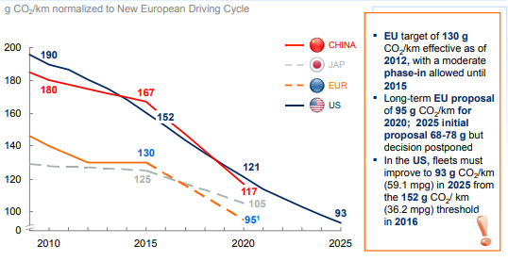
Source: (McKinsey & Company, 2020)
Apart from that, the government pressure was from urging the organisations to use the technology and manufacture less oil intensive transports.
Economic factor: There are various European governments along with cities that are incentivizing consumers intending to opt for electric mobility based on their schemes (Chasdi, 2017). Norway offering a broad package of subsidies of ~EUR 17,000 for the purchase of the compact class ICE car. At the same time, the onetime premium of GPB 4,000-7,000 based on the purchase price is offered to the buyers by the UK government for the purchase of the cars which are emitting less than 75 g/km (McKinsey & Company, 2020).
Figure 3: Stimulating EV demand: Governments
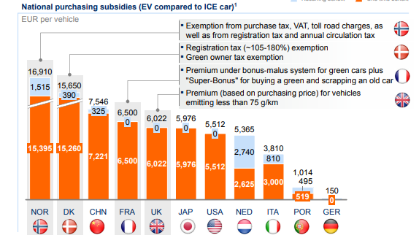
Source: (McKinsey & Company, 2020)
Social factor: with the development of the change in the lifestyles of the higher income group customers, their demand towards the changes attributed to cars has been developed with more advanced features (Shageeva et al, 2017). There are some of the key considerations preferred by them as carbon footprint reduction, driving smoothly and usage benefits, cost savings, and the electrification development, and others. Based on this social demand, the car manufacturing companies including Volvo has focused on the electrification of the engine (McKinsey & Company, 2020). The demand for the EVs in various European cities highlighting the a social demand is as below:

Figure 4: Stimulating EV demand: Cities
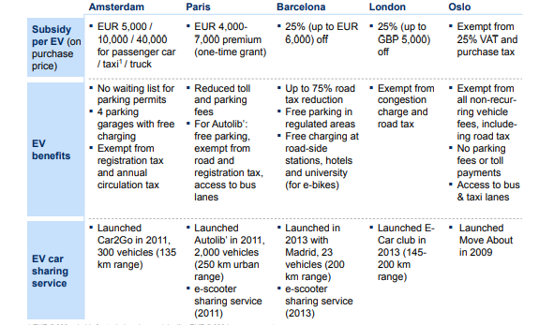
Source: (McKinsey & Company, 2020)
Thus, the economic support to motivate the social class and developing the demand from the EVs can be addressed by this.
Technological factor: prioritization of the EV technology and aim to be the leader in the technology application and to keep the value chain supply of the car manufacturing industry can be highlighted as the important driving force for shaping the new car manufacturing industry. This also has been adopted by the Volvo V60 plug-in hybrid as the example car manufacturing brand. Apart from that the large battery capacity and the Li-ion technology also is prominent in this industry to maintain change management (Dhiravidamani et al, 2018).
Legal factor: The legal support from the relevant country government highlighting various trade-related obligations, and trade-related opportunities can be highlighted as the legal support to be offered to this car manufacturing industry of Europe (Narins, 2017).
Environment factor: The environment conservation acts like the less carbon emission, maintaining the natural resource of the European countries, and recycling the resources are the prime factors focused by the management of the car manufacturing organisations in the industry. It also has been thought by Volvo management and other car manufacturing companies to bring the relevant change (Hamilton & Webster, 2018).

Porter’s five force analysis
With the help of this analysis, the competitor's analysis, and external market analysis have been addressed. The model illustration is as below:
Figure 5: Porter’s five force analysis
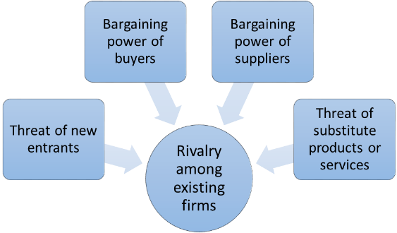
Source: (Adekola & Sergi, 2016)
Bargaining power of buyers: the bargaining power of the buyers is moderately strong in this industry. Suppliers are in a position to bargain for lower prices. Based on the intense competition in the European car manufacturing industry, demanding for more developed products, with high attributes and functions are preferred by the maximum people (Adekola & Sergi, 2016). At the same time, value for money is another important criterion considered by the target customers. Demand for the Electric vehicles with the electrified engine is the relevant demand by the high profile customers. All the car manufacturing organisation is engaged with this advancement. This has developed the high bargaining power of the buyers.
Bargaining power of suppliers:The bargaining power of the suppliers in the European car manufacturing industry is low. The threat of forwarding integration is low which has developed a low threat from the suppliers. With the help of this issue, the car manufacturing industry has aimed to develop as per the needs of the customers (Nauhria et al, 2018). Citing the example of Volvo cars, Daimler Truck AG can be highlighted as the key supplier of the organisation. More than 51,000 suppliers are working with Volvo, and more than 1, 000,000 people are working with the suppliers to deliver the needs of Volvo car manufacturing. Annually, 2,5 billion parts are delivered to the organisation, which is positive for the organisation(McKinsey & Company, 2020).
The threat of substitute products: The threat of substitute products is low in this car manufacturing industry, the subcultures can be highlighted as air industry, the bus, the trains, and others which are not the suitable option against the personal vehicles. Thus, the threat from the substitutes of this industry is low which can be utilised by the car manufacturing industry of Europe in meeting the customer’s demand using the government support and using the advanced technology application.
The threat of rivalry: The threat of rivalry is high in this industry based on the presence of numerous competitorslike Volvo, Toyota, BMW, Audi, Honda, KIA, Hyundai, Fiat, Ford, and others. Thus,it is required to concentrate by the electric vehicle industry of Europe over its operational steps and strategies incorporated and should try to enlist their name in the early adopter in the technology application for making the electrified heavy cars (Ng & Hamid, 2017).
Figure 6: Volvo competitors with their targets
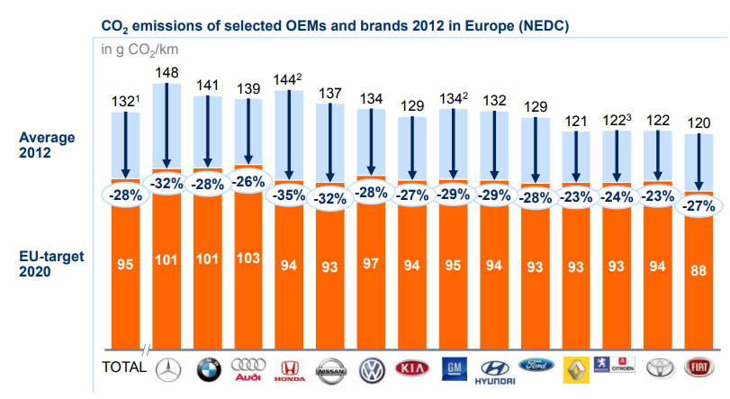
Source: (McKinsey & Company, 2020)
The threat of new entrants: This threat is low in the car manufacturing industry with the highly developed technology application as it involved a wider level of the investment, and maintenance of wider political obligations effectively. Thus, based on this less threat, electric car manufacturing industry of Europe will be able to maintain their business pressing and positioning their brand among the target customers aiming their demand fulfilment (Keegan, 2017).

A critical assessment of the organisational change
Based on the change of the market trends and change in the need for the demand in electrified engines, the changes in the electric car manufacturing industry also have taken place and as a result, all the engines starting from 2019 have been shifted towards the electrified engines (Vaughan, 2020). In this aspect Volvo, and Ford has taken its serious step to make the electrified vehicles starting from 2019. Based on the adverse consequences of global warming due to the excessive carbon emission, the decisions by the car manufacturing management has been started to get shifted towards the adaptation of the electrified engine development.
It is the target of the industry management to sell electric vehicles including the plugins and hybrids along with the pure battery-powered cars by the end of 2025 with large volume. Thus, acceptance of change management also is likely to get developed in the organisation culture effectively (Vaughan, 2020). The change management can be accepted by the employees and management of the organisation in two ways. The first concept can be highlighted as the acceptance of change management concept as the continuous as well as intrinsic to the organisation. The continuous growth and development of the organisation with the help of the application of advanced technology can be highlighted here for all car manufacturing organisations in this industry.
The second concept can be highlighted where the organisational change can be highlighted by the organisation as extrinsic as well as discontinuous. Here, the stable structures of the organizations can be highlighted, and the change can be perceived as the most disruptive. Critically, it can be stated that organisation’s management is about to focus on the first concept where the change should be intrinsic and should be incorporated with all the aspects of the organisation change.The partnership with various organisations to develop better cars to continuously grow also can be planned by the brand. The example of merger of Volvo car manufacturing company with others can be highlighted as the unplanned and based on the emergency requirement of the market. Here, the Kotter’s eight-step change management model can be used as below:
Figure 7: Kotter’s eight-step change management model
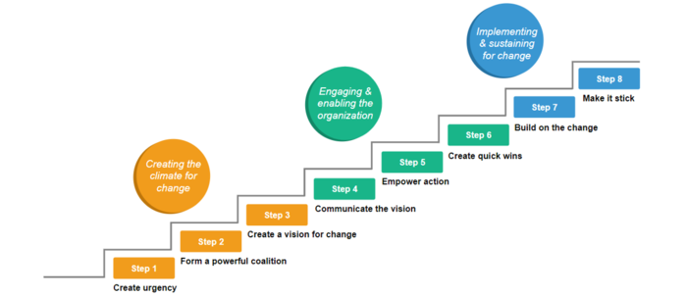
Source: (Humphreys & Munro, 2019)
Thus, as per the model creating the urgency based on environmental protection, and fewer carbonemissions to make the greenhouse gas emission within control can be stated. The powerful coalition among the employees and other organisations in the form of mergerbusiness also is an important part of the change management process of Electric vehicle car manufcatuirng industry of Europe(Humphreys & Munro, 2019). Creating the vision of change can be highlighted as the planned process by the organisation to bring 100% electric cars between the times 2019 – 2021, and also to ensure the rest of the conventional petrol and diesel range will be the hybrid engine in nature.
Again critically, it can be stated that the change management process adaptation by car manufacturing organisations was limited in nature based on the unstable organisation culture where the communication process was limited in nature due to the change in the needs and demands of the market. All the employees and staff could not be included in the decision-makingprocess so that the limiteddecisional element has developed low strategic steps. Thus,further, the changes can be aimed for better communication process development and empowering the employees to be part of the decisions making process. Accessing the technological advancement by the staff and employees also can be highlighted as the change in the organisation operational process and organisation culture (Witte, 2018). Based on this change management proecss, Volvo can be highlighted as the first car manufacturer in the European country to take the bold step to develop the electrified, hybrid cars. Above all, making the process stick with the organisation to ensure the continuous growth of the business also can be highlighted.

Reasons for the organisational changes
Transportation has been accounted for 14% growth of greenhouse gas which is not good for the global environment. The demand for the electrified engine cars along with the hybrid cars have been developed, and also the battery costs have been reduced down (McNaughton, 2018). It also has been highlighted that traditional automobile companies are concentrating on the new approaches and models inclusion to develop a new value chain to develop an overall competitive advantage. The recent trends of the incumbents in developing the Electric vehicles as the requirement for the change to bring in Volvo is as below as an example based on the case study information need:

Figure 8: Incumbents and new entrants are trying to capture new opportunities
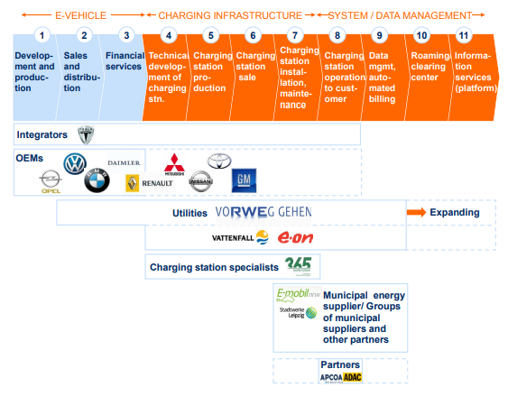
Source: (McKinsey & Company, 2020)
This electric mobility system is welcoming a wider range of innovative models to adapt the EV manufacturing model to ensure a better demand meeting approach of the automobile manufacturing trends (Witte, 2018).
The overall impact of the powertrain allocation on the value chain also can be highlighted as an important reason to take the innovation business model by Electric vehicle industry organisations in Europe to meet the market trends.
Figure 9: Impact of powertrain transformation on value chain
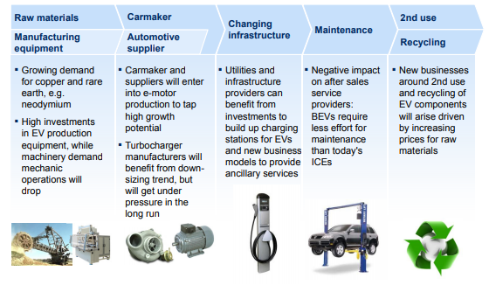
Source: (McKinsey & Company, 2020)
Therefore, the need for the market trends, the need for environment protection acts maintenance, and the aim of gaining a high competitive advantage for the sustainable position in the car manufacturing industry, the need for the organisation change by Electric vehicle manufacturing industry in Europe can be addressed (Humphreys & Munro, 2019).

Conclusion
Therefore, the overall discussion of the report has highlighted the global environment of the car manufacturing industry and its recent trends to be adopted by the car manufacturing industry aiming at its continuous growth and sustainability in the competitive market. Various models also have been used to address the aspects critically.

References
Adekola, A. and Sergi, B.S. (2016) Global business management: A cross-cultural perspective. Routledge
Barac, K., Gammie, E., Howieson, B. and Staden, M.V.( 2016) The capability and competency requirements of auditors in today's complex global business environment
Chasdi, R.J. (2017) Corporate Security Crossroads: Responding to Terrorism, Cyberthreats, and Other Hazards in the Global Business Environment. ABC-CLIO
Dhiravidamani, P., Ramkumar, A.S., Ponnambalam, S.G. and Subramanian, N. (2018) Implementation of lean manufacturing and lean audit system in an auto parts manufacturing industry–an industrial case study. International journal of computer integrated manufacturing, 31(6), pp.579-594.
Hamilton, L. and Webster, P. (2018) The international business environment. Oxford University Press
Humphreys, M. and Munro, D. (2019) Brexit and the Car Industry. Routledge
Keegan, W.J.( 2017) Global marketing management. Pearson India
McKinsey & Company,( 2020) Electric Vehicles In Europe: Gearing Up For A New Phase?.
McNaughton, R.B. (2018) Global competition and local networks. Routledge
Narins, T.P. (2017) The battery business: Lithium availability and the growth of the global electric car industry. The Extractive Industries and Society, 4(2), pp.321-328
Nauhria, Y., Kulkarni, M.S. and Pandey, S. (2018) Development of strategic value chain framework for Indian car manufacturing industry. Global Journal of Flexible Systems Management, 19(1), pp.21-40
Ng, S.C. and Hamid, N.A.A. (2017) . Green manufacturing performance measure for automobile manufacturers in 2017 International Conference on Industrial Engineering, Management Science and Application (ICIMSA) (pp. 1-5). IEEE
Shageeva, F.T., Erova, D.R., Gorordetskaya, I.M., Kraysman, N.V. and Prikhodko, L.V. (2017). Training the Achievement-oriented Engineers for the Global Business Environment. In International Conference on Interactive Collaborative Learning (pp. 343-348). Springer, Cham
Vaughan, A. (2020). All Volvo Cars To Be Electric Or Hybrid From 2019. [online] the Guardian. Available at: <https://www.theguardian.com/business/2017/jul/05/volvo-cars-electric-hybrid-2019> [Accessed 28 April 2020].
Witte, C. (2018). Consumer Perceptions Regarding Fixed Versus Negotiated Pricing in Auto Purchasing. Copyright 2018 by Institute for Global Business Research, Nashville, TN, USA, p.154

