Table of Contents
Introduction 3
Part A: Business budget-oriented decisions and performances 3
i) Presentation of business budget report with variance analysis 3
ii) Evaluating business performance engagement related to present period 6
iii) Business recommendation regarding 7
Part B: Business cost-benefit analysis support 8
First option: Own online shop 9
Second Option: Direct Amazon Selling 10
Conclusions 11
References 12

Introduction
Accounting significance is mainly identified for measuring financial stability and accounting sustainability reasons that provide a proper supportive engagement regarding organisational growth. Management Accounting concept related to individual business provides some accounting guidance including decision-supportive actions that are optimised for developing financial maintenance and accountability growth on a developing basis.
A positive disclosure of business managerial processing is initiated for maintaining the formulated development support including progressive standard costing and variance processing benefits with recognition of which the general growth including optimised values are mainly managed (Ascani et al., 2021). This report enables business decisions including comparative processing support that brings positive business stability.

Part A: Business budget-oriented decisions and performances
A proper maintenance of basic budget processing is initiated for measuring the accounting formulation and associated developmental support that brings strategic recognition support on a proper basis. Applied the identification of general accounting brings the basic recognition support that is optimised for initiating the business developmental growth including some of the sustainability structure that brings the ultimate processing of business growth and other formulated processing in a proper basis (Johnstone, 2020).
According to provided details, the organisation Amana Ltd is a family-owned tourist business that is incorporated in the United Kingdom. It has operated for more than 40 years and it is mainly initiated by dynamic industrial processing with a supportive cultural engagement as well. However, due to the reasons of the current pandemic and lockdown initiatives by the government the organisation is impacted negatively from the aspects of business revenue and operating engagement. In association with the present provided details of business cost breakdown have been provided with the presence of which a general analysis regarding business budget formulation has been initiated (Wolf et al., 2020).

i) Presentation of business budget report with variance analysis
Monthly controlling report: According to basic financial processing, the primary presence of this type of reporting engagement is initiated for measuring the business's financial and operating development support on a monthly basis with a basis on which a general recognition regarding managerial development can be initiated (Hiromoto, 2019). The presence of this report is managed for initiating the managerial tracking engagement including performance measurement support that is optimum for developing and formulating business operating compatibility on a proper basis. Such presentations related to the business are provided below;
Identification of Variance analysis related to Original budget and actual performances
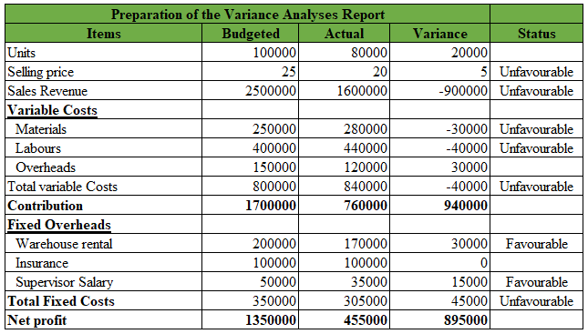
Original budget: According to the present productive engagement, a significant volume of support regarding financial budget engagement has been initiated that indicates progressive operating stability including financial compatibility values on a proper basis. A general determination of this type of engagement is also managed for initiating the feasibility value support including the accuracy level regarding financial market engagement that is optimum for business financial formulation purposes (Möller et al., 2020).

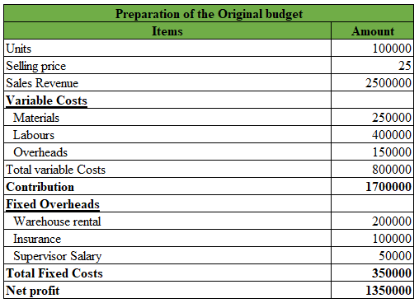
Actual budget: with the basis of present financial engagement including the operating formulation approach the identification of actual budget processing has been initiated with the identification of which proper recognition support regarding accounting formulated development for the upcoming period can be initiated as well.
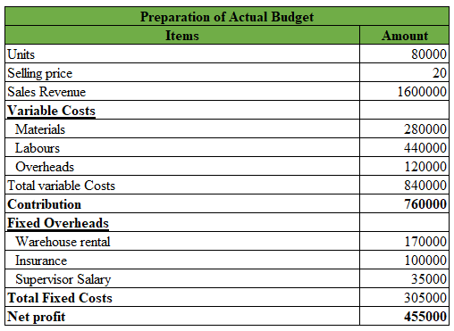
Flexible budget: The applied presence of this budget processing is initiated for recognising the basic changes associated with business revenue formulation with the support of which a basic recognition regarding business activities can be initiated on a proper basis. A proper maintenance support of this formulation is also managed for identifying the recognition regarding business static formulated approach also that is comprehensive for developing and maintaining the optimised growth support in a formulated basis. Such a presentation related to this business has been provided (Korhonen et al., 2020).
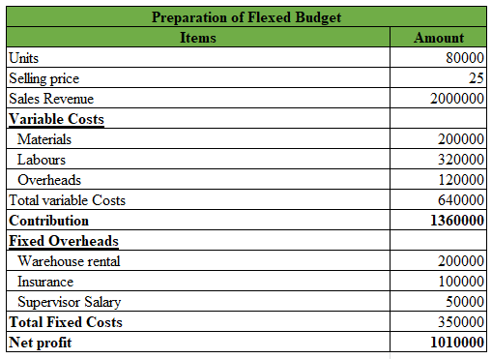

ii) Evaluating business performance engagement related to present period
Along with the current analysis, a significant volume of presentations regarding business financial processing or estimated engagement has been initiated that can be identified for recognising the business stability and formulated development on a proper basis. According to the present details, a significant volume of variance or differentiation is mainly noticed that indicates compared to the level business's original budgeted performances, the level of the business's actual financial position is different and due to such engagement, a huge level of changes in the profit or earning position of this business has been initiated as well (Gunarathne et al., 2021).
As per the present details, the volume of business sales level declined from 100,000 to 80,000 in the present position associated with the marketing demanding position. Even the same selling price level also declined from level 25 to 20 which generally indicates the insufficient financial engagement position in the current marketing structure mainly. The primary reasons behind this declining position indicate the negative approach of covid lockdown that generally declined the marketing demand position significantly. On the other hand, the presence of the current productive costing level is initiating some negative approaches over the business operating engagement as well. In the present position, while the present level of the selling price is declining, even the other product costing charges are increasing in the present position related to material from 2.50 per unit to (280,000 / 80000) = 3.50 per unit, which indicates around 1.0 per unit price enhancing position in the present level. Even the labour charges are also expended with 1.50 per unit support that ultimately resulted in declining the level of business expected contribution to the position of 9.50 per unit respectively. Therefore, it can be considered that in the present position the level of the business's financial Compatibility approach is significantly declined compared to the volume of the business's expected financial position mainly.
Associated with the basic financial engagement, the volume of business production capability is declined that generally imposes a negative approach over the business formulation including operating stability position in the covid condition mainly. Including the declining customer level due to covid, the present supply chain management of the business is also negatively impacted that influencing a certain negative approach to the business stability and accounting progressive performances mainly (Eldenburg et al., 2020). According to the present position in the present operating engagement, in order to address the losses Amana is generally required to manage a proper volume of development including product demanding support including price formulation support as well that can be managed for initiating the structural progress and optimised balancing support in a proper formulated basis.

iii) Business recommendation regarding
According to the basic operating engagement including the formulation approach, a positive volume of development regarding business productive engagement is generally required to be initiated on a proper basis so that a formulated business processing can be initiated as well. As per general engagement, it is considered that in the present position after the pandemic the management of the business needs to revise the overall operating engagement including financial processing mainly so that a positive formulation including optimised developmental support can be managed on an effective basis. Associated with the general performance structure some of the relevant business recommendations have been initiated (Alvarez et al., 2022).
Revenue processing: In the present circumstances the management of the business is generally required to provide importance to the selling price development approach on a formulated basis so that the general volume of business revenue development including operating balancing support can be managed. Additionally, a proper progressive structure regarding business marketing demand is also required to be enhanced on a supportive basis with the maintenance of which sustainable business growth can be formulated (Asiaei et al., 2022).
Cost development: In the present circumstances the management of the business is also required to manage the volume of product costing level on a proper basis with the support of which general stability including productive profit of business can also be managed on a proper basis. Application of competitive marketing analysis is also required to be managed on a developing basis in the present position before initiating the productive price determination purpose so that positive business growth including marketing opportunities can be managed on a proper basis. Along with the variable costing, fixed-cost maintenance support is also required to be established as well for future stability growth (Ameen et al., 2018).
Promotional engagement: According to the present operating engagement, the management of the business is required to initiate a supportive operation development including marketing engagement that can be initiated for managing the optimised value and other supportive formulation on a proper basis. Additionally, the present management of the business is also required to formulate proper utilisation support of social media as well so that the ultimate development includes progressive structure regarding business operation and formulation that brings sustainable and marketing initiatives on a proper basis.
Key performance indicators: According to present operating engagement the performance structure of the business basically indicates a sustainable formulated approach including operating development support mainly with the initiative of which general stability and marketing growth can be managed. In the present operating development structure, the management of the business needs to provide significance to the presence of KPI formulation on a proper basis so that the ultimate development regarding business accountability is formulated.
With the application of this type of attributes, operating progress including the sustainability approach of business can be initiated as well which brings optimised development including progressive development regarding business stability on a proper basis.

Part B: Business cost-benefit analysis support
According to general conceptual engagement under the costing, the presence of Cost-benefit analysis is mainly initiated for measuring the general advantages engagement regarding business product costing with the support of which a positive volume of support regarding business operating formulation including operating development can be formulated. Proper maintenance of this type of engagement is identified for formulating general differentiation processing including financial stability support also with the maintenance of which general progressive structure including business development can be identified as well (Al-Baghdadi et al., 2021).
Fundamentally, the engagement of this analysis is initiated for recognising the general development including basic business decision-supportive actions with the presence of which a general formulated development including the optimised growth initiatives can also be identified. It is also applied for recognising the general financial support with hidden cost determination processing support that brings positivity and accountability initiatives on a proper basis. Additionally, the engagement of this approach is also managed for initiating the basic business decision formulating and cost formulating support that brings comprehensive details including structural progress on a formulated basis as well. In some cases, application of this particular analysis is also initiated for developing competitive advantage support as well (Gonçalves and Gaio, 2021).
According to the present operating engagement it can be considered that in the present moment the management or Mr Amana has noticed that most of organisational competitors' in the present position provides significance to the presence of social media engagement for promotional purpose and also online trade processing for customers development in the area of Europe, UK and US as well. In the present position, the organisation is basically operated in three different branches related to “Brighton, Birmingham city centre and Manchester city centre” and for initiating the business operating development the management is decided to close the Brighton branches and continue the business operating engagement through 50% via branch sales and 50% through online sales support.
However, in order to consider online sales processing, owners mainly have two different options regarding using their own online shop support or initiating sales via Amazon direct selling support. According to both options, the maintenance of proper accounting analysis including a cost maintenance approach can be initiated that brings the optimised development including a progressive financial approach in a formulated basis for optimised growth and associated formulation purpose (Kostyukova et al., 2018). In accordance with the present operating engagement, the presence of business comparative analysis has been provided with the support of which a general formulation regarding business financial and operating development is provided as well. Such details are provided;

First option: Own online shop
In order to initiate the general operating maintenance including costing maintenance support, the computation of business cost statement and profit formulation has been provided that can be managed for recognising the financial optimised values and other associated financial formulation in a proper basis. Such computed details are provided.
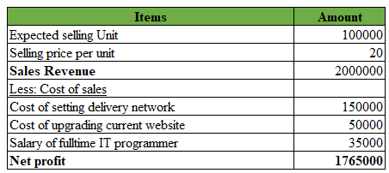

Second Option: Direct Amazon Selling
According to the present level of business marketing including the presence of business operating engagement the presence of costing and profit processing under this sales approach has been provided for initiating the general differentiation support. Such details are provided;
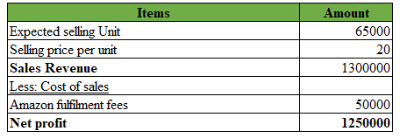
Along with the processing of this specific analysis support a significant volume of differentiation regarding business profit position is mainly recognised that indicates the present level of business operating engagement under different circumstances. As per the present marketing structure, the business has mainly two different options regarding using their own online shop support or initiating sales via Amazon direct selling support. According to both options, the maintenance of proper accounting analysis includes a cost maintenance approach that is mainly structured for evaluating the differentiation level of business profit so that depending on such business operating decisions can be managed.
According to current own online shop support, the business is able to gain around 1765000 as present net profit, while with Amazon direct sales support it can gain up to 1250000 as business profit mainly. Therefore the presence of its own sales channel provides (1765, 000 - 1250, 000) = 5, 15,000 additional profit support in the present financial period. Additionally, it can also recognise that in the present level of operating engagement, the organisation will be able to sell up to 100,000 selling units, while via Amazon it will be 65,000 only. Therefore a proper volume of development regarding productivity growth and performance approach is necessary in the present position for initiating the operating development including progressive performance stability support on a developing basis.
Additionally, the presence of an online market position related to this type of engagement generally initiates a significant level of competitive marketing position under which a proper competitive marketing gain is difficult for this type of business in the present position. Even this type of market generally indicates the involvement of business branding engagement mainly that is non-progressive for business sustainability and other associated progressive purposes. In the present position initiating the approach of business trade processing with this type of approach generally indicates the involvement of social media engagement and other associated factors engagement is generally unable to provide effective business compatibility. Associated with the present operating approach, it is mainly recognisable that the involvement of own online trade processing will be beneficial for the business from the aspects of business profit earning and operating compatibility supports.

Conclusions
Apart from the costing engagement, the presence of Management Accounting is mainly initiated for structuring the financial decisions and operating development approach that provides the operating engagement on a proper basis. A proper supportive presence of this type of processing brings proper stability including planning and controlling function as well that is comprehensive for stability and comprehensive structural processing on a formulated basis. It also identifies standardised progress including standard development support that brings the comprehensive and formulated operating engagement on an optimised basis. General maintenance of this type of engagement formulates a basic development including a marketing progressive approach for a business like Amana Ltd in order to standardise sustainable development as well as the competitive advantage support on a proper basis.

References
Al-Baghdadi, E.N., Alrub, A.A. and Rjoub, H., 2021. Sustainable Business Model and Corporate Performance: The Mediating Role of Sustainable Orientation and Management Accounting Control in the United Arab Emirates. Sustainability, 13(16), p.8947.
Alvarez, T., Sensini, L., Bello, C. and Vazquez, M., 2021. Management accounting practices and performance of SMEs in the Hotel industry: Evidence from an emerging economy. International Journal of Business and Social Science, 12(2), pp.24-35.
Ameen, A.M., Ahmed, M.F. and Abd Hafez, M.A., 2018. The impact of management accounting and how it can be implemented into the organizational culture. Dutch Journal of Finance and Management, 2(1), p.02.
Ascani, I., Ciccola, R. and Chiucchi, M.S., 2021. A structured literature review about the role of management accountants in sustainability accounting and reporting. Sustainability, 13(4), p.2357.
Asiaei, K., Bontis, N., Alizadeh, R. and Yaghoubi, M., 2022. Green intellectual capital and environmental management accounting: Natural resource orchestration in favor of environmental performance. Business Strategy and the Environment, 31(1), pp.76-93.
Eldenburg, L.G., Brooks, A., Oliver, J., Vesty, G., Dormer, R., Murthy, V. and Pawsey, N., 2020. Management accounting. John Wiley & Sons.
Gonçalves, T. and Gaio, C., 2021. The role of management accounting systems in global value strategies. Journal of Business Research, 124, pp.603-609.
Gunarathne, A.N., Lee, K.H. and Hitigala Kaluarachchilage, P.K., 2021. Institutional pressures, environmental management strategy, and organizational performance: The role of environmental management accounting. Business Strategy and the Environment, 30(2), pp.825-839.
Hiromoto, T., 2019. Restoring the relevance of management accounting. In Management Control Theory (pp. 273-288). Routledge.
Johnstone, L., 2020. A systematic analysis of environmental management systems in SMEs: Possible research directions from a management accounting and control stance. Journal of Cleaner Production, 244, p.118802.
Korhonen, T., Selos, E., Laine, T. and Suomala, P., 2020. Exploring the programmability of management accounting work for increasing automation: an interventionist case study. Accounting, Auditing & Accountability Journal.
Kostyukova, E.I., Vakhrushina, M.A., Shirobokov, V.G.E., Feskova, M.V. and Neshchadimova, T.A., 2018. Improvement cost management system for management accounting. Research Journal of Pharmaceutical, Biological and Chemical Sciences, 9(2), pp.775-779.
Möller, K., Schäffer, U. and Verbeeten, F., 2020. Digitalization in management accounting and control: an editorial. Journal of Management Control, 31(1), pp.1-8.
Wolf, T., Kuttner, M., Feldbauer-Durstmüller, B. and Mitter, C., 2020. What we know about management accountants’ changing identities and roles–a systematic literature review. Journal of Accounting & Organizational Change.

