PROJECT PLANNING AND MANAGEMENT IN WORKPLACE REPORT
(BMSW5104)

KHALIL MIAH (1709513)

20/12/2019

.
Table of Contents
Introduction 3
Project management techniques and tools 4
Project life cycle 4
Iron triangle 7
Drawing project tools and techniques 11
WBS (Work Breakdown Structure) 11
Importance of monitoring and evaluation of projects 15
Recommendations and self-development for future projects 16
Conclusion 16
Reference list 17
Appendix: Manchester redevelopment project 21

Introduction
This report sheds light on project management activities and identifying that the ability to achieve long term success and desired results can be fulfilled by following a project planning process. Most projects are done in groups or carried out by large organisations, by using various project management tools and techniques which will be discussed in this report. In order to improve the project and achieve long term success, the organisation or individuals need to adopt advanced technology within the project work. Evaluation of project and recommendations for developing future projects has also been done in this report.
In this world of rapid digitalisation, project management activities give a huge opportunity to develop or construct an organisational structure as opined by Wookey (2019). Project management and planning can be effective for providing a proper working procedure and motivation to the employees that help to execute successful project work in an exact manner especially in the construction industry such as the Manchester Regeneration project which aimed to boost the hospitality sector in the city. The project consisted of building various commercial buildings and residentials homes across Manchester that cost nearly 75 million pounds as Onetouchinvestment.co.uk (2019) describe in their article (appendix figure 1). As mentioned by Evans et al. (2019) planning and executing such are large scale project can only help the future growth of the construction firm and its employees will gain valuable experience and knowledge for future projects.

Project management techniques and tools

Project life cycle
When starting a project, it is necessary to use project management tools or techniques that help to plan and finish the selected project in a successful manner, as suggested by Andersen (2016). A good tool to begin with would be the Project Lifecycle that includes five different steps that help to execute a big and complicated project with a step by step manner as opined by Pathak (2018).
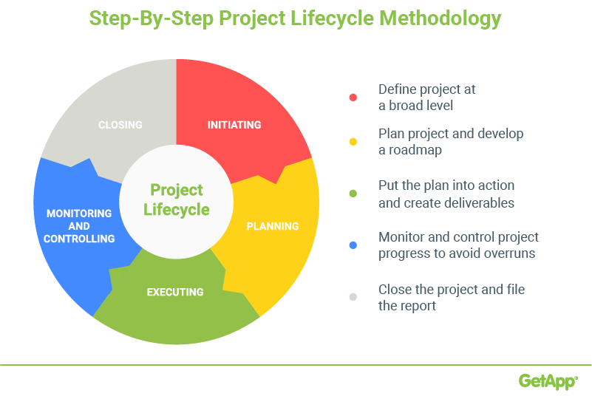

Figure 1: Steps of PMBOK methodology
(Source: Singh 2019)
Here are the five steps:
Initiating: In the first stage of Initiation, proper skills and knowledge of working in a project will be identified properly. Besides, as stated by Volkov and Kuzina (2016), it is important to schedule the work and determine what tasks need to be carried out. Before planning the project structure, team selection, budget allocation will also be done in this stage. As stated by Warren (2019) it is also important to select a project leader before starting any project to provide vision and direction, the individual should have good leadership and problem-solving skills.
Planning: After initiation of the project, planning process is required to develop strategies of carrying out tasks in more detail and setting completion dates for each task which is important to future development of the project this is also referred to as “scope management” as opined by Kashyap (2018). Carrying out a stakeholder and risk analysis are involved in planning which will be discussed further down the report, .Communication between all parties involved in various projects is very important and using internet based resources and social media platforms are the easiest and quickest way to keep everyone involved informed as opined by Barnes (2009). Google Docs and mobile Apps like What’s App, Hangouts and Evernote can be used by project teams to communicate with each other at any time of the day to complete projects more efficiently. Individuals or groups will be given tasks by the project leader who will be co-ordinating the whole project. Various tools are used in planning such as Gantt and WBS charts which will be discussed later in the report.
Executing: The execution phase involves putting all the ideas and tasks into motion and project deliverables are produced and delivered to the customers, this is usually the longest phase of any project as described by Gulec (2019). The project leader will be co-ordinating with team members and performing related tasks at the scheduled times which were created in the WBS chart. At this stage, managing key stakeholders’ expectations and keeping them informed with any progression or setback is very important as they are usually the people that are financing the whole project as explained by Caietti, (2018).

Monitoring & Controlling: In the stage of controlling, Project teams need to use the WBS and Gannt charts to monitor their progression or adjust any timeframes due to setbacks or lack of resources as usually problems may arise as stated by Future Learn (2019) who also state that at this stage project teams are comparing actual performance to their planned performance. Frequently project leaders of any organisation will motivate their employees or teams as it is their responsibility to monitor the overall process as mentioned by Matějka et al. (2016), A lack of leadership and monitoring can lead to team members going in different directions or become inattentive to the project goals as stated by Lim (2019).
Closing: In the last stage of closing, the project work has been done properly and finished within the allocated budget and given time span. Handing over the final deliverables to the customer such as project documentation and notifying all stakeholders of the closure of the project is also finalised at this point as stated by Watt (2018). Besides this Watt (2018) also mentions that individual performances are looked at, by the hierarchy to give proper feedback to the employees a bit like a lessons learned study which can be helpful for organisational growth as the findings can be transferred back to other future projects and employees gain better knowledge.

Iron triangle
It has been seen that the main three concepts of the Iron triangle are scope, time and cost. These are the main criteria of completing the project work in a flexible manner. However if one of the concepts are affected like if material prices were to rise this would affect the cost which will also affect the time and quality of the project so it is vital to have a good project manager to work with these constraints while managing a project of such a large scale as stated by Kerzner (2009). Here is an example of the iron triangle in project management for the construction of the Manchester Regeneration Project.

Scope: This project is able to fulfill the project goals
Time: This project has been completed within the 6 months
Cost: £75 m budget has selected for the project
Quality

Figure 1: Iron triangle

Scope: The Manchester redevelopment project has a huge scope to enhance the overall business of the concerned hospitality sector. Furthermore, the project is highly capable to fulfil the project goals and achieve sustainable development in a proper manner. As commented by Matějka et al. (2016), due to high perspective of achieving the long-term success, the organisation has focused to implement advanced technologies on their new redevelopment work.
Cost: As opined by Volkov and Kuzina (2016), in order to execute the big project work and deliver it in a successful manner, it is important to allocate proper budgetary amount. In this respect, £75 million has been allocated for finishing the project work. Before starting the project work, budget planning needs to be made which gives proper evaluation of the project work.
Time: In order to complete the redevelopment project activity, 6 months’ time has been allocated which helps to divide the job within a time span. This can be highly beneficial for operating the project in a flexible manner.

Quad Chart
Purpose  Sort.SiSort.com is launching a new career path and job search platform. Our group must recruit potential users of sort.com and by conducting various research methods we will then evaluate this information and present our findings and insights on how people think about using careers websites and the website design and how accessible the new platform is for users. | Stakeholders  Uwtsd  Sortyourfuture.com  Participants  Various organisations  Users
Desired end result  The desired result should be to know positive and negative points about the content and design of the website and how useful it was for users and what was their experience of using careers websites. | Measures of success  Help people find jobs  If it improves people's careers or future prospects.  Sort.com take into account users’ insights and make changes to their platform if required.

Quad Charts are basically what the project is all about and summarising it on one table and enables project teams to define what to do before they even start (Chegg.com 2019) The quad chart above was created for the launch of a new online careers service and is set up into four quadrants Project Scoping, Stakeholders and Stakeholder Analysis, Desired Outcomes (Critical Success Factors), and measures of Success (Secondary Benefits).

RISK ANALYSIS
In order to develop a project work, several risks may arise during the execution of work. Shortage of allotted budget amount, lack of involvement of employees and project team members, less communication with high stakeholders and poor strategic planning may hamper the overall project work. Here is an example of a risk analysis for the launch of a new website.
Impact  H/M/L | Likelihood  H/M/L | Risk | Category | Mitigating Action
M | L | Weather | Natural cause | Have a backup location or internet access
H | M | Confidentiality Breach | Competence | Store and lock all private information
H | M | Questionnaire not completed on time | Individual | Have extra participants
H | L | Software or computer not working | Technical | Have extra laptop or store data on USB
M | L | Emotional or psychological Risk | Individual | Calm and laid-back approach
H | M | Anonymity | Individual | Collect data that cannot be traced back to individual

It can be identified from the Risk Analysis that for this project most of the threats can occur from Individual or technical errors which are not high risk , the only risk which the team can’t avoid are natural causes and is usually the most problematic for many projects as stated by Ballesteros-Perez (2018) so having a solution to this is vital to the outcome of the project.

Drawing project tools and techniques

WBS (Work Breakdown Structure)
A WBS chart is created at the planning phase of any project and demonstrates the tasks which are required to accomplish and finish a project successfully as stated by Cohen (2012). Below is an example of a WBS created by a project team, all tasks have been outlined at various phases of the project life cycle and draw out as multiple levels similar to a hierarchical structure characterising each task and subtasks involved in this particular project. Group members will be assigned to these various tasks and will be accountable for their individual work being completed. Reddy (2019) explains that sometimes having too many tasks on a WBS can make team members spend a lot of time on these tasks or start to do everything in one go which can get a bit messy and give poor results back to the project leader who will also be busy keeping track of all these tasks.

Figure 2: WBS

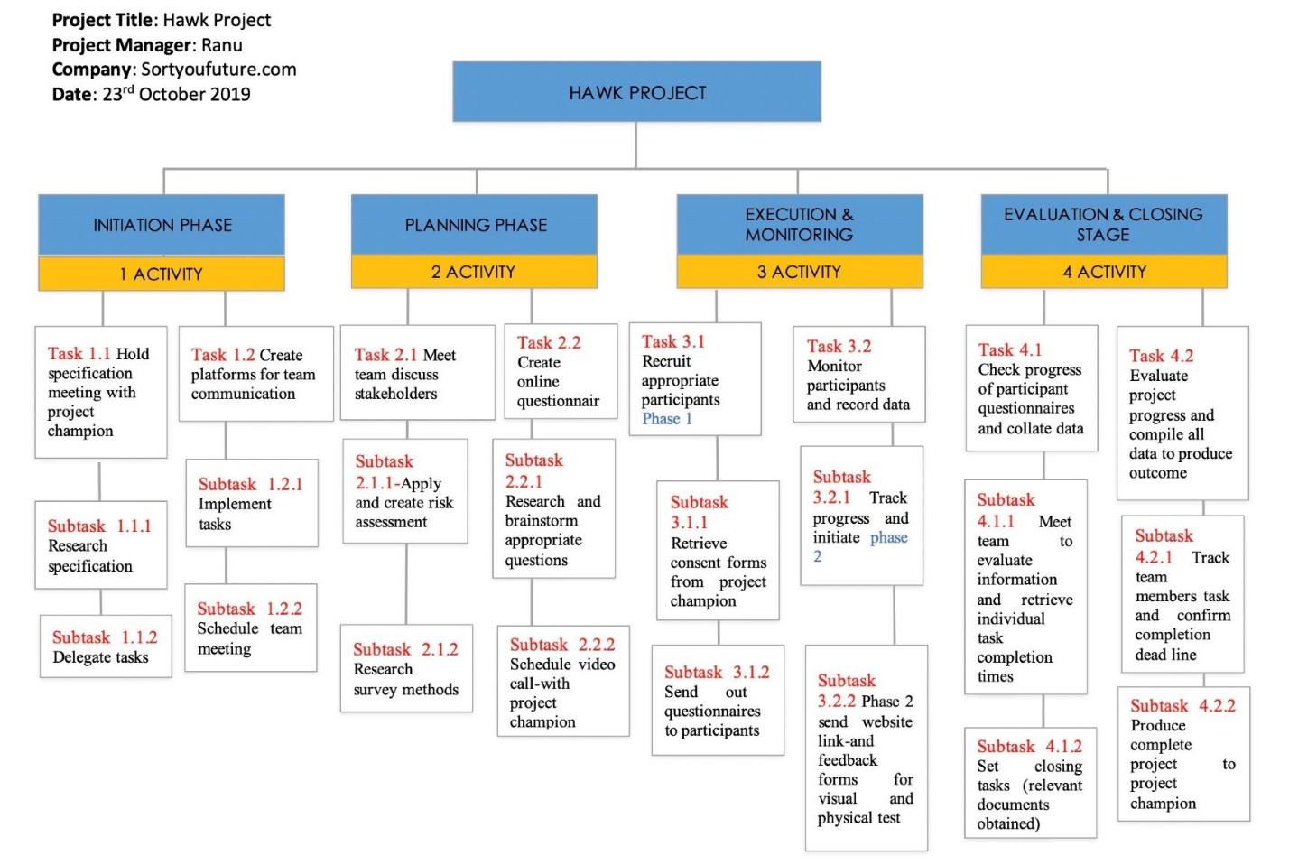

Figure 3: Gantt Chart
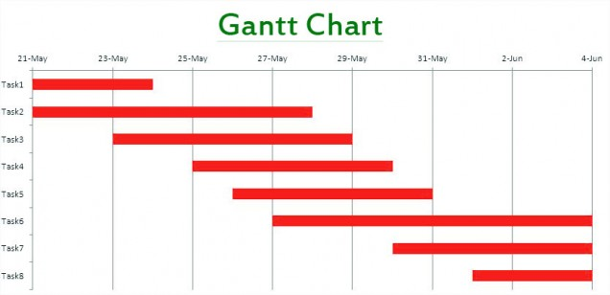
Soni (2019) opines Gannt charts are very useful in project management by displaying activities against time. The length of the bars emphasises on the time scales involved in completing certain tasks. The chart helps to keep all project teams on the same page with its visual framework and by letting everyone know how the mistiming of each tasks can have on impact on the future tasks and hinder the completion of the project in its timeframe. Soni (2019) also explains a limitation in Gantt Charts are they to not include certain restraints like time or costs so the use of another tool like the iron triangle can be observed at the same for certain projects.

Stakeholder Analysis
PRIORITY | STAKEHOLDER | STAKEHOLDER PERSPECTIVE | ACTION
H | UWTSD | CARRY OUT RESEARCH AND PROVIDE RESULTS | DESIGN QUESTIONAIR AND CARRY OUT SERVICE
H | SORTYourefuture.com | OWNER/FUNDER | TO UNDERSTAND WHAT NEEDS ARE REQUIRED FOR USERS
H | PARTICIPANTS | PROVIDE EFFECTIVE INFORMATION AND FEEDBACK | FILL OUT QUESTIONAIR AND USE PLATFORM
M | VARIOUS ORGANISATIONS(EMPLOYERS) | TO RECRUIT AND HIRE | ADVERTISE JOBS ON THE PLATFORM
H | SERVICE USERS | TO BE ABLE TO SUCSSESFULLY FIND A JOB | TO BE ABLE TO ACCESSES JOBSITE IN COMPLEATE PRIVACY AND CLEAR INFOMATION
L | EDUCATIONAL INSTATUTES | TO PROVIDE PLATFORM FOR ITS PUPILS | TO ALLOW ACCSESS TO PLATFORM VIA SCHOOL FACILITES
M | CAREER SERVICES | TO BE ABLE TO PROVIDE THE PLATFORM FOR JOBS | TO INFORM AND GUIDE JOBSEEKERS

The above table display the stakeholder analysis for an online careers site. This is created at the planning stage of any project. Watt (2019) states that prioritizing which parties have the highest to lowest interest with the project can determine what strategic direction a project team must proceed in. Keeping high interest parties informed with the project progression paramount to the success of any project. Communication to stakeholders is mainly carried out by project leaders via face to face meetings, online platforms or even a simple phone call as stated by Bowen (2019).

Importance of monitoring and evaluation of projects
In order to execute a project work, it is important to monitor as well as evaluate the overall project work in a significant manner. It has been identified that the evaluating as well as monitoring activities helps in providing information to make a strategic planning and designing the project as well as stated by Artto et al. (2016). It is also important to look out the performance of the project team members. Thus, the monitoring activities are highly beneficial for determining the lack of project work and how to resolve it properly. It has been observed that project evaluation needs to be important to modify the strategic planning and programming decisions as well.

Recommendations and self-development for future projects
Effective involvement of project tools and techniques can be advantageous for achieving long term success in a profound manner. In order to execute better project work, following recommended strategic are important to be maintained by the project teams
- In order to improve the project quality, the project teams need to adopt advanced technologies so having members with good I.T skills can be beneficial.
- In order to improve the overall project work, the project teams need to arrange a meeting with stakeholders and build a strong communication among them on a frequent basis by setting up a communication plan.

Conclusion
It can be concluded that structured project management planning can enhance company reputation and employees gain good experience (Evans et al. 2019). Using these various tools at different project stages ensures project teams have all resources available and back up plans for any issues that may arise during the project (Ballesteros 2018). Without a good project plan to determine what direction a team should progress in and by not having and a strong project leader the probabilities are high for the failure of a project as opined by (Warren 2019 and Lim 2019). Priority stakeholders must always be kept in the loop through all stages of a project as opined by Bowen (2018), as they will be bankrolling the whole project, so they need to know how their money is being spent. Some of these methods do have limitations as mentioned by (Reddy 2019 and Soni 2019) but by using a mixture of all the tools along with modern technology and the latest software products these limitations can be resolved easily.

Reference list
Andersen, E.S., 2016. Do project managers have different perspectives on project management? International Journal of Project Management, 34(1), pp.58-65.
Artto, K., Ahola, T. and Vartiainen, V., 2016. From the front end of projects to the back end of operations: Managing projects for value creation throughout the system lifecycle. International Journal of Project Management, 34(2), pp.258-270.
Ballestoras- Perez, S, (2018) Construction Management and Economics
Volume 36, 2018 - Issue 12 available at https://www.tandfonline.com/doi/full/10.1080/01446193.2018.1478109 [accessed on 15/12/2019]
Bowen ,R (2019) Ways To Keep Stakeholders Informed : available at https://www.brighthubpm.com/monitoring-projects/52884-keeping-project-stakeholders-in-the-loop/ [accessed on 15/12/2019]
Caietti, N. (2018) ’10 Strategies for Successful Project Execution’ [Online]. Available: https://www.projectmanager.com/blog/project-execution, Accessed: [11/12/ 2019]
Chegg.com (2019) available at Chegg study https://www.chegg.com/homework-help/questions-and-answers/quad-chart-quad-chart-one-page-summary-project-visual-well-descriptive-simple-tool-extreme-q25204961 [accessed on 13/12/2019]
Cohen, E. (2018) ‘A Beginner-Friendly Guide to Work Breakdown Structures (WBS)’ [Online]. Available: https://www.workamajig.com/blog/guide-to-work-breakdown-structures-wbs [accessed on 11/12/2019]
Di Maddaloni, F. and Davis, K., 2018. Project manager's perception of the local communities' stakeholder in megaprojects. An empirical investigation in the UK. International Journal of Project Management, 36(3), pp.542-565.
Evans, O.O., Susan, W.E.R.E. and Samuel, W.A.B.A.L.A., 2019. Influence of project life cycle on information and communication technology project performance in regulated savings and credit cooperatives. International Journal of Project Management, 1(1).
Future Learn, (2019) ‘The five stages of the project life cycle’ [Online]. Available: https://www.futurelearn.com/courses/importance-of-project-management-in-global-construction/0/steps/46418 [accessed on 14/12/2019]
Gulec , R (2019) available at https://blog.masterofproject.com/project-execution-process-group/ [accessed on 13/12/2019]
Kashyap,S (2019) available at https://www.proofhub.com/articles/project-management-life-cycle-5-phases [accessed on 14/12/2019]
Kerzner, H. (2009). Project management: A systems approach to planning, scheduling and controlling—Tenth edition. New York, NY: John Wiley & Sons.
Lim ,R (2019) Top 10 Main Causes Of Project Failures , available at https://project-management.com/top-10-main-causes-of-project-failure/ [accessed on 13/12/2019]
M. E. Barnes, Nora Ganim, (2009)"Social media in the 2009 inc. 500: New tools and new trends", 2009, [online] Available: http://www.masternewmedia.org/social-media-research-and-trends-do-top-brands-adopt-and-use-socialmedia/.[accessed on 14/12/2019]

Matějka, P., Kosina, V., Tomek, A., Tomek, R., Berka, V. and Šulc, D., 2016. The Integration of BIM in Later Project Life Cycle Phases in Unprepared Environment from FM Perspective. Procedia engineering, 164, pp.550-557.

Medel-Vera, C. and Ji, T., 2016. Seismic probabilistic risk analysis based on stochastic simulation of accelerograms for nuclear power plants in the UK. Progress in Nuclear Energy, 91, pp.373-388.
Onetouchinvestment.co.uk (2019), The regeneration of Manchester throughout the years, available from: https://www.onetouchinvestment.co.uk/news/advice/regeneration-manchester-throughout-years/ [accessed on: 11.12.2019]
Pathak , R (2018) available at https://project-management.com/top-5-project-management-phases/ [accessed on 12/12/2019]
Reddy .C (2019) WBS available at https://content.wisestep.com/work-breakdown-structure-advantages-disadvantages/ [accessed on 12/12/2019]
Singh, A (2019) available at gettapp.com [accessed on 12/12/2109]
Soni , C (2019) What Is Gantt Charts available at http://www.scopidea.com/blog/gantt-charts.html [accessed on 15/12/2019]
Volkov, A. and Kuzina, O., 2016. Complementary assets in the methodology of implementation unified information model of the city environment project life cycle. Procedia engineering, 153, pp.838-843
Warren, M (2019). Ten Reasons Your Project Needs a Project Manager. Work - Chron.com. available at http://work.chron.com/ten-reasons-project-needs-project-manager-5112.html [accessed on 14/12/2019]
Watt, A (2018) Project Management available at https://opentextbc.ca/projectmanagement/chapter/chapter-3-the-project-life-cycle-phases-project-management/ [accessed on 14/12/2019]
Wookey ,W (2019) https://www.businessballs.com/project-management/project-management-skills-and-techniques/ [accessed on 14/12/2019]

Appendix: Manchester redevelopment project
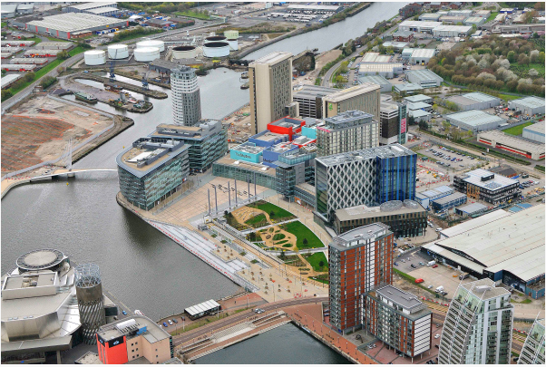
(Source: https://londonconstruction.mysmartjobboard.com/files/userfiles/manchaster6x4.jpg)

