

Programme: Master of Business Administration
Module Name: Human Capital Management
Module Code: LCMB7023

Assignment subject: Human capital management

Student Name: Md Ismail Hossan
Student Id: 2521543
Group: 02

Tutor name: Dr. Charles Oham

Wordcount: 2748

Executive Summary
This report creates an integrated Human Capital Management strategy of Aether Innovations, a technology company experiencing flat growth, high turnover, and deteriorating customer satisfaction. Consistent with the assessment outcomes as identified in the module brief, the report concentrates on re-engineering the performance management and job design to boost the performance and innovation at the organisation. The discussion shows that principal technology companies are moving into the continuous performance management framework and fluid job architecture that foster agility, teamwork, and employee involvement. Based on these findings, the report develops a growth-oriented performance appraisal system that is a combination of Objectives and Key Results (OKRs), 360-degree feedback and continuous performance reviews. This combined methodology, not only matches accountability to organisational strategy but also promotes real time learning and innovation. The report, further, constructs systematic job analysis, descriptions and specifications of key executive positions, and some of these are assisted by Job Characteristics Model. This guarantees a higher level of autonomy, a variety of skills, and significance of tasks, which are the most significant motivation and performance drivers. All in all, the report has showed that the integration of performance management with strategic job design produces a consistent system that enhances innovations, employee engagement and the long-term organisational effectiveness.

Table of Contents
Executive Summary 2
Introduction 1
Part 1: Re-Engineering Performance & Job Design 2
1. Current Practices in Technology Companies 2
1.1 Performance Appraisal Practices in Tech Firms 2
1.2 Job Design Practices in Technology Organisations 2
2. Proposed Performance Appraisal System for Aether Innovations 3
2.1 Objectives and Key Results (OKRs) 3
2.2 360 Degree Feedback 4
2.3 Continuous Performance Reviews 4
2.4 Benefits for Innovation and Engagement 5
3. Job Analysis and Job Design for Key Positions of Aether Innovations 5
3.1 Job Analysis Approach 5
3.2 Job Descriptions for Key Executive Roles 6
3.3 Job Specifications for Executive Roles of Aether Innovations 7
3.4 Application of the Job Characteristics Model for Aether Innovations 8
4. Linking Performance Management and Job Design 9
Conclusion 10
Part 2: Reflection 11
5. Reflective Learning Using Gibbs Reflective Cycle 11
6. AI and Future Career Development 13
References 15

Introduction
This report discusses the application of Human Capital Management (HCM) as the strategy of management of people to improve the performance and value creation of organisations to Aether Innovations which is struggling with flat growth, high staff turnover and falling customer satisfaction. As a technology driven organisation operating in a dynamic and innovation intensive environment, effective performance appraisal and job design are critical for sustaining competitive advantage (Armstrong & Taylor, 2023). This report aims at reviewing of existing practises, a proposal of a growth-oriented performance management system, and the design of executive roles within the framework of Job Characteristics Model and finally show how all of them work together to develop performance-oriented culture.

Part 1: Re-Engineering Performance & Job Design

1. Current Practices in Technology Companies
In response to the modern HR practises, technology companies reconsider their job design, continuous performance management and an innovation focused work structure as a way of enhancing employee engagement, collaboration and organisational performance in dynamic environments.

1.1 Performance Appraisal Practices in Tech Firms
The trend in performance appraisal practises in firms with technology has recently shifted towards the less traditional annual review systems to continuous, development-based systems. IBM has launched its own model known as the Checkpoint that focuses on regular feedback, coaching, and employee development instead of official ratings (IBM, 2016). In a similar manner, Deloitte employs the method of the Performance Snapshot, which involves managers assessing employees based on simplified and prospective questions on performance and potential (Deloitte, 2025). These models reflect a wider movement towards more agile, real-time appraisal systems which focus more on flexibility, involvement of employees, and alignment to the organisation strategy though issues about subjectivity and consistency of appraisal results persist.

1.2 Job Design Practices in Technology Organisations
The use of job design in technological organisations is moving on more in terms of flexibility, independence, and innovation structures. Spotify uses the so-called “Squad Model in which the small teams of cross-functionally oriented employees work independently enhancing the work speed and innovation (Kniberg & Ivarsson, 2012). Likewise, the Valve Corporation embraces the Flat Organisation Model, which permits staff to select projects and organise themselves without official ranks (Valve, 2012). These strategies are indicative of a transition to a decentralised job design that encourages ownership, quick decision making, and teamwork. Nevertheless, such models can cause coordination issues and role confusion, especially where large size of operations that involve organisation of accountability.

2. Proposed Performance Appraisal System for Aether Innovations
The integrated, growth-oriented performance appraisal system should be implemented in Aether Innovations, where the combination of goal alignment, multi-source evaluation, and continuous feedback is the key to innovation and adaptability.

2.1 Objectives and Key Results (OKRs)
The use of OKRs places performance appraisal as a strategic implementation tool by associating individual outputs specifically with the organisational innovation outcomes (Rompho, 2024).
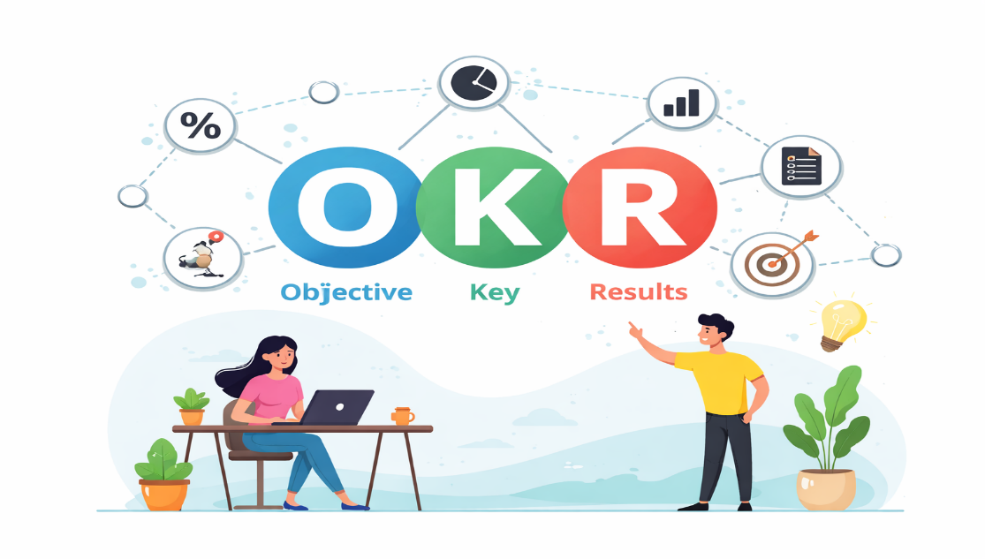
Figure: Objectives and Key Results (Cholifah and Soeling, 2025)
Aether Innovations can redirect the employee priorities towards problem solving and experimentation that is of high value through defining high-goal and measurable objectives. This brings about clarity in the direction and promotes calculated risk taking. Nevertheless, measuring the targets might limit the process of exploration especially in the research driven job where the outcomes are unpredictable (Hitt et al., 2024). Consequently, the system should be built in a manner that incorporates flexibility to identify non quantifiable contribution of innovation.

2.2 360 Degree Feedback
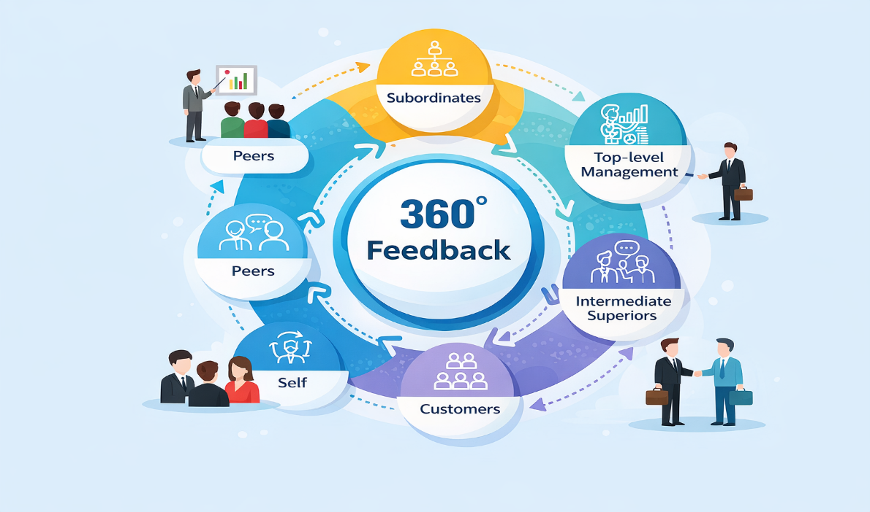
Figure: 360 Degree Feedback (Irons & Elkington, 2021)
The use of 360-degree feedback creates a holistic assessment process based on the interrelation aspect of Aether Innovations (Rompho, 2024). Using a multi-stakeholder capture, the system is aware that in technology firms, performance is often not individualistic as found in the dynamics between teams and cross-functional interactions. This will enhance accountability and promote behavioural skills like sharing of knowledge and flexibility. However, the success of such a system is limited to the integrity of the feedback processes since subjectivity or internal bias can derail the efficiency of such systems. Without a good feedback culture, there may be a risk that a system turns out to be performative but not a developmental system (Konjen, 2025).

2.3 Continuous Performance Reviews
According to Aguinis (2023), continuous performance reviews not only change the retrospective perspective of performance assessment but also provide real performances targeted on a fast-changing technological situation, which allows employees to recover rapidly. The methodology underpins the concept of agile working to enable immediate feedback, rapid improvement as well as the real-time correction of the course. It also increases employee engagement by ensuring that there is a continuous communication between the managers and employees (Irons & Elkington, 2021)
. Nevertheless, planned high frequency of reviews can cause pressure and decrease the time of reflection and under these conditions, cognitive overload could possibly occur unless treated with care.

2.4 Benefits for Innovation and Engagement
At Aether Innovations, combination of these three mechanisms forms a harmonious system of the balance between structure and flexibility. OKRs help in setting strategic direction; 360 feedback makes accountability collaborative, and continuous reviews facilitate adaptive learning. Collectively, they foster a performance-focused culture where innovation, engagement and long-term organisational development are top priorities, but performance expectations must be balanced with autonomy as well as psychological safety (Vuong & Nguyen, 2022).
3. Job Analysis and Job Design for Key Positions of Aether Innovations
Job design and job analysis makes leadership positions facilitate the organisational strategy and innovativeness (Konjen, 2025). At Aether Innovations, these identified executive functions enhance decision making, accountability, and alignment of goals to organisational objectives and employee performance.

3.1 Job Analysis Approach
A good job design must be based on an organised job analysis procedure to determine duties, skills, and performance requirements. In the case of Aether Innovations, job analysis must encompass senior executive interviews, organisational process observation and strategic analysis of objectives. Leadership capabilities can also be identified through competency-based job analysis that enables the enhancement of innovation and organisational growth (Armstrong & Taylor, 2023). This is a strategy that makes executive positions consistent with organisational strategy and offers both performance and accountability.
Job Analysis Dimension | Purpose in Aether Innovations
Task Analysis | Identify key responsibilities and decision-making duties of executive roles.
Competency Analysis | Determine leadership, technical, and strategic competencies required.
Strategic Alignment | Align executive roles with innovation, growth, and customer goals.
Performance Expectations | Define measurable outcomes linked with systems such as OKRs.
Organisational Relationships | Clarify reporting lines and collaboration between executives.
Skill Requirements | Identify essential knowledge, leadership, and technical expertise.

3.2 Job Descriptions for Key Executive Roles
A job description is a statement of purpose, duties, powers, and lines of the position in an organisation. It aids in clarifying expectations, aids in recruitment and performance evaluation and alignment with organisational strategy (Noe, 2022). At Aether Innovations, executive job descriptions are centred on strategy leadership, strategic innovation, and performance.
Position | Job Purpose | Key Responsibilities | Decision Authority | Reports To
CEO | Lead organisational strategy and growth | Define vision, oversee operations | Strategic and organisational decisions | Board of Directors
CFO | Manage financial performance | Financial planning, budgeting | Financial strategy and investments | CEO
CTO | Lead technology development | Technology strategy, infrastructure | Technical and digital systems | CEO
CIO | Drive innovation initiatives | Product innovation, digital transformation | Innovation and new projects | CEO
HR Director | Manage human capital strategy | Talent management, HR policies | Workforce planning | CEO
Head of R&D | Lead research and product development | Research projects, product innovation | Research priorities | CTO

These job descriptions define responsibilities, reporting relationships, and decision-making authority, ensuring clear leadership accountability within the organisation.

3.3 Job Specifications for Executive Roles of Aether Innovations
Job specifications are statements of the qualifications, skills and competencies that a person needs to work in a job that is successful (Hitt et al., 2024). At Aether Innovations they assist organisations in hiring employees with the right expertise and leadership skills.
Position | Education | Experience | Key Competencies
CEO | MBA or equivalent qualification | Extensive senior leadership experience | Strategic thinking, leadership, communication
CFO | Degree in finance or accounting | Financial management experience | Financial analysis, risk management
CTO | Computer science or engineering degree | Technology leadership experience | Technical expertise, innovation management
CIO | Technology or innovation management degree | Experience in innovation leadership | Creativity, strategic innovation capability
HR Director | HR or management degree | HR leadership experience | Talent management, organisational development
Head of R&D | Engineering or science degree | Research and development leadership experience | Product development, collaboration skills
These specifications guarantees that executives have knowledge, experience, and competencies to facilitate organisational performance and innovation.

3.4 Application of the Job Characteristics Model for Aether Innovations
In Aether innovations, the Job Characteristics Model is strategically intended to create executive positions that facilitate innovation, responsibility, and strategy instead of defining the lines of authority.
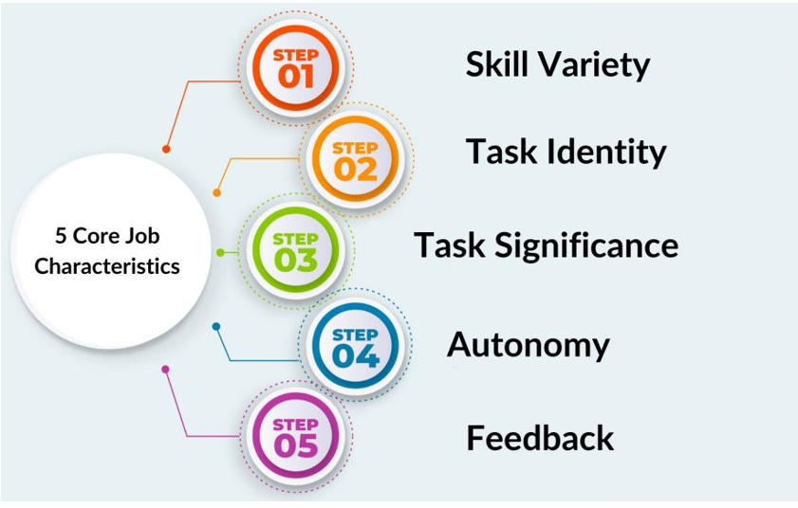
Figure: Job Characteristics Model (Kandpal et al., 2023)
Skill Variety: Aether Innovations executive roles combine technology seniority, strategic planning, and financial management, meaning leaders must perform a wide range of tasks and those that are highly mentally demanding. This will lower functional rigidity and improve adaptive problem-solving within a dynamic tech environment (Agbakwuru, 2023).
Task Identity: Leaders engage in overall processes of end-to-end innovation, including developing concepts, and implementation in the market. This complete ownership enhances accountability and provides coherence of a strategic goal and implementation (Aguinis, 2023).
Task Significance: The role of Aether Innovations executives directly influences technological innovation and competitive positioning, making the execution of roles even more meaningful and strengthening the commitment of organisational success (Tessema et al., 2025).
Autonomy: A high degree of decision-making autonomy guarantees fast innovation, but this is finely struck against performance measures to prevent strategic misalignment.
Feedback: Ongoing assessment using innovation KPIs and organisational performance data will offer real-time feedback, which will aid in evidence-based leadership and sustained development of capability (Vuong & Nguyen, 2022).

4. Linking Performance Management and Job Design
Performance management and job design at Aether innovations is a complementary system that together help in shaping a performance centred and innovation orientated culture (Armstrong, 2024). With the addition of the Job Characteristics Model, the autonomy, task identity, and measurable outcomes are incorporated directly within executive positions through the integration of OKRs, 360-degree feedback, and continuous performance reviews. Such structural alignment also sees performance expectations arising out of the design of the work itself as opposed to being superimposed and allowing executives with end-to-end responsibility to provide high quality strategic output (Tessema et al., 2025). Moreover, ongoing feedback and multi-source appraisal enhance accountability and cooperation, avert autonomy abuse and promote adaptive decision making in complicated technological settings. The interaction also increases intrinsic motivation, where employees feel more ownership, skill use and role importance, which are directly related to increased engagement and innovation output. Nevertheless, the success of such integration lies in the critical balance between flexibility and control where too much performance control can impair creativity whereas too much autonomy can result in a lack of strategic alignment (Noe, 2022). Thus, the consistency of the job design and of performance management in Aether Innovations enables a consistent system that maintains innovation and organisational performance (Vuong & Nguyen, 2022).

Conclusion
The incorporation of modern performance management and strategic job design in Aether Innovations offers a clear system to tackle the problem of low growth, high turnover and declining customer satisfaction. With the help of harmonising the OKRs, 360-degree feedback, and the continuous review with the Job Characteristics Model, the organisation will be capable of improving accountability, innovation, and engagement among employees. Importantly, sustainable performance involves balancing between autonomy and control, where flexibility promotes creativity and tasks are kept strategically focused, and the organisational performance is sustainable.

Part 2: Reflection

5. Reflective Learning Using Gibbs Reflective Cycle
The present reflection perceives the reflection cycle proposed by Gibbs to deconstruct my learning experience as a student of the Human Capital Management module and construct a personal plan of further career growth.
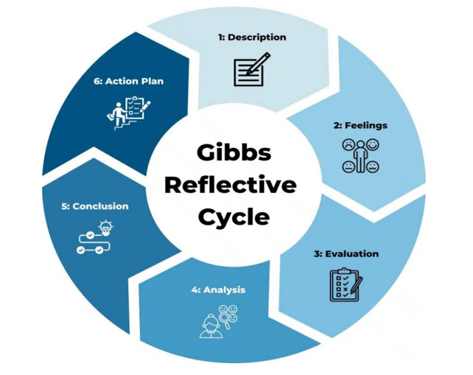
Figure: Gibbs Reflective Cycle (Harmon, 2024)
Description
This module has given me a better insight into what strategic Human Resource Management is and how it plays a role in organisational performance. The main issues were HR strategy, performance management, organisational culture, job analysis and job design. This module has shown that HR practises can be aligned with the strategy of the business to enhance innovation and engagement of employees. Lectures, case studies and assignments helped me to get to know how modern HR practises like continuous performance management and talent development should be used by organisations (Armstrong, 2024). The Aether Innovations assignment has enabled me to put HRM theories into a practical organisational setting.
Feelings
My initial perception of HRM at the start of the module was that it was primarily an administrative role that concerned acquiring staff and managing employees. Nevertheless, as the course continued, I realised that HRM is strategic in enhancing performance and innovation in the organisation. First, certain HR theories and models seemed to be complicated and inapplicable to practise. My understanding was slowly enhanced through discussions, examples and case studies. This educational experience enhanced my self-confidence in analysing HR issues and the application of theoretical concepts to the actual organisational context (Noe, 2022).
Evaluation
Generally, the module was useful since it enhanced my knowledge on the role of people management in determining the success of organisations. The use of a mix of theoretical concepts and practical examples and case studies was another major strength of the module. The strategy allowed me to learn how HR strategies can be used to solve organisational problems like employee turnover, low engagement, and decreased performance (Tessema et al., 2025). One of them involved the translation of complicated theories in the academic field into HR strategies. Nevertheless, constant learning and reflection enabled me to gain better skills of evaluating HR practises analytically.
Analysis
The module highlighted the necessity to align the HR practises with organisational strategy to enhance performance and innovation. Performance management, job design, organisational culture was some of the concepts that showed the impact of HR systems on motivation and productivity of employees. As an example, constant feedback and goal congruency stimulate the employees towards organisational objectives contributions. Correspondingly, job design that works well leads to motivation through autonomy and skills improvement (Noe, 2022). These lessons illustrated that HR practitioners should be strategic and people managers to generate high performing organisations.
Conclusion
The learning experience helped me considerably in understanding the concept of strategic HRM and its contribution to organisational success. I have understood that successful HR practises need a combination of theoretical and practical problem-solving skills (Caylan, 2024). Another critical factor brought forward during the module was the need to keep learning and practising in the HR sector.

Action Plan
Development Area | Action | Expected Outcome | Timeline
Strategic HR Knowledge | Read HRM journals and industry reports | Improve understanding of modern HR practices | Continuous
Leadership Skills | Participate in leadership workshops and training | Develop decision making and management skills | 6–12 months
HR Analytics | Learn HR data analysis tools | Improve evidence-based HR decision making | 6 months
Innovation Mindset | Attend innovation and entrepreneurship seminars | Strengthen creativity and strategic thinking | Ongoing
Professional Networking | Join HR professional associations and events | Build industry connections and career opportunities | Continuous

6. AI and Future Career Development
The modern organisations are also changing due to the increasing use of artificial Intelligence that enhances efficiency in fields like recruitment, monitoring employees, analysing workforce data, etc. AI based systems can now assist many standard HR processes such as CV screening tasks, tracking performance, and workforce analytics (Pandya & Wang, 2024). Such technologies allow organisations to process extensive amounts of data in a short duration of time and make decisions more influenced when it comes to managing a talent and planning an organisation (Budhwar et al., 2023).
Despite these improvements, AI cannot fully substitute human workers in the sphere as there are numerous HR tasks, which presuppose emotional intelligence, morality, and sophisticated decision making. Interpersonal skills are necessary to manage employees, work out conflicts in the workplace and to develop organisational culture something that is not easily achieved through technology (Verma & Singh, 2022).
Those human capabilities like leadership, communication, creativity and relationship management, hence, still play a critical role in the management of people.
I will apply AI in my future practise as assistance instead of substitution of human knowledge. The AI can help by analysing the organisational data, finding trend in the workforce, and guiding HR decisions with evidence. This will enable HR professionals to concentrate more on strategic action like engagement of employees, leadership development as well as organisational innovation (Caylan, 2024).
Simultaneously, I will also keep building explicitly human abilities such as critical thinking, openness, empathy, and shared leadership to stay relevant at an AI driven workplace.

References
Agbakwuru, K.N. (2023) ‘Reconceptualising human resource management’, International Journal of Research, 10(4), pp. 243–251.
Aguinis, H. (2023) Performance Management. 5th edn. Chicago: Chicago Business Press.
Armstrong, M. (2024) Armstrong’s Handbook of Strategic Human Resource Management. 8th edn. London: Kogan Page.
Armstrong, M. and Taylor, S. (2023) Armstrong’s Handbook of Human Resource Management Practice. 16th edn. London: Kogan Page.
Budhwar, P., Chowdhury, S., Wood, G., Aguinis, H., Bamber, G.J., Beltran, J.R., Boselie, P., Lee Cooke, F., Decker, S., DeNisi, A. and Dey, P.K., (2023). Human resource management in the age of generative artificial intelligence: Perspectives and research directions on ChatGPT. Human Resource Management Journal, 33(3), pp.606-659.
Caylan, S., (2024). Role of human resource management on strategic management. Trends, Challenges, and Practices in Contemporary Strategic Management, pp.51-69.
Cholifah, M. and Soeling, P.D., 2025. Objectives and Key Results (OKRS) and Their Role in Enhancing Employee Performance: A Systematic Literature Review. Journal of Management, 4(1), pp.149-166.
Deloitte. (2025, March 23). Reinventing performance management processes won’t unlock human performance. Here’s what will. Deloitte Insights; Deloitte. https://www.deloitte.com/us/en/insights/topics/talent/human-capital-trends/2025/employee-performance-management-optimization-effective-strategy.html?utm
Harmon, A. (2024). Gibbs’ reflective cycle . [online] EBSCO Information Services, Inc. | www.ebsco.com. Available at: https://www.ebsco.com/research-starters/education/gibbs-reflective-cycle
Hitt, M., Black, S. and Porter, L.W., (2024). Management. BoD–Books on Demand.
Irons, A. and Elkington, S., (2021). Enhancing learning through formative assessment and feedback. Routledge.
Kandpal, B., Sharma, D., Kathuria, S. and Akram, S.V., (2023), June. Imperative role of ai in employee engagement: The lens of job charactersitics model. In 2023 3rd International Conference on Pervasive Computing and Social Networking (ICPCSN) (pp. 507-511). IEEE.
Kniberg, H., & Ivarsson, A. (2012). Scaling agile @ Spotify with tribes, squads, chapters & guilds. https://blog.crisp.se/wp-content/uploads/2012/11/SpotifyScaling.pdf
Konjen, H. (2025) ‘Algorithmic management and the future of human work’, Journal of Human–Technology Interaction, 5(2), pp. 1–15.
Noe, R.A., (2022). Human resource management: Gaining a competitive advantage. McGraw-Hill Higher Education.
Pandya, S.S. and Wang, J., (2024). Artificial intelligence in career development: a scoping review. Human Resource Development International, 27(3), pp.324-344.
Rompho, N., (2024). Do objectives and key results solve organizational performance measurement issues?. Benchmarking: An International Journal, 31(3), pp.669-682.
Tessema, S.A., Yang, S. and Chen, C., (2025). The effect of human resource analytics on organizational performance: Insights from Ethiopia. Systems, 13(2), p.134.
Valve Corporation. (2012). Valve employee handbook. https://www.valvesoftware.com/en/publications
Verma, S. and Singh, V., (2022). Impact of artificial intelligence-enabled job characteristics and perceived substitution crisis on innovative work behavior of employees from high-tech firms. Computers in Human Behavior, 131, p.107215.
Vuong, T.D.N. and Nguyen, L.T., (2022). The key strategies for measuring employee performance in companies: a systematic review. Sustainability, 14(21), p.14017.

