

Portfolio – Two Tasks

Module: Introduction to Health and Social Care
Module code: LCHS4003
Lecturer Name : Mark Kane
Name: Mansur Alam
ID: 2441879

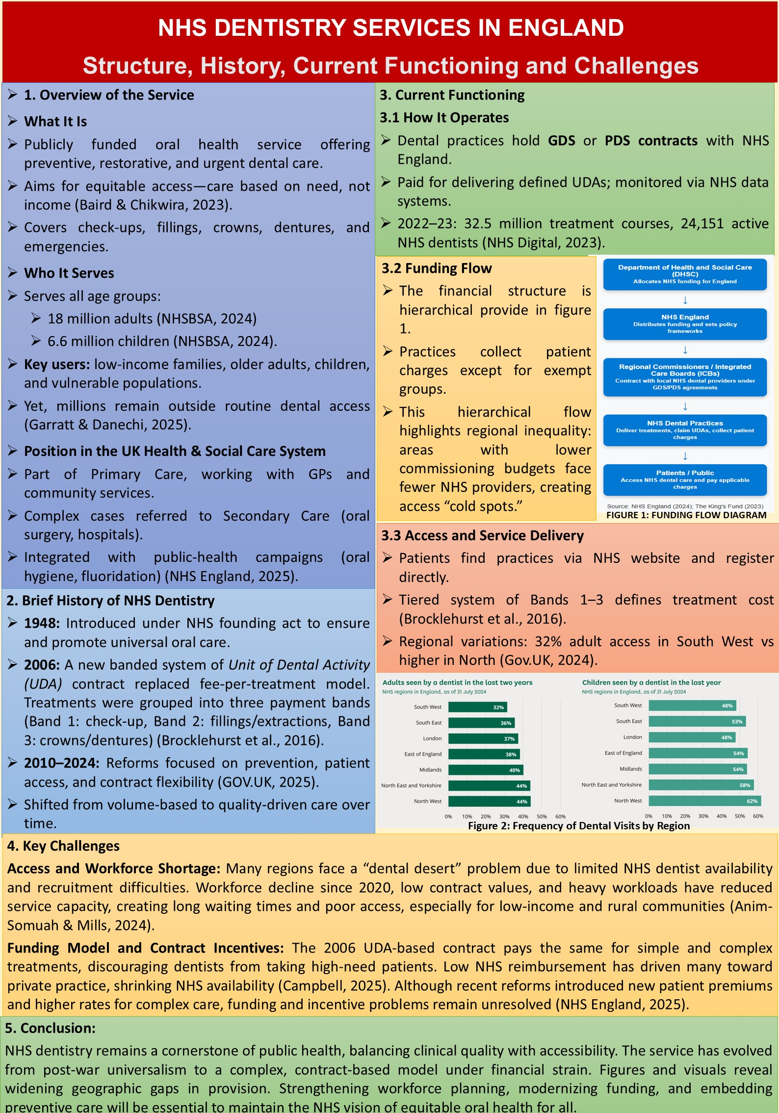
TASK 1: POSTER
REFERENCES
- Anim-Somuah, N. and Mills, I. (2024) ‘Reflections on ethnic diversity within a dental desert’, British Dental Journal, 237(6), pp. 451–455.
- Baird, B. and Chikwira, L. (2023) Dentistry in England explained. London: The King’s Fund. Available at: https://www.kingsfund.org.uk/insight-and-analysis/long-reads/dentistry-england-explained (Accessed 10 November 2025).
- Brocklehurst, P., Birch, S., McDonald, R. et al. (2016) Determining the optimal model for role substitution in NHS dental services in the UK: a mixed-methods study. Health Services and Delivery Research, 4(22). Southampton: NIHR Journals Library. Available at: https://www.ncbi.nlm.nih.gov/books/NBK378807/ (Accessed 10 November 2025).
- Campbell, D. (2025) ‘English dentists “walking away” from NHS work as fees fail to cover costs’, The Guardian, 13 February. Available at: https://www.theguardian.com/society/2025/feb/13/england-dentists-nhs-exodus-fees (Accessed 10 November 2025).
- Garratt, K. and Danechi, S. (2025) NHS dentistry in England. London: UK Parliament, House of Commons Library. Available at: https://commonslibrary.parliament.uk/research-briefings/cbp-9597/ (Accessed 10 November 2025).
- NHS Business Services Authority (NHSBSA) (2024) Dental statistics: England 2023/24. Available at: https://www.nhsbsa.nhs.uk/statistical-collections/dental-england/dental-statistics-england-202324 (Accessed 10 November 2025).
- NHS Digital (2023) NHS dental statistics for England 2022–23: annual report. Available at: https://digital.nhs.uk/data-and-information/publications/statistical/nhs-dental-statistics/2022-23-annual-report (Accessed 10 November 2025).
- NHS England (2025) Dental contracting framework. Available at: https://www.england.nhs.uk/primary-care/dentistry/dental-commissioning/dental-contract/ (Accessed 10 November 2025).
- The Lowdown NHS (2023) NHS dentistry: where did it all go wrong? The Lowdown. Available at: https://lowdownnhs.info/dentistry/nhs-dentistry-where-did-it-all-go-wrong (Accessed 10 November 2025).
- GOV.UK. (2025) NHS dentistry contract: quality and payment reforms: consultation document. Department of Health and Social Care. Available at: https://www.gov.uk/government/consultations/nhs-dentistry-contract-quality-and-payment-reforms/nhs-dentistry-contract-quality-and-payment-reforms-consultation-document

TASK 2: ESSAY

The establishment of the NHS took place on the eve of significant social and economic transformation in post-war Britain. Health care in England was previously provided through a combination of charities, insurance schemes and local-authority services that could be complicated to navigate. Treatment was typically too expensive for most, meaning access became a matter of income and geographic location (Gorsky et al., 2015; Brown, 2022). A turning point was the Beveridge Report of 1942, which identified five “giants” on the path to recovery: Want, Disease, Ignorance, Squalor and Idleness. It anatomized the welfare state: health care to be provided for free at me of need, and not at point of fee (Brown, 2022). Based on this plan, the NHS was launched on 5 July 1948 under the National Health Service Act 1946. Its core principles were that care should be universal, based on need, free at the point of use and funded through general taxation (Delamothe, 2018).
These principles aimed to turn health care from a privilege into a basic right. Everyone living in England was meant to receive treatment regardless of income or social class. At the same time, the early NHS faced heavy demand in a country still dealing with poverty, poor housing, malnutrition and war injuries, and it had to cope with shortages of staff and money (Rivett, n.d.).
Today, the NHS is one of the largest publicly funded health systems in the world, but its structure has become more complex. In England it is not a single organisation but a network of national, regional and local bodies (NHS England, 2022). At the top, the Department of Health and Social Care (DHSC) sets policy and decides the budget. NHS England uses this funding to plan, commission and oversee services. Below this level, Integrated Care Boards (ICBs) and provider trusts deliver hospital, community and primary-care services in local areas (Powell, 2023).
In practice, primary care, especially general practice, is the usual first contact. GPs and community services assess patients and, if needed, refer them to hospitals and specialist clinics. Public-health and preventive services, for example screening and vaccination, work across these levels. Money flows from central government through DHSC to NHS England, then to ICBs and finally to the organisations that provide front-line care (NHS England, 2022).
This system has clear strengths. Universal coverage is a major achievement, as residents can in principle access care without direct payment. Integrated care structures and ICBs are also designed to support closer cooperation between hospitals, GPs, social care and public-health services so that local needs are better met (NHS England, 2025).
However, serious problems limit how well the system works. Workforce shortages are a major concern. As of March 2025, there were about 100,100 vacancies across the NHS in England, including 7,700 doctors and 25,600 nurses (The King’s Fund, 2025). These gaps lead to longer waiting times, higher pressure on staff and risks to quality. The complex organisational structure also brings challenges. While several layers (DHSC, NHS England, ICBs and trusts) can support local flexibility, they can also slow decision-making and make accountability less clear (Anandaciva, 2025). Rising demand from an ageing population and more long-term conditions, combined with tight budgets, makes it harder to provide timely care in all areas, despite the founding promise of equal access.
In short, the NHS emerged from the post-war era founded on universalism, equity and free care. The present NHS is a reflection of these principles and adopting a modern health care system. The NHS continues to be a compelling model of publicly funded care but its for increase its effectiveness it must address the work force shortages, simplify the present structures and finally attract more funding so it can deliver proper services to serve its purpose.

REFERENCES
- Anandaciva, S. (2025) The reshaping of NHS national bodies has only just started – how will it finish? The King’s Fund. Available at: https://www.kingsfund.org.uk/insight-and-analysis/blogs/reshaping-nhs-national-bodies-started-finish (Accessed: 10 November 2025).
- Brown, R. (2022) Save our NHS: Literature and the National Health Service. PhD thesis. University of Kent (United Kingdom).
- Delamothe, T. (2008) ‘Founding principles’, BMJ, 336(7655), pp.1216–1218. doi:10.1136/bmj.39582.501192.94.
- Gorsky, M. (2015) ‘The NHS in Britain: Any lesson from history for universal health coverage?’, in Medcalf, A., Bhattacharya, S., Momen, H. and others (eds.) Health for all: The journey of universal health coverage. Hyderabad: Orient Blackswan, Chapter 7. Available at: https://www.ncbi.nlm.nih.gov/books/NBK316274/ (Accessed: 10 November 2025).
- NHS England (2022) Structure of the NHS. Available at: https://www.england.nhs.uk/long-read/structure-of-the-nhs/ (Accessed: 10 November 2025).
- NHS England (2025) 2025/26 priorities and operational planning guidance. Available at: https://www.england.nhs.uk/long-read/2025-26-priorities-and-operational-planning-guidance/ (Accessed: 10 November 2025).
- Powell, T. (2023) The structure of the NHS in England. House of Commons Library Research Briefing. Available at: https://researchbriefings.files.parliament.uk/documents/CBP-7206/CBP-7206.pdf (Accessed: 10 November 2025).
- Rivett, G. (no date) 1948–1957: Establishing the National Health Service. Nuffield Trust. Available at: https://www.nuffieldtrust.org.uk/chapter/1948-1957-establishing-the-national-health-service (Accessed: 10 November 2025).
- The King’s Fund (2025) Key facts and figures about the NHS. Available at: https://www.kingsfund.org.uk/insight-and-analysis/data-and-charts/key-facts-figures-nhs (Accessed: 10 November 2025).

