By: Joseph Gillespie
Student No: 2214885
Bachelor of Engineering: Embedded Electronic Systems

learning in the digital era
Assignment 1: E-Portfolio

Contents
E-Portfolio 2
Task 1 – Written Summary 3
Task 1 B 4
Task 2 – Academic poster 5
Task 3 – Automatic referencing tool 6
Task 4 – e-portfolio creation and review 7

E-Portfolio

Here is a link to my online E-Portfolio home page: https://temp-fdiumuctgdstvelkczqs.webador.co.uk/

Below is an image of the home page that you should be taken to once you follow the above link.


Task 1 – Written Summary

Below is a screenshot of task 1:
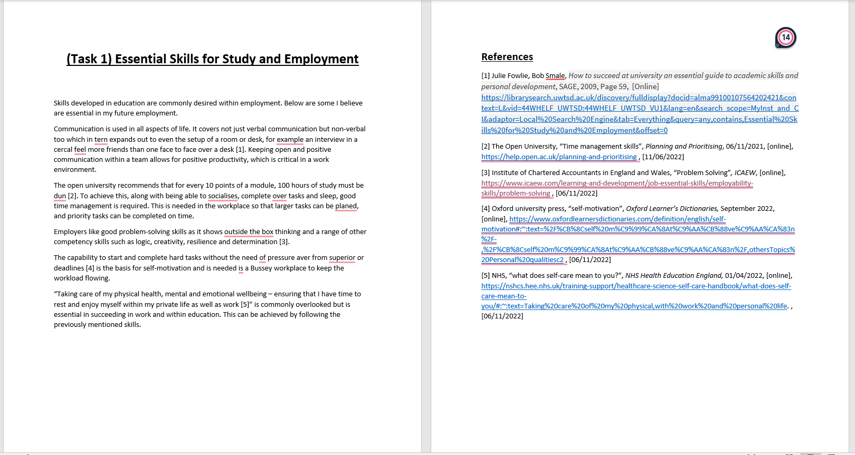

Task 1 as viewed on the e-portfolio.
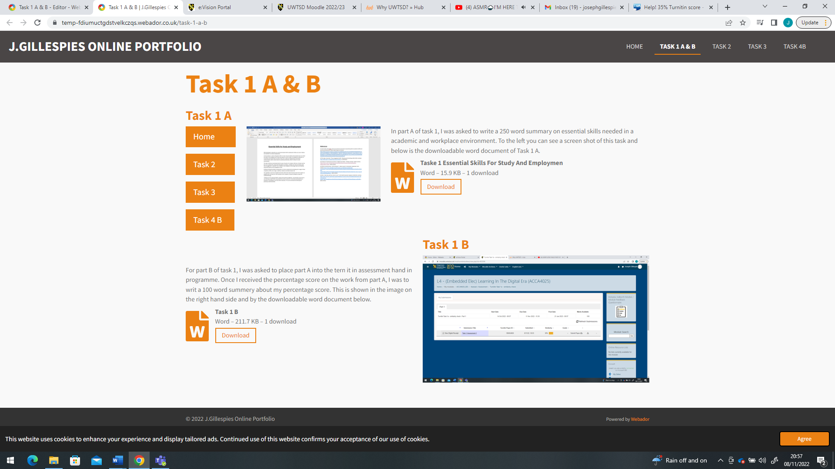

Task 1 B

The image below is task 1 B’s answers. It can also be located on the same page as task 1 on the e-portfolio.

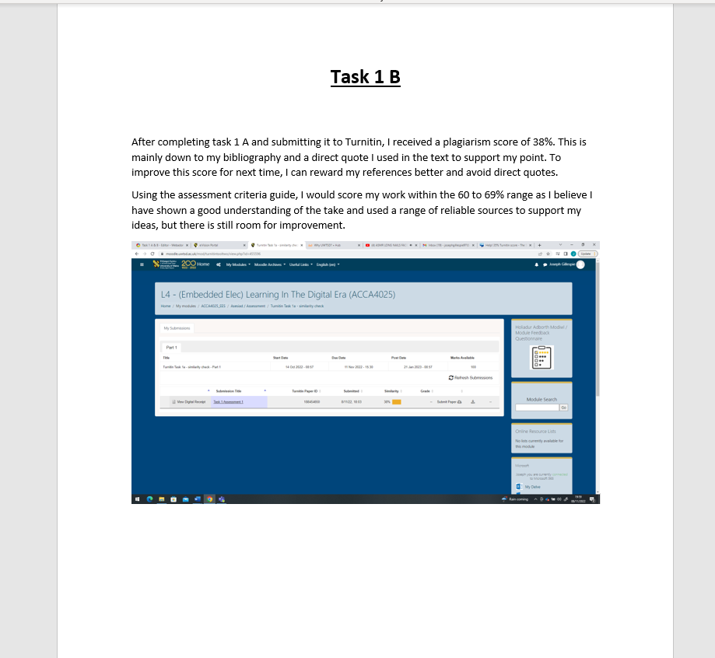

Task 2 – Academic poster

Below are images of both the academic poster and the e-portfolio page showing it and the mined map.

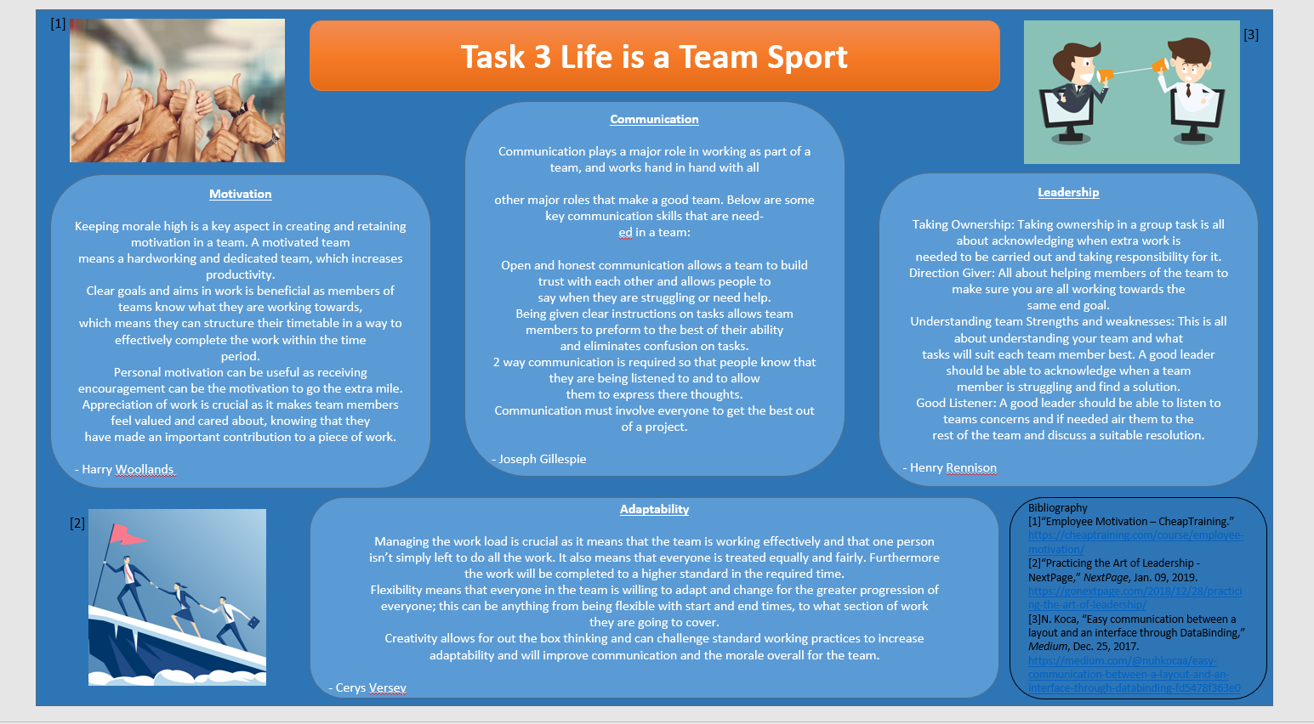
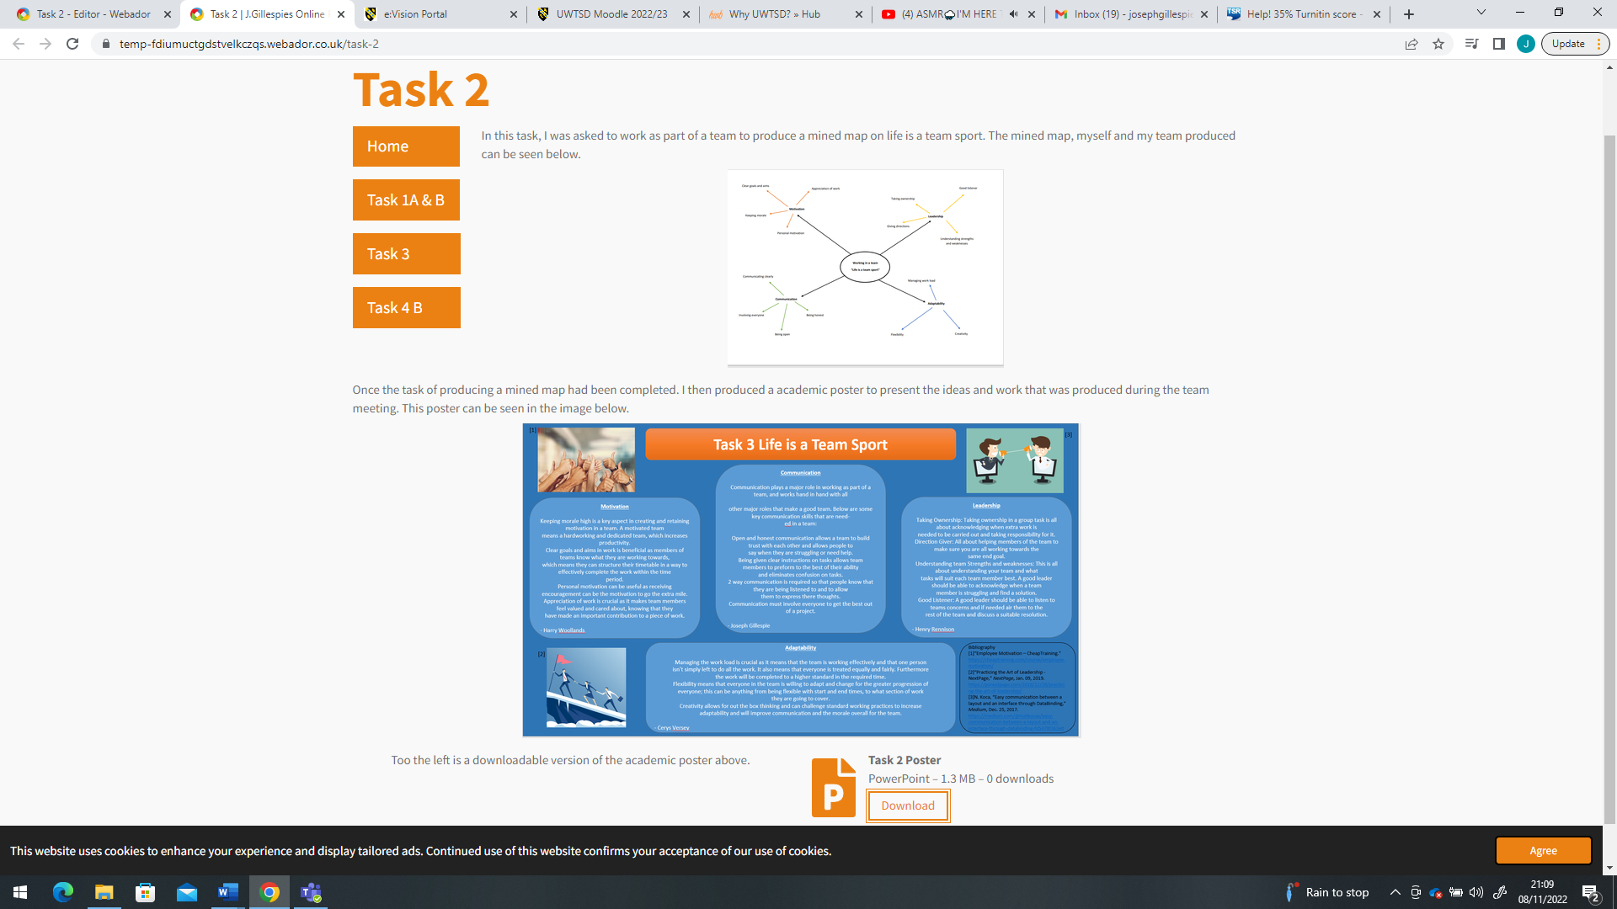

A downloadable copy of the poster is available on the e-portfolio.

Task 3 – Automatic referencing tool

Task 3s answers are in the images below.
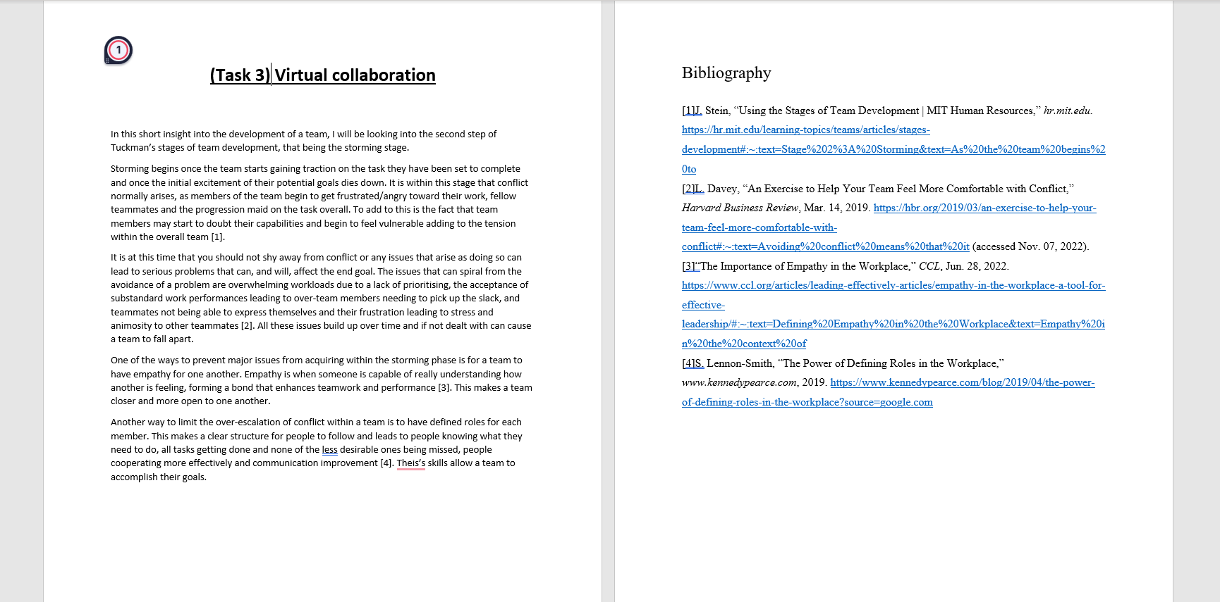

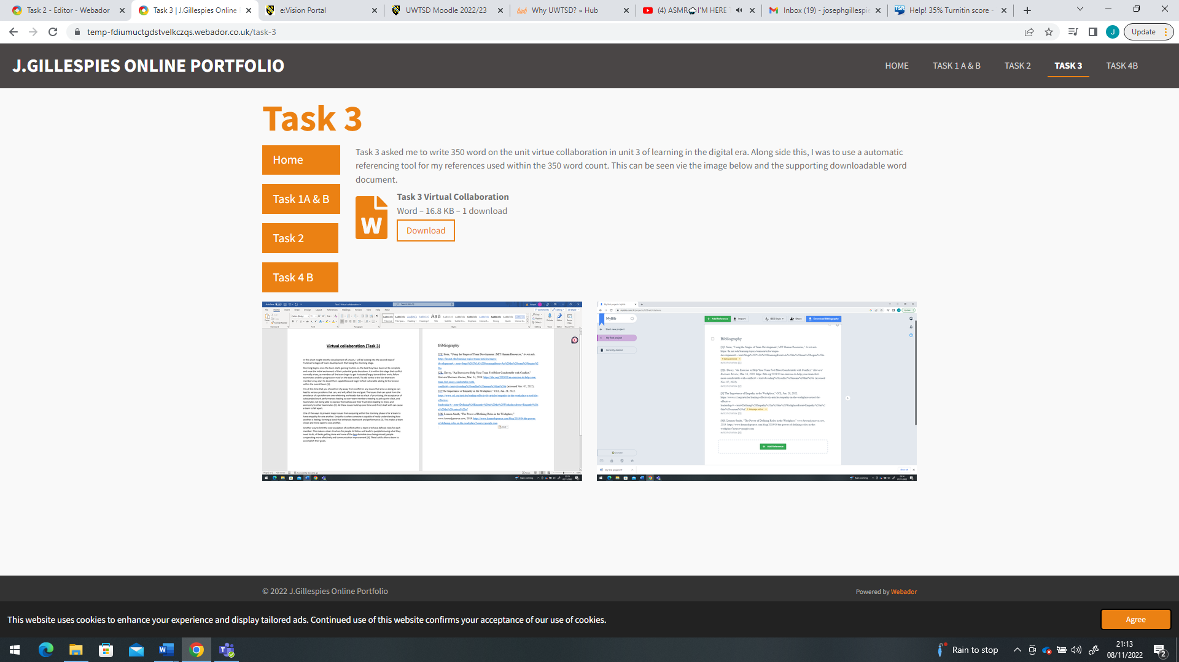

Task 4 – e-portfolio creation and review

The revue for the e-portfolio can be seen in the image below or by following the e-portfolio link.



