Feasibility Plan for an International Meeting

Future Stay: Hospitality Innovation Showcase at The Royal National Hotel UK

Student Name: Rica Chivu

Student ID: 2132458

Module Title: International Meetings Management for the Hotel Industry

Module Code: BMIH6007

Lecturer Name: Kathryn Flynn

Table of Contents

Contents | Slide No.
Introduction | 1
Literature Review | 2
Market Analysis | 3
Operational Analysis | 4
Financial Analysis | 5
Feasibility and Strategic Pre-Planning Research | 6
Conclusion | 7
References | 8

Introduction

"Future Stay: Hospitality Innovation Showcase" at The Royal National Hotel UK

• Examines technological advancements and evolving consumer tastes in hospitality.
• Focuses on education initiatives, enhanced tourist experiences, and service consistency.
• Investigates potential for regulations and strategic insights.
• Considers business challenges, market dynamics, and economic variables.

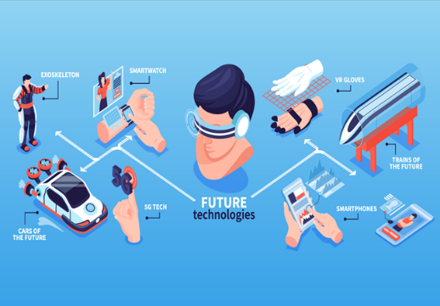

Literature Review

Innovation and Technology in the Hotel Industry
• The hotel industry has evolved due to increased visitor demands and technological advancements.
• Modern technologies are crucial for enhancing customer experiences and addressing customer needs.
• Investments in machine training and AI can provide personalized product recommendations.
• Internet of Things (IoT) devices are revolutionizing business management by simplifying real-time monitoring of company data.
• Eco-friendly practices and technology are being implemented to reduce carbon dioxide emissions and demonstrate corporate commitment.
• The COVID-19 pandemic has increased the use of contactless technology and sanitation practices in the hotel sector.


Market Analysis
"Future Stay: Hospitality Innovation Showcase" Market Research

• Determines intended audience and assesses demand.
• Assesses competitors and potential impacts on the hotel sector.
• Encourages discussions with experts about recent developments and innovative techniques.
• Growing need for events highlighting hospitality innovations and technological advances.
• Guest sector's interest in using innovative technologies for adaptability, statistical analysis, and profitable expansion.
• Future Stay event can positively impact the entire tourism sector and participants.
• Can transform sectors through innovation implementation and collaborative teamwork.

Operational Analysis
Operational Evaluation of "Future Stay: Hospitality Innovation Showcase" at The Royal National Hotel UK

• The event will be held at the Royal National Hotel in the UK, with a focus on location, employee expertise, and material acquisition.
• The hotel's central London location offers a great exhibiting area and an active setting.
• Event staff should possess skills in logistics, customer care, assembly planning, and technology integration.
• Effective problem-solving and information sharing are crucial for handling unexpected challenges.
• The project's overall goal is considered when deciding on resources and creating a funding plan.
• Organizers should plan and acquire appropriate assets to ensure a seamless display and avoid logistics issues.
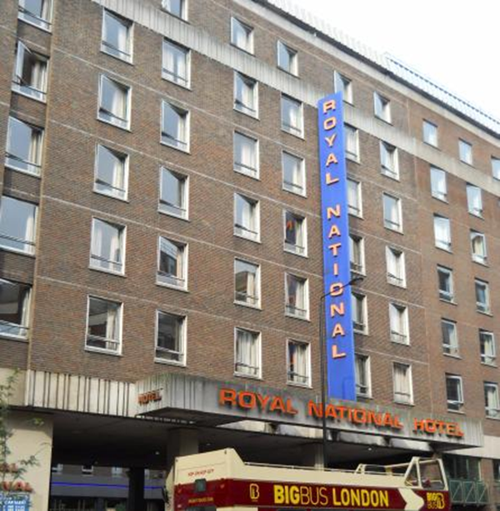

Financial Analysis
Costs incurred, earnings, and sources of profit related to the showcase are crucial.

• A detailed economic analysis is necessary to ensure the initiative's profitability and popularity.
• Expenditures include venue taxes, staff salaries, technical demos, spotlight, food, technology rentals, lighting, and conveyance.
• Comprehensive cost forecasting aids in developing a detailed budget for each aspect of the construction task.
• Predicting the projected audience and pricing tickets accordingly can help in revenue generation.
• Investments are necessary to ensure the program's financial sustainability.
• Spreading income sources and developing partnerships can minimize risk of loss and secure necessary resources.



Feasibility and Strategic Pre-Planning Research

Feasibility Studies and Priority Planning
• Comprehensive feasibility studies and priority planning are crucial for the successful launch of the intervention.
• The Royal National Hotel in the UK is chosen as the venue.
• A comprehensive team with technological skills, relationship-building abilities, and meeting planning capabilities is essential.

Key Considerations
• Identifying the target market, needs, competitors, and optimal positioning is crucial.
• The chosen market includes experts, supporters, stakeholders with new interests, and those responsible for sustainable development.
• Analyzing rival potential helps discover unique offerings and strategies.
• A promotional strategy with a unique value offer is needed for strategic positioning.
Leadership and Research
• Proper leadership and careful research can reduce risks, identify opportunities, and achieve success.
• The assessment results serve as the framework for ongoing scheduling and activities.



Conclusion
• A significant event in the evolving hospitality sector.
• Aims for innovation, equitable growth, and improved visitor experience.
• Aims to encourage business and creative change.
• Successfully organized through pre-planning and feasibility study.
• Ensured differentiation from competition through careful placement, target market selection, demand evaluation, and competitor research.
• Conducted operational financial analysis for performance and reliability.

References

- All, A., Castellar, E.N.P. and Van Looy, J., (2021). Digital Game-Based Learning effectiveness assessment: Reflections on study design. Computers & Education, 167, p.104160.
- Attaran, M., (2020). July. Digital technology enablers and their implications for supply chain management. In Supply Chain Forum: An International Journal (Vol. 21, No. 3, pp. 158-172). Taylor & Francis.
- Bisoi, S., Roy, M. and Samal, A., (2020). Impact of artificial intelligence in the hospitality industry. International Journal of Advanced Science and Technology, 29(5), pp.4265-4276.
- Bladen, C., Kennell, J., Abson, E. and Wilde, N., (2022). Events management: An introduction. Routledge.
- Chandan, A., John, M. and Potdar, V., (2023). Achieving UN SDGs in food supply chain using blockchain technology. Sustainability, 15(3), p.2109.
- Coito, T., Firme, B., Martins, M.S., Vieira, S.M., Figueiredo, J. and Sousa, J.M., (2021). Intelligent sensors for real-Time decision-making. Automation, 2(2), pp.62-82.
- Crain, M., (2021). Profit over privacy: How surveillance advertising conquered the internet. U of Minnesota Press.
- Fox, D. et al. (2014) Doing events research: from theory to practice. Routledge: Oxford.
- Gunduz Songur, A., Turktarhan, G. and Cobanoglu, C., (2023). Progress on green technology research in hotels: a literature review. Journal of Hospitality and Tourism Insights, 6(5), pp.2052-2072.
- Jawabreh, O., Shniekat, N., Saleh, M.M.A. and Ali, B., (2022). The strategic deployment of information systems attributes and financial performance in the hospitality industry. Information Sciences Letters, 11(5), p.110504.
- Jiang, Y. and Wen, J., (2020). Effects of COVID-19 on hotel marketing and management: a perspective article. International journal of contemporary hospitality management, 32(8), pp.2563-2573.
- Kulshrestha, R., Singh, P., Malakar, S.K. and Awasthi, A., (2022). Tourism, Event and Digital Media. OrangeBooks Publication.
- Li, X., Ye, Q., Law, R., & Chen, W. (2020). The Influence of Social Media on Hotel Industry Performance. International Journal of Contemporary Hospitality Management, 32(7), 2248-2271.
- Mondal, S., Das, S. and Vrana, V.G., (2023). How to bell the cat? A theoretical review of generative artificial intelligence towards digital disruption in all walks of life. Technologies, 11(2), p.44.
- Müller, G., Nagle, T.T. and Gruyaert, E., (2023). The Strategy and Tactics of Pricing: A Guide to Growing More Profitably International Student Edition. Taylor & Francis.
- Pillai, S.G., Haldorai, K., Seo, W.S. and Kim, W.G., (2021). COVID-19 and hospitality 5.0: Redefining hospitality operations. International Journal of Hospitality Management, 94, p.102869.
- Rogers, T. Wynn-Moylan, P (2022) Conferences and conventions: a global industry. 4th Edition. Routledge: Oxford
- Satitsamitpong, M., Napontun, K., Senachai, P., Tovara, S. and Daengmeesee, S., (2024). Enhancing Spectator Engagement in E-sports Events. ABAC Journal, 44(2).
- Smith, A. (2012) Events and urban regeneration: the strategic use of events to revitalise cities. Routledge: Oxford.
- Tai, Y.F., Wang, Y.C. and Luo, C.C., (2021). Technology-or human-related service innovation? Enhancing customer satisfaction, delight.

