UWTSD
Identity and Approaches to Applied Business Research
BMDM7001
Xiaohui Zeng / Alice Zeng 1811713
2019/4/26

Lecturer: | Professor Jill Venus | Internal Verifier:
Assignment Title: | Portfolio | Word count (or equivalent): | 3,500 words
Submission deadline: | April 29th, 10.00am | Return date of provisional marks & written feedback: | May 28th

Contents
Entry 1 Positionality and Individuality 1
Appendix 1 3
Appendix 2 5
Appendix 3 6
Appendix 4 7
Entry 2 Reading and Evaluating Literature and Information Sources 9
Appendix 1 11
Appendix 2 12
Appendix 3 13
Appendix 4 18
Entry 3 The Contribution of Research to Knowledge and Organizational Development 21
Appendix 1 24
Appendix 2 25
Appendix 3 27
Appendix 4 28
Entry 4 Defining the Research Question 31
Appendix 1 33
Appendix 2 34
Appendix 3 35
Appendix 4 36
Entry 5 Philosophical Frameworks for Research 38
Appendix 1 40
Appendix 2 42
Appendix 3 43
Appendix 4 47
Entry 6 Types of Research and Research Design 49
Appendix 1 52
Appendix 2 53
Appendix 3 54
Appendix 4 56
Entry 7 Research Ethics and Integrity 58
Appendix 1 60
Appendix 2 61
Appendix 3 62
Appendix 4 67

Entry 1 Positionality and Individuality
I used to take the research as an objective process because of my experiences in science technology field that “truth” could only be “revealed” but not be changed. Therefore, when I encounter the conceptions of ‘identity’, “individuality” and “positionality”, they define a new world for me in social science. These notions indicate that the process of research is the way approaching to the desired “truth”, and it varies in reflexive management process.

In general perspective, definition of “identity” refers to one’s qualities, beliefs, personality, reputation, characteristics, looks or expressions, while the definition of “individuality” makes a person or group definable, recognizable or unique. (Website of Cambridge English Dictionary, the oxford Dictionary, 2019) As the author wrote in “Individuality in Research”, that “great achievement is intimately bound up with spontaneity of interest and effort.” And “the greatest development with the most important consequences is the spontaneity of the individual” (Carmichael, 1919, p.525). From my point of view, what makes my research different from others’ is my individuality. Through a mind map sorting of myself, I obtained some distinguishing features such as family, education background, working experience. The thoughts of being a life-long learning person were originated from my parents’ positive influence, thus my past study major and academic research in Information Science were affected by them inevitably, which also constructed my individuality. Therefore, the significant issue for me is to find what underlying my mind and my most suitable field of interests, perceive sensations of outside world, and develop into a research of value without inertia.

Although I can identify elements of myself and seek to what springs from my deep individuality, I do not understand how it will specifically affect my research direction and process until the definition of “Researcher positionality” (Holmes, 2014) gives the hint. The term positionality describes both an individual’s world-view and the position they have chosen to adopt in relation to a specific research task (Foote and Bartell 2011, Savin and Howell 2013, cited in Holmes, 2014, p.2). Positionality is linked to our own constructions of identity; however, it will change over time, and its dynamism varies from one context to another. Therefore, it has potential effects on the research process, as well as on participants and the researcher (Teye, 2012) (Bourke, 2014). As Srivastava Prachi (2006) put forwards the concept of “currencies”, using “analytic languages” as a crucial tool to mediate researcher positionality and temporarily shared positionalities with research participants. Therefore, when I come into a study on education management or undertake some stage, I should realize the effect on my positionality. First of all, after years of engaging in teaching and administrative work, I should consider my individuality in the relation to the research subject, reduce to a minimum the influence of prejudice and consider the constraints or conflicts in it. Secondly, I should locate myself in the relation to the participants as an insider (Costley et al. 2010) that is from conceptions of the “Insider and Outsider” by Merton’s (1972) For instance, the investigated respondent may be my students, my colleagues, or my project leader. Thirdly through critically reflection of research process I should design the most suitable approach which seem best fitted to the context and be engaged in research with sensitive interviews, independent decision-making or rigorous quantitative analysis. I believe that “individuality” and “positionality” are both of significance for us to undertake our research and explain the world from my own reflexive perspective.

Appendix 1
Bourke, B. (2014) ‘Positionality: Reflecting on the research process’, The qualitative report, 19 (33), pp. 1-9.

Carmichael, R. D. (1919) ‘Individuality in Research’, The Scientific Monthly 9(6), pp. 514-525. http://www.jstor.org/stable/6846.

Costley, C., Elliott, Geoffrey and Gibbs, P. (2010) Doing Work Based Research: Approaches to Enquiry for Insider-Researchers. Sage, London.

Holmes Andrew. (2014) Researcher positionality – a consideration of its influence and place in research. Available at: https://www.researchgate.net/publication/260421552_Researcher_positionality_-_a_consideration_of_its (Accessed: 11th March 2019)

Merton, R.K. (1972) ‘Insiders and Outsiders: a chapter in the sociology of knowledge’, American Journal of Sociology, 78(1), pp. 9-47. http://dx.doi.org/10.1086/225294

Savin-Baden, M. and Major, C. (2013) Qualitative research. London: Routledge, pp.11-39.

Srivastava P. (2006) ‘Reconciling multiple researcher positionalities and languages in international research’, Research in Comparative and International Education, 1(3). pp. 210-222.

Teye J K. (2012) ‘Benefits, challenges, and dynamism of positionalities associated with mixed methods research in developing countries: Evidence from Ghana’, Journal of Mixed Methods Research, 6(4), pp. 379-391.

Appendix 2
Individuality. Available at: https://dictionary.cambridge.org/zhs/%E8%AF%8D%E5%85%B8/%E8%8B%B1%E8%AF%AD/individuality (Accessed: 11th March 2019)

Individuality. Available at: https://www.dictionary.com/browse/individuality (Accessed: 11th March 2019)

Individuality. Available at: https://en.oxforddictionaries.com/definition/individuality (Accessed: 11th March 2019)

Positionality. Available at: https://en.oxforddictionaries.com/definition/positionality (Accessed: 11th March 2019)

Holmes Andrew. (2014) Researcher positionality – a consideration of its influence and place in research. Available at: https://www.researchgate.net/publication/260421552_Researcher_positionality_-_a_consideration_of_its (Accessed: 11th March 2019)

Appendix 3
Quotations:
Positionality is the practice of a researcher delineating his or her own position in relation to the study, with the implication that this position may influence aspect of the study, such as the data collected or the way in which it is interpreted.
1) The fact or quality of having a position in relation to other things.
2) Sociology. The occupation or adoption of a particular position in relation to others, usually with reference to issues of culture, ethnicity, or gender. Positionality.
Source: Available at: https://en.oxforddictionaries.com/definition/positionality

Individuality:
- The quality or character of a particular person or thing that distinguishes them from others of the same kind, especially when strongly marked. Individual characteristics.
- Separate existence.
Source: Available at: https://en.oxforddictionaries.com/definition/individuality

‘Great achievement is intimately bound up with spontaneity of interest and effort.’ ‘The greatest development with the most important consequences is the spontaneity of the individual’.
Source: Carmichael,(1919), p.525.

‘The term positionality describes both an individual’s world-view and the position they have chosen to adopt in relation to a specific research task’. Source: Holmes Andrew. (2014)

Appendix 4
- Individual activity
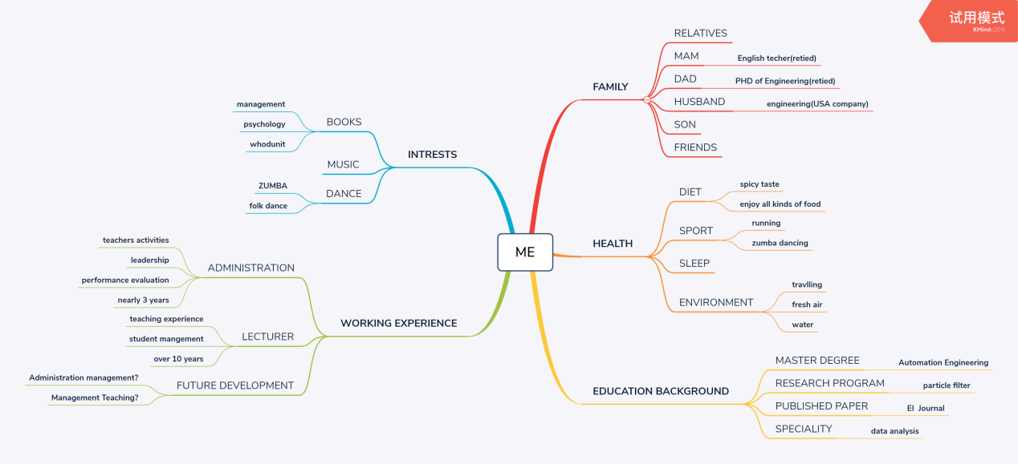
MINDMAP: Identity of ME-Alice Zeng. Xmind

- Group PPT: Brief introduction_ Benefits, Challenges, and Dynamism of Positionalities.
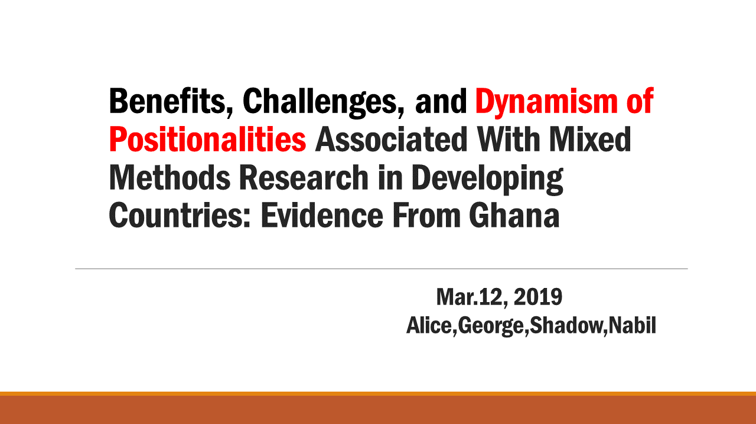
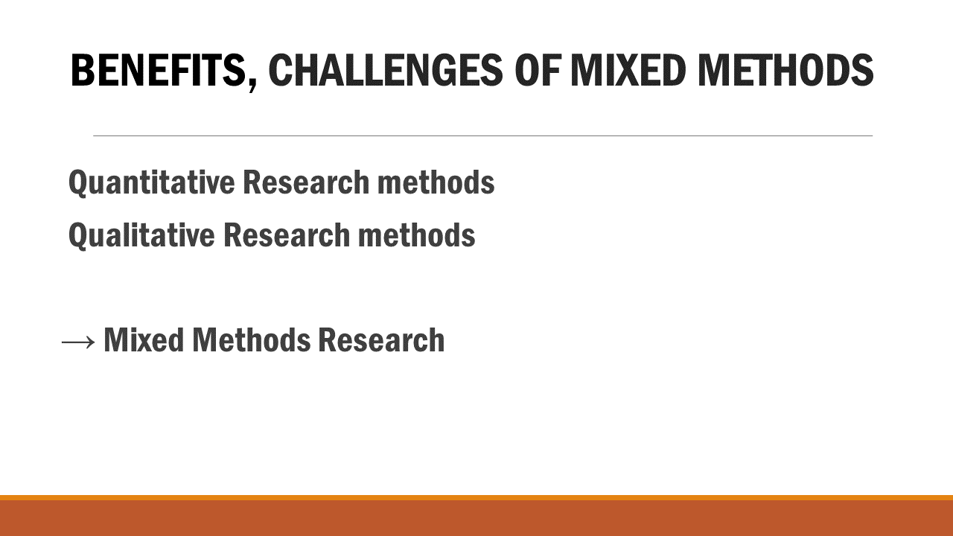
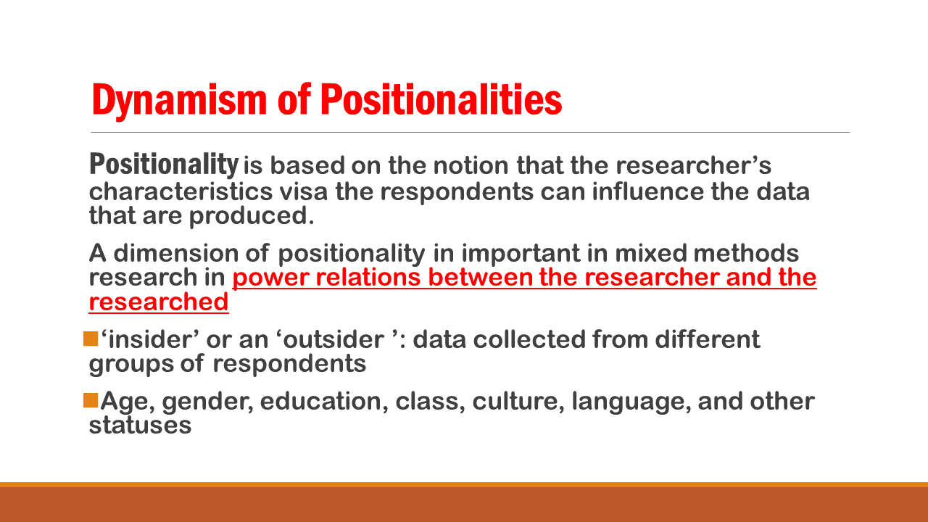

Entry 2 Reading and Evaluating Literature and Information Sources
Reading is such a time-consuming work that especially you are uncertain what you need through a whole day watching laptop screen. Therefore, reading any material for a purpose is the priority. And of course, effective reading can not only weave new ideas and information into your understanding in research, but also develop thoughts and broaden new angles to your mind (Sekaran and Bougie, 2010) (Savin and Major, 2013), no mater formative and summative evaluations(Clarke A., 1999). Reading includes critical reading, sampling reading, skimming reading, scanning reading and so on.

The journey of reading and evaluating information is generally can be summarized as follows:

Firstly, for the initial search, the key points of research can be used to find out from large amount of literature resources online such as library of UWTSD, google website, and British these online (EThOS database). Although all types of literatures available including journals, books, magazines, reports, newspapers, conference proceedings and theses should be “critically reviewed” (Cottrell, 2011), and academic journal up to date is usually a vital literature source among them. It is a preliminary step to a research field from wide-ranging overview, so a rough idea can be generated.
Secondly, through a scanning reading of literatures’ names and reliable sources (cited in Saunders and Lewis, 2012, p.37), some search terms might be refined in order to find more kinds of materials with systematic previewing. After obtained some useful thesis and websites, a skipping-reading through recording the ideas and drafting the abstract, summary of the literatures can be undertaken to gain the topic-based background knowledge. It is a process of developing a general evaluation for the research with historical review and integrative review, which can also clarify the merits and downsides of key literatures within your chosen area.
Thirdly, in order to gain a good understanding of the literature and focus more on material that is specifically relevant and valuable, discussion-brainstorm in class with the Dephi technique is necessary (Saunders and Lewis, 2012, p.46). During this period, recoding question and suggestions informed by classmates help you evaluate the feasibility of research and confirm your research standpoint more.
Fourthly, mixed review methodology of critically reading and skimming reading are adopted together in text, keeping notes and charting ideas for useful information can help the reflection and analysis (my mind map), while evaluating the relevance, value and sufficiency of literature, according to Box 3.14 checklist in “Research Methods for Business Students” (Saunders et al. 2016). Of course, then systematic critically review with “5 questions” (Saunders and Lewis, 2012, p.48) will develop you in the habit of asking yourself questions and making reasoned judgments. Therefore, some useful tips are introduced by Cunliffe (2004) for critically reading:
- Examines the evolution of research topic over a period
- Establish appropriate theories
- Identify the underlying assumptions to judge whether some viewpoint is incorrect or unreasonable
- Check supplementary information in detail, including its authors, methods, data, quotations and references

The whole procedure is not an easy feat, and just like a spiraling journey as in Saunders’ book (2016). Reading and evaluating literature and information sources do help you develop a competent knowledge and understanding of the literature in the research area.

Appendix 1
Clarke, A. (1999) Evaluation research: An introduction to principles, methods and practice. Sage.

Cottrell, S. (2011) Critical Thinking Skills. Macmillan International Higher Education.

Cunliffe, A. (2004) On Becoming a Critically Reflexive Practitioner. SAGE Journals.

Saunders, M.N., Lewis, P. (2012) Doing research in business & management: An essential guide to planning your project. Pearson.

Saunders, M., Lewis, P. and Thornhill, A. (2016) Research Methods for Business Students, 7th Ed. England: Pearson Education Limited.

Sekaran, U., Bougie, R. (2010) Research methods for business: A skill building approach 5th Ed. Chichester. Wiley.

Savin-Baden, M. and Major, C. (2013) Qualitative research. London: Routledge, pp.11-39.

Appendix 2
EThOS Website: Available at https://ethos.bl.uk/Home.do;jsessionid=E1A88525227A758F7E52B438FAEC1C41 (Accessed: 18th March 2019)

UWTSD online Library. Available at https://www.uwtsd.ac.uk/library/online-library/ (Accessed: 18th March 2019)

Delphi method. Available at
https://en.wikipedia.org/wiki/Delphi_method (Accessed: 18th March 2019)

Appendix 3
Tables:
- Table 1 different types of literature.
Source: Saunders and Lewis (2012), p.37.
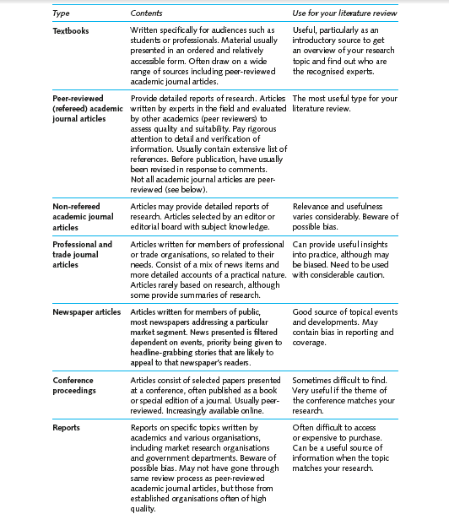

- Table 2 five questions.
Source: Saunders and Lewis (2012), p.48.
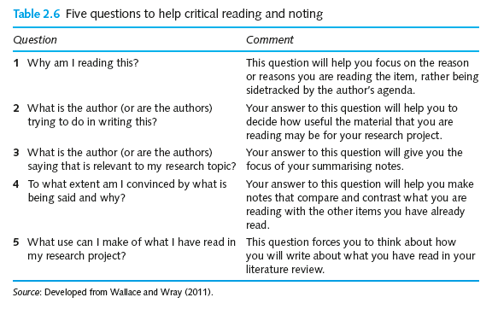

- Table 3 SmartReading some questions
Source: Cottrell (2017).
Am I a smart reader?
(adapted from Cottrell, 2017)

Do I know exactly what I’m looking for?
Have I considered what questions I’m trying to answer?
Have I considered what information I need?

Using reading lists selectively
Have I looked at the recommended reading list?
Do I know what I need to read?

Examine sources for suitability
Have I considered each source?
Have I considered:
- Whether it’s on the reading list?
- Whether it’s up to date or fairly recent?
- Whether it looks readable and manageable?
- Whether it has the information I want?

Select relevant parts of the book
Do I browse the book quickly?
Do I use the contents page, the index, the headings and the sub-headings for guidance?
Do I identify which parts of which chapters I need, and put markers in these?
Select relevant parts of the page
Do I read the chapter headings?
Do I read any sub-headings?
Do I read the first sentence of each paragraph (which should introduce the topic or idea)?
Do I look at any diagrams, graphs, or charts?
Do I read any summaries or conclusions?

Use photocopies / scans / print outs
Do I make photocopies of important pages?
Do I file electronic files?
Do I use marker pens to highlight important words and phrases (only)?
Do I jot down ideas and thoughts in the margins?
Do I make notes about the points I highlighted, to help me remember them?

Chart the main ideas
Do I map out ideas so that I can see how everything fits together?

Practice second guessing
Do I keep trying to anticipate what is coming next, or what the conclusions will be?

Read interactively
Do I think about what I’m reading?
Do I question what I’m reading? Do I look for answers to my questions?
Do I make notes of the important points, and ideas triggered by what I read?
Do I challenge the assumptions of the writer, logic of the arguments, & validity of the conclusions?

Vary reading speed and method
Do I keep changing pace, according to the needs of the text?
Do I scan rapidly for specific information?
Do I read quickly to get the general sense of a passage, and then read difficult parts more slowly?

Use markers
Do I label a corner of my own texts with a keyword summary?
Do I insert labelled bookmarks so that I can find details easily, and need fewer notes?
Do I give start ratings to valuable pages, making them easier to find later?

Maintain your attention
Do I take in what I read?
Do I make sure I’m doing so, by:
- Summing up each section?
- Taking regular breaks?
- Reading interactively?
Graphs:
- Graph 1 Checklist of literature.
Source: Saunders et al. (2016), p.105.
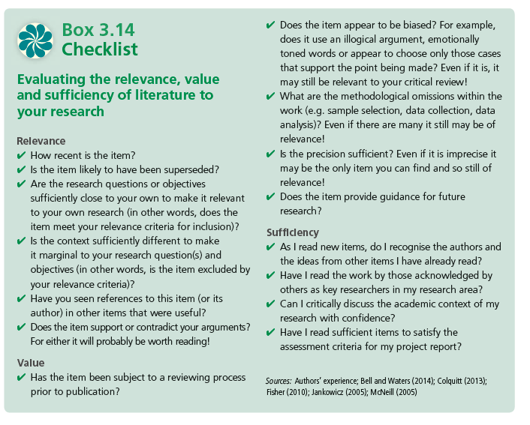
- Graph 2 the reviewing process of literature.
Source: Saunders et al. (2016), p.99,

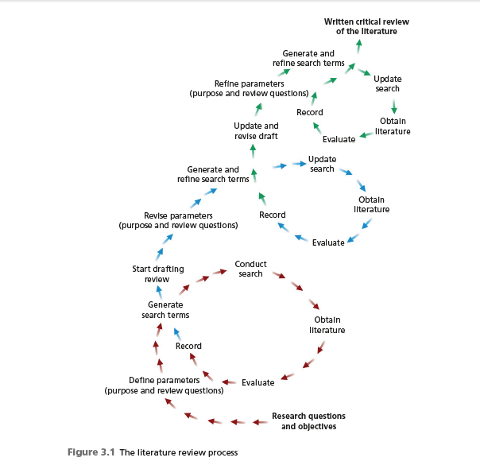

Appendix 4
- An activity of class group1 - On becoming a critically reflexive practitioner
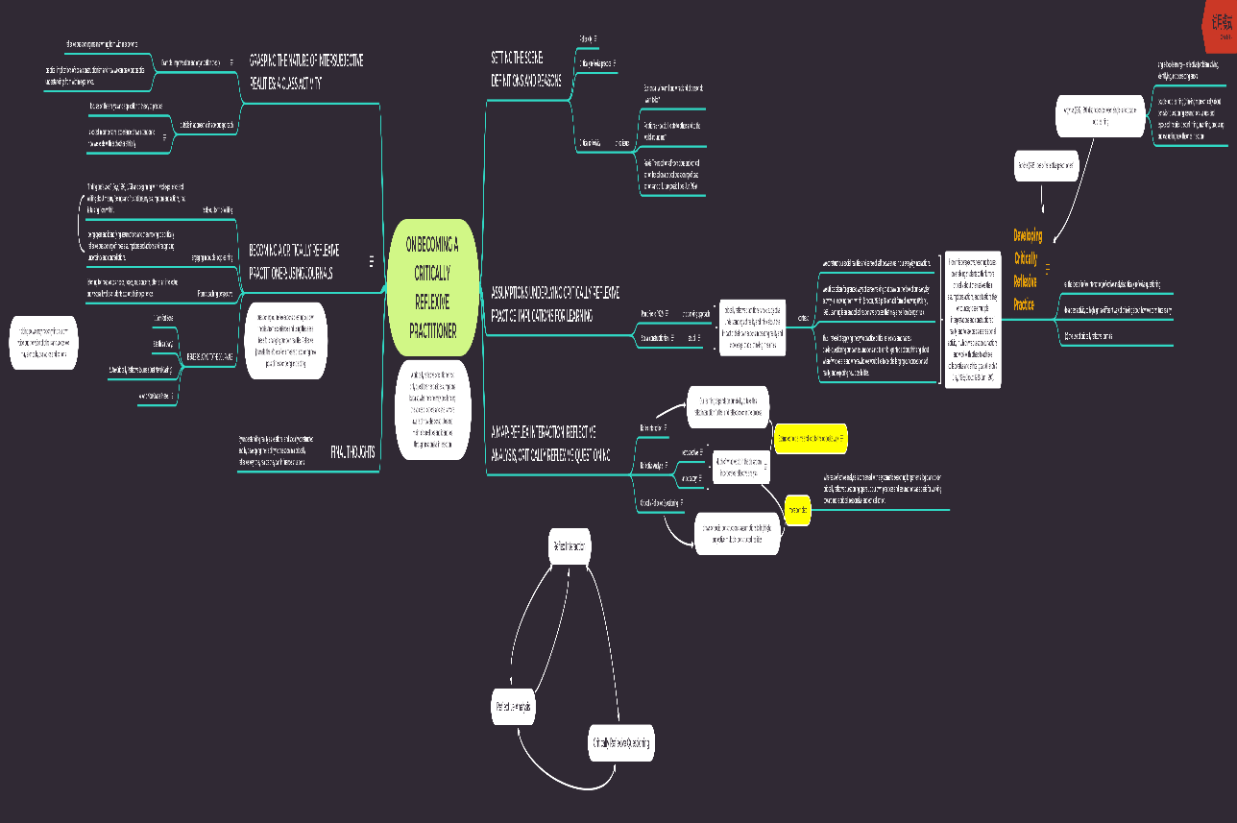

- Individual Activity:
The journey of my reading and evaluating information is generally as follow:
- Step 1: for the initial search, I defined the parameters of my research as “individual performance evaluation” and “education reform” and tried hard to find different materials in library of UWTSD online, google website and British these online (EThOS database). It was a class activity of quick search and we were requested to do some preliminary check to generate a research field. It was limited to a scanning reading process of 20 minutes.
- Step 2: I refined the search terms such as ‘innovation’ instead of ‘reform’, and ‘assessment’ instead of ‘evaluation’, in order to find more because I only had found a little materials related to my interested research, such as a website, a book and two thesis through a scanning reading of literatures’ names and reliable sources.
- Step 3: after obtained some thesis and websites, I seek out several useful materials: journal, PHD thesis and books. I recorded the ideas and drafted the abstract, summary of the literatures by skipping reading, developing a general evaluation for my subject.
- Step 4: carry on discussion-brainstorm in class and question classmates with the Dephi technique, while keeping in mind the research objectives.
- Step 5: for the second search, I revised my parameters again and undertook further searches. At this time, I focused more precisely on material that is specifically relevant and valuable. The mixed review methodology of critically reading and skimming reading was adopted together in text. I also kept notes for useful information which can help my reflection and analysis (my Xmind), while evaluating the relevance, value and sufficiency of literature to my research.
- Step 6: Systematic critically review with 5’w’+1’H’, narrow down on specific topic from the relevant literature and information sources. Therefore, I will slow down into certain section and evaluate it critically.
- Step 3-6 above could be repeated for several times.
- Individual activity:
An example of my critically reading - The consequences of IT acceptance on subsequent individual performance. XMIND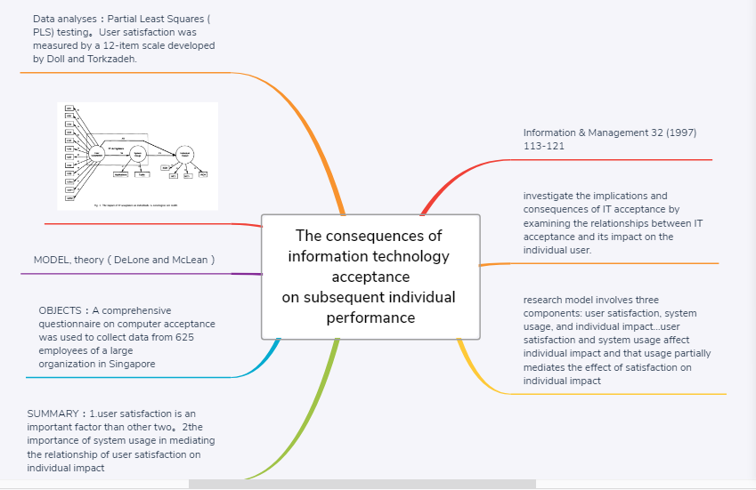

Entry 3 The Contribution of Research to Knowledge and Organizational Development
No matter how difficult to identify the criteria for knowledge, it is generally recognized that knowledge is justified true belief, and it comes from different sources such as science, religion and others (Pritchard, 2014). And in this section, we will focus on academic knowledge in scientific field. There is no doubt that we compete in increasingly knowledge-intensive world every day and our dependence on information increases more. Organizational development commonly concerns about successful organizational change and performance. Recently, it is realized that nucleus of organizational development should be expanded to their rapidly changing and complex environments through knowledge management (Chang et al. 2013, p.253), organizational learning and transformation of organizational innovation (Wikipedia website). Therefore, many organizations are drowning in information overload and yet starving for knowledge (Kanter, 1999). Sustainable competitive organizational development is especially dependent on building and exploiting core competencies, so researches are urgently required to make the transition from information into instructions as soon as possible. And the latest scholarly work and research also offer valuable contributions in exploring the fields of organizational development and knowledge prosperity, as it is shown in figue1.
Figure 1. Research contribution to knowledge and organization

It is well known that the US psychologist Abraham Maslow's A theory of Human Motivation (1943) is a classic of psychological research. By constructing “five hierarchies”, he set out the significant psychological theory that humans are inherently good and motivated to act by series of needs which varies in different life procedure. Then In 1960, the psychologist Douglas McGreor organized these needs into the pyramid graph and business theorist Chris Argyris adapted it into the business field that aims to identify and solve problems regarding the operations and efficiency of organizations (Stoi︠a︡nov, 2017). Since then, all these psychological theories and business research have influenced each other, and progressively embraced the more modern applications of knowledge and organizational management science.

During reflexion of my research topic, I could obtain much academic experiences on leadership strategy and human behavior management of JCM (Wiki website), TRA and TAM Models (Davis et al.1989) (Hackman et al.1976). I also hope its outcome can benefit for knowledge and my organization in university. Foundation of my research is based on Frederick Herzberg’s two-factor theory (or the motivator-hygiene theory). In my practical research, I will also take these factors such as responsibility, fulfilling work, payment, working conditions, policies and recognition into consideration for job satisfaction and job performance (DeShields et al. 2005). As this theory emphasizes upon job-enrichment to motivate the employees of organization by focusing on the motivational factors (YouTube website), supplementary contributions of my research can be as follows:
- Theoretically justify and modify the theory for better explaining motivation and job satisfaction in specific situation
- Provide a new point of view or method of work-quality assessment in our organization
- Practically help college directors to make better decisions on organizational development and human resource management

Decades of research in human science demonstrate its significant contribution to knowledge building and organizational development, and I believe that they also are the motivating factors of promoting innovation of research as a feedback in the same way.

Appendix 1
Chang, Yen, Chiang, & Parolia. (2013) ‘Knowledge contribution in information system development teams: An empirical research from a social cognitive perspective’, International Journal of Project Management, 31(2), pp. 252-263.

Davis, F., Bagozzi, R., & Warshaw, P. (1989) ‘User Acceptance of Computer Technology: A Comparison of Two Theoretical Models’, Management Science, 35(8), pp.982-1003. Retrieved from http://www.jstor.org/stable/2632151

DeShields Jr, O. W., Kara, A., and Kaynak, E. (2005) ‘Determinants of business student satisfaction and retention in higher education: applying Herzberg's two-factor theory’, International journal of educational management, 19(2), 128-139.

Hackman, J. R., & Oldham, G. R. (1976) ‘Motivation through the design of work: Test of a theory’, Organizational behavior and human performance, 16(2), pp. 250-279.

Pritchard, D. (2014) what is this thing called knowledge? 3rd Ed. Oxon: Routledge.

Stoi︠a︡nov, S. (2017) An analysis of Abraham Maslow's A theory of human motivation. Macat Library. Web.

Appendix 2
Organization development (2012). Available at: https://en.wikipedia.org/wiki/Organization_development (Accessed: 28th March 2019)

Job characteristic theory.
Available at: https://en.wikipedia.org/wiki/Job_characteristic_theory (Accessed: 28th March 2019)

Job Characteristics Model (JCM). Available at:
https://www.toolshero.com/management/job-characteristics-model/ (Accessed: 28th March 2019)

Maslow's hierarchy of needs. Available at: https://en.wikipedia.org/wiki/Maslow%27s_hierarchy_of_needs (Accessed: 28th March 2019)

Mister Simplify (2017).
Herzberg's Two-Factor theory of Motivation - Simplest explanation ever [video]. Available at: https://www.youtube.com/watch?v=1gyNLJx-yc0 (Accessed: 28th March 2019)

Motivation Theory: Herzberg (Two-Factor Theory) (2016) [video]. Available at: https://www.youtube.com/watch?v=f-qbGAvR4EU (Accessed: 28th March 2019)

Hofstede's cultural dimensions theory. Available at: https://en.wikipedia.org/wiki/Hofstede%27s_cultural_dimensions_theory (Accessed: 28th March 2019)

Appendix 3
Quotations:
‘In 1960, the psychologist Douglas McGreor organized these needs into the pyramid graph and business theorist Chris Argyris adapted it into the business field that aims to identify and solve problems regarding the operations and efficiency of organizations.’
Source: Stoi︠a︡nov, S. (2017).

Graph:
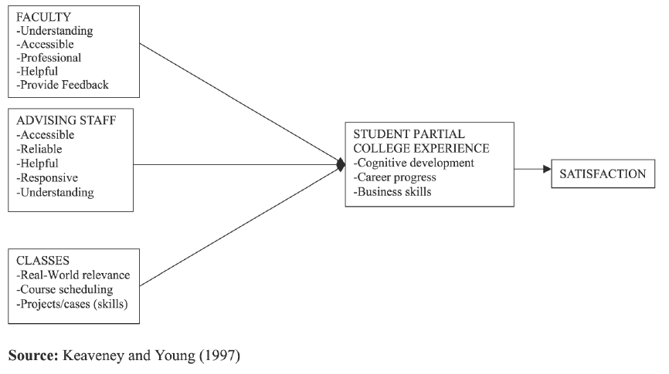
Source: Keaveney and Young(1997), cited by DeShields et al. (2005).

Appendix 4
My topic- ‘Analysis on Multiple impacts of ICT on university administrative staff’s performance’
- Class Activity
For researcher (myself):
- Satisfy Interests
- Skills improved such as critical thinking, reflexive review literatures
- Benefit for my career and personal plans….details…
- Increase my Research methodology as quantitative and qualitative methods
- Clarify my strengths and weaknesses, just your way behaviour
- Fulfil a long-term goal
- Be self-organizational and concentrated
- Combine Teaching and research, be insider and outsider
- Teamwork and group discussion
Academic knowledge:
- justify and modify the theory for better explaining motivation and job satisfaction in specific situation
- Knowledge of Organization Behaviour, such as JCM, TRA and TAM Model
- Provide some knowledge related to LEADERSHIP STRATEGIES and human resources management
- Improve method of work-quality assessment in our organization
Organization:
- Help college directors to make better decision of organizational assessment
- Help college directors to make better decision of organizational development
- Compare to study between universities with different degree of ICT use for my university to give suggestions to human resource management
Individuals:
Besides myself,
- the individual understanding of behavioural information systems phenomena such as downsize and economic
- Encourage individual use and training of ICT technology in working environment

- Class Activity:
Contributions by other’s research (Maslow, Hertzberg, Michael Porter, Hofstede)
Academic knowledge:
- Maslow: safety of their employment, love/belong is their satisfaction in their job environment.
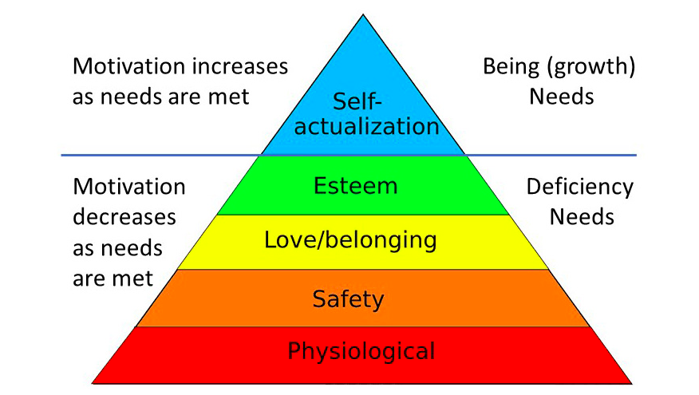
- Hertzberg: Two factor theory
The two-factor theory (also known as Herzberg's motivation-hygiene theory and dual-factor theory) states that there are certain factors in the workplace that cause job satisfaction while a separate set of factors cause dissatisfaction, all of which act independently of each other.

- Michael Porter: Five Forces Model
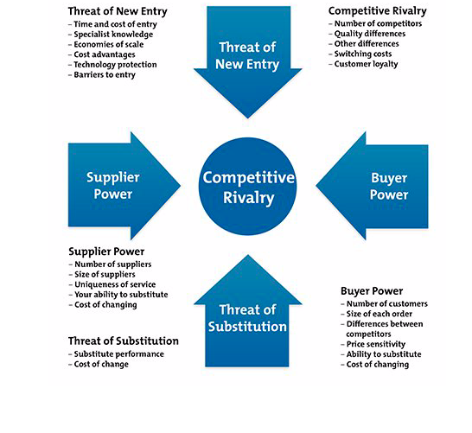

- Hofstede: Culture dimensions theory
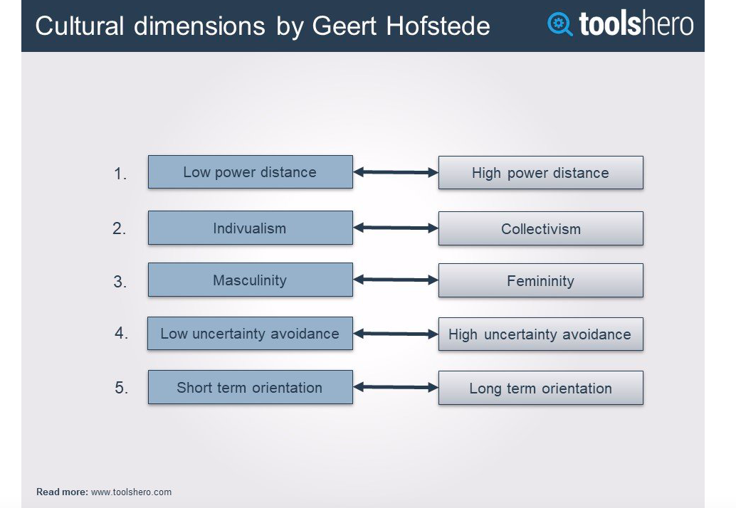

Entry 4 Defining the Research Question
Defining the research questions is like setting boundaries to the research topic, giving the framing of context, making it significative. This method could help us to shape and control the theme that will be talked about and focus on certain people, specifically actions and concrete organizations. “Once the question of ‘area’ has been settled, responsibilities, identities, purposes, causes, relationships, histories and spheres of action can be named, made known”. (Schostak and Schostak 2007, p.14)

After generating a primary topic and discussion with classmates, I became aware of the importance of choosing the topic which should match the resources available to me, in particularly, time and data. Since my prior topic is about employee performance under ICT (Information Communication Technology), I asked myself about how to develop my arguments. Although I found some theoretical literatures on TAM (Technology Acceptance Model) before, its feasibility was still a big problem because I could not figure out the methodology and access to data of employee within the available time without investigation. As Saunders’ (2012) argument of six strategies, I decided to identify my strengths and weakness, manage my research process with available resources and get access to organization (or information). Therefore, the new research idea given by my college leader occurred to my mind, which is “challenges for Chinese university brought by engineering education accreditation”, more linked to my career.

In order to refine my research ideas, I tried to discuss with my classmate in a Delphi group (Saunders 2016, p.38), provide justification to their inquiries and keep reflexion on myself, in order to narrow down the specific research topic. Expanding to a number of literatures in field of management education with questions (Saunders and Lewis, 2012, p.48), then I gradually gained a clearly acknowledge on the value of my research, and more details on my research project, such as concrete conceptions and theory, the history of my topic, even some arguments in existing findings. I also refined them with “Goldilocks test” (Clough and Nutbrown 2012, cited by Saunders 2016, p.44) to evaluate whether my research questions are either “too hot” (e.g. of a sensitive nature), “too small” (e.g. PhDs hardly to do), or “just right”, to make them become some central research questions. Because research aims is the final achievement of research, I will sort out the answers of these questions as “why”, “how” and “what” to implement a set of research objectives through whole procedure, until the essence be reflected by “Russian doll principle” (Clough and Nutbrown 2012, cited by Saunders 2016, p.44) (RoadMonkey, 2018).

Finally I organized the components of my mind map into a logical sequence of questions from three aspects: “research objects”, “background and theory research” and “methodology in research” in Appendix 4 (my mind map, individual activity). Through developing a list of strong research questions and drafting a mind map from my ideas, it indeed helps me to sort out my specific hypotheses of topic and dig out goals. And the next step for me is to answer these questions correctly with more investigations and turn it into a concrete proposal in future.

Appendix 1
Bryman, A. and Bell, E. (2015) Business Research Methods. 4th Ed. Oxford: Oxford University Press, pp. 10-15, 87-93.

Bryman, A. ed (2013) Doing research in organizations. Routledge.

Clough, P. and Nutbrown, C. (2012) A Student’s Guide to Methodology 3rd Ed. London: Sage.

Easterby-Smith, M., Thorpe, R., and Jackson, P. R. (2015) Management and business research. Sage.

Gill, J. and Johnson, P. (2010) Research Methods for Managers 4th Ed. London: Sage.

Saunders, M. N., and Lewis, P. (2012) Doing research in business & management: An essential guide to planning your project. Pearson.

Saunders, M., Lewis, P. and Thornhill, A. (2016) Research Methods for Business Students, 7th Ed. England: Pearson Education Limited.

Schostak, J., and Schostak, J. (2007) Radical research: Designing, developing and writing research to make a difference. Routledge.

Appendix 2
Goldilocks principle. Available at: https://en.wikipedia.org/wiki/Goldilocks_principle (Accessed: 10th April 2019)

What is GOLDILOCKS PRINCIPLE? (2017) Available at: https://www.youtube.com/watch?v=qT6R8BklPLQ (Accessed: 10th April 2019)

RoadMonkey, (2018) Goldilocks and the Russian Dolls. Available at:
https://hubpages.com/education/goldilocks-and-the-russian-dolls (Accessed: 10th April 2019)

Appendix 3
Quotations:
- Source: Module PPT of DBMDM7001 “Week 2 research topics and questions”.

- “Once the question of ‘area’ has been settled, responsibilities, identities, purposes, causes, relationships, histories and spheres of action can be named, made known”.
Source: Schostak and Schostak (2007), P.14.

- ‘action research’, which assumes that social phenomena are continually changing rather than static.
Source: Easterby et al. (2015).

- research questions: this may be one overall question or a number of key questions that the research process will address. These are often the precursor of research objectives.
Source: Saunders and and Lewis (2012), p.19.

Appendix 4
- Individual Activity :
My research questions are introduced from three aspects bellow:
(1). Research objects:
- What is the relationship between Chinese university and engineering education accreditation (EEA)? (Or why does university need EEA?)
- How does it be implemented in Chinese university and impact competency of students?
- What are the potential challenges brought by engineering education accreditation?
- What arguments or assumptions are evoked during the EEA procedure?
- How can we overcome the challenges?
- What are the benefits of the proposed research topic?
(2). Background and theory research:
- What is the history of the engineering education accreditation?
- What theories have been used on the topic?
- What can be inferred from current theoretical and empirical knowledge?
- What other research in related areas has been done that could inform research on the proposed problem?
(3). Methodology in research:
- What research methodology will be undertaken for the topic?
- Why use multiple methods?
- How the assumptions be tested without bias?
- What kinds of student data be collected?
- What data collection tools be used properly?
- What data analysis be more credible?
- How about reliability and validity of chosen samples?
- Individual Activity :
An example of my “Challenges brought by EEA for Chinese university. Xmind”.
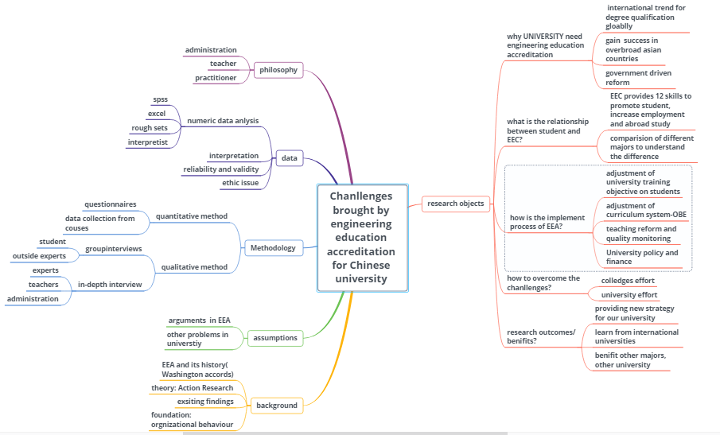

Entry 5 Philosophical Frameworks for Research
Before selecting phenomenology as a design of research, it is very significant to consider the intention of the research and the problems to be resolved. Therefore, “the term research philosophy refers to a system of beliefs and assumptions about the development of knowledge which is related to research” (Saunders et.al 2016, p.124). These assumptions include not only the realities in research (ontological assumptions), but assumptions about human knowledge (epistemological assumptions), the ways one’s own values influence research process (axiological assumptions), the methods and how the researcher interprets the findings (Crotty 1998).

The term Ontology is from two Greek words (Antwi and Hanza, 2015), for instance it refers to the way I define reality of my research, whether it is an assessment, a solution or a physical organization. Epistemology, it indicates the process in which I get to know the truth and reality. It contains not only knowledge, theory, understanding of the phenomenon, but how we explain ourselves as a practitioner. Axiology concerns about value judgment as my ethics, belief or religion while I am conducting the investigation. Therefore, three above conceptions together comprehensively shape my understanding of research questions and the whole extent, through inquiring into my mind and experiences to reflect the essences of phenomena as well as the intentionality of conscience.

Based on the theory of onion's layers in Saunders' book (2016), only after justifying my philosophy choice in the coexistence of multiple research philosophies and paradigms, I will be much clearer about the methodologies related to my research for next step. Different philosophical paradigms which center on diverse conceptions of reality (Guba,1990; Guba and Lincoln, 2000; Denzin and Lincoln, 2008) cited in Saunders (2016), which are mainly five: Positivist, Critical Realist, Interpretivist, Postmodernist, Pragmatist.

If I was a positivist researcher, I’d like to only use measurable data and standardized tools to explain behaviors. For critical realists, the reality is a structured and layered ontology being crucial (Fleetwood 2005). And interpretivist is concerned with understanding the world as it is from subjective experiences of individuals. Thus, “the reality is socially constructed – it is a human construct” (Mutch, 2005, cited in Antwi and Kasim, 2015). Postmodernists challenge organizational concepts and theories and seek to demonstrate what perspectives and realities they exclude and leave silent and whose interests they serve. For my research philosophy, I prefer to be an action-researcher (O'Gorman, 2015) or a pragmatism more who asserts that concepts are only relevant where they support action (Kelemen and Rumens 2008). And I hope to reconcile both objectivism and subjectivism, and outcome of research can achieve practical solutions. Something inspired from the illustration of O'Gorman and MacIntosh (2015), I would undertake abduction to my project and adapt hypotheses to between phenomenon and theory, to obtain a practical solution or theory value at last. According to the comparison of five research philosophies in Table 4.3 of Saunders’ book (2016, p.136), a mixed strategy of qualitative and quantitative methodology (Antwi and Kasim, 2015) will be utilized in my research and exploring phenomenon from not only insiders’ perspectives but outsiders’. Since each philosophy framework contributes a unique and valuable way of seeing the organizational world, I will insist on my initial research purpose and complete the entire research process with awareness of my research philosophy.

Appendix 1
Antwi, S, Kasim, H. (2015) ‘Qualitative and Quantitative Research Paradigms in Business Research: A Philosophical Reflection’, European Journal of Business and Management, 7(3).

Denzin, N.K., and Lincoln, Y.S. (Eds) (2008) Handbook of Critical and Indigenous Methodologies. Los Angeles, CA: Sage.

Guba, E. (1990) The Alternative Paradigm Dialogue. In Guba, E. (ed.) The Paradigm Dialogue. London:Sage.

Hammersley, M. (ed.), (1993) Social Research: Philosophy, Politics and Practice. London: Sage.

Lincoln, Y.S. and Guba, E.G. (2005) Paradigms and perspectives in contention. In N. Denzin and Y. Lincoln (eds.), Handbook of Qualitative Research 2nd Ed, pp. 163-188. Thousand Oaks, CA: Sage.

Mutch, C. (2005) Doing Educational Research: A Practitioner’s Guide to Getting Started. Wellington: NZCER Press.

O'Gorman, K. and MacIntosh, R. (2015) Research methods for business & management: A guide to writing your dissertation 2nd Ed. Global management series.

Padilla-Díaz, M. (2015) ‘Phenomenology in educational qualitative research: Philosophy as science or philosophical science’, International Journal of Educational Excellence, 1(2), pp.101-110.

Pritchard, D. (2014) what is this thing called knowledge? 3rd Ed. Oxon: Routledge.

Saunders, M., Lewis, P. and Thornhill, A. (2016) Research Methods for Business Students, 7th Ed. England: Pearson Education Limited.

Sekaran, U., and Bougie, R. (2016) Research methods for business: A skill building approach. John Wiley & Sons.

Appendix 2
Action research. Available at:
https://en.wikipedia.org/wiki/Action_researchn (Accessed: 30th March 2019)

Carol Davenport (2014) Action Research in Education. [video] Available at:
https://www.youtube.com/watch?v=TOrQ-sVTuE0 (Accessed: 30th March 2019)

John Spencer (2017) What is action research? [video] Available at: https://www.youtube.com/watch?v=Ov3F3pdhNkk (Accessed: 30th March 2019)

Appendix 3
Quotations:
- “The term research philosophy refers to a system of beliefs and assumptions about the development of knowledge which are related to research”.
Source: Saunders et al. (2016), p.124.

Graphs:
- Graph 1 The onion framework of research philosophy.
Source: Saunders et al. (2016), p.124.
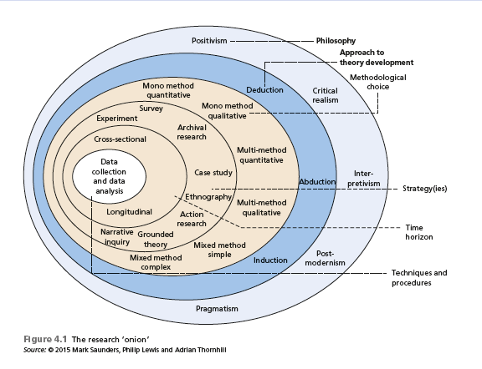
- Graph 2 The procedure of method map.
Source: O'Gorman and MacIntosh (2015).
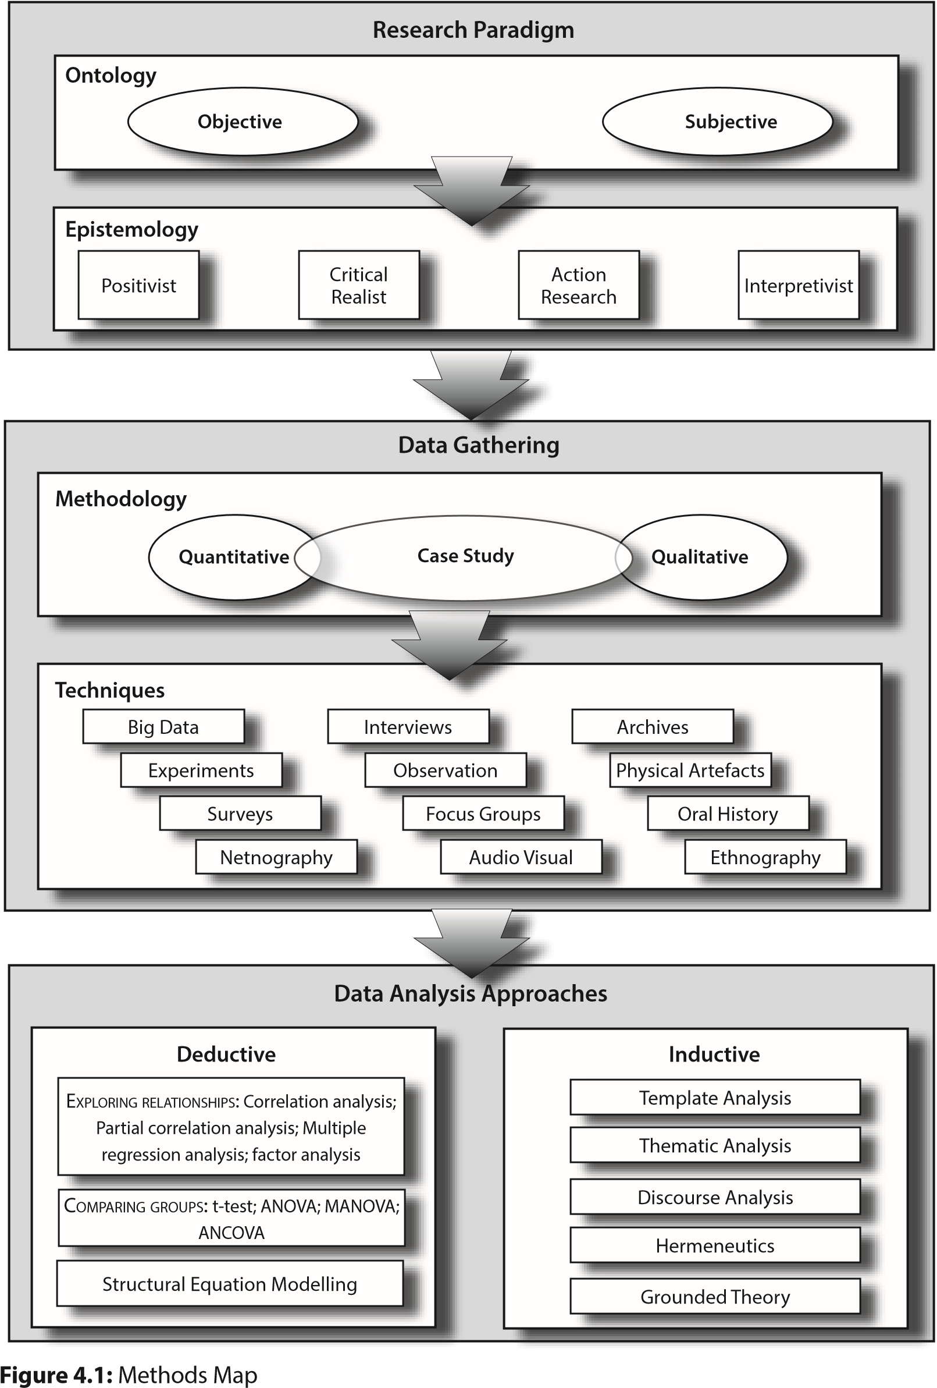

Tables :
- Table 1 Comparison of five research philosophies
Source: Saunders et al. (2016), p.136.
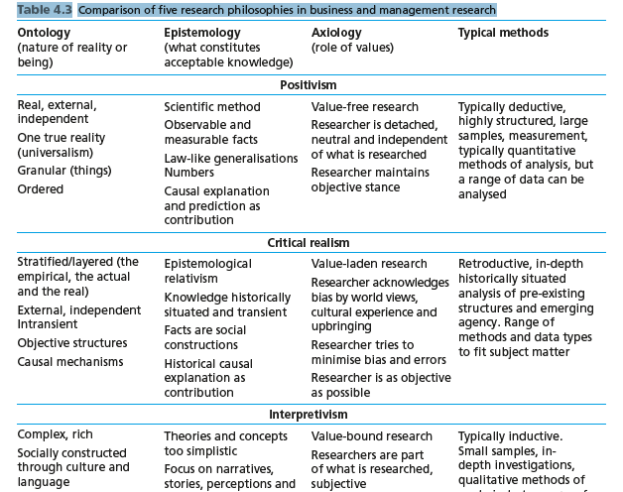
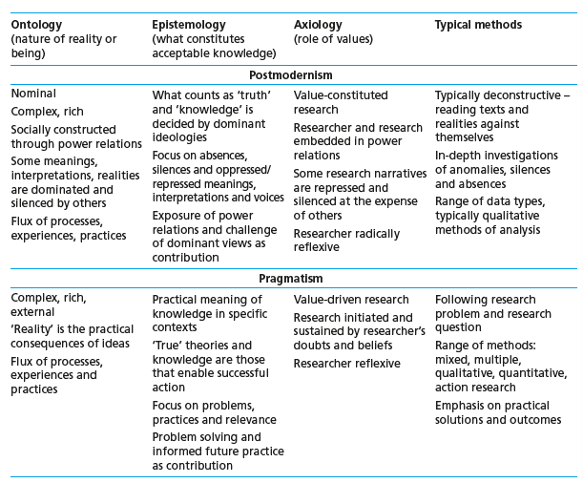

- Table 2 summary of major differences between quantitative and qualitative approaches.
Source: Antwi and Kasim (2015)
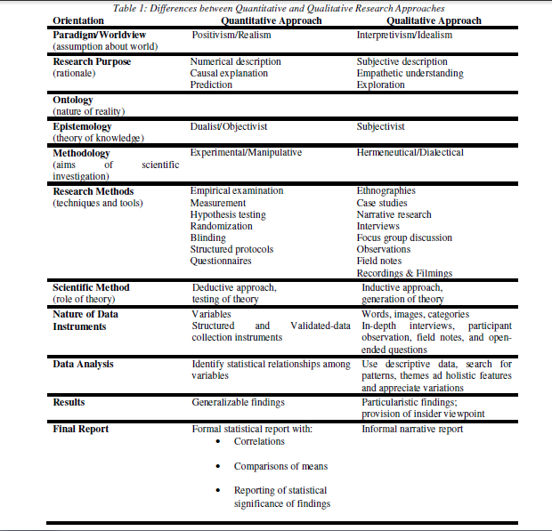

Appendix 4
- Class Activity:
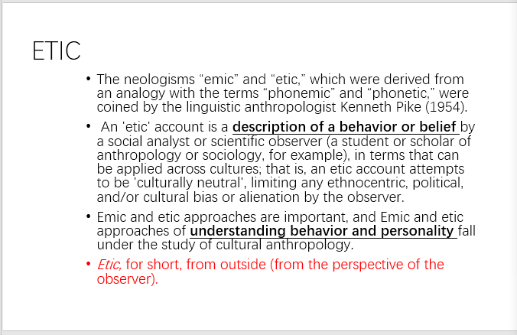

- Individual Activity :
My class presentation:
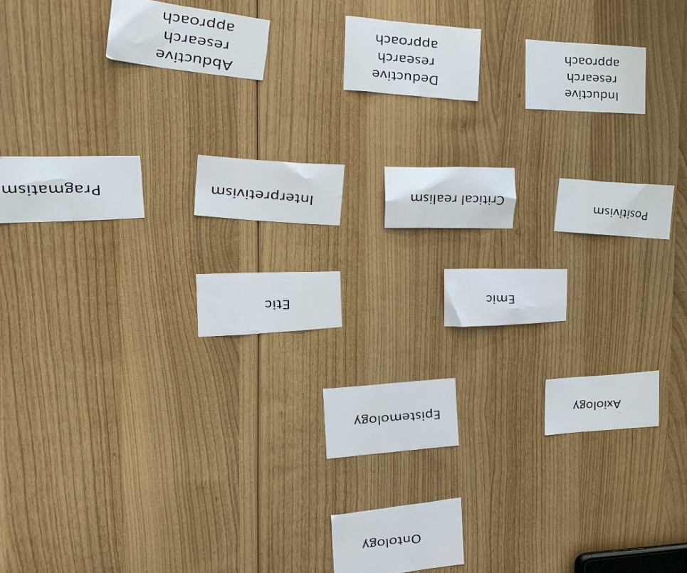
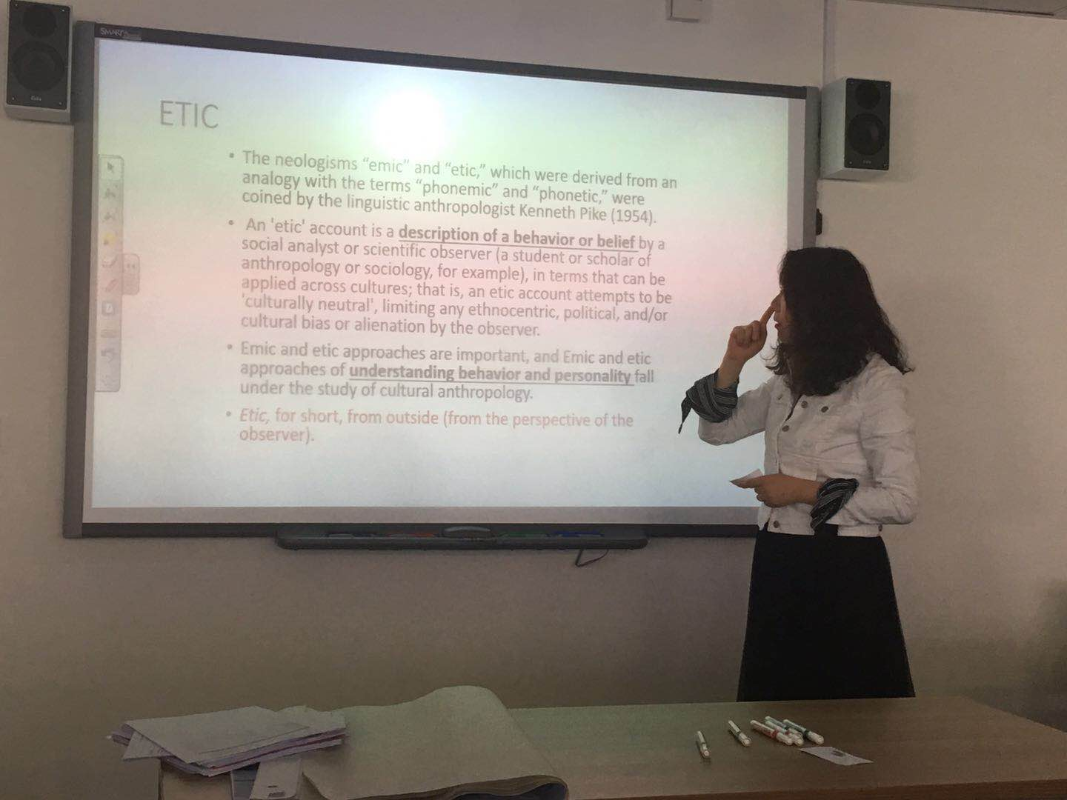

Entry 6 Types of Research and Research Design
“In many ways, designing research is like planning a journey” (Jan Thornhill 2015, cited by Saunders et al. 2016, p.163). Therefore, planning a most appropriate way to my destination of research is of significance, which is the meaning of designing research. And this procedure generally includes four aspects: methodological choice, strategy, time horizon, techniques and procedures, as shown in figure 5.1 “research onion” (Saunders et al. 2016, p.164).
It is well known that several methods such as quantitative, qualitative, multi-method or mixed method can be applied in research design. Mono quantitative method is usually used in countable data collection or numerical data analysis, for instance numbers of questionnaire or statistics of structured information. Mono qualitative method is used in some unquantifiable, open-ended information collection or analysis by contrast, for instance an interview, some words, image, and video. From perspective of my philosophy before, I would rather be an interpretivist and pragmatist mixed than a pure positivist or interpretivist, pragmatist, so the assumption informs me to choose mixed methods to design research. Through combining the use of quantitative and qualitative data collection techniques and analytical procedures, I might also undertake research associated with abduction approach (combine deduction and induction together) (Saunders and Lewis, 2012) between data and theory.

Of course, according to figure 5.3 in Saunders (2016, p. 170), my research procedure will be designed as a sequential mixed methods research project and it consists of two stages:

Firstly, a sequential explanatory research design (Creswell 2009, cited in Saunders et al. 2016, p.173) will be suggested to use in the implement progress of EEA, which involves quantitative method for lots of courses’ scales and a further qualitative analysis following. Qualitative research can be undertaken from action research (Coghlan 2011), case study or observation here. Besides, we should be care about valuable data collected by observation especially for triangulation which might raise ethical issues.

Secondly, using a concurrent triangulation design (Saunders, et al. 2016, p.170) is to separate use of quantitative and qualitative methods on students and outside experts respectively. Quantitative research is mainly undertaken with survey strategies or online questionnaires from sizeable population of respondents. Qualitative research can be undertaken from in-depth interviews, or group interviews of experts in enterprises, universities. Through comparison between how these data sets support each other, I could explore current phenomenon and further essence by triangulation-mixed method to ascertain the findings.

To sum up, just as Nastasi et al. (2010) argued that, “the research context and likely research consequences are driving forces determining the most appropriate methodological choice”, it is a various research journey how quantitative and qualitative method may be dominant and supporting role alternatively in several ways to design my research.

Lastly, for an effective questionnaire, key points such as relevance, clarity, reliability, validity and without bias are vital in planning, design and pilot stages. If any problems be found in pretest, then final questionnaire should be redesigned, which indicates the significance of “pilot” (Craig and Annette, 2018). Meanwhile, conducting qualitative research is also an iterative process of discovering researches, challenging their positionality and how they were shaped by the reflexivity in research (Palaganas et al. 2017).

Appendix 1
Coghlan, D. (2011) ‘Action Research: Exploring perspectives on a philosophy of practical knowing’, The Academy of Management Annals, Vol. 5, No. 1, pp. 53–87

Nastasi, B.K., Hitchcock, J.H. and Brown, L.M. (2010) An inclusive framework for conceptualizing mixed methods design typologies: Moving toward fully integrated synergistic research models. Handbook of mixed methods in social & behavioral research, 2, pp. 305-338.

Palaganas, E.C., Sanchez, M.C., Molintas, M., Visitacion, P. and Caricativo, R.D. (2017) Reflexivity in qualitative research.

Robson, C. (2011) Real World Research, Chichester: John Wiley and Sons.

Saunders, M. N., and Lewis, P. (2012). Doing research in business & management: An essential guide to planning your project. England: Pearson Education Limited.

Saunders, M., Lewis, P. and Thornhill, A. (2016) Research Methods for Business Students, 7th Ed. England: Pearson Education Limited.

Appendix 2
Grounded theory. Available at: https://en.wikipedia.org/wiki/Grounded_theory (Accessed: 11th April 2019)

Netnography. Available at: https://en.wikipedia.org/wiki/Netnography (Accessed: 13th April 2019)

Craig Parylo and Annette Lee (2018). Available at:
http://www.leicspart.nhs.uk/library/clinicalaudit_questionnaireslides.pptx (Accessed: 13th April 2019)

Appendix 3
Quotations:
- “In many ways, designing research is like planning a journey”.
Source: Jan Thornhill 2015, cited in Saunders et al. (2016), p.163.

- “Action research is simply a form of self-reflective enquiry undertaken by participants in social situations in order to improve the rationality and justice of their own practices, their understanding of these practices, and the situations in which the practices are carried out”.
Source: Carr and Kemmis (1986).

- “Action Research is an emergent and iterative process of inquiry that is designed to develop solutions to real organisational problems through a participative and collaborative approach, which uses different forms of knowledge, and which will have implications for participants and the organisation beyond the research project”.
Source: Coghlan 2011, cited in Saunders et al. (2016), p.189.

- “The research context and likely research consequences are driving forces determining the most appropriate methodological choice”.
Source: Nastasi et al. (2010), pp.305-338.

Graphs:
- Graph 1 Research design of mixed methods.
Source: Saunders et al.(2016), p.170.
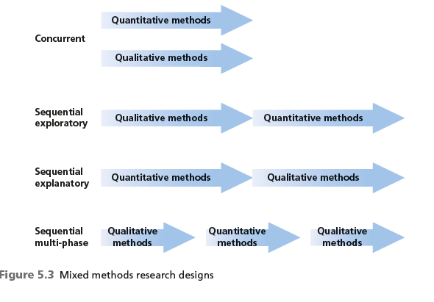

- Graph 2 Process of action research
Source: Cardno and Piggot (1996), pp.19-24.
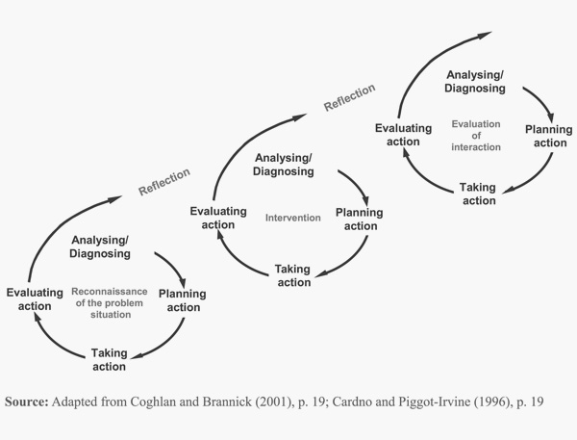

Appendix 4
- Class Activity:
Group 1 reliability.
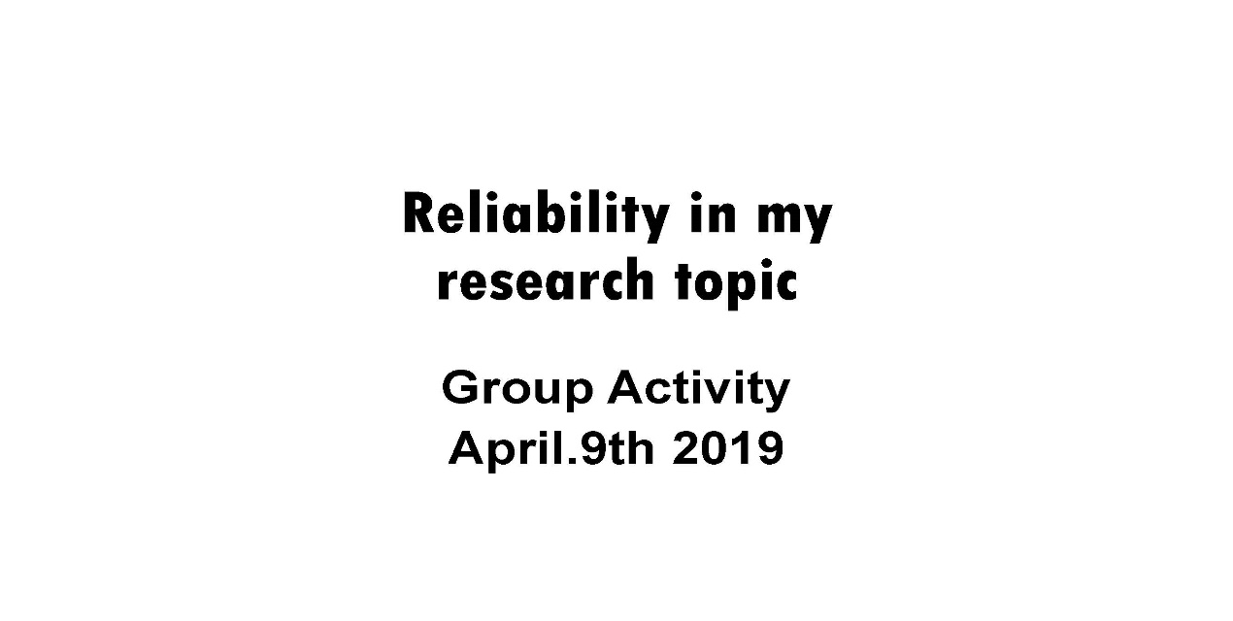
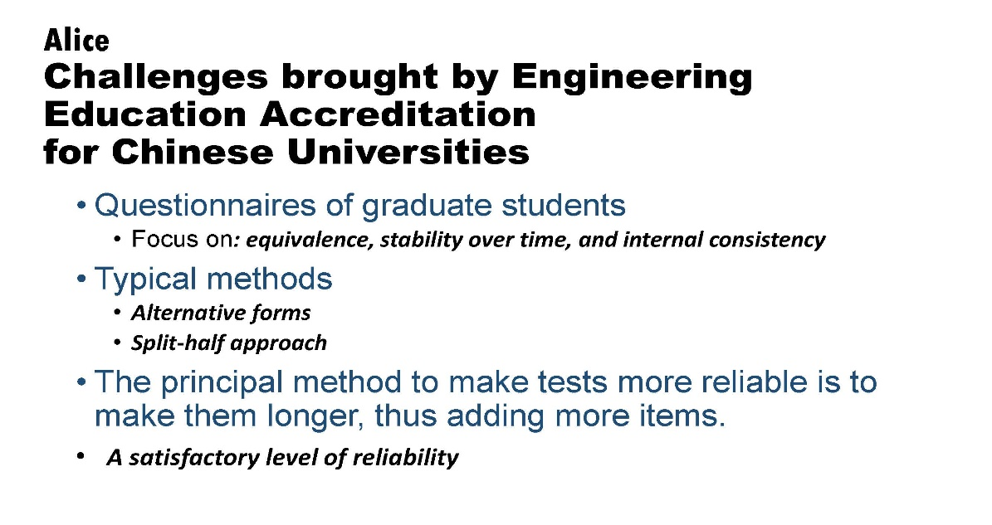

Entry 7 Research Ethics and Integrity
“Ethics refer to the standards of behaviour that guide your conduct in relation to the rights of those who become the subject of your work, or are affected by it” (Saunders et al. 2016, p.239). Research Ethics is consisted of a set of standardized rules for research behaviors which is almost eternal principles although different organizations outline their professional ethics code of conduct. And integrity in research is generally about ensuring the people who are engaged in the research activities uphold the highest values of the ethics, strive for consistency of thought and act with sincerity in whatever situations (Resnik, 2011, p.3). Most literatures only remind us to be alert and conduct research by research integrity & ethics, and they argue that ethics are the fundamental guiding principles that govern research integrity (Guillemin and Gillam, 2004.p.277). From my perspective, integrity is partly of the “guiding value” (Guillemin and Gillam, 2004, p.270) in ethics. However, there are some arguments about precise definitions of “research ethics” and “research integrity” (Steneck, 2006, p.56), that separates research ethics and research integrity from the perspectives of moral principles and professional standards totally. And Steneck also emphasizes the importance of fostering high standards for research integrity. Therefore, research integrity and research ethics maybe have some virtues of similarity and different aims.

In Saunders’ (2012), it analysed what ethical issues should be concerned about three research stages, from the design and access stage, the data collection stage to the reporting stage in details. For instance, when researchers begin to design research at the beginning, they should give assurance of confidentiality to secure that of respondent consent; be honest to respondents about data usage; give their right to withdraw from the study at any time; have an ethical obligation to use the time and way they were granted by the organisation; evaluate some topics with greater risks such as education, health or social services. When researcher are doing data collection, they should deal with the potential to harm respondents (or recognizing participant interests) (class activity); be careful with problems of “reactivity” (or “observer effect”) (Saunders and Lewis 2012, p.78) raised by observation, secondary data, practised dishonesty in data. When researchers submit the final report, they should sustain an ethical responsibility to protect individual respondents’ right to anonymity or pseudonymity (class activity), be honest to tell respondents the conclusion; promote private or public good (beneficence). Compared with this book, Saunders (2016) put forward more details in ethical and integrity issues at all stages (Saunders et al. 2016, p.250) which turns previous three stages into five ones and comprehensively explains it. What is more, he added a separate section for the general ethical issues associated with internet-mediated research due to emergence of the internet development.

Take my research for example, the main ethical consideration might be the issue of consent, respecting privacy of participants, confidentiality of data and management of data when I undertake my research methods by web pages, emails and questionnaires online; my integrity might focus on the accuracy, rigour, efficiency and objectivity of data analysis (class activity). As Sekaran and Bougie referred in 2016, the responsibility of research rests in the fact that technology should go hand in hand with the integrity and ethical practices as they pursue their daily ongoing research activities.

Appendix 1
Babbie, E.R., (2016). The practice of social research 14th Ed., Cengage Learning, USA: Nelson Education, Ltd.

Saunders, M., Lewis, P. and Thornhill, A. (2016) Research Methods for Business Students, 7th Ed. England: Pearson Education Limited.

Saunders, M. N., and Lewis, P. (2012) Doing research in business & management: An essential guide to planning your project. England: Pearson Education Limited.

Sekaran, U. and Bougie, R. (2016) Research methods for business: A skill building approach. John Wiley & Sons.

Guillemin, M. and Gillam, L.(2004) ‘Ethics, reflexivity, and “ethically important moments” in research’, Qualitative inquiry, 10(2), pp.261-280.

Resnik, D.B., (2011) ‘What is ethics in research & why is it important’, National Institute of Environmental Health Sciences, 1(10).

Steneck, N. (2006) ‘Fostering integrity in research: Definitions, current knowledge, and future directions’, Science and Engineering Ethics, 12(1), 53-74.

Appendix 2
Integrity. Available at:
https://en.wikipedia.org/wiki/Integrity (Accessed: 17th April 2019)

Research Integrity & Ethics. Available at: https://www.uwtsd.ac.uk/research/research-ethics/ (Accessed: 17th April 2019)

UWTSD Research Ethics. Available at:
https://www.uwtsd.ac.uk/research/research-ethics/ (Accessed: 17th April 2019)

UWTSD Research Integrity and Ethics Code of Practice (2017) Available at:
https://www.uwtsd.ac.uk/media/uwtsd-website/content-assets/documents/research/research-ethics-integrity-code-practice.pdf (Accessed: 17th April 2019)

Appendix 3
Quotations:
- ‘the problem of ‘reactivity’ (or ‘observer effect’), which is a particular problem with observation. This happens when those you are observing adapt their behaviour as a consequence of your observation’.
Source: Saunders and Lewis (2012), p.78.
- ‘research ethics (RE) and can be defined as the critical study of the moral problems associated with or that arise in the course of pursuing research.’
‘research integrity (RI) is defined as possessing and steadfastly adhering to professional standards, as outlined by professional organizations, research institutions and, when relevant, the government and public’.
Source: Steneck, N. (2006), p.56.
Tables:
- Table 1 Example of ethical standard.
Source: Saunders and Lewis (2012), p.75.
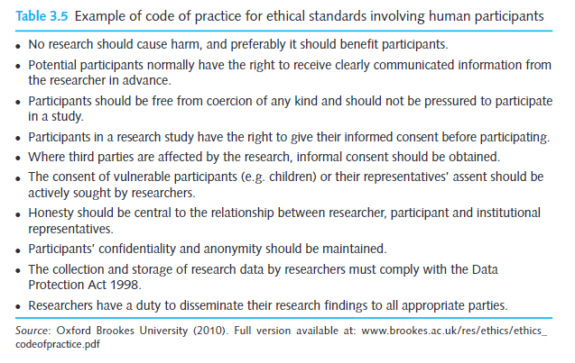
- Table 2 Possible ethical issues.
Source: Saunders and Lewis (2012), p.82.
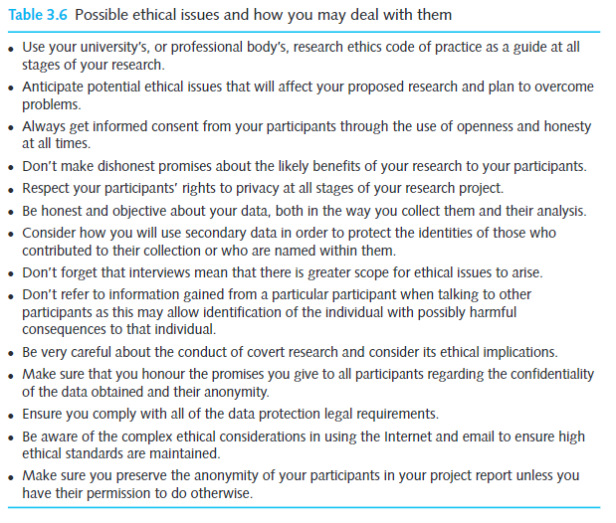

- Table 3 Ethical principle and explanations
Source: Saunders et al. (2016), p.243.
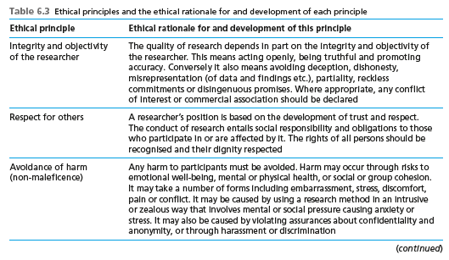
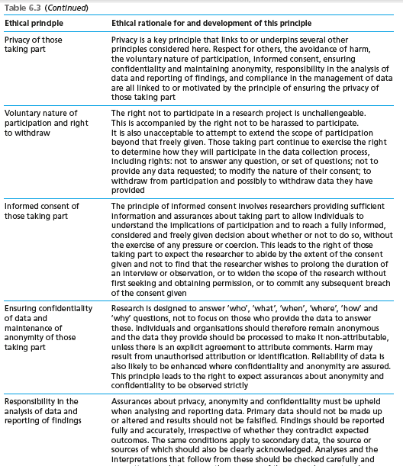
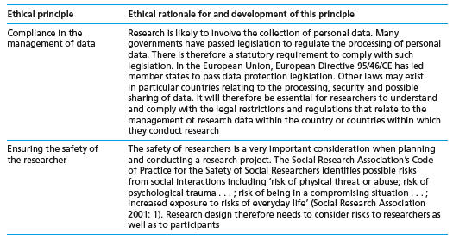
Graphs:
- Graph 1 Ethical issues at different stages
Source: Saunders et al.(2016), p.250.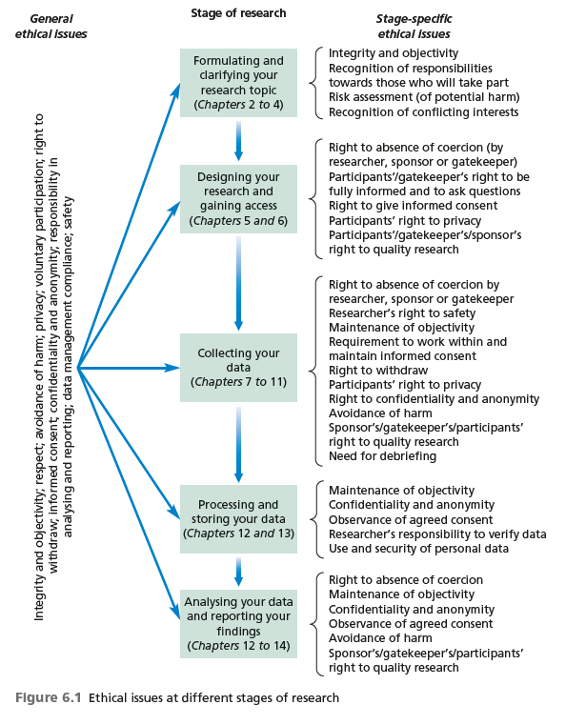

- Graph 2 Comparison of research ethics and integrity
Source: Steneck, N. (2006), p.56.
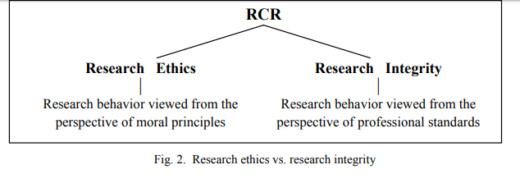

Appendix 4
- Class Activity:
Group 4- recognizing participant interests, beneficence, anonymity, confidentiality, pseudonymity.
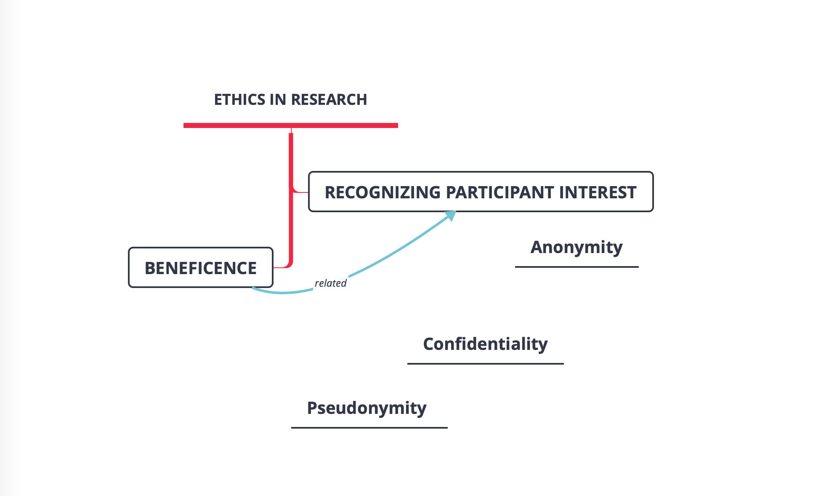
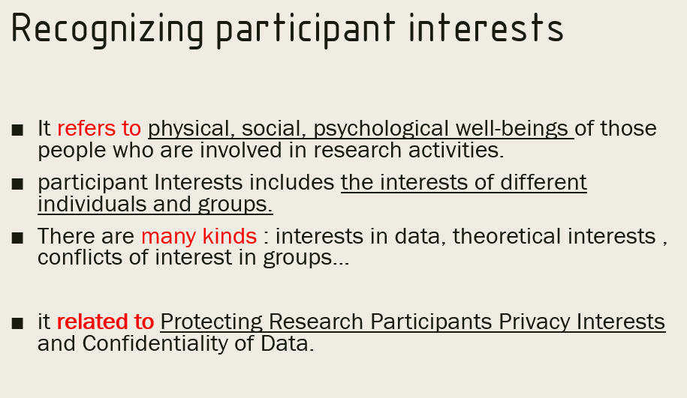
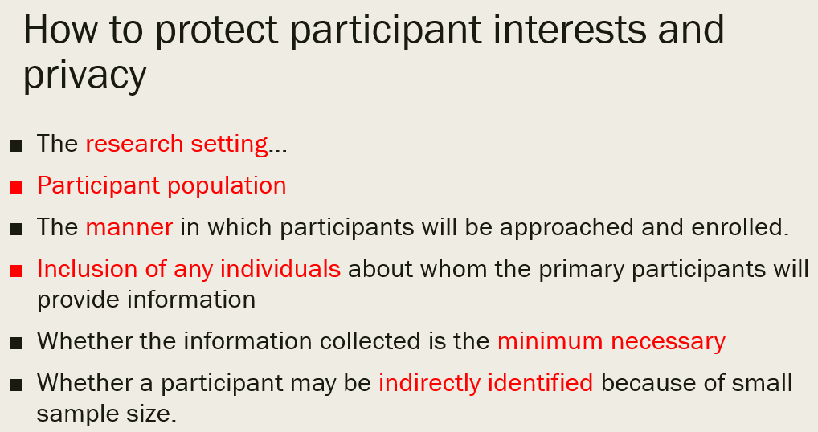
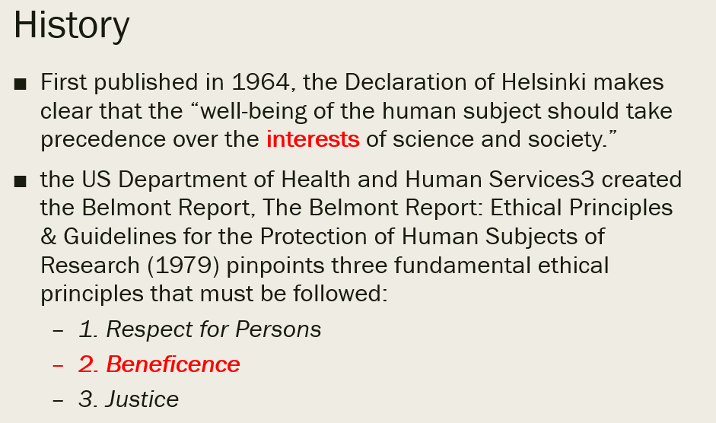
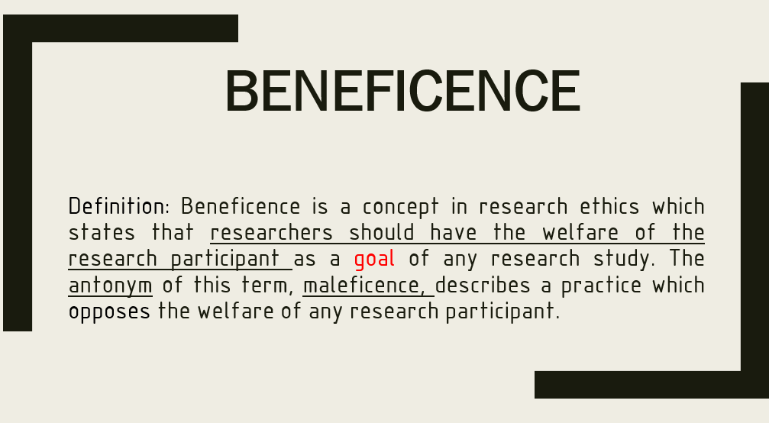
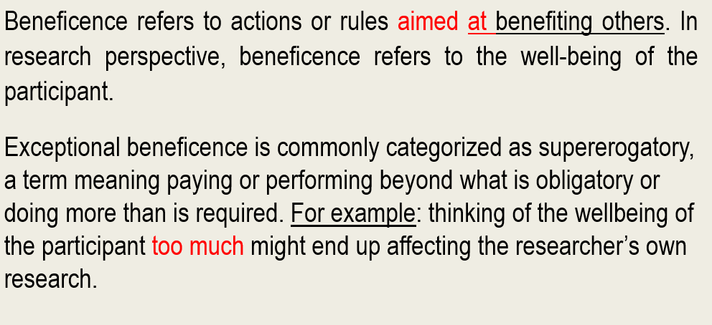
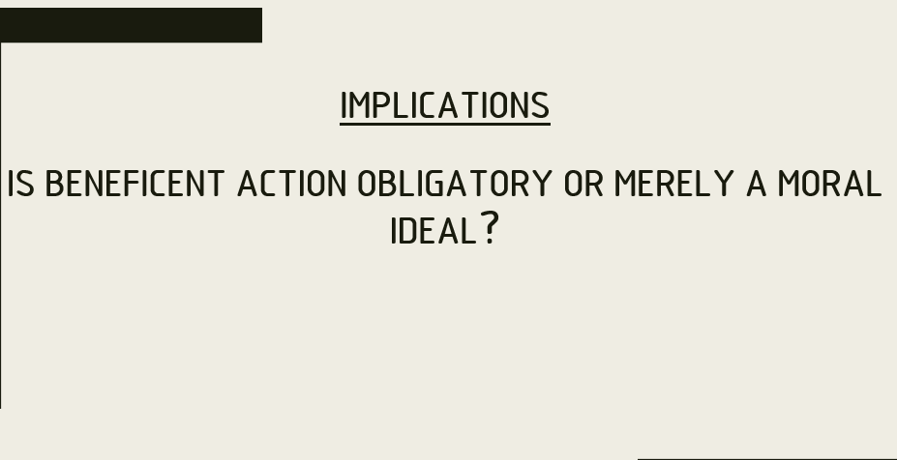
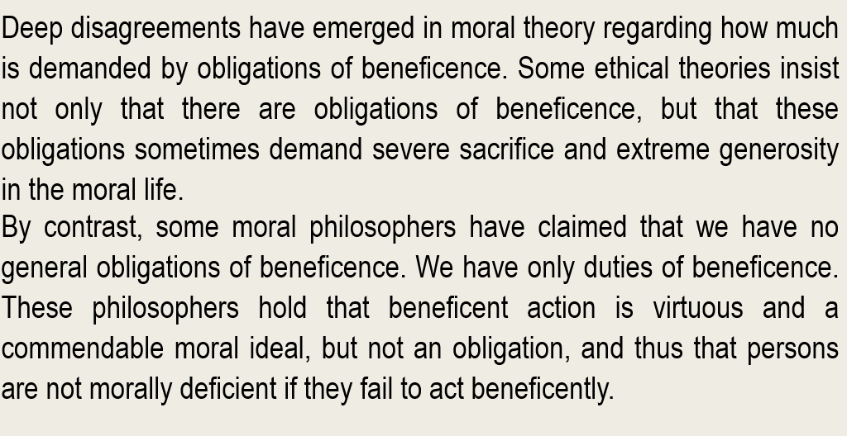
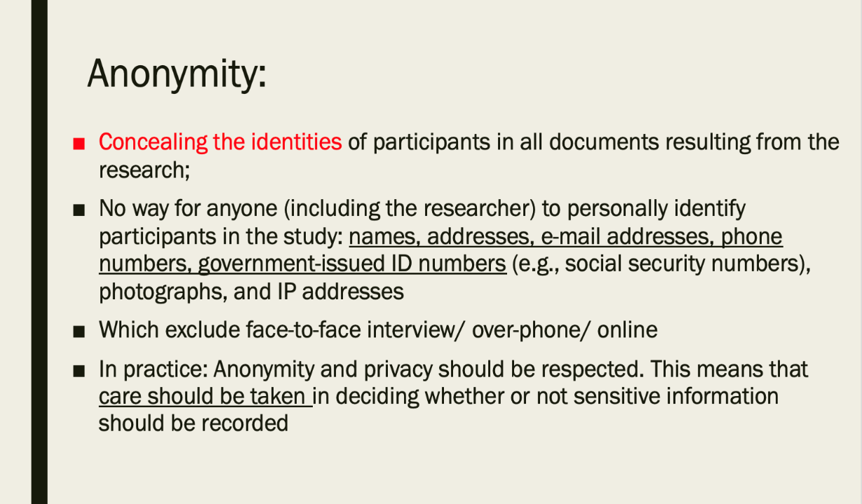
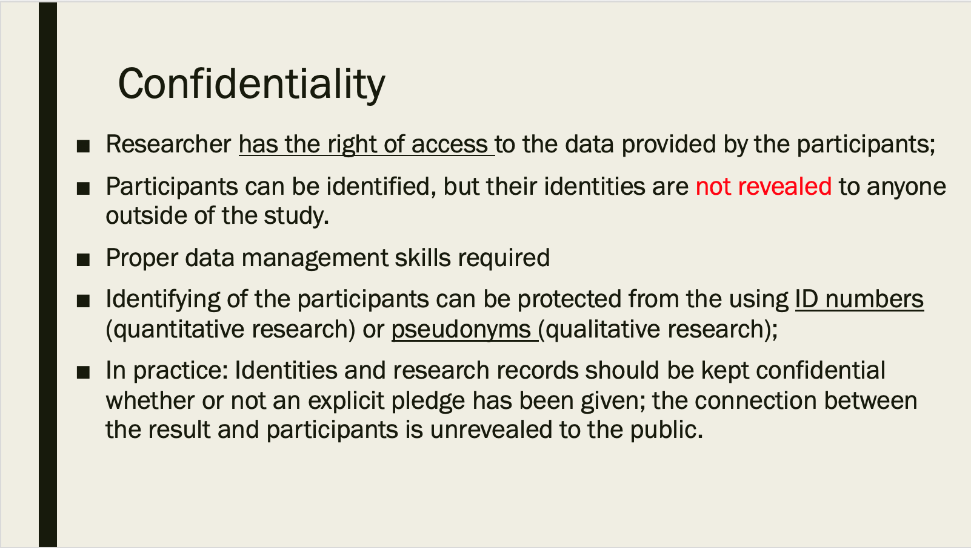
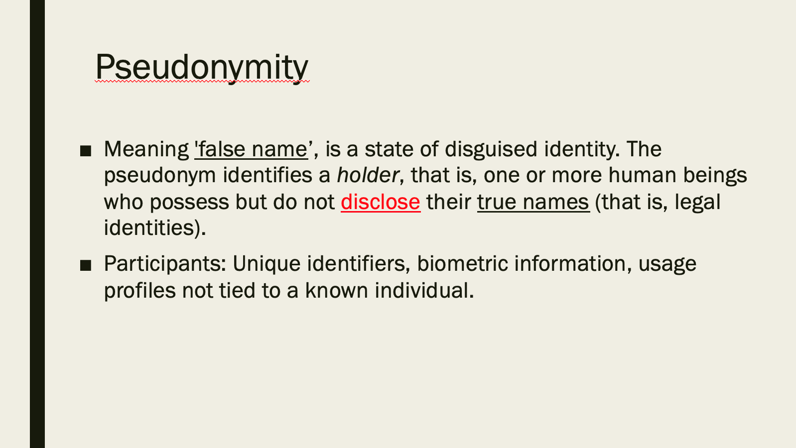

- Class Activity:
Accuracy and rigour


