

Student name: Larry Osei Kofi
Student ID: 2308809
Module name: Empowering the Older Person
Module code: BMHP6027
Lecturer’s name: Laila Surani

(Piotr Pawel Chmielewski et al., 2024)  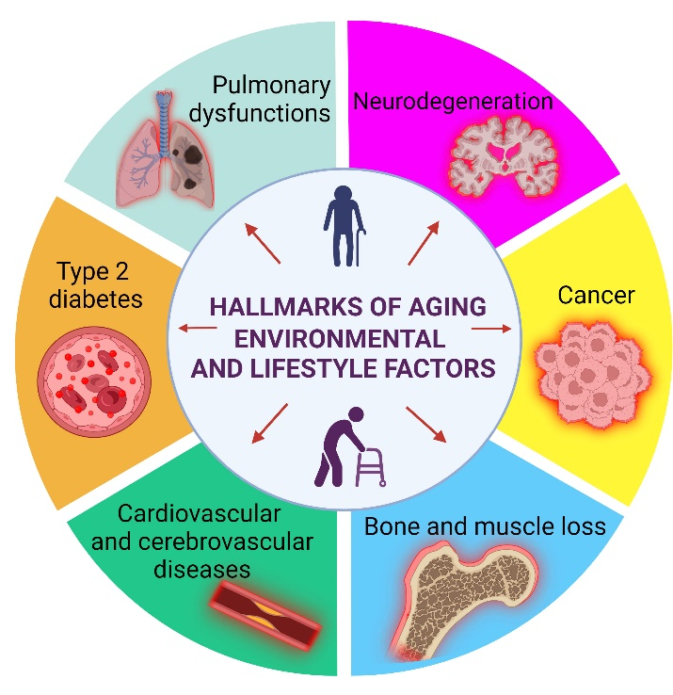 |  | CARE, EMPOWERMENT AND SUPPORT NEEDS OF THE OLDER ADULT  - Holistic approaches to care include physical, emotional and social components is needed in the process of caring and empowering adults (Zamanzadeh et al., 2026).  - Maintaining functional ability when caring for older adults is also essential to improve overall quality of life and physical performance of the adult (Itxaso Mugica-Errazquin et al., 2024).  Critical Evaluation:  - Person centred care is about giving people dignity, choice and control (Lorraine, 2024).  - When people are empowered, their self-esteem and overall wellbeing improve (Copley, 2024).  - However, lack of staff and funding means providing truly person-centred care is difficult (Care Quality Commission, 2022).  - Many older people do not feel they have a say in how they are cared for; despite guidelines stating they should be involved in decisions about their care (Halamová et al., 2025). |  | (connoryates09, 2024)  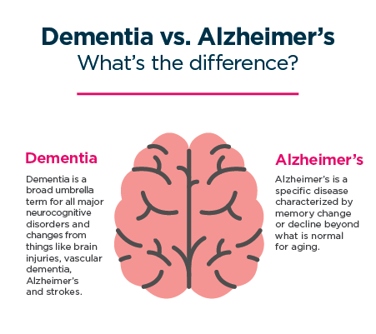
INTRODUCTION.  - As England’s population ages, more health and social care services are needed (The Health Foundation, 2023).  - Many older adults have physical decline, long-term health issues and loneliness (National Institute on Ageing, 2019).  - Age UK estimate millions of older adults live with unmet care needs (Age UK, 2024).  - This poster discusses the nature of care, empowerment, independence and the support network older people need to access.  EFFECTIVENESS OF APPROACHES AND UK POLICIES.  UK Policies:  - Care Act 2014 – provides the framework for promoting wellbeing and independence (SCIE, 2023).  - NHS Long Term Plan – provides support for delivering care in the community (NHS England, 2019)  Examples of Interventions:  - Assistive Technology (e.g., Fall Alarms)  - Home Care/Palliative Care  - Community Support Programs  Theories that Relate to Intervention: (Nilsson, Bülow and Kazemi, 2015)  - Activity Theory - argues that older adults can maintain a sense of happiness/wellbeing and good health if they continue to engage in social activities.  - Disengagement Theory - argues that as we age, we pull away from our social roles naturally. |  |  |  | CHALLENGES FACED BY OLDER ADULTS.  ((Methodist Homes, 2021).  - Physical Decline (mobility; chronic illness)  - Cognitive Decline (e.g. dementia)  - Social Isolation and Loneliness  - Financial Strain  - Poor Housing/Environment (inaccessible)  - Digital Exclusion  Critical Insights:  - These challenges are often interlinked, which makes maintaining independence more difficult.  - The absence of supports can lead to decreased quality of life and increased levels of dependency.  RECOMMENDATIONS FOR IMPROVEMENT.  (NHS England, 2025)  - More financial support for social care.  - Increase opportunities to access assistive technology.  - Offer digital training for older individuals.  - Increase the availability of community support services.  - Develop staff training on person-centred care.  By improving these areas, we can empower older adults through enhancing the quality of their care.  CONCLUSION.  In Conclusion:  - Older adults require help with integrated and person-centred care.  - While UK policy strives to promote independence there are still funding and access issues.  - By enhancing services; promoting independence, well-being and quality of life will be improved.
Critical Evaluation of Interventions:

- Intervention has reduced the number of hospital admissions and increased the level of independent living for many.

- However, difficulties associated with access to services and digital exclusion mean that there is no level of equity within the various populations regarding the support provided by the interventions.

- Funding variations have resulted in inconsistent delivery/service provision for some services.

References
Age UK (2024) 2 Million Older People Now Have Some Unmet Need for Social Care. Available at: https://www.ageuk.org.uk/latest-press/articles/2-million-older-people-now-have-some-unmet-need-for-social-care/ (Accessed: 18 March 2026).
Care Quality Commission (2022) Staff Shortages and the Impact on Patients - Care Quality Commission. Available at: https://www.cqc.org.uk/publications/monitoring-mental-health-act/2021-2022/staff-shortages (Accessed: 18 March 2026).
connoryates09 (2024) A New Drug Called Donanemab Could Be the Turning Point in the Fight against Alzheimer’s. Available at: https://www.mypharmacy.co.uk/a-new-drug-called-donanemab-could-be-the-turning-point/?srsltid=AfmBOopS7i5aJUNZYmjbZPyOYIWoa1xrfvpbc6t_Qvg96MxiXAm6FX9P (Accessed: 18 March 2026).
Copley, L. (2024) Discovering self-empowerment: 13 methods to foster it. Available at: https://positivepsychology.com/self-empowerment/ (Accessed: 18 March 2026).
Halamová, L., Locock, L., Maclaren, A., Makin, S. and Phillips, L. (2025) Involvement of older adults in shared decision-making on care transitions in the UK: an interpretative qualitative systematic review. Ageing and Society, 45(11), pp. 1–26. Doi: https://doi.org/10.1017/s0144686x25100123
Itxaso Mugica-Errazquin, Irazusta, J., Maider Kortajarena, Saioa Elosegi, Wu, B., Qi, X., Rodriguez-Larrad, A. and Rezola-Pardo, C. (2024) Maintaining Daily Living Activities in Older Adults: The Impact of a Functional Exercise Program in Long-Term Nursing Homes. A Single-Group Pre-Post Intervention. Geriatric Nursing, 60(November–December 2024), pp. 215–224. Doi: https://doi.org/10.1016/j.gerinurse.2024.09.003
Lorraine (2024) Person-Centred Care in Health and Social Care – Flourish. Available at: https://flourish.co.uk/community/person-centred-care/ (Accessed: 18 March 2026).
Methodist Homes (2021) Facts & Stats about the Older People in the UK: MHA. Available at: https://mha.org.uk/care-support/later-life-hub/facts-stats-about-older-people (Accessed: 18 March 2026).
National Institute on Ageing (2019) Social isolation and loneliness in older people pose health risks. Available at: https://www.nia.nih.gov/news/social-isolation-loneliness-older-people-pose-health-risks (Accessed: 18 March 2026).
NHS England (2019) What is personalised care? Available at: https://www.england.nhs.uk/personalisedcare/what-is-personalised-care/ (Accessed: 18 March 2026).
NHS England (2025) Improving Care for Older People. Available at: https://www.england.nhs.uk/ourwork/clinical-policy/older-people/improving-care-for-older-people/ (Accessed: 18 March 2026).
Nilsson, H., Bülow, P.H. and Kazemi, A. (2015) Mindful Sustainable Ageing: Advancing a Comprehensive Approach to the Challenges and Opportunities of Old Age. Europe’s Journal of Psychology, 11(3), pp.494–508. Doi: https://doi.org/10.5964/ejop.v11i3.949
Piotr Pawel Chmielewski, Data, K., Strzelec, B., Farzaneh, M., Amir Anbiyaiee, Zaheer, U., Uddin, S., Mohadeseh Sheykhi-Sabzehpoush, Mozdziak, P., Zabel, M., Piotr Dzięgiel and Kempisty, B. (2024) Human Ageing and Age-Related Diseases: From Underlying Mechanisms to Pro-Longevity Interventions. Ageing and Disease, 16(4). Doi: https://doi.org/10.14336/ad.2024.0280
SCIE (2023) The Care Act: Safeguarding Adults. Available at: https://www.scie.org.uk/safeguarding/adults/care-act-safeguarding-adults/ (Accessed: 18 March 2026).
The Health Foundation (2023) Our ageing population. Available at: https://www.health.org.uk/reports-and-analysis/reports/our-ageing-population (Accessed: 18 March 2026).
Zamanzadeh, V., Jasemi, M., Valizadeh, L., Keogh, B. and Taleghani, F. (2026) Effective Factors in Providing Holistic Care: A Qualitative Study. Indian Journal of Palliative Care, 21(2), pp. 214–224. Doi: https://doi.org/10.4103%2F0973-1075.156506

