Creative Venture Portfolio
When I started my creative venture, I was made aware that this was my year to create something to shift my audience’s perspective and somehow make a difference. From this I wanted to connect in the best possible way I could however grasping the beauty of my own talent. Personally, I have been surrounded by music and art throughout my childhood, I’ve had an artistic eye for colour and nature, I wanted to include this in my creative venture for this semester. I based this on country music, ranching, love and loss. I plan on using paints to blend and shape the environment, for example like Jungle Book and Bambi was 2D however the settings are layered to generate the idea of a 3D setting. However, I would also like to do 2D animation for my characters but with 3D props, for example like Aladdin and Beauty and the Beast. I plan on this because my strongest initiative is with my physical hands, that way I have more control over the image. I understand that this process is more complicated and takes longer however in the past I have set out on tasks and not been able to finish to the standard of production because of my weakness in modelling and rigging. I am prepared for the risks and I aware of the consequences, but I would rather have a story that is visually beautiful and is clear than a 3D animation that is not produced well enough that the story is not clear but is made in Maya. My only aim is to create a story that is based around a sweet lullaby based on a romantic couple that are not able to be together anymore. The project is based around love and loss, when presenting the clip needs to emit love and loss. For my past module I have done research on musical influence and my recent survey with the public concludes that the story/ lyrics are important to the music. I am happy with the results as it helps my case towards future projects that associate with emotion.
Synopsis
A story about a lonely young man who spends day by day staring at the window overlooking his vast and wide ranch. Underneath the orchard next to the window lies a gravestone, he recognizes music playing on this occasion, a blue shadow appears, and he cannot escape the presences of his wife, he lives day by day being afraid to play music again and haunted by being a widow.
Here is a link to my 2D animation reel.
https://www.youtube.com/watch?v=64KbyibrlKU

Gantt Chart
Here is my own Gantt chart that I made to track my process and to keep myself on track. 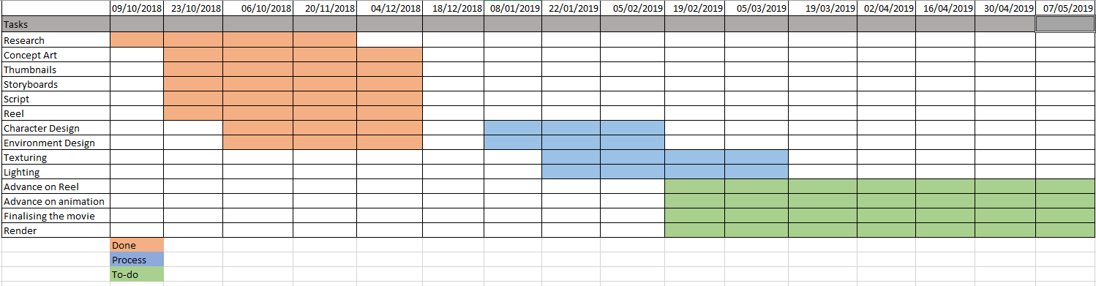
Risk Assessment
Risk | Probability | Impact | Plan
Loss of work | Medium | High | All research and work already done is kept on personal pen drives, and also uploaded periodically to the shared cloud storage.
Significant changes to project definition | Low | Low | Ideas will be changed throughout the course of the project regardless, but in the event of a large change the workload will be reassigned (?) to hopefully meet the deadline.
No access to equipment | Medium | Medium | Drawing tablets not freely available to all members, other than in the university; not always available.
Poor time management | Low | high | I have had a Gantt Chart written up since the first week, which will hopefully keep us on track
Ways of thinking
I have had to take on my own business plan to prepare myself for financial state, budgeting, marketing, investors and so on. These subjects are important to preparing and investing to produce this project. Premiering through internet to save money but to attract viewers in an affordable way. Accessible to my target audience is important to prepare as this project costs to run and needs for filling from investors. From investigating current enterprises, I found that Netflix in many homes across the UK/USA, many series and films are aired through this stream account however different audiences use different search engines for example to cover as grounds the best solution is to air on YouTube, twitch, twitter and Facebook. My target audience is based an age of understanding love and loss as well as the appeal of the beauty of the environment, I have assumed this at 10+ and mainly at females however I hope that my story has touched other people as I have tried to create a general overview of loved ones. That’s why I believe this short can be a success.

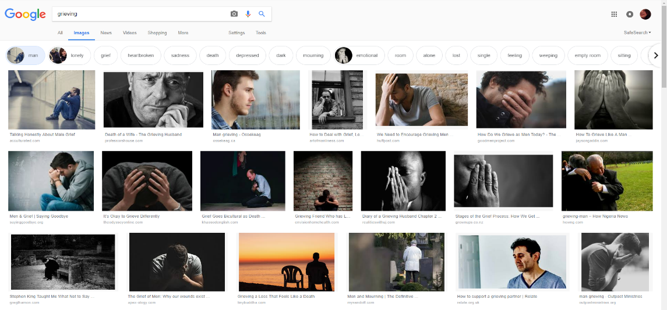

Research
Emotion and Character building
The bases of my project are based on love and loss. A part of my research on just emotion. Grief is one of the many emotions we all can face, I think with this emotion we betray through facial expression and contributes towards body language. I can aim this towards the perception of my characters. Other emotions that I want to be noticeable as features of the characters is effects like compassion, remorse, comfort and peace. I point out these subjects as the characters start off with grief, the wife tries to comfort the husband and show compassion from the remorse and we end with them both having some closure and at peace. From this research I intend to influence this through body language and story building.
Music
I am in need to research music and performing as a way to demonstrate a believable performance, for example researching duos singing, playing instruments, guitars, pianos, music room/layout, etc. For a better view please refer to my artbook. I also listen to various songs to base my story around.

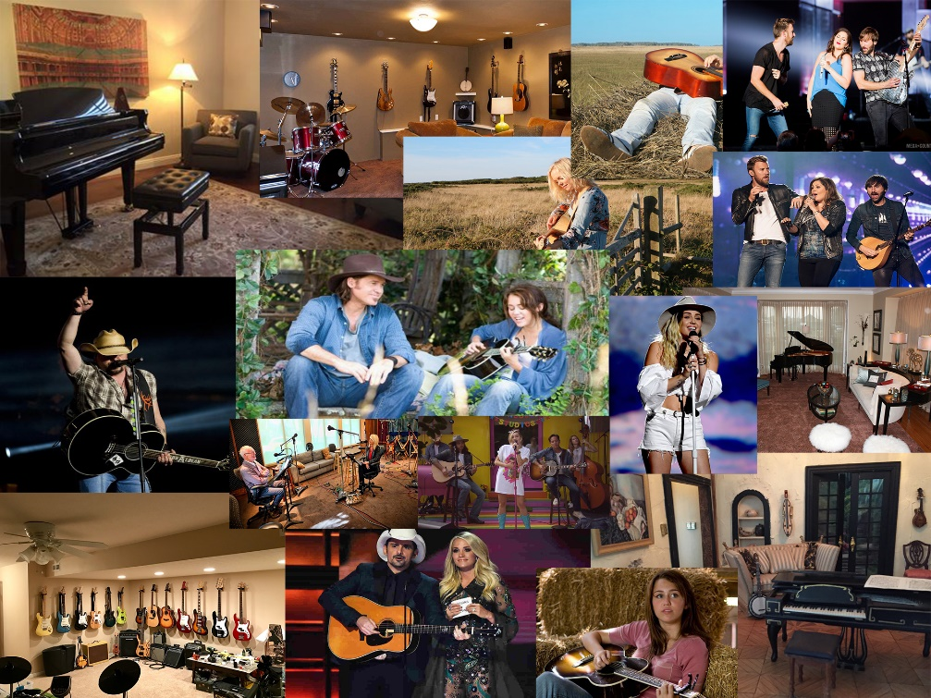

Environment
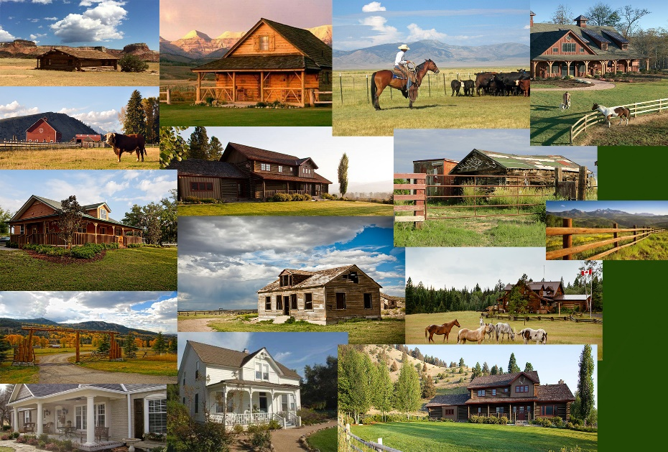
When researching for the environment setting, I had an idea of where to base my scene as the music is based on country western. However, I wanted to give the feeling of remorse and alone, so I started to look at big homes in rural areas, but I also thought that it is best that the relationship is based on being humble and loving to only each other meaning to only have modest home.

Concept Art
This is my own concept art from my initial research of the environment. The spacious outdoors is necessary to seem secluded, remote and lonely. The colour scheme is based to appeal the artistic eye. As well as subtle intel of season and weather. The weather and landscape can determine the location. The other concept is based on the emotion behind my characters. These are basic silhouettes as I just wanted to clear the relationship that it could be seen as any relation.
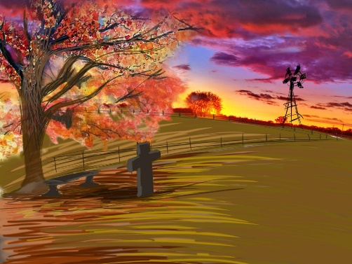
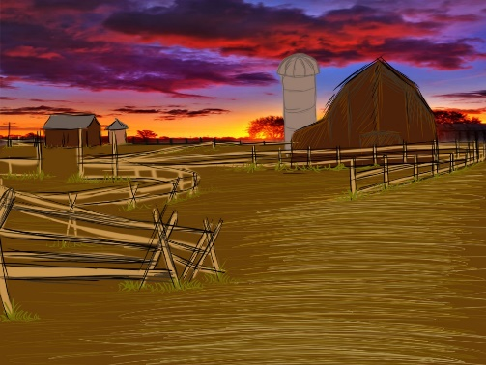

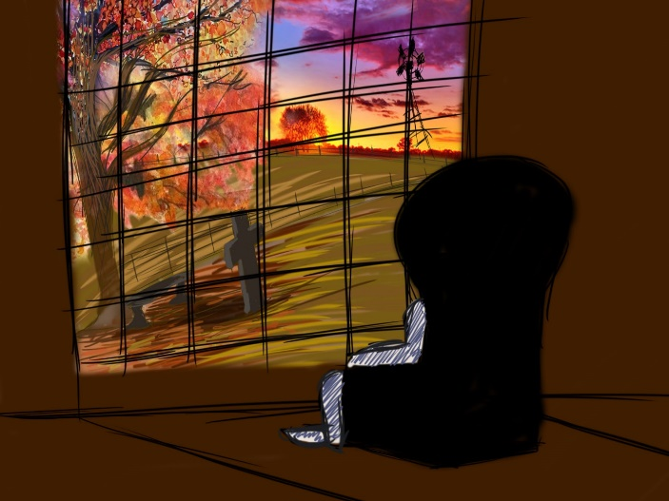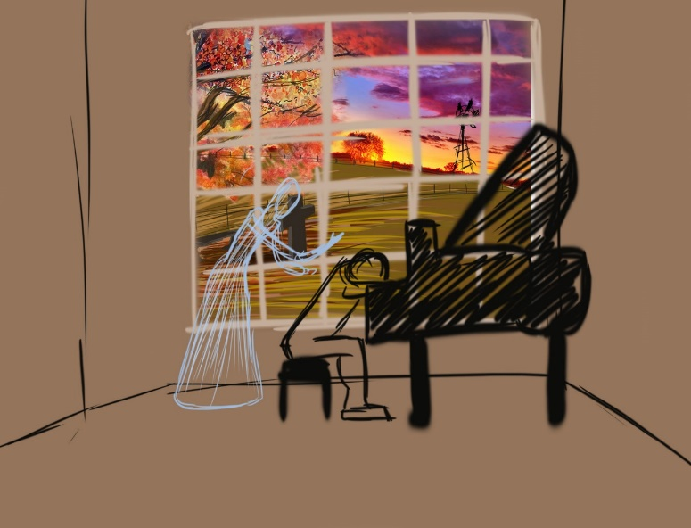

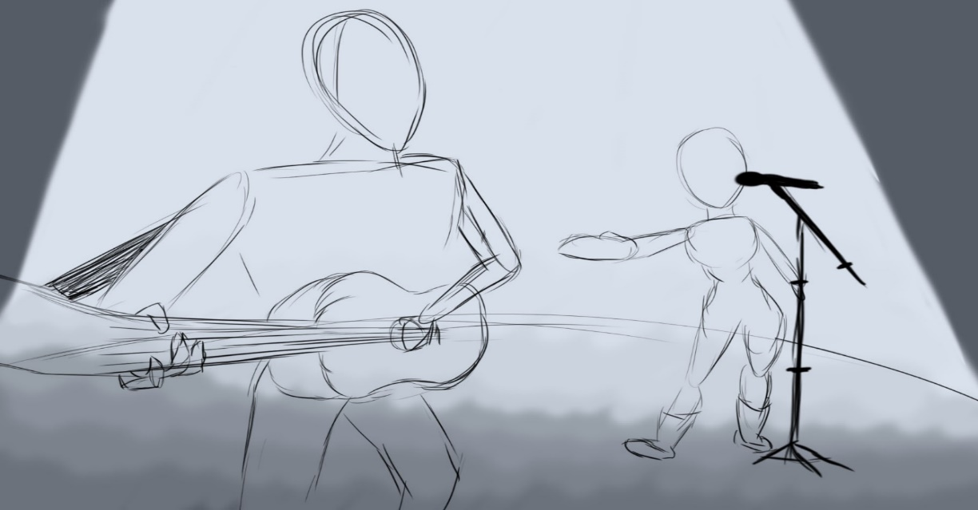
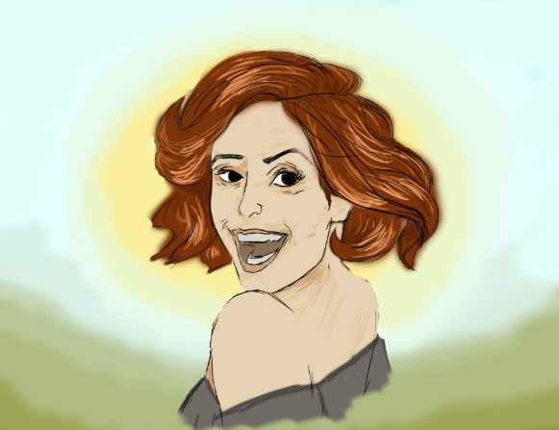
Wife
The concept art behind my red headed female character is short and sweet just like the characteristics of the wife. Her beauty is subtle but special and her look is elegant but effortless. I point out these features as I believe it is important to the character as she only time for her husband, music and her ranch. The rural home is important to her lifestyle as the most significant element of her lifestyle is her husband however being around the colour and nature inspires her write and produce music. Her emotions towards the situation of not being able to be with her husband is a struggle as she can be see her husband grieving but cannot comfort him, with all of this build up of power she manages break through on this special occasion. But the best way to complete this moment is perform their last song.
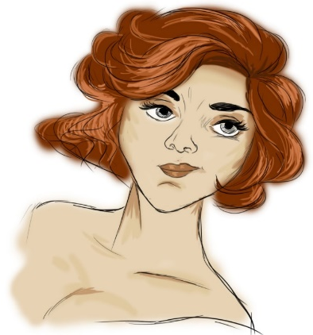

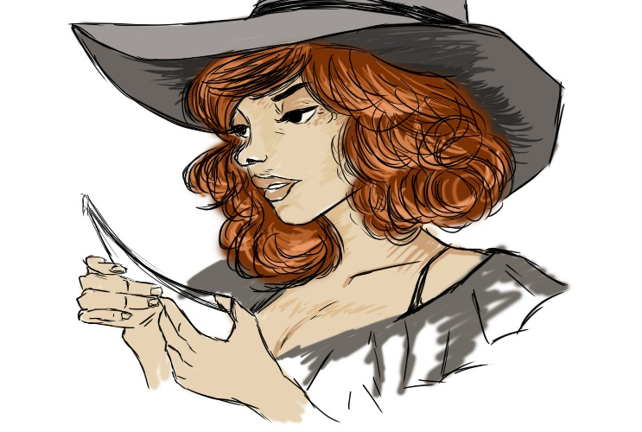

Husband
There is no main character to the project however the story starts and end on the husband by himself. I based him off my research of celebrities and other animated character. The strong jaw of a middle-aged man but the long thick locks and a man who doesn’t have time to maintain his image. The two passionate lovers share memories together and the life together is all they know. They share the same interest and have the strength to commit. The husband is a working man that has working hands, is butch and strong. This character faces a lot of grief everyday as his wife made the house a home but is unaware of the presence of his wife. He is haunted by the memories of the home and the music he will not face without his wife as the music was theirs.
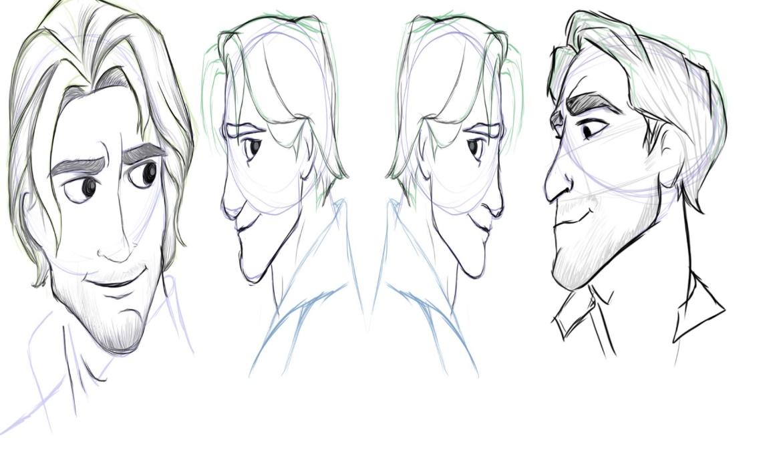

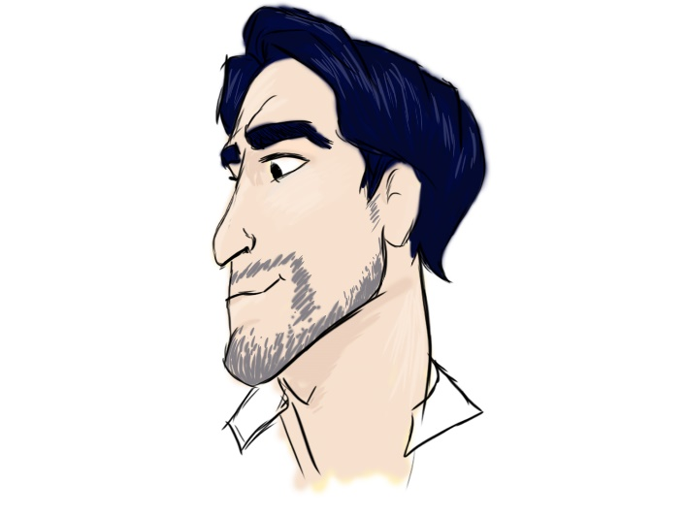
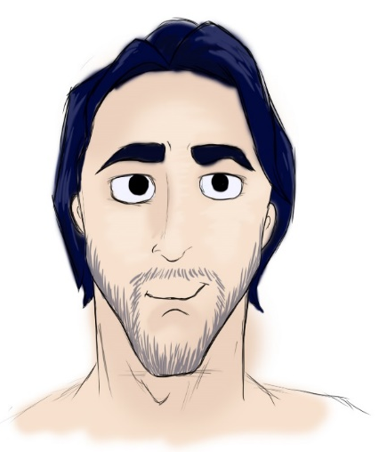

Aim of Project
For this project I have set out to create a minute long short film that contains a 20th century relationship of husband and wife that unfortunately they cannot be together however what brings them together is music. From this, the best possible outcome would be to finish the production and have a story that presents love, loss, compassion, music and peace. As well as being visually pleasing in setting and animation. Along with relating to my audience and attracting people aged 10 and above that are capable of understanding. To conclude the development, I think I’ve made good start in advancing in creating a production that is a value to me and can be a value for everyone else.

Script
Creative Venture
Last Song

EXT. DUSTY PATH. DUSK
A dirt track surrounded by green fields, on the path lays a scrap paper that reads “Last Song” floats through the sky leading to the arch way of “Coles Ranch”.
SUBTLE PIANO PLAYING.
Follow the fenced path to a rustic wooden house standing but with no life. The colours and trees circle the home. We enter the home through the window of the 20th century home.
INT. LITE LIVING SPACE WITH TWO ARMCHAIRS.
Close up to hand on the most feminine armchair to then show and hand. The hand flows along the furniture to show the living space along with the memorabilia of the home owners. The piano, the guitar, the photographs and the ern are covered in shadow of dust.
CUT TO SHOT OF EXT. ORCHARD AND GRAVE.
CUT TO CLOSE UP OF MIDDLE-AGED MAN. LOOK OF DESPAIR.
HEAR DISTANT PIANO PLAYING.
CUT TO SHOT OF PIANO KEYS PLAYING.
SHOT OF MAN LOOKING CONFUSED, TURNS BACK TO WINDOW TO GREIVE.
EXT.ORCHARD AND GRAVE.
The crusty leaves are falling to the ground and one by one we can see a figure forming. A ghostly spirit in the distance walking towards the bench.
INT.OVER THE MANS SHOULDER
The confused gentleman turns to his living space and looks at a photo of his late wife in the exact same spot.
EXT. ORCHARD AND GRAVE
The figure has gone and the man is left breath taken.
INT.PIANO SHOT
The piano is playing the man turns to see the blurred figure of his wife sitting on her stool playing a lullaby. She blushes and smiles while leading him to sit on his old rustic armchair.
CLOSE UP OF MAN TAPPING HIS GUITAR PICK.
While tapping his guitar pic to the beat of the melody, the playing continues however the woman has reached out to touch her husband, looks deep into his eyes and stands to sing. Her hand reaches out to ask her husband to join her. He takes a deep breath, stands and takes her hand.
INT. DARK STAGE, ONE SPOTLIGHT.
He finds himself reliving his glory days of his youth, holding his acoustic guitar, his wife looks and smiles, the blaze of spotlight burning on her face, they play together. The distant sounds of cheering fades.
TWO WAY SHOT OF MAN PANTING AND WIFE REACHING OUT BUT TRANSFORMING INTO DUST.
INT. LIVING SPACE.
The man finds himself back in his home, standing by the piano, still filled with adrenaline. He looks at his guitar and smiles. Everything is the same but different now.
CLOSE UP OF PIANO
Music paper reads happy anniversary.

Concept art based on stage and performing.

