

University of Wales Trinity Saint David School of Engineering
Failure Mode & Effects Analysis
Engineering Applications ACMA4007

Sebastian Parry
2306766
09/02/2024

Contents
1 Introduction i
1.1 Aims i
1.2 Objectives i
2 Literature Review ii
3 Failure Mode & Effects Analysis iii
4 Conclusion xi
5 References xii

Introduction
This technical report will outline the results of two Failure Mode Affect Analysis (FMEA) which were completed with the aim to reduce potential failure throughout the process of foil tool refurbishments.
I decided to investigate the foil process at FSG Tool & Die Ltd. to support my role as a team leader, ensuring that both engineering and management teams have a better understanding of where and why issues occur, thus reducing unnecessary rework and reduce overall workload.
The first FMEA was completed over 10 foil tool refurbishments where no previous FMEA had been completed. Issue occurrence and severity were detected which enabled me to complete the initial FMEA chart. This then led to the identification of control measures and risk management strategies.
The second FMEA was completed over the subsequent 10 foil tool refurbishments where control measures and risk management strategies were implemented, following the results of the initial FMEA.
This report will highlight any identifiable changes between the two processes and will prove the importance of completing FMEA’s in industry.

Aims
The aims are;
- To detect what issues occur and at which point in the process
- To understand why issues occur
- To put reasonable and realistic measures in place that can be followed in industry

Objectives
The objective of this report is to highlight the importance of completing FMEA’s in industry.

Literature Review
FMEA is a technique that was developed to prioritize preventative maintenance and to improve the success of high-risk processes (A.J.J. Braaksma, 2013). FMEA uses a scoring system which considers the severity, occurrence, and detectability of potential problems – 1 = lowest risk, 5 = highest risk. These numbers are multiplied to identify the risk priority number (RPN). The higher the RPN, the higher the risk meaning potential issues can be prioritized (RPN = SEV. x OCC. x DET.).
Ideally, FMEA should be a live document so that it can always be updated and maintained, this is known as continuous improvement, and it ensures the process consistently runs at optimum condition.
FMEA was originally developed for the US military and was designed around the munitions industry in the 1940’s. Following its positive results throughout the military, it was then implemented in the aerospace and nuclear industries and eventually moved over to the automotive industry, where Ford’s used it to improve production and design (Kapil Dev Sharma, 2018).
One very common FMEA process helped to eradicate the issue of the Ford Pinto, where the fuel tank would ignite following a crack which would occur upon light impact (Carlson, 2014). This was a world known issue with the Ford Pinto and became a public relations disaster (Carlson, 2014).
As per the IMechE code of conduct for professional engineers, we should quantify and limit risks in all aspects of professional work (Institute of Mechanical Engineers, unknown). FMEA can be implemented directly by engineers, to keep practice to its best possible procedure and ensuring safe working practices.
FMEA is used by Health and Safety Executives (HSE) for numerous process controls and risk management, from assessing hospital solid waste levels to interlocks for machinery (Saeed Hosseinpoor, 31 December 2023) (HSE, 2003). The HSE use FMEA throughout all industries, from risk management to improving the overall process and control.
FMEA is now used to mitigate risk in the manufacturing sector (Donald D. Tippett, 2015). Not only is it used to improve process, but it is also used in line with health and safety, such as rectifying the Ford Pinto design error.
Since its proven success within various industries, FMEA has become a widespread practice and features in most industries, worldwide (Damanaba, 2015).

Failure Mode & Effects Analysis
To start this project, I developed my understanding of the uses of FMEA and compared its benefits to other six sigma techniques, in industry. Firstly, I confirmed that FMEA would meet the criteria required to improve foil processes. Osama Alaskari, (2016), explains that FMEA significantly reduces errors and can record whether a control measurement improves the overall process.
FMEA is a great continuous development tool as highlighted by Doshi, (2016), as it provides an opportunity to identify parts of a process that require change (W C Ng, 2017). Keeping a live document of all findings can aid development and ensure that results can be monitored.
As results can be consistently monitored through the use of FMEA, it can be appropriately used to reduce handling errors and help to reduce overall cost (A. Kania, 2018). As outlined by NPD Solutions, (2015), “FMEA is designed to assist the engineer improve the quality and reliability of design. Properly used the FMEA provides the engineer several benefits. Among others, these benefits include:
- Improve product/process reliability and quality
- Increase customer satisfaction”

To start this FMEA chart, I developed a step-by-step guide of how the foil refurbishment process run through FSG. This highlighted every step, including stripping the tool, scans on hard milling operations and transportation issues.
After working on foil tools in FSG for over 10 years, I was able to identify various issues which have often caused delays, or general problems. Starting with this knowledge, I created a FMEA following the steps as shown in Figure 1.
Figure 1 – FMEA Key
This initial step enabled me to collate data and identify what impact these issues would have on future steps of the refurbishment process at FSG. After highlighting the main Potential Failure Effects, I was able to allocate a severity score. These scores indicated the level of risk and relative impact each Potential Failure Mode could have on the result of the refurbishment, as well as time and cost targets.
After scoring the severity of these issues, I had to detect the root cause of each and ensure that all aspects of the process were investigated, even though these processes were well established. Once all possible causes were identified, I moved on to allocating an occurrence score which identifies how often each issue is likely to occur throughout the process. Following this, the data was calculated to issue a RPM.
With an RPM for each Potential Cause, I was able to input relevant prevention control methods in place, in line with current health and safety guidelines. As this was the first FMEA created by FSG, there were no identifiable control measures in place. This meant I was able to implement new control measures, to reduce the occurrence of ongoing problems.
Until this FMEA was implemented, detection rate was extremely low, and many issues remained undetected until the end of each process.
Figure 2 – FMEA First Draft
Figure 2 shows how the detected issues were scored by severity, occurrence and detection rate. The incorrect milling of the female former was identified as a fundamental part of the foil tool and therefore a priority. The Potential Failure Effect for this issue is marked at 5 - highest risk, because if the top former is cut incorrectly, the tool will not produce suitable product. Both the detection and occurrence of this issue were also recorded at 5, as no control measures were in place. Although problems were identified and eventually overcome, detection of this issue would only happen in the final stages of the process, at which point rework would be required.
This process gave me an overall RPN score of 125 which is extremely poor, highlighting the requirement of control measures.
Figure 3 – FMEA draft 2 following implementation of control measures
As the milling of the female former remains a fundamental aspect of the tool functionality, the severity score remained at 5 but following the implementation of control measures, both the detection and occurrence dropped to 2, as shown in Figure 3.
The control measure implemented to mitigate incorrect milling was the QA operation of a full profile scan. To ensure this was completed at the stage inspection, the job ticket was updated and all involved were provided with scan guidance.
Displayed in Figures 4 and 5 are scans of both correct and incorrect profiles following milling operation. These images were used to support both the operators and the quality control team in ensuring all following jobs were made to the correct specification.
Offering scan training as a control measure proved extremely successful as it aided a drop in the overall RPN which, fell from 125 to 20.
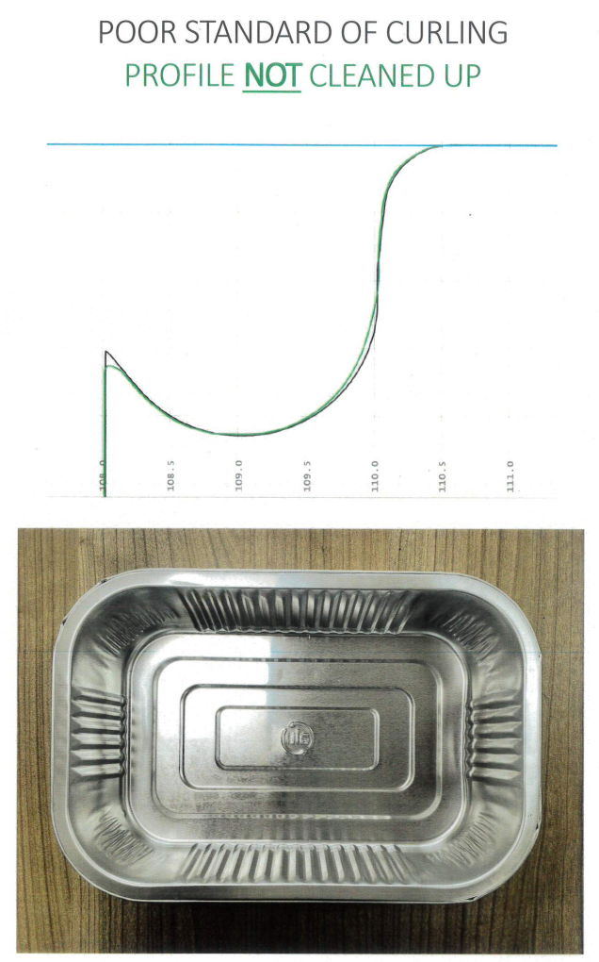
Figure 4 – Poor curl scan data – showing mismatch form and rejected component
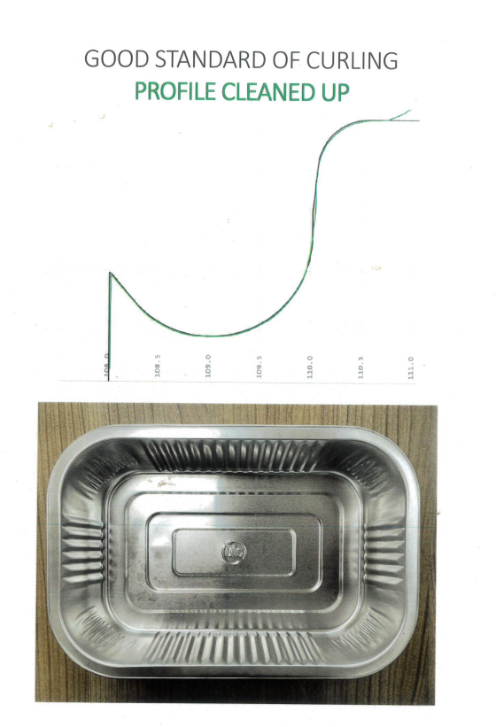
Figure 5 – Good curl scan data – showing good form and accepted component

Conclusion
Through research and implementation of FMEA on my foil project at FSG, I found that problematic processes can result in end failure and identifying issues at each stage in the process can reduce overall costs and rework hours.
Implementing risk management and prevention controls throughout each stage of the process has had a significant impact on the progress of tool refurbishments. The results obtained through the use of FMEA has resulted in an 80% decrease in rework required. Although the immediate impact has been on foil tooling, the use of FMEA has likely indirectly impacted other jobs through the factory following changes with ‘first off’ checks.
The nature of FMEA means that I can continue to monitor tool refurbishments and add and/or change control measures to suit ongoing development.
Although FMEA has generally benefited production and efficiency within FSG, the scoring system is completed using perceived severity, occurrence and detection scales. This means that the failure modes could be perceived differently from person to person and could hinder the effectiveness of the technique. It also requires users to identify all failure modes in order for the tool to offer its full efficacy, and would therefore benefit from integration with other six sigma techniques.
Despite its limitations, I found that FMEA had a high success rate within FSG and believe that the method can be a valuable tool within the manufacturing industry.

References
A. Kania, K. C.-A. J. O., 2018. Journal of Achievements in Materials and Manufacturing Engineering 2018. Application of FMEA method for an analysis of selected production process, Issue 1, pp. 34-40.
A.J.J. Braaksma, W. K. &. J. V., 2013. Failure mode and effect analysis in asset maintenance: a multiple case study in the process industry. International Journal of Production Research, 51(4), pp. 1055-1071.
Carlson, C. S., 2014. Reliability and Maintainability Symposium. Understanding and Applying the Fundamentals of FMEAs, Issue Reliability and Maintainability Symposium, p. 32.
Damanaba, P. S., 2015. Failure modes and effects analysis (FMEA) technique: a literature review. 1(1), pp. 2-3.
Datalyzer, n.d. What is FMEA?. [Online]
Available at: https://datalyzer.com/resources/what-is-fmea/
[Accessed 08 02 2024].
Donald D. Tippett, T. A. C., 2015. Project Risk Management Using the Project Risk FMEA. Engineering Management Journal, 16(4), pp. 28-35.
Doshi, J., 2016. International Journal for Quality Research. APPLICATION OF FAILURE MODE &, pp. 345-358.
HSE, 2003. Out of control. 2nd ed. s.l.:Crown.
HSE, Unknown. HSE Topic Area 5. [Online]
Available at: https://www.hse.gov.uk/quarries/education/topic5.htm
[Accessed 08 02 2024].
Institute of Mechanical Engineers, unknown. Code Of Conduct Explained. [Online]
Available at: https://www.imeche.org/about-us/imeche-governance/governance-and-finance-reviews/code-of-conduct-explained
[Accessed 08 02 2024].
Kapil Dev Sharma, S. S., 2018. Failure-Mode-and-Effect-Analysis-FMEA-Implementation. [Online]
Available at: https://www.scribd.com/document/384478002/Failure-Mode-and-Effect-Analysis-FMEA-Implementation-A-Literature-Review
[Accessed 08 02 2024].
NPD Solutions, 2015. Failure Modes and Effects Analysis (FMEA).. [Online]
Available at: https://www.npd-solutions.com/fmea.html.
[Accessed 08 02 2024].
Osama Alaskari, M. M. A. R. P.-C., 2016. International Journal of Lean Six Sigma. Development of a methodology to assist manufacturing SMEs in the selection of appropriate lean tools, Volume 7, pp. 62-84.
Saeed Hosseinpoor, T. D. ,. A. M., 31 December 2023. Comprehensive analysis of hospital solid waste levels and HSE risks using FMEA technique: A case study in northwest Iran. A case study in northwest Ira.
W C Ng, S. Y. T. H. C. L. a. P. C. T., 2017. The integration of FMEA with other problem solving tools: A review of enhancement opportunitie. Journal of Physics: Conference Series, Volume 890.

Figure 1 – FMEA Key iii
Figure 2 – FMEA First Draft v
Figure 3 – FMEA draft 2 following implementation of control measures vi
Figure 4 – Poor curl scan data – showing mismatch form and rejected component viii
Figure 5 – Good curl scan data – showing good form and accepted component ix

Personal Development Plan

Name – Sebastian Luke Parry
Degree – Beng Advanced Manufacturing and Operations.
Previous Qualifications – Performing Engineering Operations, Level 3.
Previous Experience – Toolmaker (FSG Tool and Die Limited)
Goal | Objective | Resources Required | Measurement | Target Date
Understanding the structure and process of FMEA. | - Research FEMA processes  - Create a FMEA myself so I can understand the basic function and the purpose of each part of the process | - Time management.  - FMEA Websites (see Reference on Task 2b) | - Complete an FMEA  - Ask Peers to look at my FMEA and to feedback | After completion of first FMEA
Take part in an FMEA. | - Create a spreadsheet with all calculations installed along with a key.  - Pick a process to investigate | - Time management.  - My team to be involved in raising issues.  - Quality manager relaying issues.  - Time to record data on the process of 10-tools. | - Complete an FMEA  - Ask Peers to look at my FMEA and to feedback.  - Results from FMEA to have relevance to actual process | After completion of my first FMEA
Using an FMEA try to improve a process that affect my organisation. | - Try to improve the RPN by placing risk mitigation measures in place | - My first FMEA  - Team meetings to discuss way of reducing issues/severity of issues and occurrence of issues.  - Time to run a 10-tool process to measure any improvement | - Process improvement  - FMEA score  - Profit made on tools.  - Increase of productivity | End of ten tools and then continuous improvement.
Passing my first year of university | - Pass all assignments.  - Attend all to increase my knowledge to aid my further education | - Time management. | - Course assessment  - Grades | End of the course year.
Becoming a better report writer | - To increase my understanding and knowledge of how to draft a report and its context in the correct and best format | - Time management.  - Report writing practice.  - Feedback on my assignments and reports. | - Assessment results/grades  - Feedback on reports | End of the course year.
To be able to improve the business I work for by implementing six sigma and other various skills I will learn thought-out my course. | - To increase my understanding and knowledge of business improvements including six sigma with the aim to implement it in my work. | - Lectures on Six sigma  - Research on business improvements and six sigma  - Assignments on business and six sigma to ensure I have the full understanding of it all. | - Assessment results/grades  - Feedback on reports | End of the degree



