Exploring the Opportunities and Challenges of Agriculture-Based Tourism in Sri Lanka
Abstract
Agri-tourism or agro-tourism has been gaining increasing popularity over the past several years as a means for farmers to diversify their income and also to fit into a larger scheme of rural development. Tourism, being an ever-ongoing contributor to the urban economy, puts greater pressure on agriculture to interface with tourism trends. Encouraging intersectoral linkages would, therefore, constitute a winning strategy for economic stability and an improvement to the quality of life of rural farming communities. Establishing linkages between economic sectors can prove to be mutually reinforcing, especially by encouraging financial diversification and providing a better quality of life for the rural agricultural population. This attempt was made to analyze the feasibility of agrotourism in Sri Lanka, while identifying opportunities and constraints relating to its development as a supplementary income for farmers. The whole range of agrotourism offers, including the recognition of varied agriculture across the country, the active participation and ownership attitude of farmers, a sufficient pool of skilled locals, and the natural beauty of rural environments associated with agricultural heritage and cultural traditions, may serve as opportunities for and may find the future of agrotourism in Sri Lanka.
The research examined the Nuwara Eliya District, relying heavily on empirical data obtained from interviews with key informants. Several challenges that restrict the development potential of agro-tourism were identified, encompassing both policy-related issues and those encountered at the operational level. Key barriers include insufficient institutional support, elevated input costs, limited market access, inadequate knowledge levels, weak infrastructure, a lack of training, and low entrepreneurial capacity. Agro-tourism has significant potential to enhance the livelihoods of villagers in rural regions. It is therefore possible to propose agro-tourism initiatives within the framework of national agricultural and market plans, as well as national tourism strategies, by utilizing locally available resources, clearly defined products, and fostering collaboration among various stakeholders.
Raising the farmers’ awareness is vital for the full utilization of the potential of agro-tourism. Farmers and stakeholders should be trained on handling and given necessary operational guidelines. Coordination between government ministries is fundamental to the enhancement of the tourism sector's farming linkages. In addition, it is suggested that context-specific agro-tourism standards need to be developed that are compatible with international standards in order to ensure the quality and sustainability of agro-tourism projects.
It is very much important to inform farmers about the better utilization of agro-tourism potential. It is recommended that farmers and stakeholders be trained on the handling process and provided with some operational guides. Better harmonization among ministries responsible for agriculture and tourism is required in order to strengthen the link between agriculture and tourism. Moreover, they recommend the need to develop context-based agro-tourism standards in line with international standards to guarantee the quality and sustainability of agro-tourism development.

Introduction
The tourism industry is one of the most prominent and rapidly growing economic sectors in the world, providing major benefits to host countries by presenting a variety of income-generating opportunities (Sofronov, 2018; Subash, 2015). Therefore, tourism development in underdeveloped nations has been generally recognized as a potential engine of economic growth, foreign currency gains, and job creation (Cooper et al., 2018). However, Community-based tourism (CBT) is viewed as a viable strategy for sustainable development and poverty reduction in rural areas, offering economic advantages and job opportunities to local populations (Okazaki, 2008; Prakoso et al., 2020). In many developing countries, rural people often benefit little from tourism, owing to little investment and promotional efforts orientated towards these areas (Radović et al., 2020; Ribeiro and Marques, 2002).
Sri Lanka is now in the initial phase of introducing agro-tourism as a new sector. Even if this concept is still fresh and insignificant in the country, it has ignited a lot of curiosity among the tourists who find it interesting. Additionally, in the same context, a number of developed countries have witnessed a significant change in their rural areas through the introduction of agro-tourism and thus they have simultaneously provided additional income for farmers. Likewise, a group of countries located in the Asia-Pacific region such as Thailand, Malaysia, India, Nepal, Bhutan, and Indonesia have gone through the process of implementing agro-tourism which has led to both social and economic benefits (Hamzah, 2012; Khanal et al., 2024; Pandey and Pandey, 2013). As afore-mentioned countries, agro-tourism has been the result of a carefully prepared plan that directly connects agricultural and rural development, and the most recent policies aimed at improving farmers' conditions are being enacted.
As noted by Ariyawardana (2021) the country is in the nascent stage of developing agro tourism , the implication is that Sri Lanka has all the fine elements to initiate and proliferate it. Being a nation with a long-standing agricultural economy where agriculture had been the mainstay, Sri Lanka has seen the industry of tourism as one of the main merchandises recently. After the termination of the three-decade long civil war, the country had become a more lucrative tourist destination which therefore had been enriched by nature's abundant gifts and distinct cultural influences. The nation has welcomed a substantial number of international tourists. In the year 2024, the visitor number in this lovely tourist destination crossed the 2 million marks for the first time write the highest number since 2019 (Digest, 2024; TTJ, 2024). With an impressive 38.07% year-on-year rise, this achievement marks the best annual performance since 2019. It is a strong sign of the recovery of the tourism sector, which has gone through a number of challenges in the last five years (De Silva, 2025). The Tourism Development Strategy (2011–2016) underlines the promotion of community-based tourism and suggests tourist villages as one of the actions to improve the value chains related to the rural economy (Fernando, 2017; Kpundeh, 2017; KumudumaliSH, 2020). This includes aspects such as the harvest, wildlife, agriculture, art, and religion. In such a backdrop, Sri Lanka is well-positioned to push the use of agro-tourism as a possible way to improve the socio-economic conditions of rural farming families, thus making the whole rural community more developed.
The main objective of this research is to understand the possible prospects and highlighted difficulties of developing agritourism in the farming communities of Sri Lanka, thus positioning it as a substitute income.
Sub Objectives
- To evaluate the existing situation of the agro-tourism sector in farming communities and to explore measures that might help in their economic prosperity.
- To identify the challenges and barriers confronted by farmers in the implementation and growth of agro-tourism in prevailing conditions.
Agro tourism
Agro-tourism promotes the enhancement of economic, socio-cultural, and environmental dimensions of sustainability through their integration. This economic activity is closely associated with rural communities and the environment. This sector is closely aligned with the demands of socio-cultural and environmental impacts (Ariyawardana, 2021). Therefore, research on the conservation and preservation of natural and cultural heritage is crucial for the development of a sustainable agro-tourism sector. Public authorities ought to endorse targeted initiatives that enhance sustainability in this sector, specifically to elevate the knowledge and awareness of managers and users of agro-tourism facilities. The advantages and limitations of developing sustainable agro-tourism in European countries are clear. A primary advantage is that agriculture underpins agro-tourism, significantly contributing to the support of rural areas, including their natural and cultural heritage, local communities, and overall development.
Agro-tourism is a specific segment within the broader category of rural tourism, characterised by its unique focus (Tripathi and Tiwari, 2024). Rural tourism encompasses tourism activities situated in countryside environments, involving diverse experiences associated with rural life and landscapes. Agro-tourism represents a distinct category of rural tourism occurring on farms, where visitors engage directly with agricultural practices and experience farm life firsthand (Utama, 2023). He further claimed that agro-tourism contributes to rural economic diversification by creating employment opportunities in hospitality, food services (farm- to- table), and transportation sectors. In this context, tourists participate directly in rural activities organised by accommodation providers, encompassing agricultural practices, animal husbandry, and various farm-related operations.

Phillip S. et al. (2010) offer a comprehensive review of the theoretical and practical aspects of agro-tourism categorisation (Figure 4). This categorisation establishes a five-step classification in which agro-tourism is included.
1. Non-working farm- A property that was previously engaged in agricultural activities but is no longer participating in farming operations.
2. Operational farm with limited tourist interaction- A working farm that mainly functions as a backdrop for tourism, without involving tourists in agricultural practices.
3. Operational farm with indirect tourist engagement- An operational farm that integrates regional products and services into the tourist experience, facilitating indirect interaction with agricultural production.
4. Operational farm with direct engagement yet indirect tourist involvement- An operational farm that provides demonstrations or educational activities pertaining to agriculture and rural living, allowing tourists to observe without direct participation.
5. Operational farm with direct tourist engagement- An operational farm where tourists participate actively in various rural and agricultural activities conducted on the premises.

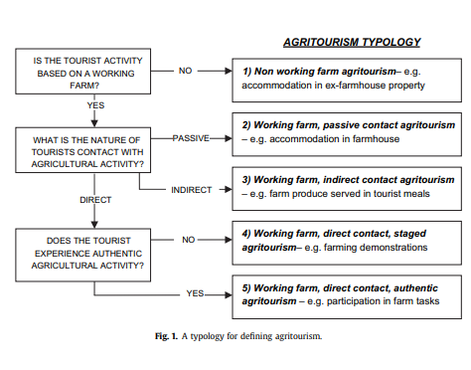

Figure 1. Agri- tourism typology

Agro-tourism involves the organisation and control of agricultural operations to provide tourism experiences. This entails the creation of activities that showcase the richness and diversity inherent in rural life, including farm tours, wine tastings, and overnight accommodations on farms. Utama (2023) stated that Agro-tourism provides various economic, social, and environmental advantages. From an economic standpoint, it can produce supplementary income for farmers and rural communities, generate employment opportunities, and promote the development of local businesses. It aids in the preservation of cultural traditions, enhances community engagement, and offers significant educational experiences for visitors. These initiatives promote sustainable farming practices, including organic agriculture and conservation efforts, while also enhancing awareness of the significance of protecting natural resources and wildlife habitats. Agro-tourism activities serve as a viable alternative to mass tourism, offering economic, social, and environmental advantages for local communities as aforementioned.
According to V and M.c (2023) the modernisation of the economy has led to the emergence of agro-tourism as a key concept in contemporary discussions regarding rural development policies, practices, and initiatives, facilitating the re-evaluation of rural resource value. They further stated that this approach can provide important insights for farmers and policymakers to embrace wider perspectives on rural development. In many developing countries, agro-tourism is promoted through policy initiatives to enhance farmers' incomes and increase their understanding of the significance and value of agriculture (Karampela et al., 2021). The primary aim of agro-tourism is to increase farm revenue by providing visitors with organised recreational and educational opportunities. Agro-tourism offers mutual benefits to both the agricultural community and the visitors (for example see : Tripathi and Tiwari, 2024), as it integrates agriculture and tourism through agro-tourism, generating new profitable markets, services, and travel experiences for extensive regional markets. Agro-tourism allows farmers to sustain agricultural practices while enhancing their families' quality of life through supplementary income as agro-tourism has been identified as a viable entrepreneurial opportunity (Chase, 2019). This presents an opportunity to promote the agricultural venue's "experience" through the efficient optimisation of resources. Wright and Annes (2016) posit that it offers a chance to market the "experience" of agricultural venues by effectively utilising resources productively and enhancing value through diverse activities associated with agriculture and the rural environment. Furthermore, value is enhanced through product diversification, the potential for increased profits via specialised production, packaging, and marketing, as well as by providing a range of services or experiences linked to a specific product or production method, including direct sales (Davis, 2006; United Nations Conference on Trade and Development, 2020, pp. 56–63). Findings from the conference noted that direct sales marketing enables producers to sell products directly to consumers, circumventing the traditional market chain and yielding higher returns for their products. As illustrated in table 1. outlines essential categories of agro-tourism, emphasising significant activities and products linked to each category (Tripathi and Tiwari, 2024).

Table 1. Agro-Tourism Activities
Farm-centred experiences | Visitors may participate in various agricultural experiences, including guided farm tours, hands-on activities such as harvesting, planting, and gathering produce, hay waggon rides, horseback excursions, live farming demonstrations, fishing in stocked ponds, wine tasting, and cattle-riding activities.
Entertainment and Educational Activities | Visitors may engage in diverse recreational and educational activities, including the exploration of nature trails, wildlife observation, hiking, kayaking, and boating. Additional activities encompass visits to farm museums and heritage sites, as well as participation in fairs, festivals, and special events that honour food, crafts, nature, flowers, art, heritage, and cultural traditions.
Local Gastronomy and Lodging | Visitors can enjoy immersive experiences such as staying at farms or ranches, sampling unique dining options, or experiencing bed and breakfast accommodations. Agro-catering services and opportunities to taste fresh farm products in scenic picnic areas also enhance the experience. In addition, cooking workshops and live demonstrations provide hands-on learning about preparing meals with locally grown ingredients.
Marketing and retail of agricultural products | Direct sales conducted on-site, including U-pick operations and roadside stands, alongside off-site sales at farmers' markets, county and state fairs, and special events, present various opportunities for farmers to market their products. Furthermore, both direct and indirect sales of value-added products provide additional opportunities for the promotion of agricultural goods.
Additional products and experiences | Engaging in the sale of locally crafted handicrafts, participating in community-based business activities, and partaking in photographs of wildlife experiences.

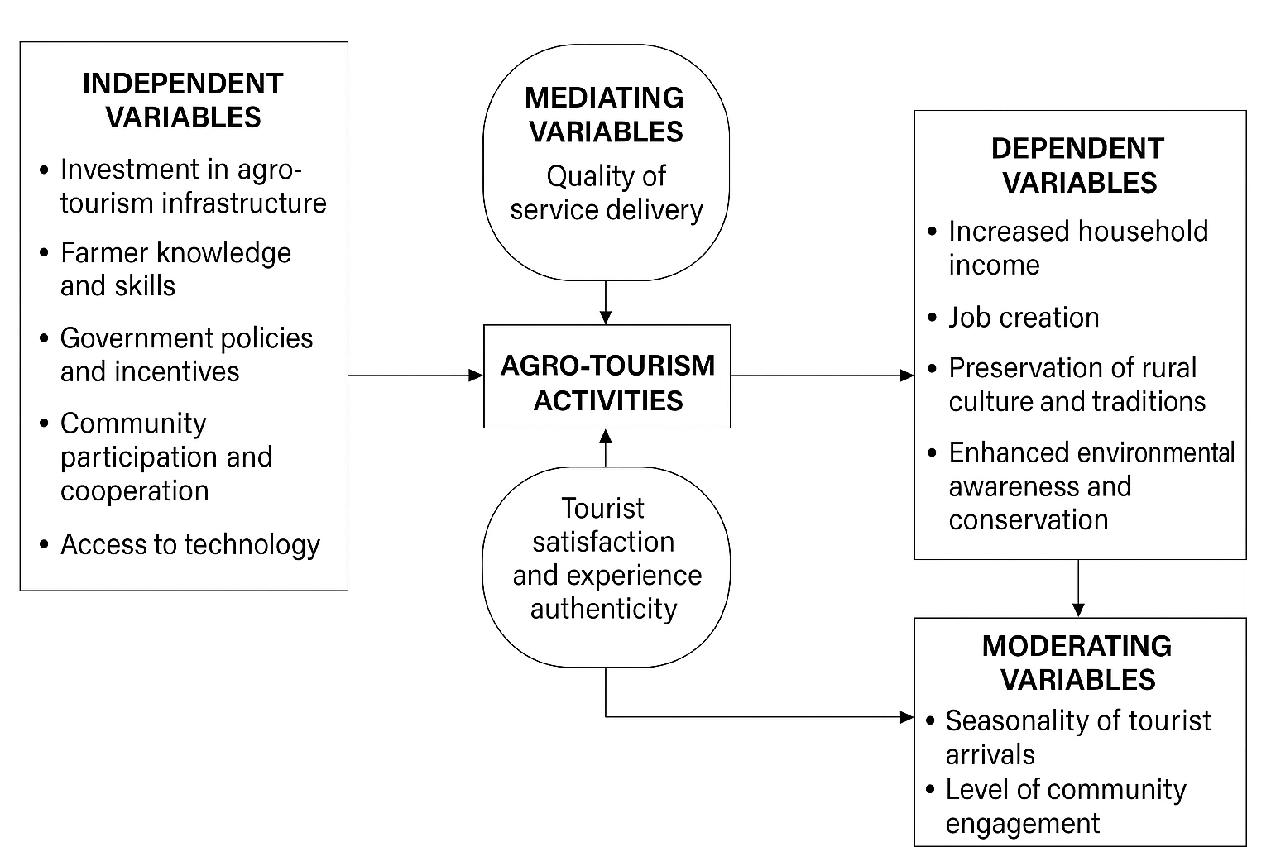
Conceptual Framework
Figure 2. Sustainable Agro-Tourism Experience Framework (SATEF)- Source: Authors’ elaboration.

The tourism sector's potential to alleviate poverty in developing countries is constrained by substantial revenue leakages, wherein a considerable portion of generated income fails to benefit the impoverished, as higher-income groups secure a significant share (Blake, 2017; Croes, 2017; Sandbrook, 2010). According to Anderson (2013) the advantages of mass tourism for local communities are limited, as a significant portion of goods and services is procured from external sources, resulting in considerable economic leakages. Consequently, alternative forms of niche tourism have developed to reduce adverse effects on local communities and the environment, while enhancing benefits for local populations.
Agro-tourism has become a significant alternative to mass tourism, providing economic, social, and environmental advantages to local communities and serving a vital function in rural development strategies and initiatives. It facilitates the re-evaluation of rural resource values amidst economic modernisation, fosters wider perspectives among farmers and policymakers (Karampela et al., 2021), and is increasingly advocated in developing nations to increase farmer incomes and raise awareness of agriculture's (Ariyawardana, 2021).
Agro-tourism seeks to enhance farm income by providing visitors with recreational and educational experiences through strategic planning and implementation. This approach benefits both the agricultural sector and visitors by establishing new markets, services, and travel opportunities, fostering agricultural diversification, improving rural socio-economic conditions, generating income prospects, and facilitating the sale of rural products (Barbieri and Streifeneder, 2019; Bevanda et al., 2018). Additionally, it enables farmers to remain engaged in agriculture and improve their families' quality of life through supplementary earnings (Tripathi and Tiwari, 2024).
Agro-tourism has been recognised as a form of entrepreneurial activity (Phelan, 2015). The approach facilitates the marketing of the agricultural venue's "experience" through the effective utilisation of resources. Value can be enhanced through the provision of diverse activities associated with agriculture and rural environments. Value can be enhanced through product diversification and the augmentation of profit potential via specialised production, packaging, and marketing strategies. Value addition encompasses the provision of various services or experiences associated with a specific product or production method, including direct sales. Curtis et al (2018), Aguglia et al (2009), and (Park et al., 2018) alleged that the direct sales marketing allows producers to sell their products directly to consumers, bypassing the traditional market chain, which can yield higher returns for their products. Furthermore, they pointed out that agro-tourism serves as a strategic mechanism for the preservation of agricultural resources, optimising their utilisation and fostering a synergistic relationship between agriculture and agro-tourism through the joint use of land, labour, and capital.
Agro-tourism contributes to rural development by leveraging underutilised farm resources such as accommodation, meals, water, labour, and space for diverse agro-tourism activities (Khanal et al., 2024; Pandey and Pandey, 2013). This approach generates supplementary income for farmers and supports the implementation of agro-tourism promotion policies, especially in developing nations. Moreover, Enhancing the local tourism sector can serve as a strategic response to the adverse impacts of economic transition in small communities. It provides income-generating opportunities for economically disadvantaged populations through employment, entrepreneurship, and participation in supply chains. As noted by Ashley et al. (2007), tourism directly contributes to increased wages and business prospects. Furthermore, infrastructure improvements associated with tourism often facilitate broader economic linkages and stimulate the emergence of new enterprises as shown in the figure 5.

Key considerations in sustainable development
Sri Lanka is promoting community-based tourism and developing tourism villages, emphasising rural tourism to enhance socio-economic outcomes. It is crucial to analyse the definitions and features of rural tourism and agro-tourism, as well as to investigate their interrelations. A comprehensive understanding of these linkages can greatly enhance the socio-economic impact of tourism initiatives across the country.
The Brundtland Report, as articulated by the United Nations Commission on Environment and Development (UNCED), delineates three fundamental pillars of sustainable development: economic growth, environmental stewardship, and social equity (Purvis et al., 2019) aiming to achieve a balance among these elements. Figure 3 below demonstrates the application of sustainable development within the context of this paper.

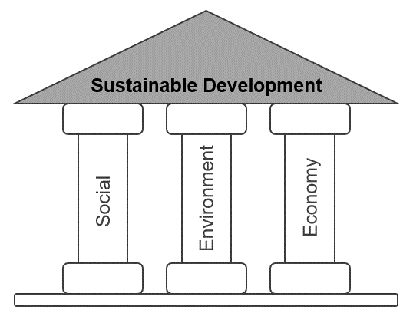

Figure 3. Pillars of Sustainable Development (Purvis et al., 2019)

Sustainable development underpins modern global frameworks that direct international collaboration. Furthermore, in 2015, the United Nations Summit established 17 Sustainable Development Goals (SDGs) as part of the Agenda for Sustainable Development, effective from 2016 (UN, 2015; UN, 2017). Moreover, in the subsequent fifteen years, initiatives aimed at the universal implementation of the new Goals across all nations were prioritised, with a focus on eradicating poverty and inequality, tackling climate change, and ensuring inclusivity for all individuals. The Sustainable Development Goals (SDGs) build on the success of the Millennium Development Goals, aiming to move forward with the ultimate goal of ending all forms of poverty (Wahyuningsih, 2018).
The supplementary objectives are intended to be applicable across all nations, regardless of their economic status, with the purpose of fostering prosperity and ensuring environmental protection. Addressing poverty requires alignment with economic growth strategies and the fulfilment of social needs, including education, employment opportunities, social support, and security, while also ensuring environmental protection is not overlooked. The aforementioned aims are designed for universal adoption across all nations, regardless of economic status, necessitating the engagement of essential stakeholders including governments, civil society, and the business sector. Furthermore, The United Nations (UN), via its Division for Sustainable Development (DSD), has indicated that a primary objective is to achieve sustainable consumption and production by minimising resource use and pollution, while advocating for a life cycle approach to product utilisation (See; United Nations Conference on Trade and Development, 2020).
Considerations on Sustainable Development in Tourism
The growth of mass tourism during the 1970s prompted worldwide apprehension regarding its economic, socio-cultural, and environmental effects, resulting in heightened focus on the advancement of more sustainable tourism practices. Sustainable tourism is fundamentally linked to the increasing global focus on sustainable development and the foundational research conducted by the Brundtland Commission 1983 (Saarinen, 2021).
Sustainable tourism can be approached through multiple methodologies. The United Nations Environment Programme (UNEP) and the World Tourism Organisation (UNWTO) (2005) define it as follows:
- The optimal utilisation of environmental resources is crucial for tourism development, while simultaneously preserving essential ecological processes and aiding in the conservation of natural resources and biodiversity.

- It points out the importance of respecting the socio-cultural authenticity of local communities, preserving their natural and cultural heritage, and promoting cultural understanding and tolerance.

- This approach ensures the sustainability of economic activities by enhancing the socio-economic welfare of all stakeholders. It includes the creation of secure employment opportunities, income generation, provision of social services for local communities, and efforts to alleviate poverty.

The UNWTO characterises sustainable tourism as a form of tourism that considers the present and future economic, social, and environmental effects, while meeting the requirements of visitors, the tourism sector, the environment, and host communities (Grandcourt, 2020). UNESCO characterises sustainable tourism as a form of tourism that honours local communities and tourists, alongside cultural heritage and environmental considerations (Rasdi et al., 2019; Sihombing et al., 2024).

Bramwell et al.(2017) and Bramwell (1993) present a significant approach to sustainable tourism, defining it as a proactive effort to alleviate the pressures and misunderstandings that emerge from the interactions among the tourism sector, tourists, the environment, and host communities. The approach to sustainable tourism is based on the premise that tourism should be incorporated into the framework of global sustainable development. This industry depends on natural and cultural heritage, along with human potential. The tourism industry must address the challenges of sustainable development and collaborate with other sectors to ensure quality resources for all tourism activities (Choudhary, 2021; Jones and Comfort, 2020).
Sustainable tourism aims to reduce its impact while achieving a balance among environmental, socio-cultural, and economic factors. In the absence of effective management, rural tourist destinations may experience adverse effects from tourism activities. The ongoing deterioration or destruction of rural areas may render them unavailable for future generations. The concept of a circular economy in tourism is essential.

Methodology
The research utilized both the primary and secondary methods of data collection for the examination of the growth of agro-tourism at a given place in Sri Lanka. Primary data were gained through various qualitative methods most prominently the key informant interviews and focus group discussions, which were drawn as they had the capacity to obtain varied detailed insights from different stakeholders that were relevant to the context. The study was developed through the insights of a mixed group of participants from agriculture and tourism sectors. Participants were professionals from hospitality and tour operations, agricultural training and research experts, community members, and representatives from grassroots organisations mostly involved with farming communities. Key informant interviews served as a source of expert opinion, practical advice, and the provision of information relative to the opportunities and constraints unfolding from agro-tourism at the local level. The interviews were necessary to triangulate the data collected throughout the study.
A number of focus group discussions were executed to get the direct views of the farming community. The farmers were given the floor to talk about their existing capacity, available resources, and willingness to participate in the agro-tourism initiatives. Participants raised possible obstacles and informed their take on the current agro-tourism initiatives. Farmers recommended new activities and products for addition to agro-tourism which would be possible to them and their communities.
Alongside the primary data, the secondary information was collected by a thorough review of both published and unpublished documents. These were academic articles, reports of local institutions and grey literature sourced online. The principal ones were the Ministry of Agriculture, the Ministry of Industrial Development, and the Ministry of Tourism besides the United Nations World Tourism Organization (UNWTO). The materials offered exceptional context and policy advice which inventoried the results in a larger perspective of development and governance frameworks referring to agro-tourism.

Study area in Sri Lanka

Research has been carried out in the Nuwara Eliya District, which is located in the Central Province of Sri Lanka, as shown in Figures 1 and 2. chosen as the place for study due to its significance in tourism and agriculture. This district was specified based on two main reasons, as a center for eco- and cultural tourism which are closely connected to agro-tourism, and its high percentage of agricultural production in Sri Lanka, which includes a variety of farming activities. The site of research was chosen according to three main factors: the tourists' accessibility to the primary attractions, the cancellation of natural and artistic culture, and the wide variety of agricultural production. Data collection and analysis were centralized in the Ambewela area, located in the district, since it was considered the most suitable area according to the predetermined selection criteria.
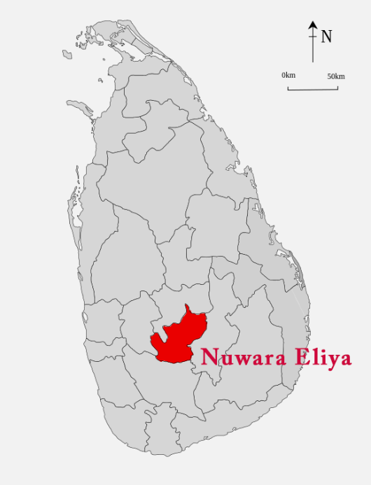

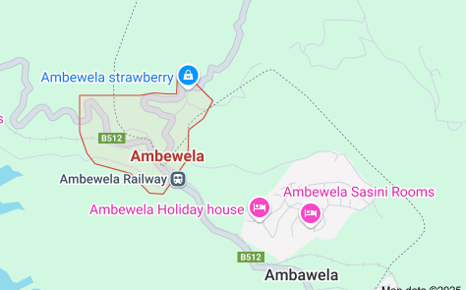

Figure 4. Nuwara Eliya District – Sri Lanka Figure 5. Ambewela map- (Google map,2025)
(Beyond, 2025)

Limitation of the study
The research emphasized two independent places that belong to the same district in Sri Lanka. The work used a qualitative method to get the perceptions and experiences of the locals about the agro-tourism in the places studied, instead of using numerical data as in other studies. The lack of access to certain financial data made it impossible to calculate the financial gains, thus limiting the analysis to a purely descriptive and interpretive format

Analysis
Participant ID | Sector | Role | Gender | Years of Experience | Notes
P01 | Agriculture | Agricultural Trainer | Male | 12 | Concentrate on the teaching of farmers and the agricultural policy.
P02 | Tourism | Tour Operator | Female | 8 | Partners with rural communities in the promotion of agritourism.
P03 | Community | Village Farmer | Male | 25 | Offered some ideas on cultural values and intergenerational knowledge.
P04 | Grassroots Organisation | Community Liaison Officer | Female | 7 | A firm supporter of women's active participation in the agritourism sector in a sustainable manner.
P05 | Hospitality | Hotel- Manager | Male | 15 | That is showing views on tourist satisfactions and local sourcing.
P06 | R&D | Agricultural Researcher | Female | 9 | Integrates tourism with sustainable farming as a main specialization.
P07 | Community | Youth Entrepreneur | Male | 5 | Different visions for the modernization of the country and the youth role in it have been suggested.
P08 | Tourism | Travel Itinerary Planner | Female | 6 | Emphasizes experiential and educational rural tours.
The Participant Profile included in Table 2. lists the demographic and contextual information of each individual involved in the study. This table is included to clarify the transparency and give a better view to the readers on the diversity, background, and relevance of the participants, thus, supporting the interpretation of the findings in the methodology and analysis sections.
Table 2. Participant Profile

The data's key themes are being discussed in Table 3, together with the participant cohort's characteristics. The enumeration of the themes in this form complies with the currently accepted methodological rules and gives a detailed picture of the degree of representation of themes in different groups of participants. In this way, the research is provided with additional analytical depth and the interpretive validity of the study is thus enriched.

Table3. Thematic Analysis of Qualitative Data
Theme | Description | Illustrative quotes | Participant Group(s) | Negative feedback
The Joint Efforts of Agriculture and Tourism. | The participants pointed out the symmetrical advantages of the phenomenon where farming techniques are attached to the tourism experience. | “People who are visiting in our place are very inquisitive about our food production; in fact, they can themselves have the practical exercise.” | Local farmers, Tour operators, Community members | A few agricultural producers expressed worries regarding their participation in tourism-related ventures, which they believe distracts them from their main agricultural activities.
Barriers to the Transfer of Knowledge | The problems connected with communicating agricultural practices to both tourism stakeholders and tourists were pointed out. | "Leisure travelers often find it challenging to follow the explanations of technical agronomy terminologies." | Specialists in agriculture, Staff of hospitality | In some cases, tour operators are not as knowledgeable about agriculture as they should be; thus, there is a possibility of them showing the wrong side of agriculture practices.
The empowerment of community through agri-tourism. | Agri-tourism was seen as a way to empower locals and revitalize the countryside. | "Our village has developed a sense of pride thanks to this project—we are now a tourist destination and we get an income." | Individuals from the community, Grassroots organisations. | Imagine if some people alone derive economic advantages from a certain situation while everyone else is left to deal with stress and exclusion in their community.
The requirement for capacity building is accentuated. | It was pointed out by a number of stakeholders that farmers are again again faced with the inadequate training in hospitality and tourism sector, and vice versa. | “There is an essential aspect for a farmer to learn it is in customer service which is also vital for a tour guide to know, about agricultural especially the process of crop and livestock production as well as the technology used.” | Pros in training, Hotel specialists, Community-based entities | Limited financial support, inaccessibility to rural training, and language difficulties are major obstacles to skill development.
Preservation of the Environment and Culture | The spotlight is on the preservation of local knowledge, ecosystems, and customary practices as a tourism resource. | "Tourists visit to see the natural beauty of things that we must take care of it and not only market it." | Local residents, Scientists in the field of Agriculture, Professionals in the Tourism sector. | Cultural dilution and environmental degradation are the potential risks resulting from the tourism activities which are poorly managed.

Discussion
Even though agriculture and tourism sectors are quite recognized in the area, agro-tourism practices are not that common among farmers. Only a handful of the agrarian group was involved in agro-tourism at the minimal level because it is still an idea that the community had never heard of. Furthermore, the primary objective of this research was to highlight the tourism activities that farmers and the community have undertaken in a specific area. The conclusions drawn from the study revealed that the specific practices of agro-tourism are greatly influenced by the unique environmental, cultural, and agricultural attributes of the location. The advancements of agro-tourism operations in the place of study were speedy and were notably influenced by the degree of tourism exposure, the types of tourists that come to the area, the existing cooperation with the tourism sector and the resources that are at the disposal of the farmers. Within the regions scrutinized in the Nuwara Eliya District, the main group of tourists targeted by these activities was the domestic tourists.
Due to the district's historical exposure to tourism activities, agro-tourism initiatives have been introduced in Ambewela which is situated in Nuwara Eliya District. There is a high degree of interest from international visitors in these types of rural tourist activities, said hotel operators based in Nuwara Eliya and Ella, which shows the possibility of growth and development in the near future. Tour operators and hoteliers have arranged village excursions that specifically highlight the ethnic culture, agricultural practices, and flora of the area's countryside to attract more international tourists. This kind of visit is characterized by the supervised marching in the village, which gives the visitors a realistic experience of the local people's life. After the guided tour, visitors could usually relax at the village lake while on the way to this endpoint along with the beautiful views of the agricultural fields and farms. Furthermore, engaged with the rural environment, tourists were given the chance to take part in traditional agricultural activities and to grow and savor the truly unique local cuisine. Specifically, foreign guests are welcomed to join the cooking of dishes and help in the process of preparing meals, which thus enhances their cultural immersion. Once in a while, some travelers would also take part in fishing at the village lake. Testimonies from visitors confirm that the stay was quite satisfactory, as they highly valued the experiences they had with the local people.
In summer, many tourists come to the local farms, and sometimes they get the chance to pick vegetables by themselves, which they consider as a special and unforgettable experience. Nevertheless, the actual observations made in the field demonstrate that such activities are not provided regularly or consistently.
Likewise, a few farmers involve tourists in the sale of their fruits and vegetables through roadside stalls, small retail outlets, or sometimes via intermediaries directly or indirectly. Increasingly, a few of them have also produced value-added strawberry jam as well. A similar number of ornamental plant growers promote the agro-tourism sector by selling flower pots in a small quantity. On the other hand, temporary accommodation facilities, which are also available to local tourists in summer, are offered by some residents. However, in general, these are not associated with farm-based activities.
Even though farmers could make earn a lot of money with the wide range of agro-tourism they can create, only a few were observed in the study area. Also, most of these activities had not yet been fully or widely integrated into the local farming. Currently, the offered agro-tourism experiences are:
- Guided visits to agriculture fields.
- Self-harvesting fruits and vegetables for tourists.
- Traditional cooking methods demonstrations along with dishes sampling.
- Authentic rural setting serving traditional meals.
- Village tours that facilitate local wildlife, picturesque landscapes, and agricultural practice exploration for visitors.
- Basic accommodation provided in village houses.
- Direct and indirect marketing of fruits, value-added farm products (e.g. jams), and handmade crafts, etc. and selling them through the community.
- Performances featuring local folk music and dance.

Challengers
Even if the farming community had the chance to broaden their scope and diversify through the growth of agro-tourism, the farmers found numerous barriers and limitations that hinder them from the full engagement in these activities. Although Ambewela is located in close vicinity of multiple tourist spots in the Nuwara-Eliya district, farmers' groups and reliable sources have recognized the ban on vending on the road as the prime hurdle to selling goods directly to the tourists. An important hurdle in reaching the full benefits of the agro-tourism sector is the lack of effective connections between local farmers and the broader tourism industry, which is the cause of reduced tourist arrivals to farm experiences. Lack of proper infrastructure has been one of the main problems in the promotion of agro-tourism activities in the farming community. The major hindrances are worsened road conditions, water scarcity, and the division of agricultural land. To be more specific, land fragmentation has been the primary issues for both the farmers and the tourists, which lead to difficulties in the planning and management of the farm-based tourism experiences.
One of the main difficulties confronted by farmers in the course of their effort to develop agro-tourism is the lack of access to the initial capital funding necessitated for provision of quality services, especially so since most of them depend solely on the income generated from agriculture. The constraints of limited institutional assistance from government institutions make it more difficult to solve these problems and find ways to extend possibilities in the form of agro-tourism. Farmers and the key informants pointed out that the lack of basic structures particularly the sitting areas and appropriate accommodation for tourists is where they are and is that they want to be. The absence of these structures not only causes discomfort to the visitors but also contributes to the limited participation of the community at large in the agro-tourism initiatives. Farmers also spoke of a deficiency of learning and knowledge about the standards of quality that should be maintained by them and stressed upon the fact that not having training andassa ofīnàbility to take part in this activity as a promising venture.

Conclusion
It can be anticipated that agro-tourism farmers will have significant chances which are going to lead them to increase their income through the management of different activities that rely on resources available around. Still, the number of agro-tourism projects within the farming community is limited and not fully integrated with the main core of the agricultural operations it should belong to. For example, farmers that usually organize on-farm agrotourism in a more permanent and systematic manner are more frequently the ones who have established contacts with the tourism sector. This illustrates the fundamental importance of the strong affiliations with tourism partners and the support of institutions in the successful implementation and growth of agro-tourism programs.
Agro-based tourism in farmers has several challenges starting from the problem in the policy to the obstacles at the grass root level. The low number of policies focused on targeted initiatives that directly encourage farmer involvement has negatively affected the development of agro-tourism as an effective rural development approach. Besides, the local barriers, which are dealt with on a day-to-day basis, have added to the problem that farmers cannot access agro-tourism opportunities.
Agro-tourism development is a good opportunity as it involves the promotion of traditional and unique forms of agriculture, authentic local dishes, accommodation services, creamery products, handicrafts, and cottage industries. The ongoing agricultural, rural, and tourism development initiatives at the national, regional, and district levels are a good foundation to promote agro-tourism. If the strategy is right, thus the participation in agro-tourism can bring various advantages for the farming community.

Reference
Aguglia, L., De Santis, F., Salvioni, C., 2009. Direct Selling: a Marketing Strategy to Shorten Distances between Production and Consumption. Unknown. https://doi.org/10.22004/AG.ECON.57657
Anderson, W., 2013. Leakages in the tourism systems: case of Zanzibar. Tour. Rev. 68, 62–76. https://doi.org/10.1108/16605371311310084
Ariyawardana, s.s.n., 2021. Sustainable tourism development in sri lanka: a sustainable approach towards agro-tourism in nuwara eliya.
Barbieri, C., Streifeneder, T., 2019. Agritourism Advances around the Globe: A Commentary from the Editors. Open Agric. 4, 712–714. https://doi.org/10.1515/opag-2019-0068
Bevanda, V., Štetić, S., The College of Tourism, Belgrade, Serbia, Economics Institute, Kralja Milana 16, 11000 Belgrade, Serbia, Pavić, L., Pažek, K., University of Maribor, Faculty of Agriculture and Life Sciences, Slovenia, Pavlovič, M., University of Maribor, Faculty of Agriculture and Life Sciences, Slovenia, 2018. Agritourism. Between agriculture and tourism. A review. Association of Economists and Managers of the Balkans in cooperation with the Faculty of Tourism and Hospitality, Ohrid, Macedonia, pp. 243–257. https://doi.org/10.31410/tmt.2018.243
Beyond, S.L. and, 2025. Sri Lanka Tours Packages for 2020 & 2021. Sri-Lanka Beyond. URL https://sri-lanka-and-beyond.com.au/tours/sea-and-safari-family-adventure-11-days/ (accessed 4.30.25).
Blake, A., 2017. Tourism and Poverty Alleviation: Tools and Policies.
Bramwell, B., Higham ,James, Lane ,Bernard, and Miller, G., 2017. Twenty-five years of sustainable tourism and the Journal of Sustainable Tourism: looking back and moving forward. J. Sustain. Tour. 25, 1–9. https://doi.org/10.1080/09669582.2017.1251689
Chase, L., 2019. Agritourism and Quality-of-Life for Farmers. Applying Quality of Life Research 337–352. https://doi.org/10.1007/978-3-319-91692-7_17
Choudhary, S., 2021. Sustainable Development Goal towards Tourism.
Cooper, C., Volo, S., Gartner, W., Scott, N., Nunkoo, R., Seetanah, B., 2018. Foreign Direct Investment and Tourism Development: A Theoretical and Empirical Review. SAGE Publications Ltd, 1 Oliver’s Yard, 55 City Road London EC1Y 1SP, pp. 556–566. https://doi.org/10.4135/9781526461452.n33
Croes, R., 2017. Tourism potential to benefit the poor: a social accounting matrix model applied to Ecuador.
Curtis, K.R., Allen, S., Slocum, S., 2018. Fresh Produce Direct Market Sales Considerations.
Davis, J.R., 2006. How Can the Poor Benefit from the Growing Markets for High Value Agricultural Products? SSRN Electron. J. https://doi.org/10.2139/ssrn.944027
De Silva, C., 2025. Tourist arrivals grow by 38% to 2 m in 2024 | Daily FT [WWW Document]. Dly. Financ. Times. URL https://www.ft.lk/front-page/Tourist-arrivals-grow-by-38-to-2-m-in-2024/44-771305 (accessed 4.23.25).
Digest, C., 2024. “Sri Lanka Welcomes 2 Million Tourists, Celebrating a Remarkable Recovery!” - Ceylon Digest [WWW Document]. URL https://www.ceylondigest.com/sri-lanka-welcomes-2-million-tourists-celebrating-a-remarkable-recovery/, https://www.ceylondigest.com/sri-lanka-welcomes-2-million-tourists-celebrating-a-remarkable-recovery/ (accessed 4.23.25).
Fernando, S., 2017. The Tourism-Led Development Strategy in Sri Lanka. J. Bus. Technol. 1. https://doi.org/10.4038/jbt.v1i1.81
Grandcourt, M.-A.E., 2020. The role of the United Nations World Tourism Organization (UNWTO) in tourism and sustainable development in Africa, in: Novelli, M., Adu-Ampong, E.A., Ribeiro, M.A. (Eds.), . Routledge, pp. 131–138. https://doi.org/10.4324/9781351022545-10
Hamzah, A., 2012. Socio-economic impact potential of agro tourism activities on Desa Wawasan Nelayan community living in Peninsular Malaysia. Afr. J. Agric. RESEEARCH 7. https://doi.org/10.5897/AJAR11.295
Jones, P., Comfort, D., 2020. The COVID-19 Crisis, Tourism and Sustainable Development. ATHENS J. Tour. 7, 75–86. https://doi.org/10.30958/ajt.7-2-1
Karampela, S., Andreopoulos, A., Koutsouris, A., 2021. “Agro”, “Agri”, or “Rural”: The Different Viewpoints of Tourism Research Combined with Sustainability and Sustainable Development. Sustainability 13, 9550. https://doi.org/10.3390/su13179550
Khanal, Aaditi, Khanal, Avishek, Basnet, F., Joshi, S., Giri, S., 2024. Agro-tourism in Nepal: Assessment of economic, cultural, and environmental impact. Humanit. J. 1, e2024007. https://doi.org/10.31893/humanitj.2024007
Kpundeh, S.E., 2017. Sri Lanka tourism - Strategic plan 2017-2020.
KumudumaliSH, T., 2020. Impact of COVID-19 on Tourism Industry: A Review.
Okazaki, E., 2008. A Community-Based Tourism Model: Its Conception and Use. J. Sustain. Tour. 16, 511–529. https://doi.org/10.1080/09669580802159594
Pandey, H., Pandey, P.R., 2013. Socio-Economic Development Through Agro- Tourism: A Case Study Of Bhaktapur, Nepal. J. Agric. Environ. 12, 59–66. https://doi.org/10.3126/aej.v12i0.7564
Park, T., Paudel, K., Sene, S., 2018. Sales impacts of direct marketing choices: treatment effects with multinomial selectivity. Eur. Rev. Agric. Econ. 45, 433–453. https://doi.org/10.1093/erae/jbx038
Phelan, C., 2015. Confronting mortality moments: death, dying and the consumption of dark tourism. Diffus.- UCLan J. Undergrad. Res.
Phillip, S., Hunter, C., Blackstock, K., 2010. A typology for defining agritourism. Tour. Manag. 31, 754–758. https://doi.org/10.1016/j.tourman.2009.08.001
Prakoso, A.A., Pradipto, E., Roychansyah, M.S., Nugraha, B.S., 2020. Community-based tourism: concepts, opportunities and challenges. J. Sustain. Tour. Entrep. 2, 95–107. https://doi.org/10.35912/joste.v2i2.563
Purvis, B., Mao, Y., Robinson, D., 2019. Three pillars of sustainability: in search of conceptual origins. Sustain. Sci. 14, 681–695. https://doi.org/10.1007/s11625-018-0627-5
Radović, G., Petrović, M.D., Demirović Bajrami, D., Radovanović, M., Vuković, N., 2020. Can Proper Funding Enhance Sustainable Tourism in Rural Settings? Evidence from a Developing Country. Sustainability 12, 7797. https://doi.org/10.3390/su12187797
Rasdi, L.M., Som, A.P.M., Usolludin, H.H., Nordin, N., 2019. Responsible tourism and quality of life: perspective of local community.
Ribeiro, M., Marques, C., 2002. Rural tourism and the development of less favoured areas—between rhetoric and practice. Int. J. Tour. Res. 4, 211–220. https://doi.org/10.1002/jtr.377
Saarinen, J., 2021. Is Being Responsible Sustainable in Tourism? Connections and Critical Differences. Sustainability 13, 6599. https://doi.org/10.3390/su13126599
Sandbrook, C.G., 2010. Putting leakage in its place: The significance of retained tourism revenue in the local context in Rural Uganda. J. Int. Dev. 22, 124–136. https://doi.org/10.1002/jid.1507
Sihombing, I.H.H., Suastini, N.M., Puja, I.B.P., 2024. Sustainable cultural tourism in the era of sustainable development. Int. J. Sustain. Compet. Tour. 3, 100–115. https://doi.org/10.34013/ijscot.v3i02.1601
Sofronov, B., 2018. The development of the travel and tourism industry in the world. Ann. Spiru Haret Univ. Econ. Ser. 18, 123–137. https://doi.org/10.26458/1847
Subash, T., 2015. Tourism in India: Potentials, Challenges and Opportunities.
Tripathi, V., Tiwari, Dr.M.V., 2024. Agro tourism: Approaches of Tourism by introducing agriculture tourism. Int. J. Agric. Ext. Soc. Dev. 7, 93–94. https://doi.org/10.33545/26180723.2024.v7.i5Sb.655
TTJ, 2024. Sri Lanka’s tourist arrivals surpass 2 million in 2024. Travel Trade J. URL https://traveltradejournal.com/sri-lankas-tourist-arrivals-surpass-2-million-in-2024/ (accessed 4.23.25).
United Nations Conference on Trade and Development, 2020. Harnessing Agricultural Trade for Sustainable Development: Guatemala 56–63. https://doi.org/10.18356/16b6bc15-en
Utama, I.G.B.R., 2023. Review Studies Key Element of Agrotourism Management. Pros. Semin. Nas. Forum Manaj. Indones. - E-ISSN 3026-4499 1, 169–180. https://doi.org/10.47747/snfmi.v1i.1497
V, L.S., M.c, D.S., 2023. Agri Tourism - A Panacea for Rural Development. IJFMR - Int. J. Multidiscip. Res. 5. https://doi.org/10.36948/ijfmr.2023.v05i06.10288
Wahyuningsih, W., 2018. Millenium develompent goals (mdgs) dan SUSTAINABLE development goals (sdgs) dalam kesejahteraan sosial, in: BISMA. p. 390. https://doi.org/10.19184/bisma.v11i3.6479
Wright, W., Annes, A., 2016. Farm Women and the Empowerment Potential in Value‐Added Agriculture. Rural Sociol. 81, 545–571. https://doi.org/10.1111/ruso.12105

