Portfolio 4 components
BMIH5003
BA International Hotel Management Foreign Languages and Cultural Awareness

Student ID: 2243006
Name :Cristina Croitoru
Lecturer: Giulia Chifari

Table of Contents
Introduction 2
The most important distinctions between Germany and England 2
In the hospitality industry, the challenges of intercultural leadership include the following: 3
Etiquette in the Workplace: 3
Conclusion 4
Portfolio 4
Component 1: Professional Reflection 4
Component 2: Training Plan 5
Component 3: Student Self-Reflection 6
Component 4 7
References: 11

Introduction
The purpose of this paper is to provide an overview of the most significant cultural differences that exist between England and Germany, with a particular emphasis on the managing of a multicultural team at Premier Inn Germany. This article examines these differences by utilising the cultural and leadership study conducted by the GLOBE Project. It also outlines potential issues that may arise when leading a team that includes employees from both nations. In conclusion, the paper offers specific instances of potential conflict areas that may arise within the context of Premier Inn (Boğan and Sarıışık, 2021).

The most important distinctions between Germany and England
o Punctuality: Germans are famed for their punctuality, however in England, there may be a more relaxed attitude towards time. This is one of the cultural and customary differences between the two countries.
o Directness versus indirectness: When it comes to communication, Germans are typically more direct than English people, who frequently use language that is more indirect.
o Hierarchy: In contrast to England, where there is often a more egalitarian perspective, German culture tends to take a more explicit approach to respecting hierarchy and authority (Haddouche and Salomone, 2022).

Work Ethic: o The Germans are well-known for their strong work ethic and work efficiency, and they frequently place an emphasis on productivity. This may be different from the English approach, which may place a greater emphasis on maintaining a healthy work-life balance.
The customs of hospitality may differ from country to country. For example, in Germany, hospitality may involve more formalities and strict adherence to rules and regulations, whereas in England, there may be a higher emphasis on warmth and friendliness for hospitality.
The Culture and Leadership Study Conducted by the GLOBE Project:
Power Distance: o Germany has a tendency to have a higher power distance, which indicates that there is a greater acceptance of hierarchy and authority in comparison to England, which may have a smaller power distance.

Uncertainty Avoidance: o In general, Germany has a higher uncertainty avoidance rating, which indicates that the country has a desire for structure and clear guidelines. The United Kingdom may demonstrate a lower level of uncertainty avoidance, which would allow for increased adaptation and flexibility.
A strong sense of assertiveness: o The German culture frequently places a high importance on assertiveness and decisiveness in leadership, whereas the English culture may accept a leadership style that is more consensual and collaborative (Choi and Sirakaya, 2021).

In the hospitality industry, the challenges of intercultural leadership include the following:
One of the most common causes of misunderstandings and incorrect interpretations is communication. Language difficulties and differences in communication styles can both contribute to this. In the case of a German team member, for instance, a direct communication style may be interpreted as impolite by an English counterpart who is accustomed to using language that is more indirect.
Challenges can arise when it comes to dispute resolution due to the fact that different cultures have different methods to conflict resolution. There is a possibility that Germans would want to confront disputes directly, whilst English team members could prefer to take a more diplomatic and indirect approach. In the event that this is not controlled appropriately, it may result in friction.
The process of making decisions: o Differences in cultural norms about decision-making procedures might result in inefficiencies or tensions within the team. For instance, a German leader who is accustomed to making decisions on their own may come into conflict with an English team member who places a high importance on collaboration and reaching consensus (Bazazo et al., 2020).

Etiquette in the Workplace:
Variations in workplace etiquette, such as meeting protocols or clothing rules, might cause members of a team to feel uncomfortable or disoriented. As was indicated previously, differences in expectations regarding punctuality could also have an effect on the morale and teamwork of the group.

The English hospitality may place a greater emphasis on informality and the development of rapport, whereas the German service may be more formal and task-oriented. This could be a potential source of conflict at Premier Inn Guest Service. Training programmes can be developed by leaders in order to guarantee a consistent experience for guests who receive service that combines both types. When it comes to feedback, the English culture may be more reluctant to provide frank criticism, whereas the German culture may be more willing to do so. Leaders have the ability to not only ensure that feedback is presented in a professional manner, but also to create a secure environment in which constructive criticism can be offered. In terms of decision-making, English teams might place a higher emphasis on discussion and reaching a consensus, whereas German teams might anticipate a more expedient and hierarchical approach. A hybrid strategy can be utilised by leaders, which enables discussion while yet ensuring that decisions are made in a timely manner (Alonso-Almeida and Bremser, 2021).

Conclusion
To effectively manage a team that includes both German and English personnel, it is essential to encourage open communication, to develop cultural awareness and sensitivity, and to provide cross-cultural training in situations where it is shown to be necessary. It is possible to enrich the dynamic of the team and contribute to its overall success by recognising and embracing the range of viewpoints and approaches that they bring to the table (Haddouche and Salomone, 2022).

Portfolio

Component 1: Professional Reflection
In the course of breakfast service at the hotel restaurant, a German visitor places an order with a British Food and Beverage (FandB) staff for a cup of coffee with milk. As a result of the employee's limited proficiency in German, the request is misunderstood, and the coffee is served without any milk. The guest, who had anticipated that the coffee would have milk, is plainly dissatisfied and lets out a frustrated expression.
Language hurdles, different cultural standards, and preconceptions can all contribute to the occurrence of cultural misunderstandings such as this one. During this particular scenario, the FandB employee's limited competence in German led to a misunderstanding of the request that was made by the guest. Additionally, cultural differences in communication methods may have played an impact. For example, Germans have a tendency to be more straightforward in their requests, whereas British people may employ language that is more oblique (Bazazo et al., 2020).
Reflection: I am aware of the necessity of developing my language skills, particularly in languages that are often spoken by hotel visitors, in order to avoid cultural misunderstandings of this nature in the future. In order to improve my skill, this may involve enrolling in language lessons or making use of language learning apps. Furthermore, I need to build a better cultural understanding and sensitivity in order to comprehend and accommodate the cultural expectations and communication methods of my guests. In order to ensure that there is clear communication, this may involve carefully listening to the guests, asking clarifying questions when there is uncertainty, and obtaining feedback. Through the cultivation of empathy and cultural competency, I will be able to improve the quality of service I provide and steer clear of future misunderstandings to the same extent (Boğan and Sarıışık, 2021).

Component 2: Training Plan
Training Plan: 1. Language Skills Development: o Provide staff with the opportunity to increase their competence in regularly spoken languages by hotel visitors, such as German, by providing them with language lessons or making available online language learning tools.
o Make available opportunities for language practice by means of role-playing scenarios that simulate interactions with guests.
o Conduct workshops or seminars on cultural differences and communication styles in order to develop employees' understanding and appreciation of varied cultural standards. o This training is referred to as cultural awareness training.
o Make available resources like as culture guides or cheat sheets that emphasise significant cultural distinctions and etiquette suggestions for interacting with visitors who come from a variety of ethnic backgrounds.
3. Enhancement of Communication Skills: o Provide training in communication skills that focuses on active listening, asking questions that clarify, and effective communication tactics in order to guarantee that employees and guests have a clear knowledge of each other's perspectives.
o In order to cultivate a culture of mutual respect and inclusivity inside the workplace, it is important to encourage individuals to express their own cultural experiences and viewpoints (Alonso-Almeida and Bremser, 2021).

Component 3: Student Self-Reflection
A refection on: Over the course of my involvement in the hotel sector, my comprehension of the significance of cultural awareness has undergone a substantial transformation. At first, I thought that cultural awareness consisted of nothing more than recognising and honouring the disparities that exist across different traditions and customs. Having said that, I have come to the realisation that cultural awareness extends beyond the recognition of superficial aspects of a culture via my experiences in the hospitality sector and through my academic studies. It entails having a grasp of the more fundamental values, beliefs, and communication styles that are responsible for shaping the behaviours and interactions of persons. My experience has shown me that cultural awareness is extremely important in the hospitality industry since it has a direct influence on the happiness of guests, the morale of employees, and the overall performance of businesses. The hotel should make an effort to understand and accommodate the preferences, expectations, and norms of guests who come from a variety of cultural backgrounds. This will allow the hotel to provide a better experience for these guests and increase their loyalty to the establishment. In addition, the promotion of a culturally inclusive work environment not only enhances the effectiveness of teamwork and communication, but it also encourages employee engagement and makes it easier to keep employees. Through my experiences, I have gained an understanding of the significance of self-reflection and ongoing education in the process of acquiring cultural competency. I have been able to improve my capacity to successfully manage international relationships in the hospitality business by actively seeking out opportunities to broaden my cultural understanding. Some examples of these possibilities include participating in cross-cultural training and immersing myself in a variety of cultural experiences (Choi and Sirakaya, 2021).


Component 4

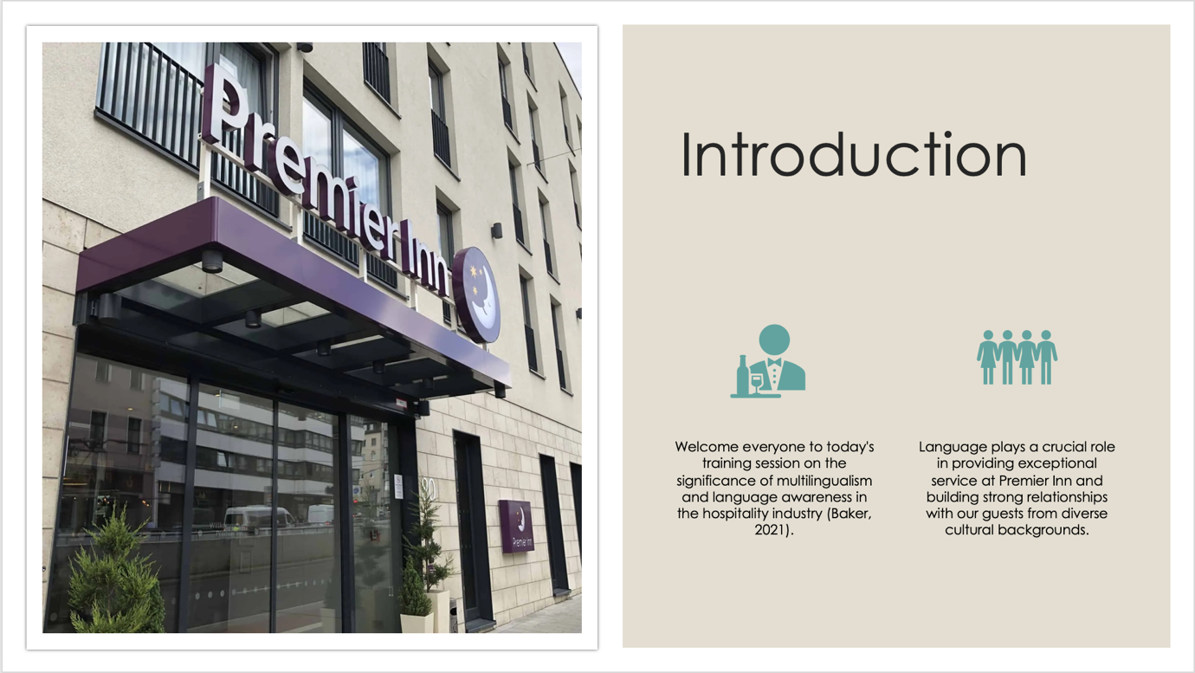

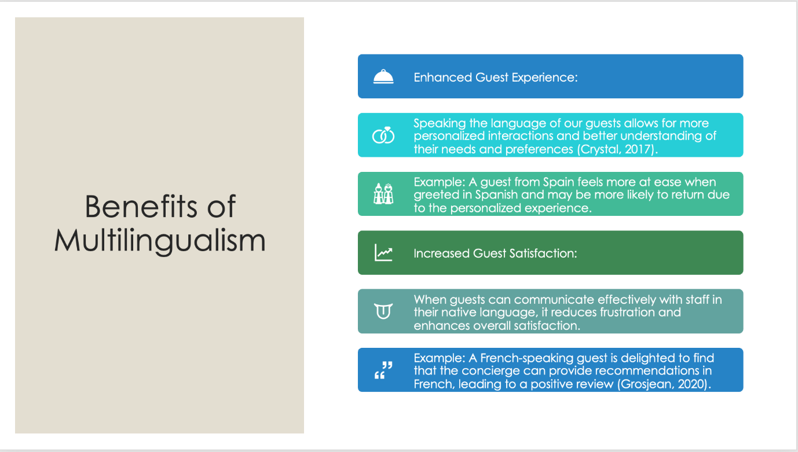

- Improved Customer Loyalty:
  - Guests are more likely to return to a hotel where they feel valued and understood, leading to increased customer loyalty.
  - Example: A German-speaking guest appreciates the effort made by the receptionist to communicate in German, fostering a sense of loyalty to the hotel brand.

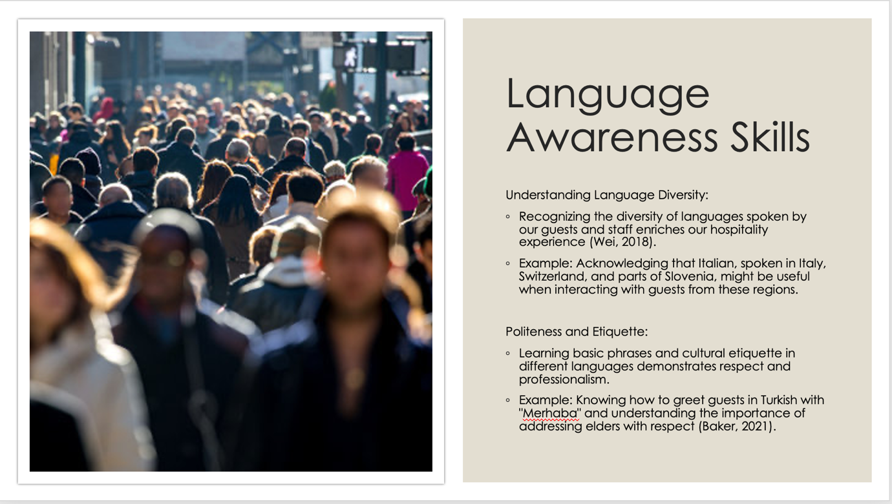

- Business Context:
  - Being aware of language nuances in a business context helps avoid misunderstandings and promotes effective communication.
  - Example: Understanding that in German culture, addressing someone by their title and last name (e.g., Herr Müller) is considered polite in a business setting (Grosjean, 2020).

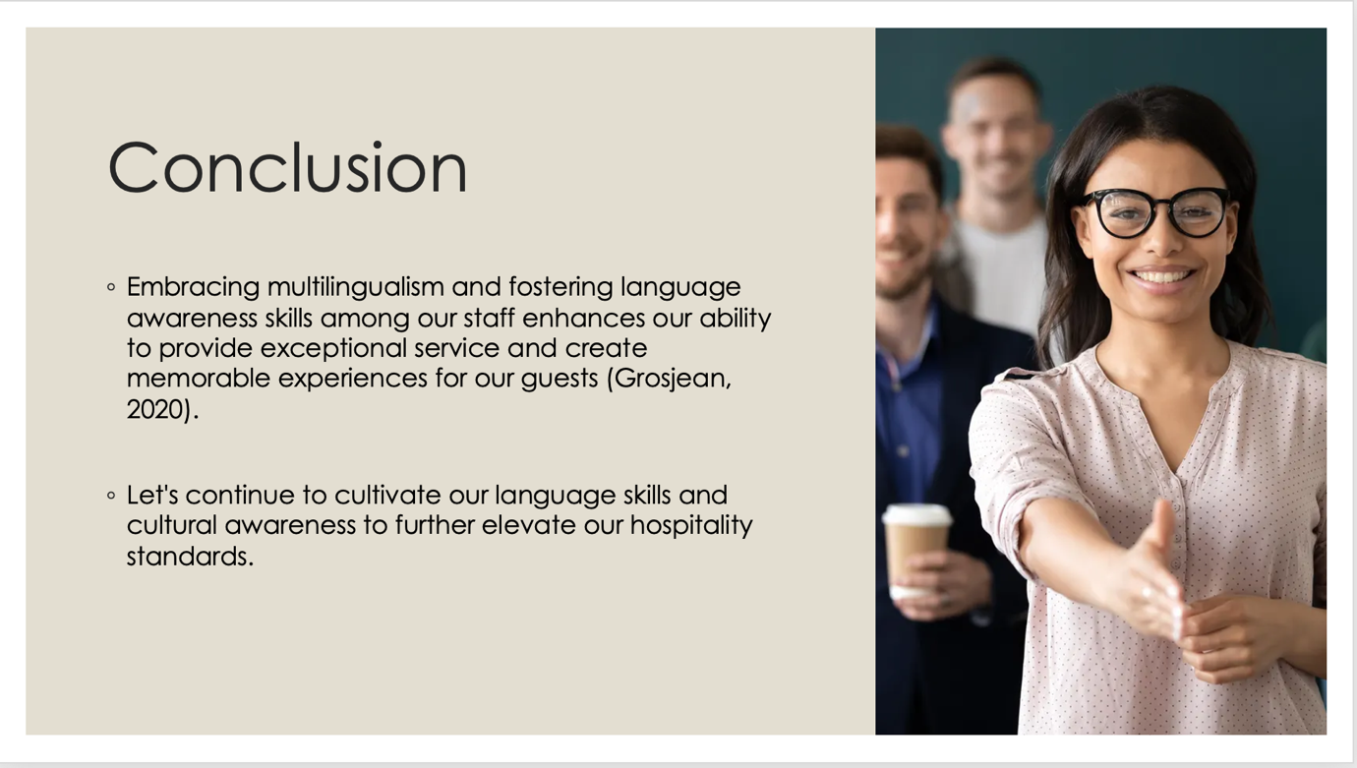

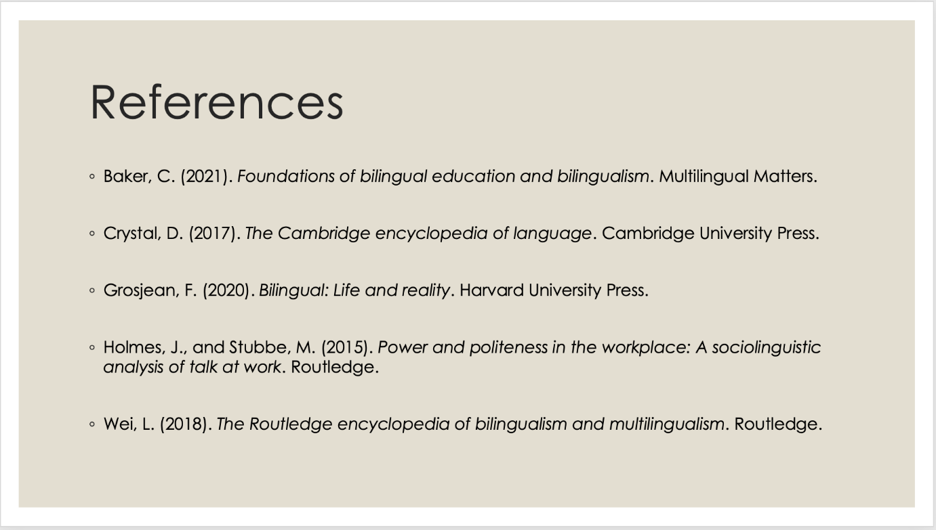

References:
Alonso-Almeida, M. M., and Bremser, K. (2021). Application of corporate social responsibility in the hotel industry: A review. Tourism Management Perspectives, 37, 100776. https://doi.org/10.1016/j.tmp.2020.100776
Bazazo, I., Alansari, M., Alqurashi, W., Alzahrani, M., and Salo, J. (2020). Understanding better management and leadership styles for successful hospitality operations. International Journal of Organizational Analysis, 28(5), 1059-1081. https://doi.org/10.1108/IJOA-08-2019-1850
Boğan, E., and Sarıışık, M. (2021). Talent management in the hotel industry: A research in five-star hotels. Journal of Human Resources in Hospitality and Tourism, 20(1), 95-119. https://doi.org/10.1080/15332845.2020.1745755
Chan, E. S. W. (2022). Hotel sustainability management: The case of PARK HOTEL Group, Singapore. Hospitality and Society, 12(1), 67-92. https://doi.org/10.1386/hosp_00036_1
Choi, H. C., and Sirakaya, E. (2021). Hotel crisis management practices: The case of Hawaii. Current Issues in Tourism, 24(10), 1372-1387. https://doi.org/10.1080/13683500.2020.1798682
Deery, M., Jago, L., Mair, J., and Varra, L. (2021). Project management in the hotel industry. International Journal of Hospitality Management, 92, 102712. https://doi.org/10.1016/j.ijhm.2020.102712
Gursoy, D., and Lam, W. (2021). The impact of organizational culture on hotel management practice and firm performance. International Journal of Contemporary Hospitality Management, 33(5), 1605-1627. https://doi.org/10.1108/IJCHM-12-2020-1391
Haddouche, H., and Salomone, C. (2022). Hotel management and corporate social responsibility: A state-of-the-art review. Journal of Hospitality and Tourism Management, 50, 191-205. https://doi.org/10.1016/j.jhtm.2022.01.004
Karatepe, O. M., and Karadas, G. (2022). Does management trust in frontline employees matter for hotel guest experiences? International Journal of Hospitality Management, 100, 103090. https://doi.org/10.1016/j.ijhm.2021.103090

