Strata Florida - The Arch.

Before we cross
Threshold unseen,
The air is soft
Senses keen.

Our purpose here to learn
we take the step ahead,
The world no longer turns
As all motion stops dead.

I see the cause
It gives me pause.
The arch that sits ahead.

A mighty arch that towers tall
Capturing all wonder and focus,
A testament to a Hallowed hall
Atmosphere threatening to choke us.

The rules we feel have changed
All reality has been lifted,
The lines of stones arranged
Our understanding of them shifted.

Visions of the past arise.
With echoes from bells of great size
This the aged stones have gifted.

The past is lost
The past is found,
We search for it despite the cost,
Search,
For the secrets of the ground.

This place built of old upon old upon old
A place that holds my country’s legacy
And demands reverence from your soul.

Wouldn’t it be nice if I felt any of that? It is pretty though.

That poem sums up my experience of Strata Florida. An imperfect summary of course, some sacrifice of honesty used for dramatic effect and illustration of point. In truth I found Strata Florida to be very interesting with pleasing views and I can see why it would create an emotional response to others who view it. Of course, as I illustrated with my poem, I myself never get any emotional responses to views, being in holy places or areas of historical significance and often feel some mild envy for those who do (which is an emotional response of a sort I guess.).

Yet there must be something to the place. I wrote a poem and I don’t like poems. I don’t like writing them and yet I felt compelled to. To express how I don't feel anything? Is that a contradiction? I suppose it is. Was this due to the fact I knew I had to do this? In part yes, but I still wanted to. I must have felt something under the surface. Perhaps we can find where this started to build within me.

The excursion to Strata Florida surprised me. It had promised to be very dull. The trip the previous week had created some expectations. A fascinating two hour trip had been expertly squeezed into five hours. The museum was a forest of cabinets and other displays with reference sheets inspired by the artful argos catalogue giving a generous five word description to each item. Occasionally you would stumble across an exhibit so grand they would feel the need to explain what it was.

Strata Florida threatened even less to do or look at. Some walls, a couple of grave stones and one barn full of things to label. Needless to say I resented the thought of becoming an early riser for this spread out collection of rocks.

The bus journey was long and soporific, so I slept. It was a pleasant nap and something I fully expected to be the highlight of the trip. After I stepped out I was first greeted by the stone barns in front of me and the firm ground. I looked up and saw a hightly metal man on the hill and wondered if he’d mind me saying hello. Perhaps that was my first spark of interest. Right at the starting line. But sparks of interest will flicker and die without fuel to burn.

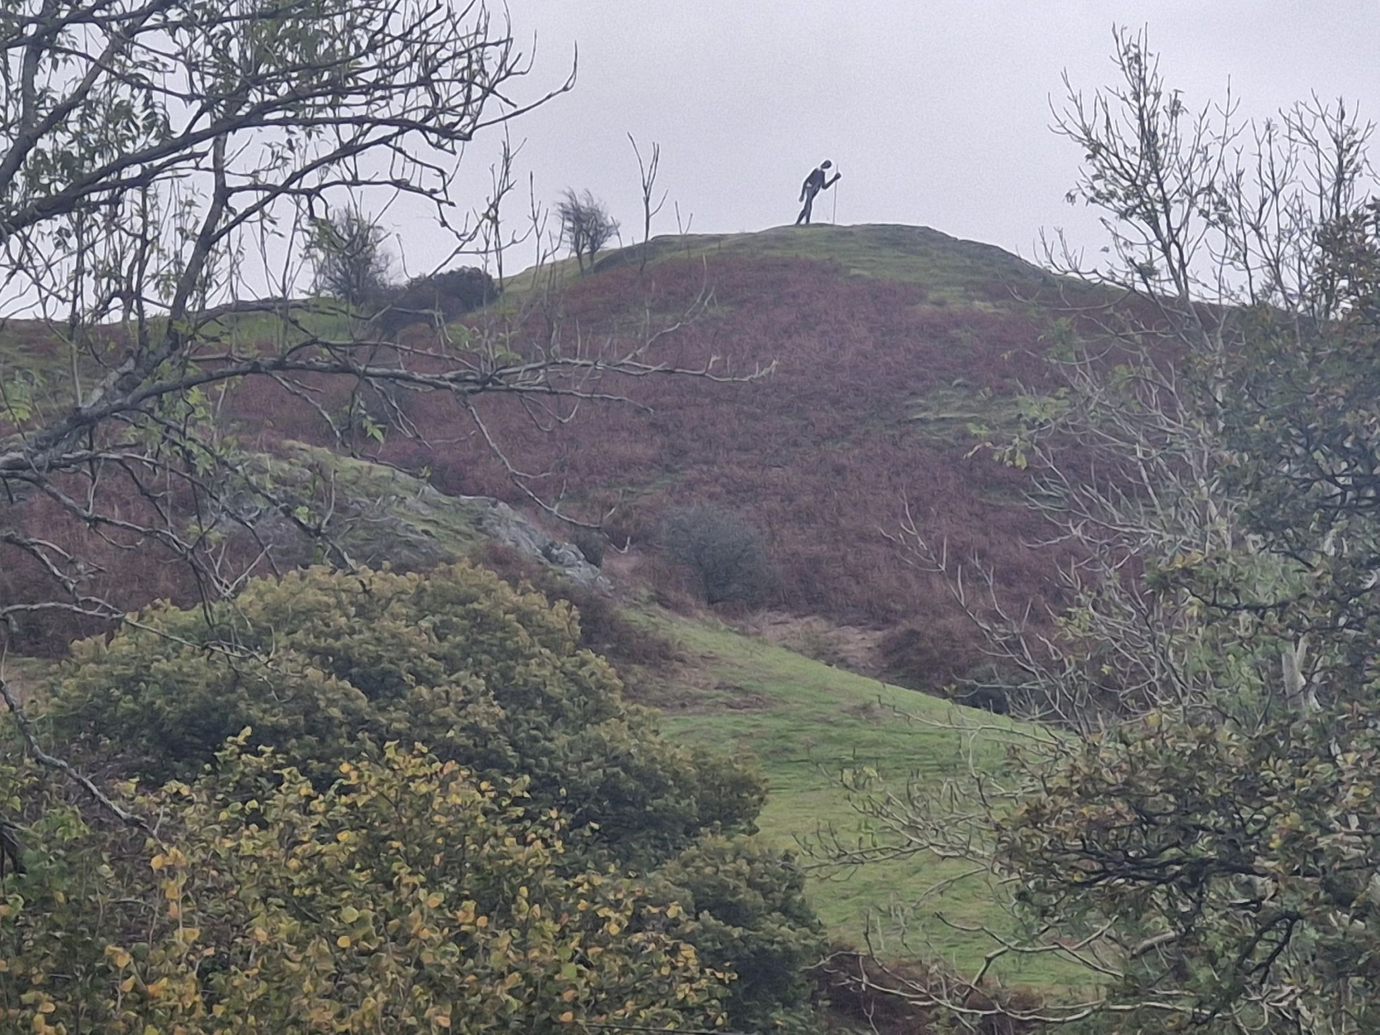

There was a briefing at the start. My mind had wandered before it began so I scrambled to catch up. I tucked the day's schedule in my mind and moved on to the first talk. The one at the site delivered by Quentin Drew. This was more interesting than an exhibit to read. The story behind the discoveries tickled my writer's brain and the facts interested me. Talks about how the story of history can change many times after the event. For many reasons, knowledge lost then rediscovered in part or in whole. The stories we tell ourselves with objects plucked from the ground. Knowledge of new discoveries ignited the imagination. What else don’t we know of the past?

We broke for lunch. I, in my enormous wisdom, had made one the night before, in comparison to those who planned to make it in the morning and ‘just get up early’ who were strangely without. They had to buy something from the shop, bless them.

We ate lunch in the picnic area, it was a field with a bench in. Quite minimalist but nonetheless effective, after all what is a picnic but the consumption of food in a field? Frankly, a bench is a luxury. We ate under the watchful gaze of our hightly metal friend on the hill we had since been informed was a pilgrim, despite this strike against him I still thought it would be nice to say hello and yet, tragically, that hello never came to pass.

We headed to the entrance area to what would have at one time been the abbey itself. This was a nice place. Lush green grass replaced the intricate patterned tiles that would have been the floor to the abbey. Hints at walls long past peaked up from the turf, whispering hints of a time long past.
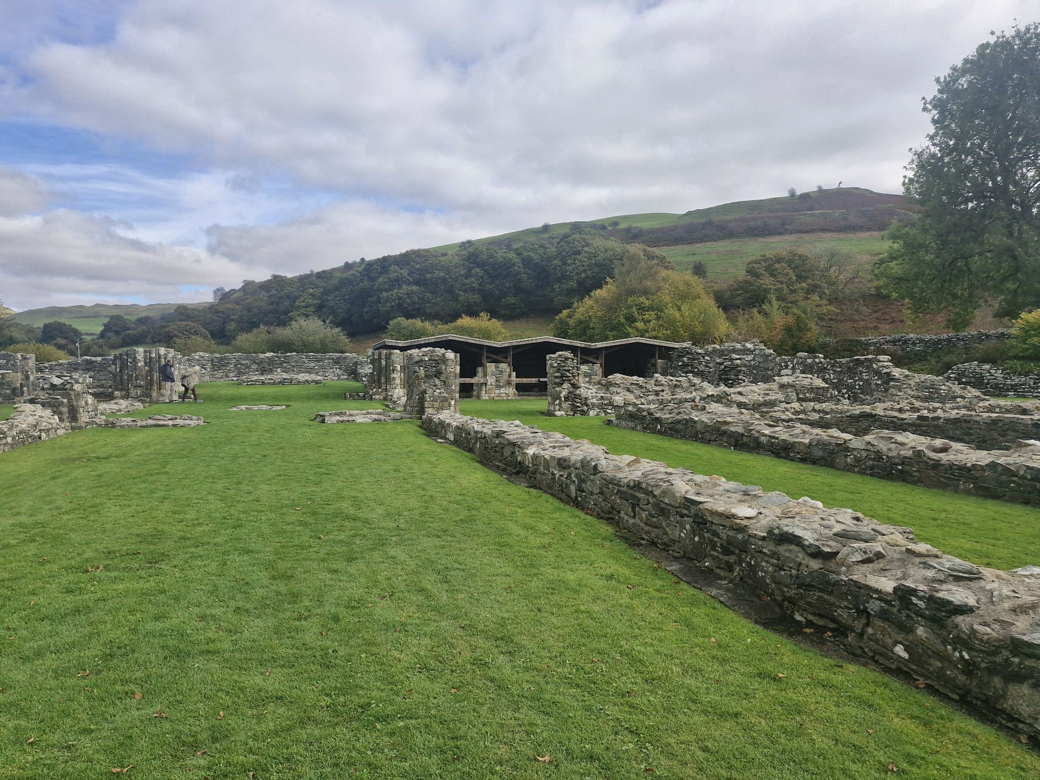

I wandered around the place going “ooh” and “ahh” in mild interest. The arch was the most interesting part. I liked it. It looked pretty and I felt the need to write about it, or rather, I thought that this would be the best thing to write about as I had promised myself I would write about something. Yet no inspiration came.

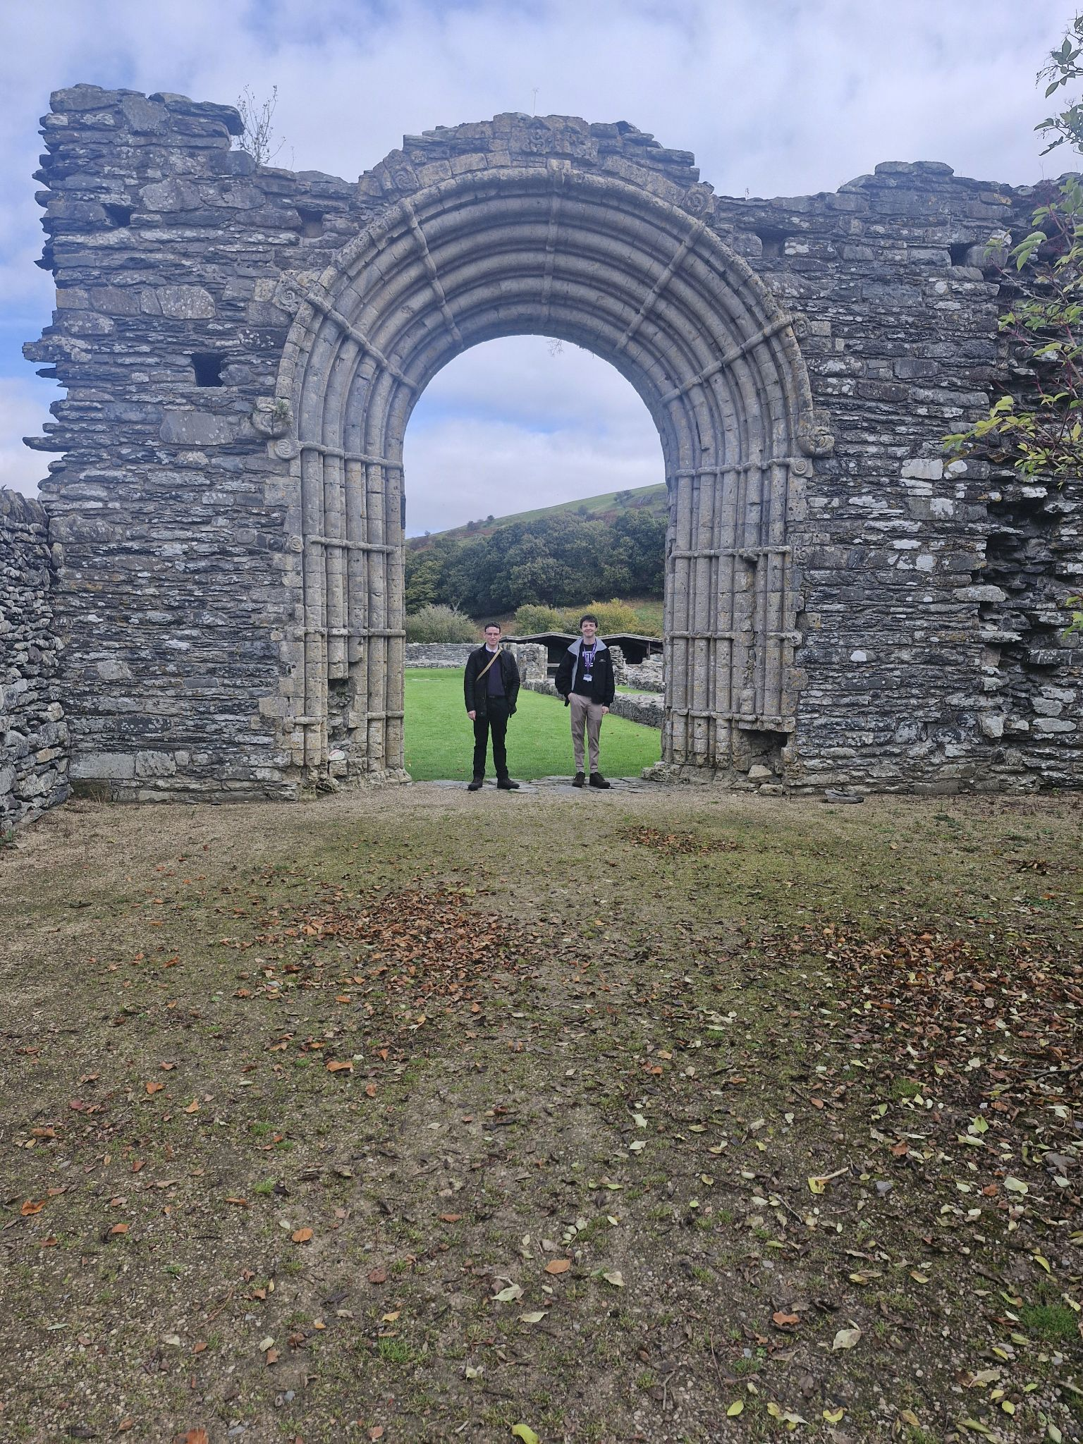

Then Quentin Drew arrived to do the second talk of the day. I was looking forward to this. The last had been interesting and I had always been a far more audio focused learner. I listened to the fun facts about the Abbey’s architecture, it was a rebellious little building with Celtic decorations and layout that screamed at the Norman churches “you’re not my real dad!”. Then I heard something that stood out to me. Quentin described a ‘liminal transition zone’, this was a space where the act of crossing the ‘threshold’ transforms one's experience or state of being to another. An emotional reaction, one I could never have. If I could have that reaction, inspiration could find me I was sure. I was jealous. Then, paradoxically, by the very act of lamenting my lack of inspiration, I found myself inspired to write about my experience of this liminal zone or rather its absence.

So there it is. I quickly scribbled the first draft of my poem before being quickly bundled back onto the bus for another nap, feeling like there was so much more to do. A museum barn yet to be visited and a metal friend yet to be made. Still I did get something out of it. Inspiration.

References:

Downing, Flo, Unnamed photograph, Camera Photograph (Unpublished 2025)

Jowett, Fergal, Strata Florida: The Arch (Unpublished Poem, 2025)

Jowett, Fergal, Unnamed photograph, Camera Photograph (Unpublished 2025)

Jowett, Fergal, Unnamed photograph, Camera Photograph (Unpublished 2025)

Fergal Jowett, Strata Florida: The Arch (Unpublished Poem, 2025)
Fergal Jowett Unnamed photograph, Camera Photograph (Unpublished 2025)
Flo Downing, Unnamed Photograph, Camera Photograph (unpublished 2025)
Fergal Jowett Unnamed photograph, Camera Photograph (Unpublished 2025)

