
Skills for the Workplace
Module Assignment Submission
Student Name: | Ripa Begum
Student Number: | 1911103
Module No: | BMSK4002
Module Title: | Effective Team Working and Communication  Part 2

Statement of Confirmation of Authenticity
By the act of making this submission, the student declares that this is the work of the student named above. The work has not, in whole or in part, been knowingly presented elsewhere for assessment, or where assessment has been built on a previous assessment, this has been identified. Where materials have been used from other sources it has been properly acknowledged. If this statement is untrue, the student acknowledges that an assessment offence has been committed.
Attention is drawn to the plagiarism and unfair practice policies of both the University and of ILM.

Table of Contents
Part 2 Communication 3
1.0 3
Communication Cycle 3
2.0 4
Assessing Own Communication Skills 4
Gap Analysis 7
PDP 8
References 9
Appendix A 10
Skills You Need Communication Quiz 10
Mind Tools Communication Quiz 11
Communication Style Quiz ……………………………………………………………………………………………..12

Part 2 Communication

1.0

Communication Cycle
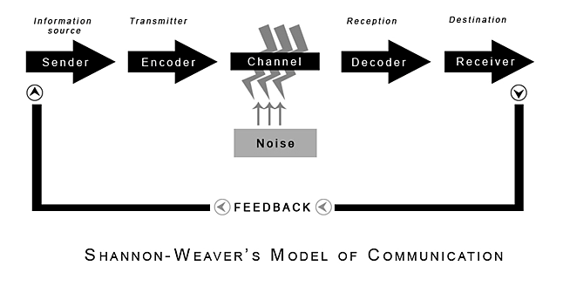
The Shannon-Weaver Communication Cycle is a communication model which analyses how messages are sent and received. It was developed in 1948 by Claude Shannon and Warren Weaver. The model was designed to show effective communication between two people – a sender and receiver but it also discusses how the messages can be misinterpreted and mixed up in the cycle (Communication Theory, 2017).
The model begins with the sender, also known as the information source, as they have the information that they want to share to begin with. They begin the process as they must choose what message they would like to send, the person they would like to send the message to and also how they will send the message to the receiver (Drew, 2020).
The encoder (also known as the transmitter) is the machine or person who changes the sender’s message into an understandable signal so that the receiver can understand what the sender’s message is. The message can be coded and communicated in different ways such as verbal communication through speech and written words or non-verbal communication such as body language (Mulder, 2017).
The channel is the way the information gets to the receiver from the sender – it is also sometimes called the medium. There can be interference in this part of the communication cycle which can lead to miscommunications – this type of interference in the model of communication is referred to as noise (Mulder, 2017). There are two types of noise: internal and external. External noise is when something that is not in control of the sender or receiver changes the meaning of the message and causes misunderstanding. This happens through the channel or medium. Internal noise is when there is a mistake of the sender or receiver’s part. This may happen when they are encoding or decoding messages (Drew, 2020)
The messages then reach the decoder (or reception). Similarly, to the encoder, the decoder is a machine or person. But, in contrast, the decoder changes the message so that the receiver understands it. For example, if the decoder was a person, the person would use decoding to interpret the sender’s message into their thoughts so that they can understand it themselves (Mulder, 2017).
The cycle ends with the receiver, which may also be known as the destination. The receiver is the person that the sender’s message must reach. The receiver may provide feedback according to the sender’s message (BusinessTopia, 2018).
Feedback is sent when the receiver of the message responds to the sender. It is an important part of the communication cycle as this is when the receiver tells the sender whether they understood the message clearly without noise and also how well they understood the sender’s message (Drew, 2020).

2.0

Assessing Own Communication Skills

In this section, the report writer will assess and discuss their own communication skills. The report writer will discuss how good their communication skills are – one-on-one, communicating in group situations and also their listening skills. In addition, the report writer will also discuss the type of communication they use most of the time.
The report writer completed a self-assessment to see their preferred and most used communication style (See Communication Style Questionnaire in Appendix A). In this questionnaire, there are four types of communication styles: assertive, passive, passive aggressive and aggressive.
According to the Communication Style Questionnaire, the report writer’s preferred communication style is assertive. Assertive communication is considered to be the most effective form of communication style. Assertive communicators are able to express their own ideas while also considering the needs of others – they aim for both sides to be content with a situation (Alvernia University, 2018). This indicates that the report writer has a good communication style and can communicate with others effectively.
Although, the report writer also scored very high on the passive communication style which could suggest they also communicate passively sometimes. Passive communicators often stay quiet when conflict arises as they are most likely to avoid confrontational situations. Also, people with a passive communication style may often have a lack of eye contact or poor body language (Alvernia University, 2018). This could indicate that these are areas the report writer has to work on in order to improve their communication style when talking with others.
Furthermore, the report writer also completed another self-assessment to see how good their communication and listening skills are (See SkillsYouNeed Communication Quiz in Appendix A). This quiz showed the report writer how good their verbal communication and listening skills are while also showing how they communicate in groups.
For verbal communication, the report writer scored 59% which shows she has average verbal communication skills. People with ideal, above average communication skills can consider their choice of words carefully and use different words for different situations with the right tone of voice and pace (SkillsYouNeed, 2017). Although, average verbal communication skills means the report writer is able to communicate with a friendly tone and can get their point across with some time (Smith, 2017). These results suggest the report writer should take the time to think about what they are saying and how they are saying their ideas when talking in order to enhance the communication process (SkillsYouNeed, 2019).
For communicating in groups, the report writer scored 51% which is average. People with above average group communication skills in groups are able to recognize other people’s concerns and ideas in an open exchange of ideas and feel confident in group situations (Simulab, 2018). Having 51% means the report writer can deal with group communication adequately but may get nervous when discussing their ideas with the other people in the group (SkillsYouNeed, 2019). The results of the SkillsYouNeed Communication Quiz suggests that in the next group situation, the report writer should watch other participants to pick up on ideas on what to do in group situations and also what to avoid doing (SkillsYouNeed, 2019).
For listening skills, the report writer earned a score of 63% which shows they have average listening skills. People with ideal listening skills give the speakers their undivided attention and acknowledge the message they are trying to get across by using body language and gestures (which we have already discussed is something the report writer should improve on) and also providing feedback to the speakers when needed (MindTools, 2020). Although, the report writer has average listening skills which may suggest they have picked up on some bad listening habits and should focus on consciously practice effective and active listening (SkillsYouNeed, 2019).
In addition, the report writer also completed another self-assessment for their communication skills (See MindTools Communication Quiz in Appendix A). In this questionnaire, the report writer scored a 38 which also shows the report writer has average communication skills. People who scored 56-75 points (above average communication skills) understand their role as a communicator when they send and receive messages and can choose the right channel to do so. Although, scoring a 38 means the report writer is a capable communicator but also may sometimes experience communication problems. The website suggests focusing on receiving messages effectively as much as sending them in order to improve the report writer’s ability to communicate (MindTools, 2019). For example, the report writer should also focus on giving feedback to the ideas they have received from the people they are talking to by improving their listening skills.
In conclusion, completing various self-assessments on communication and listening skills and the report writer’s preferred communication style suggests that the report writer is able to communicate and listen well in certain situations but there are also a lot of areas to improve on such as communicating in groups, report writer’s body language and also giving feedback to other participants by improving their listening skills so they can enhance their communication process.

Gap Analysis

Objective | Current Position | Deficiency | Action
What do I want to do? | What can I already do? | What am I lacking? | How do I fix this?
The report writer would like to become more confident when speaking and communicating in groups. | The report writer is able to discuss and communicate within a smaller group that they may already be acquainted with. | The report writer often lacks confidence when talking to larger groups of people and can sometimes become reserved and nervous. | When discussing in groups, the report writer can look at other participants to see what they should do and also what things they should try and avoid doing.  The report writer should also try and talk more with co-workers and their peers, so they begin to feel more comfortable and confident around them, making it easier to talk to them when in a group.
The report writer would like to improve their body language and maintain good eye contact when they are discussing and listening to ideas in groups in order. | The report writer is usually able to maintain good eye contact when discussing with and listening to someone most of the time. | When discussing ideas, the report writer often remains still and does not include appropriate body language and hand gestures when they are talking with or listening to somebody. | When in groups, the report writer can keep in mind certain hand gestures from other participants in the group and copy their body language when they are speaking and listening to their peers talk.  The report writer can also look online or read books on communication and body language and use those tips and ideas for the next time that they are speaking.
The report writer would like to also focus on giving feedback to other participants ideas by improving their listening skills in order to enhance the communication process. | The report can sometimes give feedback when the speaker has asked them to participate in the conversation. | The report writer does not actively give back feedback to speakers when is group discussions and only does so when asked. | The report writer should reflect back and ask questions on what the speaker is saying by looking online or in books for certain phrases that they can use in most situations.  The report writer should also respond appropriately to what the speaker is saying and should give their honest opinions by asserting their views respectfully but also making sure not to attack the speaker or put them down.

PDP

Objectives | Tasks | Success Criteria | Time Frame | Resources
List your Goals | What do you need to do to achieve these goals? | How will you identify your success? | When do they need to be done by? | Who or what do you need to help you?
The report writer would like to become more confident when communicating in groups. | The report writer should watch other participants to understand what to do and what to avoid doing in group situations.  The report writer should try and get to know more peers and co-workers so that they feel more familiar with them and can talk to them more easily. | After watching other participants and talking more with their peers, the report writer will feel more comfortable and confident in group situations – when the report writer becomes less and less nervous in those group situations, they will be successful in this goal. | December 2020 | The report writer would need to be in group situations more often in order to become used to the environment and feel comfortable.  They also need their peers and co- workers to talk to.
The report writer would like to improve their body language and maintain better eye contact when they are discussing their ideas and listening in groups. | The report writer can pay attention and keep in mind certain hand gestures and other body languages that other participants in the group do and can use these themselves when they are talking about their ideas in the group. | At the end of group discussions, the report writer can ask for feedback from their peers about their body language and see if they are improving and also if there are other things they need to work on. | December 2020. | The report writer would need their peers and the other participants in the group discussions so they can ask for feedback.  The report writer would need access to online resources and books about communication and body language.
The report writer should aim to focus on giving better feedback to speakers by trying to improve their listening skills. | The report writer should ask more questions to the speaker and reflect on what they have said by using phrases that go with most situations. found online or in books.  The speaker should also give their honest opinions to the speaker about their ideas without putting the speaker’s views and opinions down. | The report writer can ask the speakers if their feedback was helpful and if there is anything they should try and improve on. | December 2020. | The report writer would need access to online resources and books so they can find phrases online.  The report writer would also need to have more group discussions with their peers in order to give feedback to them.

References
Alvernia University (2018) ‘4 Types of Communication Styles’ Available at: https://online.alvernia.edu/articles/4-types-communication-styles/ (Accessed: 18th May 2020)
Blenkinsop, P. (2010) ‘The Communication Cycle.’ Available at: http://manyana-education.blogspot.com/2010/10/communication-cycle.html (Accessed: 14th May 2020)
Communication Theory (2017) ‘Shannon and Weaver Model of Communication’ Available at: https://www.communicationtheory.org/shannon-and-weaver-model-of-communication/ (Accessed: 14th May 2020)
Drew, C (2020) ‘Shannon-Weaver Model of Communication|7 Key Concepts (2020)’ Available at: https://helpfulprofessor.com/shannon-weaver-model/ (Accessed: 14th May 2020)
MindTools (2019) ‘How good are your communication skills?' Available at: https://www.mindtools.com/pages/article/newCS_99.htm (Accessed: 14th May 2020)
MindTools (2020) ‘Active Listening’ Available at: https://www.mindtools.com/CommSkll/ActiveListening.htm (Accessed: 20th May 2020)
Mulder, P (2017) ‘Communication Cycle Model by Shannon and Weaver’ Available at: https://www.toolshero.com/communication-skills/communication-cycle-shannon-weaver/ (Accessed: 14th May 2020)
Simulab (2018) ‘Group Communication Skills’ Available at: http://simulab.ltt.com.au/4/_TEAM300/task21.htm (Accessed: 18th May 2020)
Skills You Need (2017) ‘Verbal Communication’ Available at: https://www.skillsyouneed.com/ips/verbal-communication.html (Accessed: 18th May 2020)
Skills You Need (2019) ‘Interpersonal Skills Self-Assessment.’ Available at: https://www.skillsyouneed.com/ls/index.php/343479 (Accessed: 14th May 2020)
Smith, T. (2017) ’10 Verbal Communication Skills Worth Mastering’ Available at: https://www.littlethingsmatter.com/blog/2010/11/30/10-verbal-communication-skills-worth-mastering/ (Accessed: 18th May 2020)

Appendix A

Skills You Need Communication Quiz
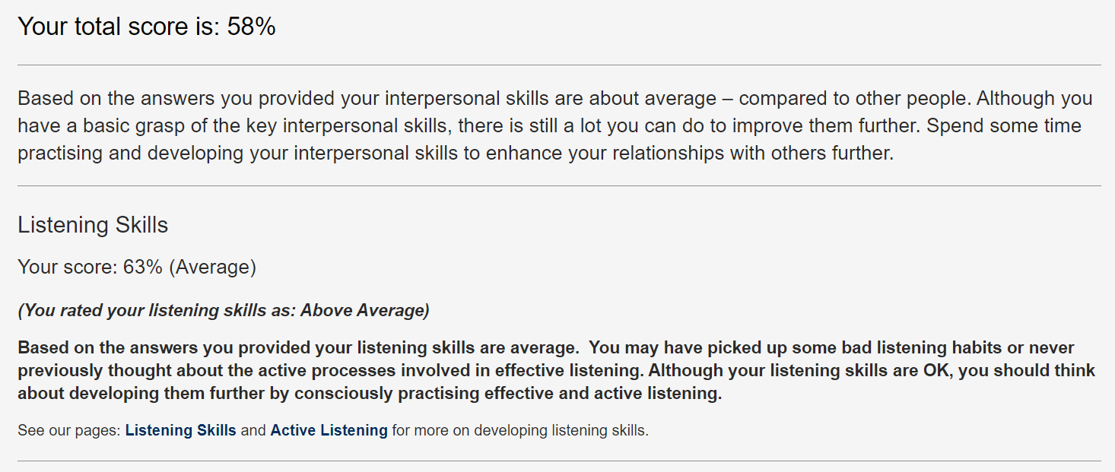
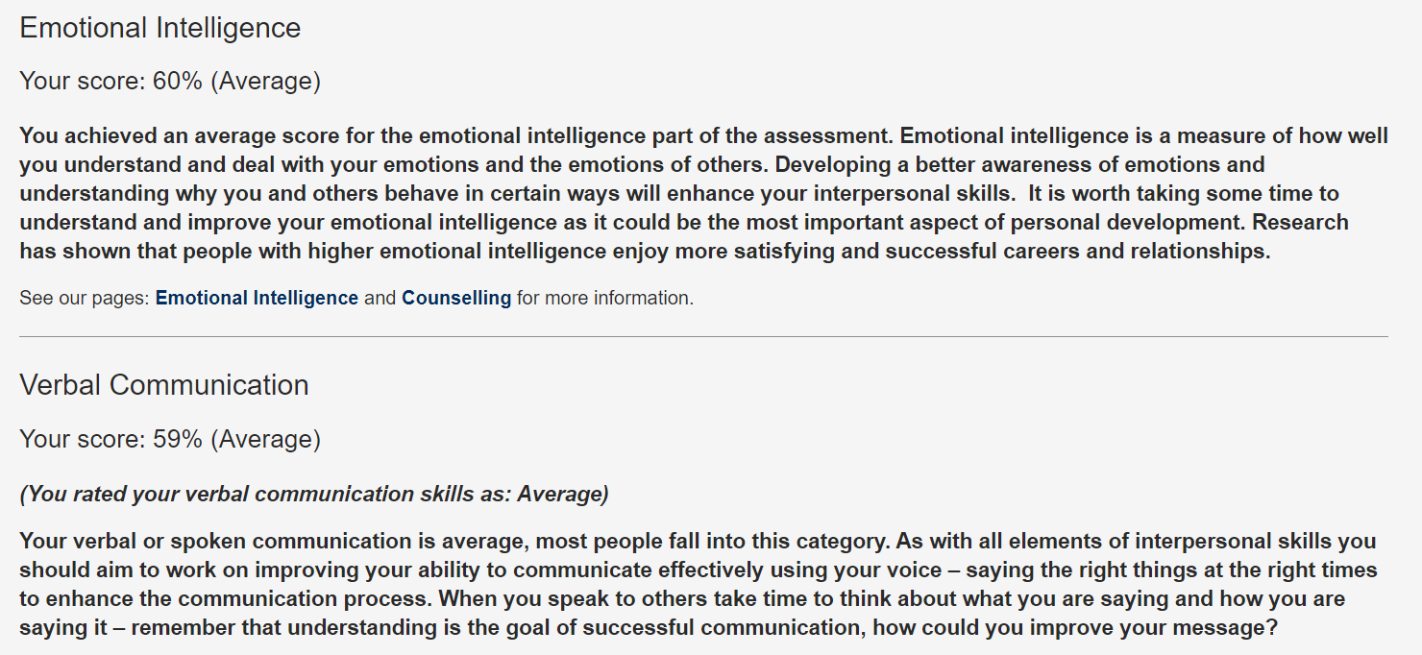
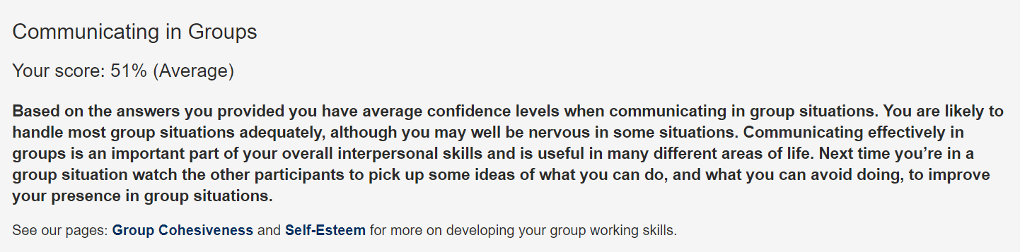

Mind Tools Communication Quiz

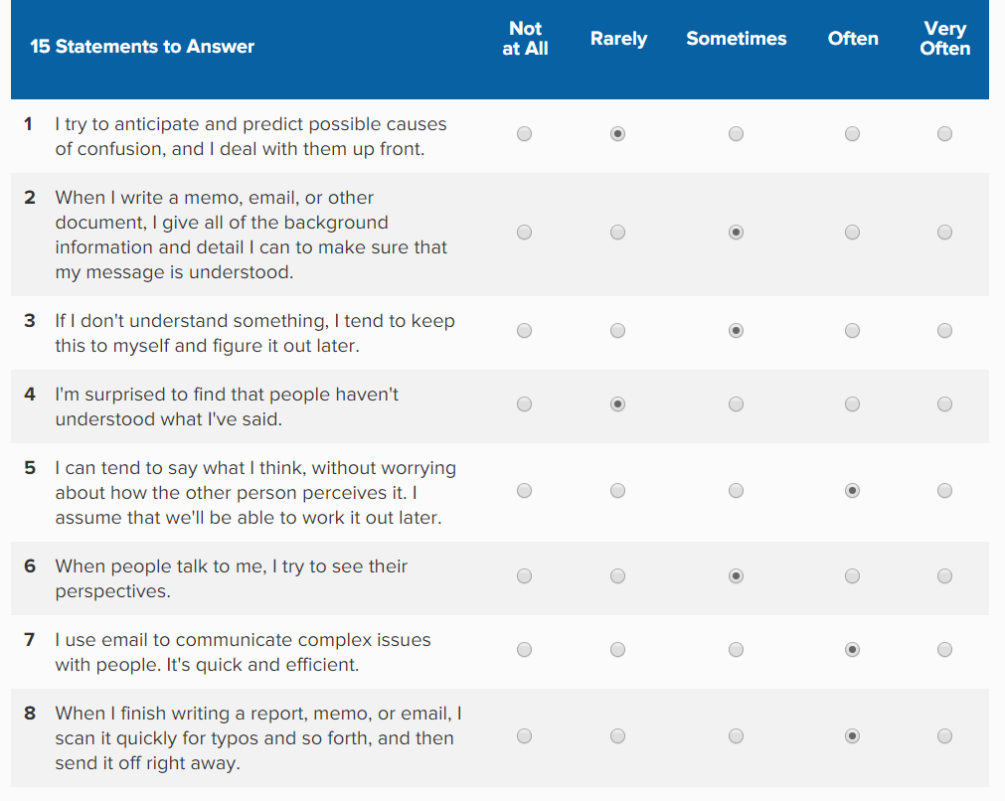
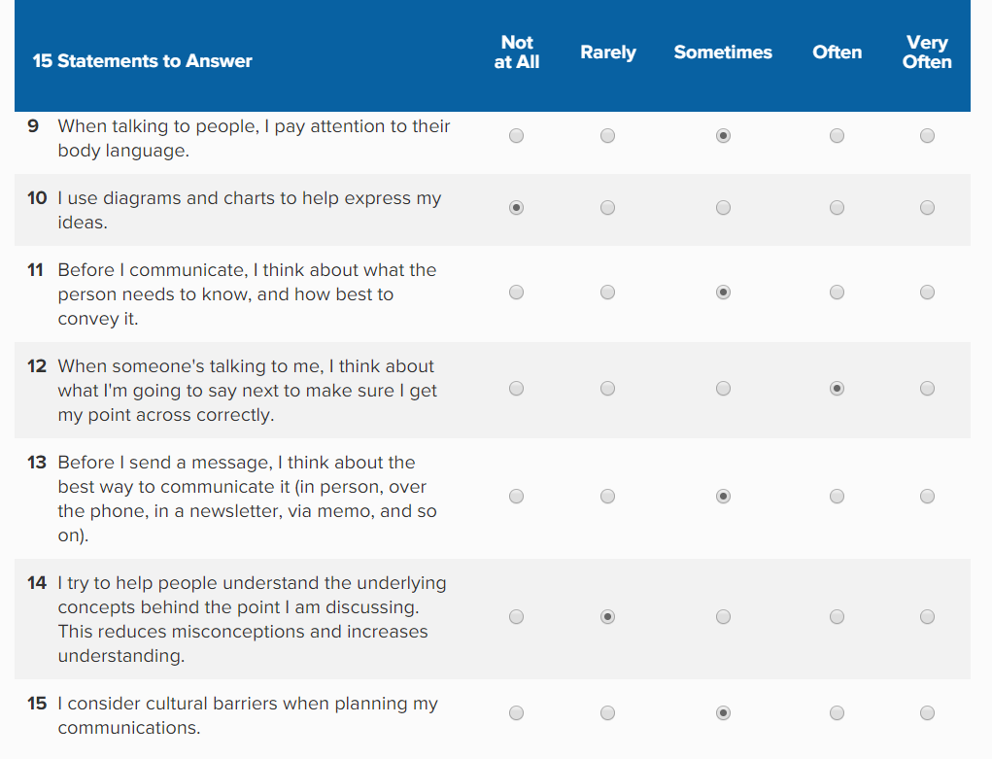
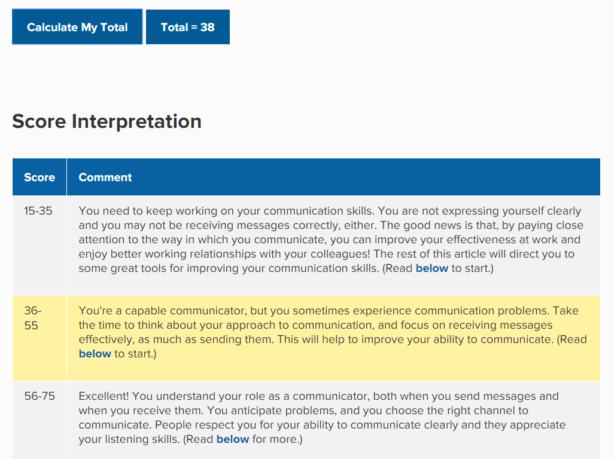

Communication Style Questionnaire:


