University of Wales Trinity Saint David
School of Engineering


Stress Analysis and Dynamics
Analyse and Simulate a Mechanical Energy Recovery System
ACMA5010
Gethin Dyer Davies
2307576
10/2025
Contents
1 Introduction 1
2 Flywheels as a Mechanical Energy Storage Device 2
2.1 Historical Development of Flywheels 2
2.2 Modern Application in Off-Grid Energy Storage and Regenerative Braking 3
3 KERS in Road Vehicles and Design Constraints 5
4 Mechanical Batteries v Chemical Batteries 8
5 Technical Analysis and Simulation of a Hybrid KERS Vehicle 9
5.1 Vehicle Kinetic Energy Before Braking 9
5.2 Energy Stored in the Flywheel After Braking 10
5.3 Flywheel Rotational Speed After Braking (RPM) 10
5.4 Vehicle Speed After Re-Acceleration Using Only KERS Energy 12
5.5 Effects on Re-Acceleration Due to Braking Speeds 13
5.6 Acceleration From Stop in 6.5 Seconds 14
5.7 Rotational Speed for a Smaller Mass Flywheel at Various Diameters 14
5.8 Assumptions 16
6 Conclusion 17
7 Appendices 18
8 References 19

Introduction

Mechanical energy recovery systems are essential components in modern engineering, particularly in automotive and renewable energy sectors. These systems aim to capture and reuse energy that would otherwise be lost, improving overall efficiency, sustainability, and performance. This report provides thorough information on the history and origin of Flywheel Energy Storage Systems (FESS) through to its current applications and function. With this, Kinetic Energy Recovery System (KERS) is explained with their design considerations and impact and advantages of mechanical batteries over chemical batteries. The second half of the report contains a comprehensive calculation analysis of a mechanical KERS.

Flywheels as a Mechanical Energy Storage Device

“Flywheel operates whereby its rotation is maintained by its own inertia,” (Bihl, 2018)

Historical Development of Flywheels
Flywheels have a long history with Yashuv & Grosman (2024) stating with new evidence that spindle whorls were used as far back as 12,000 years ago with the stone, bone or wood disk, spun as stated by Webley (2017) to smooth out the manual-powered motion. The most prominent first use of the flywheel as an energy storage device discussed by Lesley (2021), dates around 3000 BCE with the adoption of the potter’s turn table, also known as potter’s wheel. With the principle that the spinning wheel stores energy and will continue to spin through its own momentum even if pressure is applied from the potter’s hands shaping the clay, also smoothing the foot or hand powered motion. History Tools (2025) indicates in later centuries, water powered mills included flywheels with their primary role to maintain a steady rotational speed, also smoothing out the intermittent power input. Then with the industrial revolution the flywheels, now made from cast iron would still mainly be for smoothing and stabilizing in mechanical presses, with James Watt applying this principle in steam engines as stated by Oxford Scientist (2023), creating the sun and planet gear to convert the jolting reciprocating motion of the pistons into continuous rotational motion of the wheels. Buss and Shuttleworth (1999) reports the largest engines in Victorian era such as the Centennial would have produced 1.04 megawatts, while standing twelve meter tall and had flywheels nine meters in diameter. The first form of recovering kinetic energy and converting it into energy was introduced in the 1800’s integrated within horse-drawn cabs as stated by Hamada and Orhan (2022), with the first recovery braking system introduced by Frank J Sprauge in 1886 whereby the integrated motors on the locomotive would turn into generators during braking with the current then diverted through onboard resistors and sent back to the supply line. Around the same time, U.S Naval Undersea Museum (2025) indicated that the closest form of self-propelled technology using the flywheel arrived in 1870 by J A Howells with his designed torpedo, where the flywheel would be energized by steam power before being released and the flywheel motion alone would propel the torpedo.
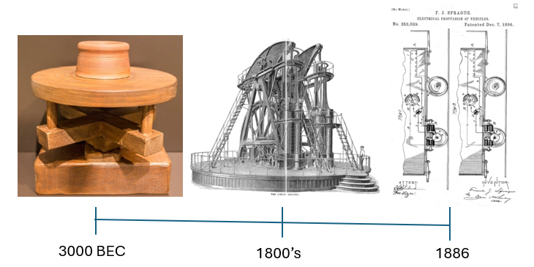
Figure 1 - Flywheel History Timeline (Atwell, 2025 ) et al.

Modern Application in Off-Grid Energy Storage and Regenerative Braking
In contemporary systems, flywheels are experiencing a resurgence as a mechanical batteries for energy recovery and storage. Mainly as explained by FD Engineering (2024) due to the drive to achieve carbon zero, driving research and development in the automotive and energy sector. In the off-grid and grid support systems of the energy sector, they provide a solution to capture surplus electricity and turn it into kinetic energy. Use with renewable sources for example, wind farm or solar farms, with the advancement in technology, greater flywheel speeds can be achieved with less resistance allowing higher energy output allowing the supply of smooth intermittent renewable energy, handling frequency regulation and rapid load changes. Allowing areas for example, Coral Bay as described by Amiryar and Pullen (2017) runs at 95% efficiency in renewable energy use at peak time and 90% over it year cycle, thanks to the inclusion of 500 kilowatt flywheel system . MTU (2021) show that FESS also offer the ability to provide short duration energy storage power for applications that require uninterruptible power making them an important asset for Hospitals, military, and other sectors.
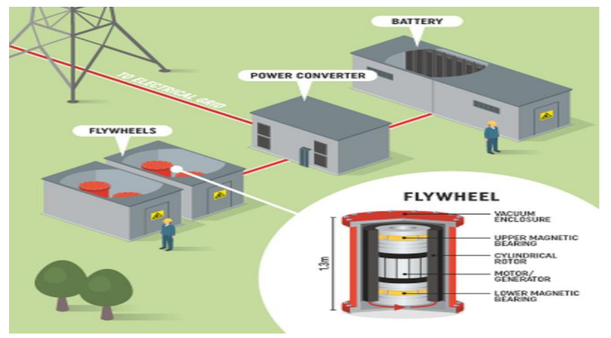
Figure 2 - Flywheel Energy Storage (Inspired Pencil, 2023)

Since it’s conception the use of regenerative braking, where kinetic energy that would be lost as heat, is instead stored in a flywheel and reused was mainly used in proto-typing and low production numbers. The Orwell electric truck in world war one as stated by Commercial Motor (1916), with Energy Education (2025) showing the technology was used in the1930’s Baku-Tbilisi-Batumi railway project and then in 1953, Swiss Gyrobus used a 1.5 tonne flywheel that spun at three 3000 revolutions per minute, stated by Oxford Scientist (2023). In 1997 the modern revolution of applying to the regenerative braking technology to mass produced automobiles had started stated by Florin (2015) with Toyota Prius launching in 1997 and now sold more than four million units and since then been introduced on racing cars and across several platforms of transport.

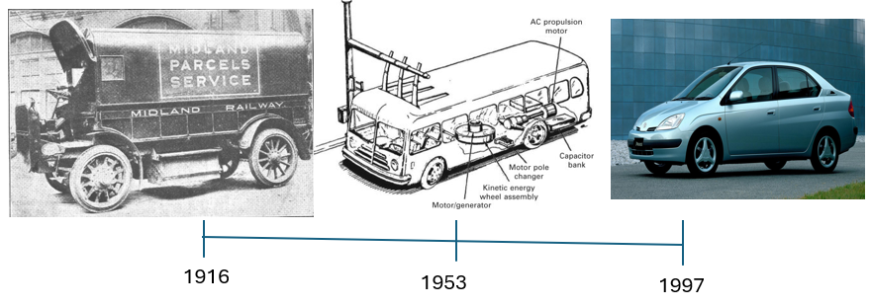
Figure 3 - Automotive Flywheel History (Commercial Motor, 1916) et al.

KERS in Road Vehicles and Design Constraints

Kinetic Energy Recovery Systems (KERS) in road vehicles as shown by Energy Education (2025) capture the energy of motion when the vehicle is braking reverting it to mechanical energy in a flywheel or into electrical energy which is stored in a battery or supercapacitor to return it during acceleration, improving efficiency and performance. Buchroithner (2023) says that several hybrid car manufacture use a flywheel system that attaches to the vehicles transmission like the Volvo S60, which uses a Flybird KERS unit connected to a sophisticated Continuously Variable Transmission (CVT) as shown in Figure 4, with the CVT managing the energy to and from the drivetrain. Volvo (2014) quotes that the vacuum sealed KERS unit uses a 6kg carbon fibre flywheel that spins up to 60,000 revolutions per minute, and this adds an additional 80hp while cutting the fuel consumption of up to twenty-five percent. Metz (2013) states the technology advancement reached race performance beneficial and were adopted on F1 cars in 2011.

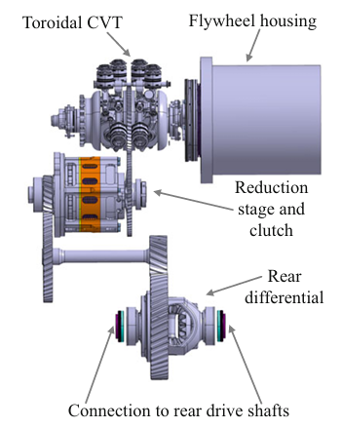
Figure 4 - KERS Unit and CVT (Buchroithner, 2023)

Designing a vehicular flywheel KERS unit poses several engineering challenges, firstly the unit must fit in an already compacted engine department, be as lightweight as possible and still cost effective against fuel savings and performance. One key selection is the material of the flywheel, flywheels made from steel are robust, heavy, and limited in maximum stress and thus speed. Buchroithner (2023) shows modern KERS flywheels tend to use composite materials like carbon fibre in a hoop-wound configuration around aluminium or steel hub, with the tensile strength improvement of 2640N/mm² and a greater energy density compared to steel. This does not only save weight but allows a greater flywheel speeds, with the Flybird F1 KERS unit working at a top speed of 64,500rpm as stated by Buchroithner (2023). Composite material does not only improve weight and performance of the unit but also improves the safety. Ashley (1993) suggests composite like cardon fibre tends to delaminate in a catastrophic failure, whereas a steel flywheel would implode into lethal fragments. Too reduce the risk of failure precision balancing is essential as an imbalance of even a few micrograms can cause severe vibrations, that not only could be felt by the vehicle operator but also cause damage and failure to bearings and other components. Just-Auto (2014) show how important and precise the balance must be by stating that Flybird manufacturing invested two million pound and developed a flywheel balancing machine capable of balancing to within 0.2 microns of the true centre line, helping to achieve 150,000 miles life expectance from the KERS unit. Amiryar and Pullen (2017) explains that the housing has two purpose, provide a vacuum sealed unit to reduce drag and aerodynamic heating on the flywheel and bearings, improving the systems performance and the other is to contain the flywheel in an event of failure. Collins (2011) shows this in Figure 5, with the inner section ‘Containment Disks’ made from a carbon fibre or other composite preventing the internal damage from damaging the external aluminium housing, which ensures vacuum integrity as stated by Ashley (1993). Vacuum is achieved by installing a pump if required, but with improved seals as developed by Flybird that can maintain a vacuum of 1x10-7bar while requiring no pump as stated by Collins (2011). With a vacuum incised housing, temperature control is a challenge and lubrication is impossible, Figure 6 from Buchroithner (2023), show installation of cooling jackets, pumps to control the temperature with bearing technology advancements allowing contact less bearings to be installed. This requires the use of magnets to keep the shaft centralised and friction free, Buss and Shuttleworth (1999) states that in most cases ball bearing are still used in conjunction with a permanent magnet or a solenoid coil, reducing the cost and engineering complexity. With all this the unit must also be able to handle the road impact and vibrations along with the driving gyroscopic forces as indicated by Ashley (1993).

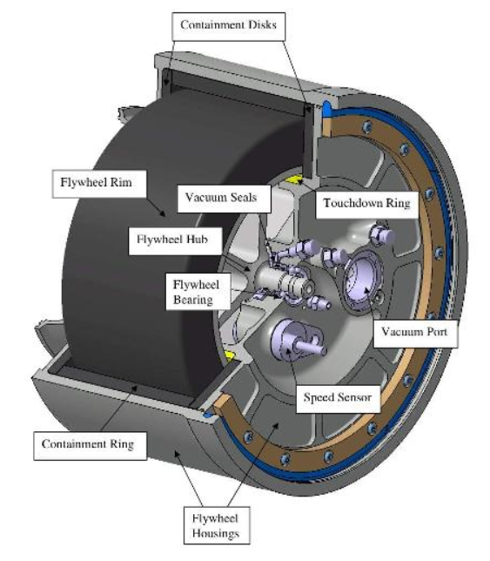
Figure 5 – KERS Flywheel Unit (Collins, 2011)

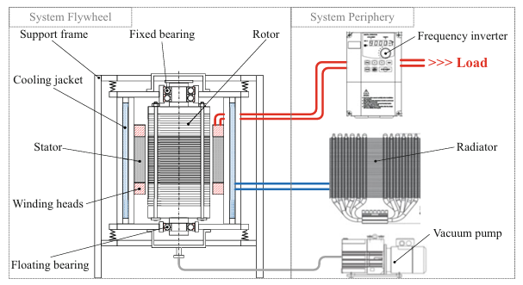
Figure 6 - Flywheel Unit Vacuum and Cooling Schematics (Buchroithner 2023)

Mechanical Batteries v Chemical Batteries

Flywheels are often termed as mechanical batteries as they store energy in a kinetic form, analogous to how electrochemical batteries, as they store energy in chemical form. Ufine (2025) states there are other mechanical systems, pumped hydro storage which pump water to a higher elevation, storing water as a gravitational potential energy, that can be released to power a generator. Compressed air energy storage (CAES), here the energy is stored as compressed air and then when released, the air drives a turbine to generate electricity. With technology advancing Arabkoohsar (2021) explains that new mechanical systems are being developed for example the pumped heat electricity storage. Mechanical batteries are deemed more environmentally friendly, additionally they have no toxic or flammable chemicals, avoiding thermal runaway and disposal issues that are associated with lithium-ion batteries. Arabkoohsar (2011) also states the major advantages of mechanical batteries is their high power density in short bursts and have an efficiency of up to 90%; this performance comes with an extremely greater life cycle and less prone to temperate performance depletion. Flywheel for example will undergo millions of charge and discharge cycles with negligible degradation with a life expectancy of twenty years, as Sharrow (2025) explains chemical batteries typically endure for only three to ten years. The limitation of mechanical batteries is that they only provide energy for short amount of time compared to chemical batteries, flywheels can hold energy for fifteen to thirty minutes, compared against chemical batteries storage of weeks. Along with this is the price, Buss and Shuttleworth (1999) explains flywheel systems require high precision engineering and specialised materials making the upfront cost more expensive.

Technical Analysis and Simulation of a Hybrid KERS Vehicle
Given a high-performance hybrid vehicle with a mass of 2080kg, equipped with a mechanical KERS flywheel system, with the flywheel mass of 6.5kg and an external diameter of 300mm that stores braking energy via a Continuously Variable Transmission. The flywheel is a thin-ring design and in a vacuum sealed unit with a combined efficiency of 80% (braking and accelerating) and has a maximum rotational speed of 50,000rpm. Using the provided data and formulas from University of Wales Trinity St David we perform the following analysis.

Vehicle Kinetic Energy Before Braking
The Kinetic Energy (KE) of the vehicle before braking from an initial speed off 55mph can be calculated using the Linear Motion formula for KE.

$$K.E=\frac{1}{2}mv²$$

m = Vehicle Mass = 2080kg
v = Vehicle Speed in m/s = Converting 55mph to kph then into m/s =24.59m/s

$55 x 1.609344=88.51392kph = \frac{m}{s}$= $\frac{88513.92}{3600}=24.59m/s$

$$K.E=\frac{1}{2} x 2080 x {\left(24.59\right)}^{2}=628854.82J$$
So, before braking the vehicle’s kinetic energy is 628854.82Joules (0.629MJ).

Energy Stored in the Flywheel After Braking
With 80% efficiency the actual energy stored in the flywheel after braking from 55mph to a rest would be:

$$E_{stored}=η⋅E_{vehicle}$$

Where ɳ = efficiency = 0.8 (80%)

$E_{stored}=0.8$ x 628854.82J = 503083.86J
Therefore, the energy stored in the flywheel would be 503083.86Jules (0.503MJ).

Flywheel Rotational Speed After Braking (RPM)
Using the Angular Motion formula for Kinetic Energy we can find the Flywheel rotational speed by solving $ω$ (angular velocity).

$$K.E=\frac{1}{2}Iω²$$

K.E = 503083.86J

I = Mass Moment of Inertia; the flywheel is labelled as a thin ring with a mass (m) of 6.5kg and a diameter of 300mm (radius r = 0.150m), using the Moment of Inertia Formula I is:

$I=mr$²

m = 6.5kg
r = 0.150m

$$I=6.5 x 0.15² = 0.146kg.m²$$
Now the Angular Motion Formula can be rearranged to find the subject $ω.$

$$ω^{2}=\frac{K.E}{\frac{1}{2}⋅I}$$

$$ω=\sqrt{\frac{K.E}{\frac{1}{2}⋅I}}$$

$$ω=\sqrt{\frac{503083.86}{\frac{1}{2}⋅0.146}}=2625.16rad/s$$
This angular speed can be converted into revolutions per minute with the formula below.

$$rpm=\frac{ω⋅60}{2π}$$

$$rpm=\frac{2625.18⋅60}{2π}=25068.62rpm$$
Therefore, the flywheel spins at about 25068rpm after absorbing the braking energy at 55mph.

Vehicle Speed After Re-Acceleration Using Only KERS Energy
Assuming that the vehicle is re-accelerating from rest using only the energy stored in the flywheel (503083.86J), we can calculate the final speed by rearranging the Kinetic Energy Linear Motion formula to find velocity (v). There is no energy loss to be considered, as it has already been accounted for in 5.2.

$$v²=\frac{K⋅E}{\frac{1}{2}⋅m}$$
$$v=\sqrt{\frac{K⋅E}{\frac{1}{2}⋅m}}$$

m = Vehicle Mass = 2080kg
K.E = Energy Stored = 503083.86J

$v=\sqrt{\frac{503083.86}{\frac{1}{2}⋅2080}}$ = 21.99m/s
The vehicles velocity is 21.99m/s, which equivalates to 49mph. (Do I need to show how I convert this to mph as mph is not stated in Q4?)
$$kph=\frac{v⋅3600}{1000}$$

$mph =\frac{kph}{1.609344}$

Effects on Re-Acceleration Due to Braking Speeds
Figure 7 shows a graph of the vehicle final re-acceleration speeds after collecting energy from different braking speed starting from 20mph with increments of 5mph up till 60mph. The formulas from 5.1, 5.2 and 5.4 are used, calculated, and plotted with Excel. Table 1 can be seen in Appendix A.
Would you like the calculations shown?
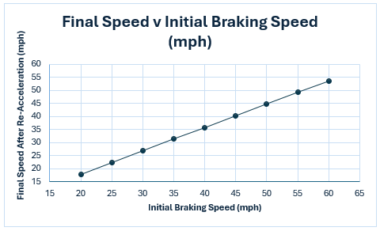
Figure 7 - Final Speed v Initial Braking Speed

We observe with Figure 7 that the graph shows a linear relationship between initial braking speeds and the final re-acceleration speeds, it also shows as the initial speed doubles, the re-acceleration speed doubles, indicting that a greater amount of energy is being stored the faster the initial braking speed is. Due to the 20% energy loss the final re-acceleration speed never achieves greater than or equal to the initial braking speed.

Acceleration From Stop in 6.5 Seconds
Knowing that braking from 60mph provides enough energy to re-accelerate to 53.67mph (23.99m/s). If the re-acceleration happens over a time of 6.5 seconds, we can calculate the average acceleration by rearranging the constant linear acceleration equation to find $a$.

$$v=u+at$$

$$a=\frac{v-u}{t}$$

$$v=Final Velocity=23.99m/s$$
$$u=Initial Velocity=0m/s$$
$$t=Time=6.5s$$

$$a=\frac{(23.99-0)}{6.5}=3.69m/s²$$
Therefore, the acceleration of the car from braking at 60mph using KERS energy is 3.69m/s².

Rotational Speed for a Smaller Mass Flywheel at Various Diameters
Exploring a KERS design for a smaller vehicle with a mass of 1510kg, the mass of the flywheel is 4.5kg. Assuming the flywheel is a thin ring we will compute the rotational speed of the flywheel if braking occurs at 60mph, with the changing facture of the flywheel’s diameter increasing from 120mm up to 240mm in increments of 20mm. Figure 8 shows the results of the speed in rpm, that has been calculated and plotted using Excel and the equations from 5.1, 5.2 and 5.3. Table 2 can be seen in Appendix B. (80% efficiency has been included).
Would you like the calculations/Equations shown?
K.E = 543178.062J
Energy stored at 80% efficiency = 434542.4496J

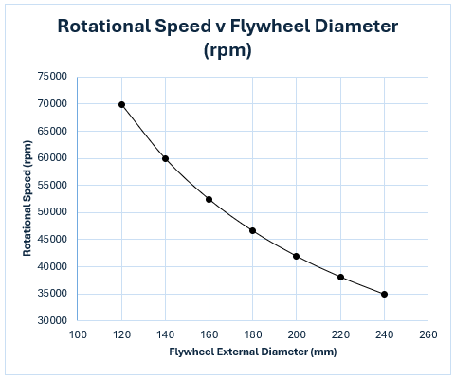
Figure 8 - Rotational Speed v Flywheel Diameter

Figure 8 shows a clear inverse relationship between flywheel size and the required rotational speed required to capture the full potential energy. At the smallest diameter 120mm, the flywheel must spin at nearly 70,000rpm to absorb the energy, on the other hand the 240mm diameter only requires spinning at approximately 35,000rpm. Other words larger flywheel diameter can store same amount of energy at a slower rotational speed.

Assumptions
In the above analysis, several assumptions were made. Using the thin ring formula to find the mass moment of inertia simplifies calculations, but a flywheel has some width, hub and shape. We’ve taken that the vacuum sealed unit is a perfectly sealed unit with no internal resistance on the flywheel and that the CVT operation can continuously adjust to allow optimal transfer of energy and no losses at any possible range change. This has allowed us to use the 80% efficiency across all speeds, which in practice, efficiency may be affected by different speeds, flywheel charge status, aerodynamics performance and other factors.

Conclusion
The assumptions allowed us to perform a tractable analysis. The results illustrate that the energy relationship and scaling of a flywheel KERS. Despite minor Idealizations, the key insights remain valid, the KERS can recapture a large fraction of a vehicle ‘s kinetic energy and resupply the energy back for an impressive acceleration. The history shows the reduction in flywheel diameter size due to material and technology improvement, with the analysis indicating by increasing the flywheel speed the energy can be stored in a smaller flywheel. The flywheel diameter, mass and speed must be balanced to achieve the energy storage goals within material and mechanical safety limits. Overall, the mechanical energy recovery system is highly efficient and powerful for a short-term energy reuse, aligning with the theoretical expectations of the flywheel as a mechanical battery. Each assumption identified could be a point for further refinement for a more detailed simulation.

Appendices
Appendix A
Table 1 - Re-Acceleration Speeds
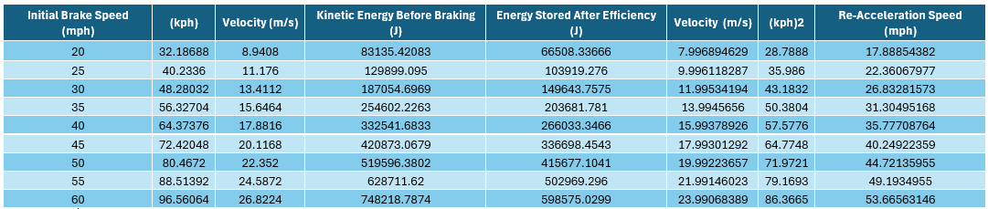

Appendix B
Table 2 - Flywheel Rotational Speeds
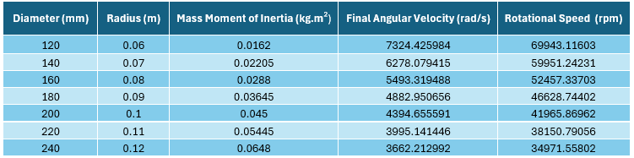

8 References

Amiryar, M.E. and Pullen, K.R., 2017. A review of flywheel energy storage system technologies and their applications. Applied Sciences, 7(3), p.286. Available at: https://doi.org/10.3390/app7030286 [Accessed 2 October 2025].
Arabkoohsar, A. (2021) Mechanical energy storage technologies. London, United Kingdom: Academic Press. Available at: https://search.ebscohost.com/login.aspx?direct=true&scope=site&db=nlebk&db=nlabk&AN=2432021 (Accessed: October 8, 2025).
Ashley, S. (1993) ‘Flywheels put a new spin on electric vehicles’, Mechanical Engineering, 115(10), p. 44. Available at: https://research-ebsco-com.imeche.idm.oclc.org/linkprocessor/plink?id=0b451cd4-b276-327e-a3db-d56daeda9215 (Accessed: 7 October 2025).
Atwell, C., 2025. Key moments in engineering history: Frank J. Sprague. Electronic Design, 26 February 2025. Available at: https://www.electronicdesign.com/technologies/industrial/article/55270922/key-moments-in-engineering-history-frank-j-sprague [Accessed 8 October 2025]
Bihl, T.J., 2018. The use and role of flywheel energy storage systems. In: A. Panosyan and H. Khaligh, eds. Energy storage at different voltage levels: technology, integration, and market aspects. London: The Institution of Engineering and Technology (IET), pp. 269–296. Available at: https://digital-library.theiet.org/content/books/10.1049/pbpo111e_ch10 [Accessed 2 October 2025].
Buchroithner, A., 2023. Flywheel energy storage: in automotive engineering. Wiesbaden, Germany: Springer Fachmedien Wiesbaden
Buss, R.J. and Shuttleworth, D., 1999. Plasma Processing for Enhanced Adhesion of Steel and Polymer Fibers to Rubber (No. SAND99-0159). Sandia National Laboratories, Albuquerque, NM, and Livermore, CA. Available at: sandia.gov/ess-ssl/publications/SAND2015-3976.pdf#:~:text=Machines using flywheels grew in,or more%2C flywheels in stationary [Accessed 2 October 2025].
Collins, S., 2011. Flywheel hybrid systems (KERS). Racecar Engineering, 24 April 2011. Available at: https://www.racecar-engineering.com/articles/f1/flywheel-hybrid-systems-kers/ [Accessed 2 October 2025]
Commercial Motor, 1916. The Orwell Electric, 6 April 1916, p. 4. Available at: https://archive.commercialmotor.com/article/6th-april-1916/4/the-orwell-electric [Accessed 6 October 2025].
Energy Education, 2025. Kinetic energy recovery system. Available at: https://energyeducation.ca/encyclopedia/Kinetic_energy_recovery_system [Accessed 6 October 2025]
Energy Education ,2025. Regenerative braking. Available at: https://energyeducation.ca/encyclopedia/Regenerative_braking [Accessed 6 October 2025].
FD Engineering, 2024. Mechanical Batteries: The Future of Energy Storage? [video online] YouTube. Available at: https://www.youtube.com/watch?v=trA5s2iGj2A [Accessed 2 October 2025].
Florin, F.I., 2015. Toyota Prius – A Successful Pioneering in Hybrid Vehicle World. [PDF] Politehnica University of Bucharest. Available at: https://d1wqtxts1xzle7.cloudfront.net/53214199/ContentServer-libre.pdf?... [Accessed 6 October 2025].
Hamada, A.T. and Orhan, M.F., 2022. An overview of regenerative braking systems. Journal of Energy Storage, 52(Part C), p.105033. Available at: https://doi.org/10.1016/j.est.2022.105033 [Accessed 2 October 2025].
History Tools, 2025. How do flywheels store energy?. Available at: https://www.historytools.org/concepts/how-do-flywheels-store-energy [Accessed 2 October 2025].
Inspired Pencil, (pictures 2023). Flywheel energy storage. Available at: https://ar.inspiredpencil.com/pictures-2023/flywheel-energy-storage [Accessed 8 October 2025].
Just-Auto, 2014. Analysis: Volvo / Flybrid KERS technology. Available at: https://www.just-auto.com/features/analysis-volvo-flybrid-kers-technology/ [Accessed 7 October 2025]
Lesley, 2021. Potter’s wheel history: how ancient pottery wheels evolved. [online] Pottery Crafters. Published 18 November 2021. Available at: https://potterycrafters.com/potters-wheel-history-how-ancient-pottery-wheels-evolved/ [Accessed 2 October 2025].
Metz, L.D., 2013. Potential for passenger car energy recovery through the use of kinetic energy recovery systems (KERS). SAE Technical Paper 2013-01-0407. Warrendale, PA: SAE International. Available at: https://doi.org/10.4271/2013-01-0407 [Accessed 6 October 2025].
MTU, 2021. How dynamic UPS works[video]. Available at: https://www.youtube.com/watch?v=Ow1AePLZcTs [Accessed 2 October 2025]
Oxford Scientist, 2023. The wheels on the bus… return of the flywheel. [online] The Oxford Scientist, 7 September 2023 (published), 1 October 2023 (updated). Available at: https://oxsci.org/the-flywheels-on-the-bus/ [Accessed 2 October 2025].
Reddit, 2020. 1997 Toyota Prius: the official car of. [online] r/regularcarreviews. Available at: https://www.reddit.com/r/regularcarreviews/comments/kd92uh/1997_toyota_prius_the_official_car_of/ [Accessed 8 October 2025]
Sharrow, T., 2025. The lifespan of batteries: understanding how long they really last. SoftHandTech, 5 April 2025. Available at: https://softhandtech.com/how-long-do-batteries-last/ [Accessed 8 October 2025].
Sri, K., 2023. Gyrobus. LinkedIn. Available at: https://www.linkedin.com/pulse/gyrobus-kaviya-sri [Accessed 8 October 2025]
Ufine, 2025. What is a mechanical battery? Exploring the future of energy storage. [online] Ufine Battery. Updated 9 January 2025. Available at: https://www.ufinebattery.com/blog/what-is-a-mechanical-battery-exploring-the-future-of-energy-storage/ [Accessed 8 October 2025]
U.S. Naval Undersea Museum, 2025. The Remarkable Story of a Howell Torpedo. Available at: https://navalunderseamuseum.org/howell/ [Accessed 2 October 2025].
Volvo Car Group, 2014. Volvo Car Group and Flybrid conduct UK testing of flywheel KERS technology. Volvo Media. Available at: https://www.media.volvocars.com/uk/en-gb/media/pressreleases/141626/volvo-car-group-and-flybrid-conduct-uk-testing-of-flywheel-kers-technology [Accessed 2 October 2025].
Webley, R., 2017. Spindle whorls. [online] Finds Recording Guides. Created 13 March 2017. Available at: https://finds.org.uk/counties/findsrecordingguides/spindle-whorls/ [Accessed 2 October 2025].
Yashuv, T. and Grosman, L., 2024. 12,000-year-old spindle whorls and the innovation of wheeled rotational technologies. PLOS ONE, 19(11), e0312007. Available at: https://doi.org/10.1371/journal.pone.0312007 [Accessed 2 October 2025].

